uzairjan

[Type the company name]

10/24/2018

DOCUMENTATION

2018

BY:

KHALIDA & ARSHIQ

We are really grateful because we managed to complete our E-project within the time given by our teacher **Sir Amjad**. This assignment could not be completed without the effort and co-operation from our group members, Group members; **Arshiq Waqar & Khalida.**

We also sincerely thank our teacher **Sir Amjad** for the guidance and encouragement in finishing this project and also for teaching us in this course.

Last but not the least, we would like to express our gratitude to our friends and respondents for the support and willingness directly or indirectly to spend some times with us to fill in the questionnaires.

**CONTENT**

1. Introduction------------------------------------------------- 4
2. Objectives of the Project------------------------------- 6
3. Topic of our Project--------------------------------------- 7
4. Hardware/Software Requirements------------------ 8
5. Work Analysis----------------------------------------------- 9
6. Design -------------------------------------------------------- 10
7. Homepage ------------------------------------------------- 11
8. Header -------------------------------------------------------- 12
9. Navigation Bar ---------------------------------------------- 13
10. Contact us---------------------------------------------------17
11. About Us ---------------------------------------------------- 19

**INTRODUCTION**

The thirst for learning, upgrading technical skills and applying the concepts in real life environment at a fast pace is what the industry demands from IT professionals today. However busy work schedules, far-flung locations, unavailability of convenient time-slots pose as major barriers when it comes to applying the concepts into realism. And hence the need to look out for alternative means of implementation in the form of laddered approach.

The above truly pose as constraints especially for our students too! With their busy schedules, it is indeed difficult for our students to keep up with the genuine and constant need for integrated application which can be seen live especially so in the field of IT education where technology can change on the spur of a moment. *Well, technology does come to our rescue at such times!!*

Keeping the above in mind and in tune with our constant endeavour to use Technology in our training model, we at Aptech have thought of revolutionizing the way our students learn and implement the concepts using tools themselves by providing a *live and synchronous eProject learning environment!*

**So what is this eProject?**

eProject is a step-by-step learning environment that closely simulates the classroom and Lab based learning environment into actual implementation. It is a project implementation at your fingertips!! An electronic, live juncture on the machine that allows you to

* Practice step by step i.e. laddered approach.
* Build a larger more robust application.
* Usage of certain utilities in applications designed by user.
* Single program to unified code leading to a complete application.
* Learn implementation of concepts in a phased manner.
* Enhance skills and add value.
* Work on real life projects.
* Give a real life scenario and help to create applications more complicated and useful.
* Mentoring through email support.

The students at the centre are expected to complete this eProject and send complete project along with the documentation to eprojects@aptechfze.ae

Looking forward to a positive response from your end!!

**OBJECTIVE OF PROJECT**

The Objective of this program is to give a sample project to work on real life projects. These applications help you build a larger more robust application.

The objective is not to teach you JavaScript/Dreamweaver but to provide you with a real life scenario and help you create basic applications using the tools.

You can revise the chapters before you start with the project.

This project is meant for students who have completed the module of ***Dreamweaver***. These programs should be done in the Lab sessions with assistance of the faculty if required.

It is very essential that a student has a clear understanding of the subject. Students should go through the project and solve the assignments as per requirements given.

Kindly get back @ eprojects@aptechfze.ae in case of any doubts regarding the application or its objectives.

**TOPIC OF OUR PROJECT**

**SHALE PIZZAS**

**Problem Statement**

Shale-PIZZAAsss is famous for Pizzas, Pasta food. Shale-PIZZAAsss was opened with one restaurant in the year 1960 and now it has more than 1000 restaurant across the countries. A website needs to be designed must display the menus, Contact Us (so as to call a make order). Details of various franchise, locations, feedback must be included.

**Requirement Specification:**

The Web site is to be created based on the following requirements.

1. Home Page must display the image section of the website.
2. Color combination must be made precise in the application.
3. Links such as
   * Home
   * Menu
     1. Pizza
     2. Garlic Breads
     3. Pizza Sandwiches
     4. Desserts
     5. Beverages
   * Menu Download
   * Store Location
   * Locations
   * Contact Us
   * Feedback
   * Franchise Info
4. Other Additional Links such as
   * Weekend Special
   * Combo offers
   * Gallery
5. Navigation of the project must be made precise
6. Look and feel must be made user friendly.

**Hardware/ Software Requirements**

**Hardware**

* A minimum computer system that will help you access all the tools in the courses is a Pentium 166 or better
* 64 Megabytes of RAM or better

**Software**

* Notepad/HTML editor
* Dreamweaver
* IE 5.0/ Netscape 6.0

**WORK ANALYSIS**

|  |  |  |
| --- | --- | --- |
| Task | Arshiq waqar | Khalida |
| Analysis |  |  |
| Design |  |  |
| Coding |  |  |
| Testing |  |  |
| Documentation |  |  |

**DESIGN**

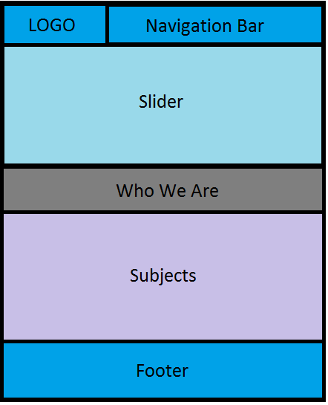

**HOME PAGE**

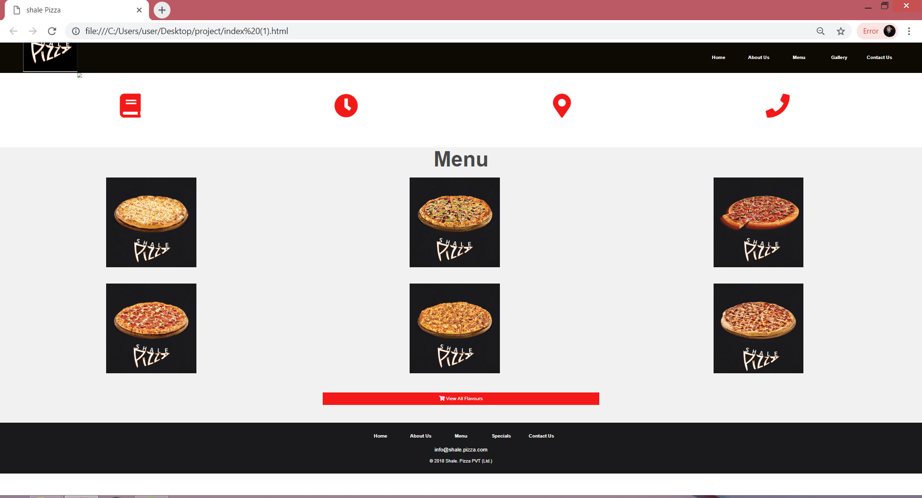 **HTML**

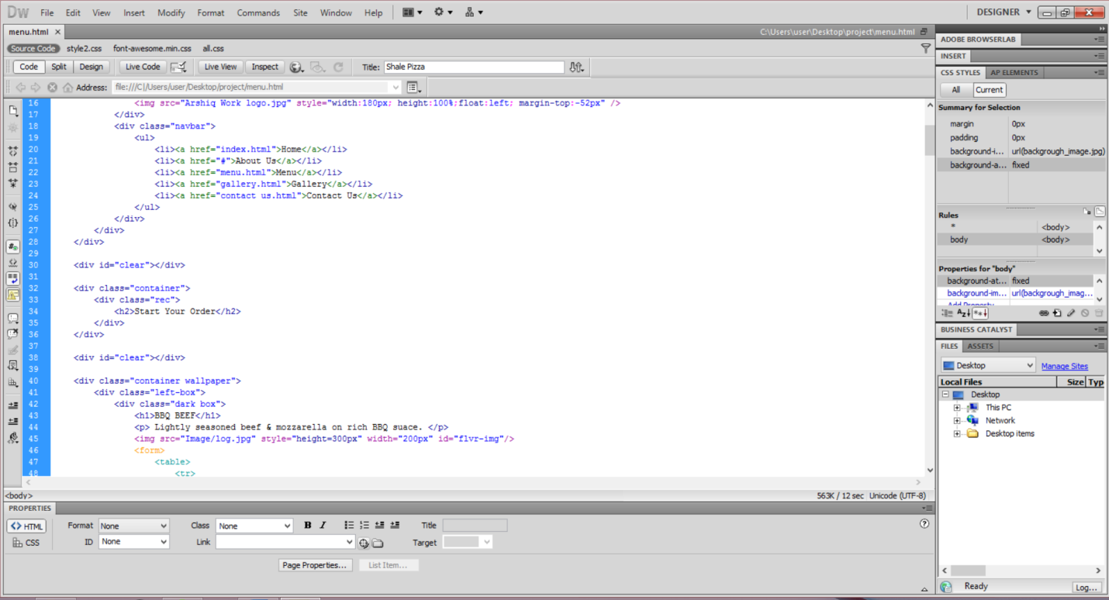

**CSS**

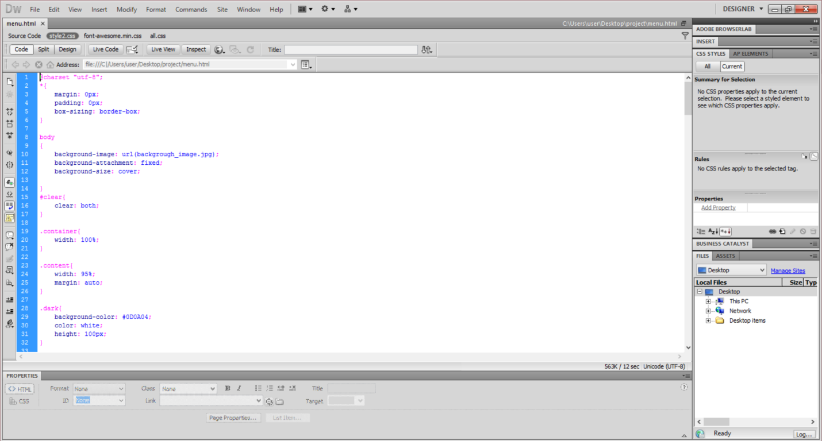

**NAV BAR**



**HTML**

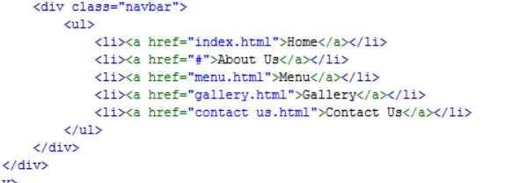

**CSS**

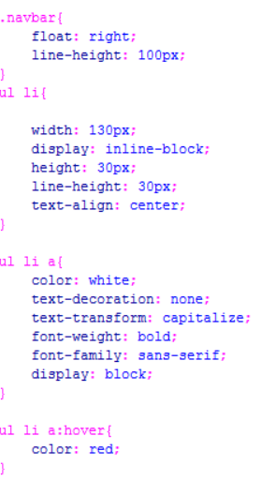

**MENU**

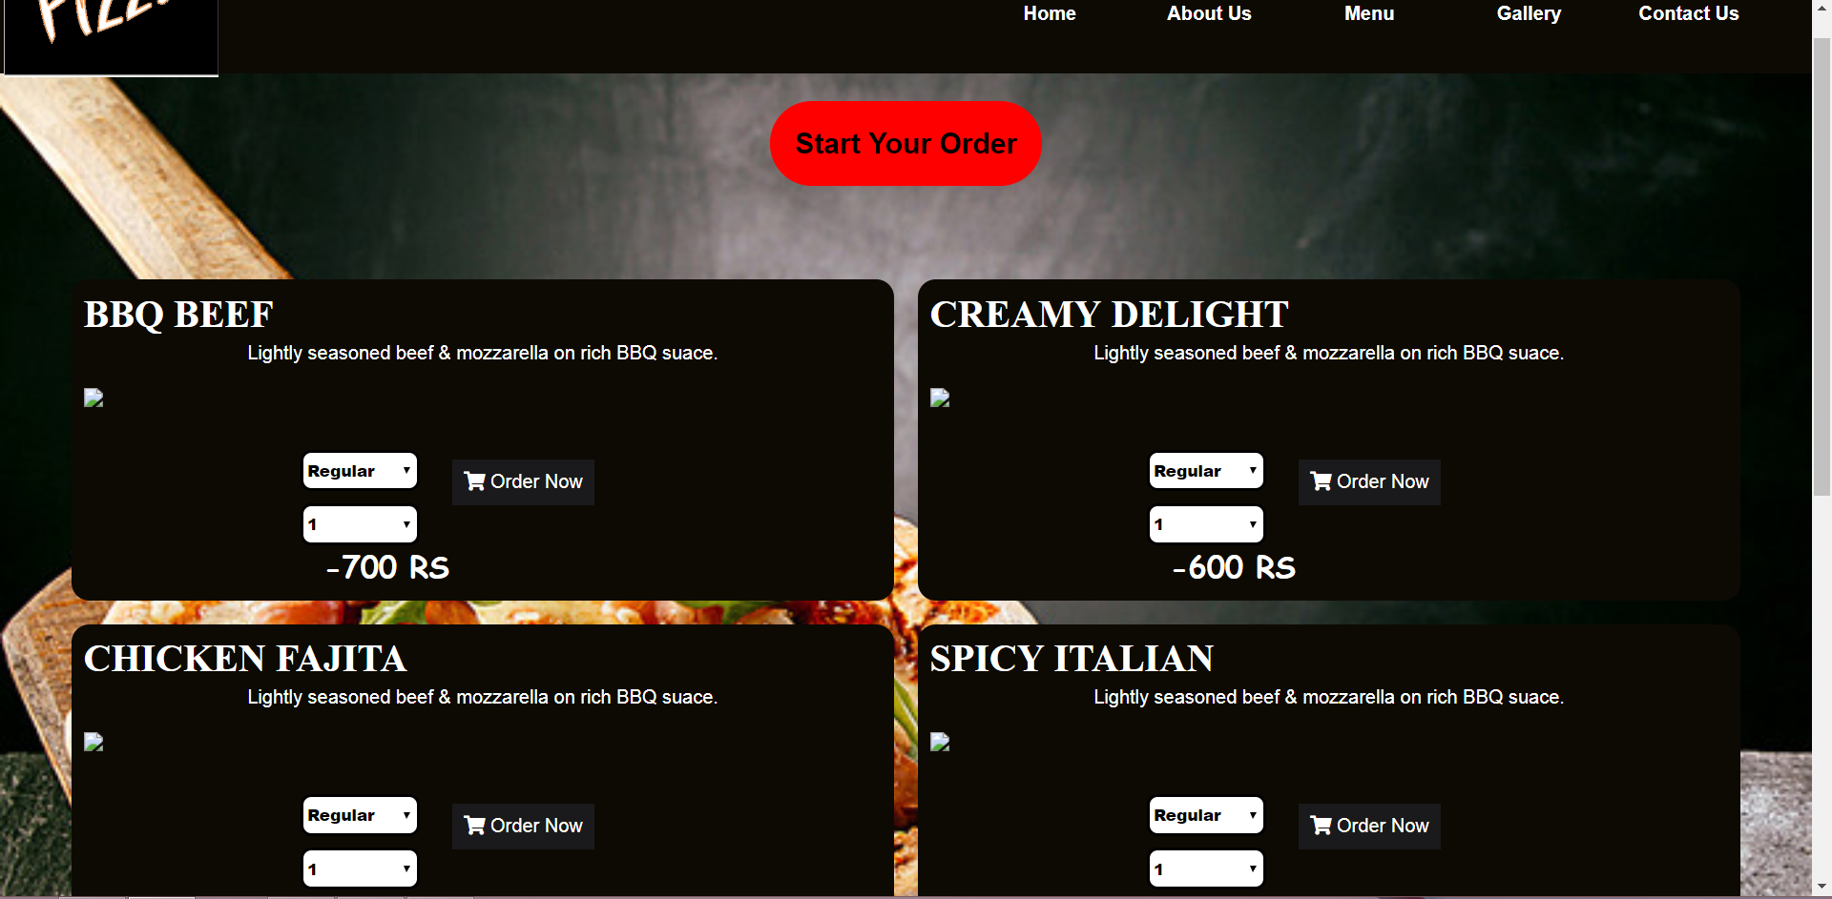

**HTML**

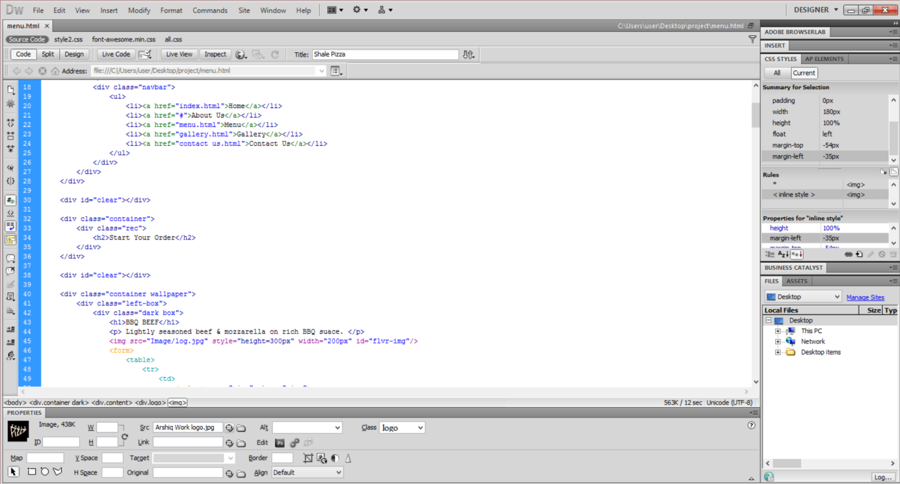

**CSS**

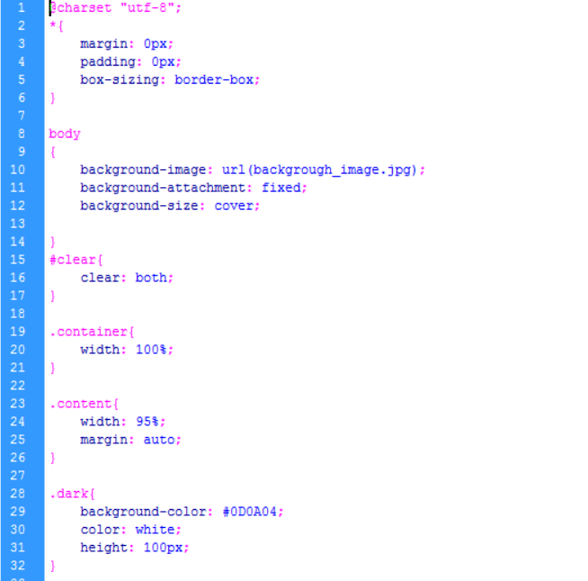

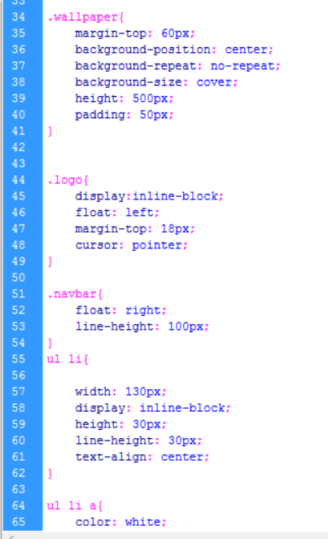

**CONTACT US**

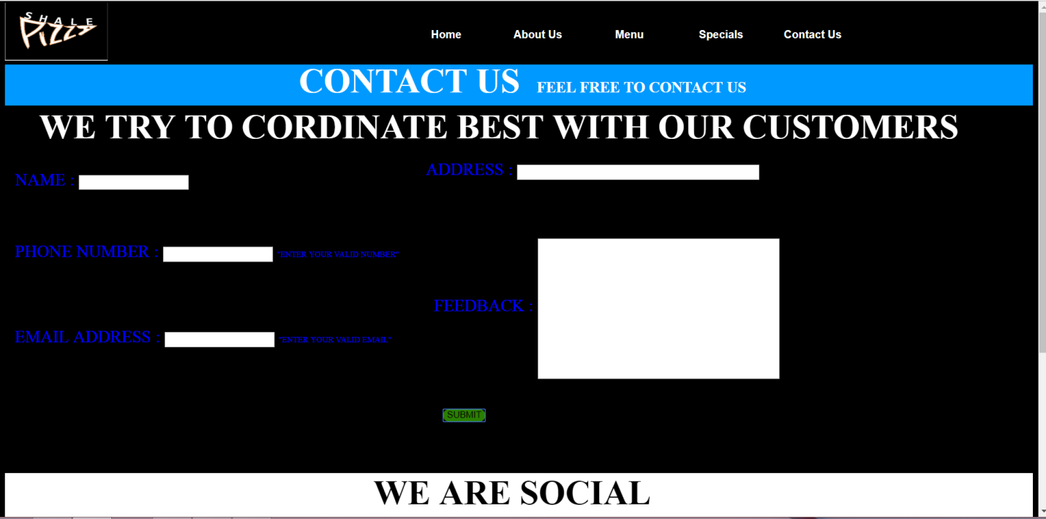

**HTML**

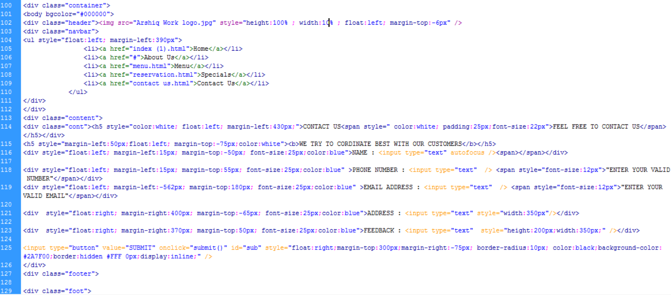

**CSS**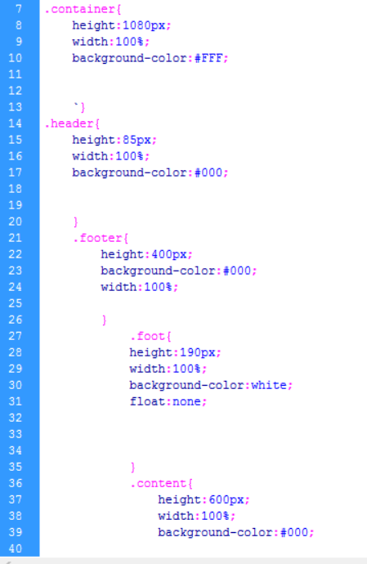

**THANK YOU**