2018

MUHAMMAD YASEEN

HP

10/22/2018

SPORTS INFO



dsadas

gsfdsf

# ACKNOWLEDGMENT

We are really grateful because we managed to complete our project within the time given by our teacher . This assignment cannot be completed without the effort and co-operation from our group members, Group members; **MUHAMMAD YASEEN**

We also sincerely thank our teacherfor the guidance and encouragement in finishing this project and also for teaching us in this course.

Last but not the least, we would like to express our gratitude to our friends and respondents for the support and willingness directly or indirectly to spend some times with us to fill in the questionnaires.

**CONTENT**

1. Introduction------------------------------------------------- 3
2. E-project------------------------------------------------------4
3. Objectives of the Project-------------------------------5
4. Information included ------------------------------------6
5. Hardware/Software Requirements------------------7
6. Work Analysis----------------------------------------------- 8
7. Layout --------------------------------------------------------9
8. Homepage ------------------------------------------------10

* Code---------------------------------------------------11
* Css-------------------------------------------------------12

1. About Us-----------------------------------------------------13

Introduction

The thirst for learning, upgrading technical skills and applying the concepts in real life environment at a fast pace is what the industry demands from IT professionals today. However busy work schedules, far-flung locations, unavailability of convenient time-slots pose as major barriers when it comes to applying the concepts into realism. And hence the need to look out for alternative means of implementation in the form of laddered approach.

The above truly pose as constraints especially for our students too! With their busy schedules, it is indeed difficult for our students to keep up with the genuine and constant need for integrated application which can be seen live especially so in the field of IT education where technology can change on the spur of a moment. *Well, technology does come to our rescue at such times!!*

Keeping the above in mind and in tune with our constant endeavour to use Technology in our training model, we at Aptech have thought of revolutionizing the way our students learn and implement the concepts using tools themselves by providing a *live and synchronous eProject learning environment!*

**So what is this eProject?**

**eProject is a step-by-step learning environment that closely simulates the classroom and Lab based learning environment into actual implementation. It is a project implementation at your fingertips!! An electronic, live juncture on the machine that allows you to**

* **Practice step by step i.e. laddered approach.**
* **Build a larger more robust application.**
* **Usage of certain utilities in applications designed by user.**
* **Single program to unified code leading to a complete application.**
* **Learn implementation of concepts in a phased manner.**
* **Enhance skills and add value.**
* **Work on real life projects.**
* **Give a real life scenario and help to create applications more complicated and useful.**
* **Mentoring through email support.**

**The students at the centre are expected to complete this eProject and send complete project along with the documentation to eprojects@aptechfze.ae**

**Looking forward to a positive response from your end!!**

**Objectives of the project**

The Objective of this program is to give a sample project to work on real life projects. These applications help you build a larger more robust application.

The objective is not to teach you JavaScript/Dreamweaver but to provide you with a real life scenario and help you create basic applications using the tools.

You can revise the chapters before you start with the project.

This project is meant for students who have completed the module of ***Dreamweaver***. These programs should be done in the Lab sessions with assistance of the faculty if required.

It is very essential that a student has a clear understanding of the subject. Students should go through the project and solve the assignments as per requirements given.

Kindly get back @ eprojects@aptechfze.ae in case of any doubts regarding the application or its objectives.

# INFORMATION INCLUDED

1. Home page with suitable logo.

2. A menu which will include all the functions implemented in the site.

3. The site should provide the information about following sports:

a. Football

b. Judo

c. Tennis

d. Motorcycle Racing

e. Volleyball

f. Golf

g. Chess

h. Billiards

i. Badminton

j. Swimming

k. Athletics

4.

**a. How many players play the game?**

**b. Strategy of the game.**

**c. Is it a team game?**

**d. Rules of the game.**

**e. Some important facts about the game (when was the game invented,**

**any special tournament like World cup / Wimbledon is played etc etc).**

**f. Statistics/ records.**

**WORK ANALYSIS**

|  |  |  |
| --- | --- | --- |
| Task | M.Yaseen | M.yaseen |
| Analysis |  |  |
| Design |  |  |
| Coding |  |  |
| Testing |  |  |
| Documentation |  |  |

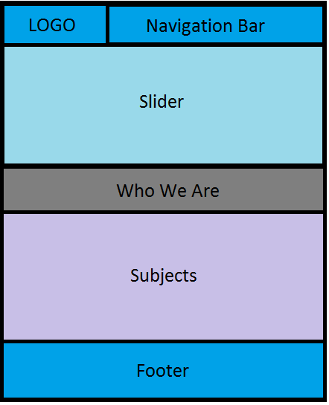**LAYOUT**

# HOME PAGE

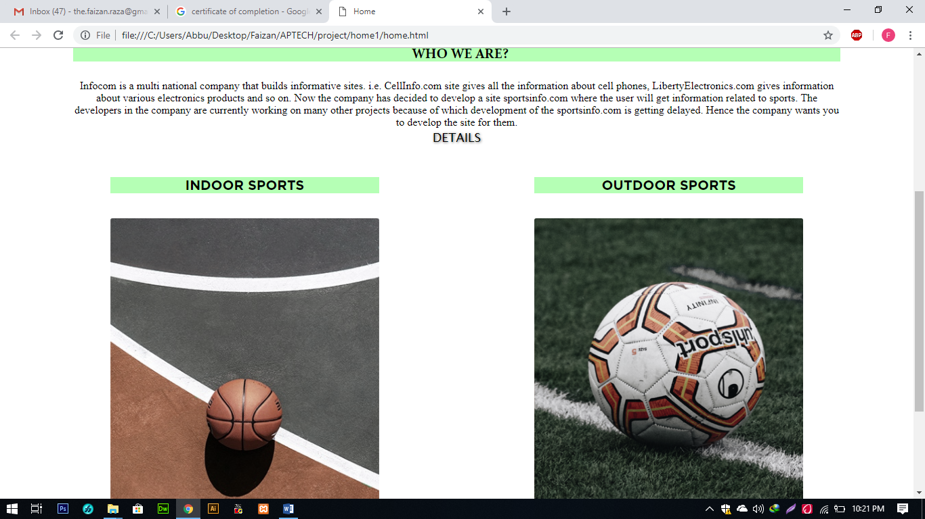

Code

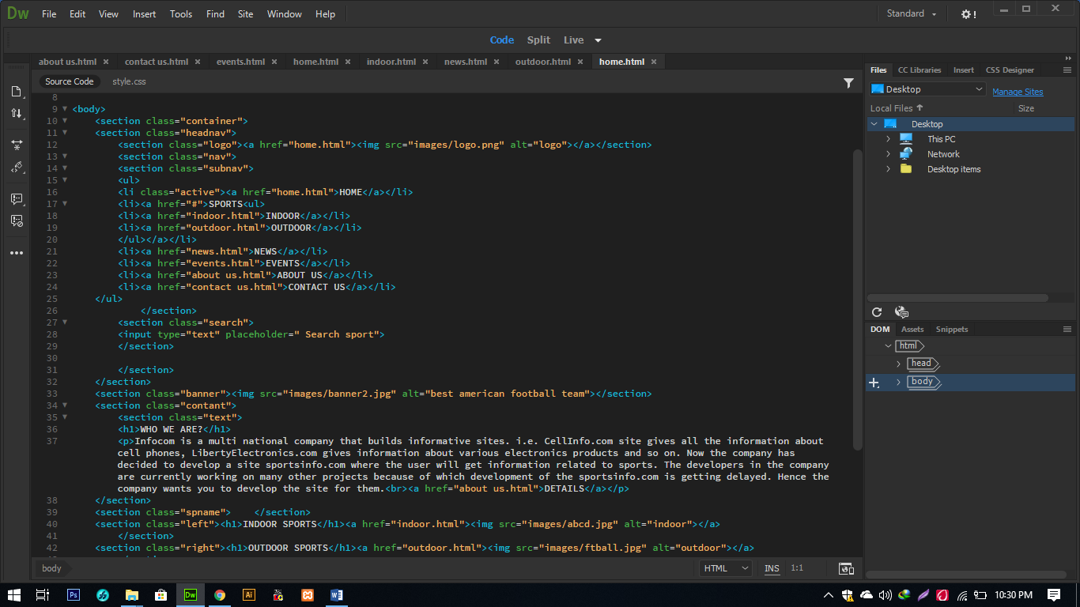

css

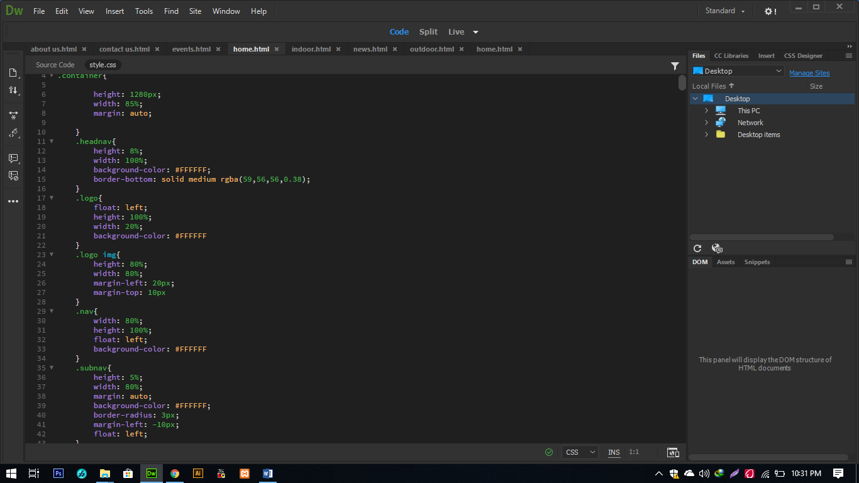

**ABOUT US**

**Infocom** is a multi national company that builds informative sites. i.e. **CellInfo.com**

site gives all the information about cell phones, **LibertyElectronics.com** gives

information about various electronics products and so on. Now the company has

decided to develop a **site sportsinfo.com** where the user will get information related

to sports. The developers in the company are currently working on many other

projects because of which development of the **sportsinfo.com** is getting delayed.

Hence the company wants you to develop the site for them.

SOME OF MY WEB PAGES:

