**Seekbar**

MainActivity.java

**package** com.saya.seekbar;

**import** android.os.Bundle;

**import** android.app.Activity;

**import** android.graphics.Color;

**import** android.view.Menu;

**import** android.widget.RelativeLayout;

**import** android.widget.SeekBar;

**import** android.widget.SeekBar.OnSeekBarChangeListener;

/* Add "implements OnSeekBarChangeListener" and "Add Unimplemented Method" to MainActivity */

**public** **class** MainActivity **extends** Activity **implements** OnSeekBarChangeListener {

SeekBar red, green, blue; // Three SeekBars

RelativeLayout MainScreen;

@Override

**protected** **void** onCreate(Bundle savedInstanceState) {

**super**.onCreate(savedInstanceState);

setContentView(R.layout.***activity_main***);

MainScreen=(RelativeLayout) findViewById(R.id.***screen***);

/* id's for SeekBars */

red=(SeekBar)findViewById(R.id.***seekBar1***);

green=(SeekBar) findViewById(R.id.***seekBar2***);

blue=(SeekBar)findViewById(R.id.***seekBar3***);

/* Current objects of colors(SeekBars) */

red.setOnSeekBarChangeListener(**this**);

green.setOnSeekBarChangeListener(**this**);

blue.setOnSeekBarChangeListener(**this**);

}

@Override

**public** **boolean** onCreateOptionsMenu(Menu menu) {

// Inflate the menu; this adds items to the action bar if it is present.

getMenuInflater().inflate(R.menu.***main***, menu);

**return** **true**;

}

@Override

**public** **void** onProgressChanged(SeekBar seekBar, **int** progress, **boolean** fromUser) {

// **TODO** Auto-generated method stub

MainScreen.setBackgroundColor(Color.*rgb*(red.getProgress(), green.getProgress(), blue.getProgress()));

}

@Override

**public** **void** onStartTrackingTouch(SeekBar seekBar) {

// **TODO** Auto-generated method stub

}

@Override

**public** **void** onStopTrackingTouch(SeekBar seekBar) {

// **TODO** Auto-generated method stub

}

}

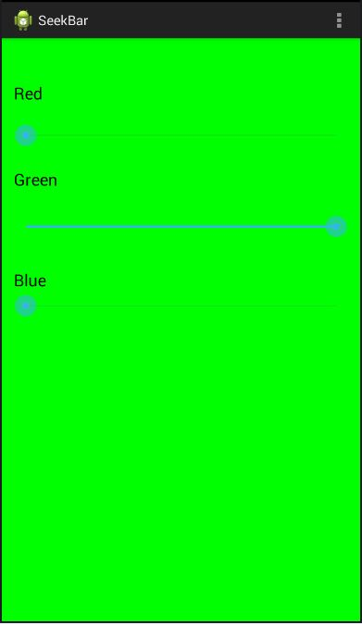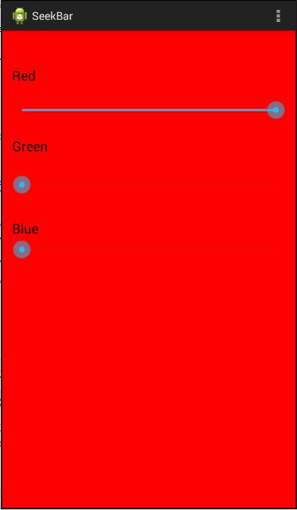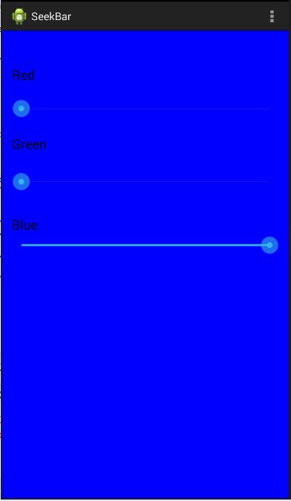Output:

ListView

MainActivity.java

**package** com.e.listview;

**import** android.os.Bundle;

**import** android.app.Activity;

**import** android.view.View;

**import** android.widget.AdapterView;

**import** android.widget.AdapterView.OnItemClickListener;

**import** android.widget.ArrayAdapter;

**import** android.widget.ListView;

**import** android.widget.Toast;

**public** **class** MainActivity **extends** Activity {

String[] months= {"January", "February", "March", "April", "May", "June", "July","August", "september","October", "November", "December"};

ListView lv;

@Override

**protected** **void** onCreate(Bundle savedInstanceState) {

**super**.onCreate(savedInstanceState);

setContentView(R.layout.***activity_main***);

lv=(ListView)findViewById(R.id.***listview***);

ArrayAdapter<String> adapter=**new** ArrayAdapter<String>(getApplicationContext(), android.R.layout.***simple_expandable_list_item_1***, months);

lv.setAdapter(adapter);

lv.setOnItemClickListener(**new** OnItemClickListener() {

@Override

**public** **void** onItemClick(AdapterView<?> parent, View view, **int** position, **long** id) {

// **TODO** Auto-generated method stub

Toast.*makeText*(getApplicationContext(), months[position], Toast.***LENGTH_SHORT***).show();

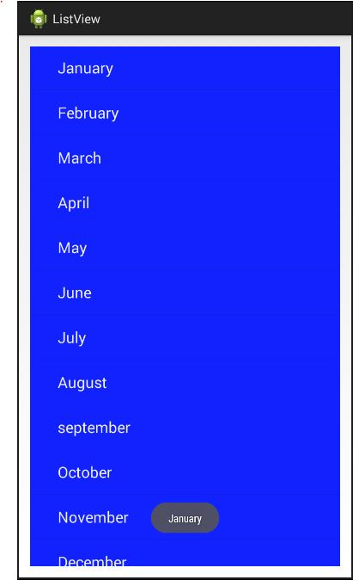 }

});

}

}

Calculator

MainActivity.java

**package** com.saya.simplecalculator;

**import** android.os.Bundle;

**import** android.app.Activity;

**import** android.widget.EditText;

**import** android.widget.RadioButton;

**import** android.widget.RadioGroup;

**import** android.widget.RadioGroup.OnCheckedChangeListener;

**public** **class** MainActivity **extends** Activity **implements** OnCheckedChangeListener {

EditText et1, et2, et3;

RadioGroup rg;

RadioButton rb0, rb1, rb2, rb3;

@Override

**protected** **void** onCreate(Bundle savedInstanceState) {

**super**.onCreate(savedInstanceState);

setContentView(R.layout.***activity_main***);

et1=(EditText) findViewById(R.id.***editText1***);

et2=(EditText) findViewById(R.id.***editText2***);

et3=(EditText) findViewById(R.id.***editText3***);

rg=(RadioGroup) findViewById(R.id.***radioGroup1***);

rb0=(RadioButton) findViewById(R.id.***radio0***);

rb1=(RadioButton) findViewById(R.id.***radio1***);

rb2=(RadioButton) findViewById(R.id.***radio2***);

rb3=(RadioButton) findViewById(R.id.***radio3***);

rg.setOnCheckedChangeListener(**this**);

}

@Override

**public** **void** onCheckedChanged(RadioGroup group, **int** arg1) {

// **TODO** Auto-generated method stub

**float** n1, n2, n3=0;

n1=Float.*parseFloat*(et1.getText().toString());

n2=Float.*parseFloat*(et2.getText().toString());

**if**(arg1 == rb0.getId())

n3=n1+n2;

**else** **if**(arg1 == rb1.getId())

n3=n1-n2;

**else** **if**(arg1 == rb2.getId())

n3=n1*n2;

**else** **if**(arg1 == rb3.getId())

n3=n1/n2;

et3.setText(n3+"");

}

}

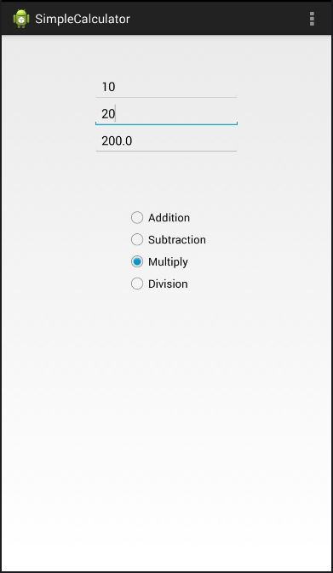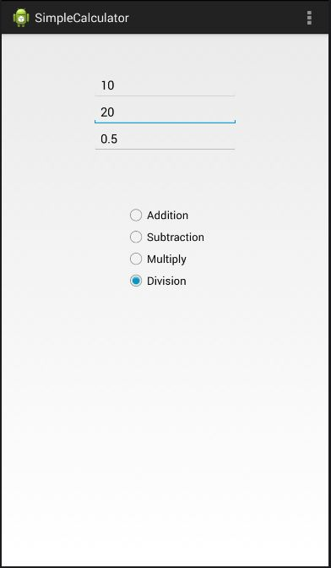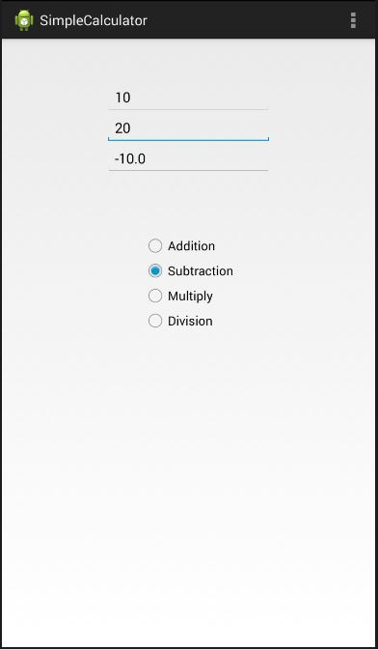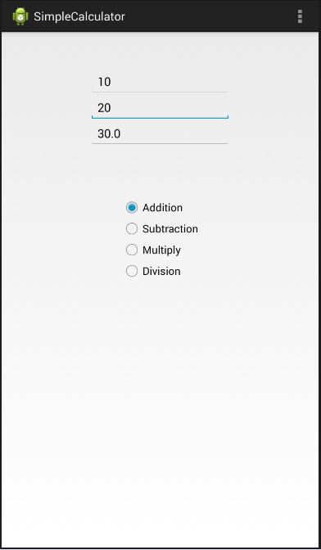

**File Read and Write**

MainActivity.java

**package** com.ic.filereadwrite;

**import** android.os.Bundle;

**import** java.io.BufferedReader;

**import** java.io.FileOutputStream;

**import** java.io.InputStreamReader;

**import** android.app.Activity;

**import** android.view.View;

**import** android.view.View.OnClickListener;

**import** android.widget.Button;

**import** android.widget.EditText;

**import** android.widget.Toast;

**public** **class** MainActivity **extends** Activity {

Button btnsave,btnclear,btnload,btnclose;

EditText et;

@Override

**protected** **void** onCreate(Bundle savedInstanceState) {

**super**.onCreate(savedInstanceState);

setContentView(R.layout.***activity_main***);

et=(EditText)findViewById(R.id.***editText1***);

btnsave=(Button)findViewById(R.id.***btnsave***);

btnload=(Button)findViewById(R.id.***btnload***);

btnclear=(Button)findViewById(R.id.***btnclear***);

btnclose=(Button)findViewById(R.id.***btnclose***);

btnsave.setOnClickListener(**new** OnClickListener() {

@Override

**public** **void** onClick(View arg0) {

// **TODO** Auto-generated method stub

**try** {

FileOutputStream fos=openFileOutput("myfile", ***MODE_PRIVATE***);

fos.write(et.getText().toString().getBytes());

fos.close();

Toast.*makeText*(getApplicationContext(), "File Saved", Toast.***LENGTH_SHORT***).show();

} **catch** (Exception e) {

Toast.*makeText*(getApplicationContext(), e.getMessage(), Toast.***LENGTH_SHORT***).show();

e.printStackTrace();

}

}

});

btnclear.setOnClickListener(**new** OnClickListener() {

@Override

**public** **void** onClick(View arg0) {

// **TODO** Auto-generated method stub

et.setText("");

}

});

btnload.setOnClickListener(**new** OnClickListener() {

@Override

**public** **void** onClick(View arg0) {

// **TODO** Auto-generated method stub

**try** {

BufferedReader reader = **new** BufferedReader(**new** InputStreamReader(openFileInput("myfile")));

String textline;

StringBuffer strbuffer=**new** StringBuffer();

**while**( (textline=reader.readLine()) != **null**){

strbuffer.append(textline+"\n");

}

et.setText(strbuffer.toString());

} **catch** (Exception e) {

Toast.*makeText*(getApplicationContext(), e.getMessage(), Toast.***LENGTH_SHORT***).show();

e.printStackTrace(); }

}

});

btnclose.setOnClickListener(**new** OnClickListener() {

@Override

**public** **void** onClick(View arg0) {

// **TODO** Auto-generated method stub

finish();

}

});

}

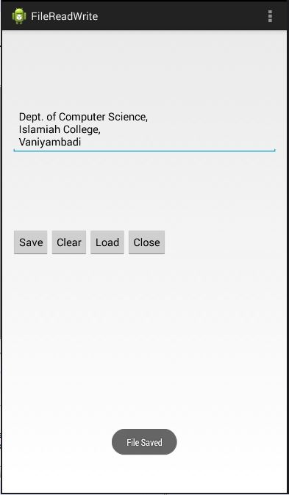}

IntentActivity

MainActivity.java

**package** com.saya.intentapp;

**import** android.os.Bundle;

**import** android.app.Activity;

**import** android.content.Intent;

**import** android.view.View;

**import** android.widget.Button;

**import** android.widget.EditText;

**public** **class** MainActivity **extends** Activity {

Button button;

EditText et;

@Override

**protected** **void** onCreate(Bundle savedInstanceState) {

**super**.onCreate(savedInstanceState);

setContentView(R.layout.***activity_main***);

et=(EditText) findViewById(R.id.***editText1***);

button=(Button) findViewById(R.id.***button1***);

button.setOnClickListener(**new** View.OnClickListener() {

@Override

**public** **void** onClick(View v) {

// **TODO** Auto-generated method stub

Intent intent = **new** Intent(getApplicationContext(), SecondActivity.**class**);

intent.putExtra("id", et.getText().toString());

startActivity(intent);

}

});

}

}

SecondActivity.java

**package** com.saya.intentapp;

**import** android.os.Bundle;

**import** android.app.Activity;

**import** android.view.View;

**import** android.view.View.OnClickListener;

**import** android.widget.Button;

**import** android.widget.TextView;

**public** **class** SecondActivity **extends** Activity {

TextView tv;

Button bt;

@Override

**protected** **void** onCreate(Bundle savedInstanceState) {

**super**.onCreate(savedInstanceState);

setContentView(R.layout.***activity_second***);

tv=(TextView) findViewById(R.id.***textView1***);

tv.setText(getIntent().getExtras().getString("id").toString());

bt=(Button) findViewById(R.id.***button1***);

bt.setOnClickListener(**new** OnClickListener() {

@Override

**public** **void** onClick(View v) {

// **TODO** Auto-generated method stub

finish();

}

});

}

}

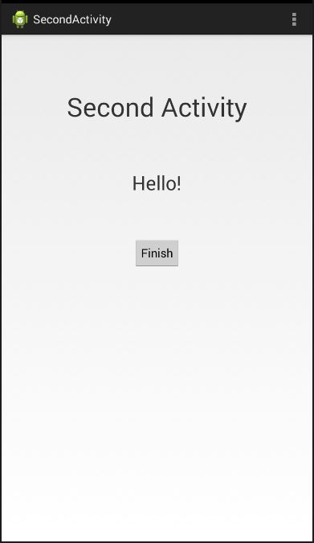

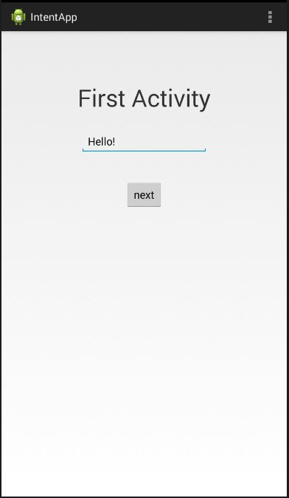

Status Bar Notification

MainActivity.java

**package** com.ic.statusbarnotification;

**import** android.os.Bundle;

**import** android.app.Activity;

**import** android.app.Notification;

**import** android.app.NotificationManager;

**import** android.app.PendingIntent;

**import** android.content.Context;

**import** android.content.Intent;

**import** android.view.View;

**import** android.view.View.OnClickListener;

**import** android.widget.Button;

**public** **class** MainActivity **extends** Activity {

@Override

**protected** **void** onCreate(Bundle savedInstanceState) {

**super**.onCreate(savedInstanceState);

setContentView(R.layout.***activity_main***);

Button btn = (Button)findViewById(R.id.***button1***);

btn.setOnClickListener(**new** OnClickListener() {

@Override

**public** **void** onClick(View v) {

// **TODO** Auto-generated method stub

NotificationManager nm= (NotificationManager) getSystemService(***NOTIFICATION_SERVICE***);

Notification notification= **new** ~~Notification~~(android.R.drawable.***stat_notify_more***,"You have got an email", System.*currentTimeMillis*());

Context context=MainActivity.**this**;

Intent intent = **new** Intent(context,MainActivity.**class**);

PendingIntent pending = PendingIntent.*getActivity*(getApplicationContext(), 0, intent, 0);

notification.~~setLatestEventInfo~~(context, "Email from facebook", "You have 4 friends request", pending);

nm.notify(0, notification); // zero is the notification id.

}

});

}

}

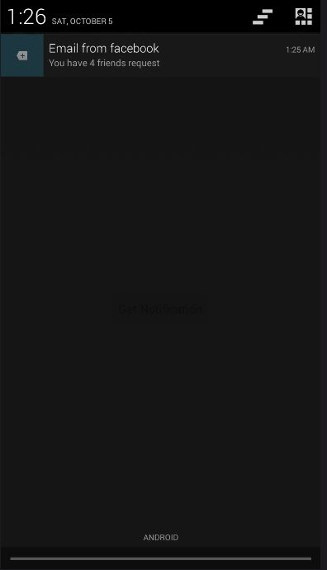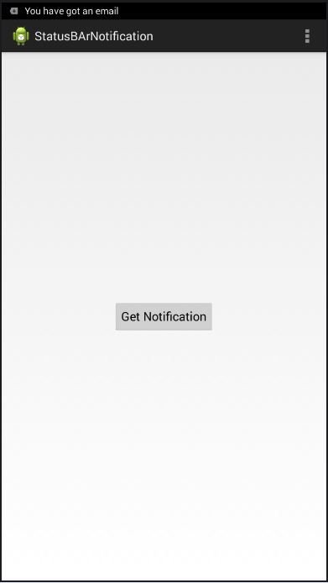

Splash Screen

MainActivity.java

**package** com.saya.splashscreen;

**import** android.os.Bundle;

**import** android.os.Handler;

**import** android.app.Activity;

**import** android.content.Intent;

**public** **class** MainActivity **extends** Activity {

@Override

**protected** **void** onCreate(Bundle savedInstanceState) {

**super**.onCreate(savedInstanceState);

setContentView(R.layout.***activity_main***);

Handler myhandler = **new** Handler();

myhandler.postDelayed(**new** Runnable() {

@Override

**public** **void** run() {

// **TODO** Auto-generated method stub

finish();

Intent myintent = **new** Intent(MainActivity.**this**, SecondActivity.**class**);

startActivity(myintent);

}

}, 4000); // this is 4 seconds

}

}

SecondActivity.java

**package** com.saya.splashscreen;

**import** android.os.Bundle;

**import** android.app.Activity;

**public** **class** SecondActivity **extends** Activity {

@Override

**protected** **void** onCreate(Bundle savedInstanceState) {

**super**.onCreate(savedInstanceState);

setContentView(R.layout.***activity_second***);

}

}

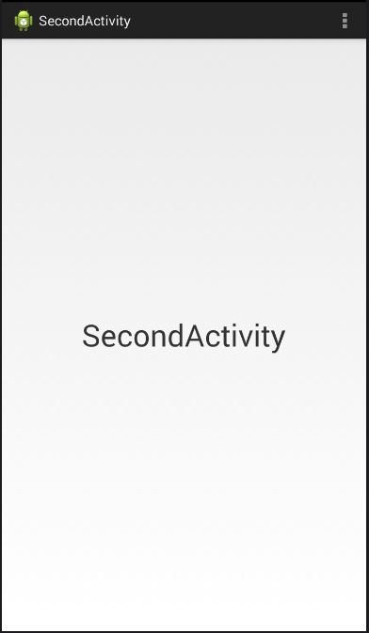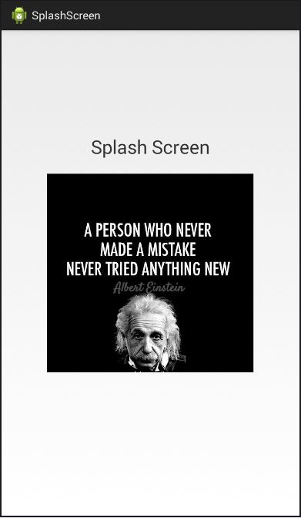

Alert Dialog

MainActivity.java

**package** com.ic.alertdialogs;

**import** android.os.Bundle;

**import** android.app.Activity;

**import** android.app.AlertDialog;

**import** android.content.DialogInterface;

**import** android.view.View;

**import** android.view.View.OnClickListener;

**import** android.widget.Button;

**import** android.widget.Toast;

**public** **class** MainActivity **extends** Activity **implements** OnClickListener {

Button btn1,btn2,btn3;

@Override

**protected** **void** onCreate(Bundle savedInstanceState) {

**super**.onCreate(savedInstanceState);

setContentView(R.layout.***activity_main***);

btn1=(Button)findViewById(R.id.***button1***);

btn2=(Button)findViewById(R.id.***button2***);

btn3=(Button)findViewById(R.id.***button3***);

btn1.setOnClickListener(**this**);

btn2.setOnClickListener(**this**);

btn3.setOnClickListener(**this**);

}

@Override

**public** **void** onClick(View v) {

// **TODO** Auto-generated method stub

**switch**(v.getId())

{

**case** R.id.***button1***:

showdialog1();

**break**;

**case** R.id.***button2***:

showdialog2();

**break**;

**case** R.id.***button3***:

showdialog3();

**break**;

}

}

**private** **void** showdialog1() {

AlertDialog.Builder builder=**new** AlertDialog.Builder(**this**);

builder.setTitle("Confirm Delete");

builder.setMessage("Are You sure to Delete?");

builder.setPositiveButton("Yes", **new** DialogInterface.OnClickListener() {

@Override

**public** **void** onClick(DialogInterface dialog, **int** which) {

Toast.*makeText*(getApplicationContext(), "Yes is Selected", Toast.***LENGTH_SHORT***).show();

}

});

builder.setNegativeButton("No", **new** DialogInterface.OnClickListener() {

@Override

**public** **void** onClick(DialogInterface arg0, **int** arg1) {

Toast.*makeText*(getApplicationContext(), "No is Selected", Toast.***LENGTH_SHORT***).show();

}

});

AlertDialog mydialog = builder.create();

mydialog.show();

}

**private** **void** showdialog2() {

AlertDialog.Builder builder=**new** AlertDialog.Builder(**this**);

**final** String[] colors={"Red","Green","Blue","Cyan","Yellow","Pink"};

builder.setTitle("Select a Color ");

builder.setItems(colors, **new** DialogInterface.OnClickListener() {

@Override

**public** **void** onClick(DialogInterface dialog, **int** which) {

Toast.*makeText*(getApplicationContext(), colors[which], Toast.***LENGTH_SHORT***).show();

}

});

AlertDialog mydialog = builder.create();

mydialog.show();

}

**private** **void** showdialog3() {

AlertDialog.Builder builder=**new** AlertDialog.Builder(**this**);

**final** String[] colors={"Red","Green","Blue","Cyan","Yellow","Pink"};

builder.setTitle("Select a Color ");

builder.setSingleChoiceItems(colors, -1, **new** DialogInterface.OnClickListener() {

@Override

**public** **void** onClick(DialogInterface dialog, **int** which) {

Toast.*makeText*(getApplicationContext(), colors[which], Toast.***LENGTH_SHORT***).show();

}

});

AlertDialog mydialog = builder.create();

mydialog.show();

}

}

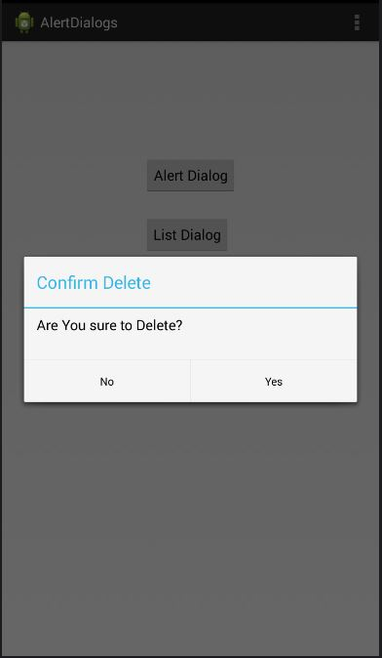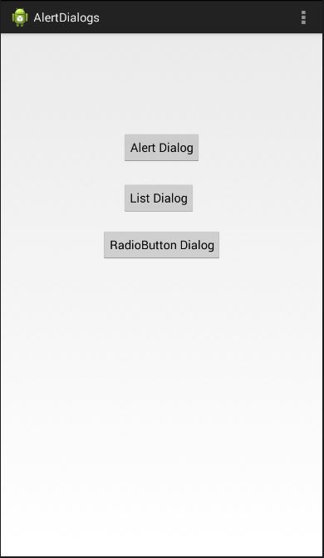

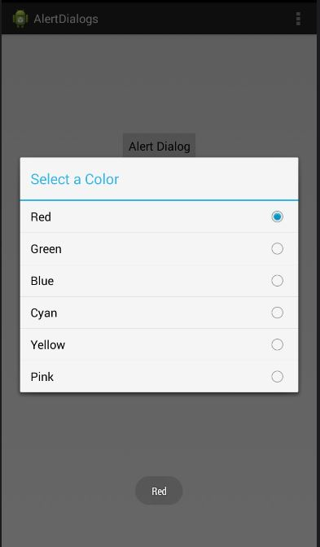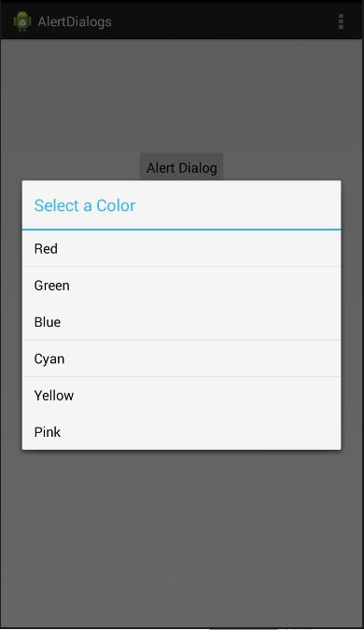

Tab Widget Talking Clock

MainActivity.java

**package** com.ic.talkingclock;

**import** android.os.Bundle;

**import** android.speech.tts.TextToSpeech;

**import** android.speech.tts.TextToSpeech.OnInitListener;

**import** java.util.Calendar;

**import** android.app.Activity;

**import** android.app.~~TabActivity~~;

**import** android.view.View;

**import** android.view.View.OnClickListener;

**import** android.widget.AnalogClock;

**import** android.widget.TabHost;

**import** android.widget.Toast;

**public** **class** MainActivity **extends** ~~TabActivity~~ **implements** OnInitListener{

AnalogClock ac;

TextToSpeech tts;

**int** h,m,s;

@Override

**protected** **void** onCreate(Bundle savedInstanceState) {

**super**.~~onCreate~~(savedInstanceState);

setContentView(R.layout.***activity_main***);

TabHost mytabHost=~~getTabHost~~(); mytabHost.addTab(mytabHost.newTabSpec("tab1").setIndicator("AnalogClock").setContent(R.id.***tab1***));

mytabHost.addTab(mytabHost.newTabSpec("tab2").setIndicator("DigitalClock").setContent(R.id.***tab2***));

ac=(AnalogClock)findViewById(R.id.***analogClock1***);

tts=**new** TextToSpeech(**this**, **this**);

ac.setOnClickListener(**new** OnClickListener() {

@Override

**public** **void** onClick(View v) {

Calendar c = Calendar.*getInstance*();

h=c.get(Calendar.***HOUR***);

m=c.get(Calendar.***MINUTE***);

s=c.get(Calendar.***SECOND***);

String t="The time is "+h+" Hours"+m+" Minutes"+s+" Seconds";

Toast.*makeText*(getApplicationContext(), t, Toast.***LENGTH_LONG***).show();

tts.speak(t, TextToSpeech.***QUEUE_FLUSH***, **null**);

}

});

}

@Override

**public** **void** onInit(**int** status) {

// **TODO** Auto-generated method stub

}

}

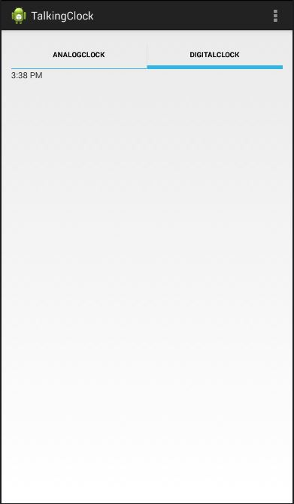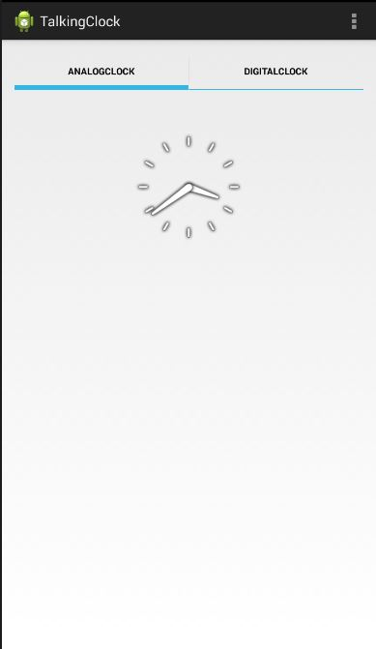

Multi Language List

MainActivity.java

**package** com.saya.multi;

**import** android.os.Bundle;

**import** android.app.Activity;

**import** android.view.View;

**import** android.widget.AdapterView;

**import** android.widget.AdapterView.OnItemClickListener;

**import** android.widget.ArrayAdapter;

**import** android.widget.ListView;

**import** android.widget.Toast;

**public** **class** MainActivity **extends** Activity {

ListView lv;

@Override

**protected** **void** onCreate(Bundle savedInstanceState) {

**super**.onCreate(savedInstanceState);

setContentView(R.layout.***activity_main***);

lv=(ListView)findViewById(R.id.***listView1***);

**final** ArrayAdapter<CharSequence>

myadapter = ArrayAdapter.*createFromResource*(getApplicationContext(), R.array.***days*** ,android.R.layout.***simple_list_item_1***);

lv.setAdapter(myadapter);

lv.setOnItemClickListener(**new** OnItemClickListener() {

@Override

**public** **void** onItemClick(AdapterView<?> parent, View view, **int** position, **long** id) {

// **TODO** Auto-generated method stub

Toast.*makeText*(getApplicationContext(), myadapter.getItem(position), Toast.***LENGTH_SHORT***).show();

}

});

}

}

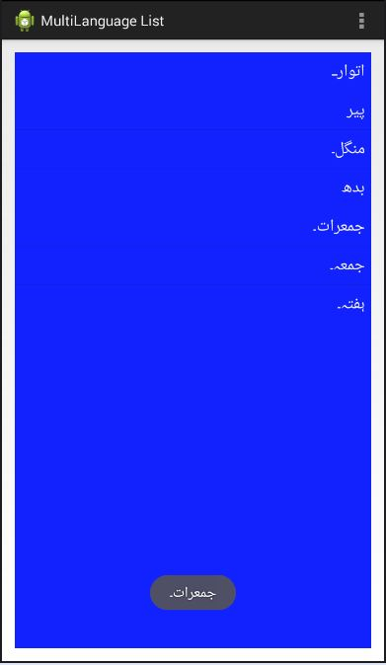

Shared Preference

MainActivity.java

**package** com.ic.sharedpreference;

**import** android.os.Bundle;

**import** android.app.Activity;

**import** android.content.SharedPreferences;

**import** android.widget.EditText;

**public** **class** MainActivity **extends** Activity {

EditText et1, et2;

@Override

**protected** **void** onCreate(Bundle savedInstanceState) {

**super**.onCreate(savedInstanceState);

setContentView(R.layout.***activity_main***);

et1=(EditText) findViewById(R.id.***editText1***);

et2=(EditText) findViewById(R.id.***editText2***);

SharedPreferences settings = getSharedPreferences("MYPREFS", 0);

et1.setText(settings.getString("name", ""));

et2.setText(settings.getString("email", ""));

}

@Override

**protected** **void** onStop() {

**super**.onStop();

SharedPreferences settings = getSharedPreferences("MYPREFS", 0);

SharedPreferences.Editor editor = settings.edit();

editor.putString("name", et1.getText().toString());

editor.putString("email", et2.getText().toString());

editor.commit();

 

