**USERFLOW GUIDE**

Description:

To utilize all functionalities of the course system for the Tandon School of Engineering, I have provided some guidance on the navigation of the website.

To gain access to the website as a user, all that is required is an internet connection and a functional web browser where the url is input to access the website. (In this case since it is not released yet, this is not applicable)

Next, I have included below four different flowcharts that describe the flow and routing from one page or button to the next alongside a minimal description. These flowcharts include a non-logged in user guide, and then three flowcharts which display the navigation details after the login is successful for students, admin, or instructors.

In addition, I have added some explanations and extra guidance for easier user navigation through the website.

**FLOWCHART GUIDE FOR NON-LOGGED IN USERS**

**FLOWCHART GUIDE FOR LOGGED IN ADMINISTRATOR USERS**

**FLOWCHART GUIDE FOR LOGGED IN INSTRUCTOR USERS**

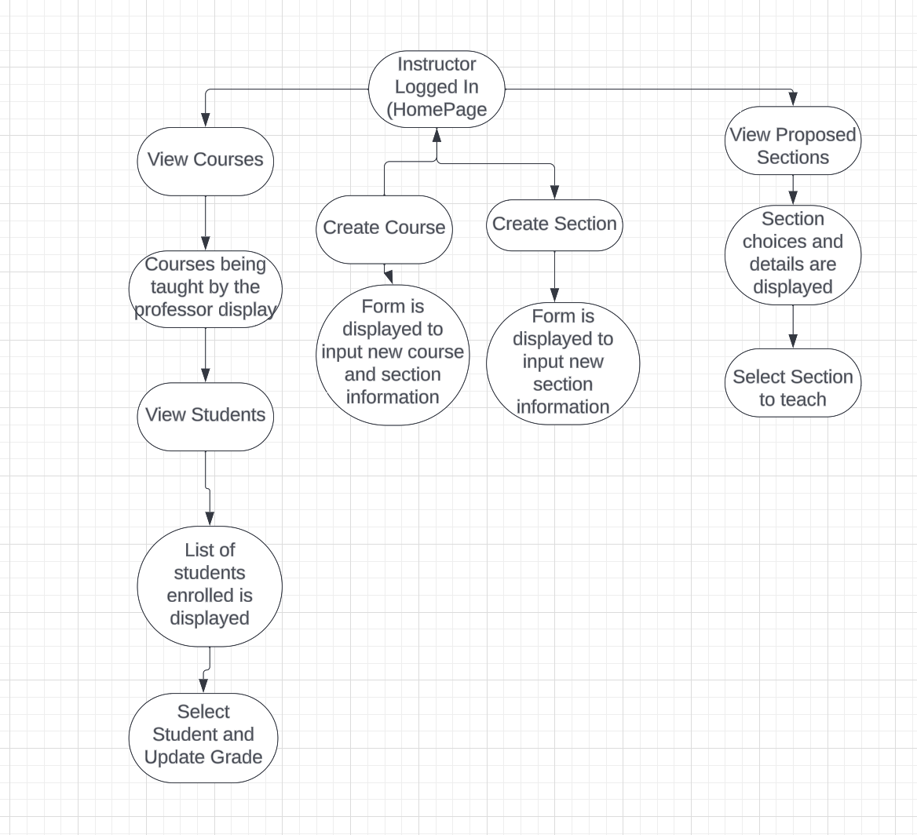

**\FLOWCHART GUIDE FOR LOGGED IN STUDENT USERS**

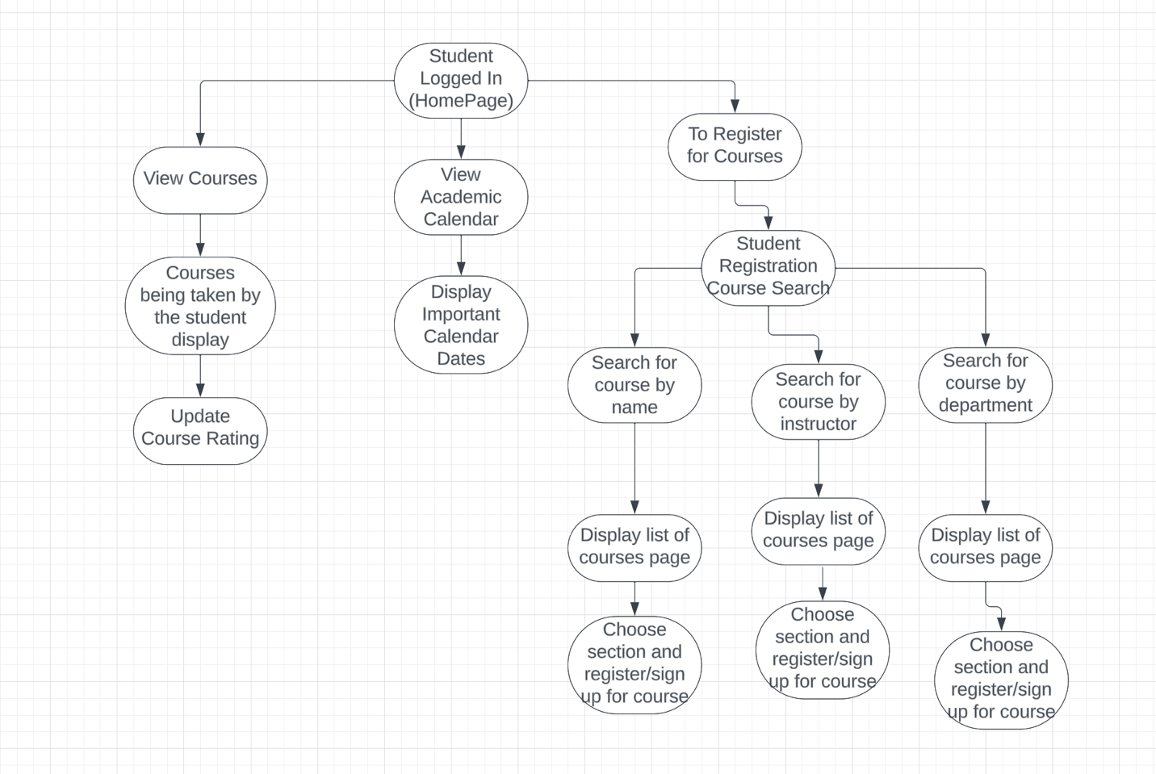

**EXTRAS:**

* Included on many of the pages post login are the buttons LOGOUT and GO BACK
  + If LOGOUT is pressed, all sessions are killed, and the user is redirected to the Non-logged homepage to start over or exit the website.
  + If GO BACK is pressed and the user is logged in, the logged in user stays logged in, and is redirected to the previous page to the one they are on
  + If GO BACK is pressed and the user is not logged in, the user is redirected to the previous page, but the information is not remembered