UNIVERSITY OF ENGINEERING AND TECHNOLOGY,
PESHAWAR PAKISTAN
Main Campus

CS-224 Web Technologies
Lab Manual No. 03
Submitted By
Name: Yaseen khan
Registration No. 24PWBCS1391
Semester: BS CS 3rd
Section: C
Submission Date: 15/03/2026
Submitted To
Sir Mohammad
DEPARTMENT OF COMPUTER SCIENCE & IT
UNIVERSITY OF ENGINEERING AND TECHNOLOGY, PESHAWAR, PAKISTAN

Index.html
<!DOCTYPE html>
<html lang="en">
<head>
<meta charset="UTF-8">
<title>CSS Lab 03 & 04</title>
<link rel="stylesheet" href="styles/main.css">
<style>
body{font-family:Arial;background:#f4f6f8;text-align:center;}
h1{background:#2c3e50;color:white;padding:15px;}
nav ul{list-style:none;padding:0;}
nav li{display:inline;margin:10px;}
nav a{text-decoration:none;color:#2c3e50;font-weight:bold;}
nav a:hover{color:#e67e22;}
p{width:70%;margin:auto;font-size:16px;}
</style>
</head>
<body>
<h1>CSS Lab 03 & 04 Showcase</h1>
<nav>
<ul>
<li><a href="exercises/selectors.html">Selectors</a></li>
<li><a href="exercises/typography.html">Typography</a></li>
<li><a href="exercises/backgrounds.html">Backgrounds</a></li>
<li><a href="exercises/images.html">Images</a></li>
</ul>
</nav>
<p>This project demonstrates CSS fundamentals including selectors, typography, backgrounds, image styling, box model, and transitions.</p>
</body>
</html>

Index output
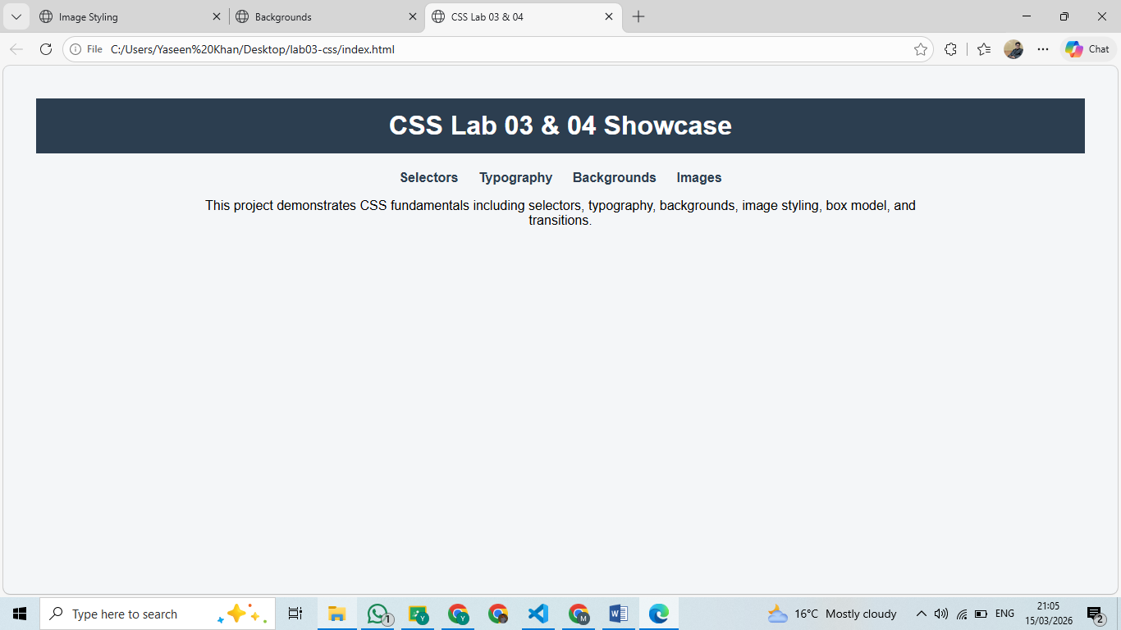
Typography.HTML
<!DOCTYPE html>
<html lang="en">
<head>
<meta charset="UTF-8">
<title>Typography</title>
<link rel="stylesheet" href="../styles/typography.css">
<link href="https://fonts.googleapis.com/css2?family=Poppins&family=Roboto&family=Playfair+Display&display=swap" rel="stylesheet">
</head>

<body>
<h1>Typography Showcase</h1>

<p class="poppins">This text uses Poppins font.</p>
<p class="roboto">This text uses Roboto font.</p>
<p class="playfair">This text uses Playfair Display font.</p>
<p class="shadow">Example of text shadow.</p>

</body>
</html>

Output:
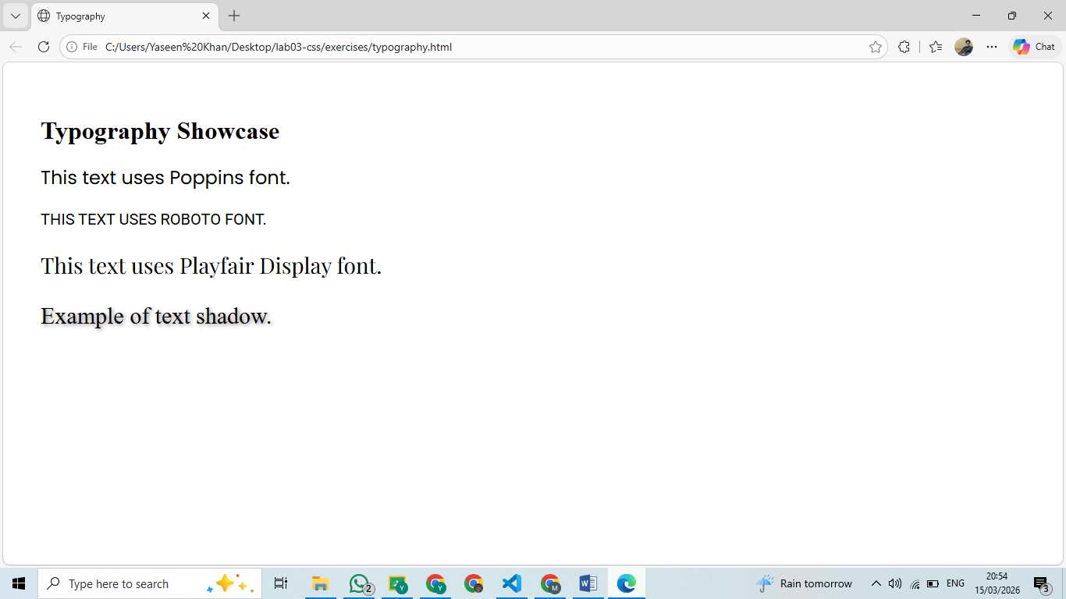
Selectors:
<!DOCTYPE html>
<html lang="en">
<head>
<meta charset="UTF-8">
<title>Selectors Practice</title>
<link rel="stylesheet" href="../styles/main.css">

<style>
body{background:#f2f2f2;font-family:Arial;}
#title{color:darkblue;text-align:center;}
.text{color:green;font-style:italic;}
p{color:#444;}
.container span{color:purple;font-weight:bold;}
input[type="text"]{border:2px solid orange;padding:5px;}
a{color:blue;text-decoration:none;}
a:hover{color:red;text-decoration:underline;}
ul li{color:brown;margin:4px;}
</style>

</head>

<body>

<h1 id="title">CSS Selectors</h1>

<p class="text">Paragraph styled with class selector.</p>
<p>Another paragraph for element selector.</p>

<div class="container">
<span>Descendant selector example</span>
</div>

<input type="text" placeholder="Attribute selector example">
<a href="#">Hover over this link</a>

<ul>
<li>Item 1</li>
<li>Item 2</li>
<li>Item 3</li>
</ul>

</body>
</html>

Selectors Output:
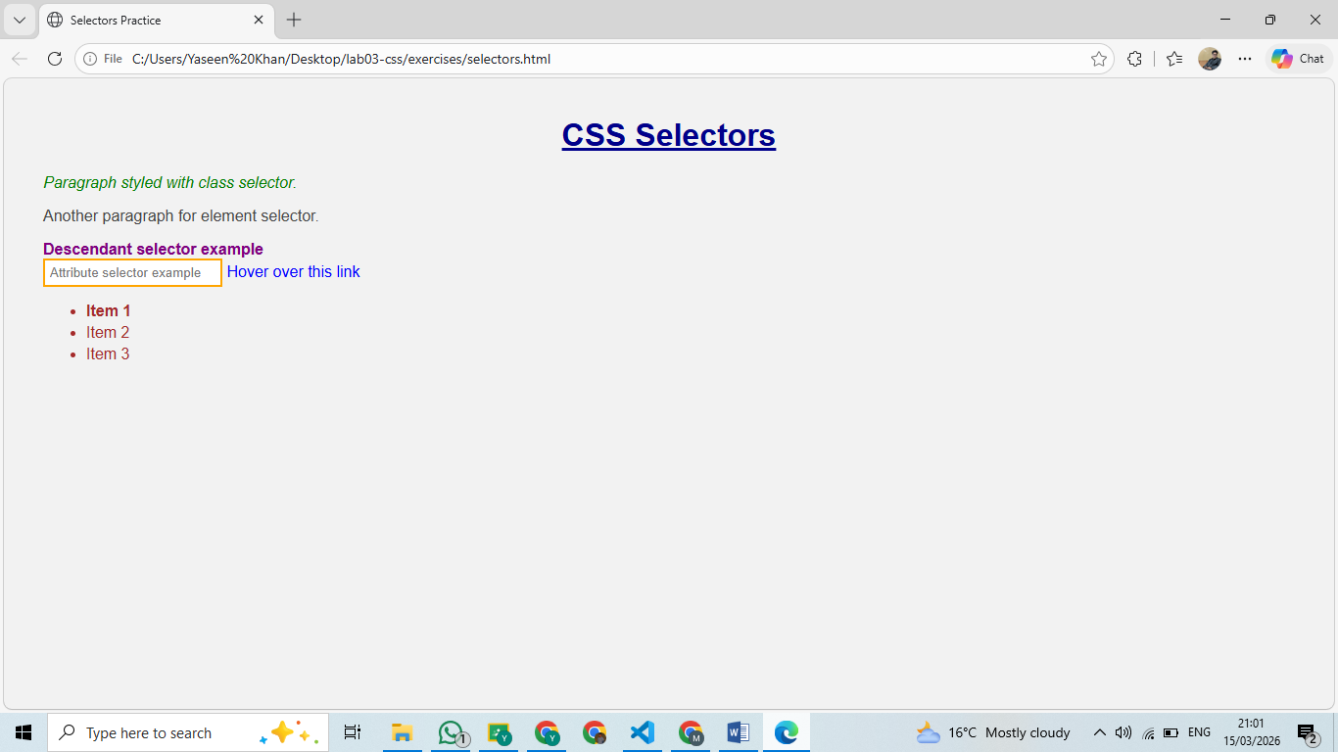
Images.html
<!DOCTYPE html>
<html lang="en">
<head>
<meta charset="UTF-8">
<title>Image Styling</title>
<style>
img { margin: 10px; transition: 0.3s; }
.rounded { border-radius: 15px; }
.circle { border-radius: 50%; border: 2px solid #3498db; }
.hover-effect:hover { transform: scale(1.05); }
</style>
</head>
<body>

<h1>Image Gallery</h1>

<img src="../images/Bab-e-khyber.jpg" class="rounded" alt="Bab-e-Khyber">
<img src="../images/circle.jpg" class="circle" alt="Circle">
<img src="../images/natural.jpg" class="hover-effect" alt="Natural">

</body>
</html>

Images screenshot
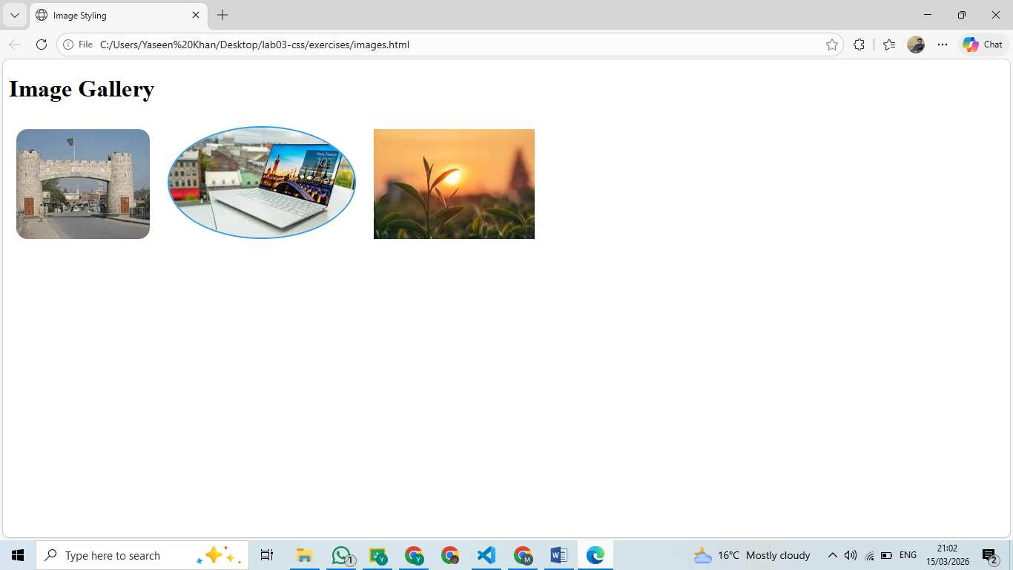
Backgrounds.html

<!DOCTYPE html>
<html lang="en">
<head>
<meta charset="UTF-8">
<title>Backgrounds</title>
<link rel="stylesheet" href="../styles/effects.css">
</head>
<body>
<div class="solid">Solid Background</div>
<div class="gradient">Gradient Background</div>
<div class="image-bg">Image Background</div>
</body>
</html>

Background output
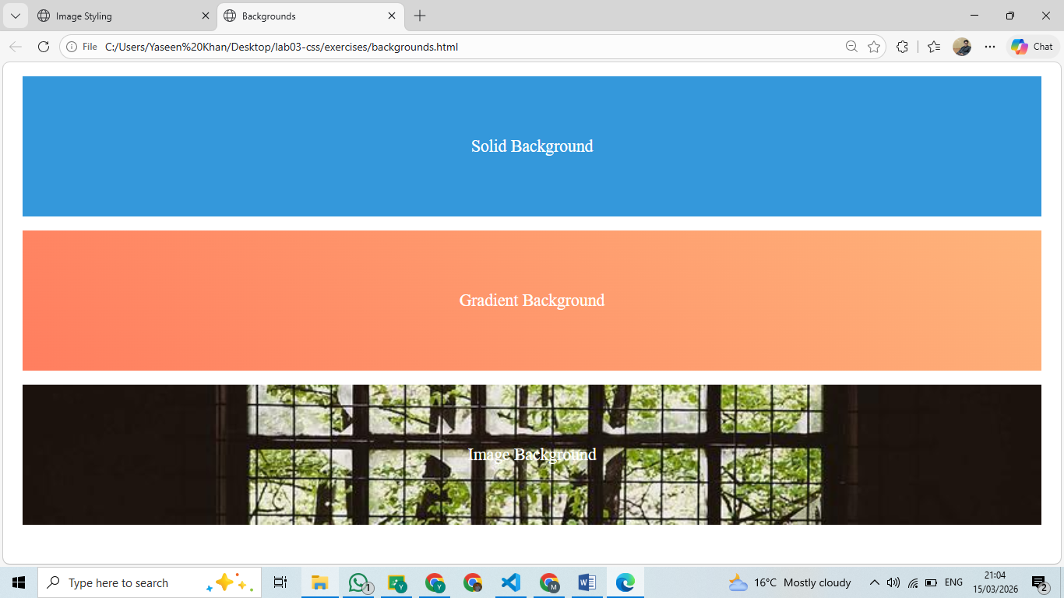
components.css code:
img{
margin:20px;
width:200px;
transition:0.4s;
}
.rounded{
border-radius:10px;
border:3px solid #333;
}
.circle{
border-radius:50%;
}
.hover-effect:hover{
transform:scale(1.2);
filter:grayscale(100%);
}

Effects.css code:
div{
height:200px;
margin:20px;
display:flex;
align-items:center;
justify-content:center;
color:white;
font-size:24px;
}
.solid{
background:#3498db;
}
.gradient{
background:linear-gradient(45deg,#ff7e5f,#feb47b);
}
.image-bg{
background:url('https://picsum.photos/800/400') no-repeat center/cover;
}

Main.css code :
body{
font-family: Arial, sans-serif;
margin:40px;
}
h1{
color:#333;
}
.text{
color:blue;
}
#title{
text-decoration:underline;
}
*{
box-sizing:border-box;
}
.container span{
color:rgb(11, 216, 11);
}
a:hover{
color:rgb(230, 10, 10);
}
ul li:first-child{
font-weight:bold;
}

typography.css code :
body{
padding:40px;
}
.poppins{
font-family:'Poppins',sans-serif;
font-size:24px;
}
.roboto{
font-family:'Roboto',sans-serif;
font-size:20px;
text-transform:uppercase;
}
.playfair{
font-family:'Playfair Display',serif;
font-size:28px;
}
.shadow{
font-size:30px;
text-shadow:2px 2px 5px gray;
}

Readme

CSS Lab 03 & 04

Yaseen khan
section c

Folders:
- styles: CSS files
- exercises: HTML practice pages

Get repositry link : https://github.com/Yaseenkhan334612/web-technologies
Published site link : https://yaseenkhan334612.github.io/web-technologies/web_lab_03/

