FINSIGHT
NovaCrest Bank

Name: Shaik Yaseen
Email: yaseenshaik7860@gmail.com

Day 1 – Data Ingestion
6.1) Kafka Topic Setup
1. Checked Kafka and zookeeper are running or not with the help of JPS.
2. Created Topic txn-raw with 3 Partitions.
3. Created Topic txn-flagged with 1 Partition.
4. Listed the topics
5. Described the topics

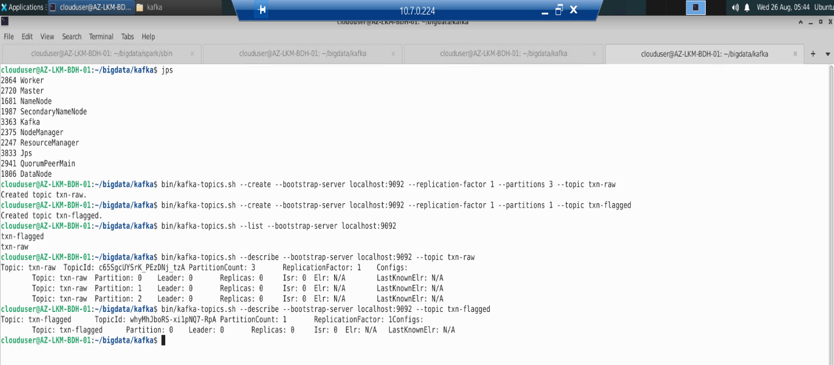

--- Finding Transactions.csv
--- Also checking and Verifying
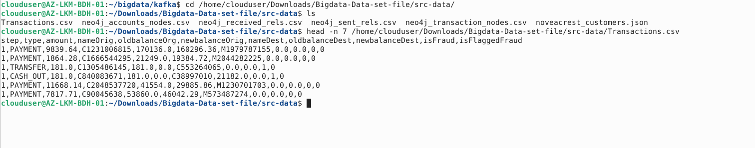
6.2) Python Kafka Producer
1) Created producer.py file
Path : /home/clouduser/producer.py

- Read the raw dataset Transactions.csv line by line.
- Converted CSV text fields into typed variables (int, float, string).
- Structured each row into a standard JSON message containing:
  - schema: Column definitions and data types (int32, double, string).
  - payload: The actual transaction values.
- Sent each message to the txn-raw topic with key = nameOrig.
- Throttled throughput to 1,000 messages per second using time.sleep().

2) Ran python3 producer.py

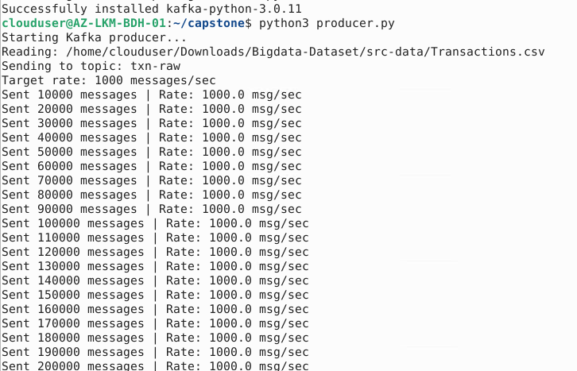

#Verification
kafka-console-consumer.sh --bootstrap-server localhost:9092 --topic txn-raw --from-beginning --max-messages 5
6.3) HDFS Landing Structure
1) Create HDFS Directories
2) verifying Directories 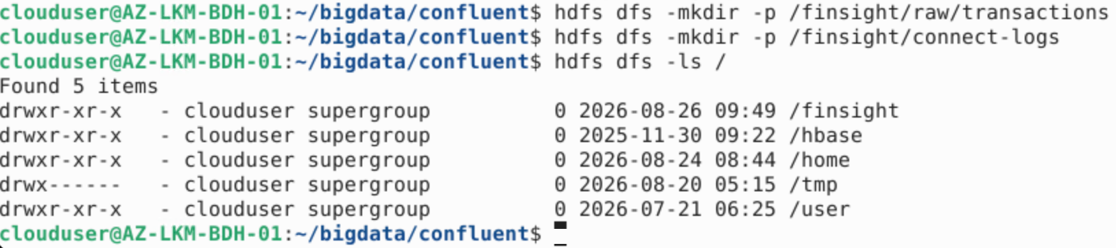

2) Created the HDFS Sink Configuration
Path : /home/clouduser/capstone/hdfs-sink.properties
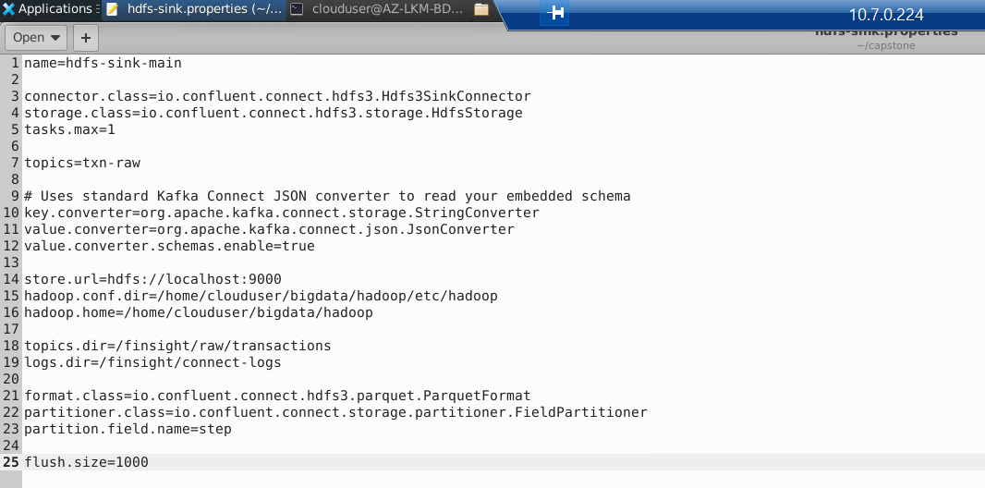

3)Start Kafka connect
1. cd /home/clouduser/bigdata/confluent
2. bin/connect-standalone etc/schema-registry/connect-avro- standalone.properties /home/clouduser/capstone/hdfs-sink.properties
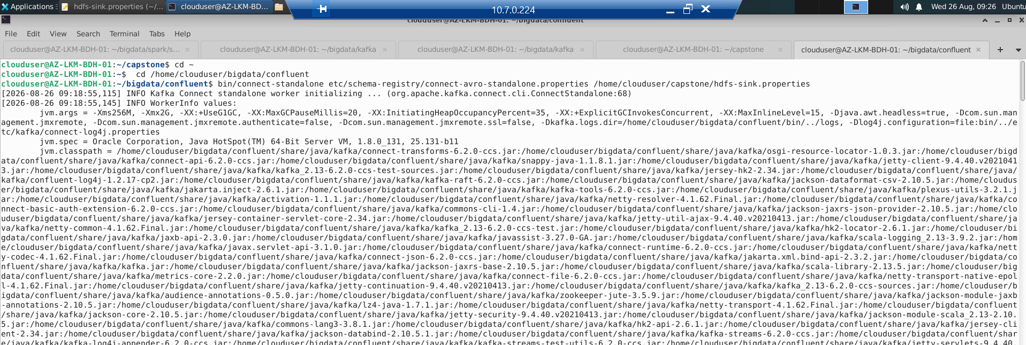
# 1. View all step partitions:
hdfs dfs -ls /finsight/raw/transactions/txn-raw/
# 2. View the Parquet file inside a partition (e.g. step=1 or step=19):
hdfs dfs -ls /finsight/raw/transactions/txn-raw/step=19/
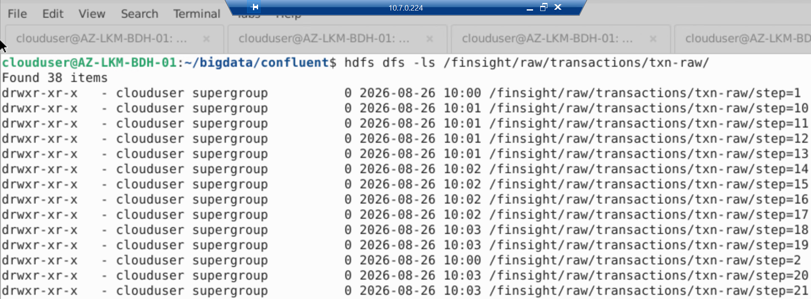

#3 Parquet data files stored inside that folder
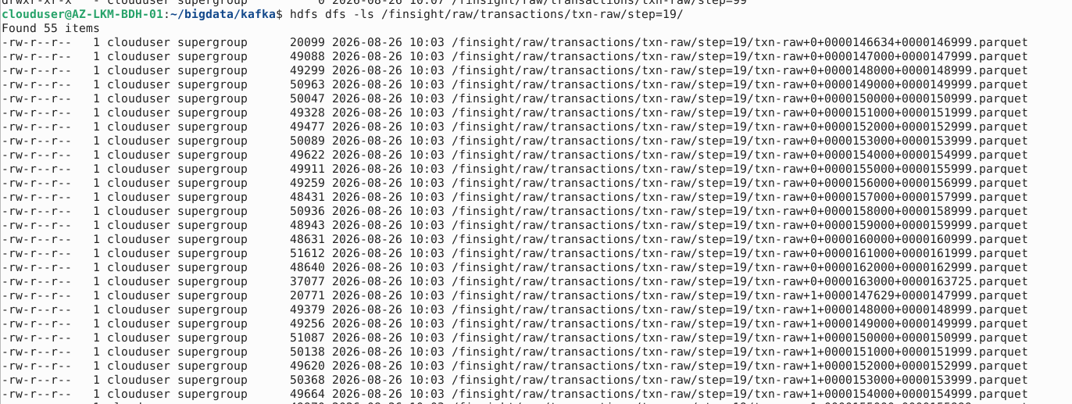

Day 2 – Spark Processing
7.1) Spark Streaming — Real-Time Fraud Detection
1)Create HDFS Folders for Checkpoints & Metrics
hdfs dfs -mkdir -p /finsight/checkpoints/fraud
hdfs dfs -mkdir -p /finsight/processed/streaming_metrics

2)Create fraud_detection.py
3) run
spark-submit --packages org.apache.spark:spark-sql-kafka-0-10_2.12:3.3.0 /home/clouduser/capstone/fraud_detection.py
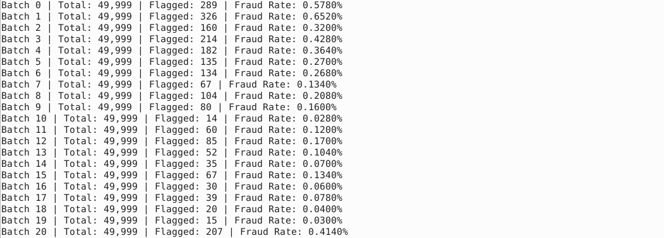

4) Verification:
Check Flagged Fraud Records in txn-flagged Kafka Topic
bin/kafka-console-consumer.sh --bootstrap-server localhost:9092 --topic txn-flagged --from-beginning --max-messages 2
5) Check the Streaming Metrics in HDFS:
hdfs dfs -ls /finsight/processed/streaming_metrics
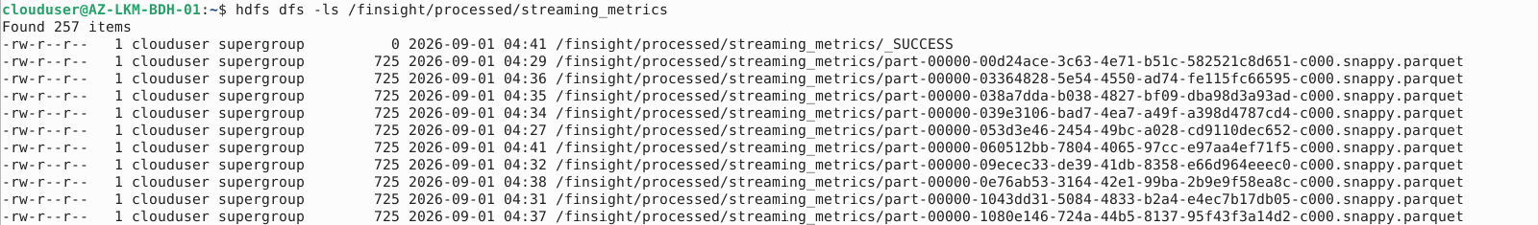

6) count the total flagged fraud records
bin/kafka-console-consumer.sh --bootstrap-server localhost:9092 --topic txn-flagged --from-beginning --timeout-ms 5000 | wc -l

7.2) Spark Streaming — Real-Time Customer Churn Detection
STEP 1: 1) Create the txn-churn Kafka Topic
bin/kafka-topics.sh --bootstrap-server localhost:9092 --create --topic txn-churn --partitions 1 --replication-factor 1
2) Verify it exists
bin/kafka-topics.sh --bootstrap-server localhost:9092 --describe --topic txn-churn

STEP 2: Create HDFS Folders for Churn Alerts & Checkpoints
hdfs dfs -mkdir -p /finsight/processed/churn_alerts
hdfs dfs -mkdir -p /finsight/checkpoints/churn

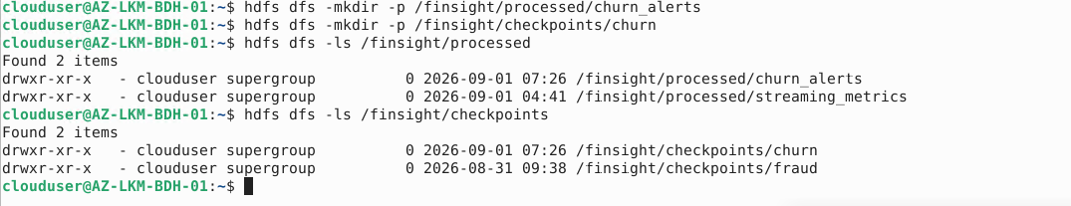

STEP 3: Create the churn_detection.py
nano /home/clouduser/capstone/churn_detection.py

STEP 4: Run the Churn Detection Job
spark-submit --packages org.apache.spark:spark-sql-kafka-0-10_2.12:3.3.0 /home/clouduser/capstone/churn_detection.py

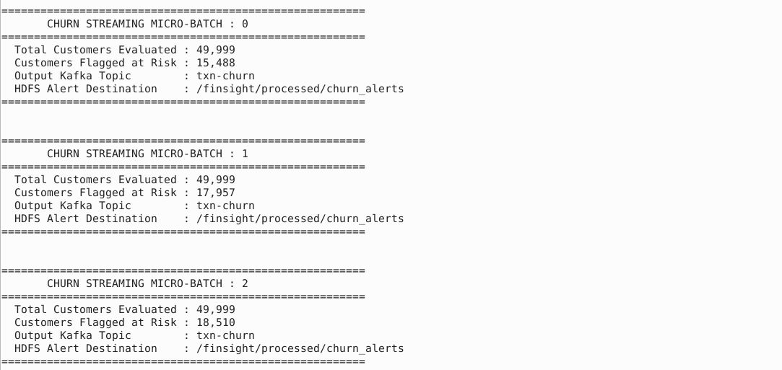

Verify :
bin/kafka-console-consumer.sh --bootstrap-server localhost:9092 --topic txn-churn --from-beginning --max-messages 3
7.3) Spark Core — Batch Risk Scoring
STEP 1: Create HDFS Folders for Outputs
hdfs dfs -mkdir -p /finsight/processed/risk_scores
hdfs dfs -mkdir -p /finsight/processed/daily_summary
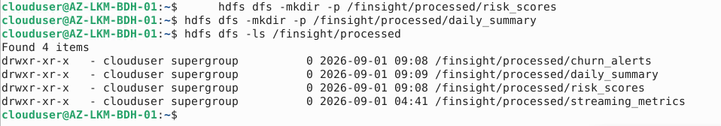

STEP 2: Create the risk_scoring.py Script
nano /home/clouduser/capstone/batch_risk_scoring.py

STEP 3: Run the Batch Risk Scoring Job
spark-submit /home/clouduser/capstone/risk_scoring.py

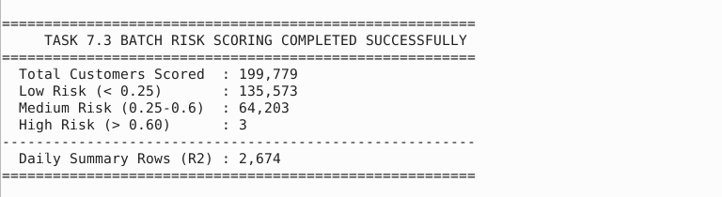

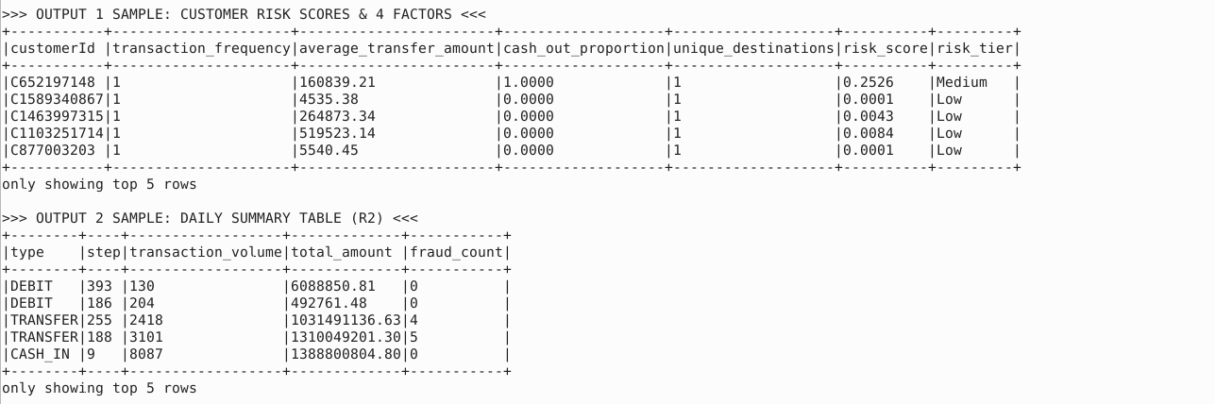
Verification in HDFS:
hdfs dfs -ls /finsight/processed/risk_scores
hdfs dfs -ls /finsight/processed/daily_summary
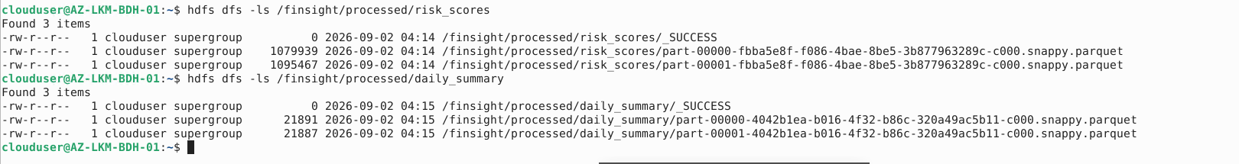

7.4) Spark Core — Customer Lifetime Value(CLV) Scoring
STEP 1: Create the HDFS Output Folder
hdfs dfs -mkdir -p /finsight/processed/clv_scores
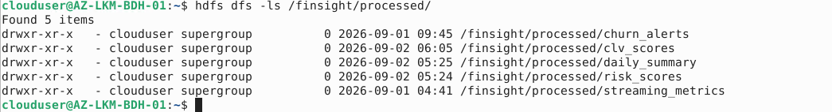

STEP 2: Create the clv_scoring.py Script
nano /home/clouduser/capstone/clv_scoring.py
spark-submit /home/clouduser/capstone/clv_scoring.py
STEP 3: CLV Component Validation Table

STEP 4: Customer segment distribution
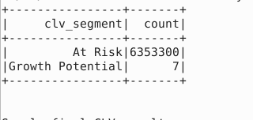
STEP 5: Customer CLV Ranking Table
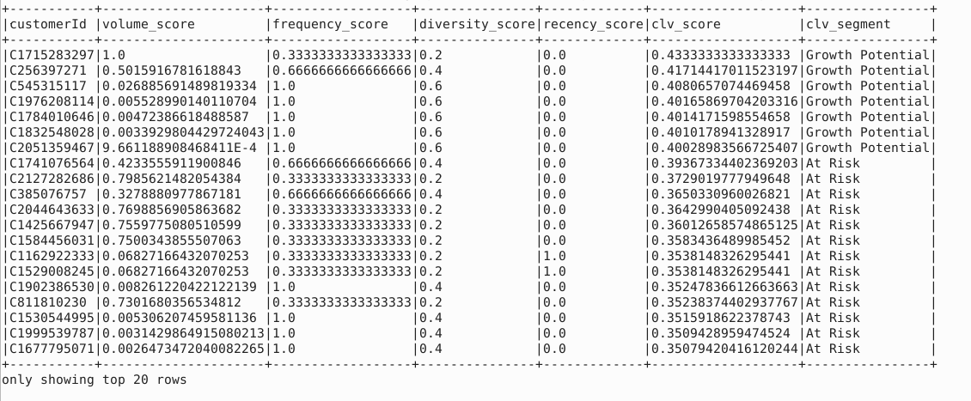

STEP 6 : Final Validation Box & Hive Table Registration
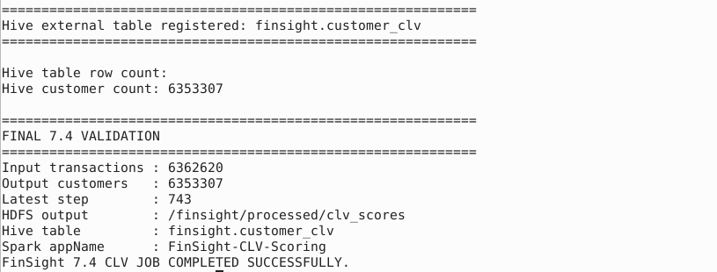

7.5) Spark SQL — Compliance Aggregation
STEP 1: Create HDFS Output Directories
hdfs dfs -mkdir -p /finsight/processed/customer_fraud_summary
hdfs dfs -mkdir -p /finsight/processed/weekly_compliance_summary
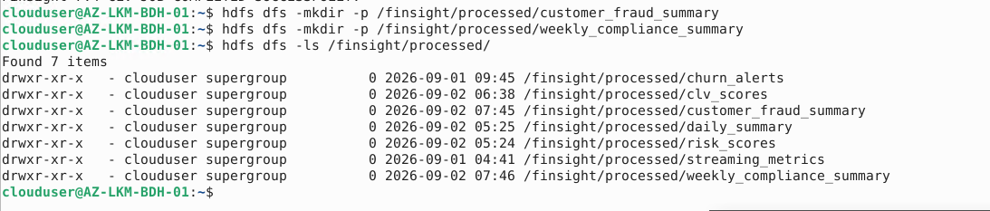
STEP 2: Create the spark_sql_jobs.py Script
nano /home/clouduser/capstone/spark_sql_jobs.py
STEP 3: Run the 2 Modes
For Compliance Summary:
spark-submit /home/clouduser/capstone/spark_sql_jobs.py --mode compliance
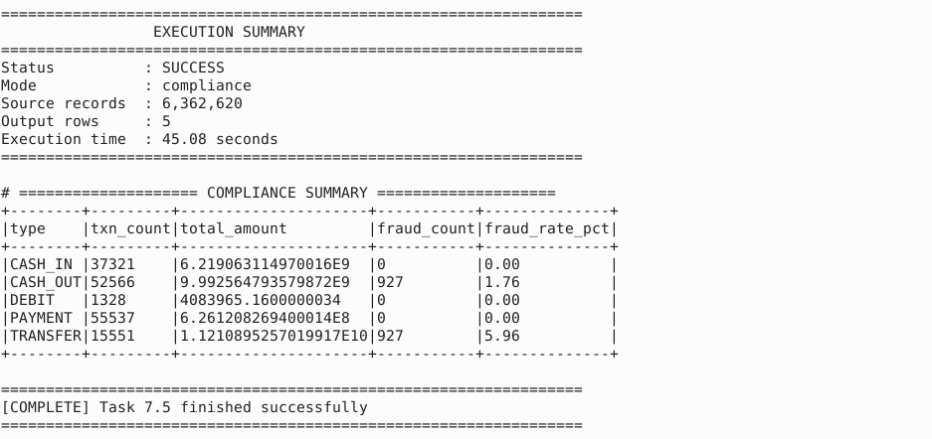

For Customer Fraud Summary:
spark-submit /home/clouduser/capstone/spark_sql_jobs.py --mode customer_summary
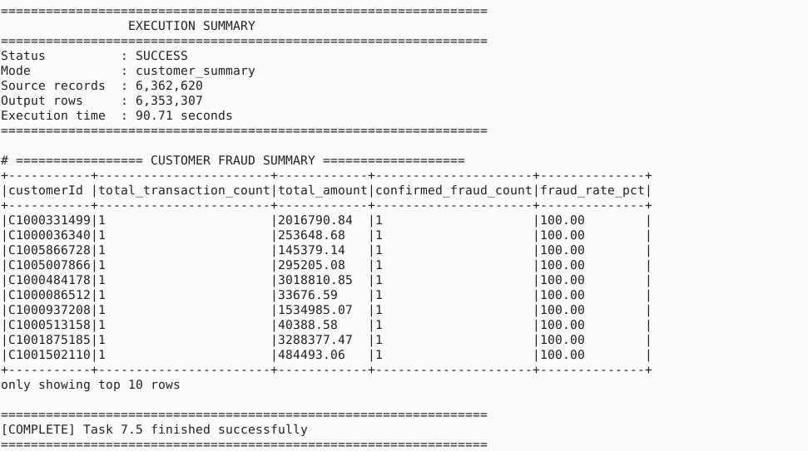
7.6) Spark SQL — Account Dormancy Report
STEP 1: Create HDFS Output & Export Folders
hdfs dfs -mkdir -p /finsight/processed/dormancy_report
hdfs dfs -mkdir -p /finsight/exports/dormancy_report

STEP 2: Update spark_sql_jobs.py
STEP 3: Execute Task
spark-submit /home/clouduser/capstone/spark_sql_jobs.py --mode dormancy
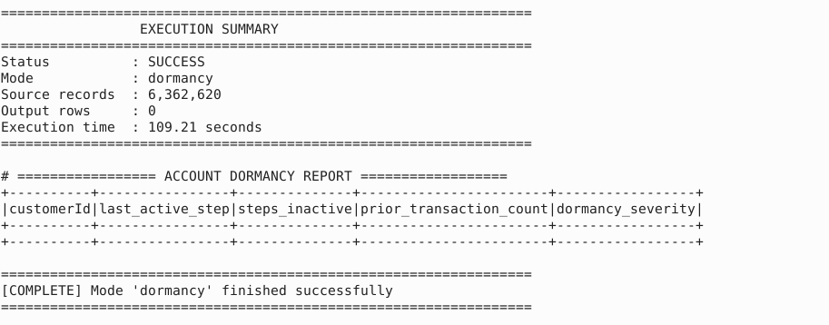

DAY 3 – Database Configuration
8.1) Hive — Data Warehouse Layer
STEP 1: Create Database
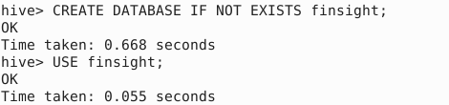

STEP 2 : Create External Table
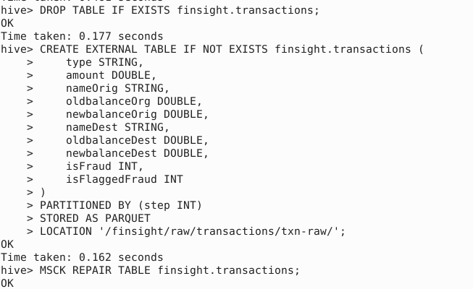

STEP 3: Create the Fraud View (Requirement R1)
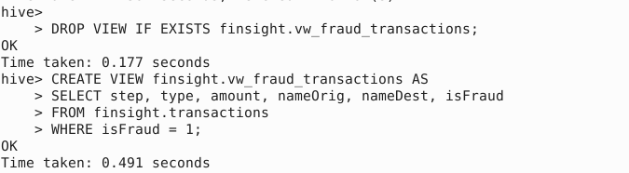

STEP 4: Compute Table Statistics (Requirement R2)

STEP 5: Verify Your Tables & Sample Data
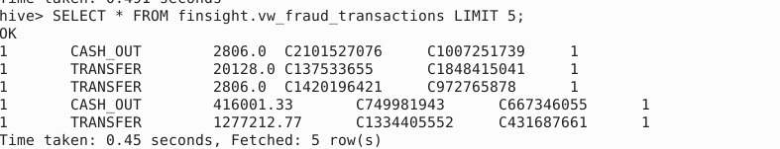
8.2) Hive — Transaction Summary Mart
STEP 1: Create the finsight.txn_summary_mart Table
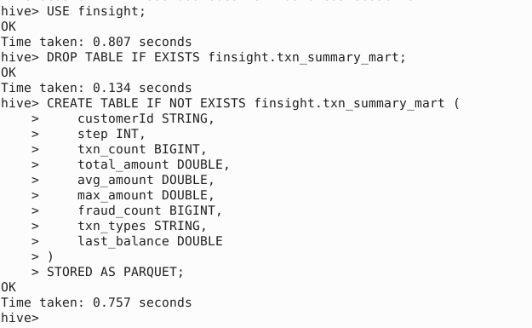

STEP 2: Fill Table With Data (Calculate Customer Totals)
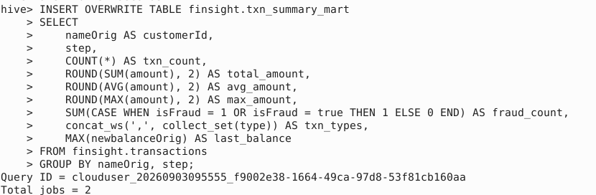
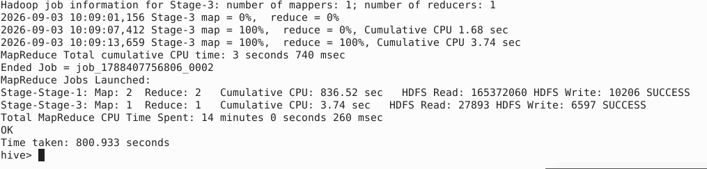
STEP 3: Compute Column Statistics (Requirement R1)
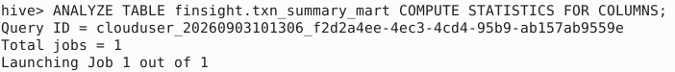
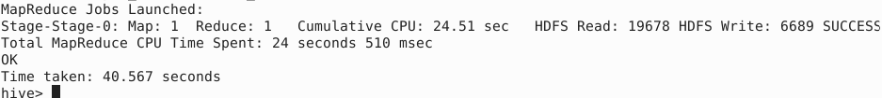
STEP 4: Verify the Table Data
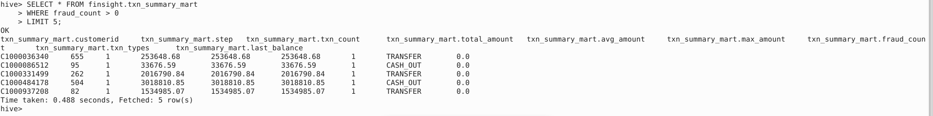

8.3) MongoDB — Customer Document Store
STEP 1: Import the 10,000 Customer JSON Documents
mongoimport --db finsight --collection customers --drop --file "/home/clouduser/Downloads/Bigdata-Dataset/src-data/noveacrest_customers.json" –jsonArray

STEP 2: Open the MongoDB Shell
mongosh

STEP 3: Create the Compound Index (Requirement R1):
use finsight
db.customers.createIndex({ customerId: 1, segment: 1 })

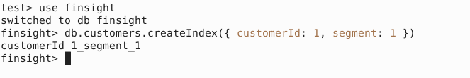

STEP 4: Run the Aggregation Pipeline Query (Requirement R2):
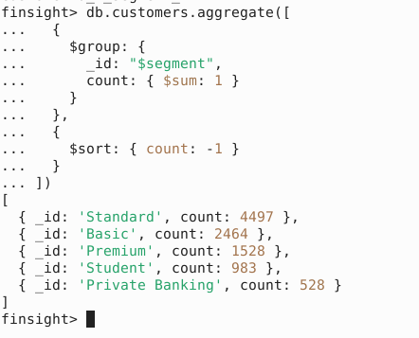

STEP 5: Verify 1 Sample Customer Document
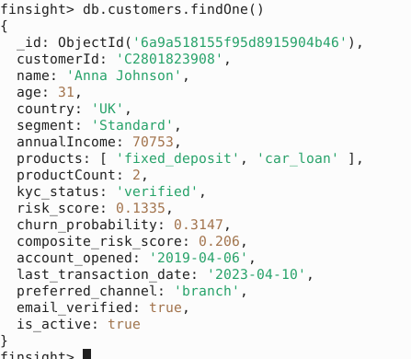

8.4) Neo4j — Fraud Knowledge Graph
STEP 1: Create Constraints (For Speed & Uniqueness)
CREATE CONSTRAINT account_id_unique IF NOT EXISTS FOR (a:Account) REQUIRE a.accountId IS UNIQUE;
CREATE CONSTRAINT txn_id_unique IF NOT EXISTS FOR (t:Transaction) REQUIRE t.txnId IS UNIQUE;
SHOW CONSTRAINTS;
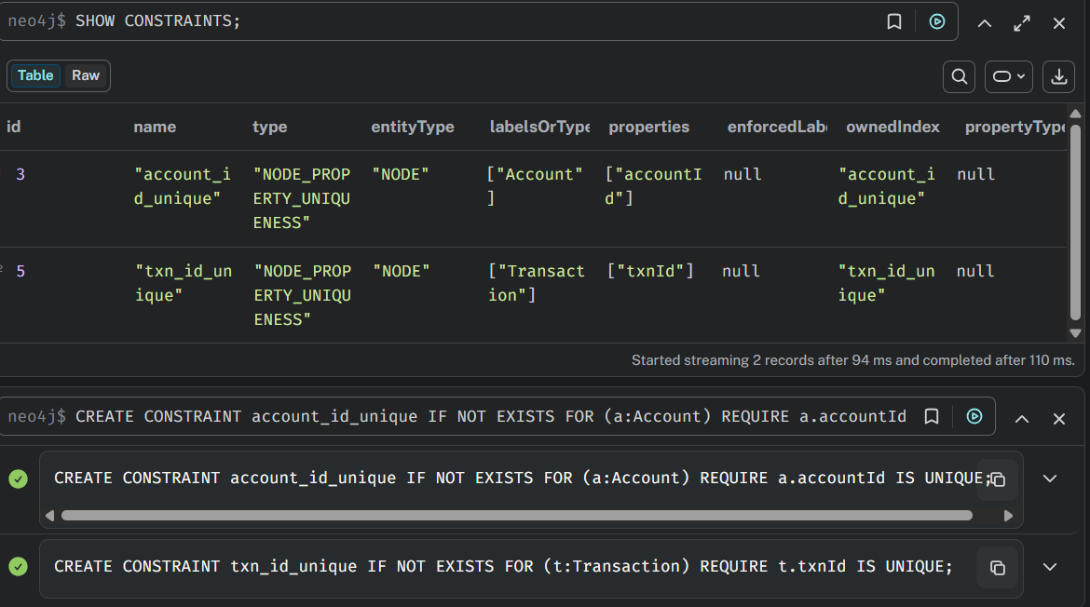

STEP 2: Load Account Nodes & Verify
LOAD CSV WITH HEADERS FROM 'file:///neo4j_accounts_nodes.csv' AS row
MERGE (a:Account {accountId: row['accountId:ID']})
SET a.accountType = row.accountType;

Verify:
MATCH (a:Account) RETURN count(a) AS total_account_nodes;
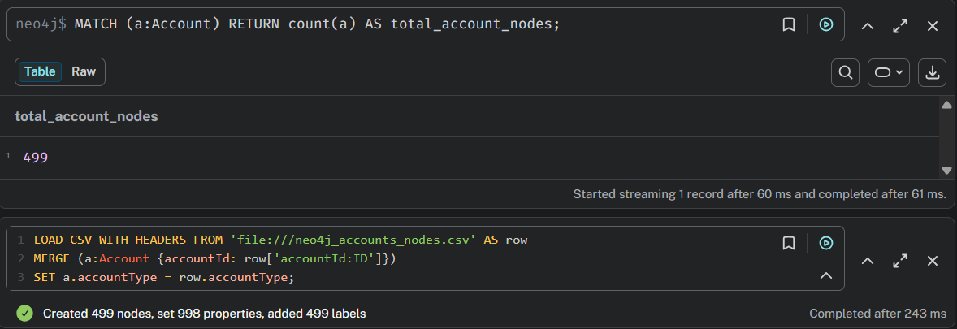

STEP 3: Load Transaction Nodes & Verify
LOAD CSV WITH HEADERS FROM 'file:///neo4j_transaction_nodes.csv' AS row
MERGE (t:Transaction {txnId: row['txnId:ID']})
SET t.step = toInteger(row['step:int']),
t.type = row.type,
t.amount = toFloat(row['amount:float']),
t.isFraud = toInteger(row['isFraud:int']);
Verify :
MATCH (t:Transaction) RETURN count(t) AS total_transaction_nodes;

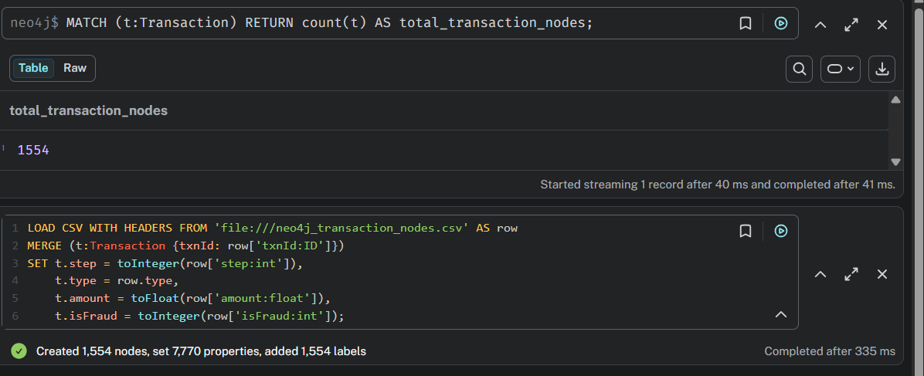

STEP 4: Load :SENT Relationships & Verify
LOAD CSV WITH HEADERS FROM 'file:///neo4j_sent_rels.csv' AS row
MATCH (a:Account {accountId: row[':START_ID']})
MATCH (t:Transaction {txnId: row[':END_ID']})
MERGE (a)-[r:SENT]->(t)
SET r.amount = toFloat(row['amount:float']),
r.step = toInteger(row['step:int']),
r.transactionType = row.transactionType;
Verify :
MATCH ()-[r:SENT]->() RETURN count(r) AS total_sent_relationships;
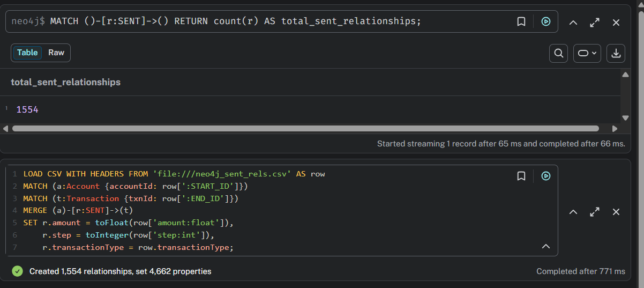

STEP 5: Load :RECEIVED_BY Relationships
LOAD CSV WITH HEADERS FROM 'file:///neo4j_received_rels.csv' AS row
MATCH (t:Transaction {txnId: row[':START_ID']})
MATCH (a:Account {accountId: row[':END_ID']})
MERGE (t)-[r:RECEIVED_BY]->(a)
SET r.newbalanceDest = toFloat(row['newbalanceDest:float']),
r.isFraud = toInteger(row['isFraud:int']);
Verify:
MATCH ()-[r:RECEIVED_BY]->() RETURN count(r) AS total_received_relationships;
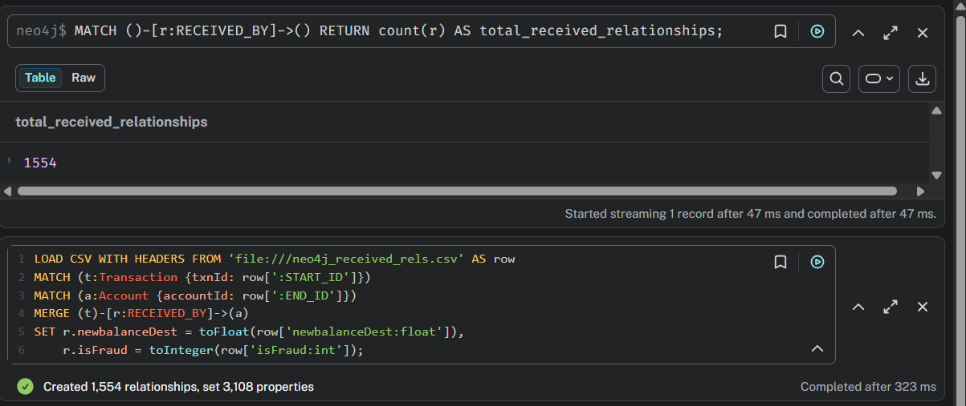
STEP 6: Execute the Money Mule Detection Cypher Query
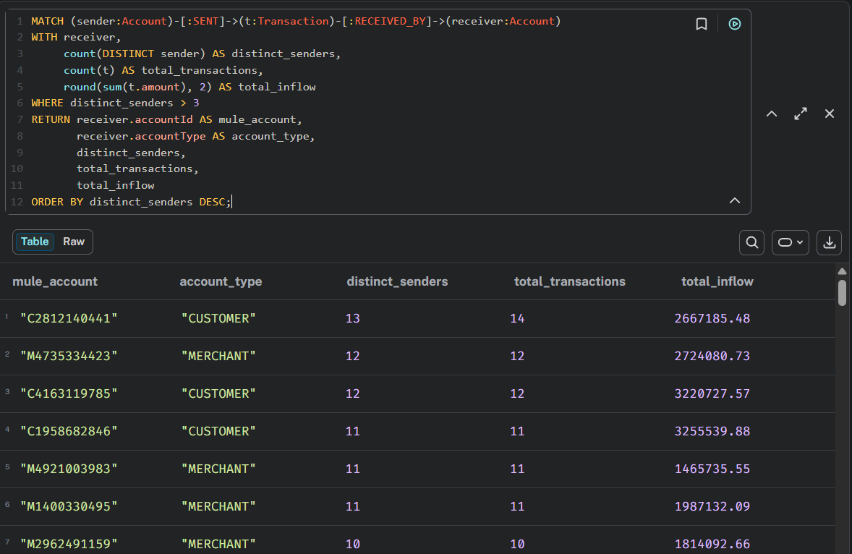

Graph Visualization:

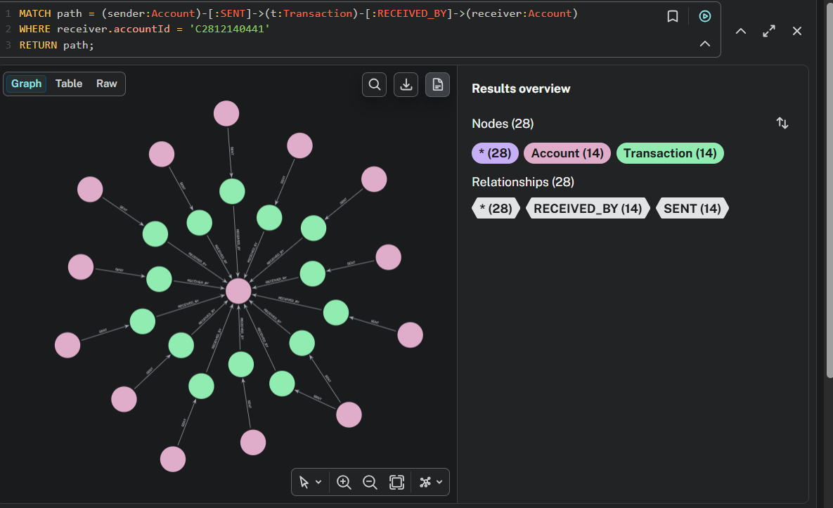
Table Visualization:
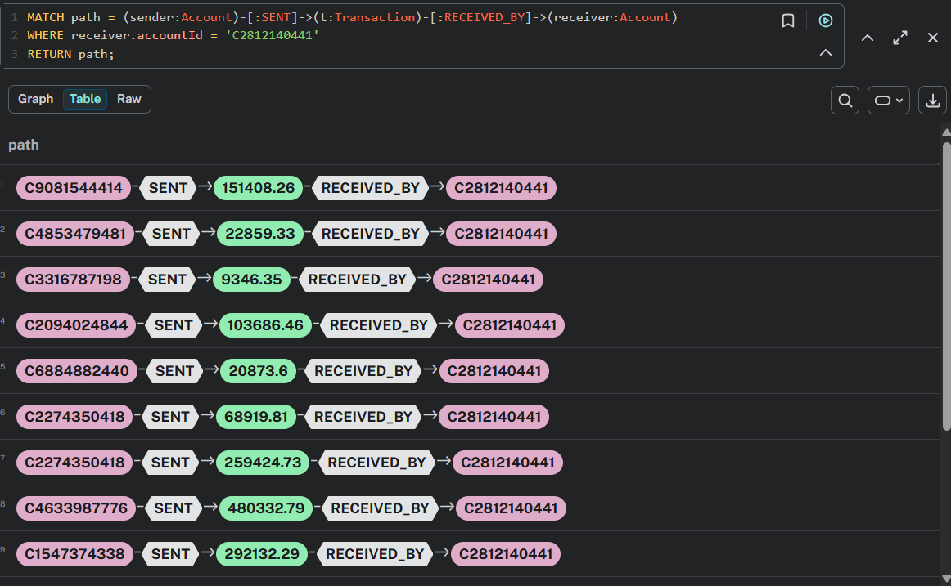

DAY 4 – Alteryx – Data Blending and Feature Engineering
9.1) Workflow 1 — Customer Risk Blend
Step 1: Load Input Data
Input A: Loaded customer_fraud_summary.csv
Input B: Loaded noveacrest_customers.csv
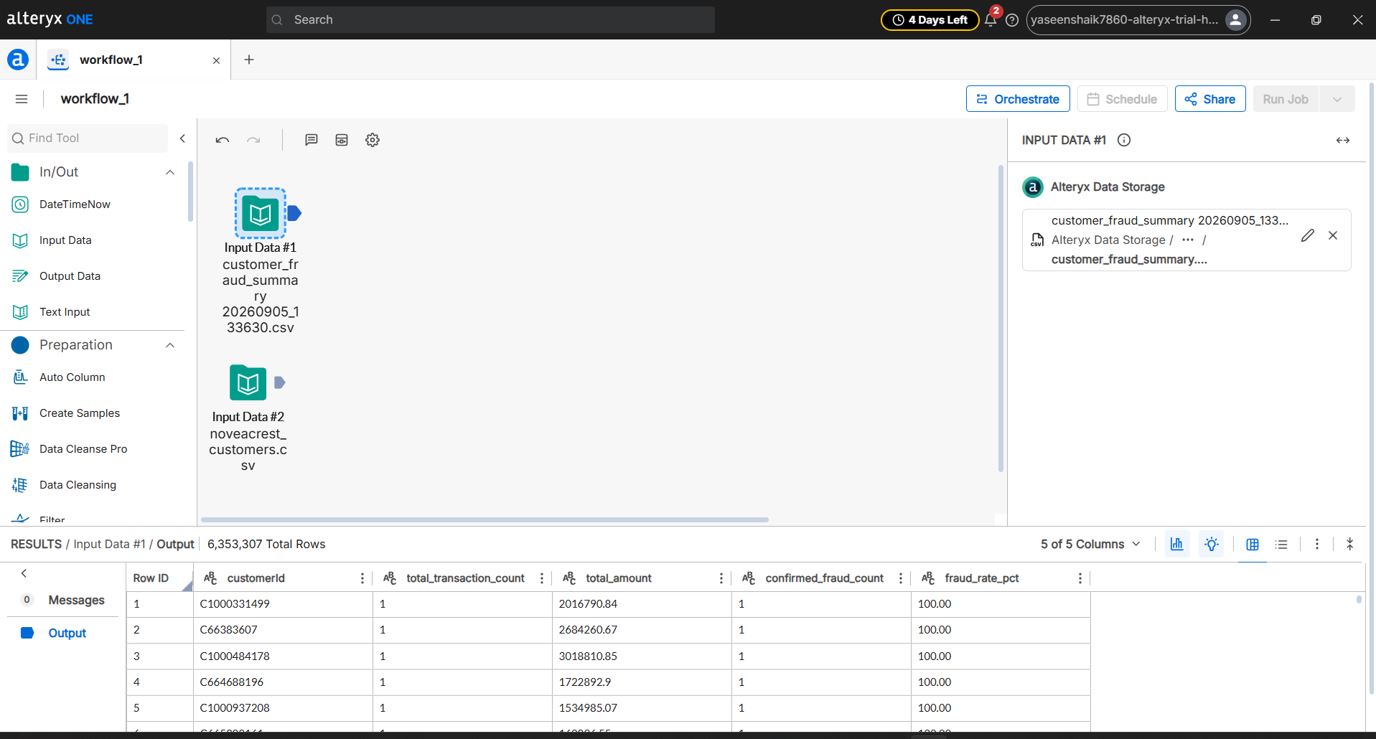

Step 2: Join Datasets
Added a Join Tool and connected Input A to Left (L) and Input B to Right (R).
Joined both datasets on customerId = customerId.
Uncheck the duplicate Right_customerId in the column list below to keep it clean.
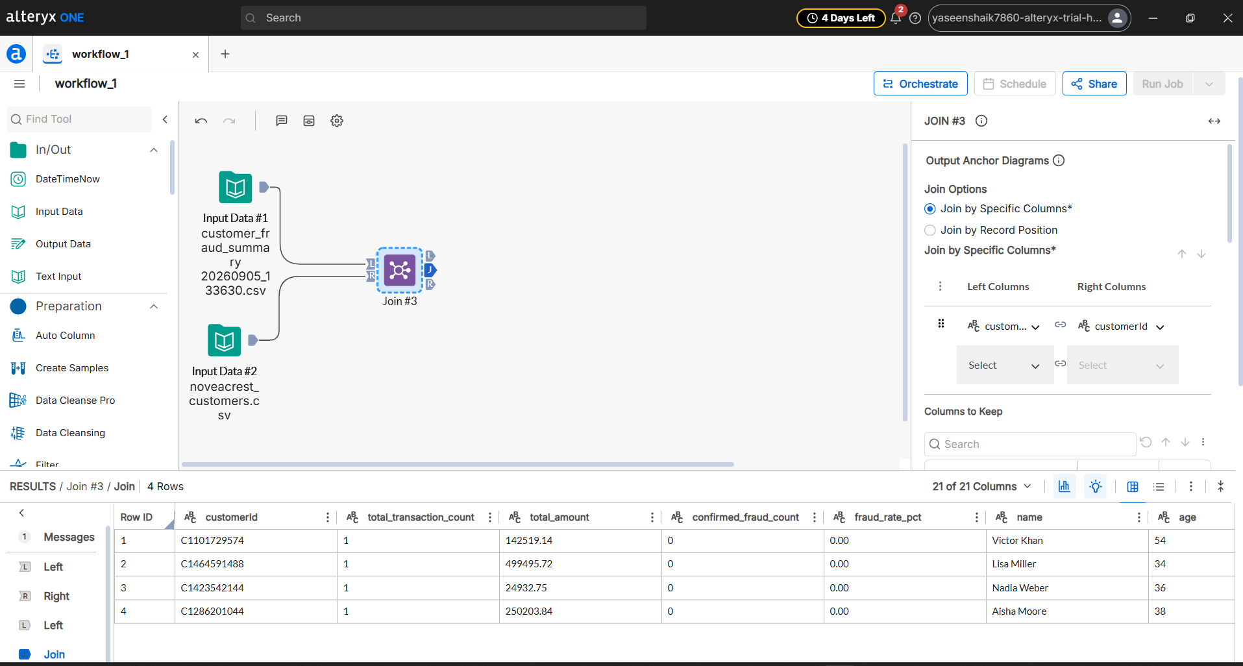

Step 3: Auto-Detect Data Types (Auto Column Tool)
Connected an Auto Column Tool to the Join (J) output.
Automatically converted Data types
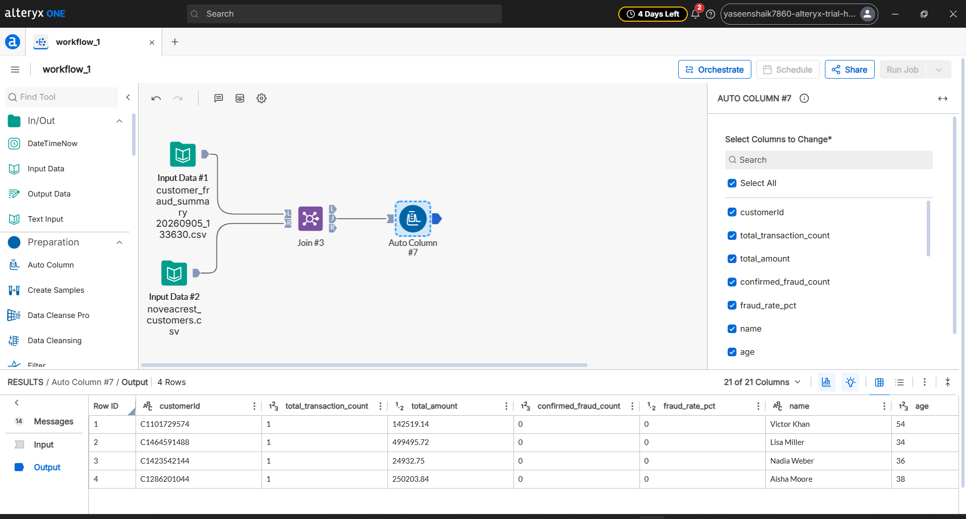
Step 4: Calculate Composite Risk Score
Connected a Formula Tool to the middle Join output (J).
Selected the existing column composite_risk_score.
Applied the formula: $\text{composite}\text{_}\text{risk}\text{_}\text{score}=\left(\text{fraud}\text{_}\text{rate}\text{_}\text{pct}×0.6\right)+\left(\text{churn}\text{_}\text{probability}×0.4\right)$
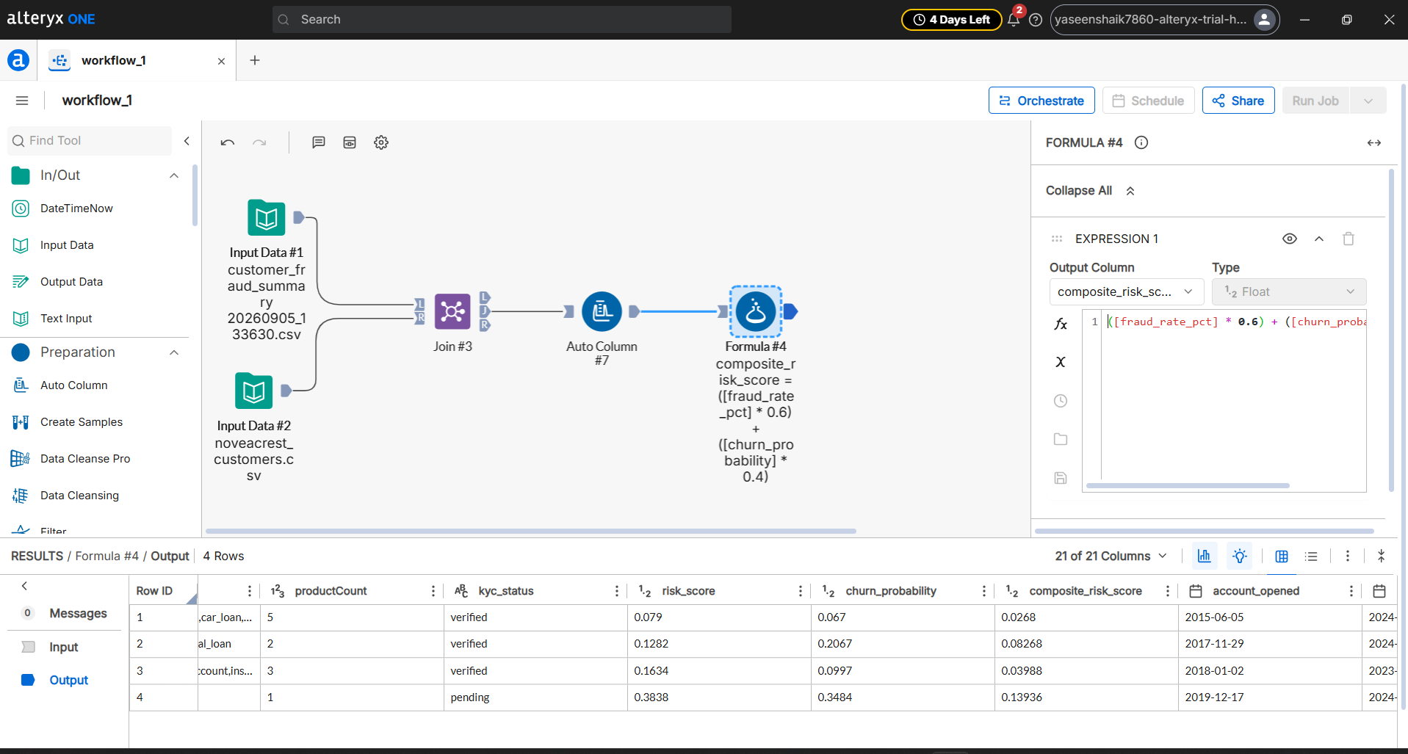
Step 5: Final Workflow 1
Added an Output Data Tool connected to the Formula tool.
Exported the final blended feature store as customer_risk_blend.xlsx
Clicked the Run Job button to execute the entire pipeline.
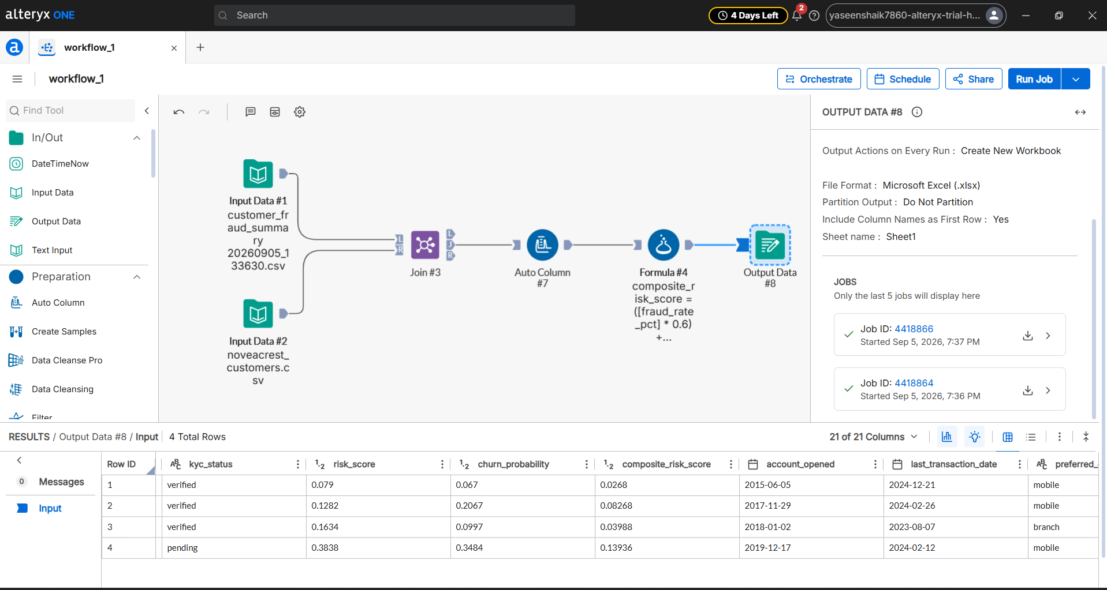
Verification of Job:
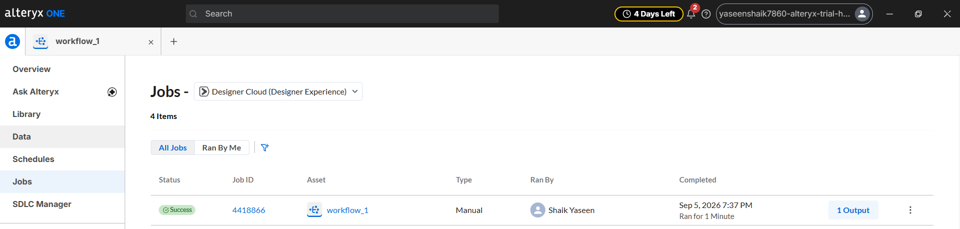

9.2) Workflow 2 — Transaction Summary
Step 1: Load Input Data
Draged an Input Data Tool to load daily_summary.csv
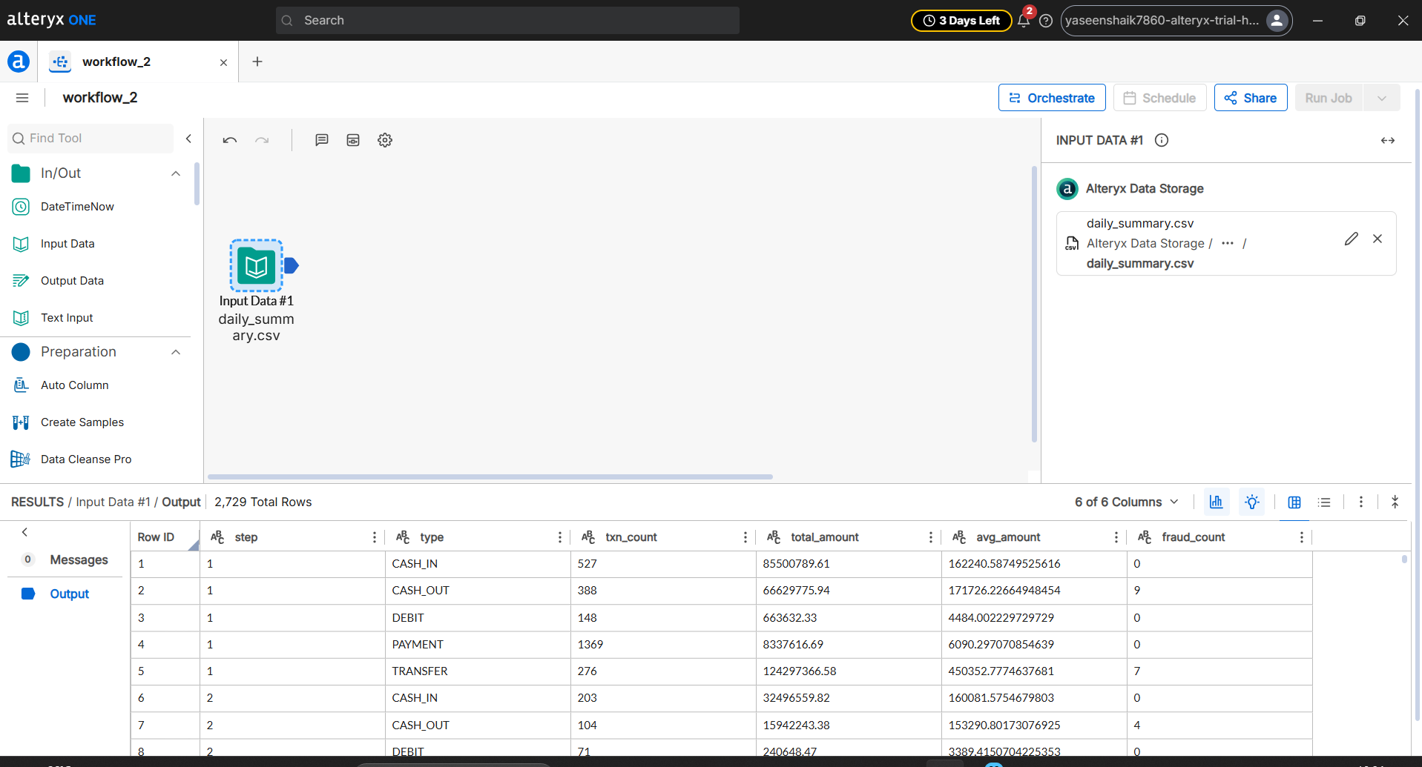

Step 2: Set Data Types (Select Tool)
Added a Select Tool connected to Input Data.
Converted avg_amount and total_amount to numeric Float data types for mathematical operations.
Converted step , txn_count , fraud_count to Integer.
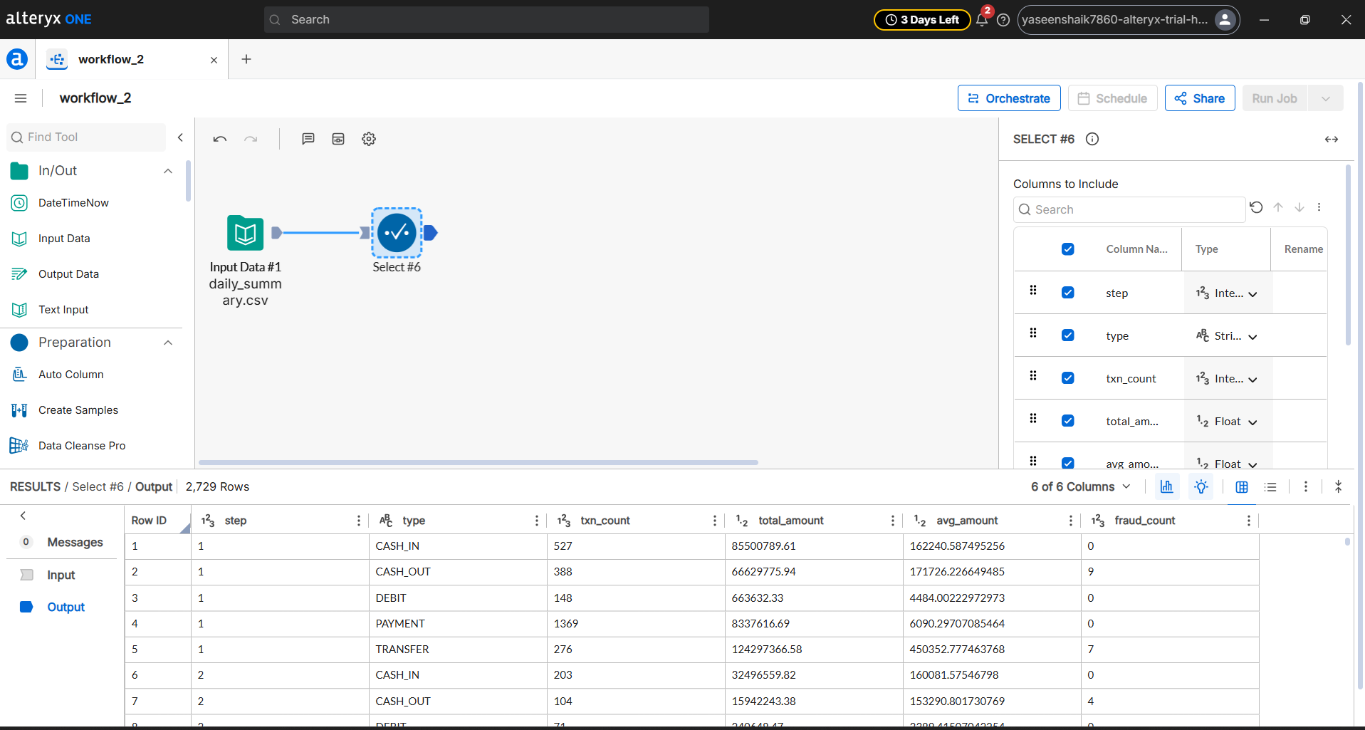

Step 3: Filter First 7 Days (Filter Tool)
Added a Filter Tool connected to the Select tool.
Applied the condition in Advanced Filter: [step] >= 1 AND [step] <= 168 to keep the first 7 simulation days (168 hours).
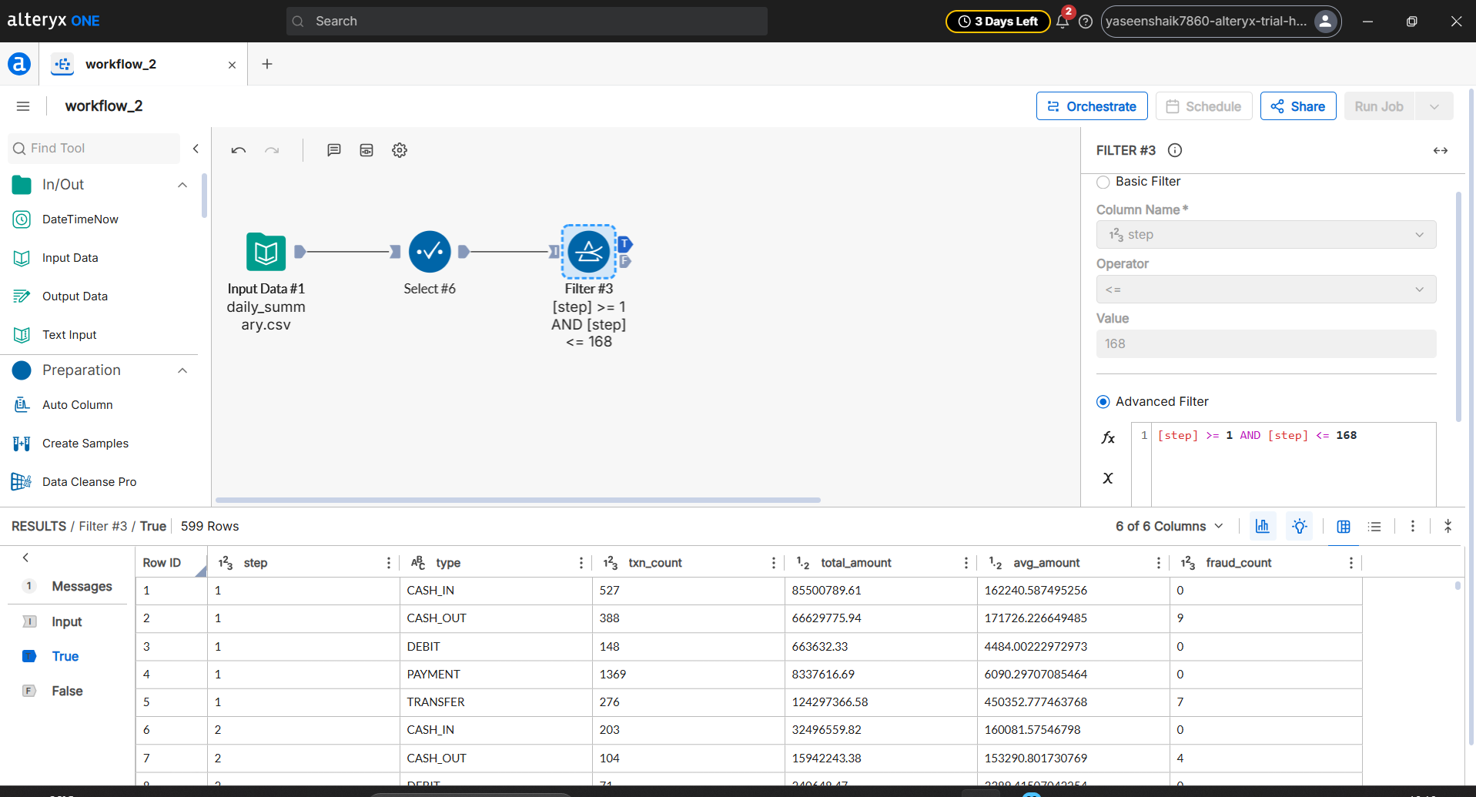

Step 4: Summarize Data (Summarize Tool)
Connected a Summarize Tool to the True (T) output of the Filter tool.
Added Action : type $⟶$ Group By
Added Action : step $⟶$ Group By
Added Action : txn_count $⟶$ Sum (Renamed to total_volume)
Added Action : avg_amount $⟶$ Average (Renamed to Avg_Transaction_amount)
Added Action : fraud_count $⟶$ Sum (Renamed to fraud_count)
Generated 599 summarized rows.
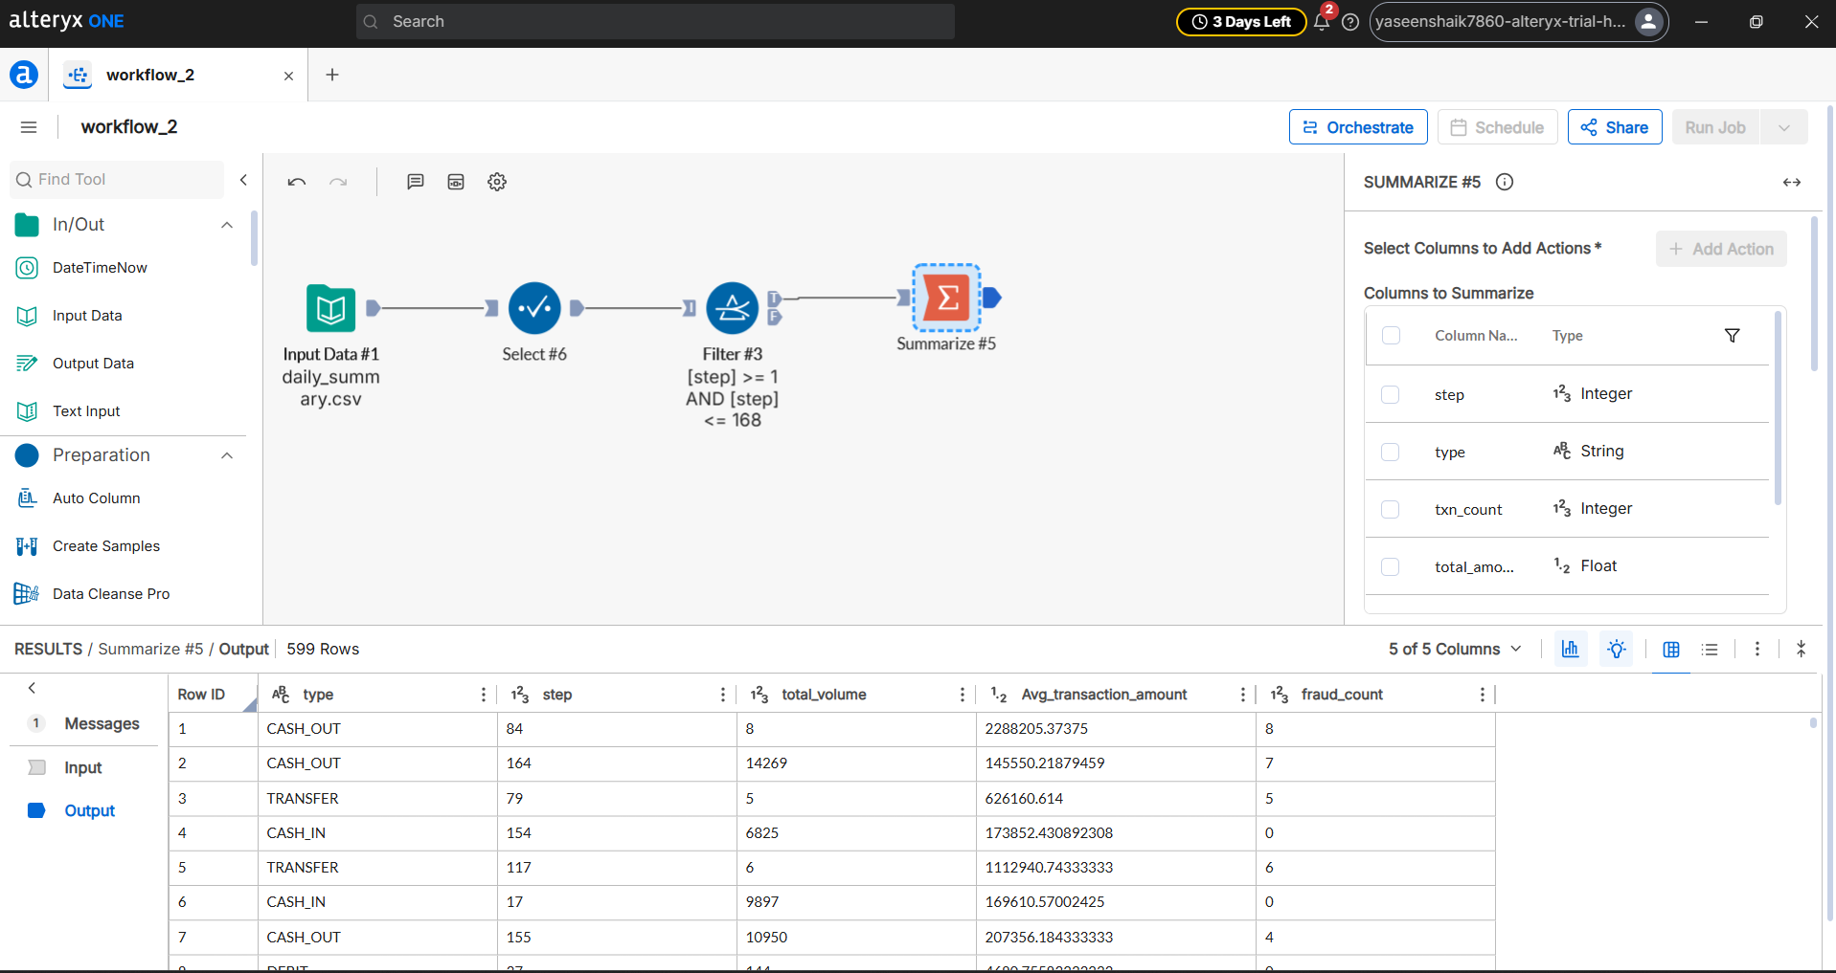

Step 5: Final Workflow
Added an Output Data Tool connected to the Summarize tool.
Exported the final summarized dataset as transaction_summary.csv

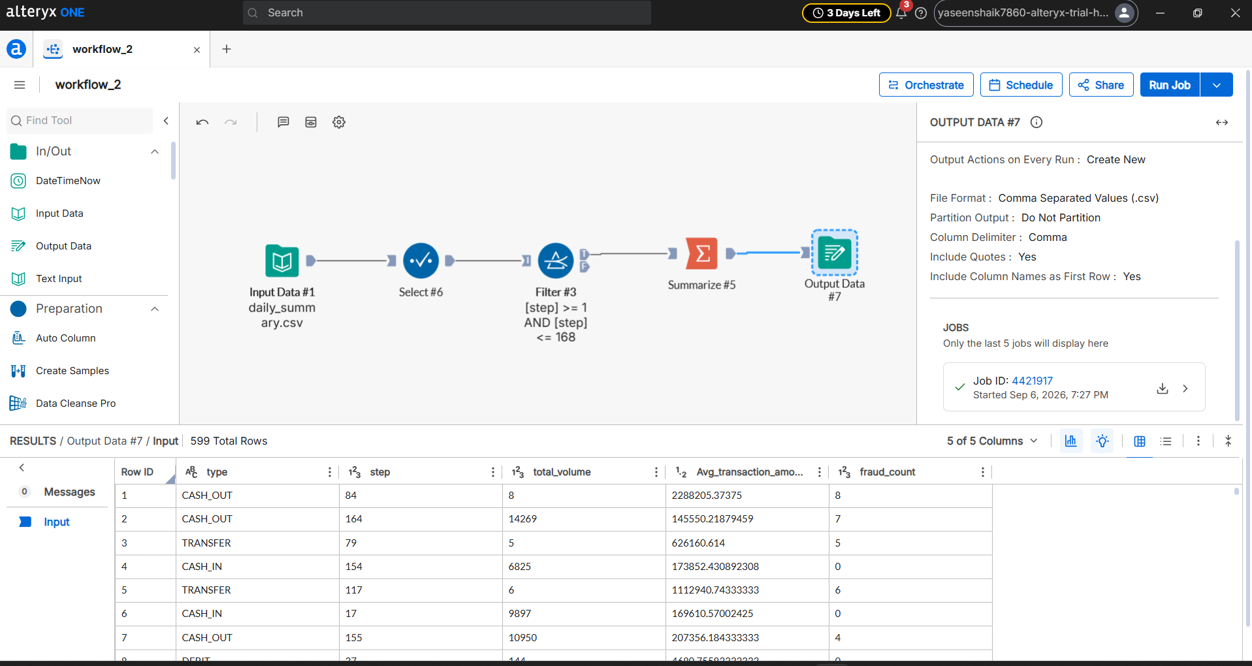

Verification of Job:
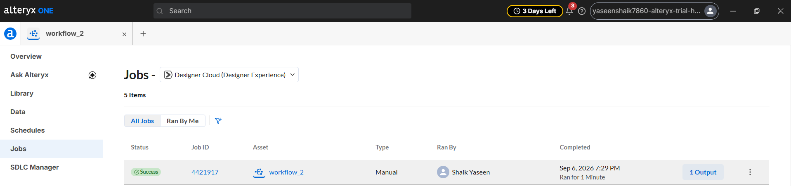

DAY 5 – Power BI Dashboards
10. Power BI Dashboards
Dashboard Page 1 — Fraud Alert Board
Step 1: Header Banner & Status Badge
Created the top header banner with the title FinSight — Fraud AlertBoard.
Applied background colour
Step 2: Created DAX Measures & 4 KPI Cards
- Created DAX Measures: Created DAX measures to calculate the 4 KPI numbers and their green subtitle text from the streaming dataset.
- Applied Container & Colour Formatting: Formatted all 4 cards with dark container backgrounds, rounded borders, coloured callout values, and green subtitle text.
CREATING 4 KPI CARDS:
- Card 1 (Total Flagged)
- Card 2 (Fraud Rate Pct)
- Card 3 (Total Flagged Value)
- Card 4 (False Positive Rate)
Step 3: Created Visual 1 — Daily Fraud Volume by Type (Line Chart)
- Placed a Line Chart on theleft.
- Set X-axis to step (simulation timeline), Y-axis to fraud_count, and Legend to type
- Applied colour formatting to lines and styled the chart background.
- Shows how fraud counts change over time across different transaction types.
Step 4: Created Visual 2 — Fraud Count by Type (Bar Chart)
- Placed a Clustered Bar Chart on the top right.
- Set Y-axis to Transaction Types and X-axis to Sum of fraud_count.
- Applied colour formatting to the bars and turned on data labels
- Shows that fraud is concentrated in CASH_OUT (959) and TRANSFER (945), with zero fraud in other categories.
Step 5: Created Visual 3 — Flagged Transactions (Table)
- Selected a Table visual.
- Added columns: step, nameOrig, nameDest, type, amount, and isFraud.
- Applied colour formatting to table rows, header, and gridlines.
- Displays Table.
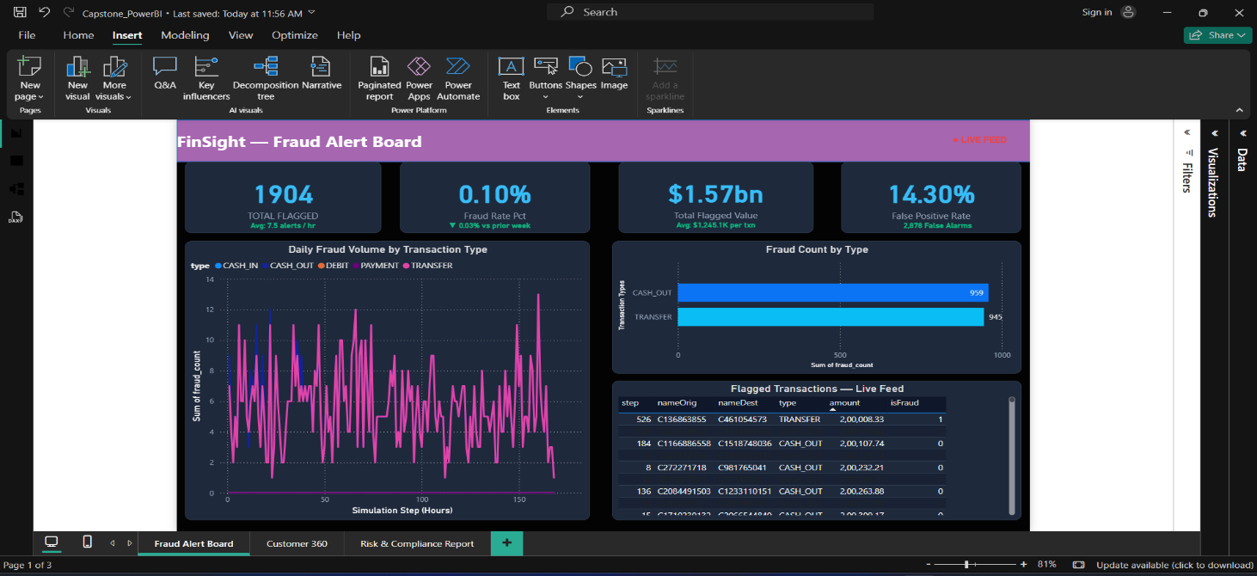
Dashboard Page 2 — FinSight — Customer 360 (Portfolio View)
Step 1: Header Banner & Status Badge
- Created the top header banner
- Added the 5 SEGMENTS badge on the top right to indicate the 5 customer portfolio tiers.
- Applied Background colour.
Step 2: Created the 4 KPI Cards with the help of DAX measures
Created DAX Measures: Built dynamic DAX measures for Total Customers, Average Risk Score, Average Churn Probability, and Average Products Held, along with subtitle benchmark measures.
Applied Container & Color Formatting: Formatted all 4 cards with dark container backgrounds, rounded borders, coloured callout values.
- Card 1 (Total Customers)
- Card 2 (Avg Risk Score)
- Card 3 (Avg Churn Prob)
- Card 4 (Avg Products Held)
Step 3: Created Visual 1 — Risk Score vs Churn Probability (Scatter Plot)
- Selected a Scatter Plot.
- Set X-axis to Risk Score, Y-axis to Churn Probability, and Legend to Segment.
- Coloured the 5 segments
- Helps relationship managers identify high-risk, high-churn customer
Step 4: Created Visual 2 — Customer Count by Segment (Bar Chart)
- Placed a Horizontal Clustered Bar Chart.
- Set Y-axis to segment and X-axis to Count of customerId.
- Applied colour formatting matching the segment colors, enabled data labels.
- Displays portfolio composition
Step 5: Created Visual 3 — Churn Probability Heatmap (Matrix Table)
- Selected a Matrix visual
- Set Rows to segment, Columns to channel and Values to Average of churn_probability.
- Applied colour formatting to identify which segment and channel combinations carry the highest churn risk

Step 6: Created Visual 4 — CLV Tier Distribution (Donut Chart)
- Selected a Donut Chart
- Set Legend to CLV_tier and Values to Count of customerId.
- Applied color formatting to the donut slices and styled the container background.
- Displays customer lifetime value segments (At Risk, Growth Potential)

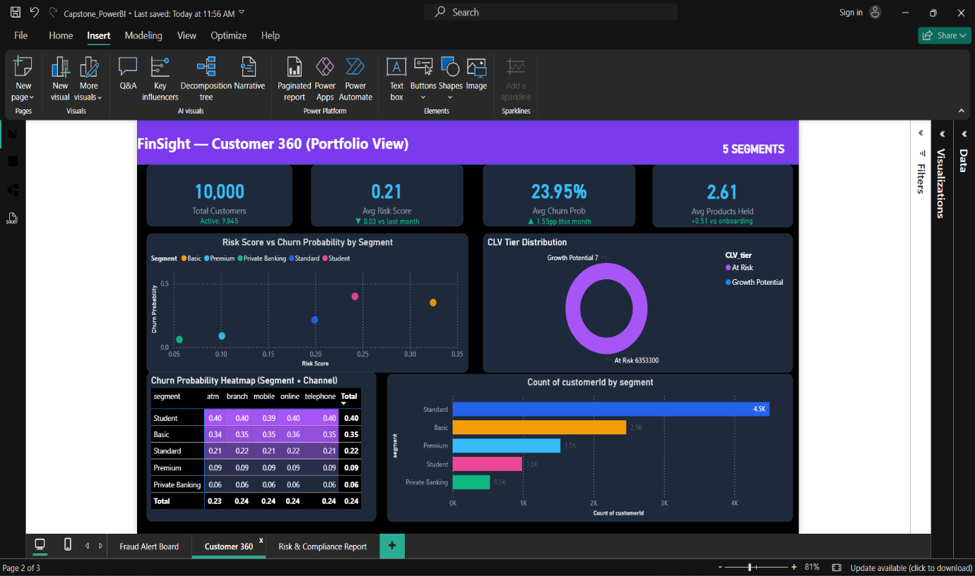

Dashboard Page 3 — FinSight — Risk & Compliance Report.
Step 1: Header Banner
- Created the top header banner and added title.
- Applied background colour formatting.
Step 2: Created DAX Measures & 4 KPI Cards
- Created DAX measures for Total Transactions, Total Volume, Confirmed Fraud, Dormancy count, and their green subtitle indicators.
- Applied Container & Colour Formatting: Formatted all 4 cards with dark container backgrounds, rounded borders, coloured callout values,

CREATED 4 KPI CARDS:
- Card 1 (Total Transactions)
- Card 2 (Total Volume)
- Card 3 (Confirmed Fraud)
- Card 4 (Dormant Accounts)
Step 3: Created Transaction Type Filter (Slicer)
- Selected a Slicer visual
- Added the field type from compliance_summary and set style to Tile.
- Applied button styling and container colour formatting with title FILTER BY TRANSACTION TYPE.
- Allows compliance officers to click any transaction category (CASH_IN, CASH_OUT, DEBIT, PAYMENT, TRANSFER) to instantly filter the entire report.
Step 4: Created Visual 1 — Transaction Volume by Type (Column Chart)
- Selected a Clustered Column Chart
- Set X-axis to Transaction Type and Y-axis to Total Volume .
- Applied colour formatting to the columns,

Step 5: Created Visual 2 — Weekly Fraud Rate Trend vs Target Line (Line Chart)
- Selected a Line Chart
- Set X-axis to Week (Weeks 1 to 5) and Y-axis to Weekly Fraud Rate (%).
- Added a constant Target Threshold Line at 0.60% using the Analytics pane.
- Applied smooth line styling and colour formatting to monitor weekly fraud trajectory and detect when fraud crosses the target ceiling

Step 6: Created Visual 3 — Compliance Table (Audit Data Table)
- Selected a Table visual
- Added the 6 required audit columns
- Added a DAX calculated column for Risk_Classification to classify transaction categories into HIGH RISK, MEDIUM RISK, and LOW RISK.
- Applied alternating row color formatting, styled headers,

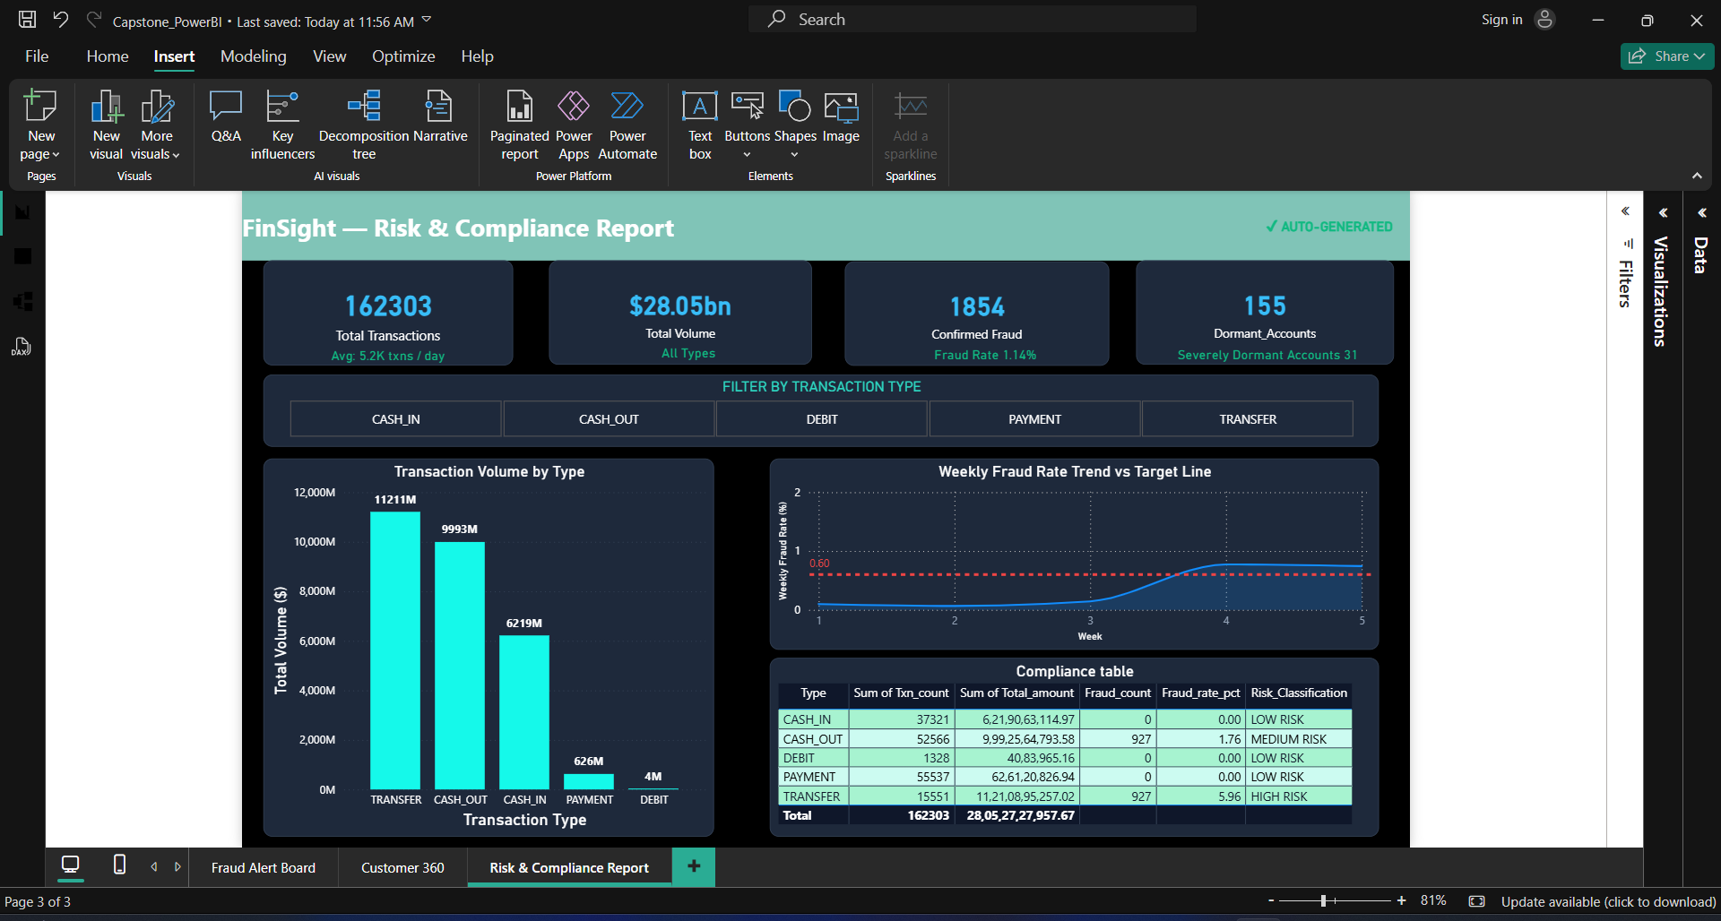

NOTE: The ZIP folder is organized into Day 1 to Day 5.
IN ZIP Folder Each day and Each Task Screenshots are uploaded.
NOTE: All Python files (.py), Hive SQL queries, MongoDB queries and Alteryx workflows are provided in their respective task folders.

