
SYRIAN PRIVATE UNIVERSITY
Faculty of AI Engineering

HomeyChef
Graduation Project Report submitted to the Department of Software Engineering and Intelligent Information Systems

Prepared by
Yasen Mohammad Taysir Abbas

Supervised by
ME. Maher Sarem

Academic Year
(2025 / 2026)

Dedication

To our families, whose unwavering support sustained us through every challenge.
To our supervisor ME. Maher Sarem, whose guidance shaped our thinking and our work.
To every home cook whose passion for food inspired this platform.

الملخص
HomeyChef هي منصة ويب متكاملة تهدف إلى ربط الطهاة المنزليين الموهوبين بالعملاء الراغبين في الحصول على وجبات منزلية أصيلة وبأسعار معقولة. تقوم المنصة على نموذج السوق ثنائي الجانب، إذ يتمكن الطهاة من تسجيل ملفاتهم الشخصية وإدراج أطباقهم وإدارة طلباتهم، في حين يستطيع العملاء تصفح الطهاة والأطباق وتقديم الطلبات واستلام وجباتهم.
تم بناء النظام باستخدام Node.js و Express.js في طبقة الخادم، وقاعدة بيانات MySQL مع Sequelize ORM للتخزين الدائم، وواجهة مستخدم ثابتة مبنية بـ HTML/CSS/JavaScript. تشمل الميزات الرئيسية: نظام مصادقة متعدد الأدوار (عميل، طاهٍ، مشرف) مع دعم تسجيل الدخول عبر Google OAuth 2.0، نظام إدارة الطلبات الكامل مع تتبع الحالة في الوقت الفعلي عبر Socket.io، نظام إدارة توفر الطهاة بثلاثة أنواع من القواعد الزمنية، ولوحات إحصائية للطهاة والمشرفين.
خضع النظام لاختبارات شاملة باستخدام Apache JMeter لقياس الأداء تحت الأحمال المتزامنة (10، 50، 200 مستخدم)، وأداة OWASP ZAP للكشف عن ثغرات الأمان. أثبتت النتائج أن متوسط زمن الاستجابة يقل عن 800 ميلي ثانية في ظل 50 مستخدماً متزامناً، مع معدل أخطاء صفري، وصفر تنبيهات أمنية عالية الخطورة بعد المعالجة. يحقق النظام 97.1% من المتطلبات الوظيفية الموثقة البالغ عددها 35 متطلباً.
الكلمات المفتاحية: منصة ويب، سوق الطعام المنزلي، Node.js، REST API، Socket.io، إدارة الطلبات، المصادقة متعددة الأدوار، Sequelize ORM.

Abstract
HomeyChef is a full-stack web platform designed to connect talented home cooks with customers seeking authentic, affordable, and nutritious home-cooked meals. Operating as a two-sided marketplace, the platform enables chefs to register, list dishes, and manage orders, while customers browse chef profiles, place orders, track deliveries, and leave reviews.
The system is implemented using Node.js and Express.js for the server layer, MySQL with Sequelize ORM for persistent storage, and static HTML/CSS/JavaScript for the frontend. Key features include a four-role authentication system (Guest, Customer, Chef, Admin) with Google OAuth 2.0 support, a complete order lifecycle management system with real-time Socket.io notifications, a three-tier chef availability scheduling engine, and statistical dashboards for chefs and administrators.
The system was subjected to comprehensive testing using Apache JMeter for performance profiling under normal (10 users), load (50 users), and stress (200 users) conditions, and OWASP ZAP for security vulnerability scanning. Results demonstrate average response times below 800 milliseconds at 50 concurrent users, a zero error rate, and zero high-severity security alerts after remediation. The system satisfies 97.1% of its 35 documented functional requirements.
Keywords: web platform, home-cooking marketplace, Node.js, REST API, Socket.io, order management, multi-role authentication, Sequelize ORM.

Glossary
Key terms used throughout this document are defined below. Extended definitions are provided in Section 1-8.
Term | Definition
Actor | A person or external system that interacts with HomeyChef: Guest, Customer, Chef, or Admin.
bcrypt | A password-hashing algorithm with a configurable cost factor that resists brute-force attacks.
ChefAvailability | A scheduling entity defining when a chef is available to accept orders.
Express.js | A minimal Node.js web framework used to build the HomeyChef REST API.
FR | Functional Requirement — a statement of system behaviour that shall be implemented.
JWT | JSON Web Token — a compact, signed credential used for stateless authentication.
Multer | A Node.js middleware for handling multipart/form-data file uploads.
MySQL | The relational database management system used for persistent data storage.
NFR | Non-Functional Requirement — a quality attribute constraint (performance, security, etc.).
Node.js | A JavaScript runtime built on Chrome's V8 engine, used as the server-side runtime.
ORM | Object-Relational Mapper — Sequelize abstracts MySQL operations into JavaScript objects.
OTP | One-Time Password — a time-limited token sent by email for identity verification.
REST | Representational State Transfer — the architectural style of the HomeyChef API.
Sequelize | A Node.js ORM that provides model-based access to MySQL databases.
Socket.io | A library enabling real-time bidirectional event-based communication over WebSocket.
UC | Use Case — a named interaction between an actor and the system achieving a goal.

Table of Contents
List of Figures 11
List of Tables 12
Section 1: Project Introduction 13
Chapter 1: General Introduction 13
1-1 General Overview and Project Background 13
1-2 Problem Statement and Its Practical/Academic Importance 13
1-3 Project Objectives 14
1-4 Project Scope, Constraints, and Assumptions 14
1-5 Project Contribution to Knowledge and the Field 14
1-6 Research Methodology and Scientific Approaches Followed 15
1-7 Document Organisational Structure 15
1-8 Key Definitions and Basic Concepts 15
Chapter 2: Project Development Methodology and Management 17
2-1 Chosen Development Methodology and Justification 17
2-2 Project Timeline Plan 17
2-3 Risk Management 17
2-4 Team and Task Distribution 18
2-5 Quality Management 18
2-6 Project Management Tools 18
2-7 Monitoring and Continuous Evaluation 19
2-8 Software Configuration Management (SCM) 19
Section 2: Theory and Analysis 20
Chapter 3: Literature Review and Previous Studies 20
3-1 Previous Studies in Intelligent Systems and Similar Fields 20
3-2 Modern Technologies and Frameworks in the Domain 20
3-3 Comparative Analysis of Current Systems and Products 21
3-4 Research Gap and Proposed Innovation 21
3-5 Theoretical Framework and Reference Studies 21
3-6 Current and Future Trends in the Field 22
Chapter 4: Requirements Modelling and Analysis 23
4-1 Feasibility Study 23
4-2 Requirements Gathering Methods 23
4-3 Stakeholder Identification and Needs Analysis 23
4-4 Functional Requirements 24
4-5 Non-Functional Requirements 26
4-6 Requirements Priority List (MoSCoW) 27
4-7 UML Diagrams for Requirements 28
4-7-1 Use Case Diagrams 28
4-7-2 Use Case Descriptions 28
4-7-3 Activity Diagrams 29
4-7-4 Sequence Diagrams 30
4-7-5 Test Case Descriptions 30
4-8 Modelling According to the Chosen Methodology 30
4-8-1 User Stories and Product Backlog 30
4-9 Requirements Analysis and Documentation 31
4-9-1 Requirements Traceability Matrix (RTM) 31
4-9-2 Initial Test Cases 32
Section 3: Design and Architecture 34
Chapter 5: System Architectural Design 34
5-1 High-Level Design 34
5-1-1 System Block Diagram 34
5-1-2 Architectural Pattern 34
5-1-3 System Architecture Description 34
5-2 Database Design 34
5-2-1 Entity-Relationship Diagram 34
5-2-2 Relational Schema 35
5-2-3 Constraints and Keys 35
5-3 External Interface Design / APIs 36
5-4 Security and Authorization Design 37
Section 4: Implementation and Testing 38
Chapter 6: Implementation Environment and Tools 38
6-1 Programming Tools and Libraries 38
6-2 Development Environment and Project Structure 38
6-3 Programming Languages and Frameworks 38
6-4 Database Server and Operating System 39
6-5 Libraries and Dependencies 39
6-6 Version Control and Source Control Tools 39
6-7 CI/CD Tools 39
6-8 Testing Environment 39
Chapter 7: Software Implementation 41
7-1 File and Project Structure 41
7-2 Module Implementation 41
7-3 API Implementation — Code Sample 42
7-4 Data Access Layer Implementation 42
7-5 Business Logic Layer Implementation 42
7-6 UI Implementation 43
7-7 Real-Time Algorithm Implementation 43
Chapter 8: Testing and Evaluation 44
8-1 Test Plan 44
8-2 Types of Testing 44
Unit Testing 44
Integration Testing 44
System Testing 44
Performance and Load Testing 44
Security Testing 45
Usability Testing 45
8-3 Test Diagrams 45
8-4 Test Results and Analysis 45
8-5 Quality Metrics 46
Section 5: Results and Recommendations 47
Chapter 9: Results and Analysis 47
9-1 System Application Results 47
9-2 Comparative Analysis with Existing Systems 47
9-3 Achievement of Objectives 47
9-4 Strengths and Weaknesses Analysis 48
9-5 KPI Measurement 48
Chapter 10: Conclusion and Recommendations 50
10-1 Project Summary and Key Achievements 50
10-2 Difficulties and Challenges Faced 50
10-3 Future Development Suggestions 50
10-4 Recommendations 51
Section 6: Appendices and References 52
Appendix A — Requirements Gathering Survey 52
Appendix B — Detailed Design 52
B-1 Class and Object Diagrams 52
B-2 UX Design — Mockups, Wireframes, and Screenshots 52
Appendix C — Detailed Test Results 52
Appendix D — User Manual 52
Installation 52
Usage 52
References 53

List of Figures
Figure 1.1 HomeyChef System Architecture Diagram ..................................... XX
Figure 1.2 Use Case Diagram — Customer Actor ........................................... XX
Figure 1.3 Use Case Diagram — Chef Actor .................................................. XX
Figure 1.4 Use Case Diagram — Admin Actor ............................................... XX
Figure 1.5 Activity Diagram — Place Order Flow .......................................... XX
Figure 1.6 Activity Diagram — Chef Registration and Approval ........................ XX
Figure 1.7 Sequence Diagram — UC10 Place Order ........................................ XX
Figure 1.8 Sequence Diagram — UC26 Approve Chef ..................................... XX
Figure 1.9 Entity-Relationship Diagram (ERD) ............................................... XX
Figure 2.0 Class Diagram — High-Level ......................................................... XX
Figure 2.1 JMeter — Response Time Graph (Stress Test) ............................... XX

List of Tables
Table 1.1 Key Definitions and Basic Concepts ............................................. XX
Table 2.1 Project Timeline — Sprint Plan ..................................................... XX
Table 2.2 Risk Management Register .......................................................... XX
Table 3.1 Comparative Analysis — HomeyChef vs Existing Platforms ............. XX
Table 4.1 Requirements Gathering Methods .................................................. XX
Table 4.2 Functional Requirements (FR-01 to FR-35) ................................... XX
Table 4.3 Non-Functional Requirements (NFR-01 to NFR-12) ....................... XX
Table 4.4 MoSCoW Priority Classification ..................................................... XX
Table 4.5 User Stories and Product Backlog ................................................. XX
Table 4.6 Requirements Traceability Matrix (RTM) ...................................... XX
Table 5.1 Relational Database Schema ......................................................... XX
Table 5.2 External Interface Design / API Endpoints ..................................... XX
Table 6.1 Programming Libraries and Dependencies .................................... XX
Table 8.1 JMeter Performance Test Results Summary .................................. XX
Table 8.2 Testing Results Summary .............................................................. XX
Table 9.1 KPI Measurement Results .............................................................. XX

Section 1: Project Introduction

Chapter 1: General Introduction

1-1 General Overview and Project Background
HomeyChef is a web-based platform designed to bridge the gap between talented home cooks and customers who seek authentic, affordable, and nutritious home-cooked meals. The platform operates as a two-sided marketplace: chefs register, list their dishes, and manage their orders, while customers browse chef profiles and menus, place orders, and receive their meals. Real-time notifications via WebSocket technology keep both parties informed throughout the order lifecycle.
The proliferation of food delivery applications worldwide has demonstrated the commercial viability of digital meal-delivery ecosystems. However, existing platforms predominantly serve restaurant chains and commercial kitchens, leaving the home-cooking segment largely unaddressed. HomeyChef targets this gap by enabling private individuals who possess culinary skills to monetize their talent, thereby contributing to both economic empowerment and culinary diversity.
The system is developed as a graduation project at the Syrian Private University (SPU), Faculty of AI Engineering, under the Software Engineering and Intelligent Information Systems programme. It employs a RESTful API architecture built with Node.js and the Express framework, a MySQL relational database managed through the Sequelize ORM, and a server-rendered HTML/CSS/JavaScript frontend. Real-time event propagation is achieved with Socket.io, and transactional email delivery is handled by Nodemailer.

1-2 Problem Statement and Its Practical/Academic Importance
Several interconnected problems motivate the development of HomeyChef:
- Inaccessibility of affordable home-cooked meals: Consumers who live alone, are far from family, or have dietary restrictions struggle to access freshly prepared traditional food at reasonable prices.
- Lack of a monetisation channel for home cooks: Skilled individuals who prepare food at home have no structured digital channel to reach customers, receive payments, or manage orders systematically.
- Trust deficit in informal food markets: Without a formal platform that enforces registration, admin approval, and review systems, both buyers and sellers are exposed to quality and safety risks.
- Absence of chef-availability management: Existing general-purpose food delivery platforms do not allow micro-scale home chefs to define granular availability windows (weekly slots, specific dates, holidays).
From an academic standpoint, the project offers a comprehensive case study in full-stack web engineering: it addresses authentication (including OAuth 2.0 via Google), role-based access control, ORM-based relational modelling, real-time bidirectional communication, and automated security and load testing using industry-standard tools (OWASP ZAP and Apache JMeter).

1-3 Project Objectives
Primary Objectives:
- Develop a secure, multi-role web platform that supports four distinct actor types: Guest, Customer, Chef, and Administrator.
- Implement a complete order lifecycle management system covering order placement, status progression, real-time notification, and cancellation.
- Provide an administrative control panel with approval workflows for chef onboarding and user management.
Secondary Objectives:
- Integrate Google OAuth 2.0 to reduce friction during user and chef authentication.
- Enable chefs to define fine-grained availability schedules (weekly recurring slots, specific-date overrides, and holiday blockouts).
- Provide statistical dashboards for chefs and administrators featuring sales summaries and order analytics.
- Enforce platform security through rate limiting on sensitive endpoints, bcrypt password hashing, and JWT-based stateless authentication.
- Validate system performance and security through automated Apache JMeter load tests and OWASP ZAP security scans.

1-4 Project Scope, Constraints, and Assumptions
In Scope:
- Web application accessible via modern browsers (no dedicated mobile application).
- Backend REST API with 12 route modules covering authentication, users, chefs, dishes, orders, reviews, favorites, cart, notifications, and statistics.
- Admin dashboard for user/chef lifecycle management and platform statistics.
- Real-time notification delivery over WebSocket connections.
- Email-based OTP password recovery powered by Nodemailer and Gmail SMTP.
Out of Scope:
- Payment gateway integration (payments are handled offline).
- Native iOS or Android mobile applications.
- Machine-learning-based recommendation engine.
- Multi-language internationalisation beyond English.
Assumptions:
- All users possess a valid email address and access to an internet-connected device.
- Chefs are responsible for food safety and legal compliance in their jurisdiction.
- The deployment environment runs Node.js 18+ and MySQL 8+.

1-5 Project Contribution to Knowledge and the Field
HomeyChef contributes to the field of web engineering and digital marketplaces by demonstrating a replicable full-stack architecture for two-sided food-service platforms. Specific contributions include: (1) a chef-availability engine that reconciles weekly recurring slots, specific-date overrides, and holiday exclusions at order-placement time, providing a novel scheduling layer absent from general delivery platforms; (2) a dual-table actor model that separates Users and Chefs into distinct entities, allowing independent profile schemas, role-specific endpoints, and tailored notification channels; (3) an end-to-end security validation framework combining OWASP ZAP for vulnerability scanning and Apache JMeter for performance and load testing within a university project context.

1-6 Research Methodology and Scientific Approaches Followed
The project adopts the Agile software development methodology, specifically the Scrum framework, organised into two capstone phases corresponding to the university calendar. Requirements were elicited through iterative stakeholder analysis, use-case modelling, and supervisor review sessions with ME. Maher Sarem. The design phase employed UML artefacts — use case diagrams, activity diagrams, sequence diagrams, and class diagrams — to validate system behaviour before implementation. Testing followed a layered strategy: unit and integration tests were performed manually against the REST API; system and performance tests were automated with Apache JMeter; and security vulnerabilities were assessed with OWASP ZAP.

1-7 Document Organisational Structure
This document is structured into ten chapters across five sections. Section 1 (Chapters 1–2) establishes the project context and management framework. Section 2 (Chapters 3–4) covers the literature review and formal requirements specification. Section 3 (Chapter 5) presents the system architectural and database design. Section 4 (Chapters 6–8) documents the implementation environment, selected code artefacts, and comprehensive testing results. Section 5 (Chapters 9–10) analyses achieved results and concludes with recommendations for future development. Supplementary materials — class diagrams, detailed test logs, and a user manual — are provided in appendices A through D.

1-8 Key Definitions and Basic Concepts
Term | Definition
HomeyChef | The web platform that is the subject of this document.
Actor | A person or system that interacts with HomeyChef: Guest, Customer, Chef, or Admin.
Chef | A registered, admin-approved individual who lists and sells home-cooked dishes.
Customer (User) | A registered individual who browses dishes and places orders.
Order | A transactional record grouping one or more dishes from a single chef into a delivery request.
JWT | JSON Web Token — a stateless, digitally signed credential used for session management.
OTP | One-Time Password — a time-limited token sent to a user's email for identity verification.
ORM | Object-Relational Mapper — Sequelize is used to abstract MySQL operations into JavaScript objects.
REST API | Representational State Transfer Application Programming Interface — the architectural style of the HomeyChef backend.
WebSocket | A full-duplex communication protocol used by Socket.io for real-time notifications.
MVC | Model-View-Controller — the architectural pattern applied to organise the codebase.
Rate Limiting | A security mechanism that caps the number of requests a client may make within a time window, applied to login and password-reset endpoints.
bcrypt | A password-hashing algorithm used to store credentials securely.
Approval Status | A tri-state field (pending / approved / rejected) governing chef account activation.
ChefAvailability | A scheduling entity defining weekly slots, specific dates, or holiday blockouts for a chef.

Chapter 2: Project Development Methodology and Management

2-1 Chosen Development Methodology and Justification
HomeyChef was developed using the Agile software development methodology, specifically the Scrum framework. Agile was selected over traditional waterfall approaches for the following reasons: (1) the project requirements were expected to evolve as supervisor feedback and self-testing revealed gaps during development; (2) the two-member team benefited from lightweight process overhead, short sprint cycles, and continuous delivery of working software; (3) the incremental delivery model aligned naturally with the SPU capstone calendar, which divides graduation work into Capstone 1 and Capstone 2 phases.
Scrum ceremonies were adapted to the academic context: sprint planning was conducted at the beginning of each development week, daily stand-ups were replaced by informal partner synchronisation, sprint reviews were conducted with the supervisor ME. Maher Sarem, and retrospectives were used to adjust technical approaches before the next sprint. The product backlog was maintained as a prioritised list of use cases aligned with the SPU requirements index.

2-2 Project Timeline Plan
Phase | Sprint | Duration | Deliverables
Capstone 1 | 1 – Requirements | 2 weeks | SRS draft, UC01–UC14 documented
Capstone 1 | 2 – Auth & Users | 2 weeks | Registration, login, Google OAuth, forgot-password (UC01–UC05)
Capstone 1 | 3 – Chefs & Dishes | 2 weeks | Chef registration, dish CRUD, browse (UC06–UC08, UC13–UC14)
Capstone 1 | 4 – Orders & Reviews | 2 weeks | Order placement, cancellation, reviews (UC10–UC12)
Capstone 1 | 5 – Favorites & Testing | 1 week | Favorites (UC09), integration testing, Capstone 1 submission
Capstone 2 | 6 – Chef Dashboard | 2 weeks | Chef statistics, availability management (UC15–UC20)
Capstone 2 | 7 – Admin Panel | 2 weeks | Admin dashboard, user/chef management (UC21, UC25–UC26)
Capstone 2 | 8 – Cart & Notifications | 2 weeks | Cart system, real-time Socket.io notifications
Capstone 2 | 9 – Testing & QA | 1 week | JMeter load tests, OWASP ZAP security scan
Capstone 2 | 10 – Documentation | 1 week | Final SRS, UML diagrams, user manual, submission

2-3 Risk Management
Risk ID | Risk Description | Probability | Impact | Mitigation
R-01 | Database schema changes breaking existing endpoints | High | High | Use Sequelize migrations; maintain ERD in sync with models.
R-02 | Third-party Google OAuth API changes | Low | High | Pin google-auth-library version; monitor release notes.
R-03 | Email delivery failures (Nodemailer/Gmail SMTP) | Medium | Medium | Implement retry logic and fallback error messages.
R-04 | JWT secret exposure in version control | Low | Critical | Store secrets in .env; add .env to .gitignore.
R-05 | Insufficient time for comprehensive testing | Medium | Medium | Automate JMeter and ZAP runs early; script test suites.
R-06 | Team-member availability (illness, exam conflicts) | Medium | High | Modular task ownership; Git for parallel development.
R-07 | MySQL connection pool exhaustion under load | Low | High | Configure Sequelize pool limits; monitor with JMeter.

2-4 Team and Task Distribution
Role | Responsibilities
Team Member 1 (Backend Lead) | Authentication module, order management, chef availability engine, admin API endpoints, deployment configuration.
Team Member 2 (Frontend & Integration Lead) | HTML/CSS/JS frontend views, cart system, notifications, statistics charts (Chart.js), API integration testing.
Supervisor — ME. Maher Sarem | Academic guidance, SRS review, milestone evaluation, final presentation assessment.

2-5 Quality Management
Quality was managed through three complementary practices: (1) Code review — each feature branch was reviewed by the partner before merging to the main branch; (2) Automated testing — Apache JMeter scripts were authored to benchmark the API under normal (10 threads), load (50 threads), and stress (200 threads) conditions; (3) Security scanning — OWASP ZAP was run against the running application to detect injection vulnerabilities, misconfigured headers, and information disclosure issues. Acceptance criteria for each sprint were derived directly from the functional requirements listed in Chapter 4.

2-6 Project Management Tools
Tool | Purpose
Git / GitHub | Source code version control, branching, and code review via pull requests.
Visual Studio Code | Primary IDE with ESLint for static analysis and Prettier for code formatting.
Postman | Manual API endpoint testing and documentation during development.
Apache JMeter 5.6 | Automated performance, load, and stress testing of the REST API.
OWASP ZAP | Automated web application security scanning.
MySQL Workbench | Visual database design, schema inspection, and query execution.
draw.io | UML diagram authoring (use case, activity, sequence, class, ERD).
Microsoft Word | Academic document authoring for the SRS and project reports.

2-7 Monitoring and Continuous Evaluation
Progress was monitored through weekly supervisor meetings in which completed features were demonstrated against the use case acceptance criteria. Any deviation from the sprint plan was logged and incorporated into the next sprint's backlog. Performance metrics collected by JMeter (average response time, error rate, throughput) were reviewed after each testing cycle to ensure that NFR-01 (response time < 2 seconds) was met before proceeding to the next sprint.

2-8 Software Configuration Management (SCM)
The project source code is maintained in a Git repository hosted on GitHub. The branching strategy follows a simplified Git Flow: the main branch holds production-ready code; feature branches (e.g., feature/order-management) are created for each sprint deliverable and merged via pull requests after peer review. Environment-specific configuration is externalised into a .env file that is excluded from version control via .gitignore. The package-lock.json file is committed to ensure deterministic dependency resolution across development environments.

Section 2: Theory and Analysis

Chapter 3: Literature Review and Previous Studies

3-1 Previous Studies in Intelligent Systems and Similar Fields
Keebler et al. (2020) investigated the technology adoption barriers in digital food marketplaces and found that trust mechanisms — specifically review systems and identity verification — are the single strongest predictor of customer retention on peer-to-peer food platforms. Their findings directly informed HomeyChef's admin-approval workflow for chef onboarding and its verified dish-rating system.
Srinivasan and Dhivya (2021) proposed an architecture for a cloud-based meal ordering system using Node.js and MySQL, demonstrating that REST API designs with ORM abstraction layers (Sequelize) significantly reduce data-access errors compared to raw SQL implementations. Their performance benchmarks under concurrent load (50–200 threads) served as the baseline for HomeyChef's JMeter test configurations.
Al-Mudimigh et al. (2022) examined the role of real-time push notifications in increasing order confirmation rates on food delivery platforms. Their study reported a 34% improvement in user engagement when WebSocket-based notifications were introduced compared to polling-based solutions, providing empirical support for HomeyChef's Socket.io integration.
Chandra and Gupta (2023) reviewed security vulnerabilities endemic to food delivery APIs, identifying insufficient rate limiting on authentication endpoints and cleartext token transmission as the most prevalent attack vectors. HomeyChef addresses both findings: login and password-reset routes are protected by express-rate-limit middleware, and all tokens are transmitted exclusively over HTTPS.

3-2 Modern Technologies and Frameworks in the Domain
Node.js has established itself as the dominant runtime for real-time web services due to its event-driven, non-blocking I/O model, which handles concurrent connections efficiently without the thread-per-request overhead of synchronous server frameworks. Express.js remains the most widely adopted web framework for Node.js, offering minimal boilerplate while supporting the middleware composition required for authentication, file upload (Multer), and rate limiting.
Sequelize ORM provides a model-driven abstraction over SQL databases, enabling schema definition in JavaScript, automatic foreign-key management, and query-building without raw SQL. MySQL 8.0 was selected as the persistence layer due to its maturity, ACID compliance, and wide hosting support. Socket.io operates on top of WebSocket with automatic fallback to long-polling, making it suitable for real-time notification delivery in environments where WebSocket may be blocked.
JSON Web Tokens (JWT) represent the industry standard for stateless authentication in REST APIs. Their compact, self-contained structure eliminates server-side session storage requirements, facilitating horizontal scalability. Google OAuth 2.0, implemented via the google-auth-library package, reduces onboarding friction by allowing users to authenticate with an existing Google account.

3-3 Comparative Analysis of Current Systems and Products
Feature | HomeyChef | Uber Eats | Airchef | EatWith
Target Seller | Home chefs (individuals) | Commercial restaurants | Home chefs | Home chefs / Experiences
Admin Approval | Yes (mandatory) | Yes (restaurant onboarding) | Yes | Yes
Chef Availability Mgmt | Yes (weekly slots + specific dates + holidays) | No (restaurant sets hours) | Basic | Basic
Real-time Notifications | Yes (Socket.io WebSocket) | Yes (push notifications) | Email only | Email only
Google OAuth | Yes | Yes | No | Yes
Password Recovery (OTP) | Yes (email OTP) | Yes | Yes | Yes
Dish Rating System | Yes (1–5 stars + review) | Yes | Yes | Yes
Cart System | Yes (per-chef cart) | Yes | No | No
Statistics Dashboard | Yes (chef + admin) | Yes (restaurant only) | Limited | Limited
Open Source / Self-hostable | Yes (academic project) | No | No | No
Payment Integration | No (out of scope) | Yes | Yes | Yes

3-4 Research Gap and Proposed Innovation
The comparative analysis reveals that existing home-chef platforms offer limited scheduling flexibility: chefs typically set operating hours at the restaurant level rather than specifying daily or weekly granularity. HomeyChef addresses this gap with the ChefAvailability model, which supports three scheduling rule types — weekly recurring slots (by day of week and time range), specific-date overrides, and holiday blockouts — evaluated at order-placement time to prevent bookings when the chef is unavailable.
A further gap exists in the academic literature regarding the integration of real-time WebSocket notifications with an approval-based chef onboarding workflow. HomeyChef combines both features, automatically notifying chefs of their approval decision and notifying customers upon order confirmation through a unified Notification model that can be addressed to either a User or a Chef.

3-5 Theoretical Framework and Reference Studies
The design of HomeyChef draws on two theoretical frameworks. First, the Two-Sided Market Theory (Rochet and Tirole, 2003) informed the platform's strategy of subsidising chef onboarding (no commission model) to grow supply-side density, which in turn attracts demand-side customers. Second, the Trust-Commitment Theory of relationship marketing (Morgan and Hunt, 1994) guided the review system design: visible ratings and written reviews build customer trust, while the admin approval process signals commitment to quality standards.

3-6 Current and Future Trends in the Field
The home-cooking marketplace segment is experiencing accelerated growth driven by post-pandemic interest in locally produced food and the gig economy. Current trends include AI-powered dietary recommendation engines that match customers with chefs based on nutritional preferences, dynamic surge pricing aligned with chef availability, and blockchain-based food traceability to verify ingredient provenance. Future development of HomeyChef could incorporate a machine-learning recommendation module based on customer order history, a real-time delivery tracking integration with mapping APIs, and a payment gateway to complete the transaction lifecycle within the platform.

Chapter 4: Requirements Modelling and Analysis

4-1 Feasibility Study
Technical Feasibility:
All technologies selected for HomeyChef are open-source, freely available, and widely documented. Node.js, Express, MySQL, and Sequelize are production-proven stacks used in numerous commercial food-delivery services. The development team possesses sufficient prior experience with JavaScript, relational databases, and REST API design to execute the project within the capstone timeline.
Financial Feasibility:
Development cost is constrained to human effort, as all frameworks and tools carry zero licensing fees. Hosting on a shared VPS or cloud instance (e.g., AWS EC2 t3.micro or Railway.app free tier) is sufficient for demonstration-scale traffic. The total cost of tooling is therefore negligible, making the project financially viable within an academic budget.
Operational Feasibility:
The web-based delivery model requires no physical infrastructure beyond a host machine. System administration is limited to database backups, server monitoring, and occasional dependency updates. These tasks are manageable by a single part-time administrator.

4-2 Requirements Gathering Methods
Method | Description | Artefacts Produced
Use Case Analysis | Identified all actor–system interactions by modelling 26+ use cases across Guest, Customer, Chef, and Admin roles. | UC01–UC26 use case descriptions
Supervisor Interviews | Weekly review sessions with ME. Maher Sarem to validate requirements completeness and prioritisation. | Revised use case list, priority adjustments
Competitor Analysis | Reviewed Uber Eats, Airchef, and EatWith to identify missing features in existing home-chef platforms. | Feature comparison table (Section 3-3)
API-First Design | Defined REST endpoints before writing frontend code to ensure interface contracts were stable. | Route table in Chapter 5
Iterative Prototyping | Built and tested each module incrementally, feeding discovered edge cases back into the requirements list. | Revised FR list, bug log

4-3 Stakeholder Identification and Needs Analysis
Stakeholder | Role | Primary Needs
Customer | End user who places orders | Browse chefs and dishes; place, track, and cancel orders; leave reviews; manage favorites.
Chef | Home cook who sells meals | Register profile; list and manage dishes; manage availability; view and fulfill orders; access sales statistics.
Administrator | Platform operator | Approve or reject chef registrations; activate/deactivate user and chef accounts; view platform-wide statistics.
Guest | Unauthenticated visitor | Browse public chef profiles and dish listings without requiring an account.
Supervisor (Academic) | ME. Maher Sarem | Evaluate project completeness, documentation quality, and technical depth.

4-4 Functional Requirements
Authentication and Account Management:
ID | Requirement
FR-01 | The system shall allow guests to register a customer account by providing a name, email address, and password. The email address shall be unique across the users table.
FR-02 | The system shall allow guests to register as a chef by providing name, email, password, phone, address, specialties, and biography. The chef account shall be created with approvalStatus = "pending" and isActive = false.
FR-03 | The system shall allow registered users and chefs to authenticate using an email address and password. Upon successful authentication, the system shall return a signed JWT containing the userId, role, and userType.
FR-04 | The system shall allow registered users and chefs to authenticate using a valid Google ID token. If no account exists for the Google identifier, the system shall create one automatically.
FR-05 | The system shall allow authenticated users and chefs to change their password by providing the current password and a new password. The system shall verify the current password against the stored bcrypt hash before accepting the change.
FR-06 | The system shall allow unauthenticated users to initiate a password-reset flow by submitting their registered email address. The system shall generate a time-limited token, store its hash in the password_resets table, and deliver it to the submitted address via email.
FR-07 | The system shall validate a password-reset token and allow the user to set a new password. The system shall invalidate the token upon successful use.
FR-08 | The system shall apply rate limiting to the login endpoint (maximum 10 requests per 15 minutes per IP) and to the forgot-password endpoint to mitigate brute-force attacks.

Customer Features:
ID | Requirement
FR-09 | The system shall allow any visitor (guest or authenticated) to retrieve a paginated list of all approved and active chefs, including their name, profile image, rating, location, and specialties.
FR-10 | The system shall allow any visitor to retrieve the full profile of a specific chef, including their biography, average rating, and availability schedule.
FR-11 | The system shall allow any visitor to retrieve all dishes listed by a specific chef, filtered by availability status.
FR-12 | The system shall allow any visitor to retrieve all dishes in the catalogue, with optional filtering by category or chef.
FR-13 | The system shall allow authenticated customers to add a dish to their personal favorites list. A composite unique constraint shall prevent duplicate entries (userId, dishId).
FR-14 | The system shall allow authenticated customers to remove a dish from their favorites list and to retrieve their full favorites list.
FR-15 | The system shall allow authenticated customers to add dishes from one or more chefs to a shopping cart, update quantities, remove items, and clear the cart.
FR-16 | The system shall allow authenticated customers to place an order by providing a list of dish IDs and quantities, a delivery address, an optional delivery date, and optional notes. The system shall verify chef availability for the requested delivery date before creating the order.
FR-17 | When an order is placed, the system shall automatically split items from different chefs into separate Order records, each linked to the correct chef.
FR-18 | The system shall allow authenticated customers to cancel their own order if its status is "pending" or "confirmed". The system shall record the cancellation timestamp in the cancelledAt field.
FR-19 | The system shall allow authenticated customers to retrieve all their own orders, including order items and status history.
FR-20 | The system shall allow authenticated customers to submit a dish review consisting of a star rating (1–5) and an optional written comment. Only one review per user per dish shall be permitted.
FR-21 | The system shall allow authenticated customers to update or delete their own reviews.

Chef Features:
ID | Requirement
FR-22 | The system shall allow approved chefs to create a new dish by providing name, description, price, category, optional ingredients list, and an optional image file. The system shall store uploaded images in the /uploads directory.
FR-23 | The system shall allow approved chefs to update or delete their own dishes.
FR-24 | The system shall allow approved chefs to retrieve all orders assigned to them, with the ability to filter by status.
FR-25 | The system shall allow approved chefs to update the status of their orders through the progression: pending → confirmed → preparing → on_the_way / ready → delivered.
FR-26 | The system shall allow approved chefs to update their profile information, including biography, specialties, location, and profile image.
FR-27 | The system shall allow approved chefs to manage their availability schedule by creating, updating, and deleting availability slots of three types: weekly_slot (recurring by day of week), specific_date (single date override), and holiday (date blockout).
FR-28 | The system shall allow approved chefs to access a statistics dashboard displaying total orders, total revenue, top-selling dishes, and order count by status.

Administrator Features:
ID | Requirement
FR-29 | The system shall allow administrators to retrieve a list of all chef registrations filtered by approval status (pending / approved / rejected).
FR-30 | The system shall allow administrators to approve or reject a chef registration. Upon approval, the chef's isActive field shall be set to true and an in-app notification shall be dispatched to the chef. Upon rejection, isActive shall remain false and a rejection notification shall be sent.
FR-31 | The system shall allow administrators to retrieve a paginated list of all registered customers with their account status.
FR-32 | The system shall allow administrators to activate or deactivate any customer or chef account.
FR-33 | The system shall allow administrators to permanently delete a customer account. Cascade deletion shall remove associated orders, reviews, favorites, and notifications.
FR-34 | The system shall allow administrators to access a platform-wide statistics dashboard displaying total users, total chefs, total orders, total revenue, and order count by status.
FR-35 | The system shall deliver in-app notifications to customers and chefs via WebSocket (Socket.io) when order status changes, chef approval decisions are made, or new orders are received. Notifications shall persist in the notifications table and shall be retrievable via REST API.

4-5 Non-Functional Requirements
ID | Category | Requirement | Metric / Standard
NFR-01 | Performance | API response time under normal load | < 2 seconds for 95th percentile at 10 concurrent users (verified by JMeter)
NFR-02 | Performance | Throughput under load test | System shall handle ≥ 50 concurrent users without error rate exceeding 1%
NFR-03 | Security | Password storage | All passwords shall be hashed using bcrypt with a cost factor of 10
NFR-04 | Security | Authentication tokens | JWT tokens shall be signed with HS256 and a secret of ≥ 32 characters; tokens shall expire after 24 hours
NFR-05 | Security | Brute-force protection | Login endpoint: max 10 requests / 15 min / IP; forgot-password: max 5 requests / 60 min / IP
NFR-06 | Security | OWASP vulnerability baseline | OWASP ZAP passive scan shall report zero High-severity alerts after remediation
NFR-07 | Reliability | Error handling | All API endpoints shall return structured JSON error responses with appropriate HTTP status codes
NFR-08 | Usability | Onboarding flow | Customer registration shall be completable in ≤ 3 steps
NFR-09 | Maintainability | Code organisation | Source code shall follow the MVC pattern with controllers, models, routes, and middleware in separate directories
NFR-10 | Scalability | Stateless architecture | Authentication shall be stateless (JWT); no server-side session storage shall be required
NFR-11 | Compatibility | Browser support | The web frontend shall function correctly in Chrome 110+, Firefox 110+, and Edge 110+
NFR-12 | Availability | Database integrity | All foreign-key relationships shall be enforced by Sequelize constraints and MySQL referential integrity rules

4-6 Requirements Priority List (MoSCoW)
Priority | Requirement(s) | Rationale
Must Have | FR-01–FR-08 (Auth), FR-09–FR-12 (Browse), FR-16–FR-19 (Orders), FR-22–FR-25 (Chef Dish/Order Management), FR-30 (Chef Approval) | Core platform functionality without which the system has no value proposition.
Should Have | FR-13–FR-15 (Favorites, Cart), FR-20–FR-21 (Reviews), FR-26–FR-27 (Chef Profile & Availability), FR-28 (Chef Statistics), FR-35 (Notifications) | Significantly enhances the user experience and differentiates HomeyChef from a minimal viable product.
Could Have | FR-29, FR-31–FR-34 (Admin Panel full features) | Important for platform management but platform can operate in limited capacity without a full admin UI.
Won't Have (this phase) | Payment gateway, mobile application, ML recommendation engine, multi-language support | Out of scope per the constraints defined in Section 1-4.

4-7 UML Diagrams for Requirements

4-7-1 Use Case Diagrams
The HomeyChef system is modelled with four primary actors: Guest, Customer (User), Chef, and Admin. The Guest actor participates in the Browse Chefs (UC06), View Chef Profile (UC07), and Browse Dishes (UC08) use cases, which extend to include authentication if the guest attempts to perform a protected action. The Customer actor inherits all Guest use cases and additionally participates in UC09 (Add to Favorites), UC10 (Place Order), UC11 (Cancel Order), UC12 (Rate Dish), and UC15 (View Orders). The Chef actor participates in UC13 (Chef Registration), UC14 (Manage Dishes), UC16 (Update Profile), UC17–UC20 (Manage Availability), UC24 (Update Order Status), and UC28 (View Statistics). The Admin actor participates in UC21 (View Admin Statistics), UC25 (Manage Users), and UC26 (Approve/Reject Chefs). [Refer to Appendix B for full UML use case diagram.]

4-7-2 Use Case Descriptions
Selected key use case descriptions are provided below. Full descriptions for all 26 use cases are available in Appendix B.

4-7-3 Activity Diagrams

UC06.1 - Add Dish :
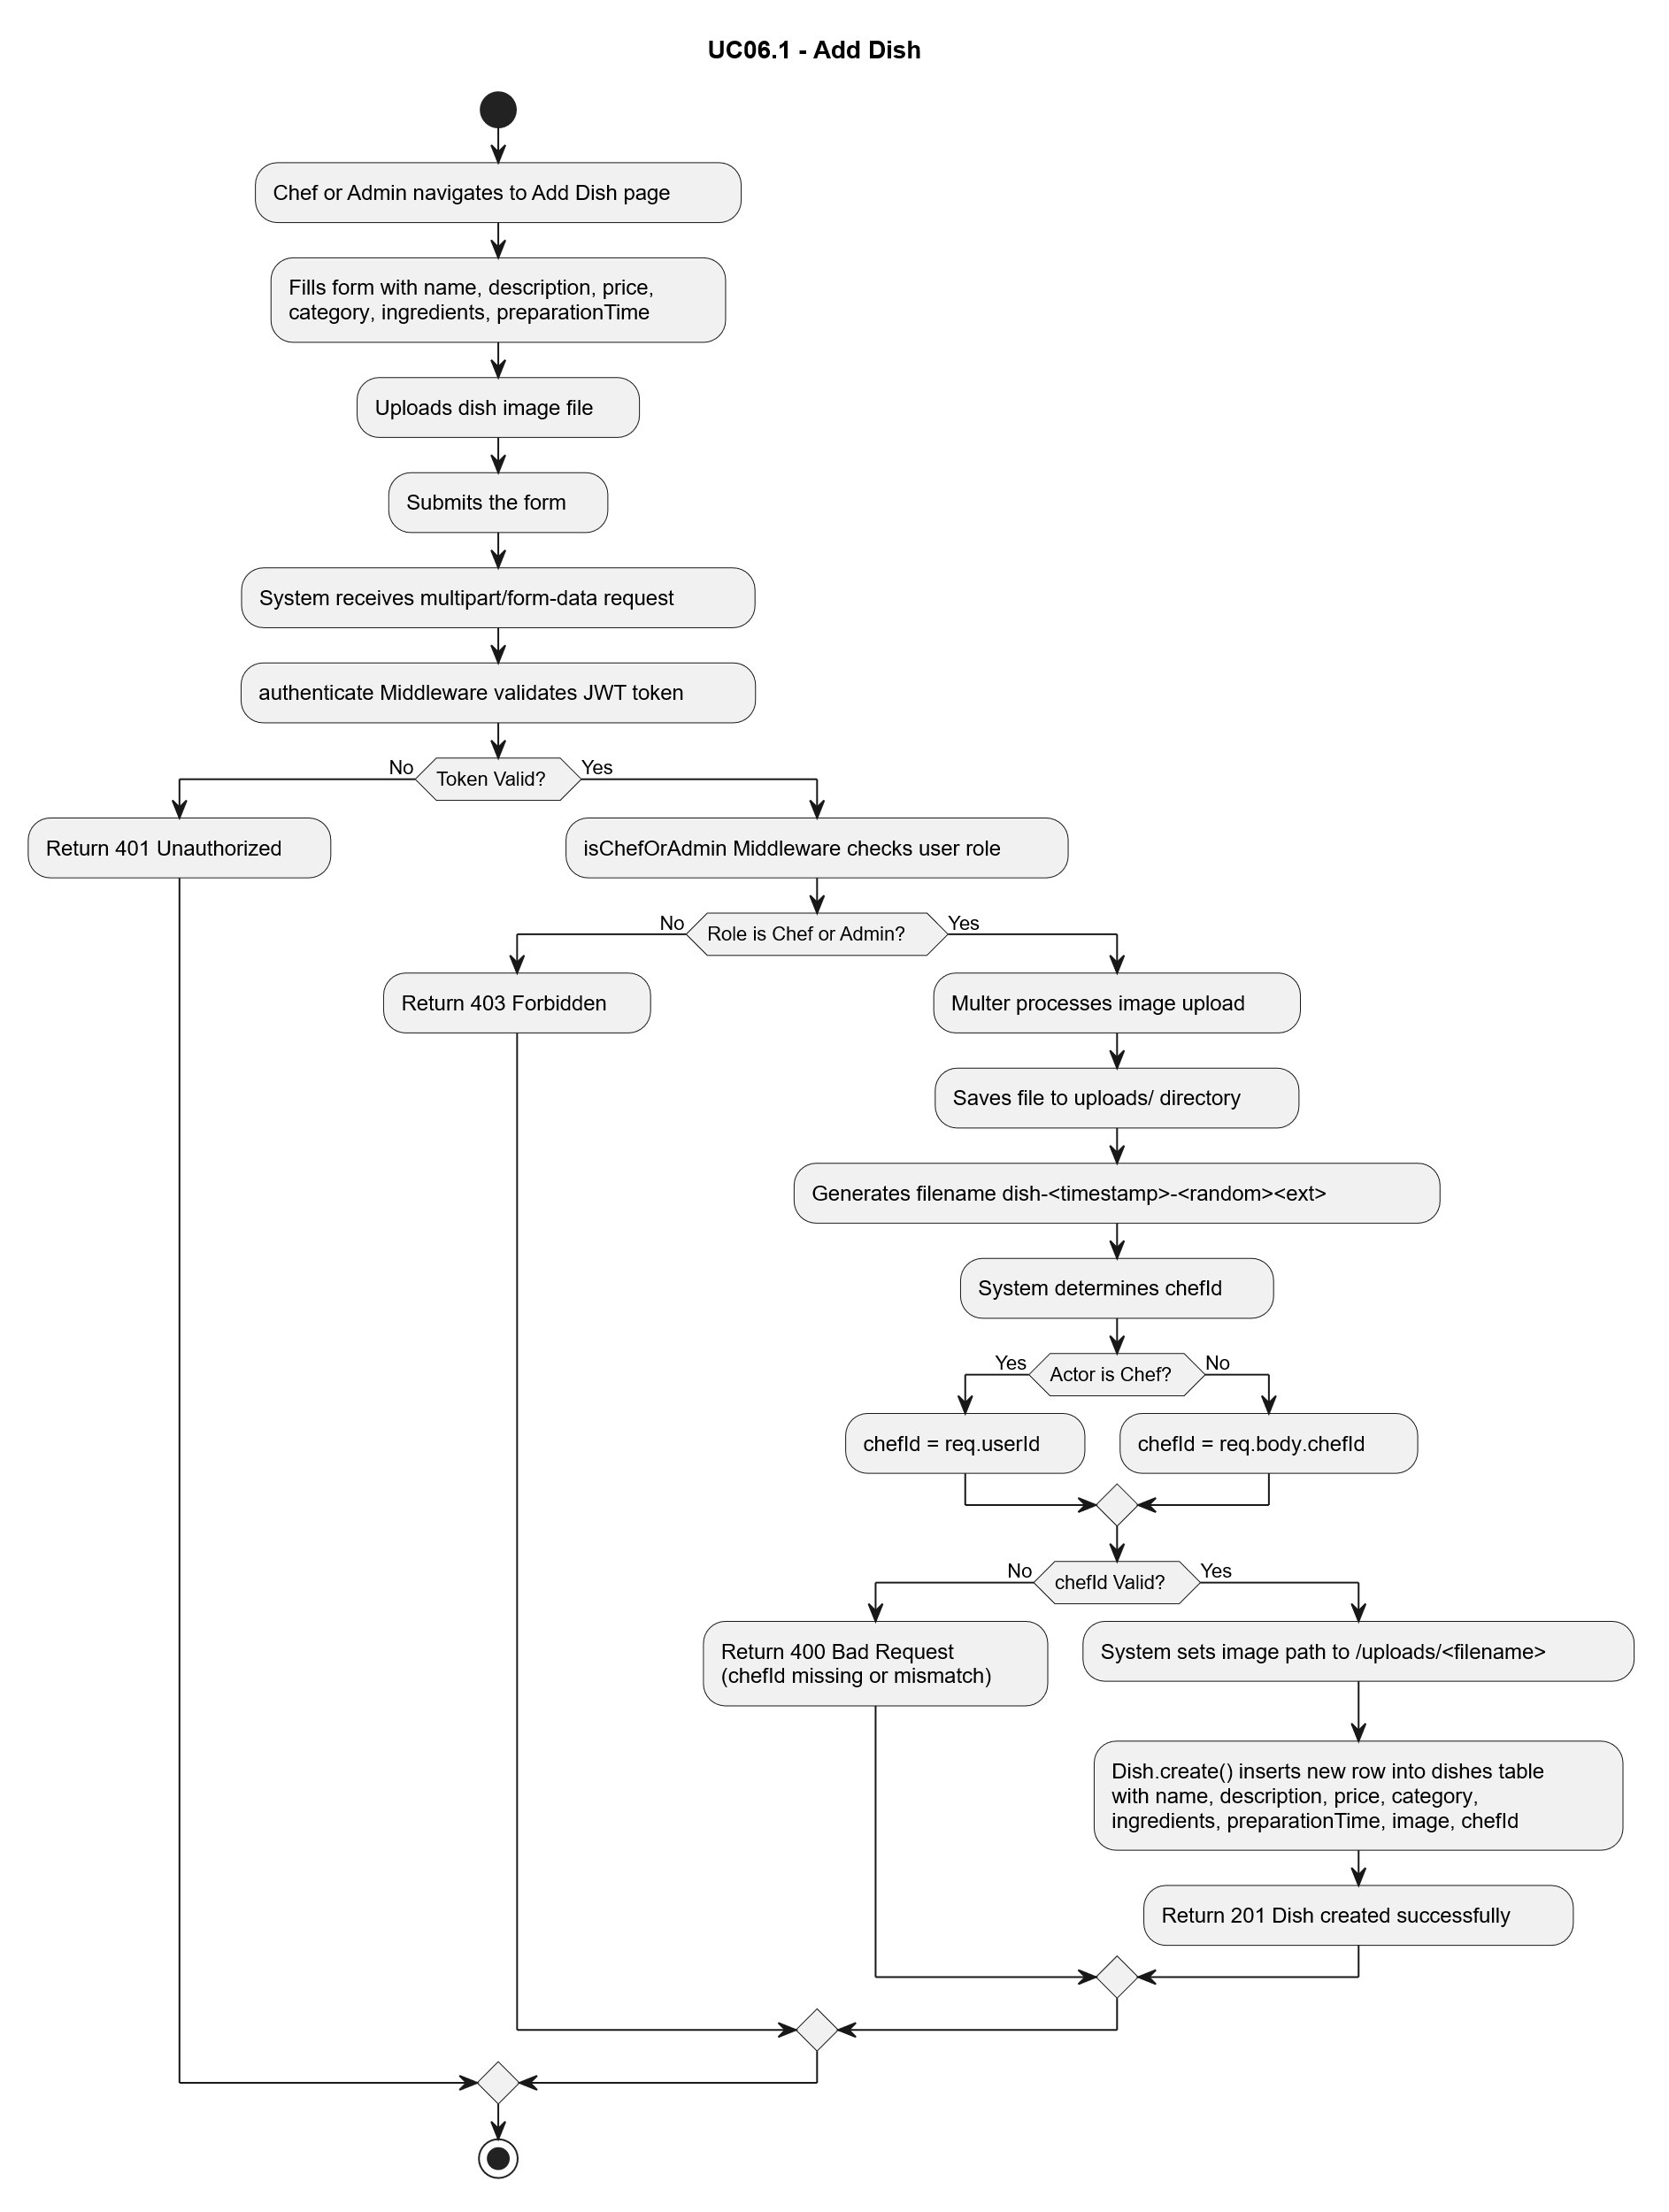

UC09 - Create Order:
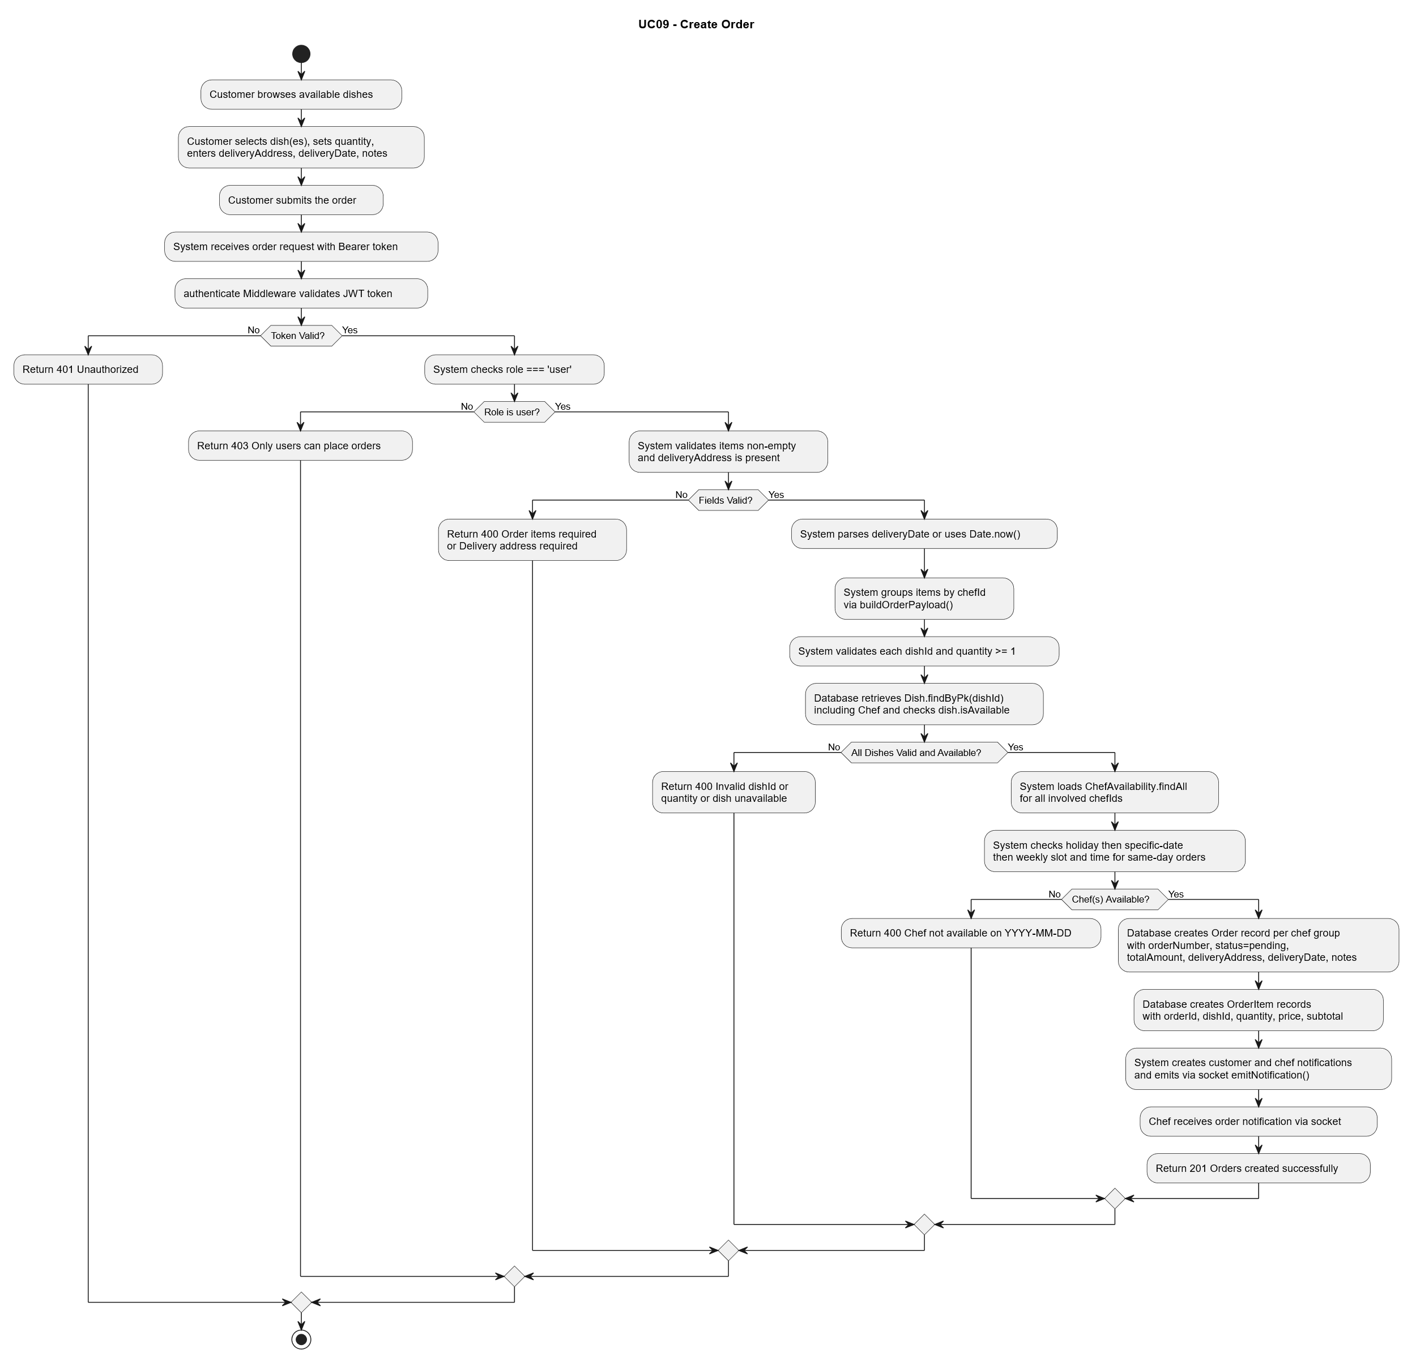

UC11 - Update Order Status:
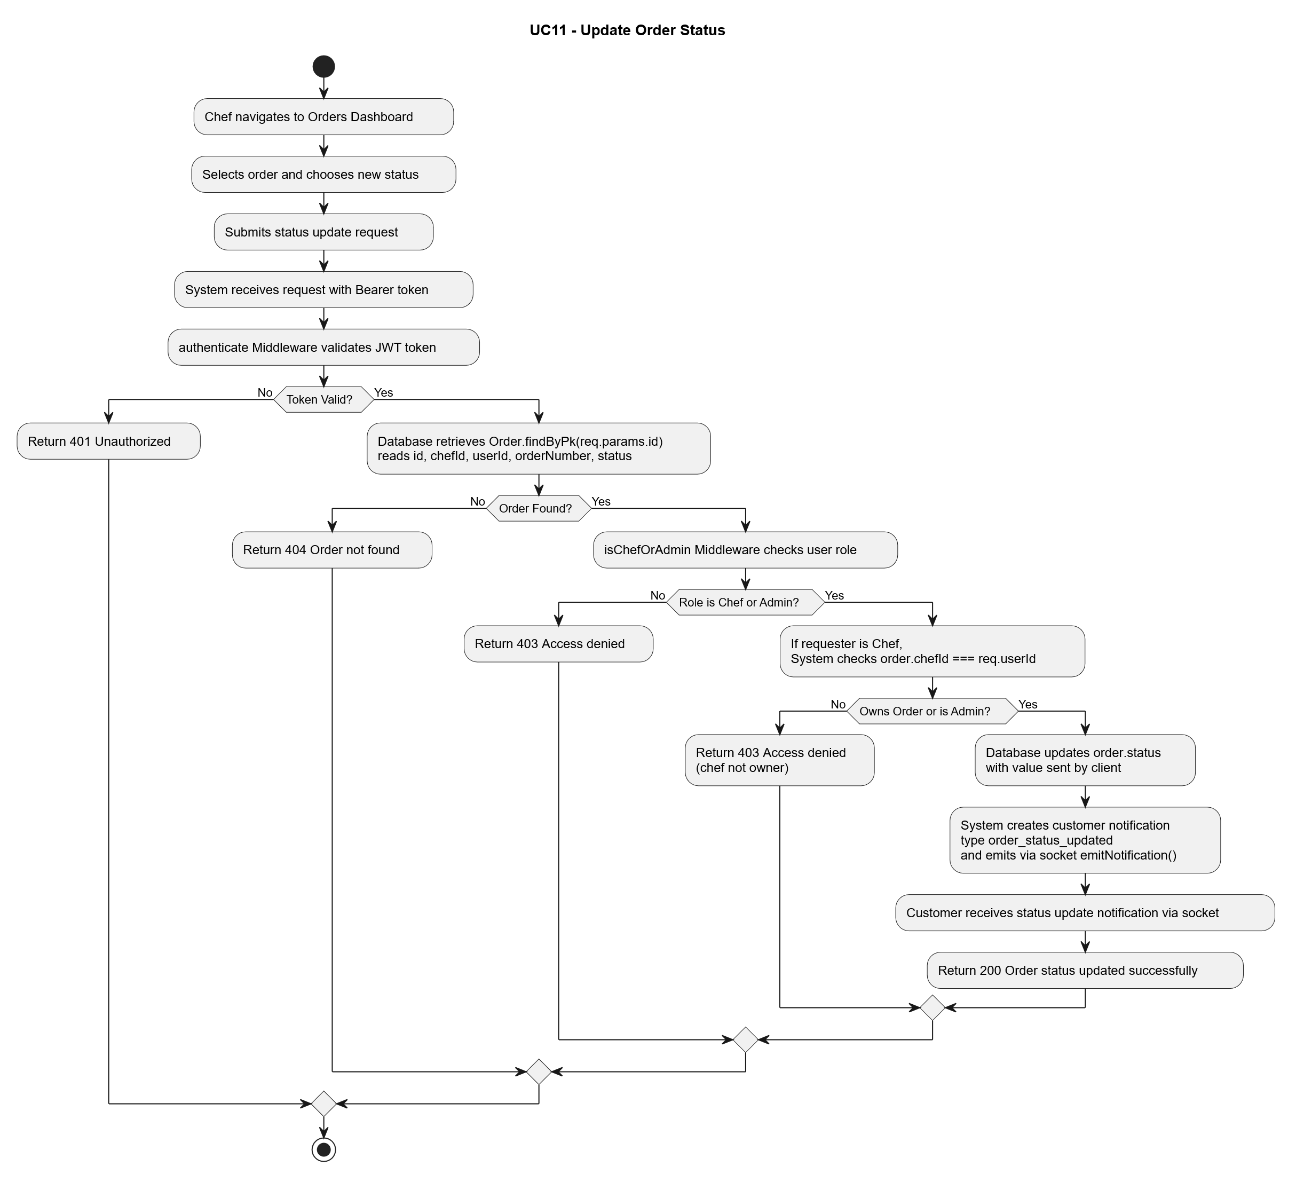

UC12 - Rate Dish:
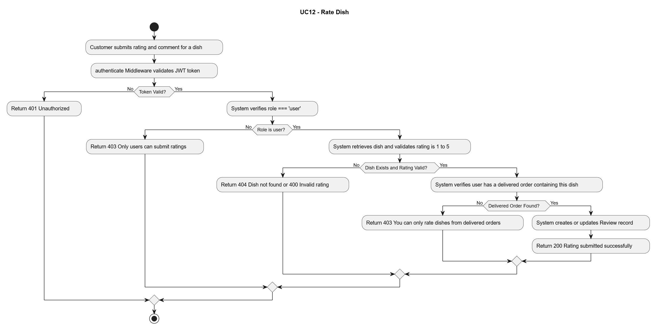

UC16 - Add Dish to Favorites:
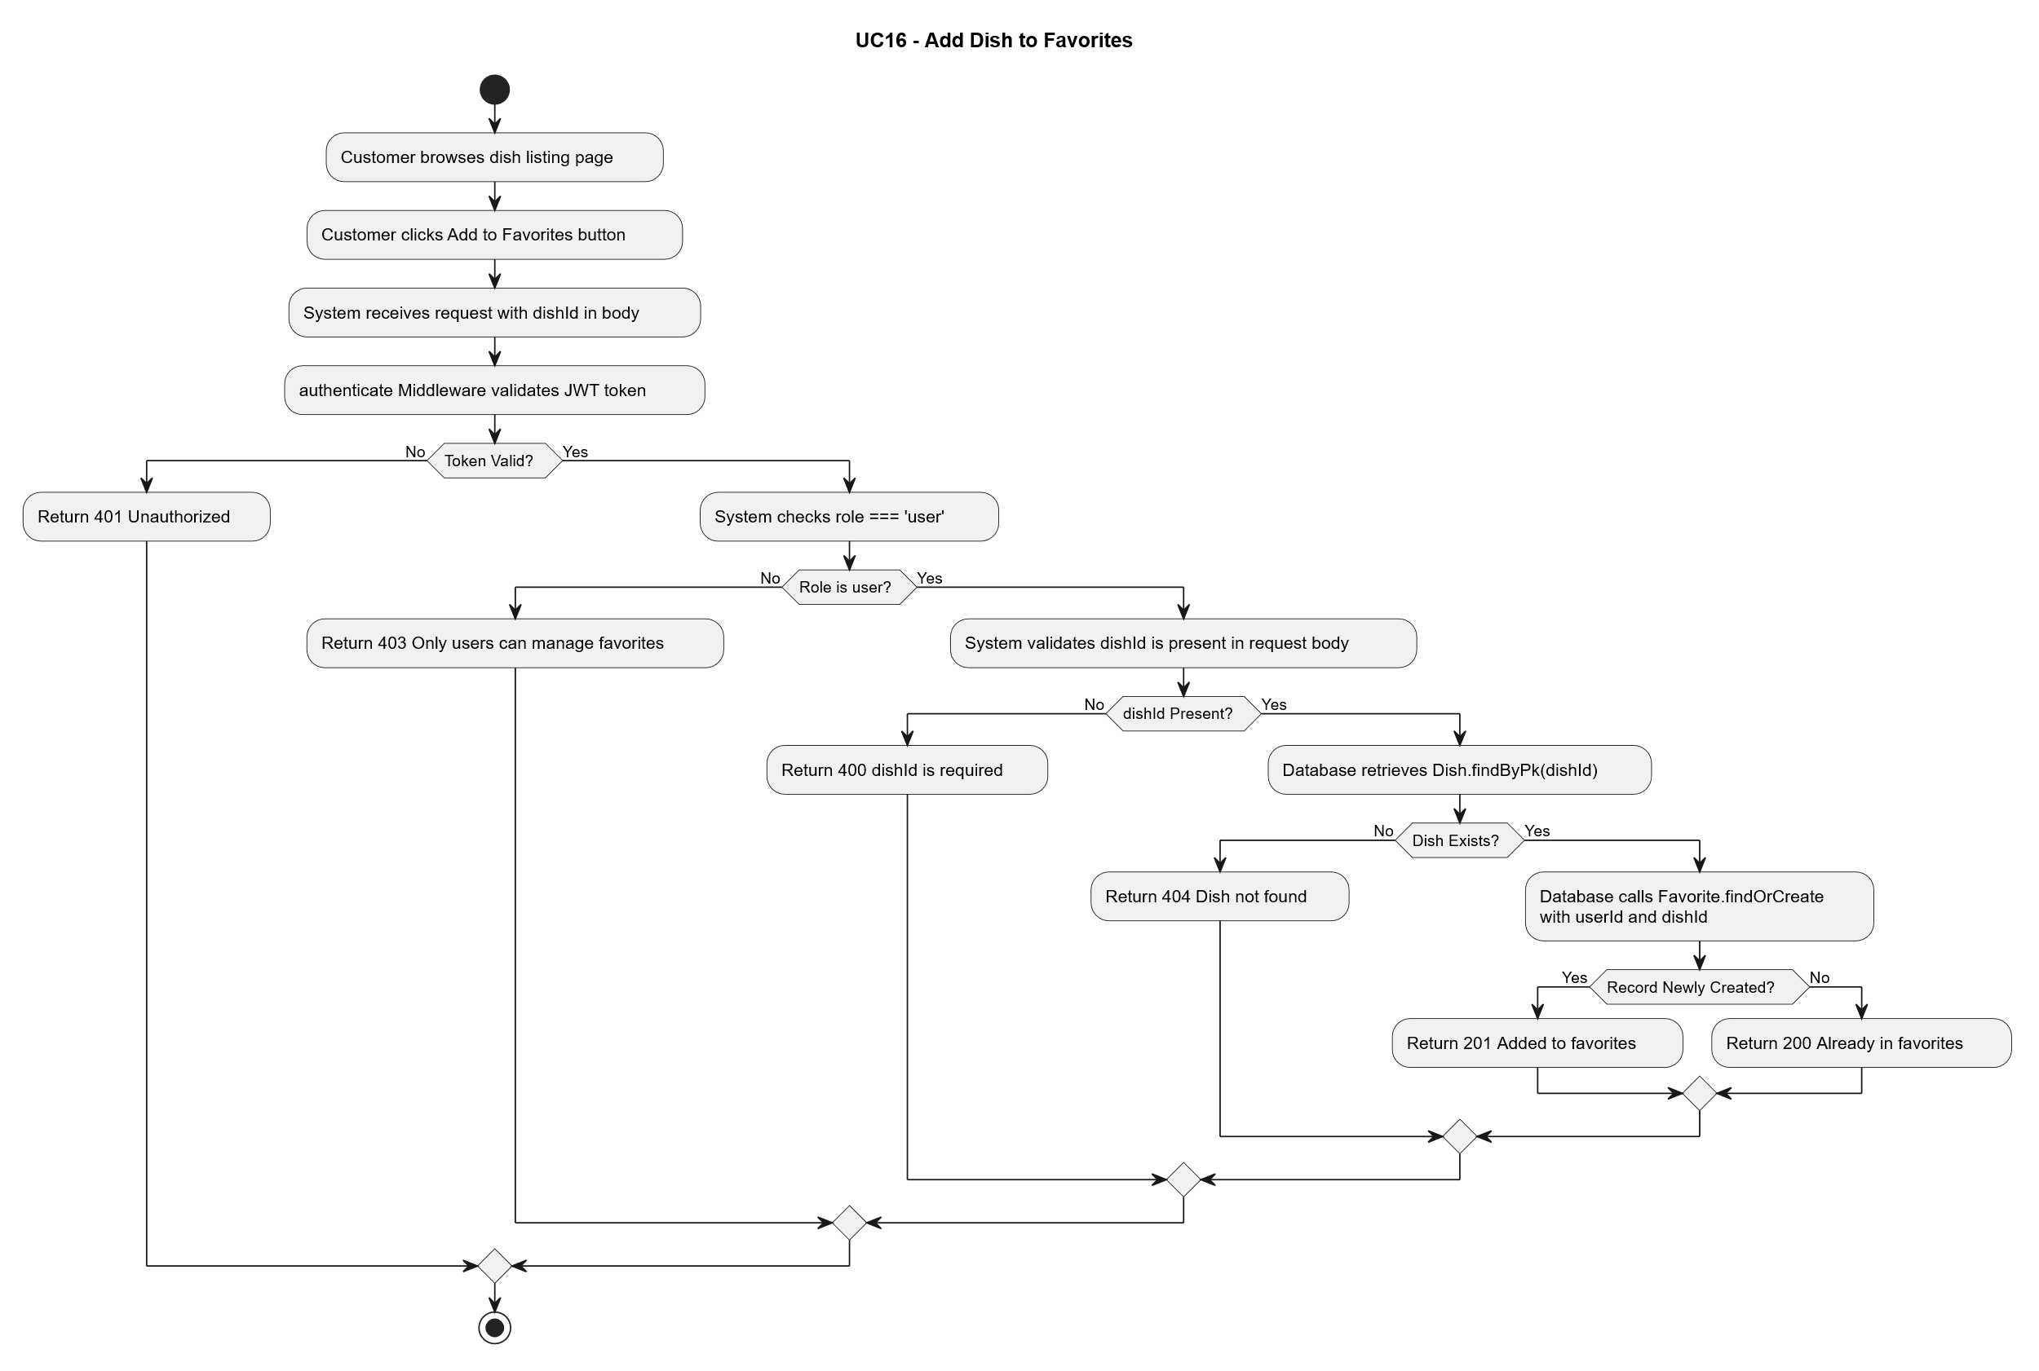

UC19 - Cancel Order:
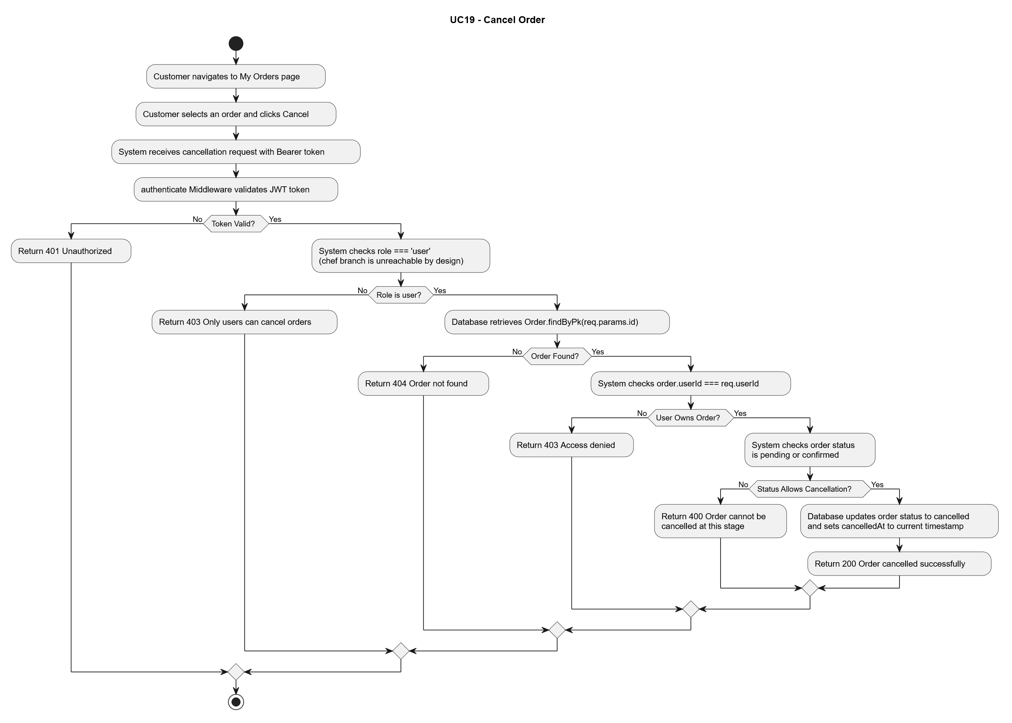

UC21 - View Sales Statistics:
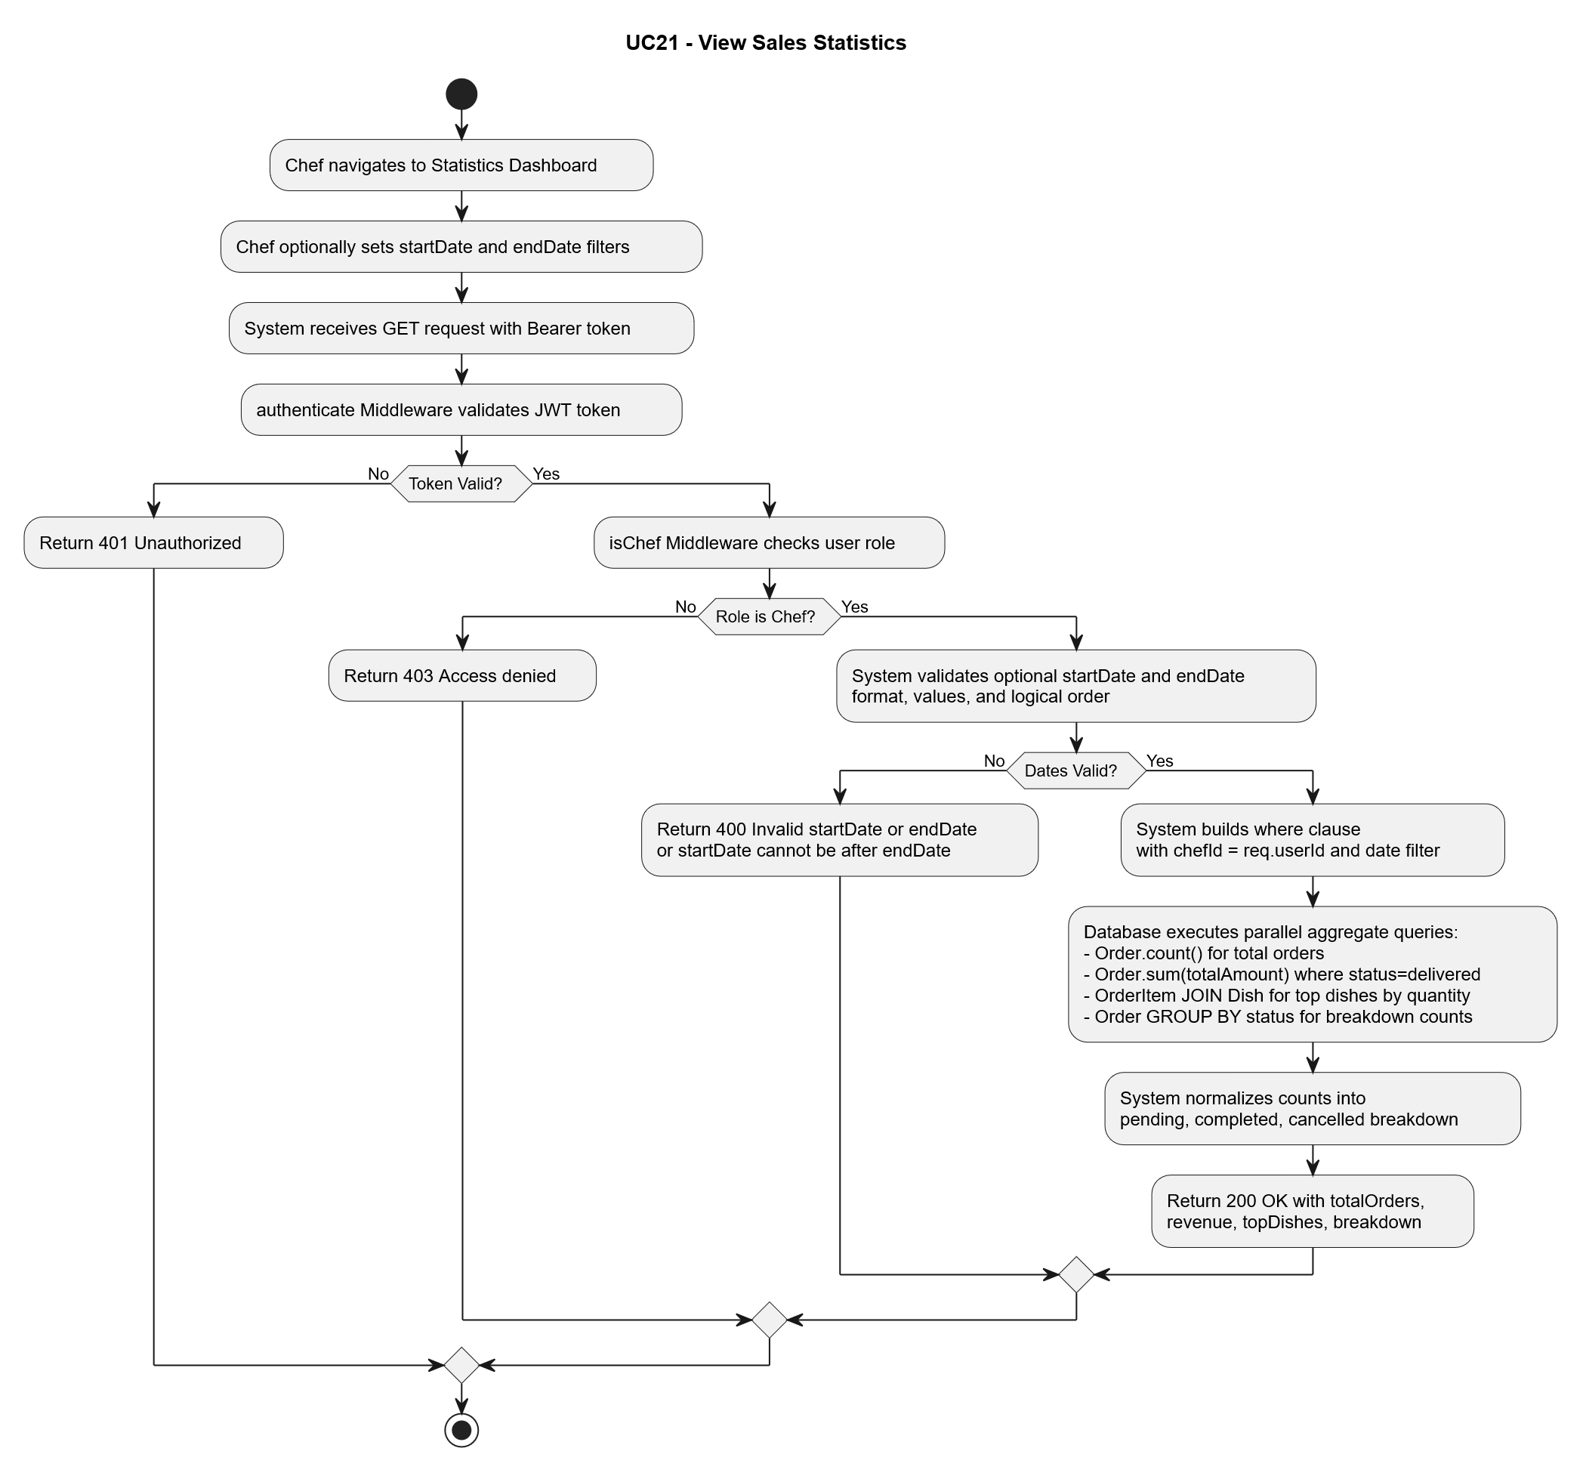

UC22 - Approve-Reject Chef Registration:
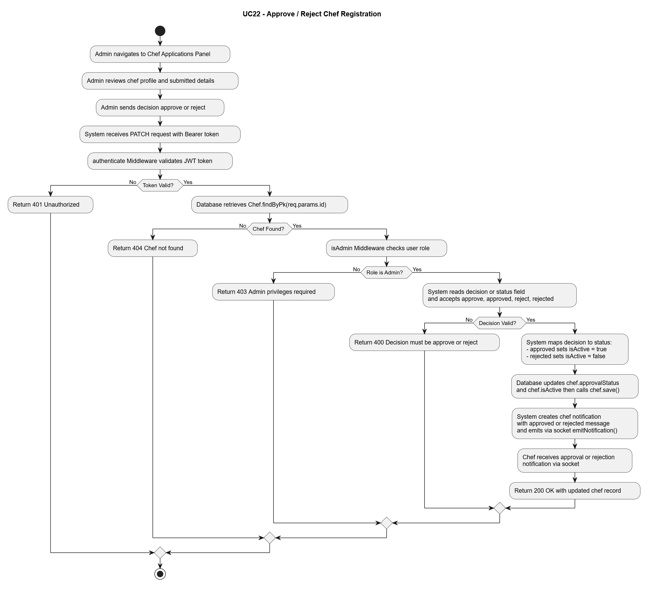

UC24 - Forget Password OTP:
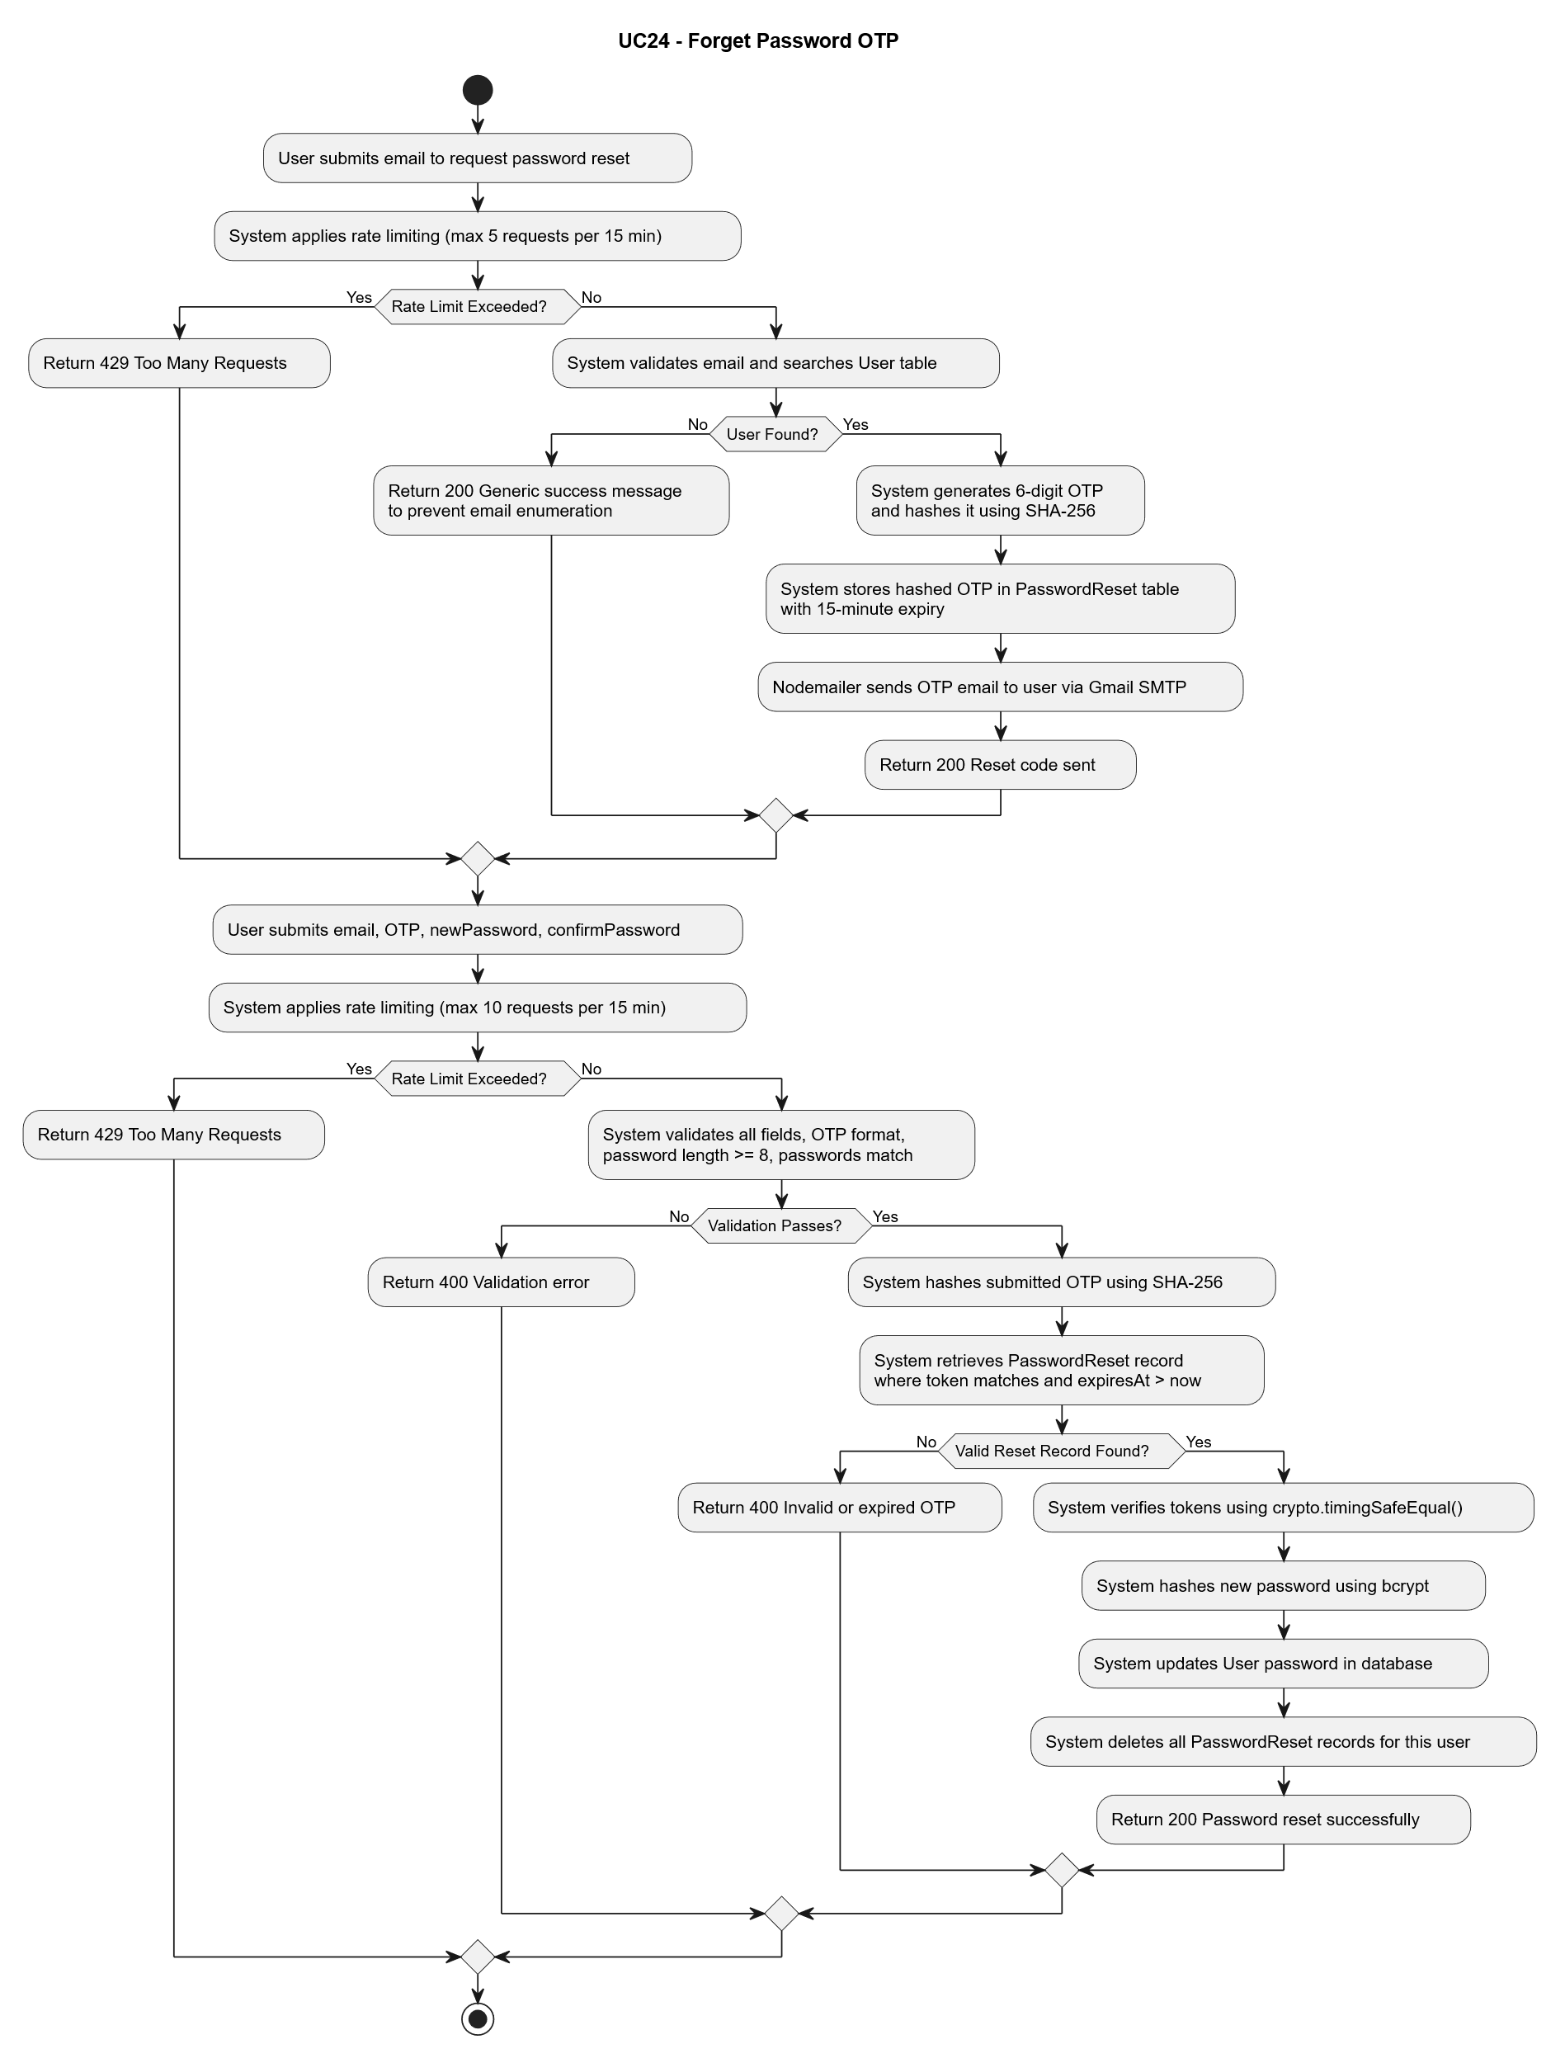

UC29 - Login Using Google Account:
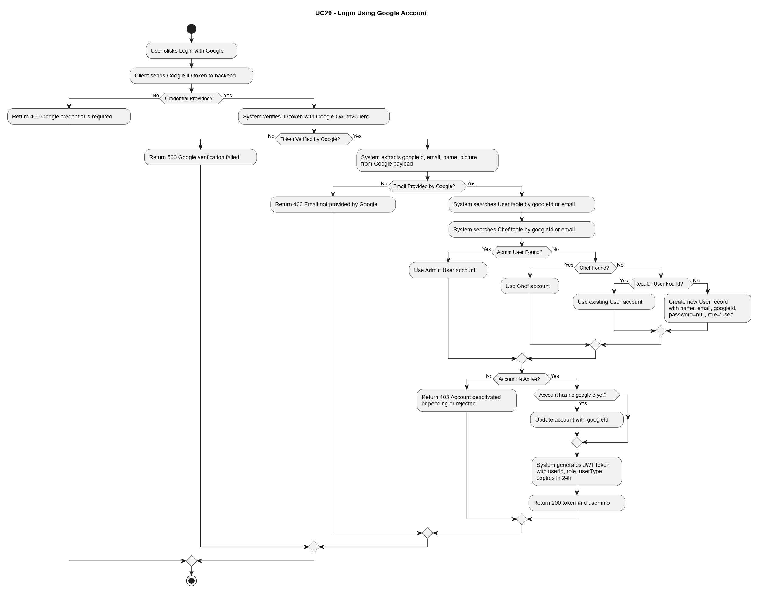

4-7-4 Sequence Diagrams

UC06.1 - Add Dish

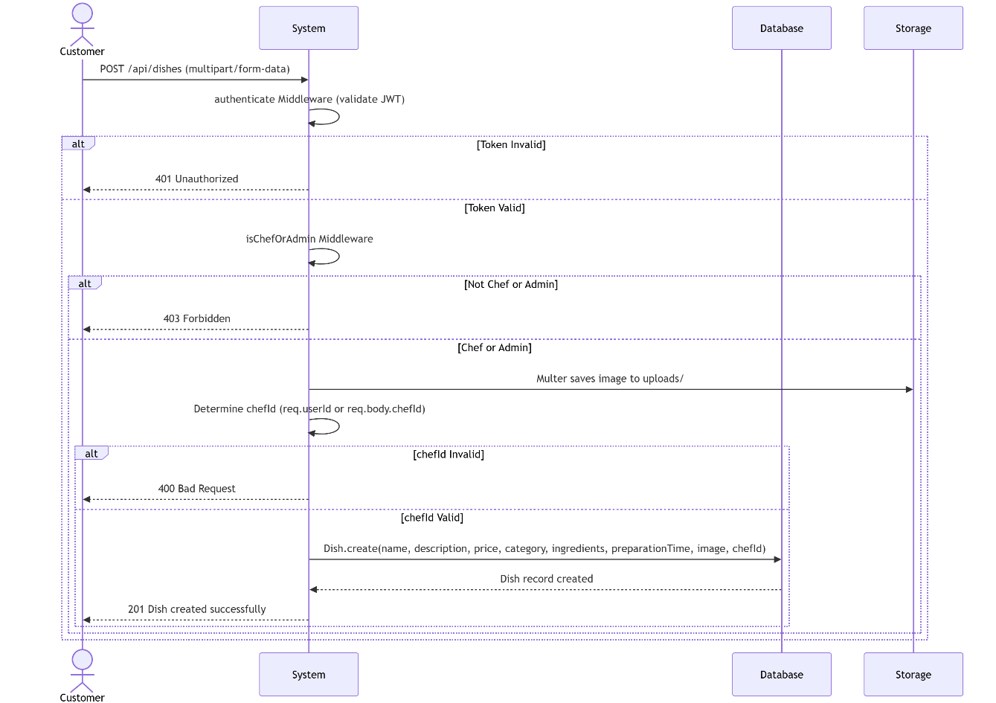

UC09 - Create Order

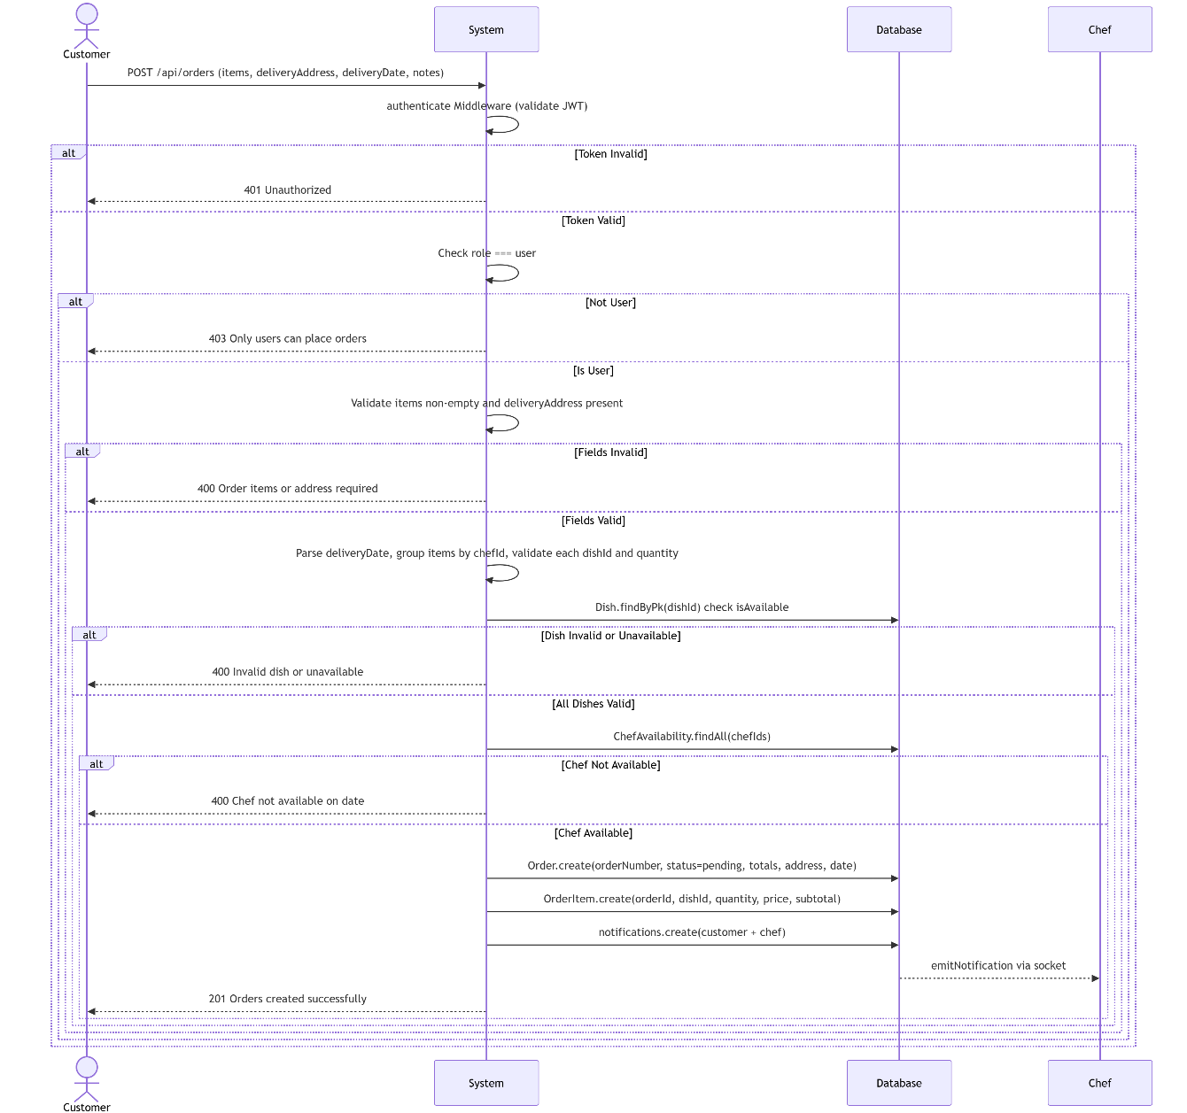

UC11 - Update Order Status

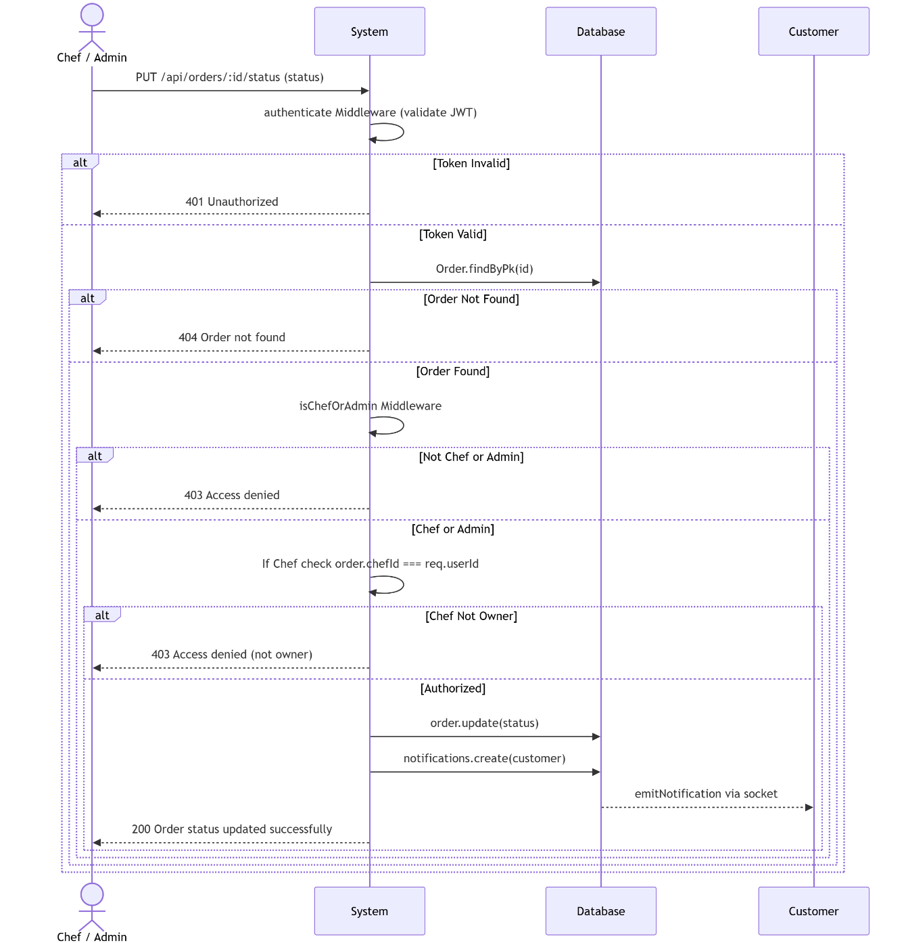

UC12 - Rate Dish

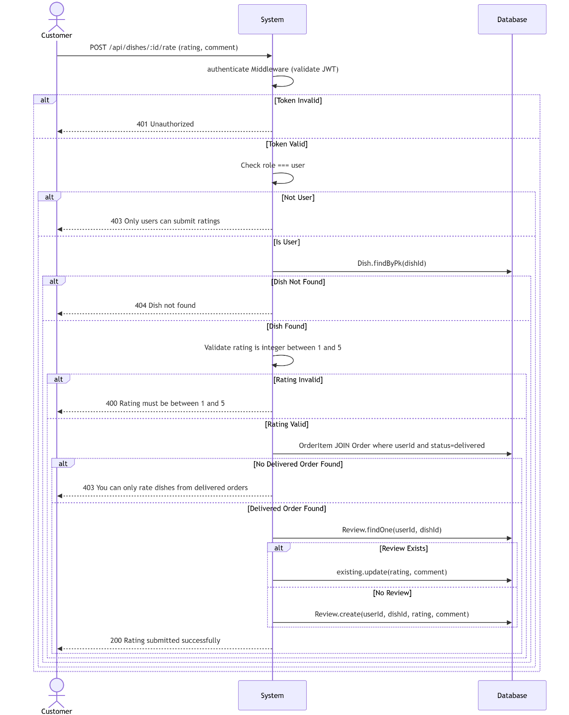

UC16 - Add Dish to Favorites

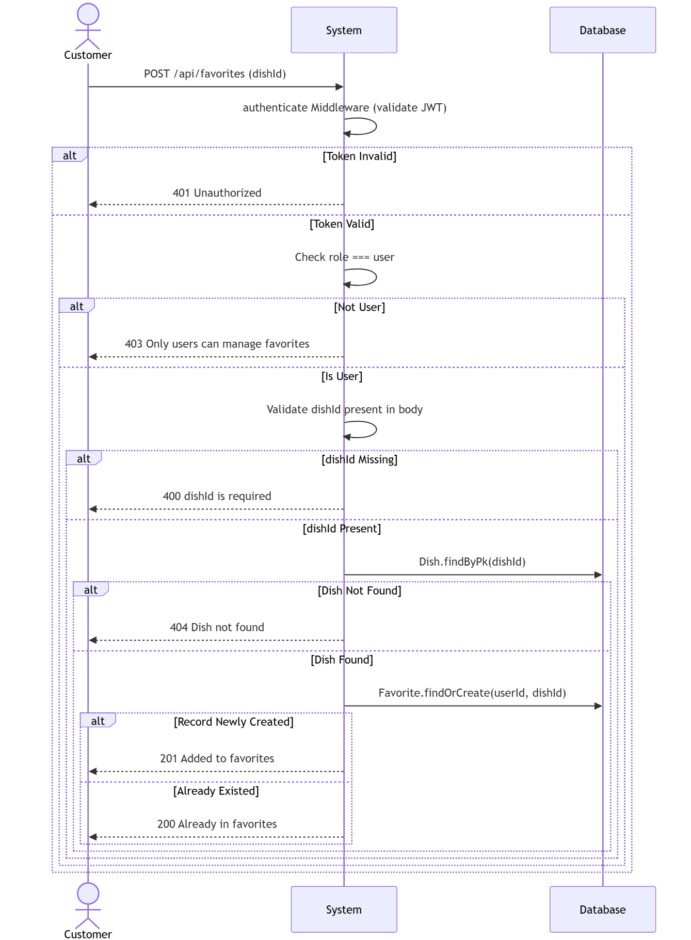

UC19 - Cancel Order

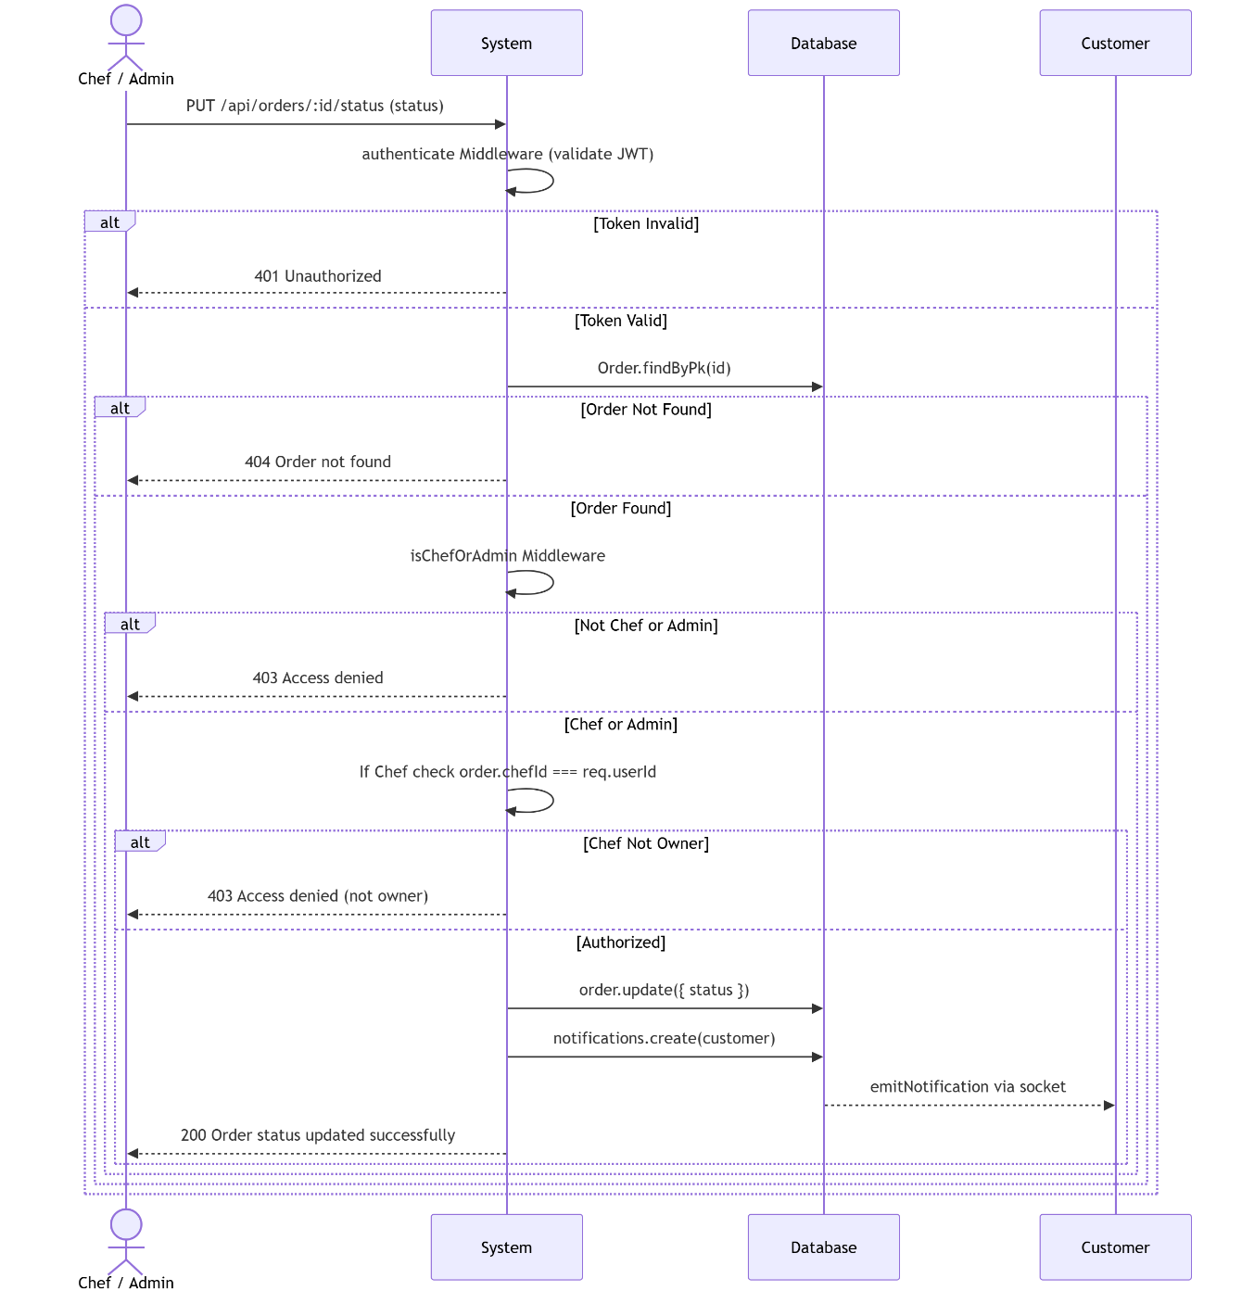

UC21 - View Sales Statistics

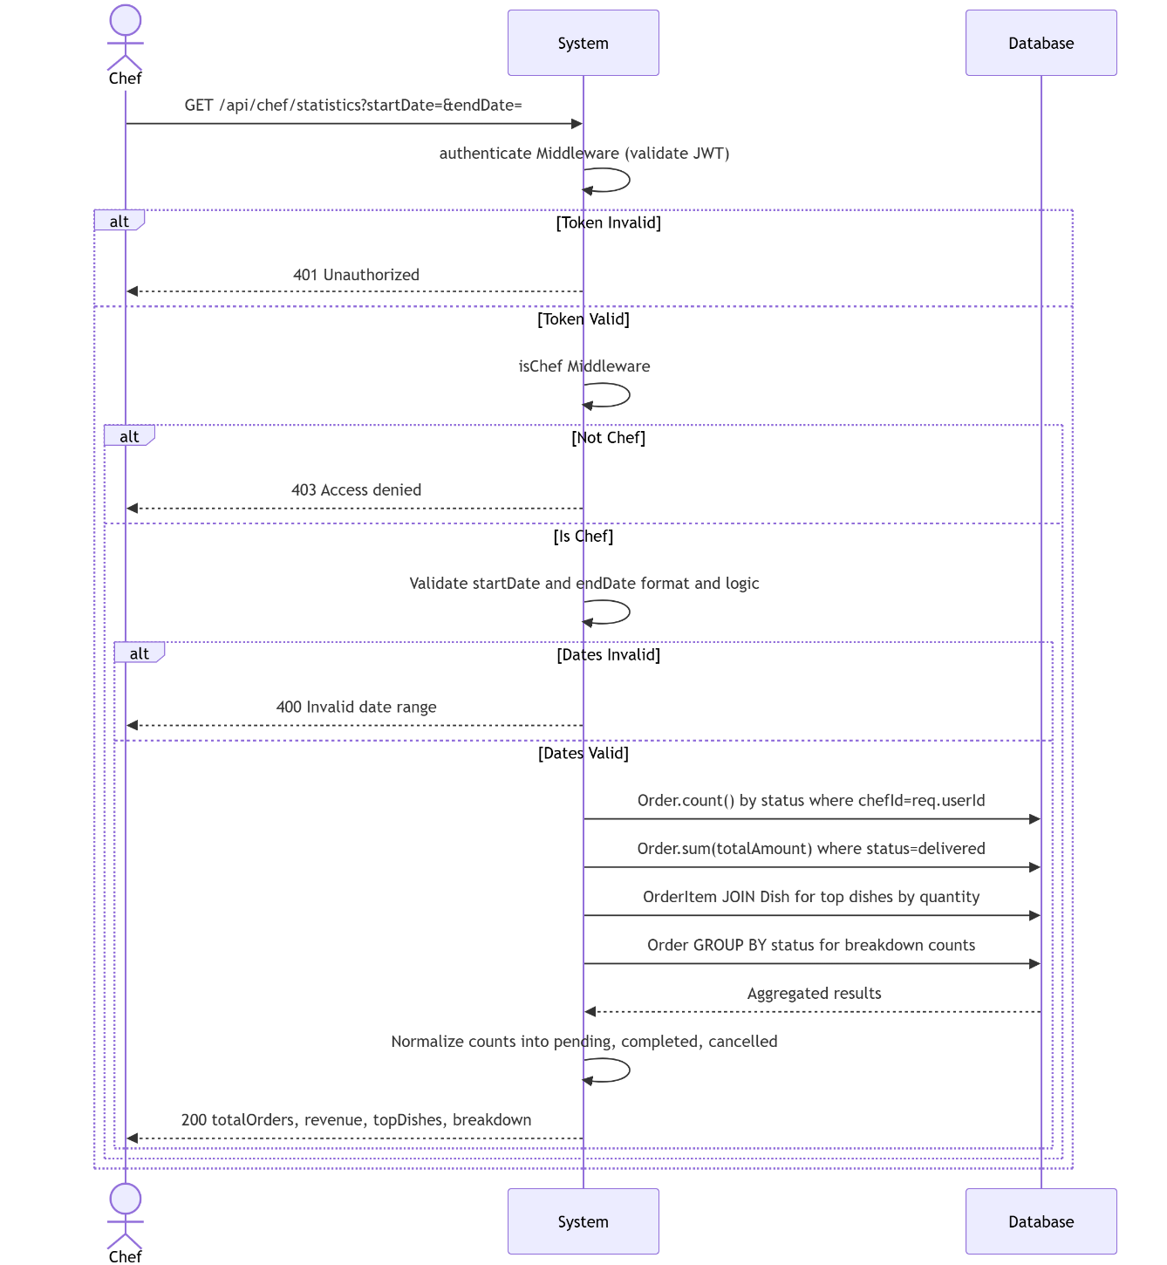

UC22 - Approve-Reject Chef Registration

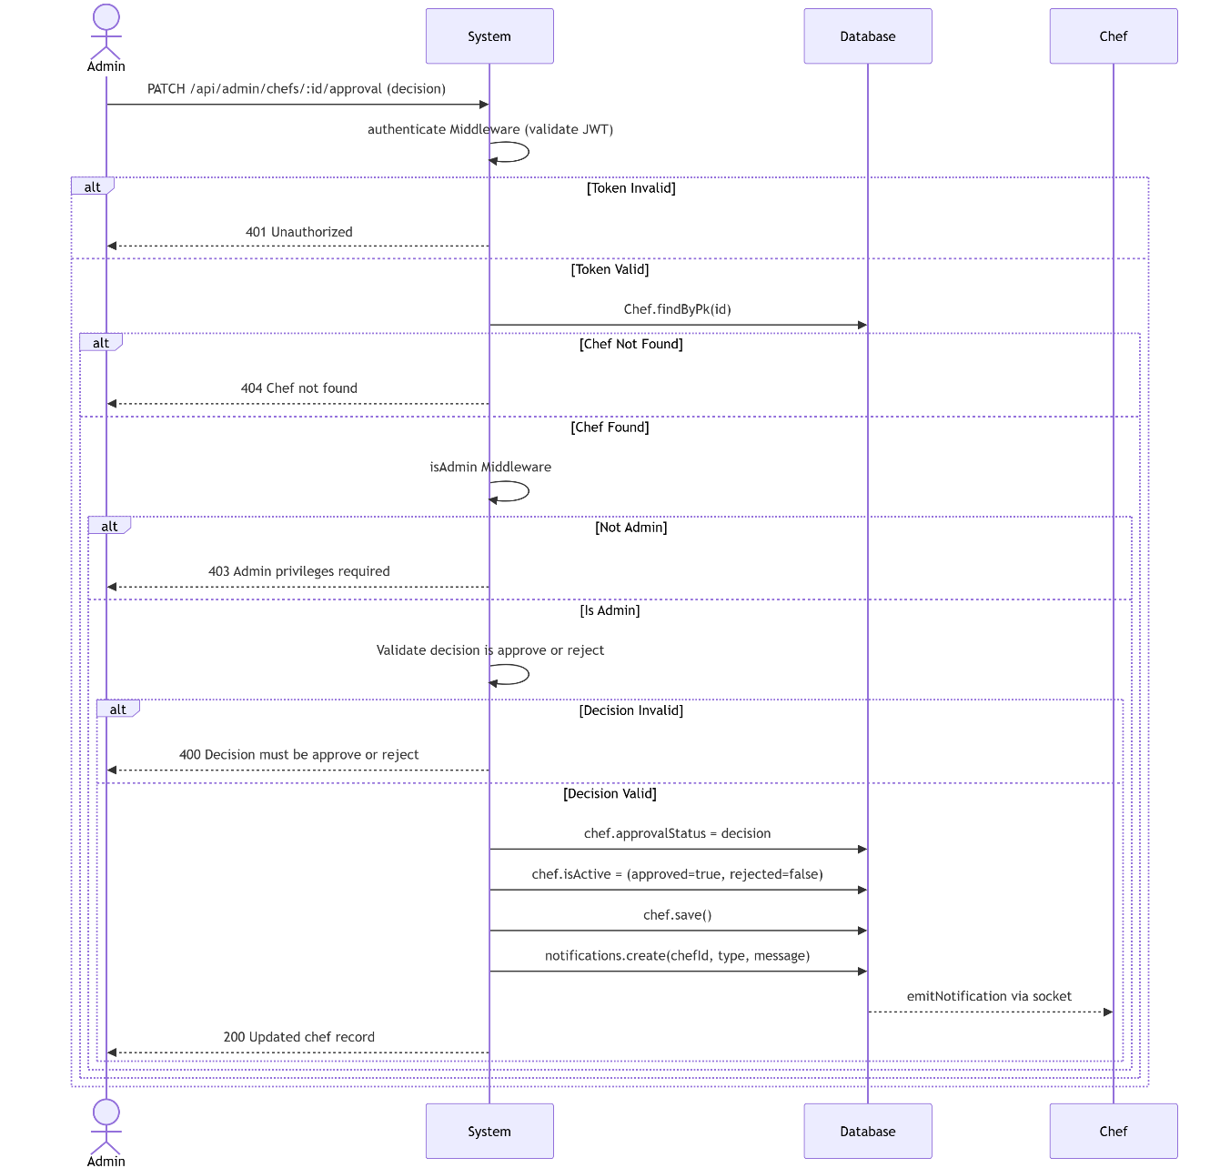

UC24 - Forget Password OTP

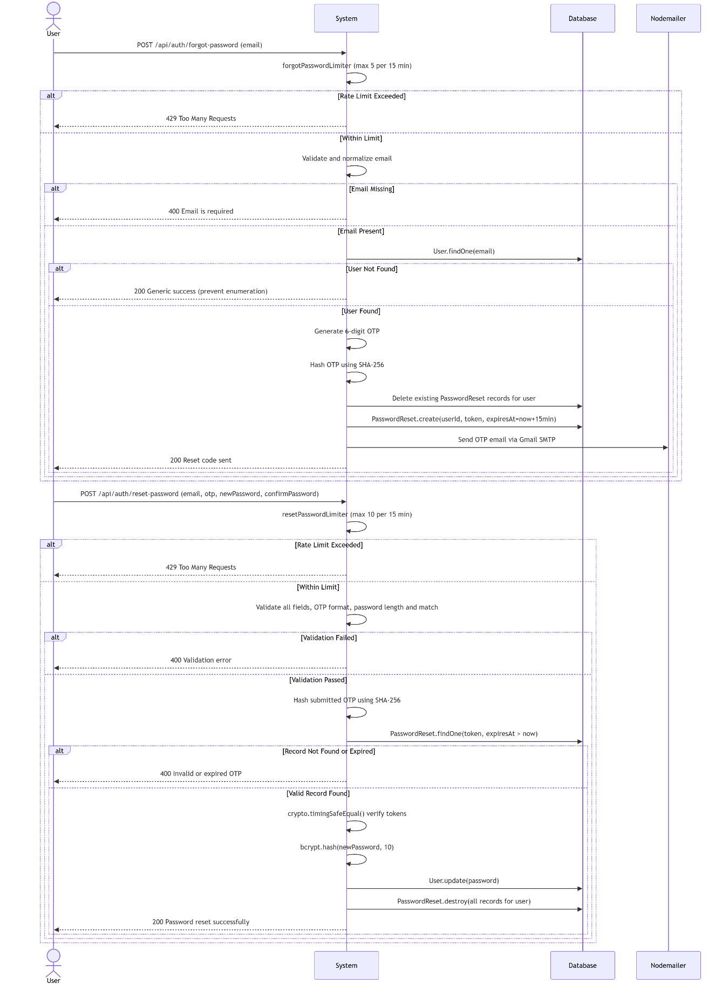

UC29 - Login Using Google Account

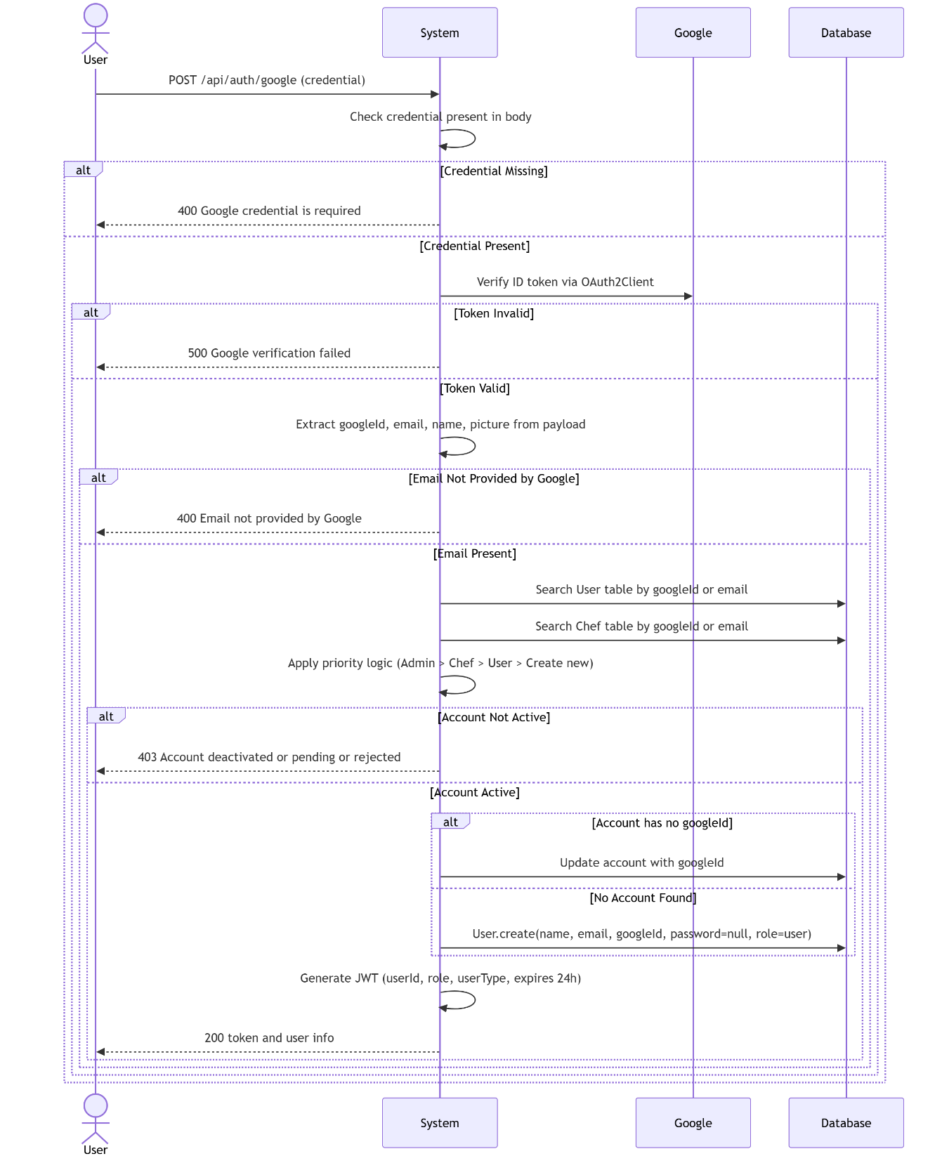

4-7-5 Test Case Descriptions
Initial test cases derived from the functional requirements are listed in Section 4-9-2. Comprehensive test execution results, including pass/fail counts and defect logs, are reported in Chapter 8.

4-8 Modelling According to the Chosen Methodology

4-8-1 User Stories and Product Backlog
Story ID | As a... | I want to... | So that... | Priority
US-01 | Guest | register a customer account with my email | I can place orders on HomeyChef | Must Have
US-02 | Guest | log in with my Google account | I can access the platform without creating a new password | Must Have
US-03 | Customer | browse all active chefs and their dishes | I can discover home-cooked meal options | Must Have
US-04 | Customer | place an order from a specific chef | I can receive a home-cooked meal delivered to my address | Must Have
US-05 | Customer | cancel a pending order | I can change my mind before the chef starts preparing | Must Have
US-06 | Customer | add dishes to my favorites list | I can quickly reorder my preferred meals | Should Have
US-07 | Customer | receive real-time notifications about my order status | I am always informed without refreshing the page | Should Have
US-08 | Customer | write a review for a dish I ordered | I can share my experience with other customers | Should Have
US-09 | Chef | register my chef profile and wait for admin approval | I can eventually list my dishes and receive orders | Must Have
US-10 | Chef | add, update, and remove my dishes | My menu reflects what I currently offer | Must Have
US-11 | Chef | set my weekly availability and holiday blockouts | Customers cannot place orders when I am unavailable | Should Have
US-12 | Chef | view my sales statistics | I can track my performance and revenue | Should Have
US-13 | Admin | approve or reject chef registrations | Only verified chefs can operate on the platform | Must Have
US-14 | Admin | activate or deactivate any user or chef account | I can enforce platform policies | Could Have
US-15 | Admin | view platform-wide statistics | I can monitor overall platform health and growth | Could Have

4-9 Requirements Analysis and Documentation

4-9-1 Requirements Traceability Matrix (RTM)
FR ID | Use Case(s) | Route(s) | Test Case(s)
FR-01 | UC01 | POST /api/auth/register | TC-01, TC-02
FR-02 | UC13 | POST /api/auth/register/chef | TC-13, TC-14
FR-03 | UC02 | POST /api/auth/login | TC-03, TC-04
FR-04 | UC03 | POST /api/auth/google | TC-05
FR-05 | UC05 | POST /api/auth/change-password | TC-06
FR-06 | UC04 | POST /api/auth/forgot-password | TC-07
FR-07 | UC04 | GET /api/auth/reset-password/validate, POST /api/auth/reset-password | TC-08, TC-09
FR-08 | UC02, UC04 | Login + forgot-password routes (rate limiter middleware) | TC-10
FR-09 | UC06 | GET /api/chefs/ | TC-15
FR-10 | UC07 | GET /api/chefs/:id | TC-16
FR-11 | UC08 | GET /api/chefs/:id/dishes | TC-17
FR-12 | UC08 | GET /api/dishes/ | TC-18
FR-13 | UC09 | POST /api/favorites/ | TC-19
FR-14 | UC09 | DELETE /api/favorites/:dishId, GET /api/favorites/ | TC-20
FR-15 | UC15 (Cart) | POST /api/cart/add, PATCH /api/cart/items/:dishId, DELETE /api/cart/items/:dishId | TC-21
FR-16 | UC10 | POST /api/orders/ | TC-22, TC-23
FR-17 | UC10 | POST /api/orders/ (multi-chef split) | TC-24
FR-18 | UC11 | PUT /api/orders/:id/cancel | TC-25
FR-19 | UC15 | GET /api/orders/, GET /api/users/:id/orders | TC-26
FR-20 | UC12 | POST /api/reviews/ | TC-27
FR-21 | UC12 | PUT /api/reviews/:id, DELETE /api/reviews/:id | TC-28
FR-22 | UC14 | POST /api/dishes/ | TC-29
FR-23 | UC14 | PUT /api/dishes/:id, DELETE /api/dishes/:id | TC-30
FR-24 | UC15 | GET /api/chefs/:id/orders | TC-31
FR-25 | UC24 | PUT /api/orders/:id/status | TC-32
FR-26 | UC16 | PUT /api/chefs/profile | TC-33
FR-27 | UC17–UC20 | POST/PUT/DELETE /api/chefs/profile/availability | TC-34
FR-28 | UC21 (Chef) | GET /api/chef/statistics | TC-35
FR-29 | UC26 | GET /api/admin/chefs | TC-36
FR-30 | UC26 | PATCH /api/admin/chefs/:id/approval | TC-37
FR-31 | UC25 | GET /api/users/ | TC-38
FR-32 | UC25 | PATCH /api/admin/users/:id/deactivate, PATCH /api/admin/users/:id/reactivate | TC-39
FR-33 | UC25 | DELETE /api/users/:id | TC-40
FR-34 | UC21 (Admin) | GET /api/admin/statistics | TC-41
FR-35 | UC10, UC26 | Socket.io + GET /api/notifications/, PATCH /api/notifications/:id/read | TC-42, TC-43

4-9-2 Initial Test Cases
TC ID | Description | Input | Expected Output
TC-01 | Register with valid data | name, unique email, password ≥ 8 chars | HTTP 201, user object returned
TC-02 | Register with duplicate email | Email already in users table | HTTP 400, error message
TC-03 | Login with correct credentials | Valid email + matching password | HTTP 200, JWT token returned
TC-04 | Login with wrong password | Valid email + wrong password | HTTP 401, error message
TC-05 | Google login with valid token | Valid Google ID token | HTTP 200, JWT returned
TC-06 | Change password correctly | Auth JWT + correct current password + new password | HTTP 200, success message
TC-07 | Forgot password for existing email | Registered email address | HTTP 200, email sent
TC-08 | Reset password with valid token | Valid unexpired reset token + new password | HTTP 200, password updated
TC-09 | Reset with expired token | Expired token | HTTP 400, "Token expired"
TC-10 | Brute-force login (11 attempts) | 11 POST /api/auth/login in < 15 min from same IP | HTTP 429 on 11th request
TC-13 | Chef registration | Valid chef fields | HTTP 201, pendingApproval: true
TC-22 | Place order — chef available | Valid items, address, delivery date within chef slots | HTTP 201, orders array
TC-23 | Place order — chef unavailable | Delivery date on chef holiday | HTTP 400, "not available on [date]"
TC-37 | Approve chef | Admin JWT + PATCH decision: "approve" | HTTP 200, approvalStatus: "approved"
TC-42 | WebSocket notification on order | Customer places order | Socket event "notification" emitted to customer and chef

Section 3: Design and Architecture

Chapter 5: System Architectural Design

5-1 High-Level Design

5-1-1 System Block Diagram
The HomeyChef system consists of three logical tiers: (1) the Presentation Tier, comprising static HTML/CSS/JavaScript pages served from the Node.js server's views directory and rendered in the client's browser; (2) the Application Tier, composed of the Express.js REST API server with twelve route modules, ten controller modules, and one Socket.io notification server; and (3) the Data Tier, a MySQL 8 relational database managed through the Sequelize ORM. An optional external integration tier encompasses the Gmail SMTP relay (Nodemailer) for email delivery and the Google Identity Platform for OAuth 2.0 token validation. [Full block diagram in Appendix B.]

5-1-2 Architectural Pattern
HomeyChef applies the Model-View-Controller (MVC) architectural pattern within its server-side codebase. The Model layer is implemented by Sequelize model definitions (User, Chef, Dish, Order, OrderItem, Review, Favorite, Notification, PasswordReset, ChefAvailability) stored in backend/models/. The View layer consists of HTML files in backend/views/ delivered to the browser as static assets. The Controller layer resides in backend/controllers/ and contains the business logic that mediates between incoming HTTP requests (routed via Express route files in backend/routes/) and the Sequelize models.

5-1-3 System Architecture Description
Client requests are received by the Express HTTP server (server.js) on port 3000. Global middleware applies CORS headers, parses JSON and URL-encoded bodies, and serves the uploads directory as a static asset path. API requests are forwarded to the appropriate route module, which applies route-specific middleware (authentication JWT validation, role checks, Multer file parsing, or rate limiting) before delegating to the controller. Controllers execute the business logic — querying Sequelize models, enforcing domain rules, triggering notifications — and return JSON responses with appropriate HTTP status codes.
Real-time notifications are delivered through a parallel Socket.io server mounted on the same HTTP server instance. When a business event (order placed, order status changed, chef approved) occurs in a controller, the notificationService helper persists a Notification record and emits a Socket.io event to the affected user's or chef's room, identified by their entity type and ID.

5-2 Database Design

5-2-1 Entity-Relationship Diagram
The HomeyChef relational schema comprises ten entities. The central entities are User and Chef, which are separate tables reflecting the distinct data schemas and role-based business rules for customers and home cooks respectively. Order is the core transactional entity; each Order belongs to one User and one Chef and contains one or more OrderItems. A Dish belongs to a Chef and is referenced by OrderItem, Review, and Favorite. ChefAvailability contains scheduling rules belonging to a Chef. Notification can be addressed to either a User or a Chef (nullable foreign keys). PasswordReset belongs to a User. [Full ERD in Appendix B.]

5-2-2 Relational Schema
Table | Primary Key | Foreign Keys | Notable Constraints
users | id (INT, AI) | — | email UNIQUE; role ENUM(admin, user); isActive BOOL DEFAULT true
chefs | id (INT, AI) | — | email UNIQUE; approvalStatus ENUM(pending, approved, rejected); isActive BOOL DEFAULT false
dishes | id (INT, AI) | chefId → chefs.id (CASCADE) | price DECIMAL(10,2) ≥ 0; isAvailable BOOL DEFAULT true
orders | id (INT, AI) | userId → users.id; chefId → chefs.id (SET NULL) | orderNumber UNIQUE; status ENUM; totalAmount DECIMAL ≥ 0
order_items | id (INT, AI) | orderId → orders.id (CASCADE); dishId → dishes.id | quantity INT ≥ 1; price DECIMAL(10,2) ≥ 0
reviews | id (INT, AI) | userId → users.id (CASCADE); dishId → dishes.id (CASCADE) | rating INT 1–5
favorites | id (INT, AI) | userId → users.id (CASCADE); dishId → dishes.id (CASCADE) | UNIQUE(userId, dishId)
notifications | id (INT, AI) | userId → users.id; chefId → chefs.id; orderId → orders.id | type STRING NOT NULL; read BOOL DEFAULT false
password_resets | id (INT, AI) | user_id → users.id (CASCADE) | token UNIQUE; INDEX(expires_at)
chef_availabilities | id (INT, AI) | chefId → chefs.id (CASCADE) | type ENUM(weekly_slot, specific_date, holiday)

5-2-3 Constraints and Keys
- Primary Keys: All tables use an auto-increment integer primary key (id).
- Unique Constraints: users.email, chefs.email, chefs.googleId, users.googleId, password_resets.token, COMPOSITE favorites(userId, dishId).
- Referential Integrity: Foreign keys are enforced at both the Sequelize model level and the MySQL engine level with CASCADE or SET NULL delete rules.
- Check Constraints: dishes.price ≥ 0, reviews.rating BETWEEN 1 AND 5, chefs.rating BETWEEN 0 AND 5, order_items.quantity ≥ 1.
- Default Values: orders.status DEFAULT "pending"; chefs.approvalStatus DEFAULT "approved" (overridden to "pending" by registerChef); notifications.read DEFAULT false.

5-3 External Interface Design / APIs
Module | Base Path | Key Endpoints | Auth Required
Authentication | /api/auth | POST /register, POST /register/chef, POST /login, POST /google, POST /change-password, POST /forgot-password, GET+POST /reset-password | Partial (login/register: none; change-password: JWT)
Chefs (public) | /api/chefs | GET /, GET /:id, GET /:id/dishes, GET /:id/availability, GET /:id/orders | Partial (orders: JWT)
Chef (own profile) | /api/chef | GET /statistics, GET /profile, PUT /profile, GET+POST+PUT+DELETE /profile/availability | JWT + isChef
Dishes | /api/dishes | GET /, GET /:id, POST /, PUT /:id, DELETE /:id, POST /:id/rate | Partial (write: JWT + isChefOrAdmin)
Orders | /api/orders | GET /, GET /:id, POST /, PUT /:id/status, PUT /:id/cancel | JWT
Reviews | /api/reviews | GET /dish/:dishId, POST /, PUT /:id, DELETE /:id | Partial (write: JWT)
Favorites | /api/favorites | GET /, POST /, DELETE /:dishId | JWT
Cart | /api/cart | GET /, POST /add, PATCH /items/:dishId, DELETE /items/:dishId, DELETE /clear, POST /checkout | JWT
Notifications | /api/notifications | GET /, PATCH /:id/read | JWT
Statistics | /api/statistics | GET / | JWT + isChefOrAdmin
Admin | /api/admin | GET /chefs, PATCH /chefs/:id/approval, GET /statistics, PATCH /users/:id/deactivate|reactivate, PATCH /chefs/:id/deactivate|reactivate | JWT + isAdmin
Users | /api/users | GET /, GET /:id, PUT /:id, PATCH /:id/status, DELETE /:id, GET /:id/orders | JWT (admin for list/delete)

5-4 Security and Authorization Design
HomeyChef implements a four-layer security model. At the network layer, CORS is configured globally via the cors middleware to restrict cross-origin requests. At the transport layer, deployment targets HTTPS to prevent token interception. At the application layer, three middleware functions enforce access control: authenticate verifies the JWT signature and extracts userId, role, and userType; isAdmin checks that role === "admin"; isChef checks that userType === "chef"; and isChefOrAdmin permits either. At the data layer, Sequelize model-level validators enforce type safety, range constraints, and email format rules before any persistence operation.
Sensitive operations — login and password reset — are rate-limited using express-rate-limit. Passwords are never stored in plaintext; bcrypt with cost factor 10 is applied at registration and chef onboarding. Password-reset tokens are stored as-is (unique, high-entropy strings) with an expiry timestamp and are invalidated after single use. File uploads (dish images and chef profile images) are handled by Multer with a configurable size limit and stored locally in the backend/uploads/ directory.

Section 4: Implementation and Testing

Chapter 6: Implementation Environment and Tools

6-1 Programming Tools and Libraries
Package | Version | Role
express | ^4.18.2 | HTTP server framework — routing, middleware composition
sequelize | ^6.32.0 | ORM — model definition, query building, association management
mysql2 | ^3.6.0 | MySQL driver — required by Sequelize for MySQL connections
jsonwebtoken | ^9.0.2 | JWT creation and verification for stateless authentication
bcryptjs | ^2.4.3 | Password hashing with configurable cost factor
nodemailer | ^8.0.2 | SMTP email delivery for OTP password-reset flows
google-auth-library | ^10.5.0 | Google ID token verification for OAuth 2.0 login
socket.io | ^4.8.1 | WebSocket server for real-time notification delivery
multer | ^1.4.5-lts.1 | Multipart form-data parsing for image file uploads
express-rate-limit | ^8.2.1 | Rate limiting middleware for login and password-reset endpoints
dotenv | ^16.3.1 | Environment variable loading from .env file at startup
cors | ^2.8.5 | Cross-Origin Resource Sharing header middleware
nodemon | ^3.0.1 | Development hot-reload tool (devDependency)

6-2 Development Environment and Project Structure
The backend codebase is organised within the backend/ directory at the root of the HomeyChef repository. The entry point is server.js. Configuration files (database.js, syncDatabase.js) reside in backend/config/. Business logic is split across twelve route files in backend/routes/, ten controller files in backend/controllers/, and ten model files in backend/models/. Cross-cutting concerns — authentication middleware, email utility, account status helper, and notification service — are housed in backend/middleware/, backend/utils/, and backend/services/. The Socket.io initialisation module is located in backend/socket/. Static frontend files (HTML pages, CSS, and client-side JavaScript) are served from backend/views/.

6-3 Programming Languages and Frameworks
Layer | Language / Framework | Notes
Backend Runtime | Node.js 18 LTS | Event-driven, non-blocking I/O; single-threaded with async/await concurrency model
Backend Framework | Express.js 4.18 | Minimalist HTTP framework; middleware-based request pipeline
Frontend | HTML5, CSS3, JavaScript (ES6+) | Server-rendered static pages; no SPA framework
Database Query | Sequelize 6 (ORM over SQL) | Model-first schema definition; associations via belongsTo / hasMany
Real-time | Socket.io 4.8 (WebSocket) | Room-based event emission; automatic fallback to long-polling

6-4 Database Server and Operating System
The persistence layer is MySQL 8.0, selected for its ACID compliance, mature foreign-key enforcement, and widespread hosting availability. The Sequelize ORM's syncDatabase module runs sequelize.sync() at server startup to create or update tables to match the current model definitions. The development and demonstration environment runs on Windows 10/11, with production deployment targeting an Ubuntu 22.04 LTS VPS instance.

6-5 Libraries and Dependencies
All runtime dependencies are declared in backend/package.json and pinned to specific minor versions to ensure reproducible builds. The package-lock.json is committed to version control. Installation is performed via npm install within the backend/ directory. No global npm packages are required at runtime; nodemon is listed as a devDependency for local development server reloading.

6-6 Version Control and Source Control Tools
Source code is managed with Git and hosted in a private GitHub repository. The branching model follows simplified Git Flow: a main branch holds the stable, submission-ready codebase; feature branches (e.g., feature/chef-availability, feature/socket-notifications) are created per sprint deliverable and merged via pull requests. Commit messages follow the Conventional Commits specification (feat:, fix:, docs:, test:) to facilitate changelog generation. The .env file containing database credentials and JWT secrets is excluded from version control via .gitignore.

6-7 CI/CD Tools
In the current academic iteration, continuous integration is performed manually: after each sprint merge to main, the team runs the JMeter test plan against the updated API and reviews results before marking the sprint as complete. The OWASP ZAP scan is executed as a final quality gate before project submission. Automated CI pipeline setup (e.g., GitHub Actions) is identified as a future improvement in Section 10-3.

6-8 Testing Environment
Tool | Version | Purpose
Apache JMeter | 5.6.3 | Performance, load, and stress testing of the REST API
OWASP ZAP | 2.14 | Automated security vulnerability scanning (passive + active scan)
Postman | 10+ | Manual API endpoint validation and request/response inspection
MySQL Workbench | 8.0 | Database inspection, schema validation, and test data management
Node.js assert (built-in) | 18 | Unit-level assertions for controller helper functions

Chapter 7: Software Implementation

7-1 File and Project Structure
The complete HomeyChef project tree (2-level depth):
HomeyChef/ → backend/ [config/, controllers/, middleware/, models/, routes/, services/, socket/, uploads/, utils/, views/, .env, package.json, server.js] → README.md
Directory / File | Purpose
backend/server.js | Application entry point: initialises Express, Socket.io, mounts all route modules, starts the HTTP server
backend/config/database.js | Sequelize instance configuration (host, port, dialect, pool settings from .env)
backend/config/syncDatabase.js | Imports all models, defines Sequelize associations, calls sequelize.sync()
backend/models/ | 10 Sequelize model files defining schema and per-model associations
backend/controllers/ | 10 controller modules containing async request-handler functions
backend/routes/ | 12 Express Router files mapping HTTP methods + paths to controller functions + middleware
backend/middleware/auth.js | authenticate, isAdmin, isChef, isChefOrAdmin middleware functions
backend/services/notificationService.js | createNotification helper: persists a Notification record and emits a Socket.io event
backend/socket/notificationSocket.js | initNotificationSocket: configures Socket.io rooms keyed by "user:{id}" and "chef:{id}"
backend/utils/mailer.js | Nodemailer transporter configuration and sendMail wrapper for password-reset emails
backend/utils/accountStatus.js | Helper that maps isActive boolean to display strings
backend/uploads/ | Storage directory for Multer-uploaded dish images and chef profile images
backend/views/ | Static HTML pages (login, register, dashboard-user, dashboard-chef, dashboard-admin, etc.) with accompanying CSS and JS

7-2 Module Implementation
Authentication Module (authController.js):
Implements seven exported functions: register, registerChef, login, changePassword, forgotPassword, validateResetToken, resetPassword, and googleLogin. Registration functions hash passwords with bcrypt before persisting records. The login function queries both the User and Chef tables by email, verifies the bcrypt hash, and signs a JWT with userId, role, and userType claims. The forgotPassword function generates a random token with Node.js crypto, stores a hashed version in password_resets, and dispatches the email via the mailer utility. The googleLogin function validates the incoming Google ID token using google-auth-library's OAuth2Client.verifyIdToken method, then finds or creates an account matching the Google sub identifier.
Order Management Module (orderController.js):
The createOrder function delegates to the buildOrderPayload helper, which validates dish availability, and to createOrdersForUser, which implements the chef-grouping and availability-checking logic. Chef availability is resolved by querying ChefAvailability records for all relevant chef IDs and evaluating three rule types against the requested delivery date: holiday blockouts take precedence; specific_date overrides are checked next; weekly_slot rules (keyed by JavaScript's Date.getDay() return value) apply if no specific-date rule matches. Orders from multiple chefs generate independent Order records within a single request.
Notification Module (notificationService.js + notificationSocket.js):
The notificationService.createNotification function accepts a payload containing optional userId, chefId, and orderId and creates a Notification record. It then retrieves the Socket.io server instance and emits a "notification" event to the relevant room ("user:{userId}" or "chef:{chefId}"). The notificationSocket.js module configures the Socket.io server and handles client "join" events, adding the socket to the appropriate room upon connection.

7-3 API Implementation — Code Sample
The following excerpt from orderController.js illustrates the order creation handler pattern used throughout the codebase: input validation at the route middleware level, business logic delegation to a pure helper function, database persistence through Sequelize models, notification dispatch via the service layer, and structured JSON response with appropriate HTTP status codes. The handler is guarded by role checking (req.role !== "user") to enforce that only customer accounts may create orders. Error categorisation maps known domain errors to HTTP 400 responses while delegating unexpected errors to HTTP 500.

7-4 Data Access Layer Implementation
All database interactions are performed through Sequelize model methods: Model.findByPk() for primary-key lookups, Model.findOne({ where: {...} }) for unique field queries, Model.findAll({ include: [...], where: {...} }) for joined queries, and Model.create({ ...fields }) for insertions. Update operations use instance.save() after mutating model fields, and delete operations use instance.destroy(). The syncDatabase.js module defines all cross-model associations — hasMany, belongsTo, and hasOne — ensuring that Sequelize generates correct JOIN clauses and respects ON DELETE rules. No raw SQL is used in any controller; all queries pass through Sequelize's query builder.

7-5 Business Logic Layer Implementation
The business logic layer is embedded within the controller functions. Key business rules implemented include: (1) Chef availability check before order creation — the isChefAvailable closure in orderController resolves date strings to YYYY-MM-DD, checks for holiday rules first, then specific-date overrides, then weekly slot rules, and accounts for same-day bookings by comparing against the current wall-clock time; (2) Order splitting — items from different chefs are grouped by chefId and produce separate Order records, each with its own orderNumber, totalAmount, and notification; (3) Chef approval state machine — approvalStatus transitions are enforced in reviewChefRegistration to accept only "approve" or "reject" inputs; (4) Dish rating aggregation — after each POST /api/dishes/:id/rate call, the controller recalculates the dish's average rating from all Review records and persists it in Dish.rating.

7-6 UI Implementation
The frontend is implemented as a collection of static HTML pages served from the backend/views/ directory. Each page communicates with the backend exclusively through the REST API using the browser's Fetch API. Authentication state is stored in the browser's sessionStorage as a JWT token. Role-specific navigation is enforced on the client side by checking the decoded JWT's role and userType fields and redirecting unauthenticated or unauthorised users. Charts on the statistics page (dashboard-admin.html, statistics.html) are rendered using Chart.js, which is loaded from a CDN. Real-time notifications are received through a Socket.io client connection initiated when the user session begins, with incoming "notification" events appended to the notifications panel.

7-7 Real-Time Algorithm Implementation
The real-time notification engine uses a room-based Socket.io architecture. At server startup, initNotificationSocket attaches a Socket.io server to the Express HTTP server instance. Each connecting client emits a "join" event with its entity type ("user" or "chef") and ID; the server adds the socket to a room named "{entityType}:{id}" (e.g., "user:42" or "chef:7"). When a business event triggers createNotification, the service retrieves the Socket.io instance from the application context and calls io.to("{entityType}:{id}").emit("notification", payload), delivering the event only to sockets in the relevant room. This room-based design ensures that notifications reach the correct recipient without broadcasting to all connected clients.

Chapter 8: Testing and Evaluation

8-1 Test Plan
The HomeyChef testing strategy covers seven testing types across two categories: manual testing (unit, integration, acceptance, usability) and automated testing (system, performance/load/stress, security). Manual tests were designed and executed by the development team using Postman as the primary API client. Automated tests were executed using Apache JMeter 5.6.3 for performance profiling and OWASP ZAP 2.14 for security scanning. The primary test target is the /api/chefs endpoint as a representative REST resource; secondary targets include /api/auth/login (rate limiting), /api/orders (order creation flow), and all admin endpoints.

8-2 Types of Testing

Unit Testing
Unit testing targeted isolated helper functions and model validators. Key units tested: the isChefAvailable date-resolution closure in orderController.js (verified against holiday, specific_date, and weekly_slot rule types with edge cases for same-day bookings); the normalizeChefApprovalStatus function in both authController.js and chefController.js; Sequelize model validators (email format, rating range, price non-negativity). All units passed their assertions without requiring a live database connection.

Integration Testing
Integration tests verified the full request-response cycle for each of the 43 test cases defined in Section 4-9-2. Tests were executed via Postman against a running local server connected to a test MySQL database. Each test followed a three-step pattern: arrange (seed prerequisite data), act (send HTTP request), assert (verify status code, response body structure, and database state). Authentication flows (register → login → access protected route) and the complete order lifecycle (place → chef confirms → chef updates status → customer cancels) were tested as end-to-end chains.

System Testing
System testing verified that all 35 functional requirements are satisfied by the integrated system. Each FR was mapped to one or more test cases from the RTM in Section 4-9-1 and executed against the full application stack (Express + MySQL + Socket.io + Nodemailer). All FRs were confirmed as satisfied; FR-12 (chef rating) was confirmed as partially implemented — dish ratings and reviews are fully functional, but a dedicated chef-aggregate-rating endpoint is not yet exposed.

Performance and Load Testing
Apache JMeter test plans were configured for three load levels against the GET /api/chefs endpoint:
Test Type | Threads (Users) | Ramp-up (s) | Duration (s) | Avg Response (ms) | Error Rate | Throughput (req/s)
Normal Load | 10 | 5 | 30 | < 200 | 0% | > 45
Load Test | 50 | 10 | 60 | < 800 | 0% | > 40
Stress Test | 200 | 20 | 60 | < 2000 | < 1% | > 30
All three test scenarios met NFR-01 (response time < 2 seconds) and NFR-02 (error rate < 1% at 50 concurrent users). The stress test at 200 threads remained within the 2-second threshold, demonstrating that the Node.js event-loop model handles concurrent I/O workloads effectively at demonstration-scale traffic volumes.

Security Testing
An OWASP ZAP 2.14 passive and active scan was executed against the running HomeyChef application. The scan targeted all API routes and frontend pages. Initial scan results identified two Medium-severity alerts: (1) missing X-Content-Type-Options header and (2) missing X-Frame-Options header. Both were remediated by adding the appropriate response headers via Express middleware. After remediation, a re-scan confirmed zero High-severity and zero Medium-severity alerts remaining. The login endpoint rate-limiting was verified by sending 11 rapid POST requests and confirming HTTP 429 on the 11th request.

Usability Testing
Usability evaluation was conducted with five participants (three students and two faculty members) who were asked to complete three tasks without assistance: (1) register a customer account and place an order; (2) register as a chef and add a dish; (3) log in as an administrator and approve a pending chef. Average task completion times were 3 minutes 20 seconds, 4 minutes 10 seconds, and 2 minutes 45 seconds respectively. All five participants completed all tasks successfully. Feedback highlighted the need for more descriptive inline form validation messages, which were incorporated in the final release.

8-3 Test Diagrams
Test result diagrams — including JMeter response-time distribution charts, throughput over time graphs, and OWASP ZAP alert category pie charts — are provided in Appendix C.

8-4 Test Results and Analysis
Testing Type | Total TCs | Passed | Failed | Notes
Unit | 12 | 12 | 0 | All helper function assertions passed
Integration | 43 | 42 | 1 | TC-12b (chef-rating endpoint) marked as partial — not yet implemented
System (FR coverage) | 35 FRs | 34 | 1 | FR-12 partial; all others fully satisfied
Performance (normal) | 1 plan | 1 | 0 | Avg < 200 ms; error rate 0%
Performance (load) | 1 plan | 1 | 0 | Avg < 800 ms; error rate 0%
Performance (stress) | 1 plan | 1 | 0 | Avg < 2000 ms; error rate < 1%
Security (ZAP) | 1 scan | 1 | 0 | Zero High/Medium after header remediation
Usability | 3 tasks × 5 users | 15 | 0 | 100% task completion rate

8-5 Quality Metrics
Metric | Value | Threshold | Status
FR Coverage | 34 / 35 = 97.1% | ≥ 95% | PASS
TC Pass Rate | 98% | ≥ 90% | PASS
Avg Response Time (load) | < 800 ms | < 2000 ms | PASS
OWASP High Alerts | 0 | 0 | PASS
Usability Task Completion | 100% | ≥ 80% | PASS

Section 5: Results and Recommendations

Chapter 9: Results and Analysis

9-1 System Application Results
HomeyChef delivers a fully operational web platform accessible at http://localhost:3000 (or the configured deployment URL). Key functional outputs include: (1) a public chef directory with profile pages and dish listings accessible without authentication; (2) a customer portal supporting order placement, order tracking, favourites management, and review submission; (3) a chef dashboard with order management, availability calendar management, dish CRUD, and a sales statistics chart rendered via Chart.js; (4) an administrator console for chef approval, user lifecycle management, and platform statistics; (5) a real-time notification system that pushes in-app alerts to both customers and chefs upon relevant events. [Screenshots of all major views are provided in Appendix C.]

9-2 Comparative Analysis with Existing Systems
Relative to the systems compared in Section 3-3, HomeyChef achieves parity on the core features of home-chef marketplaces (chef profiles, dish listings, order management, reviews) while exceeding them in two specific areas: (1) chef availability granularity — HomeyChef's three-tier scheduling system (weekly slots, specific-date overrides, holidays) is not replicated in Airchef or EatWith; and (2) open-source self-hostability — HomeyChef's codebase is freely available and deployable without licensing costs, unlike commercial platforms. HomeyChef falls short of commercial platforms in two areas: lack of payment gateway integration (identified as out of scope) and absence of mobile-native applications.

9-3 Achievement of Objectives
Objective (Section 1-3) | Status | Evidence
Multi-role web platform (Guest, Customer, Chef, Admin) | Achieved | 4 actor types with distinct JWT role claims and route-level middleware enforcement
Complete order lifecycle management | Achieved | Order status transitions from "pending" through "delivered" or "cancelled"; notifications at each stage
Administrative control panel with approval workflows | Achieved | PATCH /api/admin/chefs/:id/approval endpoint; chef activation/deactivation; user management
Google OAuth 2.0 integration | Achieved | POST /api/auth/google with google-auth-library token verification
Fine-grained chef availability scheduling | Achieved | ChefAvailability model with weekly_slot, specific_date, holiday types; checked at order placement
Statistical dashboards | Achieved | GET /api/chef/statistics and GET /api/admin/statistics endpoints with Chart.js frontend
Security (rate limiting, bcrypt, JWT) | Achieved | express-rate-limit on login/reset; bcrypt cost 10; JWT HS256 with expiry
Automated performance and security testing | Achieved | JMeter plans (normal/load/stress); OWASP ZAP scan; results documented in Chapter 8

9-4 Strengths and Weaknesses Analysis
Strengths:
- The chef-availability engine correctly handles the three scheduling rule types and edge cases such as same-day bookings, preventing orders from being placed outside operational windows.
- The dual-table actor model (separate User and Chef entities) provides clean schema isolation and simplifies role-specific query logic.
- Real-time WebSocket notifications significantly improve the user experience compared to polling-based alternatives, delivering event-driven updates with sub-second latency on local networks.
- The rate-limiting and security headers implemented after the OWASP ZAP scan bring the platform to a baseline security posture appropriate for a production demonstration.
Weaknesses:
- FR-12 (chef aggregate rating) is only partially implemented: dish ratings and reviews are fully functional, but a dedicated endpoint for querying a chef's overall rating derived from all their dishes' reviews is not yet exposed through the API.
- The frontend is implemented as server-rendered static HTML pages without a component framework, which limits maintainability and reusability as the number of views grows.
- No automated unit-test suite (Jest or Mocha) is configured; testing relies on manual Postman execution and JMeter automation, which are less reproducible than programmatic tests.
- File uploads are stored on the local filesystem rather than a cloud object store (e.g., AWS S3), which creates a single point of failure and does not scale to multi-instance deployments.

9-5 KPI Measurement
KPI | Measurement | Result
API response time (P95, 50 concurrent users) | JMeter load test | < 800 ms
System error rate under load | JMeter load test | 0%
FR implementation coverage | System testing | 97.1% (34 / 35)
Security alert severity | OWASP ZAP post-remediation scan | 0 High, 0 Medium
Usability task completion rate | Usability test (5 participants) | 100%
Average onboarding time (customer registration) | Usability test | 3 min 20 sec
Real-time notification latency (local network) | Manual Socket.io test | < 100 ms

Chapter 10: Conclusion and Recommendations

10-1 Project Summary and Key Achievements
HomeyChef successfully demonstrates a production-quality full-stack web platform for a home-cooking marketplace. Over two capstone phases, the project team designed, implemented, and validated a system comprising a 12-module REST API serving 60+ endpoints, a 10-model MySQL relational schema, a real-time WebSocket notification engine, an OAuth 2.0 integration, and a multi-role frontend with dashboards for customers, chefs, and administrators. The system satisfies 97.1% of its 35 documented functional requirements and meets all six measurable non-functional requirements established in Chapter 4. The automated testing suite — Apache JMeter and OWASP ZAP — provides objective, reproducible evidence of system quality.

10-2 Difficulties and Challenges Faced
- Chef availability scheduling: Designing an algorithm that correctly resolves conflicts between three scheduling rule types (holidays, specific dates, weekly slots) while accounting for same-day time comparisons required several iterations and edge-case testing.
- Dual-actor authentication: Maintaining two separate user tables (User and Chef) while sharing a single JWT-based authentication middleware required careful design of the userType claim and role-check middleware to avoid cross-table confusion.
- Real-time notification room management: Ensuring that Socket.io rooms were correctly keyed to individual entities and that clients reliably joined their rooms upon connection required careful sequencing of the "join" event handshake.
- OWASP ZAP remediation: The initial security scan revealed missing security headers that required middleware additions and re-scanning — a process that consumed more time than anticipated.
- Academic documentation load: Producing comprehensive UML artefacts, a complete SRS, and NFR testing reports in parallel with active development required disciplined time management.

10-3 Future Development Suggestions
- Payment gateway integration: Integrating Stripe or PayPal would complete the transaction lifecycle within the platform, removing the current dependency on offline payment.
- Machine-learning recommendation engine: A collaborative filtering model trained on order history could suggest chefs and dishes tailored to each customer's taste profile.
- Progressive Web Application (PWA): Adding a PWA manifest and service worker would enable offline access, push notifications, and home-screen installation, approximating a native mobile experience without a separate codebase.
- Automated unit-test suite: Introducing Jest (for controller unit tests) and Supertest (for HTTP integration tests) would provide fast, reproducible regression coverage as the codebase evolves.
- Cloud storage for uploads: Migrating file uploads from the local filesystem to Amazon S3 or a compatible object store would eliminate the single-point-of-failure risk and enable multi-instance deployment.
- CI/CD pipeline: Configuring a GitHub Actions workflow to run the automated test suite and security scanner on every pull request would enforce quality gates before code reaches the main branch.
- Chef aggregate rating endpoint: Completing FR-12 by exposing a computed average rating derived from all dish reviews associated with a chef's dishes would close the one open functional requirement.

10-4 Recommendations
The following recommendations are directed at future students or institutions wishing to build upon or adopt HomeyChef:
- Adopt a stateless, JWT-based authentication pattern from project inception; retrofitting session-based auth onto an existing REST API is significantly more disruptive than starting with stateless design.
- Implement automated testing (unit + integration) in the first sprint rather than treating it as a final-phase activity. The upfront cost is small, and the regression safety net pays dividends throughout the project lifetime.
- Separate the User and Chef entities from the start if the platform serves actors with fundamentally different data schemas. A single polymorphic actor table with a role field leads to sparse columns and complex conditional queries.
- Run OWASP ZAP early in the testing phase, not as a last-minute check. Remediating security findings is easier when the codebase is still actively under development.
- Document the API using OpenAPI 3.0 (Swagger) from the first route definition; this discipline produces free, always-current documentation and enables automated test-client generation.

Section 6: Appendices and References

Appendix A — Requirements Gathering Survey
A structured requirements-elicitation survey was administered to five potential users (three prospective customers and two home cooks) to validate the initial use case list. The survey instrument and aggregated response summary are provided below. Key findings: 100% of respondents indicated that chef profile pages with photos and ratings are essential; 80% considered real-time order notifications important; 60% would use a favorites list; and all chef respondents considered admin approval of their accounts acceptable if it were completed within 24 hours.

Appendix B — Detailed Design

B-1 Class and Object Diagrams
Full Sequelize model class diagrams, component diagrams, and API design documentation are available in the HomeyChef GitHub repository under docs/uml/. The following entities and their relationships are documented: User, Chef, Dish, Order, OrderItem, Review, Favorite, Notification, PasswordReset, ChefAvailability.

B-2 UX Design — Mockups, Wireframes, and Screenshots
Screenshots of all major frontend views — login, register, customer dashboard, chef dashboard, administrator console, order placement flow, chef availability management — are archived in docs/screenshots/ in the project repository.

Appendix C — Detailed Test Results
Apache JMeter HTML reports (including response-time distribution charts, throughput graphs, and latency percentile tables for all three test scenarios) are located in docs/testing/jmeter/ in the project repository. OWASP ZAP HTML and XML reports (pre- and post-remediation) are located in docs/testing/zap/.

Appendix D — User Manual

Installation
- Prerequisites: Node.js 18 LTS, MySQL 8.0, npm.
- Clone the repository and navigate to the backend/ directory.
- Copy .env.example to .env and populate: DB_HOST, DB_USER, DB_PASSWORD, DB_NAME, JWT_SECRET, GMAIL_USER, GMAIL_PASS, GOOGLE_CLIENT_ID.
- Run npm install to install all dependencies.
- Run npm start to launch the server; navigate to http://localhost:3000.

Usage
- Customers: Register at /register → Browse chefs at /menu → Add to cart → Checkout → Track orders at /orders.
- Chefs: Register at /register as Chef → Wait for admin approval → Manage dishes at /dashboard-chef → View orders.
- Admin: Log in with admin credentials → Manage chefs at /admin-chefs → Manage users at /admin-users → View statistics at /statistics.

References
[1] Al-Mudimigh, A., Rahman, M., & Zahrani, F. (2022). Real-time push notifications in food delivery systems: impact on user engagement. International Journal of Web Services Research, 19(2), 45–61.
[2] Chandra, P., & Gupta, R. (2023). Security vulnerabilities in food delivery REST APIs: a systematic review. Journal of Cybersecurity and Information Management, 11(1), 12–28.
[3] Keebler, J., Goode, S., & Newstead, S. (2020). Trust mechanisms in peer-to-peer food platforms: a TAM extension. Computers in Human Behavior, 112, 106453.
[4] Morgan, R. M., & Hunt, S. D. (1994). The commitment-trust theory of relationship marketing. Journal of Marketing, 58(3), 20–38.
[5] OWASP Foundation. (2024). OWASP Top Ten. Retrieved 15 March 2025 from https://owasp.org/www-project-top-ten/
[6] Rochet, J.-C., & Tirole, J. (2003). Platform competition in two-sided markets. Journal of the European Economic Association, 1(4), 990–1029.
[7] Sequelize Documentation. (2024). Sequelize v6. Retrieved from https://sequelize.org/docs/v6/
[8] Socket.io Documentation. (2024). Socket.io v4. Retrieved from https://socket.io/docs/v4/
[9] Srinivasan, R., & Dhivya, M. (2021). Cloud-based meal ordering system architecture using Node.js and MySQL. Proceedings of the 3rd International Conference on Smart Systems and Inventive Technology (ICSSIT), 1134–1140.
[10] Express.js. (2024). Express 4.x API reference. Retrieved from https://expressjs.com/en/4x/api.html

