Mini Compiler Project Report

Title:
Design and Implementation of a Mini Compiler using Python (PLY)

Submitted by:
Name: Yasesh Chandra
Program: B.Tech CSE (Data Science)
Institute: GITAM University, Hyderabad

1. Abstract
This project demonstrates the design and implementation of a Mini Compiler that accepts arithmetic expressions and control structures, verifies syntax and semantics, and generates intermediate and optimized code. The compiler is developed in Python using the PLY (Python Lex-Yacc) library. It performs lexical analysis, parsing, semantic checking, and code generation to produce Three Address Code (TAC) and pseudo assembly.

2. Objectives
- To understand the major phases of a compiler.
- To implement a compiler for a small expression-based language.
- To design lexical, syntax, and semantic analyzers using PLY.
- To generate Three Address Code (TAC) for intermediate representation.
- To perform simple code optimization (constant folding).
- To translate intermediate code to pseudo assembly.

3. Tools and Technologies Used
Tool / Language | Purpose
Python 3.x | Main implementation language
PLY (Python Lex-Yacc) | Lexical and syntax analysis
VS Code / Terminal | Development environment
Graphviz (optional) | Parse tree visualization
macOS | Operating environment

4. System Design
The compiler operates in several key phases, each responsible for part of the translation process from high-level source code to intermediate and pseudo-assembly representations.

5. Methodology
- Lexical Analysis: Implemented using PLY’s lex module.
- Syntax Analysis: Grammar supports declarations, assignments, if-else, while loops, and arithmetic.
- Semantic Analysis: Tracks declared variables and ensures correct usage.
- Intermediate Code Generation: Produces Three Address Code (TAC).
- Optimization: Performs constant folding.
- Code Generation: Outputs equivalent pseudo assembly.

6. Example Program
Input:
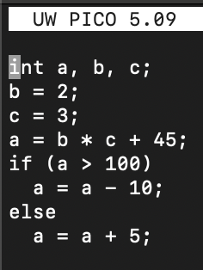
Output:
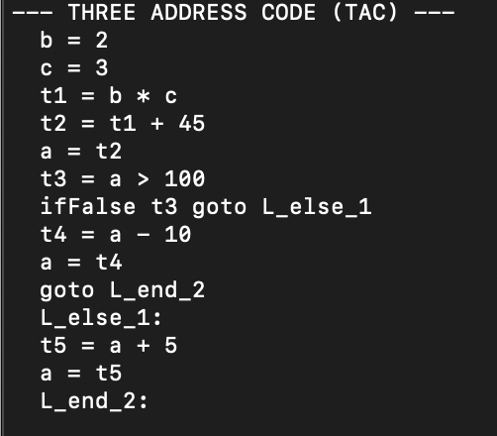

7. Results and Discussion
The compiler successfully recognizes valid programs, detects semantic errors, and generates correct Three Address Code and pseudo assembly. Optimization improves efficiency by folding constant expressions.

8. Conclusion
The Mini Compiler was successfully designed and implemented using Python and PLY. It demonstrates essential compiler design phases and generates optimized intermediate code. This project provides practical insight into compiler construction principles.

9. Future Scope
- Implement loop unrolling and dead code elimination.
- Add support for for-loops and boolean operations.
- Integrate backend to generate real assembly code.
- Enhance error recovery and debugging support.

10. References
- Alfred V. Aho et al. - Compilers: Principles, Techniques, and Tools (Dragon Book)
- PLY Documentation - https://www.dabeaz.com/ply/
- Educational compiler projects on GitHub (2024–2025)

