Experiment No. 7

Aim: Experiment on MongoDB

Theory:
MongoDB is an open-source, document-oriented NoSQL database designed to handle large volumes of unstructured or semi-structured data. Unlike traditional relational databases (RDBMS), MongoDB stores information in JSON-like documents called BSON (Binary JSON), which allows for a flexible and dynamic schema. It is widely adopted in modern applications due to its scalability, high performance, and ease of use. MongoDB provides official drivers for popular programming languages, including C, C++, C#, .NET, Go, Java, Node.js, Perl, PHP, Python, Ruby, Scala, and Swift, enabling developers to build applications in their preferred language. Major companies using MongoDB include Facebook, Google, Adobe, Nokia, and eBay.

How MongoDB Works
MongoDB operates as a database server where multiple databases can be created. Within each database, data is stored in collections, and each collection contains documents, which are the equivalent of records in RDBMS. The relationship between databases, collections, and documents is hierarchical:
Database → Collection → Document
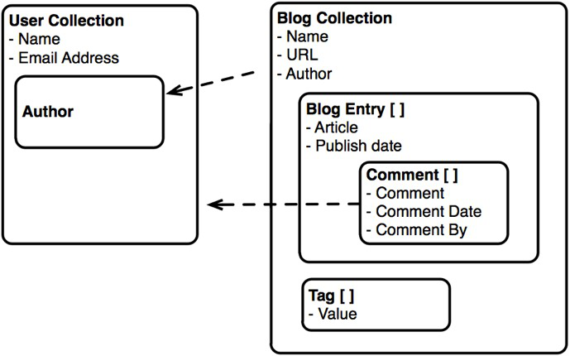

Key Features of MongoDB
- Schema-less Database
  - Collections can store documents with different structures.
  - No fixed columns are required, allowing easy modifications and updates.
- Document-Oriented Storage
  - Data is stored in key-value pairs within documents instead of rows and columns.
  - Each document has a unique object ID, offering flexibility compared to relational tables.
- Indexing
  - Every document field can be indexed with primary and secondary indexes, speeding up query performance.
- Scalability
  - Supports horizontal scaling through sharding, which distributes large datasets across multiple servers using a shard key.
- Replication
  - Provides high availability and redundancy by creating multiple copies of data across different servers.
- Aggregation
  - Allows operations on grouped data to produce computed results, similar to SQL’s GROUP BY.
  - Supports aggregation pipelines, map-reduce functions, and single-purpose aggregation methods.
- High Performance
  - Optimized for fast data access, persistence, and retrieval due to indexing, replication, and scalability features.

MongoDB and the CAP Theorem
The CAP theorem states that a distributed system can guarantee at most two of three properties: Consistency (C), Availability (A), and Partition Tolerance (P).
- MongoDB Classification: By default, MongoDB is an AP system (Availability + Partition Tolerance), prioritizing uptime and fault tolerance.
- Trade-offs:
  - Consistency: Offers eventual consistency by default. Stronger consistency can be achieved using replica sets and write concerns (e.g., “majority” write concern).
  - Availability: Ensured through replica sets. Failover elects a new primary automatically if the original primary fails.
  - Partition Tolerance: Allows operations to continue during network partitions, which may temporarily cause inconsistencies.

Common Uses of MongoDB
- Content Management Systems (CMS)
  - Flexible schema allows management of diverse content types dynamically.
- E-commerce Platforms
  - Efficiently handles large product catalogs, user profiles, shopping carts, and transaction data.
- Real-Time Analytics
  - Supports fast data ingestion and querying for monitoring, fraud detection, and personalized recommendations.
- Internet of Things (IoT)
  - Scalable storage for massive sensor and device data, enabling real-time analysis and decision-making.
- Gaming Applications
  - Manages complex data structures like player profiles, scores, achievements, and game states efficiently.
Code:
STEP 1

Starting the MongoDB Shell (mongosh) and establishing a connection with the local MongoDB server.

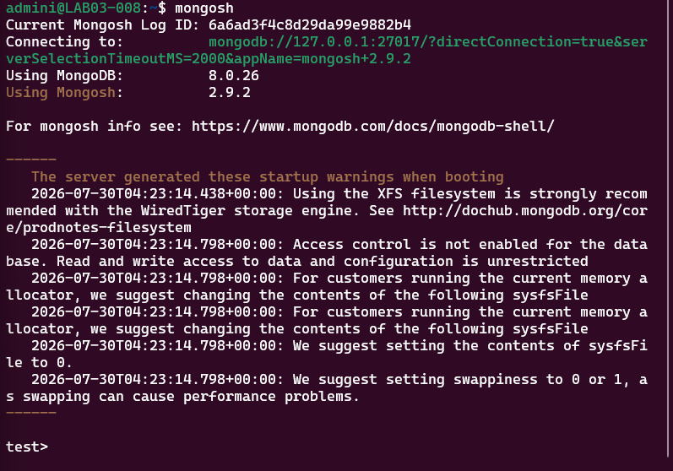

STEP 2

Switching to the retail database using the use command and displaying the current database.

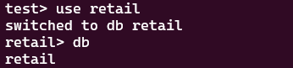

STEP 3

Executing the show dbs command to view all databases available in the MongoDB server.

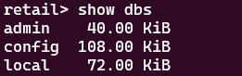

STEP 4

Inserting a document into the sales collection and verifying the creation of the retail database.

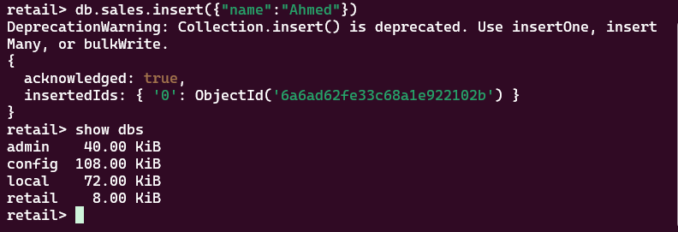

STEP 5

Switching to the mydb database and deleting it using the dropDatabase() command.

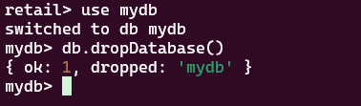

STEP 6

Switching to the retail database and creating a new collection named products.

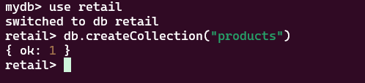

STEP 7

Executing the show collections command to display the collections available in the retail database.

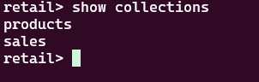

STEP 8

Creating a capped collection named gadget with a specified size and maximum number of documents.

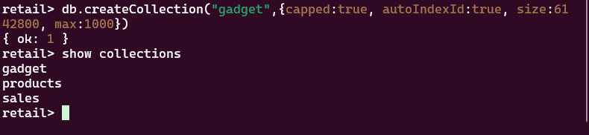

STEP 9

Inserting a document into the created collection and displaying the available collections in the database.

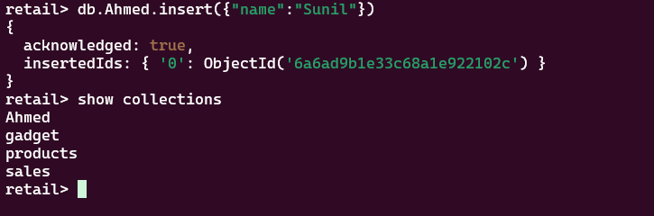

STEP 10

Displaying the collections and deleting the gadget collection using the drop() command.

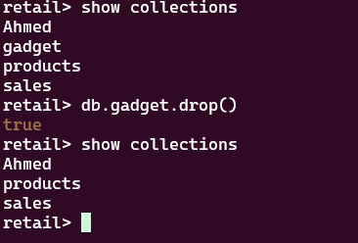

STEP 11

Inserting an iPhone document into the gadgets collection and retrieving the stored document using the find() command.

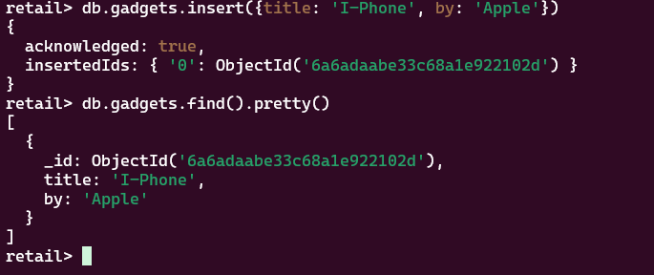

STEP 12

Inserting multiple product documents with title, manufacturer, and description fields into the gadgets collection.

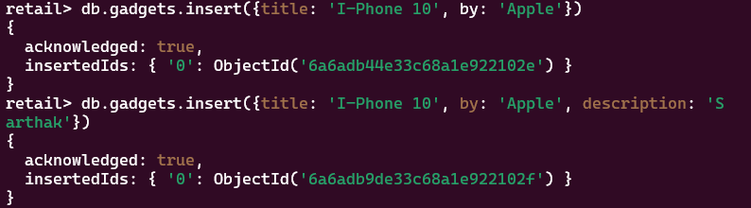

STEP 13

Retrieving documents from the gadgets collection based on the manufacturer using a query condition.

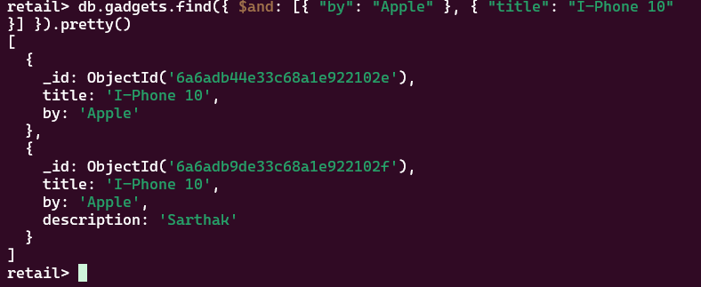

STEP 14

Using the $or operator to retrieve products manufactured by either Apple or Samsung.

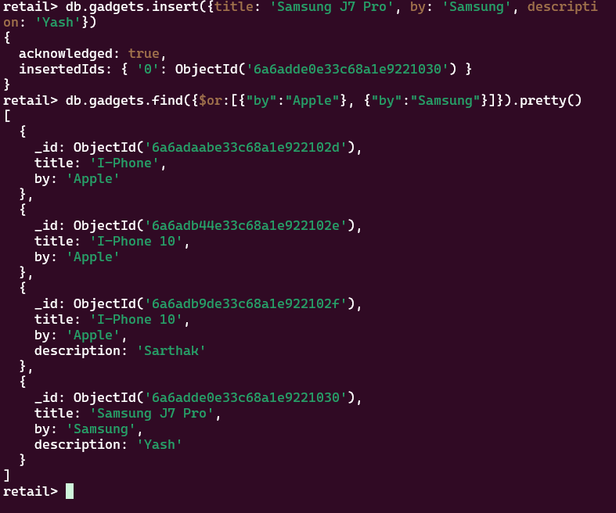

STEP 15

Retrieving documents using multiple conditions based on the product title, manufacturer, and description.

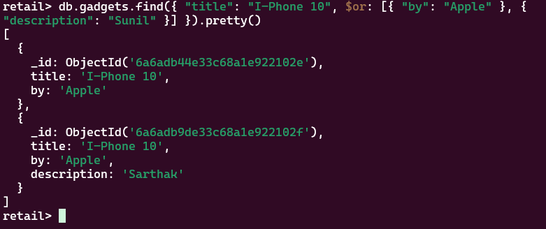

STEP 16

Updating an existing product document using the $set operator to modify its field value.

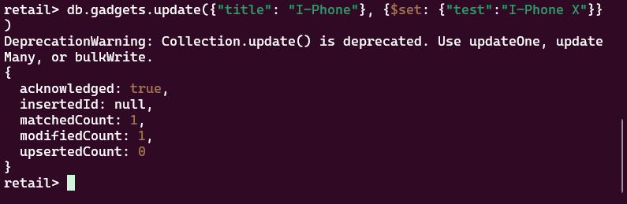

STEP 17

Inserting a product document into the sales collection.

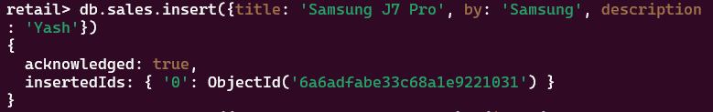

STEP 18

Updating the document in the sales collection and displaying the updated records.

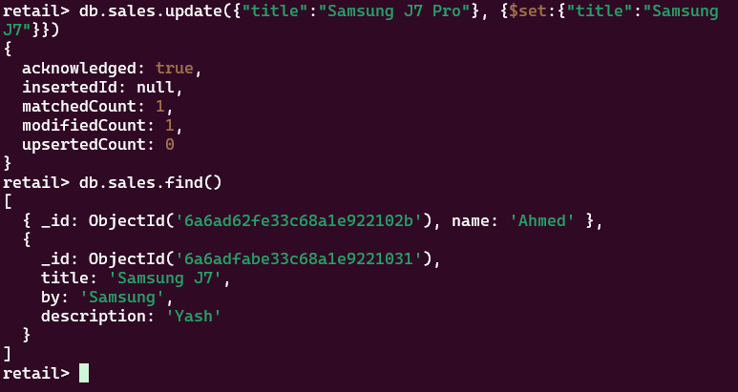

STEP 19

Removing the document from the sales collection using the remove() command.

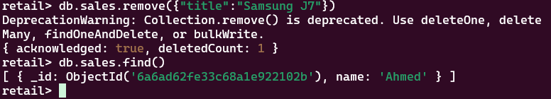

STEP 20

Using projection to retrieve only the description field while excluding the _id field from the query results.

STEP 21

Using the limit() and skip() methods to control and restrict the number of documents returned by the query.

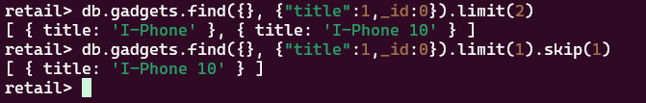

STEP 22

Sorting the product documents by the title field in descending order using the sort() method.

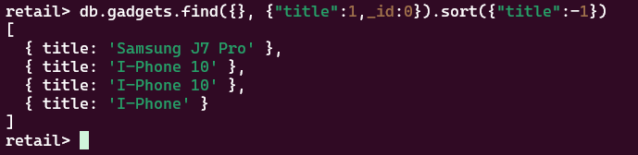

STEP 23

Creating an index on the title and description fields of the gadgets collection using ensureIndex().

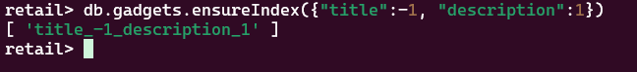

STEP 24

Performing aggregation using the $group and $sum operators to calculate the number of products for each manufacturer.

