Experiment No. 1

Aim : Installation Guideline for Hadoop and Hadoop Basic Commands (HDFS)
Theory :
Apache Hadoop is an open-source framework designed for storing and processing large volumes of structured, semi-structured, and unstructured data across clusters of computers. It enables distributed storage and parallel processing, making it suitable for Big Data applications. One of the core components of Hadoop is the Hadoop Distributed File System (HDFS), which provides reliable, scalable, and fault-tolerant storage by distributing data across multiple nodes. HDFS allows users to perform various file operations through shell commands such as creating directories, copying files, changing permissions, and managing storage efficiently. The experiment focuses on understanding and using these basic HDFS commands for file and directory management.
The Hadoop Distributed File System (HDFS) is a distributed storage system designed to store very large files across multiple machines while ensuring reliability and high availability. Unlike traditional file systems, HDFS divides files into fixed-size blocks and stores these blocks across different DataNodes in a Hadoop cluster. To protect against hardware failures, each block is replicated across multiple nodes according to a configurable replication factor.
HDFS follows a master-slave architecture. The NameNode manages the metadata of the file system, including file names, directory structures, permissions, and block locations. The DataNodes store the actual data blocks and communicate with the NameNode to perform read and write operations.
Users interact with HDFS using shell commands that closely resemble Linux file system commands. These commands allow users to list files and directories, create folders, upload and download files, copy or move files, delete data, check disk usage, modify file permissions, change ownership, and manage replication factors. HDFS also provides utilities to check file system health, balance data across nodes, and manage safe mode operations.
Because HDFS is optimized for high-throughput access rather than low-latency access, it is particularly suitable for batch processing applications that analyze large datasets. It is widely used with other Hadoop ecosystem tools such as Hive, Pig, Sqoop, MapReduce, and Spark to build complete Big Data processing pipelines.

Advantages
- Provides reliable and fault-tolerant storage through data replication.
- Easily scales by adding additional nodes to the Hadoop cluster.
- Supports storage of massive datasets distributed across multiple machines.
- Offers high throughput for reading and writing large files.
- Cost-effective because it uses commodity hardware.
- Automatically recovers from hardware failures using replicated data.
- Provides a simple command-line interface similar to Linux file systems.
- Integrates seamlessly with the Hadoop ecosystem for Big Data analytics.

Disadvantages
- Not suitable for storing a large number of small files.
- High storage overhead due to block replication.
- Optimized for batch processing rather than real-time applications.
- Random read/write performance is slower than conventional file systems.
- NameNode management can become a bottleneck in very large clusters.
- Requires knowledge of distributed systems for installation and administration.

Real-Life Applications
- Storage and analysis of social media data.
- Processing web server logs and clickstream data.
- Banking and financial fraud detection.
- Healthcare data management and medical record analytics.
- E-commerce recommendation systems.
- Data warehousing and business intelligence applications.
- Scientific research involving large datasets such as genome sequencing.
- Telecommunication network monitoring and log analysis.
- Enterprise backup and archival storage.
- Machine learning and Big Data analytics workflows.

Architecture Diagram:
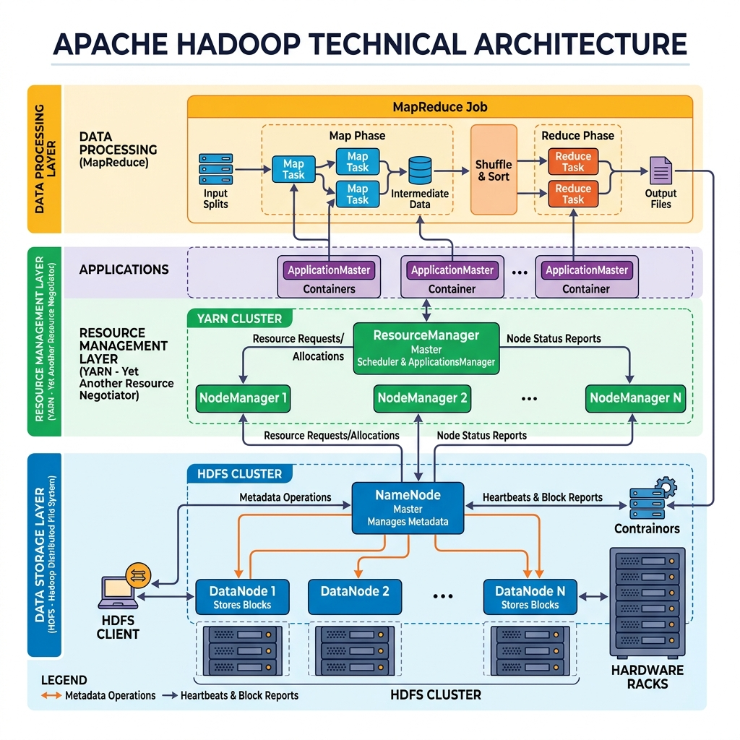

STEP 1
Open VMware Workstation Player and load the Cloudera QuickStart Virtual Machine.
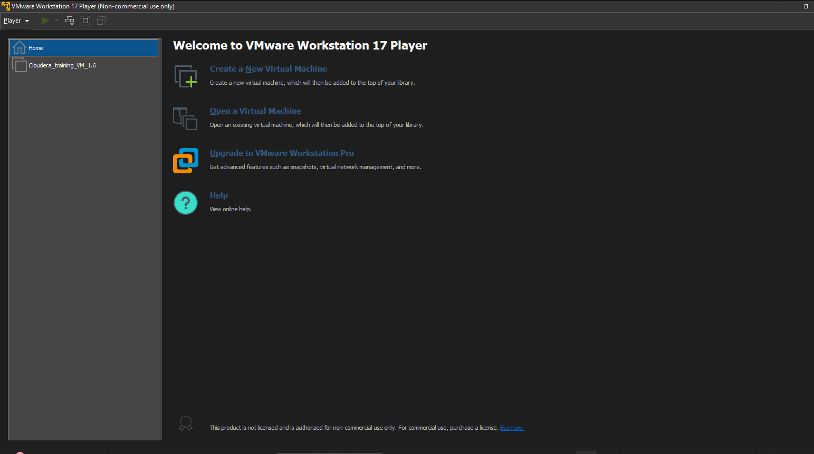

STEP 2
Boot the Cloudera VM and wait for the Linux desktop to load successfully.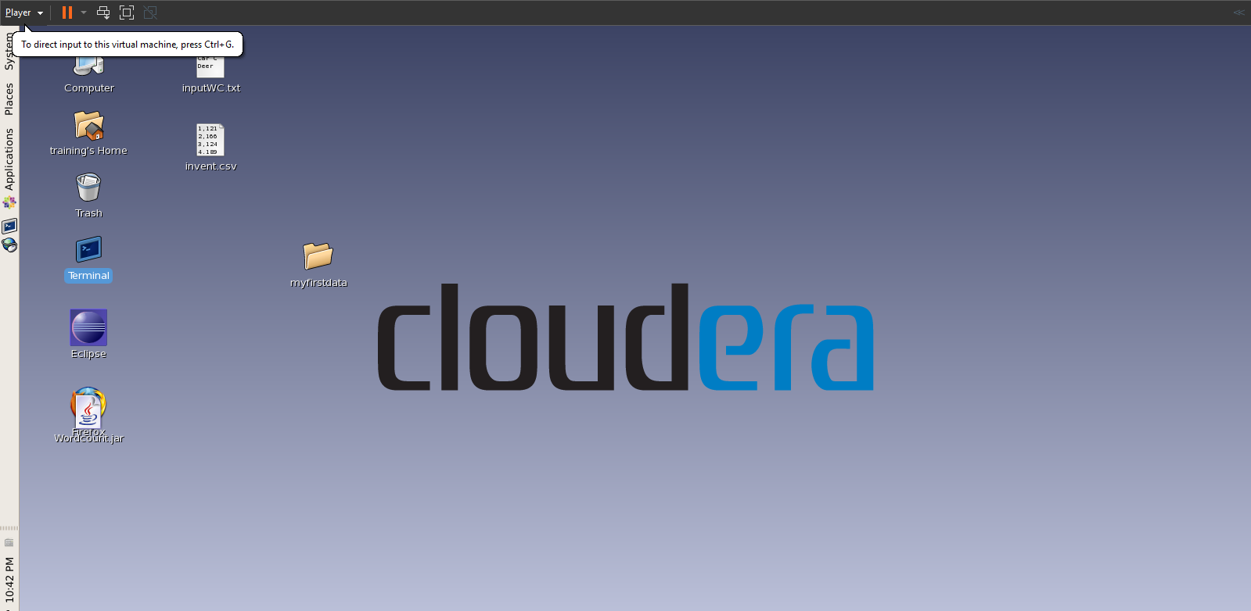

STEP 3
Open the terminal and verify the installed Hadoop version using the hadoop version command.
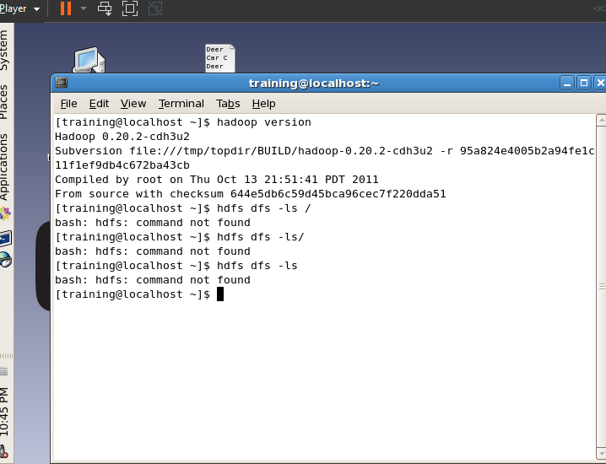
STEP 4
Display the contents of the HDFS root directory using the hadoop fs -ls / command.
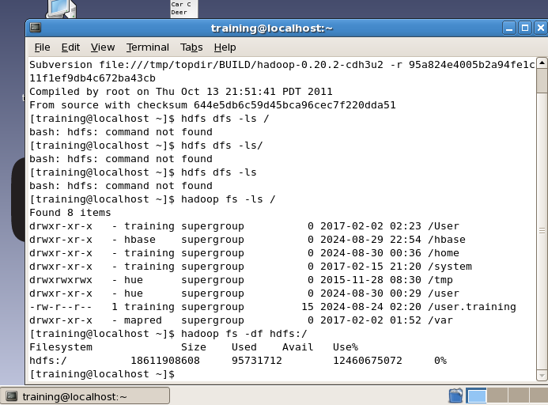
STEP 5
Check the available and used storage space of HDFS using the hadoop fs -df command.
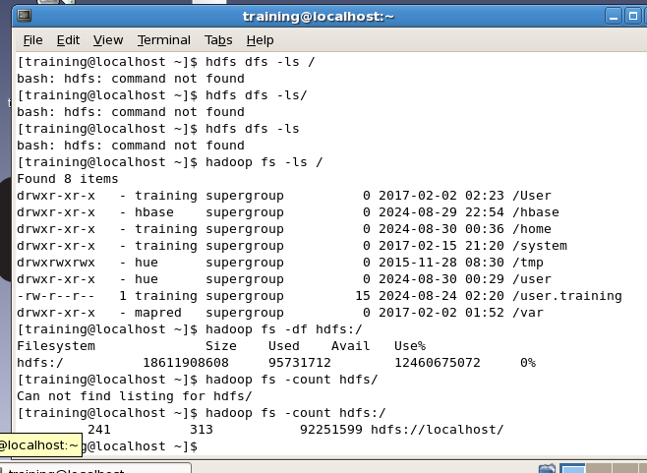
STEP 6
Count the number of files, directories, and total storage in HDFS using the hadoop fs -count command.
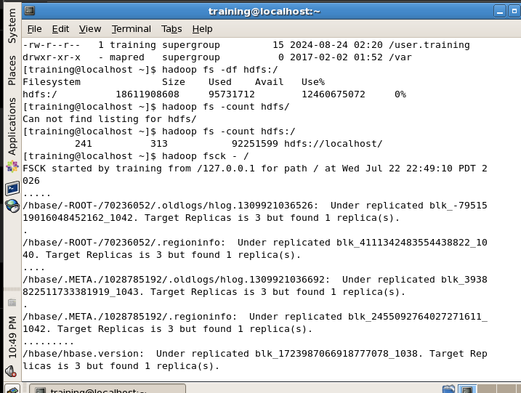
STEP 7
Verify the health of the Hadoop Distributed File System using the hadoop fsck command.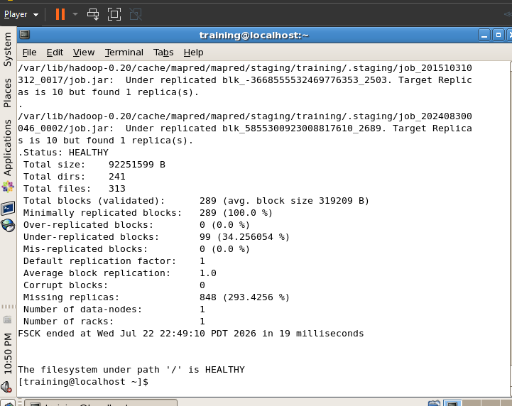

STEP 8
Create a new directory named hadoop inside the user's HDFS directory.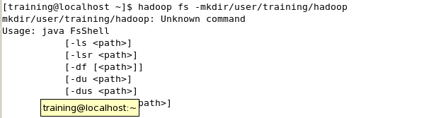

STEP 9
Upload the sample text file from the local file system into HDFS.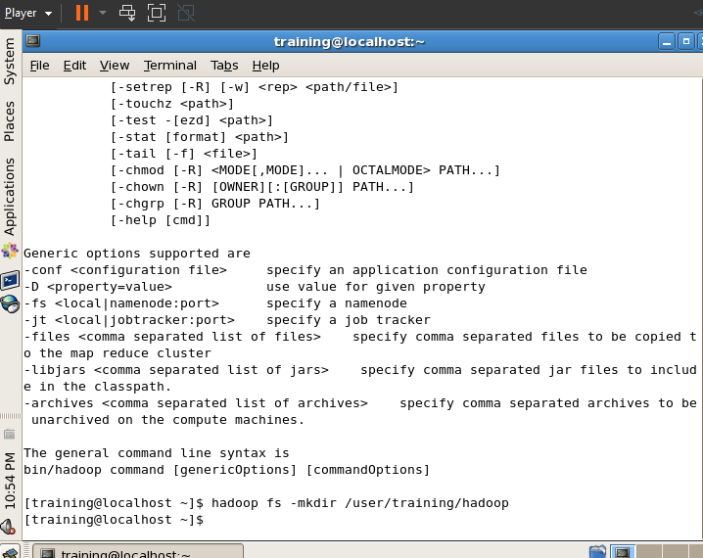

STEP 10
Verify that the uploaded file is successfully stored in HDFS.
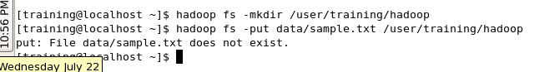

STEP 11
Upload the retail1 directory into HDFS.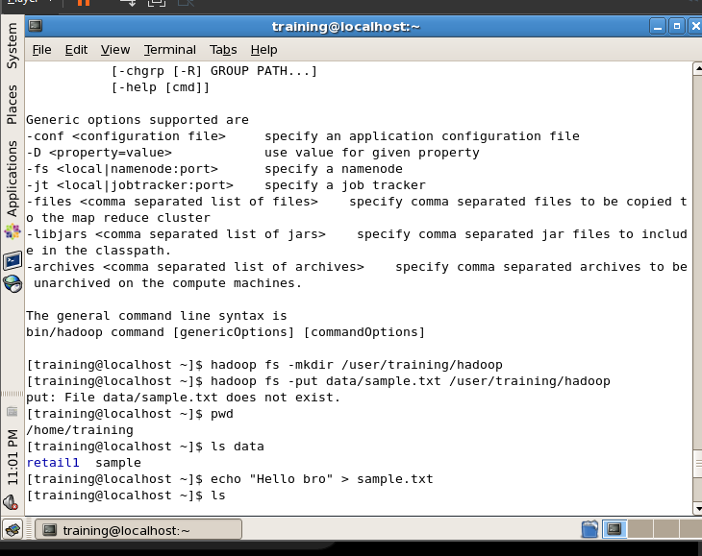
STEP 12
Display the size of the uploaded directory using the du command. 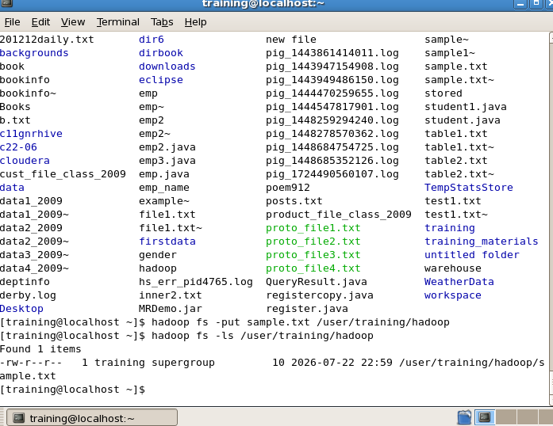
STEP 13
Delete a selected file from the uploaded directory.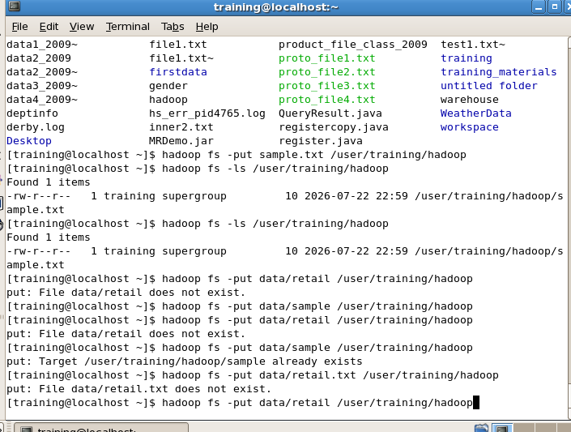
STEP 14
Verify that the file has been successfully deleted.
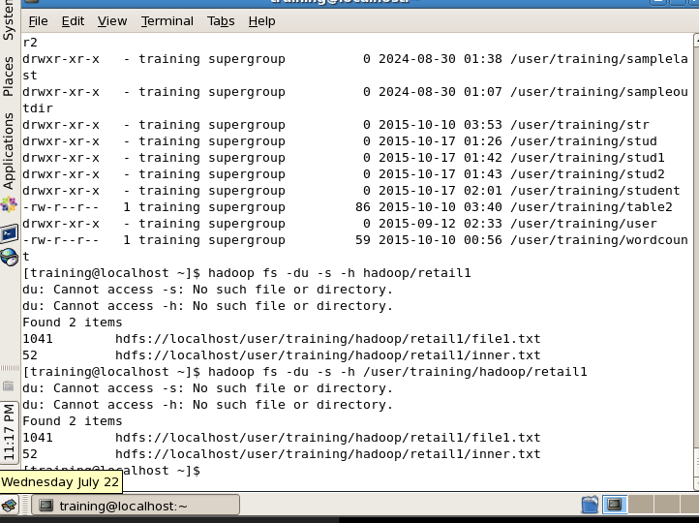
STEP 15
Remove all remaining files inside the uploaded directory.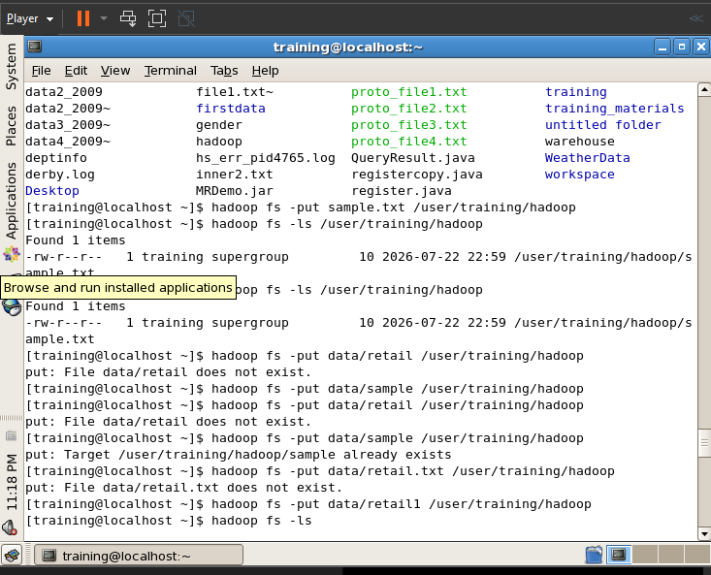
STEP 16
Empty the HDFS trash to permanently remove deleted files.
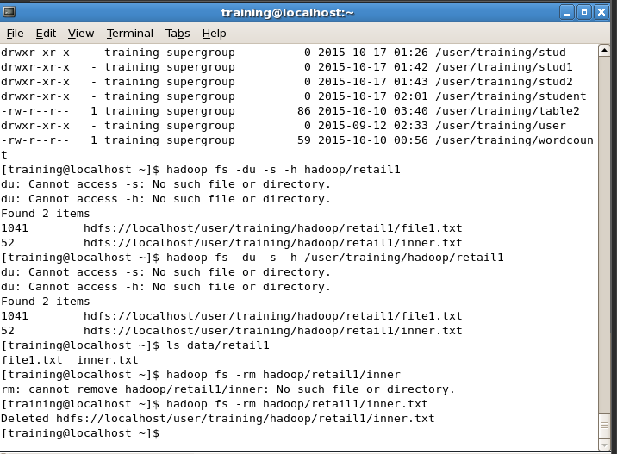

STEP 17
Delete the entire directory from HDFS.
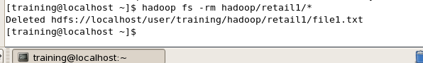

STEP 18
Verify that the directory has been successfully removed.
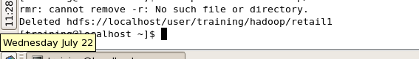

STEP 19
Copy a local file (inner2.txt) into HDFS using the copyFromLocal command.
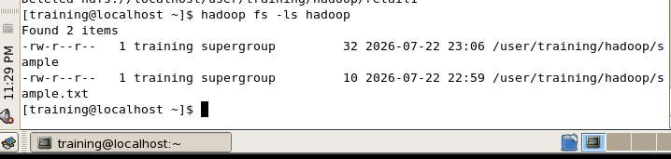

STEP 20
Display the contents of the copied file using the cat command.
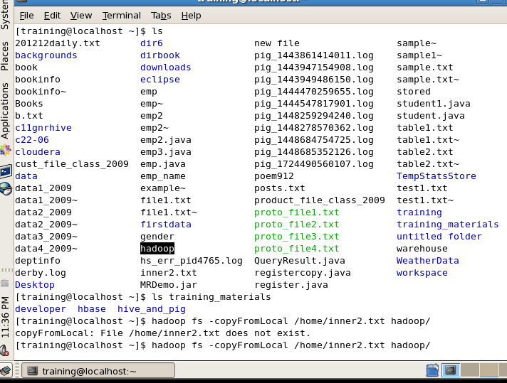

STEP 21
Copy the file from HDFS back to the local file system using the copyToLocal command.
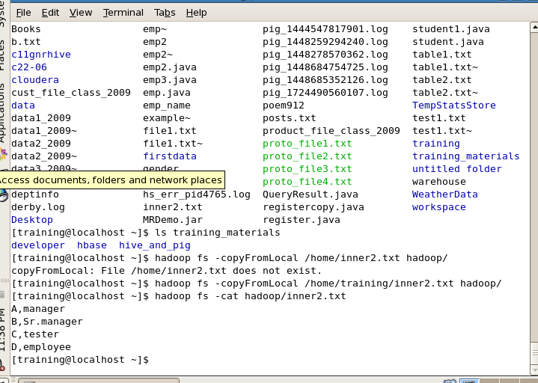

STEP 22
Copy files from one HDFS directory to another using the cp command.
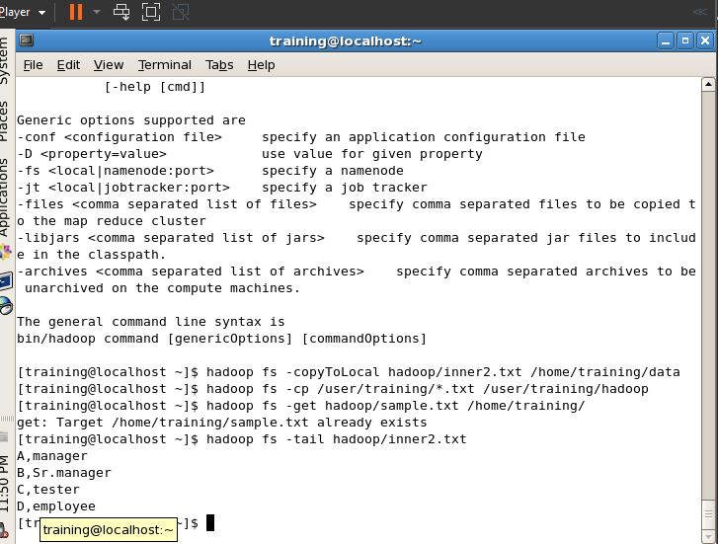

STEP 23
Download a file from HDFS using the get command.
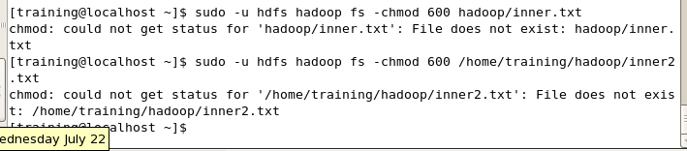

STEP 24
Display the last few lines of the file using the tail command.
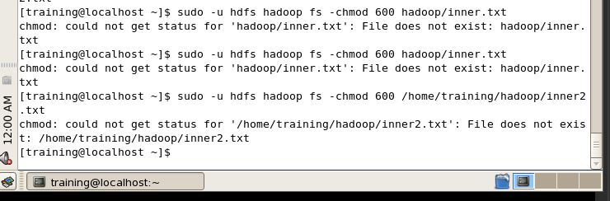

STEP 25
Modify file permissions using the chmod command.
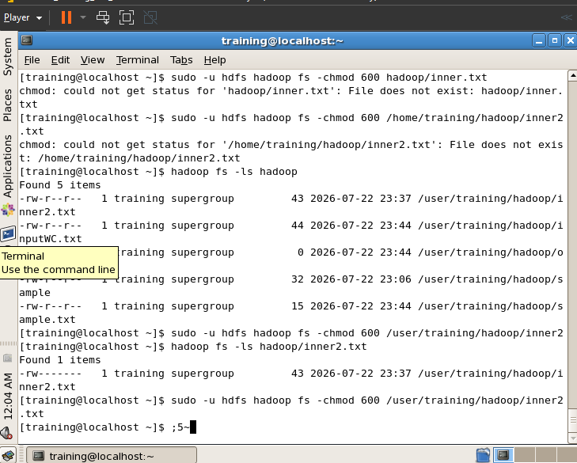

STEP 26
Change the owner of the file using the chown command.
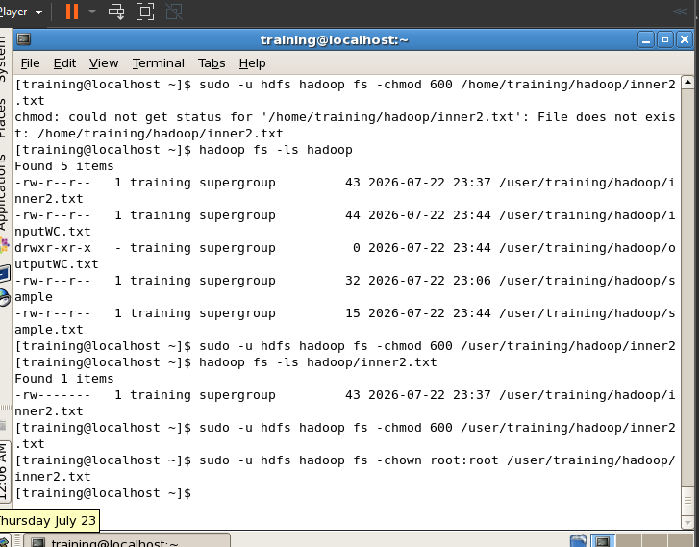
STEP 27
Change the group ownership using the chgrp command.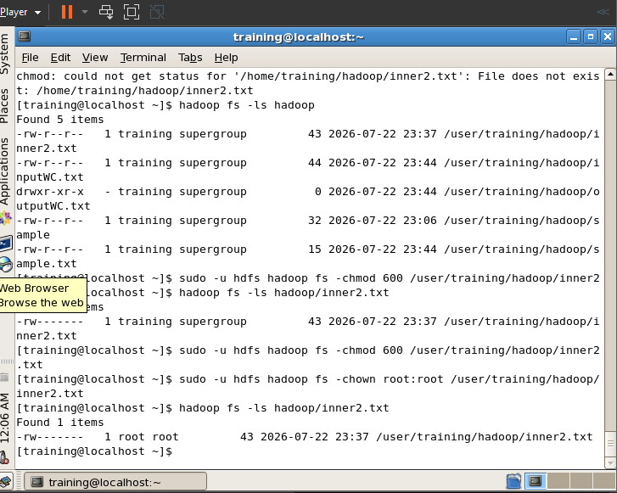

STEP 28
Rename the HDFS directory using the mv command.
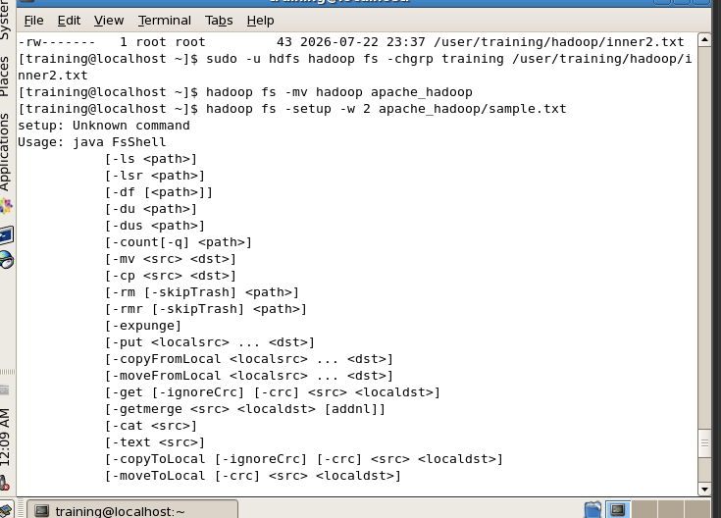

STEP 29
Change the replication factor of a file using the setrep command.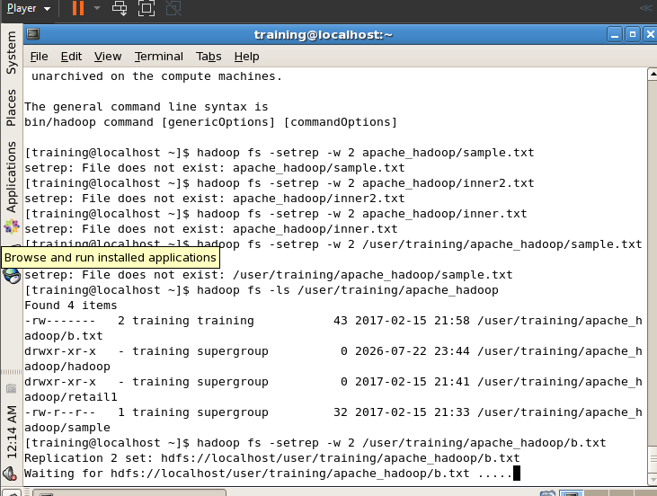

STEP 30
Perform distributed copy operations between Hadoop directories using the distcp command (where supported).
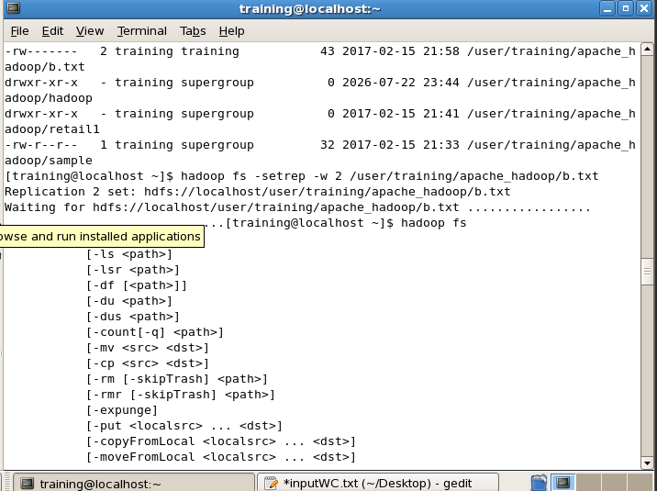

STEP 31
Display the list of all available HDFS shell commands.
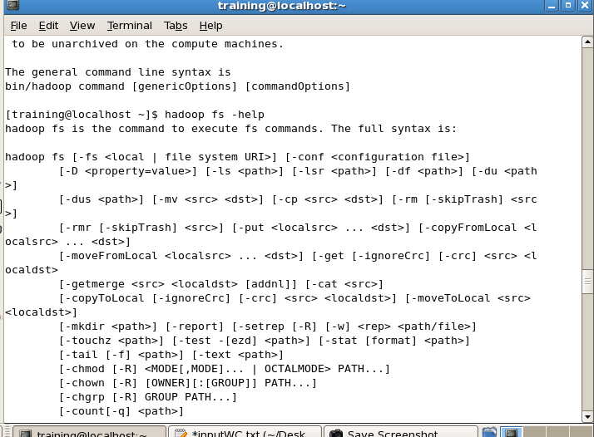
STEP 32
Display detailed help information for Hadoop File System commands.
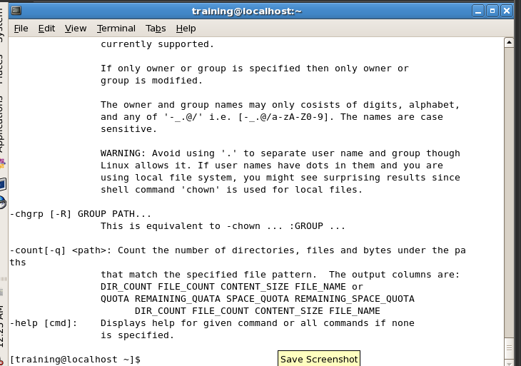

Conclusion :
Through this experiment, the installation of Hadoop using Cloudera Quickstart VM on VirtualBox was successfully completed. Furthermore, basic HDFS commands were practiced to understand the distributed file system operations, file management, and permission handling in Hadoop.

