Experiment No. 2

Aim : Using SqoopTool To Transfer Data Between Hadoop And MySQL
Introduction
Apache Sqoop is an open-source tool developed by the Apache Software Foundation for efficiently transferring large volumes of data between relational database management systems (RDBMS) and the Hadoop ecosystem. It acts as a bridge between structured databases such as MySQL, Oracle, PostgreSQL, and SQL Server and Hadoop components like HDFS, Hive, and HBase. Sqoop automates the import and export of data using parallel processing, making it much faster than manual data transfer methods. In this experiment, Sqoop is used to import data from a MySQL database into HDFS and export the processed data back from HDFS into MySQL.
Theory
Apache Sqoop (SQL-to-Hadoop and Hadoop-to-SQL) is a data transfer tool specifically designed to exchange data between relational databases and Hadoop. Organizations often store transactional data in relational databases while using Hadoop for large-scale storage and analysis. Sqoop simplifies the movement of data between these two environments without requiring custom scripts or complex programming.
Sqoop provides two primary operations:
- Import: Transfers tables or query results from an RDBMS into Hadoop Distributed File System (HDFS), Hive, or HBase. During the import process, each row of a database table becomes a record in Hadoop. Data can be stored as text files, Avro files, or Sequence files depending on user requirements.
- Export: Transfers processed data from HDFS back into a relational database. Sqoop reads the data stored in HDFS, converts it into database records, and inserts it into an existing database table.
One of the major advantages of Sqoop is its ability to perform data transfer in parallel using multiple MapReduce tasks called mappers. This significantly improves transfer speed for large datasets. Sqoop also supports incremental imports, compression, direct connectors for several databases, and seamless integration with other Hadoop ecosystem tools such as Hive, Pig, and HBase.
In Big Data environments, Sqoop is commonly used to migrate enterprise data from operational databases into Hadoop for analysis and then export processed results back into business applications. It eliminates manual effort, reduces transfer time, and ensures reliable movement of structured data between different platforms.
Advantages
- Enables fast and efficient transfer of data between Hadoop and relational databases.
- Supports parallel data transfer using multiple mappers for improved performance.
- Eliminates the need for writing custom import and export scripts.
- Integrates seamlessly with HDFS, Hive, HBase, and other Hadoop ecosystem tools.
- Supports incremental imports, reducing unnecessary data transfer.
- Works with multiple relational databases such as MySQL, Oracle, PostgreSQL, and SQL Server.
- Reliable and fault-tolerant data transfer using Hadoop's distributed processing capabilities.
- Easy to use through simple command-line operations.

Disadvantages
- Primarily designed for structured data and relational databases only.
- Does not support real-time or streaming data transfer.
- Performance depends on the speed of both the database server and Hadoop cluster.
- Requires JDBC drivers and proper database connectivity.
- Not suitable for transferring unstructured or semi-structured data directly.
- Configuration can become complex in large enterprise environments.

Real-Life Applications
- Importing customer transaction data from banking databases into Hadoop for fraud detection.
- Migrating enterprise sales and inventory data from MySQL to HDFS for analytics.
- Exporting processed Big Data results back into business databases for reporting.
- Data migration during enterprise data warehouse modernization.
- Integrating traditional relational databases with Hadoop-based data lakes.
- Healthcare organizations transferring patient records for large-scale analysis.
- E-commerce companies analyzing customer purchase history and exporting insights to operational databases.
- Telecommunications companies importing call detail records (CDRs) into Hadoop for network analysis and billing.

Architecture Diagram:
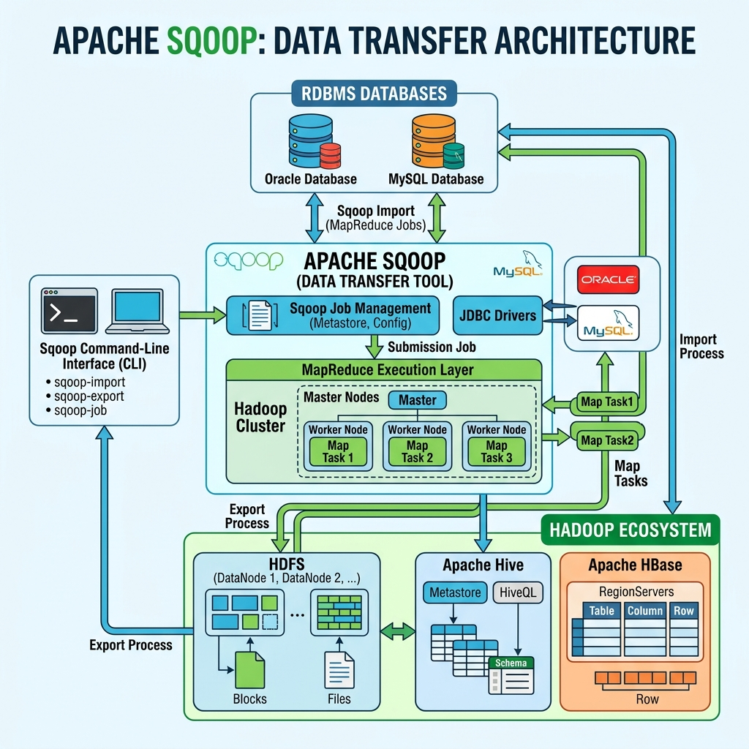

STEP 1
Open the Cloudera QuickStart Virtual Machine and launch the terminal. Connect to the MySQL server using the root user credentials (root) to begin the database operations required for the Sqoop experiment. A successful login confirms that the MySQL server is running correctly and is ready to create databases and tables.
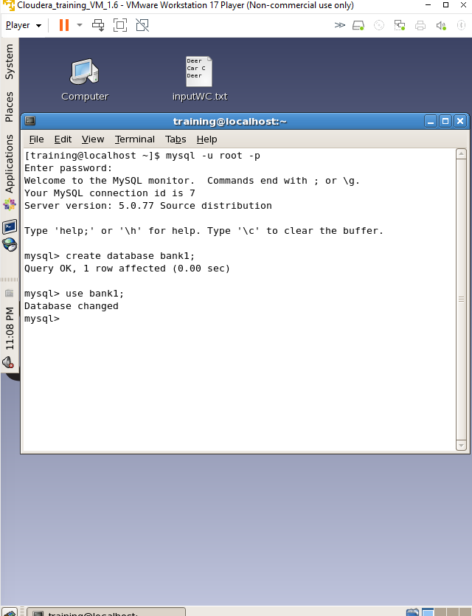

STEP 2
Create a new MySQL database named bank using the CREATE DATABASE command. This database serves as the source relational database from which records will later be imported into Hadoop using Sqoop. After creation, verify the database using the SHOW DATABASES command.
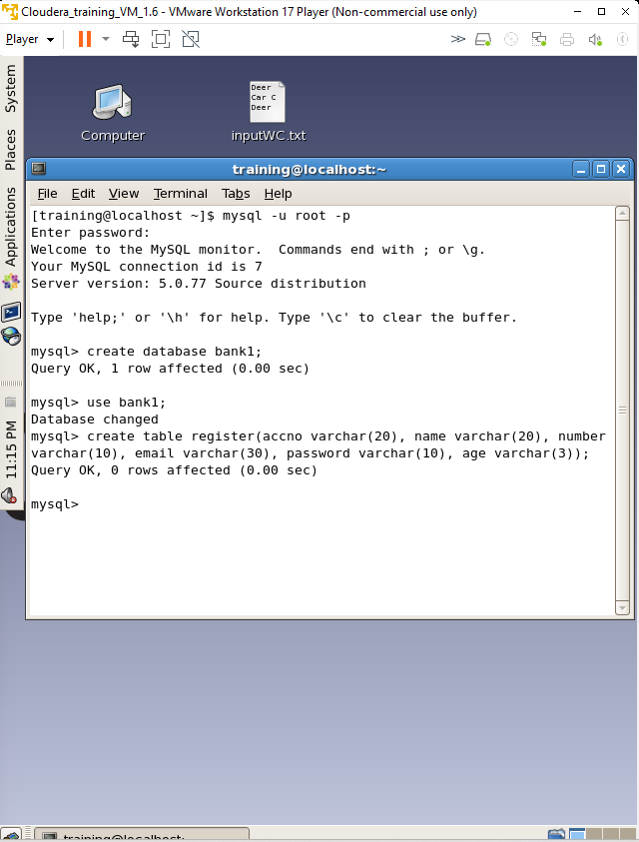

STEP 3
Select the bank database using the USE command and create a table named register with the required columns. The table structure defines the schema that will store customer records before transferring them to Hadoop. Verify the table structure using the DESCRIBE command.
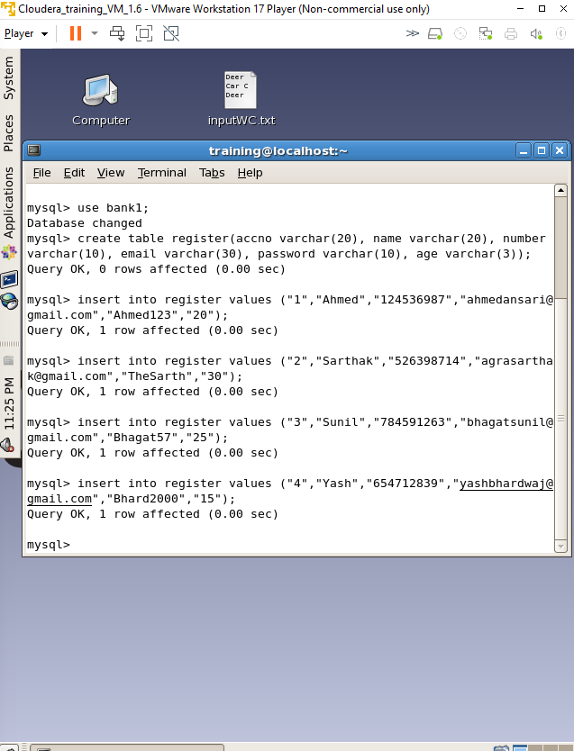

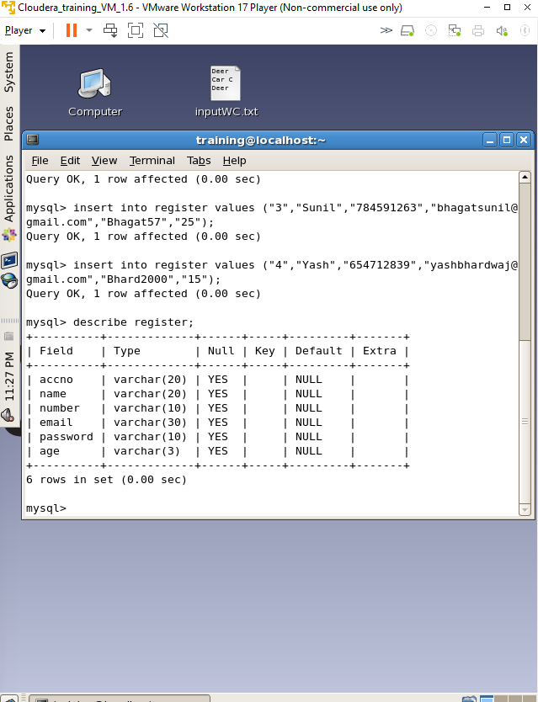

STEP 4
Insert sample records into the register table using SQL INSERT statements. These records act as the source data that will later be imported from MySQL into Hadoop using Sqoop. Verify that the data has been inserted successfully before proceeding.
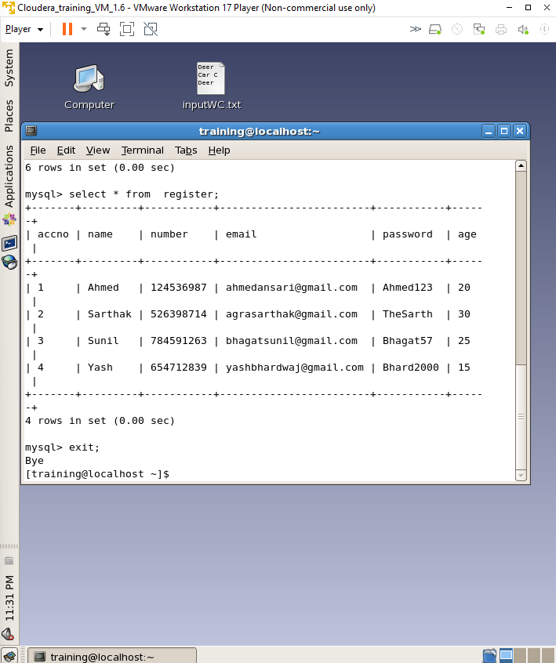

STEP 5
Exit the MySQL console and create a destination directory in the Cloudera file system. Execute the Sqoop Import command to transfer the contents of the register table from the MySQL database into Hadoop HDFS. During execution, Sqoop creates a MapReduce job that reads data from MySQL and stores it in the specified HDFS directory.
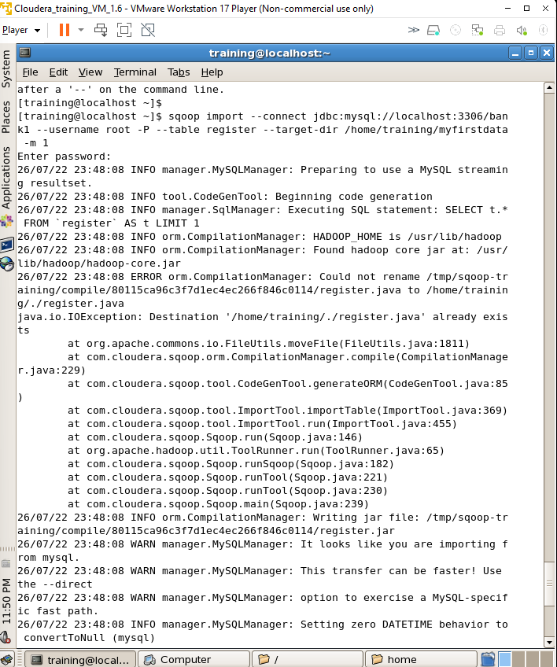

STEP 6
Verify that the import operation completed successfully by listing the files stored in the HDFS destination directory and displaying the contents of the generated data file. This confirms that all records from MySQL have been successfully transferred into Hadoop HDFS.
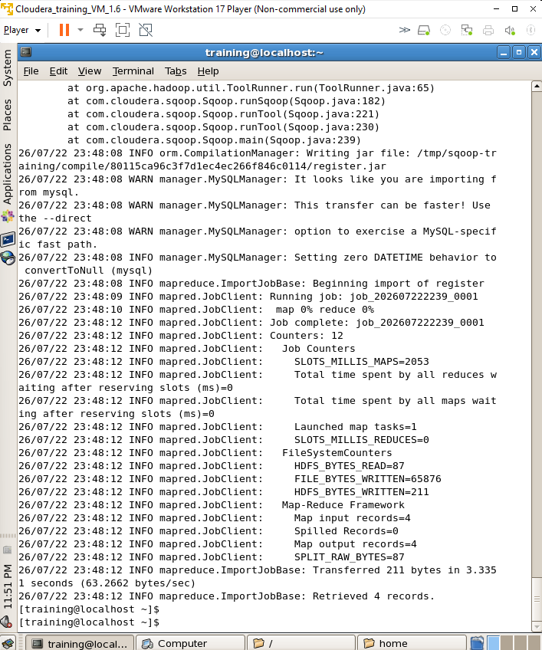

STEP 7
Create another MySQL table named registercopy with the same structure as the original register table. This table acts as the destination for exporting the data stored in Hadoop HDFS back into the relational database.
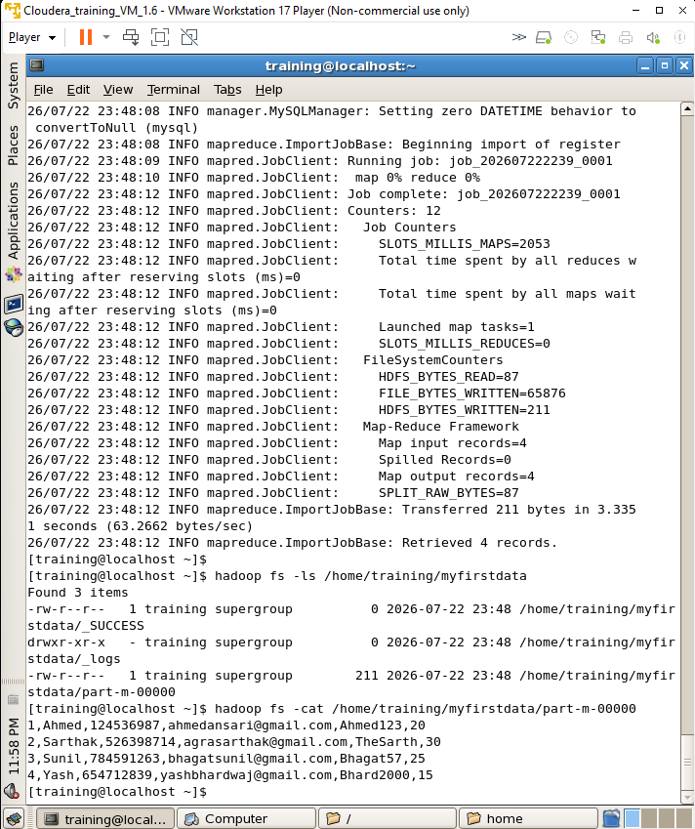

STEP 8
Execute the Sqoop Export command to transfer the records stored in the HDFS directory into the registercopy table in MySQL. Sqoop reads the HDFS files and inserts the records into the relational database, demonstrating successful data movement from Hadoop back to MySQL.
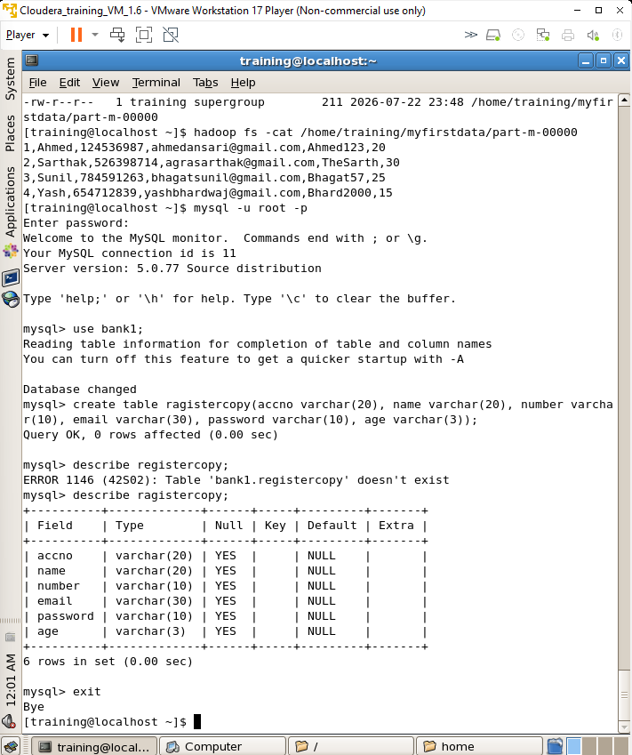

STEP 9
Log in to the MySQL server and retrieve all records from the registercopy table using the SELECT statement. The successful display of all records confirms that the data has been exported correctly from Hadoop HDFS to the MySQL database without any loss.
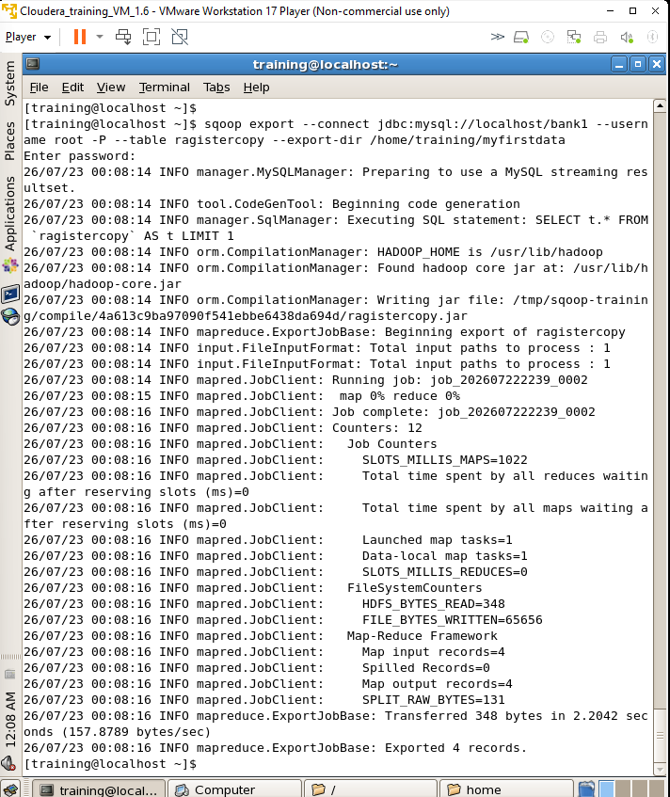

Final Verification Output
Final confirmation screen displaying the complete MySQL output of the successfully exported data.
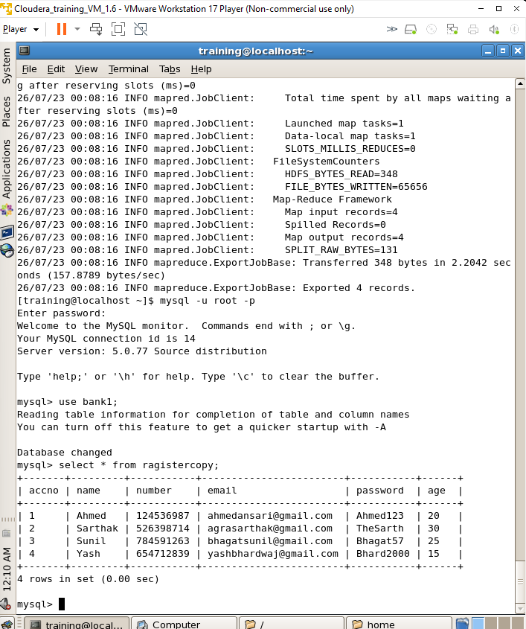

Conclusion :
Through this experiment, the process of transferring generic structured data between a relational database (MySQL) and Hadoop (HDFS) was successfully demonstrated using Apache Sqoop. The operations of Sqoop Import and Sqoop Export were performed to read tables from MySQL into Hadoop, and similarly to load distributed data from Hadoop back into MySQL tables without any data loss.

