EXPERIMENT 4

Aim
Experiment for Word Counting using Hadoop Map-Reduce.

Theory

Introduction
In the age of Big Data, processing massive volumes of information efficiently is a major challenge. Traditional systems struggle with large-scale datasets due to limitations in storage and computation. Hadoop, an open-source framework, addresses this problem by enabling distributed storage and processing of big data. Its core component, MapReduce, follows a divide-and-conquer strategy to process datasets across multiple nodes in parallel.
A classic example to understand MapReduce is the Word Count problem, which counts the occurrences of each word in a dataset stored in the Hadoop Distributed File System (HDFS).

Working of Word Count in MapReduce
1. Input Splitting
The dataset is divided into fixed-size chunks (input splits). These splits are distributed across nodes in the Hadoop cluster.
2. Mapper Phase
Reads each line of text, splits (tokenizes) the line into words, and emits a key-value pair for each word in the form (word, 1).
3. Shuffle and Sort
The framework automatically groups values belonging to the same key. For example, if “data” occurs three times, the intermediate result is (data, [1, 1, 1]).
4. Reducer Phase
The Reducer takes each key and its list of values and sums the values to compute the final count. For example, (data, [1, 1, 1]) becomes (data, 3).
5. Final Output
The results are written back to HDFS as a word frequency list.

MapReduce Flow
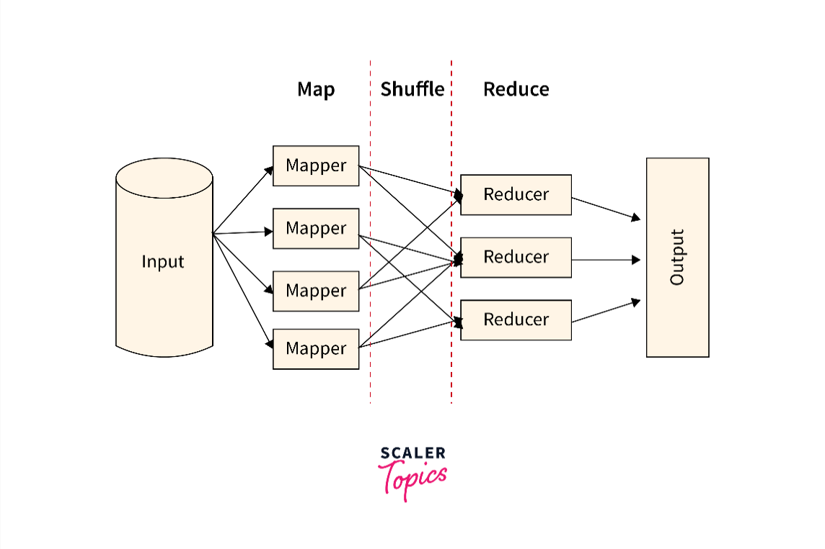
Figure 1: MapReduce flow for Word Count

Example
Input File (in HDFS):
Hadoop is fast
Hadoop is reliable
Mapper Output:
(Hadoop, 1), (is, 1), (fast, 1)
(Hadoop, 1), (is, 1), (reliable, 1)
After Shuffle and Sort:
Hadoop → [1, 1]
is → [1, 1]
fast → [1]
reliable → [1]
Reducer Output:
Hadoop 2
is 2
fast 1
reliable 1

Advantages of MapReduce Word Count
- Highly scalable, capable of processing terabytes or petabytes.
- Fault-tolerant—failed tasks are automatically re-executed.
- Supports parallel processing across nodes.
- Cost-effective, works on commodity hardware.
- Developers only focus on map and reduce logic, simplifying large-scale processing.

Disadvantages of MapReduce Word Count
- High latency—not suitable for real-time tasks.
- Requires knowledge of distributed programming.
- Iterative algorithms are inefficient due to repeated disk I/O.
- Heavy disk operations for intermediate data.
- Limited querying capabilities compared to SQL-based systems.

Applications
- Log Analysis – Count occurrences of “ERROR” or “FAILURE” in server logs.
- Search Engines – Calculate word frequencies to build indexes and rank results.
- Social Media Analytics – Track trending words/hashtags (e.g., #Elections).
- Email Spam Detection – Identify frequent spam keywords like “lottery” or “urgent”.
- Digital Libraries – Analyze word distribution in research papers and books.
- Text Mining & Sentiment Analysis – Detect frequent positive/negative words in reviews or surveys.

Real-World Usage
- Google initially built MapReduce for indexing billions of web pages.
- Amazon applies it to analyze customer reviews and product trends.
- Financial institutions use it for fraud detection via keyword analysis in logs.

Implementation / Code

1. Create a Java Project in Eclipse
Open Eclipse IDE → File → New → Java Project. Name the project: wordCountJob.
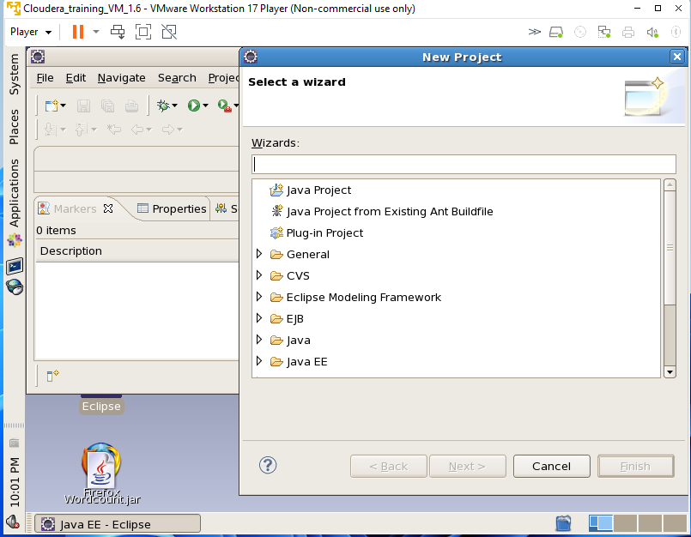
Figure 2: Creating the Java project in Eclipse.

2. Add Classes to the Project
Right-click on wordCountJob → New → Class. Create WordCount.java, WordMapper.java and WordReducer.java.
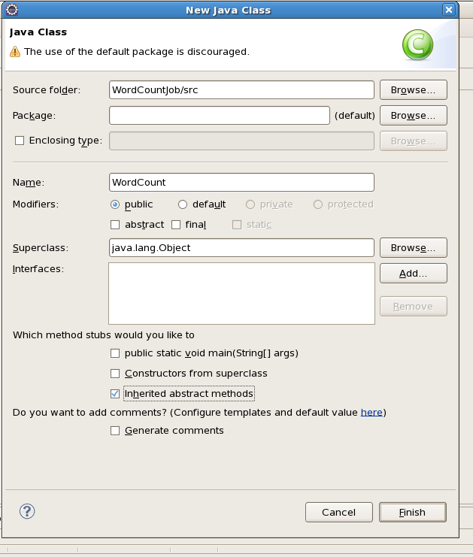
Figure 3: Creating the WordCount Java class.
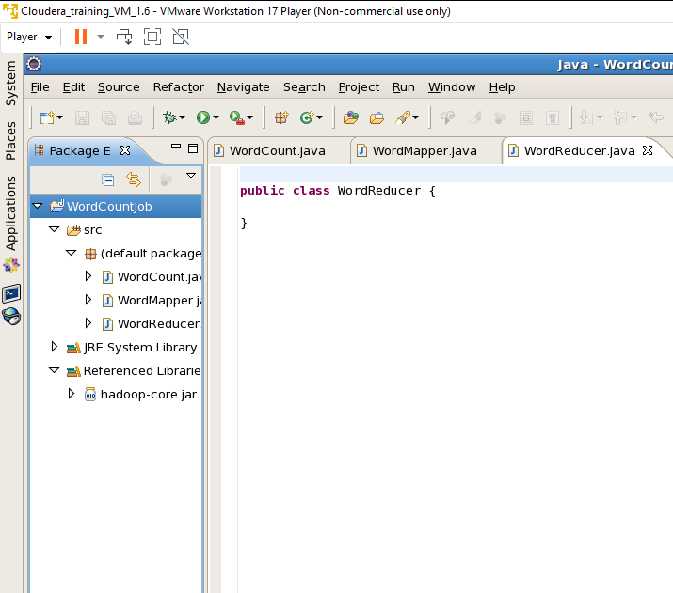
Figure 4: Word Count project structure with the required Java classes.

3. Add Code to Each File

Prog 1: WordCount.java
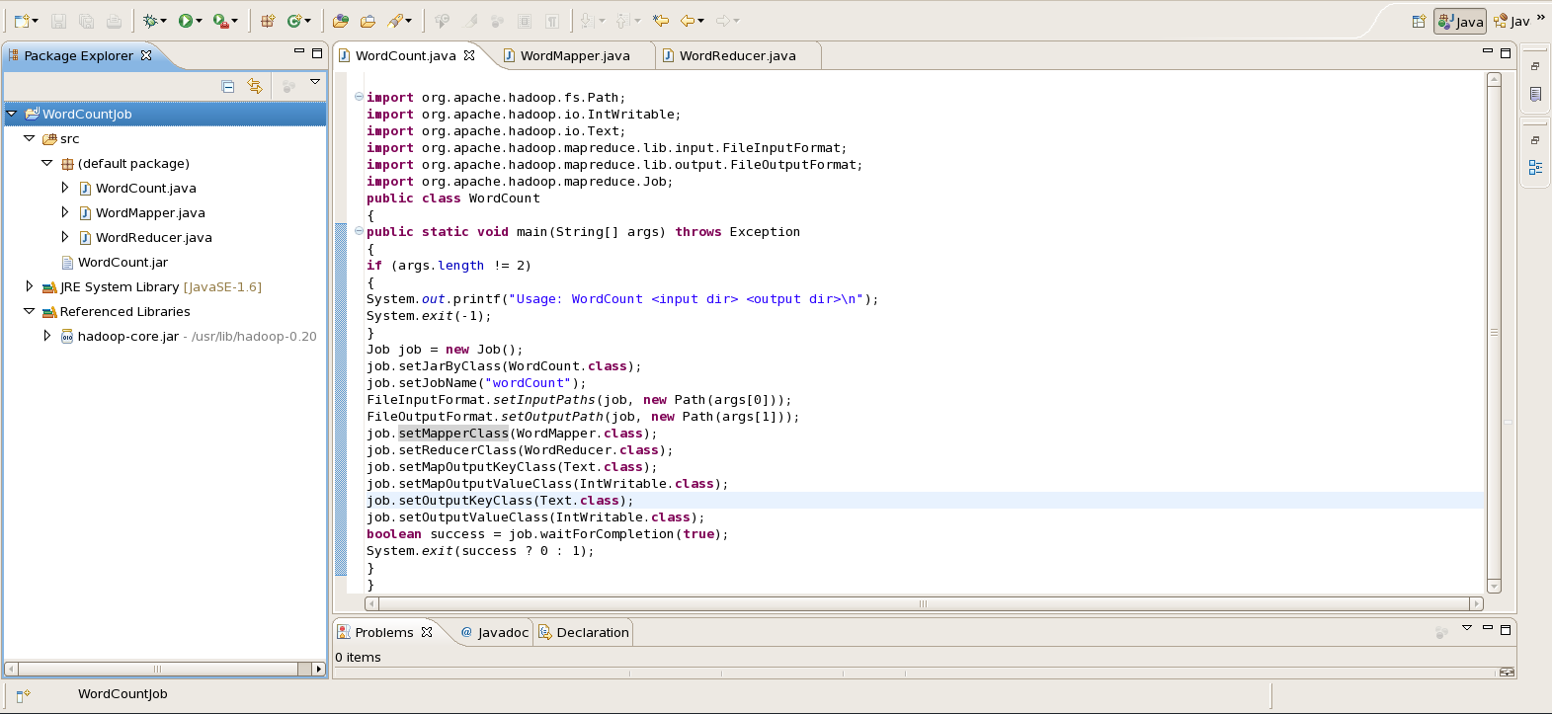
Figure 5: WordCount.java implementation.

Prog 2: WordMapper.java
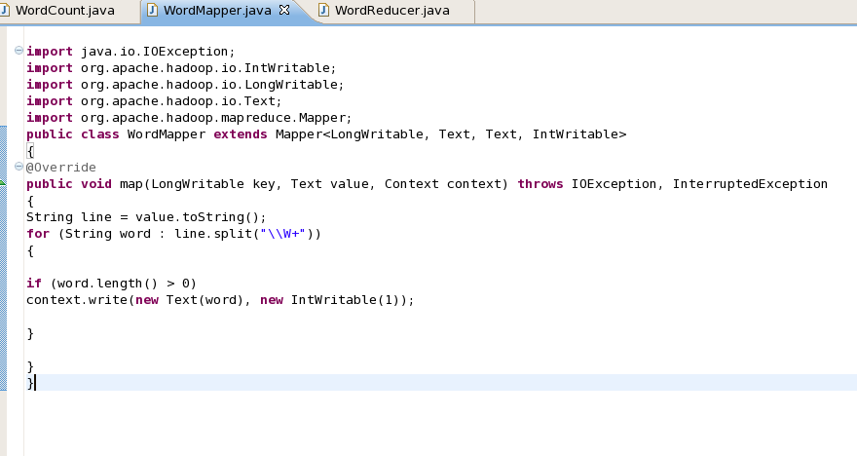
Figure 6: WordMapper.java implementation.

Prog 3: WordReducer.java
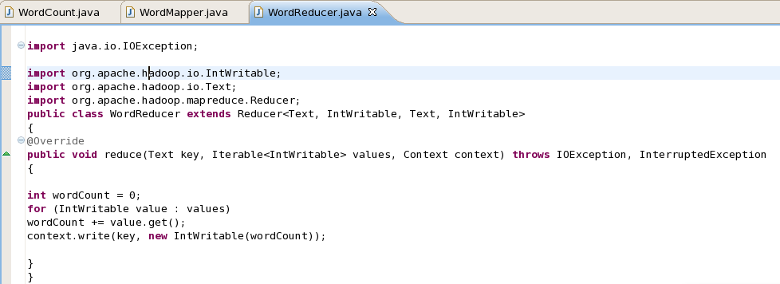
Figure 7: WordReducer.java implementation.

4. Add External Hadoop Libraries
Right-click on wordCountJob → Build Path → Configure Build Path → Libraries → Add External JARs. Navigate to /usr/lib/hadoop/ and add the required Hadoop core JARs and libraries.

5. Export Project to JAR File
Right-click on the project → Export → Java → JAR File. Choose the export destination and name the file wordCount.jar.
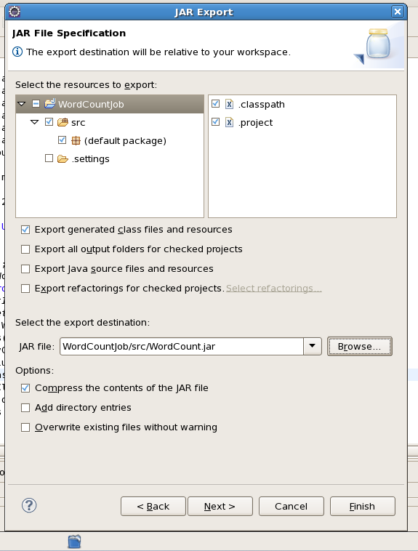
Figure 8: Exporting the Hadoop Word Count project as a JAR file.

6. Prepare the Sample Input File
The sample input file used in the supplied execution contains the following lines:
Hiten Comps
Sawan Chem
Samarth IT
Akash MBA
Vrajesh Seclore
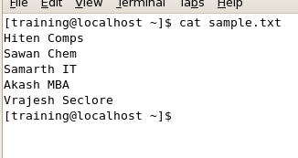
Figure 9: Contents of sample.txt used as input.

7. Upload Input File to HDFS
The input file is uploaded to the HDFS directory /user/training/sampleoutdir using the Hadoop file-system commands.
Figure 10: Word Count JAR and related files in the Hadoop workspace.
Figure 11: Removing the previous HDFS output directory before execution.

8. Run the JAR File using Hadoop
The Word Count JAR is executed using Hadoop with the input path and output directory. The supplied execution log shows the Map and Reduce phases completing successfully.
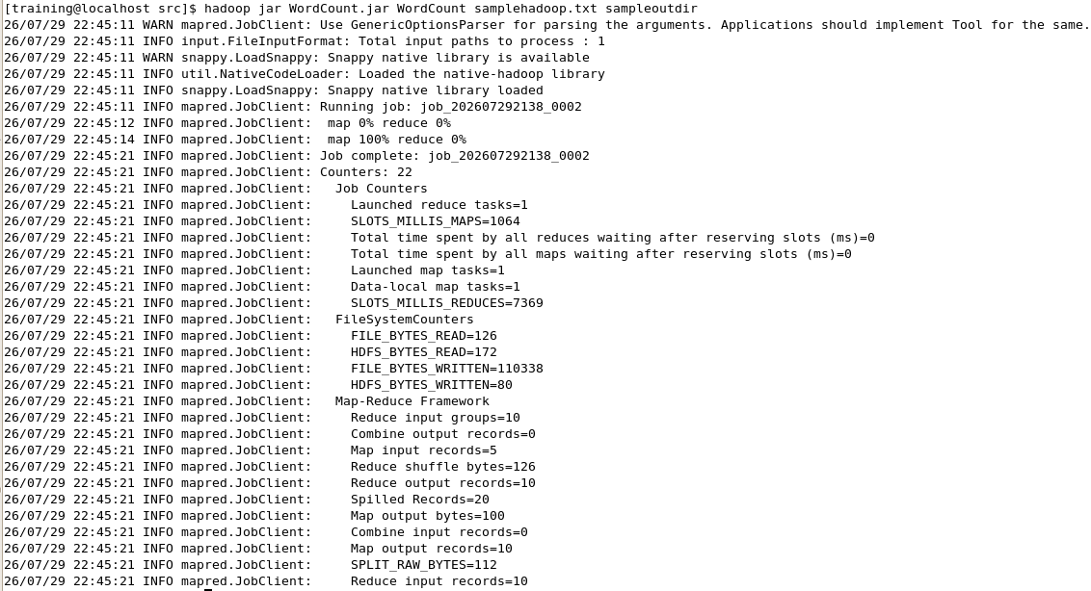
Figure 12: Successful execution of the Hadoop MapReduce Word Count job.

9. View Output
After the job completes, the generated output directory is checked and the part-r-00000 file is displayed.
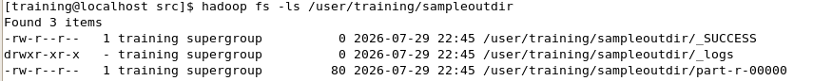
Figure 13: Generated HDFS output directory and part-r-00000 file.
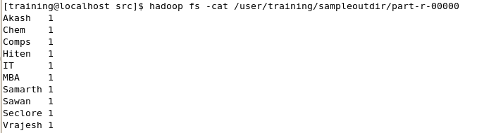
Figure 14: Final Word Count output.

Result
The Word Count program was successfully implemented and executed using Hadoop MapReduce. The supplied execution log shows the Map phase reaching 100% and the Reduce phase reaching 100%, followed by successful job completion. The final output contains the frequency of each word in the input file.

Conclusion
The Word Count program is the most fundamental example to grasp Hadoop MapReduce. It clearly demonstrates the roles of the Mapper, Shuffle & Sort, and Reducer phases in distributed processing. While MapReduce is powerful for batch analytics, it has limitations compared to modern frameworks like Apache Spark. Nevertheless, it remains a foundation of Big Data processing and large-scale analytics.

