EXPERIMENT 5

Aim
To perform data processing and analysis operations using Apache Pig and Pig Latin on Hadoop.

Theory

Introduction
Apache Pig is a high-level platform built for analyzing large datasets on Apache Hadoop. It uses a scripting language called Pig Latin, which provides an abstraction over the complexities of writing raw MapReduce jobs in Java. Pig was originally developed by Yahoo Research in 2006 to help researchers analyze massive datasets without manually coding MapReduce programs.
In short: Pig = High-Level Data Processing Language (Pig Latin) + Execution Environment

What is Apache Pig?
Apache Pig is a data analysis platform that represents data transformations as flows. It is tightly integrated with Hadoop and allows developers to perform data manipulation operations in a simple, SQL-like way.
- Pig Latin → High-level data flow language.
- Execution Engine → Converts Pig Latin scripts into MapReduce jobs and runs them on Hadoop.

Key Features of Apache Pig
- Rich Set of Operators → Supports join, filter, group, sort, etc.
- Ease of Programming → Syntax similar to SQL queries.
- Automatic Optimization → Execution plans are optimized internally.
- Extensibility → Supports User Defined Functions (UDFs) in multiple languages.
- Handles Complex Data → Works with structured, semi-structured, and unstructured data.

Pig Architecture
Pig processes a Pig Latin script through parsing, optimization, compilation and execution. The resulting jobs are executed using Hadoop.
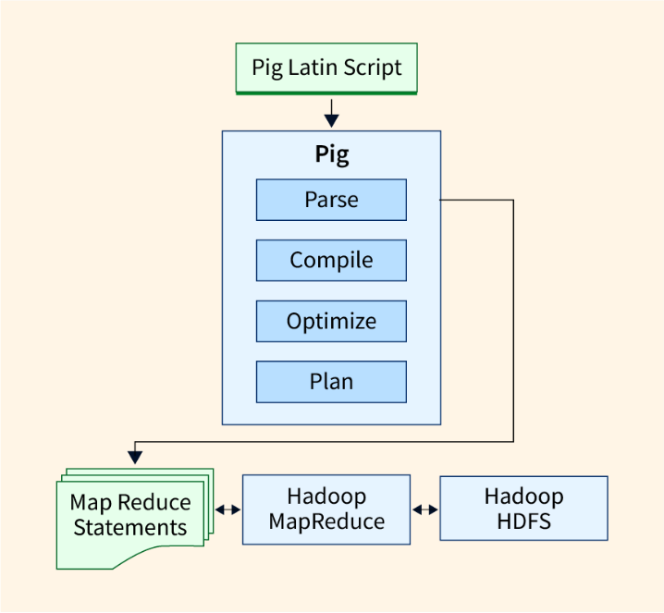
Figure 1: Apache Pig architecture

Components of Pig Architecture
- Pig Scripts (Input Layer) – Written in Pig Latin. Schema is optional and operations include LOAD, FILTER, GROUP, JOIN, FOREACH and STORE.
- Parser (Syntax Analysis) – Validates Pig Latin scripts, performs lexical analysis and grammar checks, reports errors and generates an Abstract Syntax Tree (AST).
- Optimizer (Logical Optimization) – Improves query efficiency using filter pushdown, projection pushdown and multi-query optimization.
- Compiler (Code Generation) – Converts the optimized plan into MapReduce jobs, creates an execution DAG and integrates User Defined Functions (UDFs).
- Execution Engine (Runtime) – Runs the MapReduce jobs on Hadoop. It supports Local Mode, MapReduce Mode and Tez Mode and handles job submission and monitoring.

Pig Data Types
Scalar Types: int, long, float, double, chararray, bytearray, boolean, datetime
Complex Types:
- Tuple → Ordered set of fields.
- Bag → Collection of tuples.
- Map → Key-value pairs.

Common Pig Operations
- LOAD → Load data from file system.
- STORE → Save data to file system.
- DUMP → Display data on console.
- FILTER → Select records based on conditions.
- FOREACH → Apply transformations to each record.
- GROUP → Group records by field(s).
- JOIN → Join multiple datasets.
- ORDER → Sort records.
- DISTINCT → Remove duplicates.
- CROSS → Cartesian product of datasets.
- COGROUP → Group multiple datasets together.

Advantages of Apache Pig
- Reduced Development Time → Shorter, easier scripts than MapReduce.
- Automatic Optimization → Execution plans optimized internally.
- Multi-query Optimization → Minimizes redundant scans.
- Extensible → UDFs supported in Java, Python, JavaScript, Ruby and Groovy.
- Lazy Evaluation → Execution deferred until DUMP or STORE.
- Schema Flexibility → Works with or without schema.
- Hadoop Integration → Works seamlessly with HDFS, HBase, etc.

Disadvantages of Apache Pig
- Learning Curve → Requires learning Pig Latin and new concepts.
- Performance Overhead → Abstraction adds some cost compared to raw MapReduce.
- Batch-Oriented → Not suitable for real-time processing.
- Debugging Complexity → Troubleshooting large scripts can be hard.
- MapReduce Dependency → Performance limited by MapReduce’s constraints.

Uses of Apache Pig
- ETL Operations → Extract, Transform, Load workflows in data lakes/warehouses.
- Log Processing → Analyze web, app and server logs.
- Data Transformation → Data cleansing, format conversions and preparation.
- Research & Prototyping → Quick analysis and experimentation.
- Ad-hoc Analysis → Exploratory queries on Hadoop datasets.
- Report Generation → Summaries and reports from big data.

Procedure / Implementation
The following screenshots are selected from the actual Experiment 5 execution supplied in the ZIP. Only screenshots that directly demonstrate the required Pig operations are included.

1. Loading and Displaying Department Data
Department data is loaded into a Pig relation using PigStorage(',') with fields such as id, name, department name and salary.
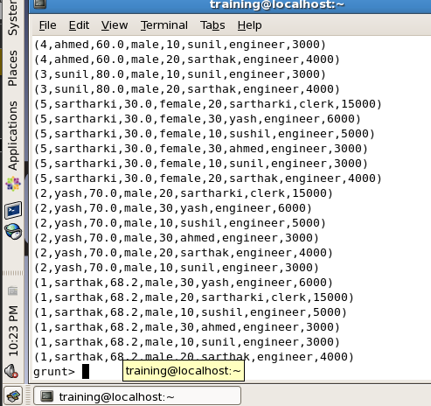
Figure 2: Output of the CROSS operation using student and department data.

2. DISTINCT Operation
The DISTINCT operation removes duplicate tuples from relation A.
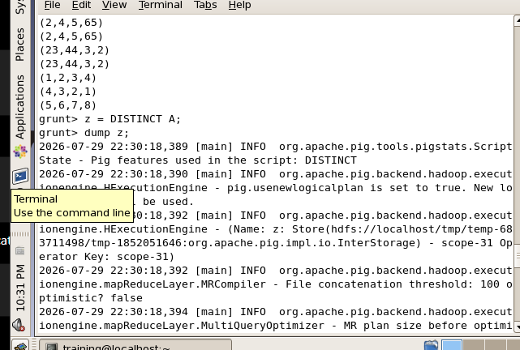
Figure 3: Pig command for DISTINCT operation.
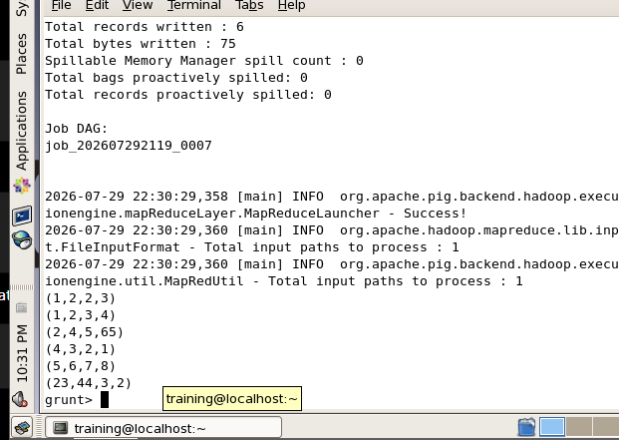
Figure 4: Output after applying DISTINCT.

3. FILTER Operation
The FILTER operation selects records satisfying a specified condition.
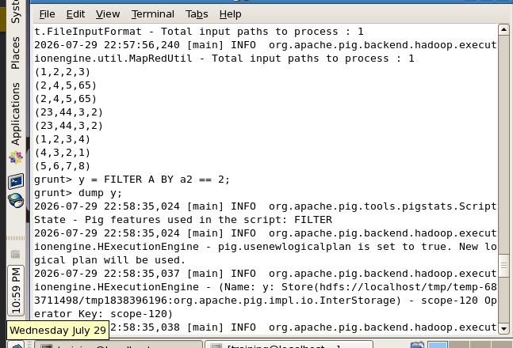
Figure 5: FILTER operation using a numeric condition.
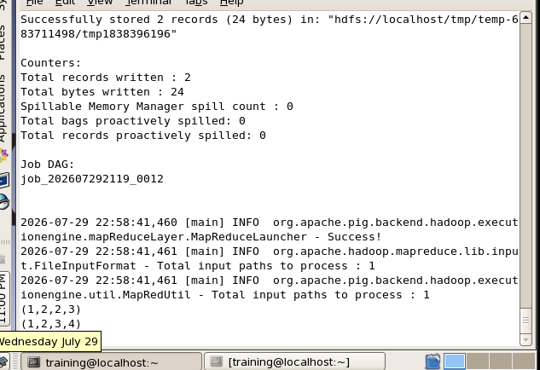
Figure 6: Output of the FILTER operation.

4. FOREACH / Data Projection
FOREACH is used to project selected fields from the department relation.
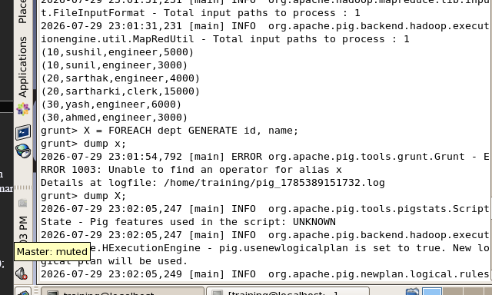
Figure 7: FOREACH operation for data projection.
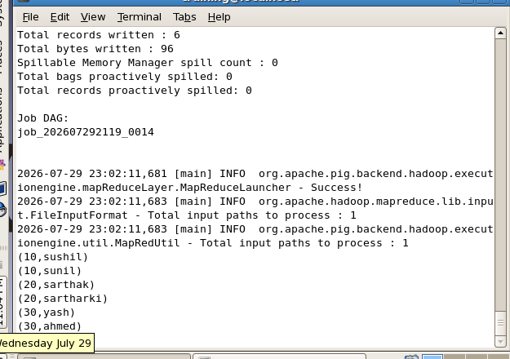
Figure 8: Output showing selected id and name fields.

5. COGROUP Operation
COGROUP groups records from two relations using a common key.
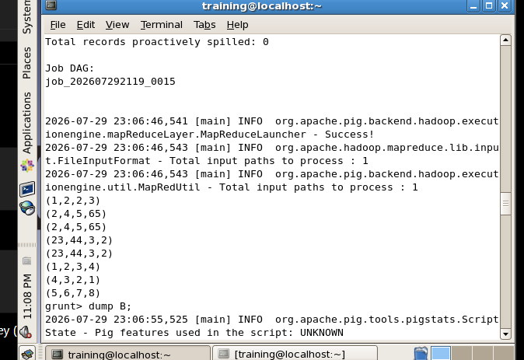
Figure 9: Displaying relation B before COGROUP.
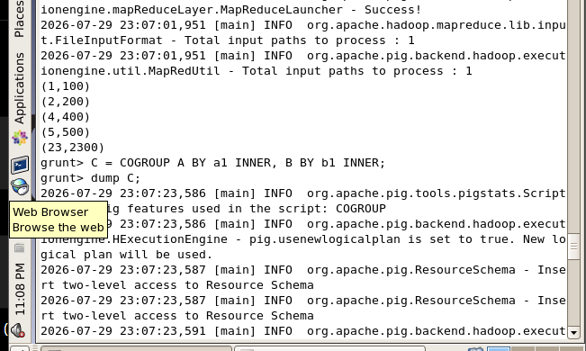
Figure 10: COGROUP command and execution.
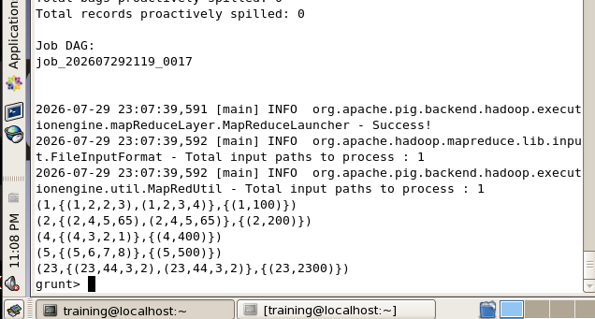
Figure 11: Output of the COGROUP operation.

6. Advanced COGROUP Processing – Selecting B.b2
FOREACH is applied to the COGROUP result to extract the group and the B.b2 field.
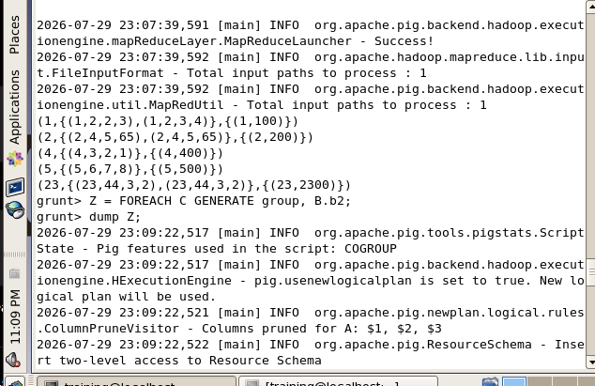
Figure 12: Advanced COGROUP processing using B.b2.
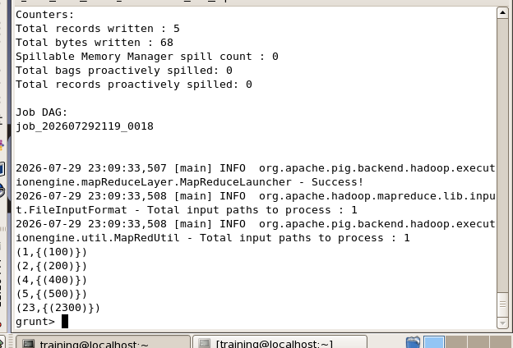
Figure 13: Output of the advanced COGROUP operation.

7. Advanced COGROUP Processing – Selecting A Fields
The COGROUP result is further processed to extract group and selected fields from relation A.
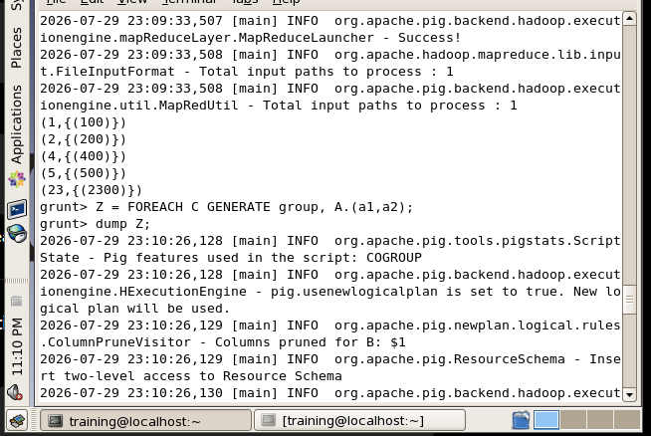
Figure 14: Advanced COGROUP processing using A.(a1,a2).
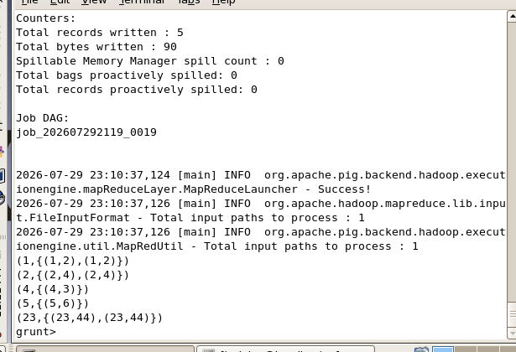
Figure 15: Final output of the advanced COGROUP processing.

Result
The Apache Pig experiment was successfully performed on Hadoop. The supplied execution screenshots demonstrate data loading and processing using Pig Latin operations including CROSS, DISTINCT, FILTER, FOREACH and COGROUP, along with advanced COGROUP processing.

Conclusion
Apache Pig simplifies big data processing by providing Pig Latin, a high-level scripting language that abstracts away the complexities of writing MapReduce programs. In this experiment, different Pig Latin operations were executed successfully and their outputs were verified. The experiment demonstrates how Pig can be used for batch data analysis and transformation on Hadoop.

