Experiment No. 6

Aim : Create HIVE Database and Descriptive analytics (basic statistics).
Theory :
Apache Hive is a distributed data warehouse framework that simplifies the processing of large datasets stored in the Hadoop Distributed File System (HDFS). Developed originally by Facebook, Hive provides a SQL-like interface called Hive Query Language (HQL), allowing users to perform data analysis without writing complex Java-based MapReduce programs. Hive is primarily designed for Online Analytical Processing (OLAP) and is widely used for business intelligence, reporting, and large-scale data analysis.
Hive organizes data into databases, tables, partitions, and buckets, similar to traditional relational database systems. Metadata such as table definitions, column types, partitions, and storage information is maintained in the Hive Metastore, which is usually implemented using a relational database such as MySQL or Derby. Hive also uses Serializer/Deserializer (SerDe) components to convert data between HDFS files and Hive tables.
HQL supports a wide range of SQL-like operations, including Data Definition Language (DDL) commands such as CREATE, ALTER, DROP, and DESCRIBE, as well as Data Manipulation Language (DML) commands such as LOAD, INSERT, and SELECT. It also provides aggregate functions like COUNT, SUM, AVG, MIN, and MAX, along with filtering, sorting, grouping, and joining capabilities. These features allow users to efficiently perform analytical queries on massive datasets.
Unlike traditional relational databases, Hive is optimized for batch processing rather than real-time transaction processing. It provides high scalability by leveraging Hadoop's distributed storage and processing capabilities, making it suitable for analyzing terabytes or petabytes of structured data. Hive integrates seamlessly with other Hadoop ecosystem tools such as Pig, HBase, Sqoop, and Spark, making it an important component of modern Big Data analytics platforms.

Advantages
- Provides an SQL-like query language (HQL) that is easy for SQL users to learn.
- Eliminates the need to write complex MapReduce programs.
- Capable of processing very large datasets stored in HDFS.
- Supports Data Definition Language (DDL), Data Manipulation Language (DML), and User Defined Functions (UDFs).
- Easily integrates with other Hadoop ecosystem tools such as Pig, HBase, Sqoop, and Spark.
- Supports partitioning and bucketing for improved query performance.
- Highly scalable and fault tolerant due to Hadoop's distributed architecture.
- Suitable for ETL operations, data warehousing, and business intelligence applications.

Disadvantages
- Not suitable for Online Transaction Processing (OLTP) applications.
- Higher query execution time compared to traditional relational databases.
- Not designed for real-time data processing.
- Limited support for row-level updates and deletes in older Hive versions.
- Performance depends on the underlying Hadoop cluster configuration.
- Less efficient for small datasets and interactive applications.

Real-Life Applications
- Enterprise data warehousing and business intelligence.
- ETL (Extract, Transform, Load) operations for Big Data platforms.
- Analysis of customer purchase and sales data.
- Banking and financial transaction analytics.
- Healthcare data analysis and patient record management.
- Telecommunications usage and call detail record analysis.
- Web log and clickstream analysis.
- Social media data analytics.
- Large-scale reporting and dashboard generation.
- Data preparation for machine learning and predictive analytics.

Architecture Diagram:
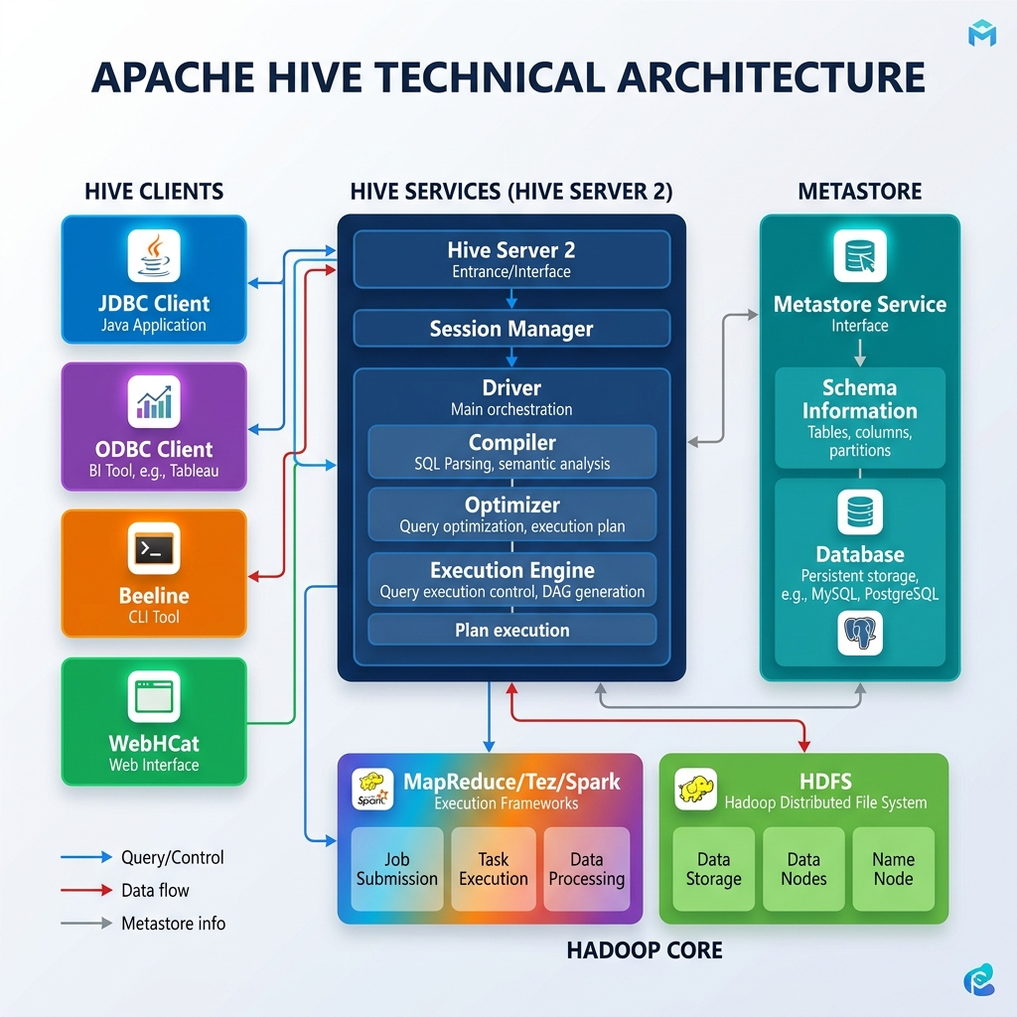

STEP 1
Starts the Hive terminal CLI and lists all existing databases using show databases;.
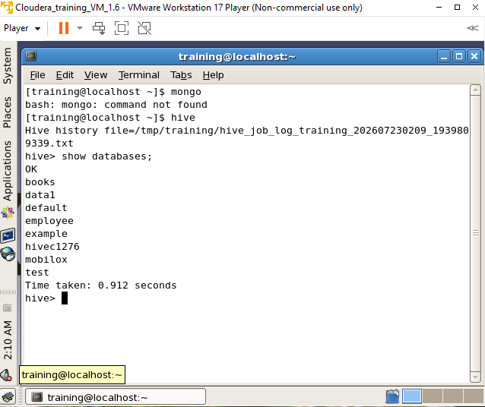

STEP 2
Lists all existing tables in the active Hive database using show tables;.
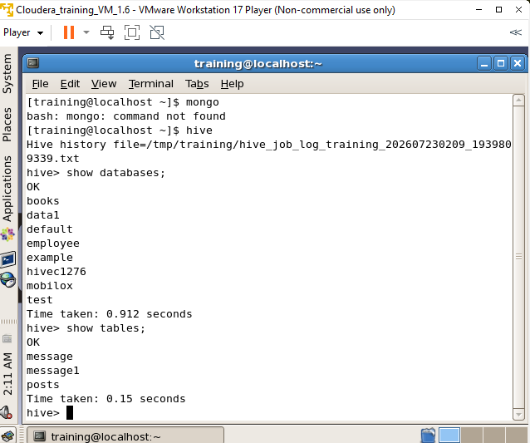

STEP 3
Attempts to switch to a non-existent database, returning a metadata error.
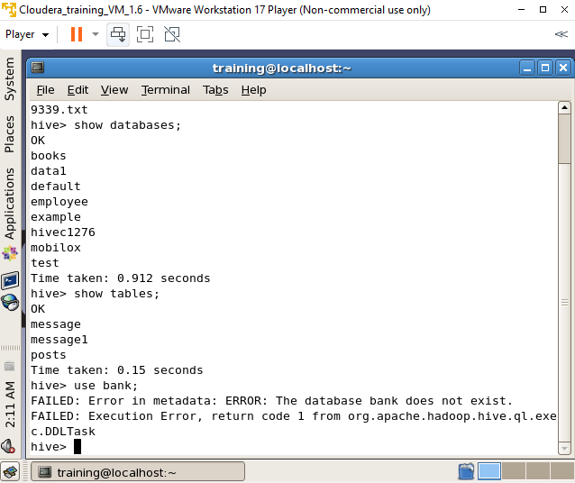

STEP 4
Creates a new database in Hive using create database <database_name>;.
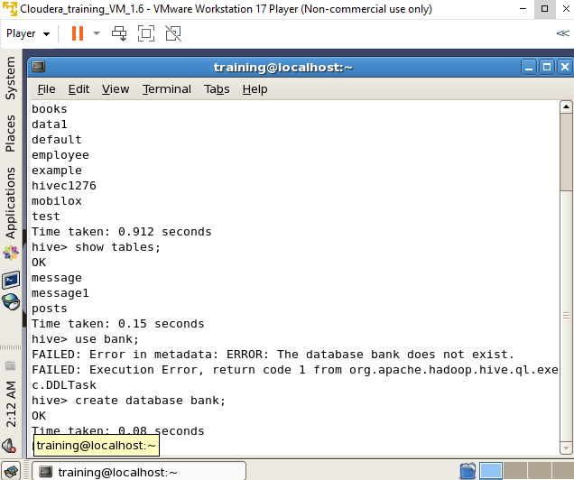

STEP 5
Switches to the active database and creates a delimited table structure using create table <table_name>(...).
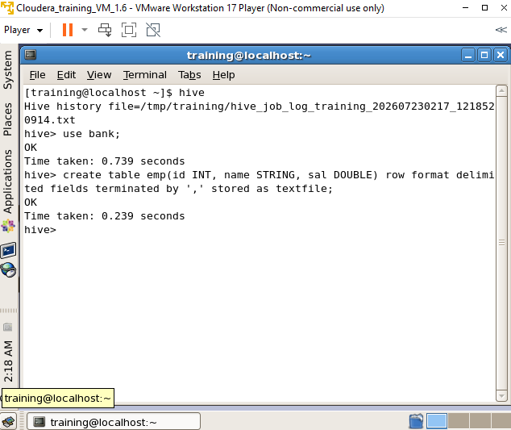

STEP 6
Describes the column schema and data types of a specific table using describe <table_name>;.
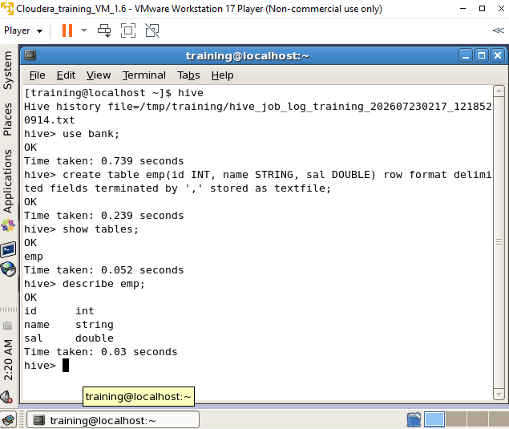

STEP 7
Loads local text file data into the designated Hive database table using load data local inpath ....
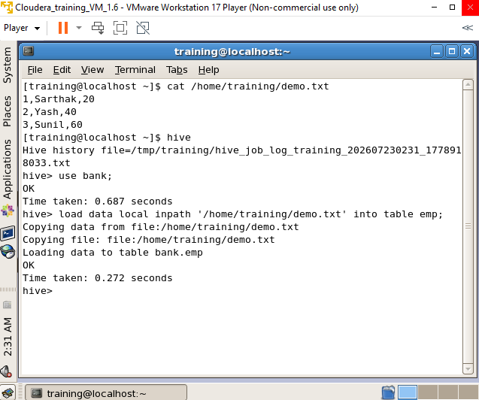

STEP 8
Fetches and displays all records stored inside the table using select * from <table_name>;.
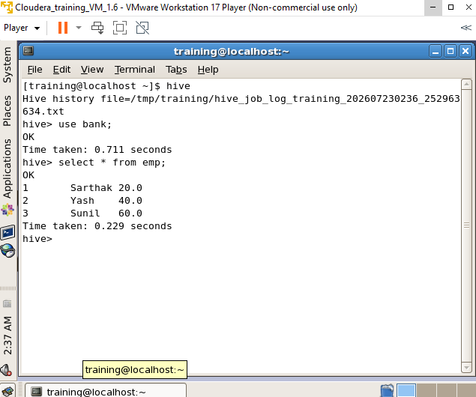

STEP 9
Renames an existing table to a new name using alter table <table_name> rename to <new_table_name>;.
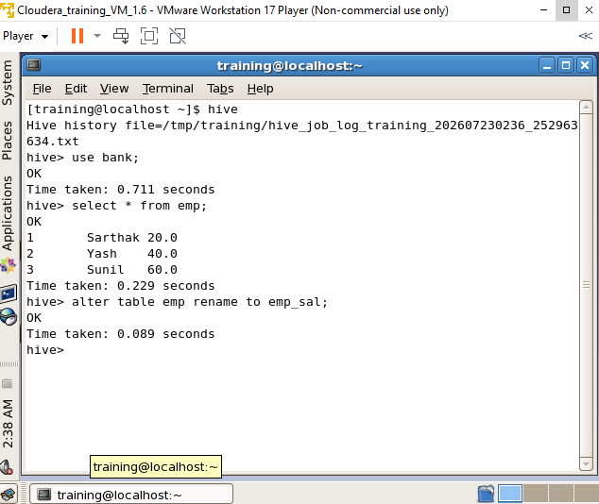

STEP 10
Runs a MapReduce-backed conditional query to filter records matching a specific column value.
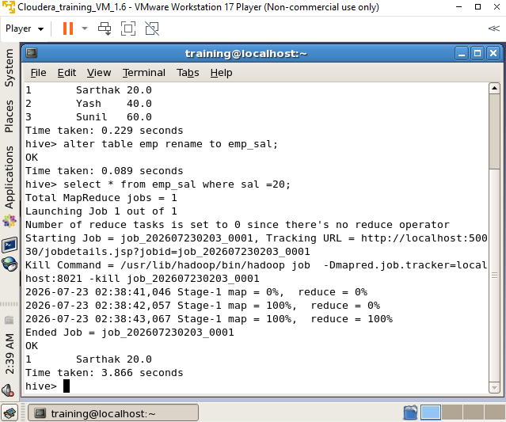

STEP 11
Executes an aggregation query using select count(*) from <table_name>; to count total records via MapReduce.
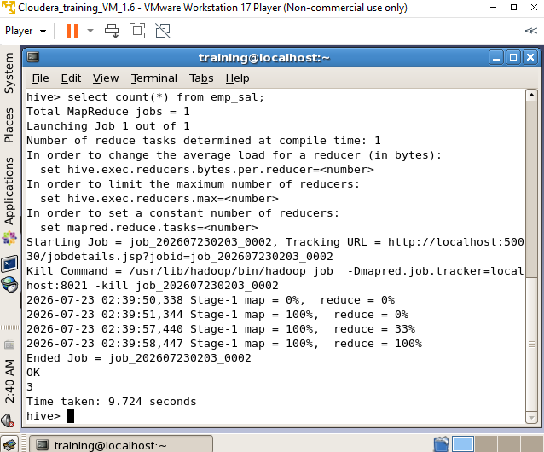

STEP 12
Calculates the average value of a numeric column using select AVG(<column_name>) as <alias> from <table_name>;.
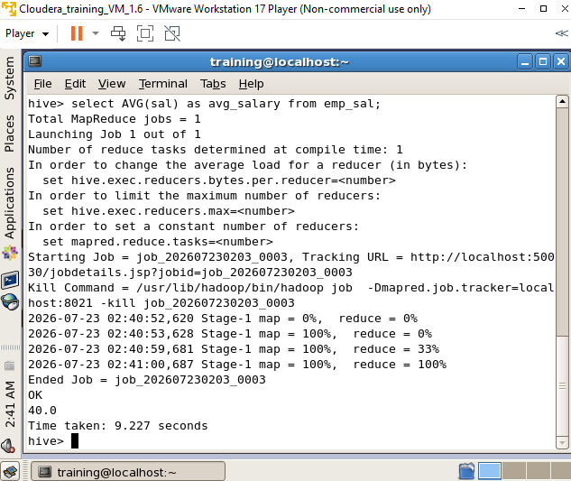

STEP 13
Finds the maximum value in a numeric column using select MAX(<column_name>) as <alias> from <table_name>;.
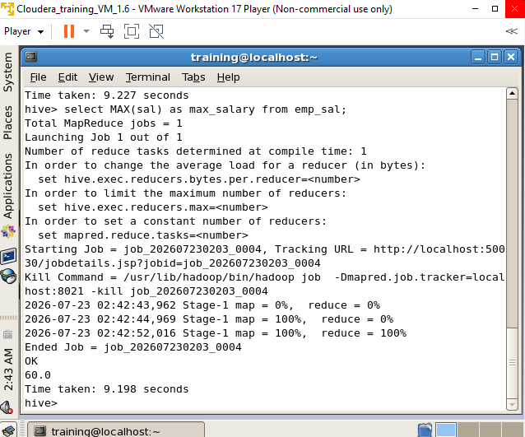

STEP 14
Removes the specified table from the database schema using drop table <table_name>;.
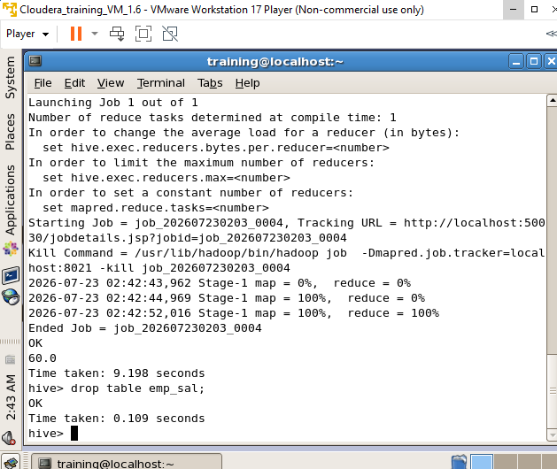

STEP 15
Closes the current session and exits the Hive CLI using exit;.
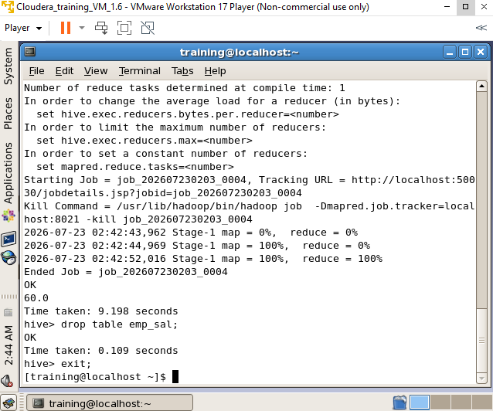

Conclusion :
Through this experiment, the capabilities of Apache Hive as a data warehouse solution within the Hadoop ecosystem were successfully explored. Various Hive shell commands were executed to create and manage databases and tables, load local data into the distributed storage, and run both simple and MapReduce-backed analytical queries using HQL. This provided practical experience in performing data definition, data manipulation, and data aggregation operations on large-scale datasets.

