Student ID | 23CS056 | Student Name | Yash Parmar
Subject Code & Name | CSE304: Full Stack Development | Practical | 13 | Academic Year | 2025-26

Task – 13
Aim
A tax form website asks users to enter income from two sources. You need to take these numbers and display the total income. Use Express JS, accept inputs via POST, and show results using EJS templates. Validate user input and avoid client-side calculations. Keep the interface user-friendly and clear.
Code
GitHub Repository Link: -
Output
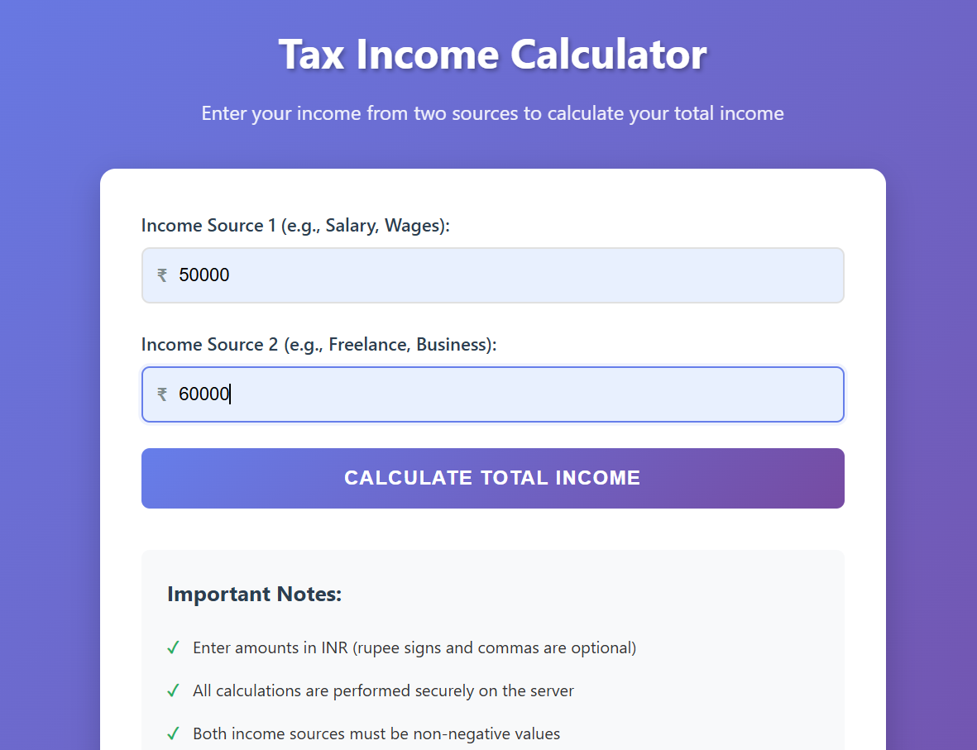
Figure 1: Home page

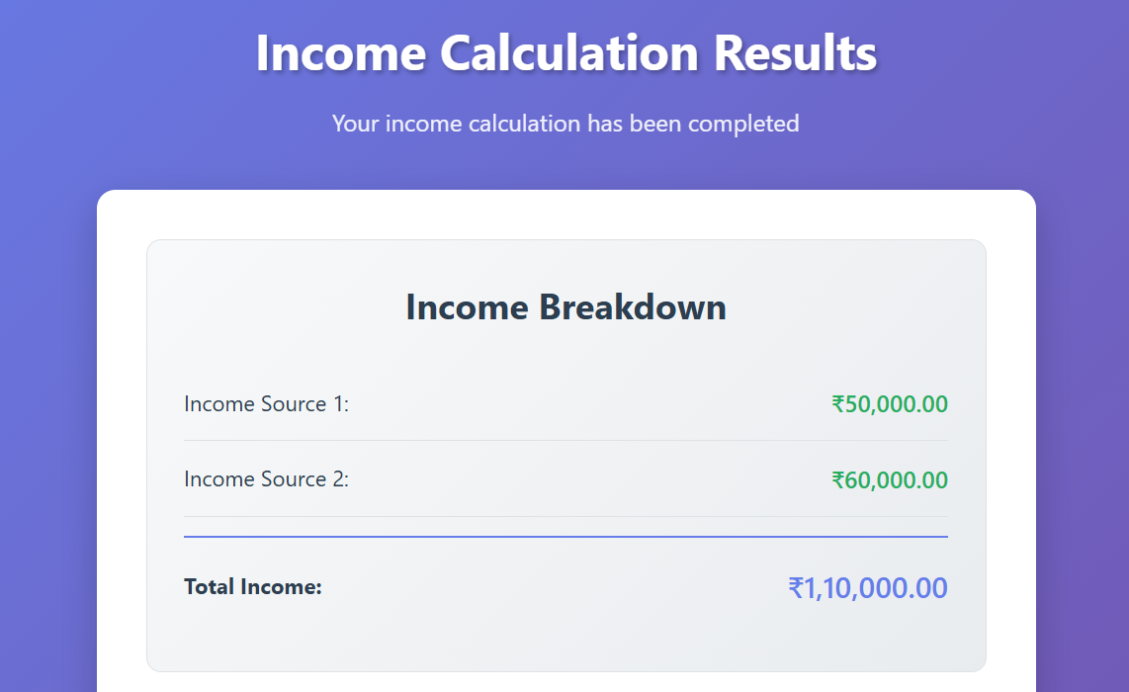

Figure 2: Calculated income

