Student ID | 23CS056 | Student Name | Yash Parmar
Subject Code & Name | CSE304: Full Stack Development | Practical | 7 | Academic Year | 2025-26

Task – 7
Aim
Creating a React Sidebar Navigation Menu involves using React Hooks to manage the state and handle the functionality of the sidebar, such as opening and closing the menu, and navigating between different sections of the webpage.
Code
GitHub Repository Link: - https://github.com/Yash-109/FSD/tree/main/practical-7
Output
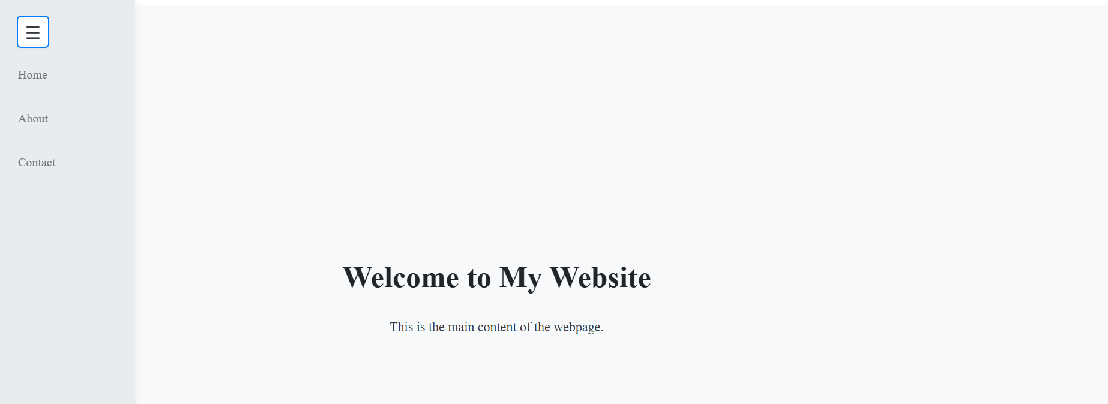

Figure 1: Home screen with menu

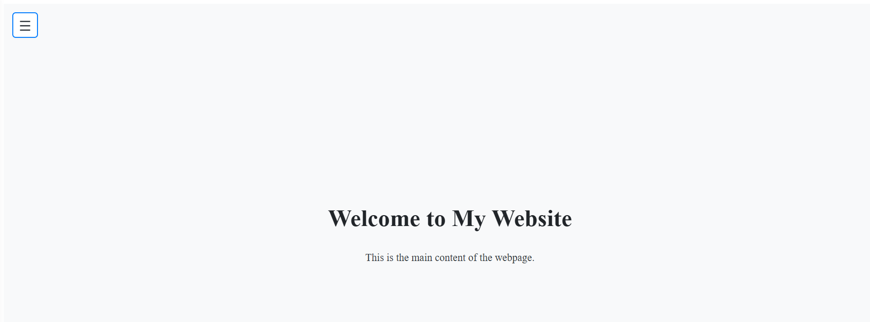

Figure 2: Home screen without menu

