Student ID | 23CS056 | Student Name | Yash Parmar
Subject Code & Name | CSE304: Full Stack Development | Practical | 8 | Academic Year | 2025-26

Task – 8
Aim
You’re hired to create a tool for gym users to count their exercise reps. They want a simple interface to increase or decrease the count with each move. Build a web-based counter that updates instantly when users click buttons. Make it easy to use on both mobile and desktop. Ensure the counter doesn't reset on page reload unless reset manually.
Code
GitHub Repository Link: - https://github.com/Yash-109/FSD/tree/main/practical-8
Output
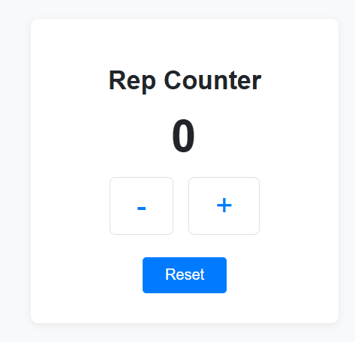

Figure 1: Rep counter

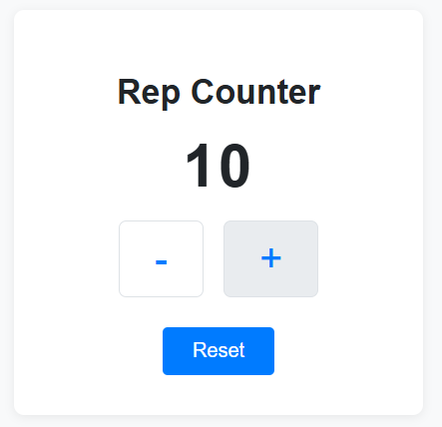

Figure 2: Rep counter after reload

