Student ID | 23CS056 | Student Name | Yash Parmar
Subject Code & Name | CSE304: Full Stack Development | Practical | 10 | Academic Year | 2025-26

Task – 10
Aim
A company stores error logs in .txt files on the server. You need to create a tool for developers to view these logs via a browser. Write an Express JS app that reads a text file and shows its content on a web page. Include error handling if the file is missing or inaccessible. This helps developers debug without accessing the server files directly.
Code
GitHub Repository Link: https://github.com/Yash-109/FSD/tree/main/practical-10
Output
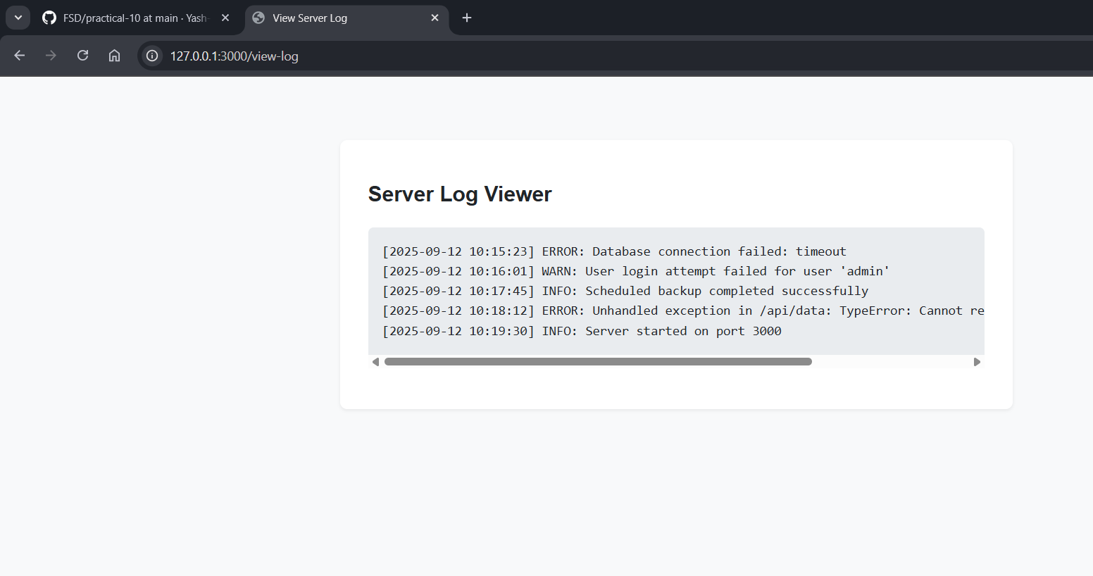Figure 1: Log Page

