Student ID | 23CS056 | Student Name | Yash Parmar
Subject Code & Name | CSE304: Full Stack Development | Practical | 11 | Academic Year | 2025-26

Task – 11
Aim
You're onboarding a new team and need a project template. Create a basic Express JS app with a /home route. When users visit this route, they should see a greeting message. This route will later serve as a dashboard page. Use this as the base for future web applications.
Code
GitHub Repository Link: https://github.com/Yash-109/FSD/tree/main/practical-11
Output
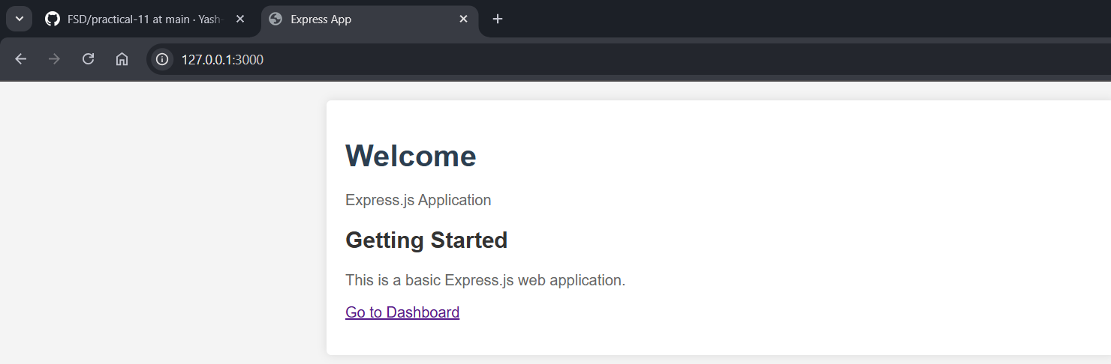Figure 1: Dashboard Page

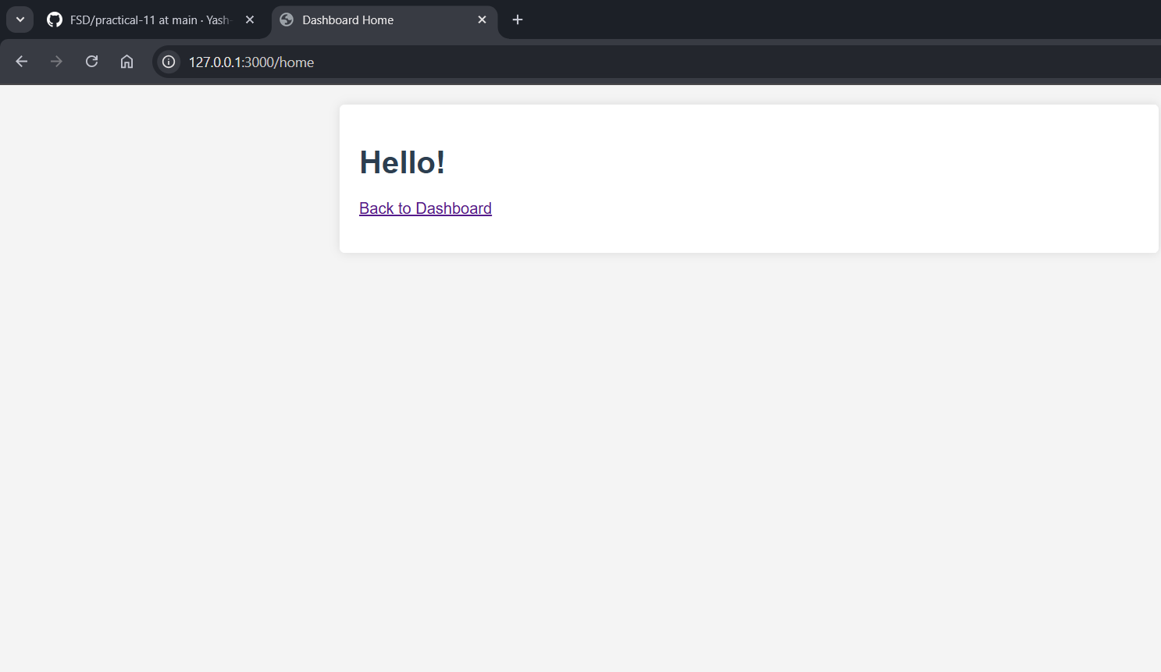
Figure 2: Home Page

