Student ID | 23CS056 | Student Name | Yash Parmar
Subject Code & Name | CSE304: Full Stack Development | Practical | 12 | Academic Year | 2025-26

Task – 12
Aim
You’re building a simple web-based calculator for kids. Create a form where users enter two numbers. Use Express JS to perform basic operations: add, subtract, multiply, divide. Display the result on the screen. Ensure invalid inputs (like letters) are handled properly.
Code
GitHub Repository Link: https://github.com/Yash-109/FSD/tree/main/practical-12
Output
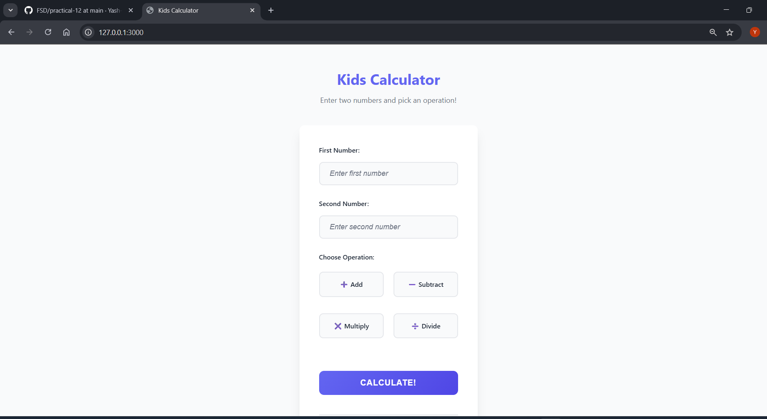Figure 1: Landing Page
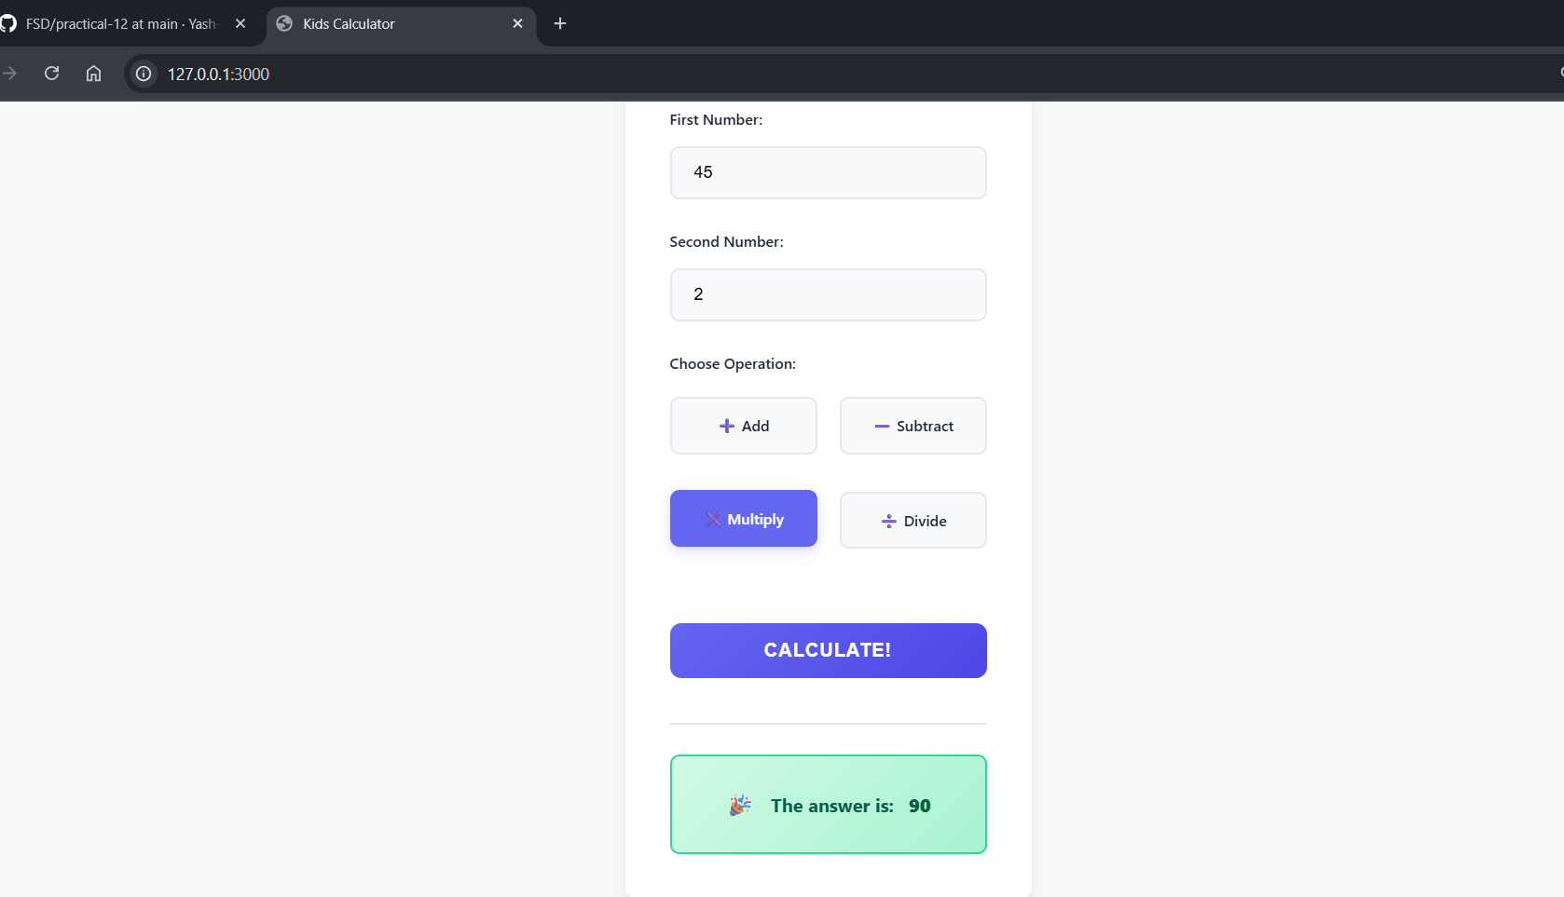Figure 2: After Calculation

