Student ID | 23CS056 | Student Name | Yash Parmar
Subject Code & Name | CSE304: Full Stack Development | Practical | 9 | Academic Year | 2025-26

Task – 9
Aim
Your manager asks you to set up a backend for a small product site. As a proof of concept, create a basic Express JS server. When someone visits the home route, it should display “Welcome to our site”. This helps your team understand the Express framework structure. Keep the code clean and scalable for future features.
Code
GitHub Repository Link: https://github.com/Yash-109/FSD/tree/main/practical-9
Output
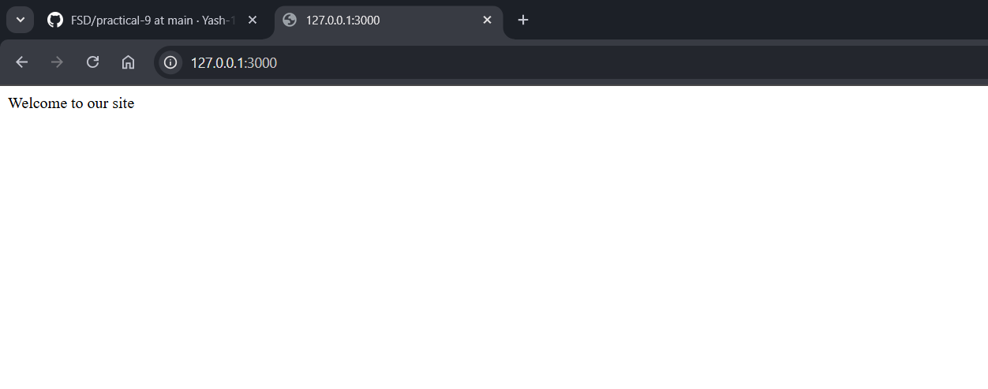Figure 1: Welcome Page

