Student ID(s) | 23CS047 | Student Name | Kunj Mungalpara
Student ID(s) | 23CS048 | Student Name | Raxeetkumar Nakum
Student ID(s) | 23CS056 | Student Name | Yash Parmar
Subject Code & Name | CSE304: Full Stack Development | Mini Project |  | Academic Year | 2025-26

Thinkly
Project definition: Thinkly is an online full-stack Learning Management System built with React, Node.js, Express, and MongoDB. Thinkly provides a comprehensive platform for online education with separate interfaces for instructors and students.
GitHub Repository Link: https://github.com/kunj24/Thinkly
Output:

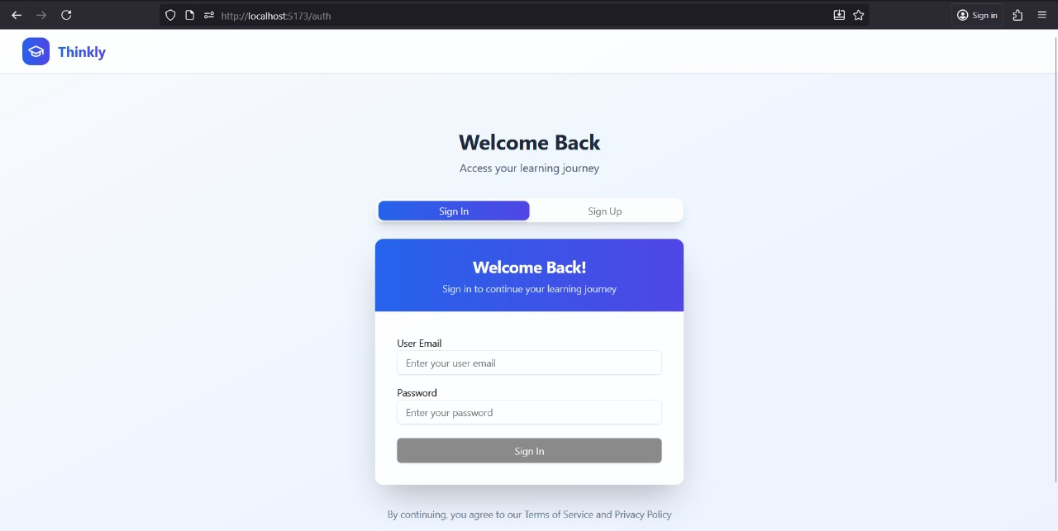
Figure-1.1 Login Page

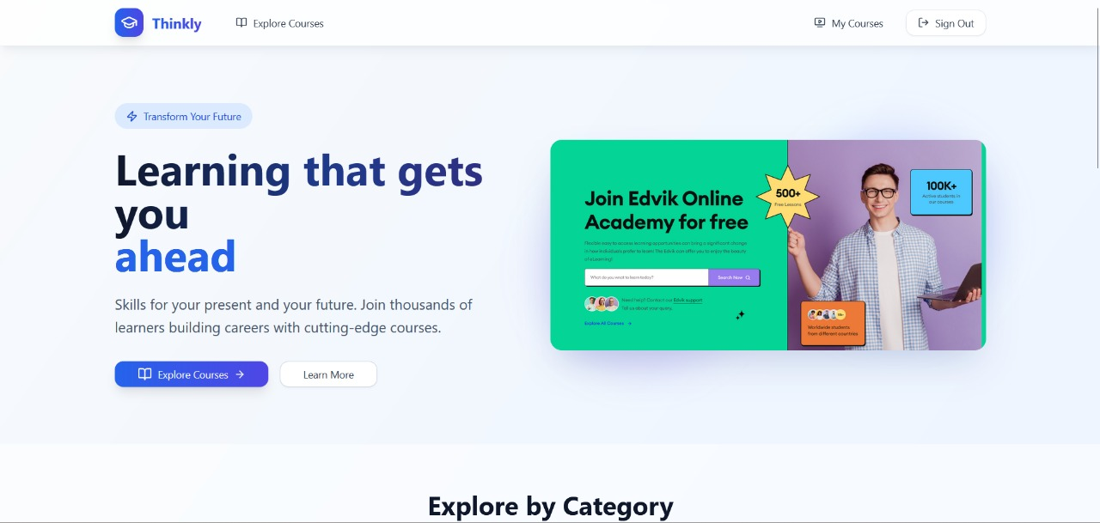

Figure-1.2 Home Page

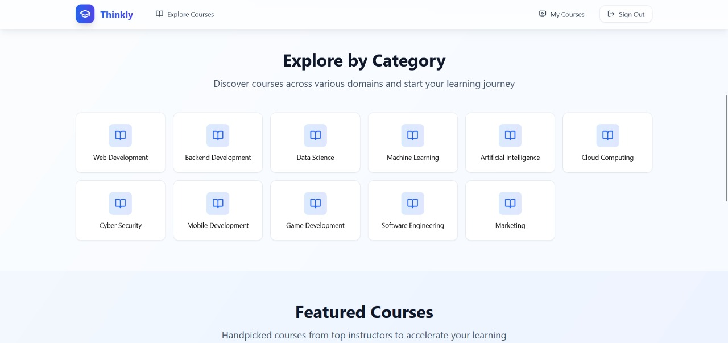

Figure-1.3 Home Page_2 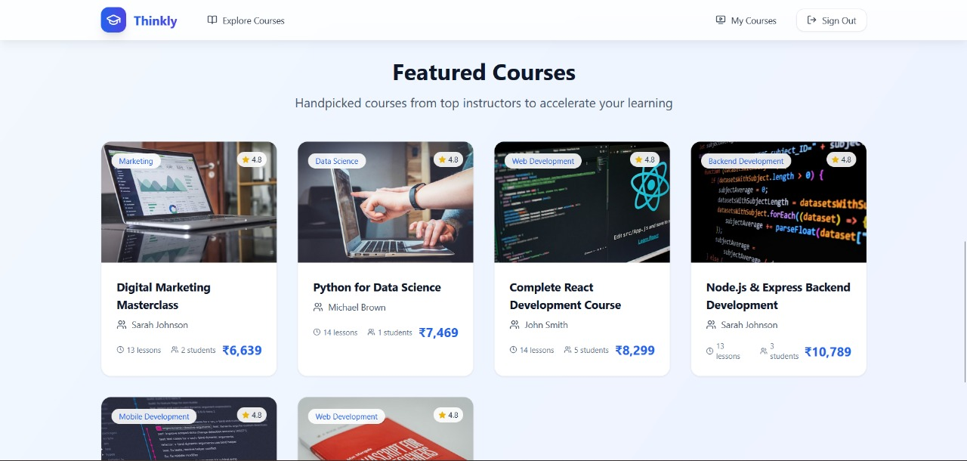

Figure-1.4 Home Page_3

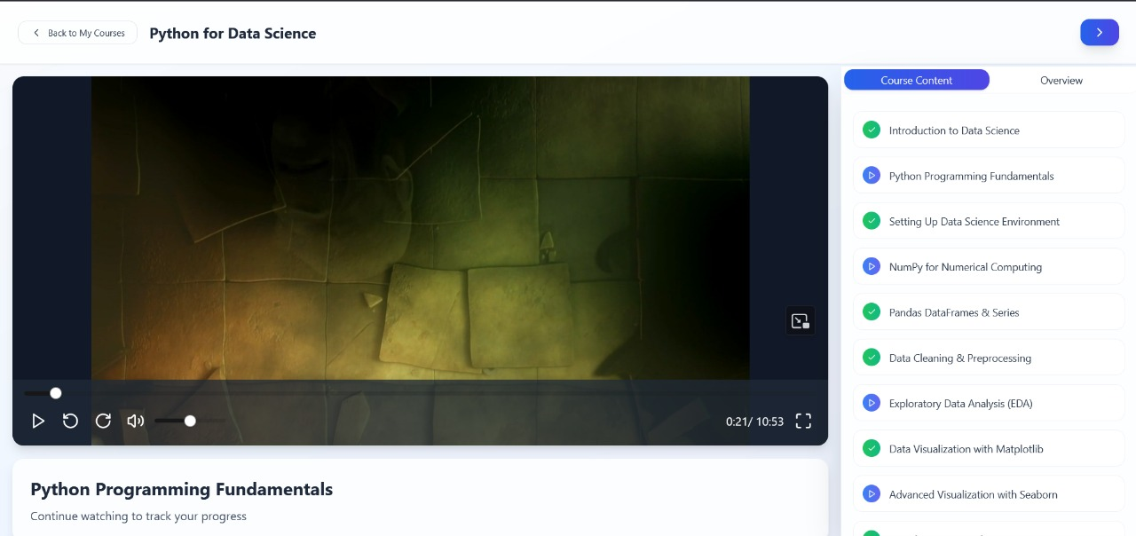

Figure-1.5 Course Page

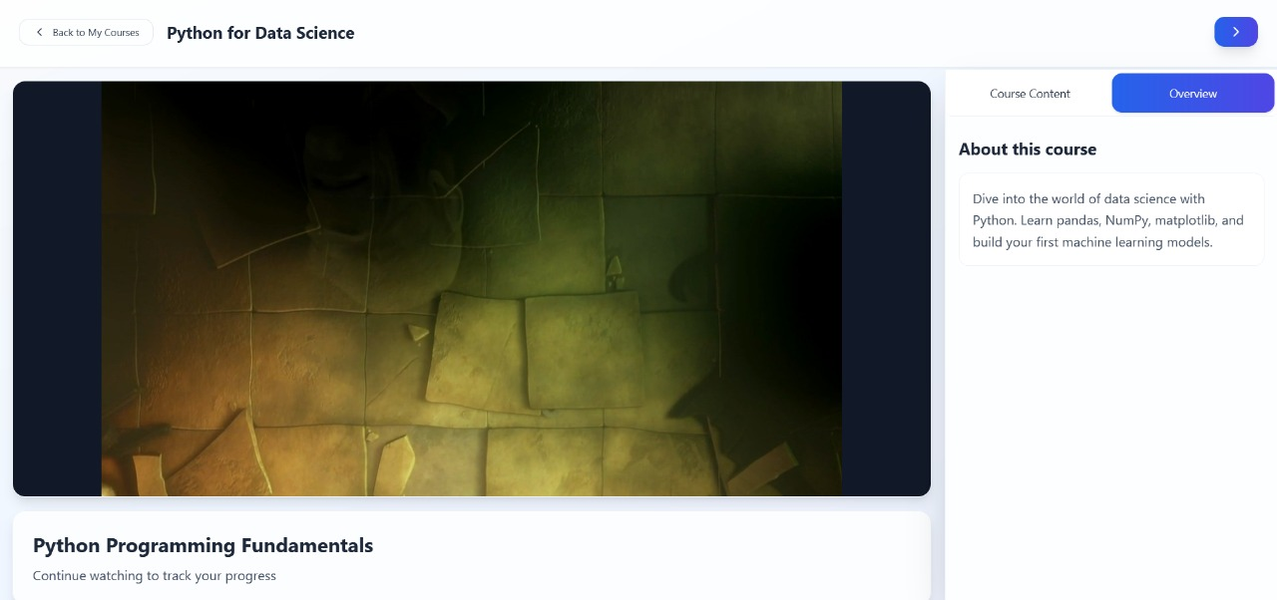

Figure-1.6 Course Overview Page



Figure-1.7 Browse Courses Page

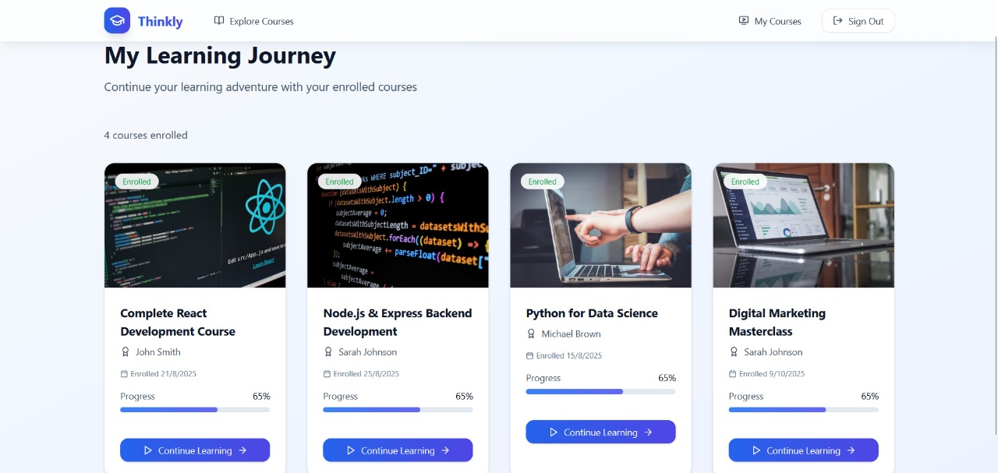

Figure-1.8 Enrolled Courses Page

