Student ID | 23CS056 | Student Name | Yash Parmar
Subject Code & Name | CSE304: Full Stack Development | Practical | 1 | Academic Year | 2025-26

Task – 1
Aim
Create a real-time voting system where users can vote on a poll and see the results updated in real-time using only JavaScript, HTML, and CSS.
Code
GitHub Repository Link : https://github.com/Yash-109/FSD/tree/main/practical-1
Output
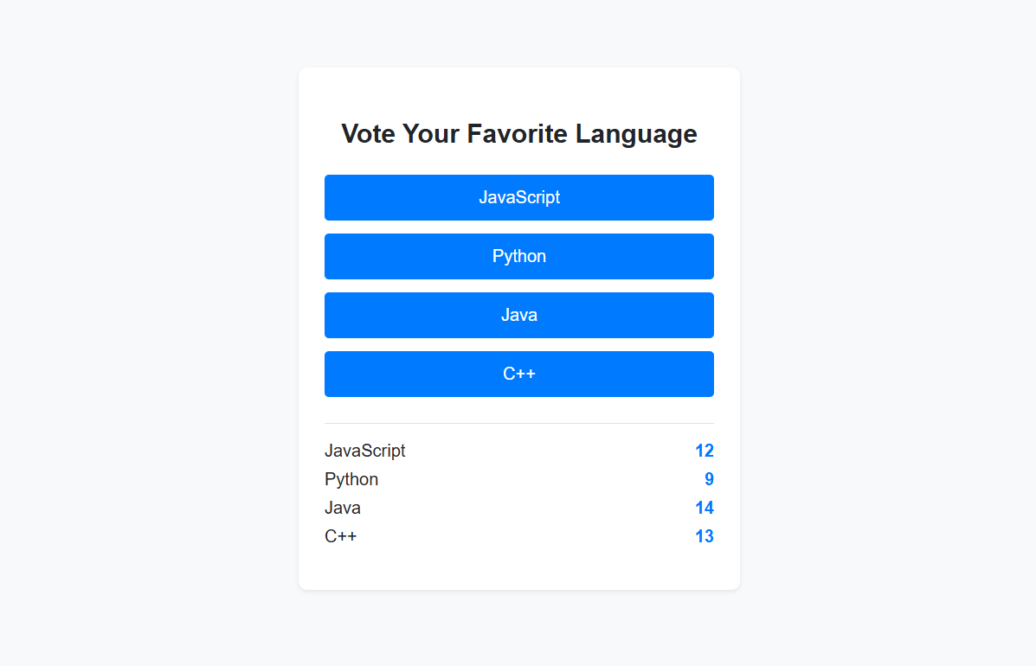Figure 1: Voting

