Student ID | 23CS056 | Student Name | Yash Parmar
Subject Code & Name | CSE304: Full Stack Development | Practical | 2 | Academic Year | 2025-26

Task – 2
Aim
Create a simple weather application that displays a hardcoded 3 temperature for a given city. This simple weather application demonstrates basic HTML structure for user input, CSS styling for layout and appearance, and JavaScript functionality to handle user interactions and display dynamic content. It provides a foundational example of building an interactive web application using essential front-end technologies. Technologies Used: HTML, CSS, JavaScript (ES6)
Code
GitHub Repository Link: https://github.com/Yash-109/FSD/tree/main/practical-2
Output
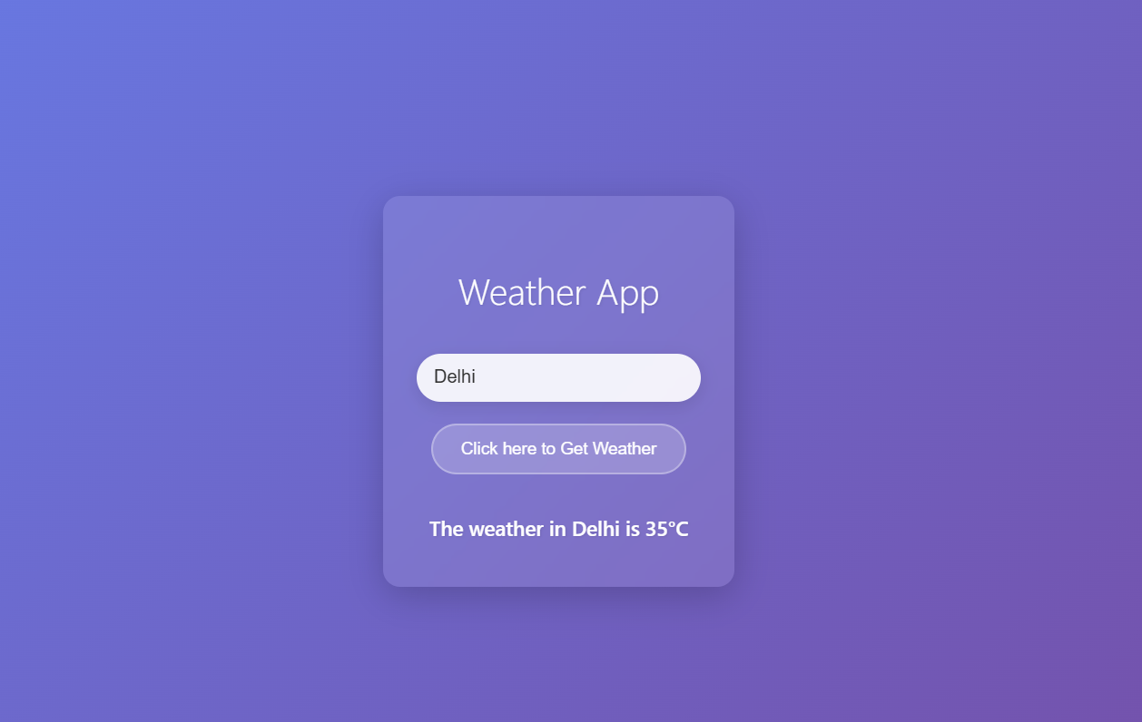Figure 1: Simple Weather Application

