Student ID | 23CS056 | Student Name | Yash Parmar
Subject Code & Name | CSE304: Full Stack Development | Practical | 3 | Academic Year | 2025-26

Task – 3
Aim
Create a React page that displays a Welcome message with the current local date and time which changes every second. Use the React JSX concept.
Note: Use the setInterval function to update the time.
Code
GitHub Repository Link: https://github.com/Yash-109/FSD/tree/main/practical-3
Output
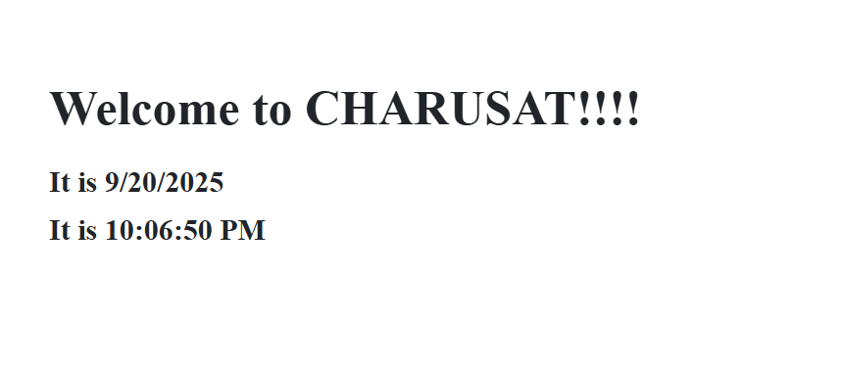Figure 1: Task - 3

