Student ID | 23CS056 | Student Name | Yash Parmar
Subject Code & Name | CSE304: Full Stack Development | Practical | 4 | Academic Year | 2025-26

Task – 4
Aim
Create a Counter App that includes the functionality of Increment, Decrement, Reset, and Increment Five.
The app also has two text boxes for first and surname names, the contents of which are shown as text on the same page. Utilize the React Hooks idea
Code
GitHub Repository Link:
Output
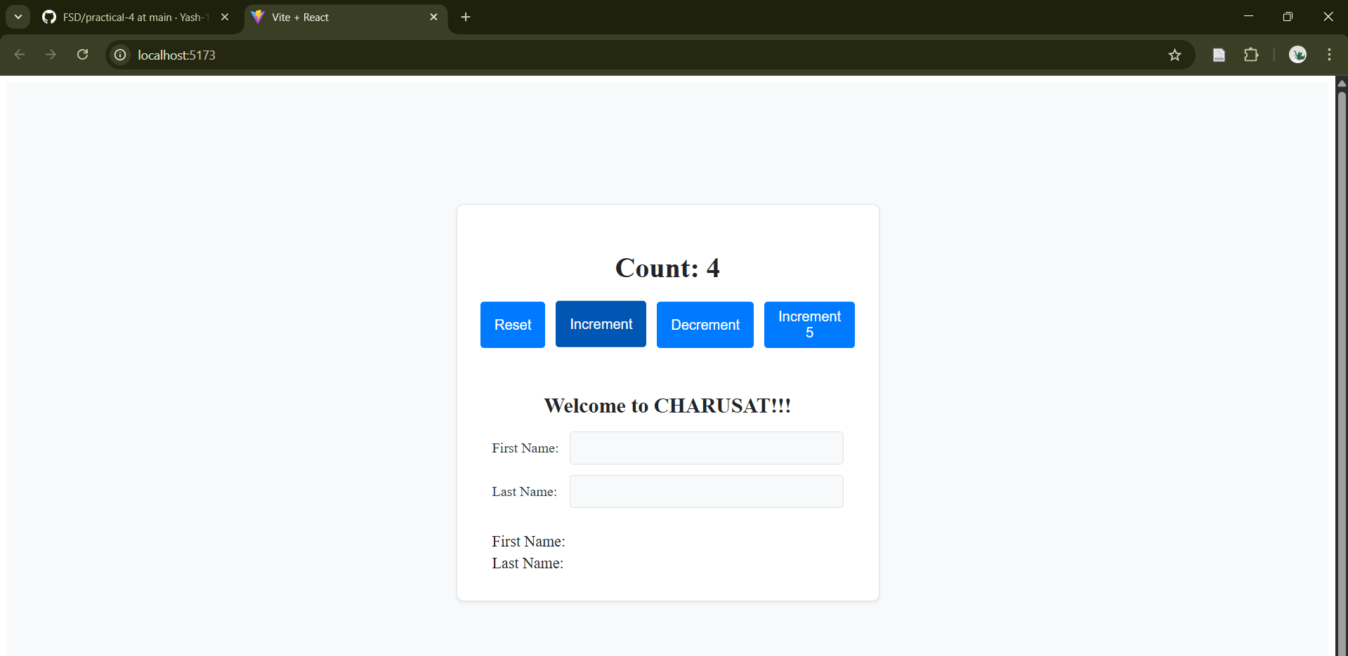Figure 1: Task - 4
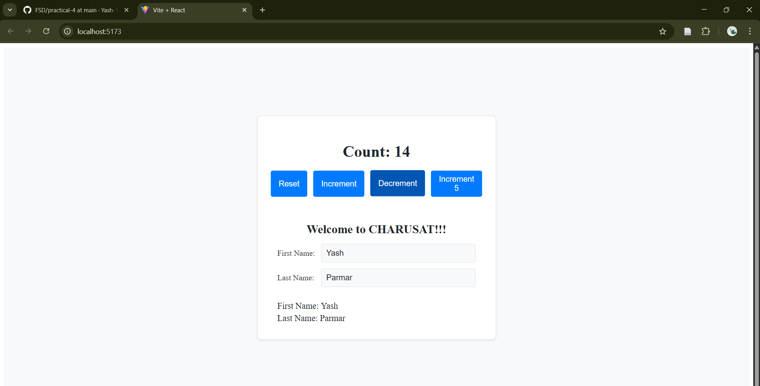
Figure 2: Negative counter

