SAP ANALYTICS CLOUD • SUPPLY CHAIN ANALYTICS

My First Hands on SAP Analytics Cloud Project
Supply Chain Inventory & Replenishment Control Tower
From a raw CSV dataset to a SAC story and executive dashboard

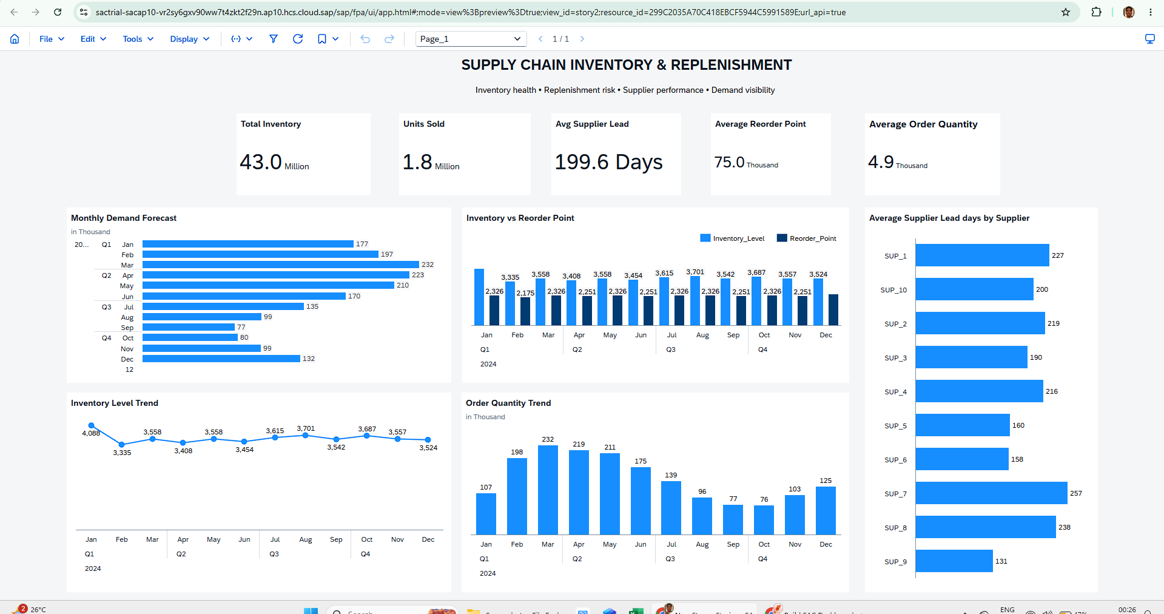

Figure 1. Final Supply Chain Inventory & Replenishment dashboard.

01 / WHY I BUILT THIS PROJECT

Why I built this project
I wanted my first SAC project to be practical, complete and easy to explain in an interview.
This project is my first hands-on work with SAP Analytics Cloud. I started without an existing SAC dashboard and worked through the platform step by step: I explored the SAC interface, loaded a supply-chain CSV, created and validated a dataset, worked with measures and calculations, and then built a story with KPI cards and charts.
I chose supply-chain inventory and replenishment because it gave me a clear business use case for learning analytics. The final dashboard brings inventory, demand forecast, reorder point, order quantity and supplier lead-time information into one view.

Why this matters
This project gives me something concrete to discuss: I have actually opened SAC, created an analytical asset, worked with data and built a story. I am not presenting myself as an experienced SAP consultant; I am showing that I can learn the platform and apply it to a business problem.

Project at a glance
Area | What I completed
Platform | SAP Analytics Cloud (SAC)
Data source | Supply-chain CSV dataset
Dataset | SC_Inventory_Replenishment_Analytics
Dataset size / SAC analysis view | 91,250 source rows, 2,000-row sample available for interactive analysis in the SAC trial setup, 15 fields
Story focus | Inventory, demand, replenishment and supplier lead time
Final output | One-page Supply Chain Inventory & Replenishment Control Tower

SAP ANALYTICS CLOUD • SUPPLY CHAIN ANALYTICS
02 / HOW I GOT STARTED WITH THE SAC INTERFACE

How I got started with the SAC interface
I first focused on understanding where the main SAC functions were before working with the data.

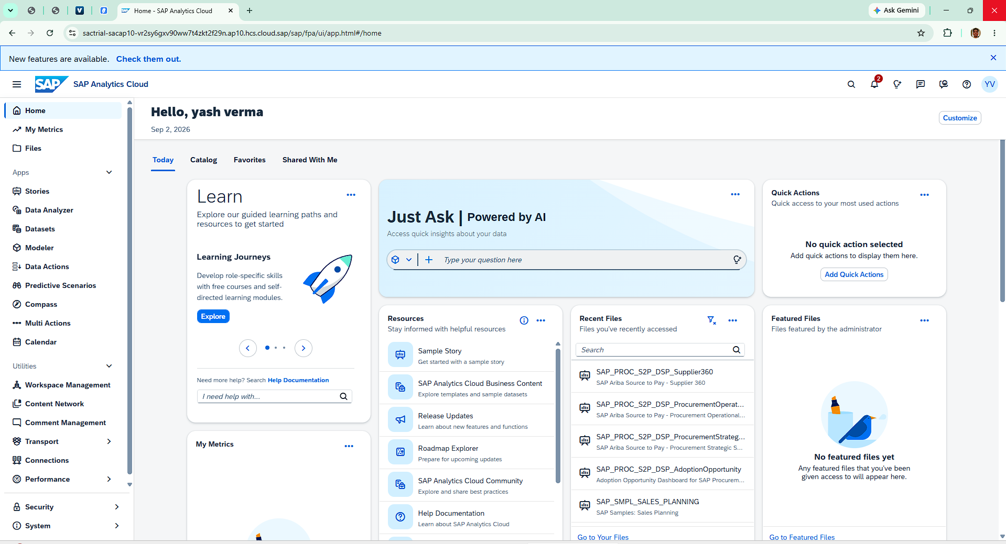

Figure 2. SAC Home screen used at the beginning of the project.

The Home screen was my starting point. From the left navigation I could see the main areas available to me, including Home, Files, Stories, Data Analyzer, Datasets, Modeler and other SAC utilities. For this project, the two areas I used most were Datasets and Stories.
My initial navigation
Open SAP Analytics Cloud and understand the main navigation.
Go to Datasets because I wanted to start from a raw file rather than an existing model.
Create the analytical dataset first and validate it before building visualizations.
Move to Stories only after the data was available and checked.
What I learned at this stage
SAC is not only a chart-building tool. The workflow makes more sense when I think about it as: data → analytical fields/measures → story → dashboard.

SAP ANALYTICS CLOUD • SUPPLY CHAIN ANALYTICS
03 / LOADING THE SUPPLY-CHAIN DATASET

Loading the supply-chain dataset
The next step was to bring the raw CSV into SAC and create a usable dataset.

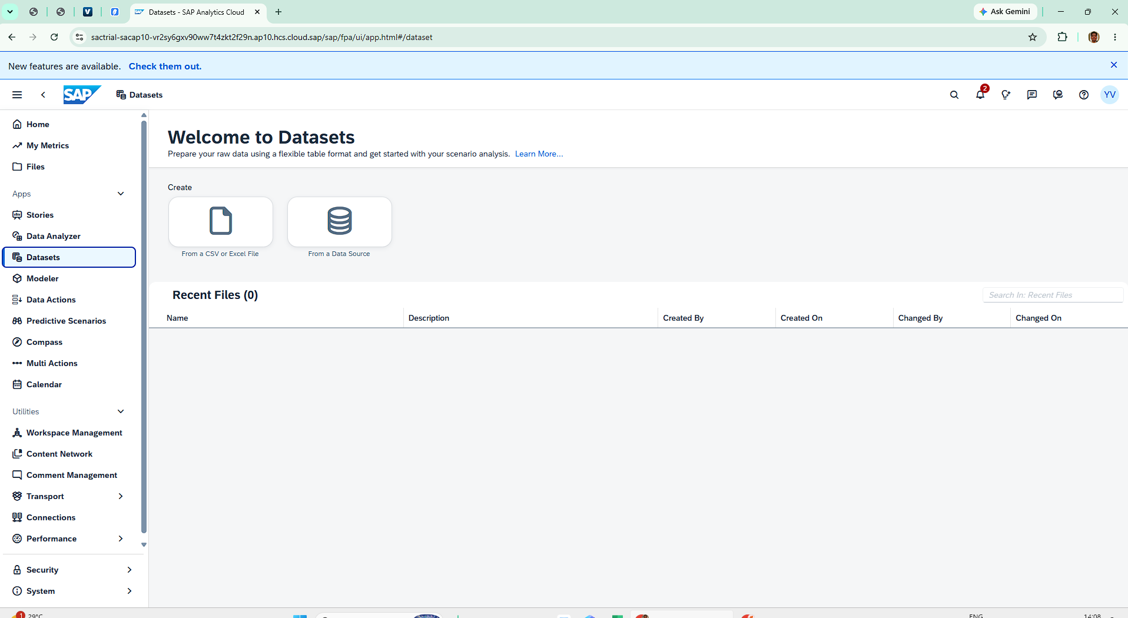

Figure 3. Starting dataset creation from a CSV/Excel file.

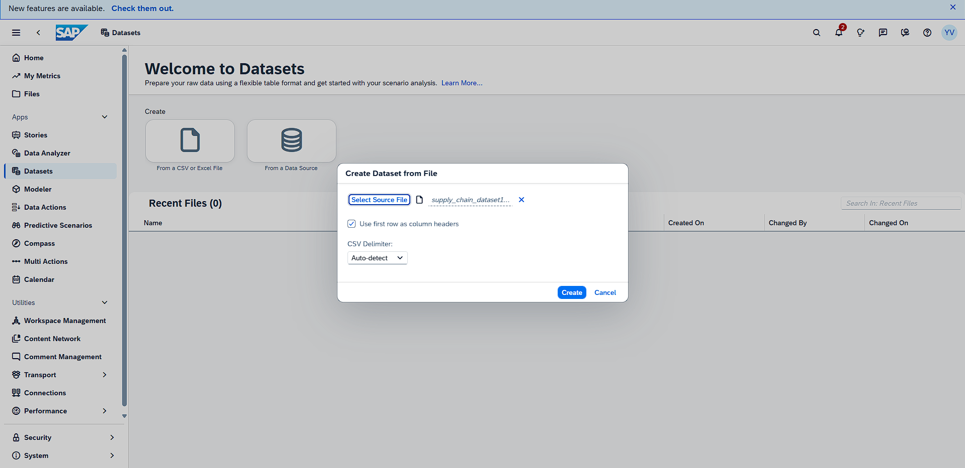

Figure 4. Configuring the source file before creating the dataset.

What I did
- Opened the Datasets area from the SAC navigation.
- Selected “From a CSV or Excel File.”
- Selected the supply-chain dataset file.
- Kept “Use first row as column headers” enabled so the existing field names were used.
- Left the CSV delimiter on Auto-detect.
- Created the dataset and continued to the save step.

Why I kept the original field names
Keeping names such as Units_Sold, Inventory_Level, Reorder_Point and Supplier_Lead_Time_Days made the later chart configuration easier to follow and easier for me to explain.

SAP ANALYTICS CLOUD • SUPPLY CHAIN ANALYTICS
04 / SAVING, REVIEWING AND VALIDATING THE DATASET

Saving, reviewing and validating the dataset
Before creating the story, I wanted to make sure the dataset was correctly created and usable.
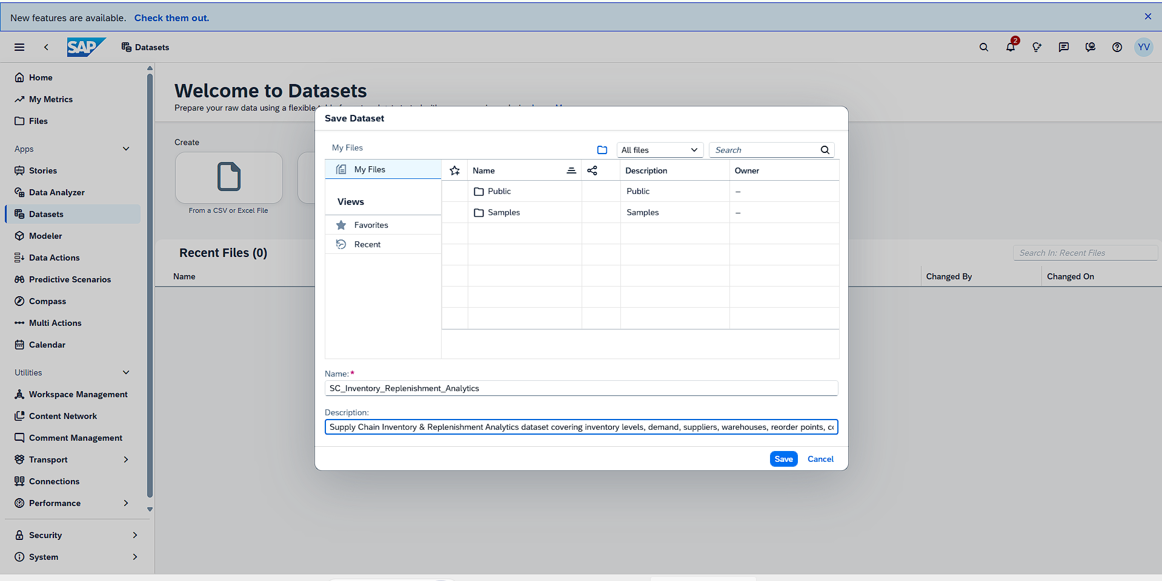

Figure 5. Saving the dataset as SC_Inventory_Replenishment_Analytics.

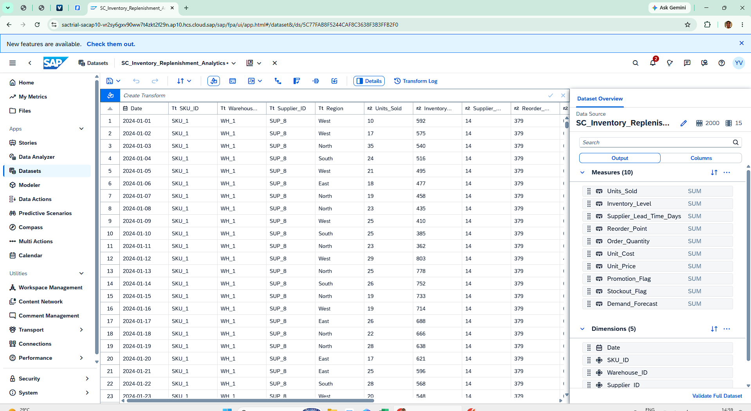

Figure 6. Dataset overview and analytical fields.

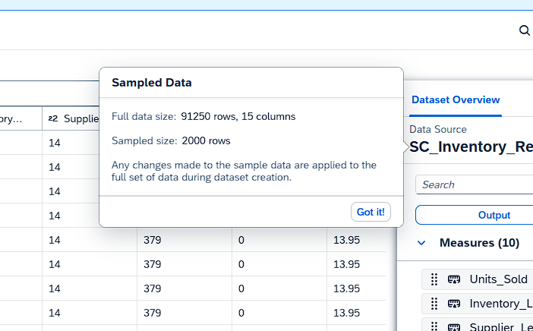

Figure 7. Full dataset validation completed successfully.

I saved the dataset with the name “SC_Inventory_Replenishment_Analytics” and added a description covering the supply-chain subject area. The SAC dataset overview showed a full data size of 91,250 rows and 15 columns, with 2,000 rows available as the sampled dataset for interactive analysis.
Validation checkpoint
SAC displayed “Your dataset has no issues.” I used this as my checkpoint before moving into story development.

Why I did not skip validation
The dashboard would only be useful if the underlying dataset was structurally sound. Running validation also gave me confidence that I could move to the story stage without carrying an obvious dataset issue forward.

SAP ANALYTICS CLOUD • SUPPLY CHAIN ANALYTICS
05 / UNDERSTANDING THE DATA INSIDE SAC

Understanding the data inside SAC
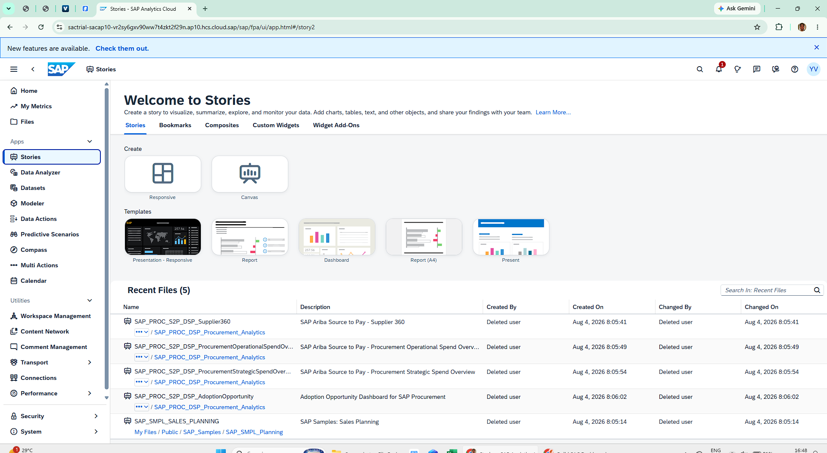
This was the point where I started connecting the fields to the business questions I wanted the dashboard to answer.

Figure 8. SAC Stories area used to begin story development.

Field / calculation | How I used it
Inventory_Level | Total inventory KPI and inventory trend
Units_Sold | Units sold KPI
Demand_Forecast | Monthly demand forecast chart
Reorder_Point | Compared with inventory level
Order_Quantity | Average KPI and monthly order quantity trend
Supplier_Lead_Time_Days | Supplier lead-time analysis
Average Order Quantity | Executive-level average KPI
Average Reorder Point | Executive-level average KPI
Average Supplier Lead Time | Executive-level average KPI

Dimensions used for analysis
The dataset structure shown in SAC included Date, SKU_ID, Warehouse_ID, Supplier_ID and Region as dimensions. These fields provide the context needed to analyze measures by time, product, warehouse, supplier or region.

SAP ANALYTICS CLOUD • SUPPLY CHAIN ANALYTICS
06 / CREATING THE SAC STORY

Creating the SAC story
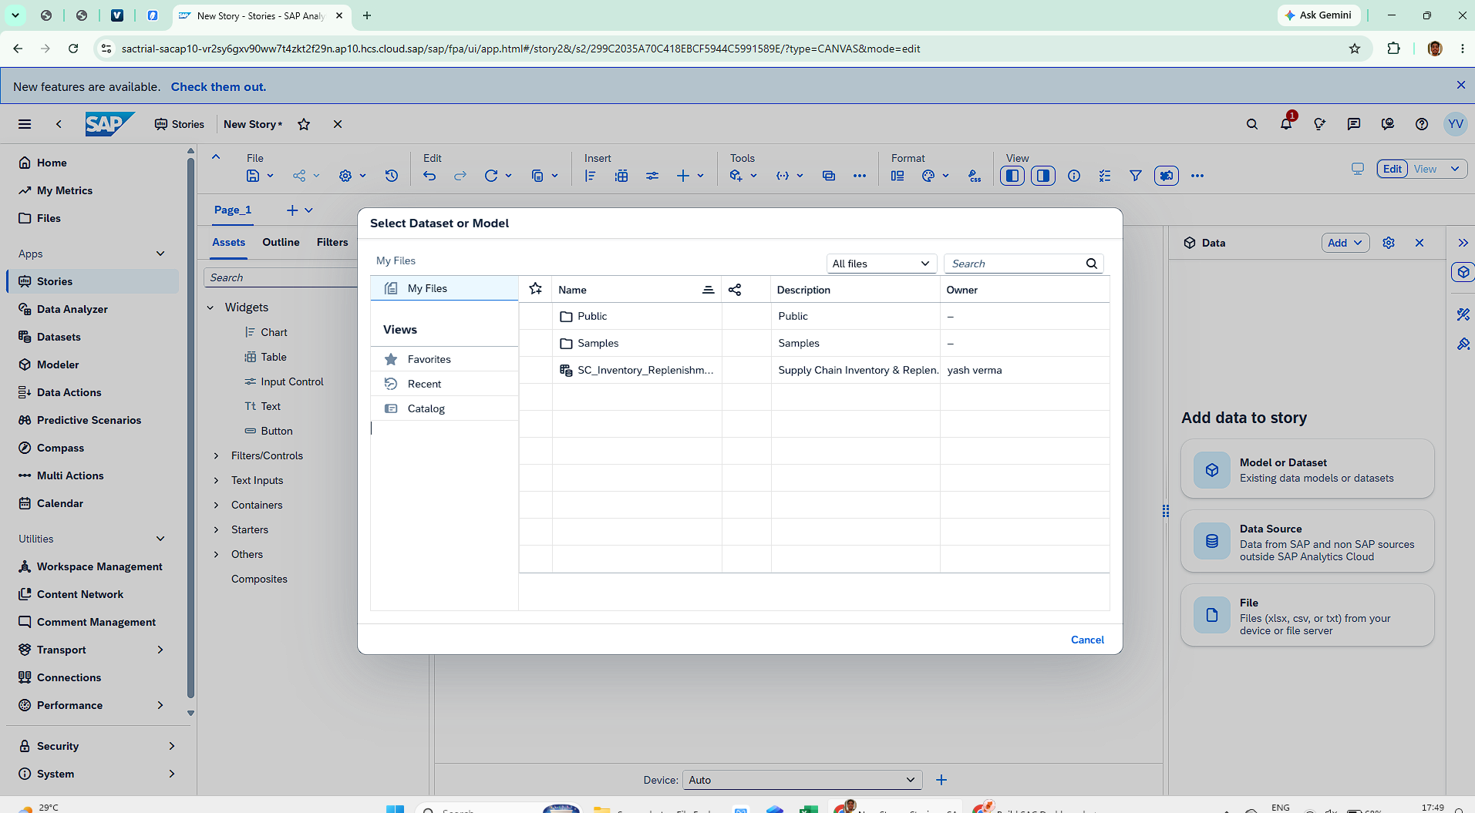
Once the dataset was ready, I connected it to a new story and started building the dashboard.

Figure 9. Selecting the project dataset for the story.
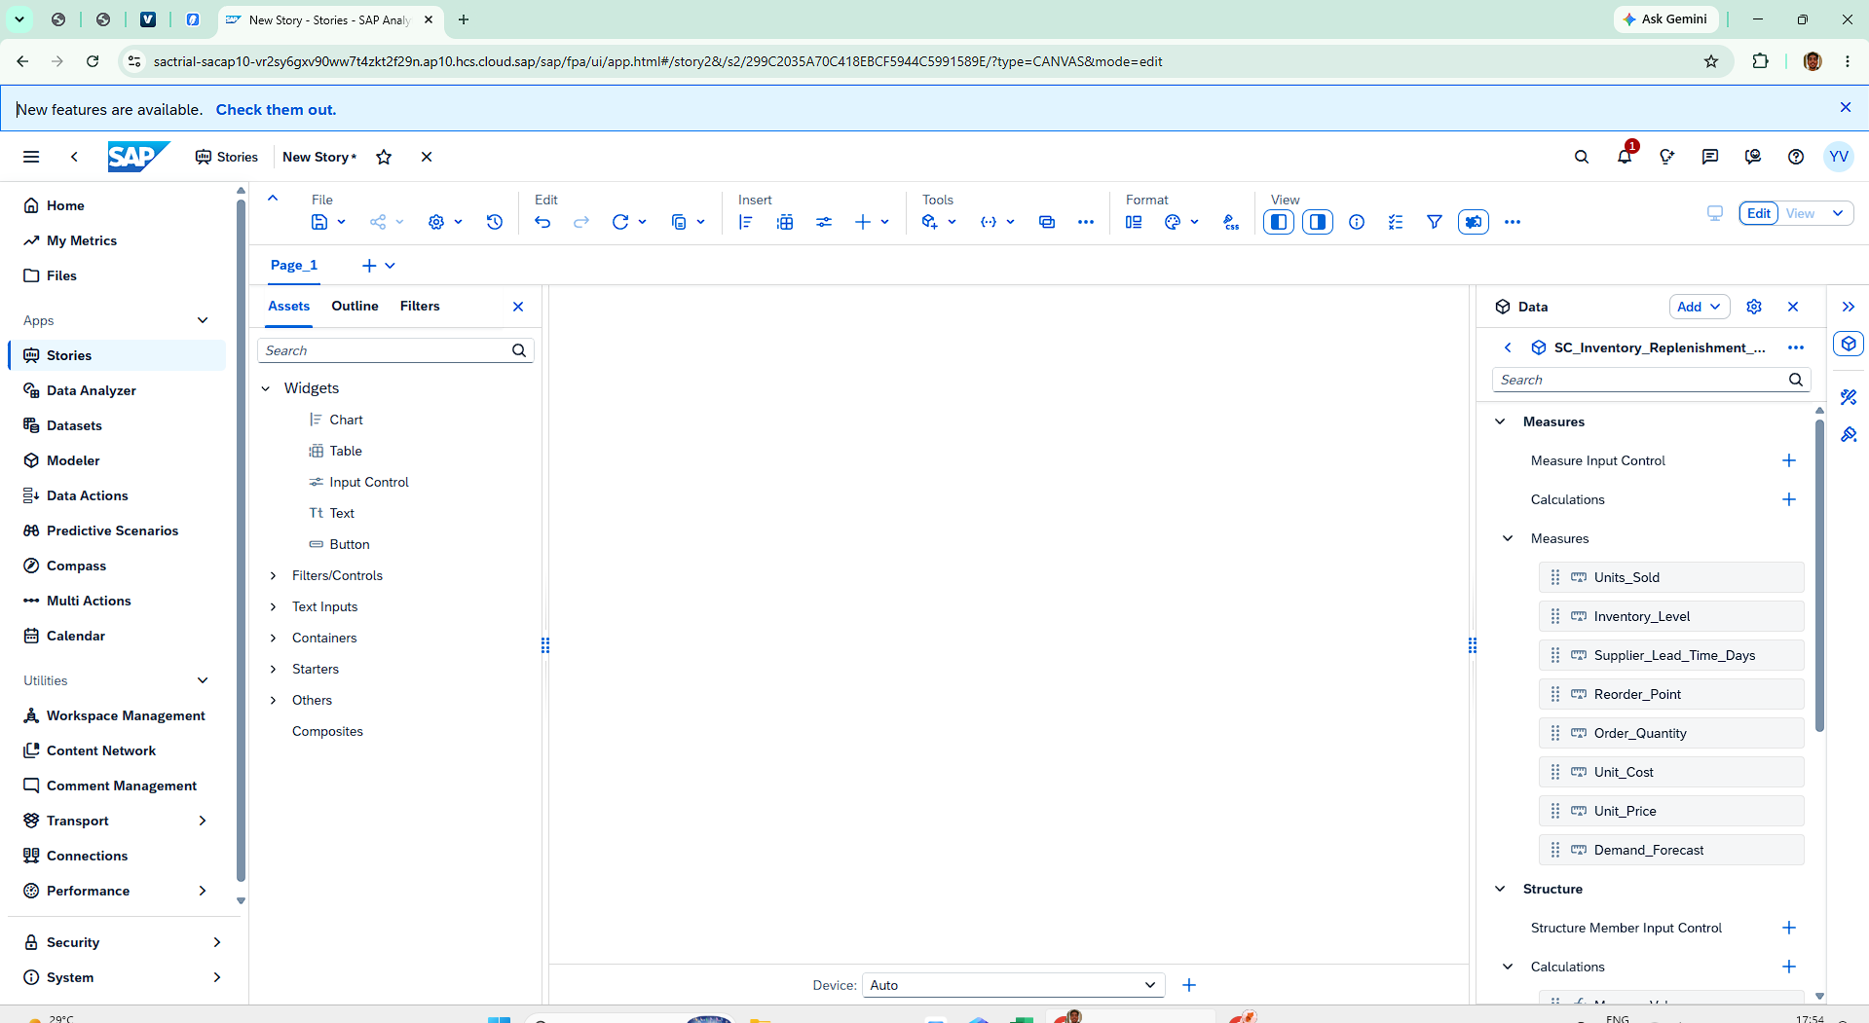

Figure 10. First story canvas with the dataset available.

- Created a new SAC Story using the Canvas experience.
- Selected SC_Inventory_Replenishment_Analytics as the data source.
- Reviewed the available measures before placing charts.
- Started with the main KPI requirements and then added analytical charts.
- Used the story canvas to arrange the dashboard into a clear top-to-bottom reading order.

The dashboard questions I kept in mind
Question | Dashboard element
How much inventory is available? | Total Inventory KPI + Inventory Level Trend
How much is being sold? | Units Sold KPI
What demand is expected? | Monthly Demand Forecast
Is inventory above the reorder point? | Inventory vs Reorder Point
How long do suppliers take? | Avg Supplier Lead + Supplier comparison
What is the typical order quantity? | Average Order Quantity + Order Quantity Trend
My main learning here
A field by itself does not make a useful KPI. I had to think about the measure, its aggregation and the dimension I wanted to analyze it against. This became especially important while configuring charts.

SAP ANALYTICS CLOUD • SUPPLY CHAIN ANALYTICS
07 / BUILDING AND TROUBLESHOOTING THE CHARTS

Building and troubleshooting the charts
The first chart attempts were part of the learning process. I used SAC's Builder panel to understand what each visualization needed.
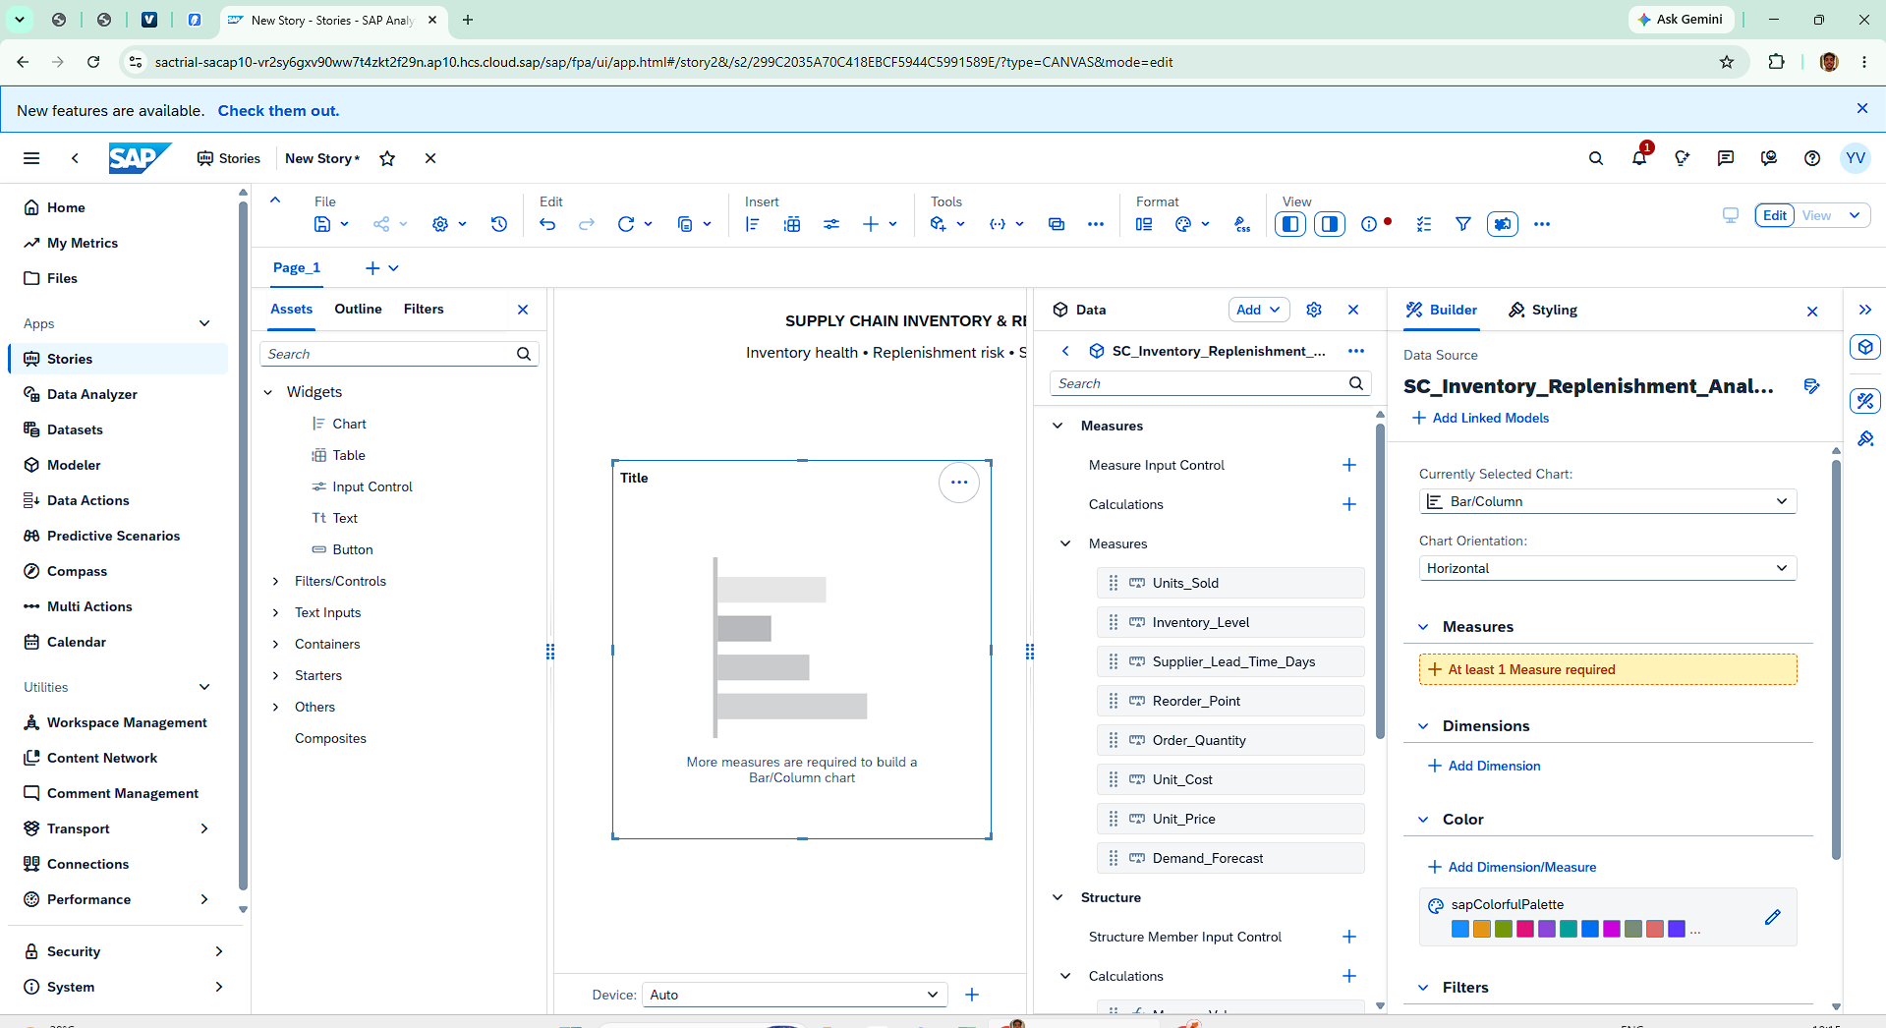

Figure 11. Configuring a chart through the Builder panel.

While creating the story, I reached configuration states where SAC displayed messages such as “At least 1 Measure required.” Instead of treating this as a failure, I used the Builder panel to understand what the selected chart type required.
What I corrected
- Selected an appropriate chart type for the question I wanted to answer.
- Added the required measure instead of leaving the chart without an analytical value.
- Added a dimension where the chart needed categories such as month or supplier.
- Checked the result visually and adjusted the chart when the first configuration was not useful.

What this shows about my hands on work
The project was not built from a finished template. I worked through SAC's configuration requirements, made mistakes in the setup, corrected them and continued until the story produced the intended view.

SAP ANALYTICS CLOUD • SUPPLY CHAIN ANALYTICS
08 / HOW THE DASHBOARD DEVELOPED

How the dashboard developed
I improved the story in iterations rather than trying to make the final layout in one attempt.

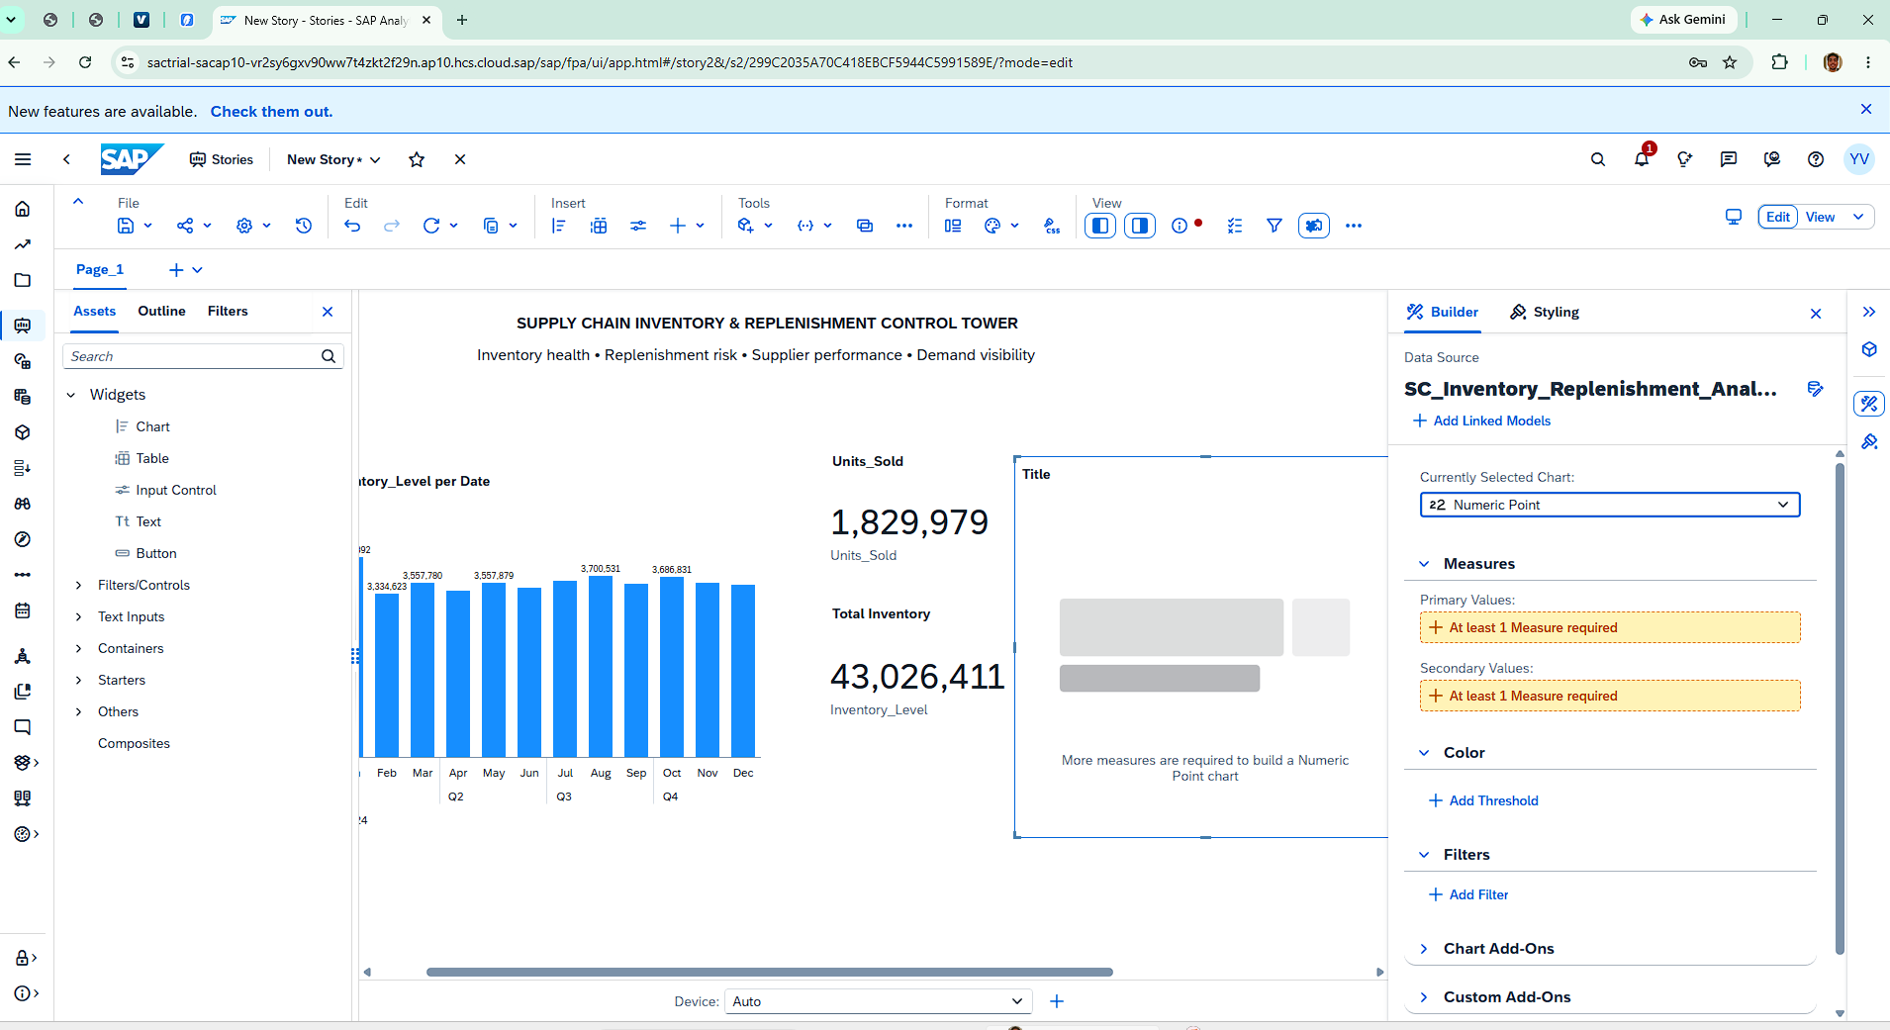

Figure 12. First complete dashboard version.

A useful lesson I took from this
Chart selection should start from the business question. For example, a monthly demand question needs a time dimension, while a supplier comparison needs Supplier_ID. This helped me stop thinking only about “which chart looks good?” and start thinking about “which chart explains the data correctly?”

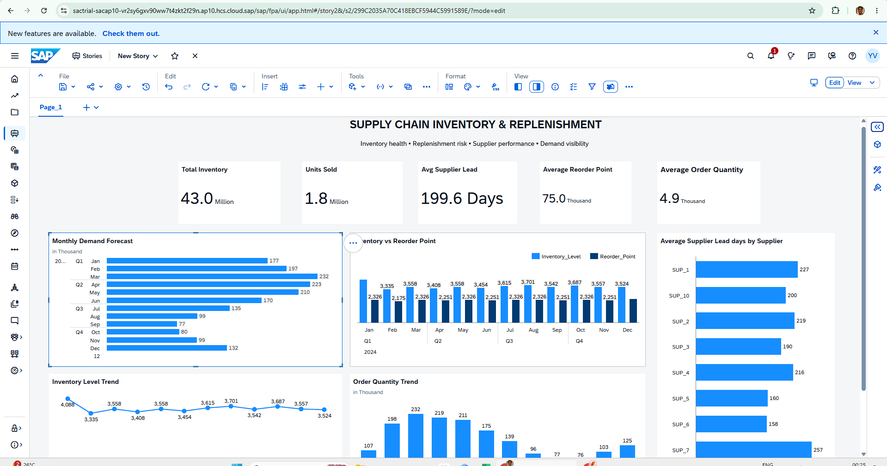

Figure 13. Refined dashboard version.

What I changed while refining it
- Placed the most important KPIs at the top so the overall status can be understood quickly.
- Grouped demand and inventory/reorder information in the main analytical area.
- Added inventory and order-quantity trends to provide time-based context.
- Added supplier lead-time comparison so supplier differences could be seen without opening another view.
- Improved spacing and alignment so the page reads as one dashboard rather than a collection of separate charts.

My design approach
I kept the dashboard focused on a small set of supply-chain questions. I did not add a chart simply because the dataset contained another field.

SAP ANALYTICS CLOUD • SUPPLY CHAIN ANALYTICS
09 / THE FINAL DASHBOARD AND WHAT I LEARNED FROM THE DATA

The final dashboard and what I learned from the data
The final story combines five KPI cards with demand, inventory, replenishment, order-quantity and supplier views.


Figure 14. Final Supply Chain Inventory & Replenishment Control Tower.

Final KPI snapshot
KPI | Displayed value
Total Inventory | 43.0 Million
Units Sold | 1.8 Million
Avg Supplier Lead | 199.6 Days
Average Reorder Point | 75.0 Thousand
Average Order Quantity | 4.9 Thousand

Key observations from my final dashboard
- Monthly demand forecast is highest around March at about 232 thousand and falls to about 77 thousand in September before recovering toward December.
- Inventory levels remain above the displayed reorder-point values in the monthly comparison shown in the dashboard.
- Supplier lead time varies significantly in the displayed supplier comparison, from about 131 days for SUP_9 to about 257 days for SUP_7.
- Order quantity follows a similar broad pattern to demand: it rises toward March and then declines through September/October before recovering toward December.
These observations are based on the project dataset and the values displayed in the final story. I use them to demonstrate how I can read a SAC dashboard and connect multiple measures instead of treating each chart separately.

SAP ANALYTICS CLOUD • SUPPLY CHAIN ANALYTICS
10 / WHAT THIS PROJECT GIVES ME AS AN SAP FRESHER

What this project gives me as an SAP fresher
This is the part I would carry into my resume, portfolio and interviews.
Hands-on SAC skills I can now demonstrate
Skill area | Evidence from my project
SAC navigation | Worked through Home, Datasets and Stories.
Dataset creation | Created a dataset from a CSV/Excel file.
Dataset configuration | Used the first row as headers and configured the source.
Data validation | Ran full dataset validation and received a no-issues confirmation.
Measures & calculations | Worked with operational measures and average-based calculations.
Story development | Connected the dataset to a Canvas story.
Chart configuration | Worked with measures, dimensions and chart Builder settings.
Dashboard design | Created KPI cards and a structured one-page control tower.
Analytical thinking | Connected inventory, demand, reorder point, order quantity and supplier lead time.
Troubleshooting | Resolved chart configuration requirements during the build.

How I would write this on my resume
- Built a self-directed Supply Chain Inventory & Replenishment Control Tower in SAP Analytics Cloud using a 91,250-row, 15-field supply-chain dataset, with a 2,000-row sample used for interactive analysis in the SAC trial environment.
- Created and validated a SAC dataset from a CSV source, configured measures/calculations and developed a Canvas story with KPI cards and analytical charts.
- Analyzed inventory, demand forecast, reorder points, order quantities and supplier lead times through an executive-style SAC dashboard.

Why I consider this useful for my first SAP role
The biggest value of this project is that I can show actual platform exposure. I started from the interface, worked with a dataset, learned SAC's analytical structure, built a story and finished with a working dashboard.

SAP ANALYTICS CLOUD • SUPPLY CHAIN ANALYTICS
11 / WHAT I WOULD DO NEXT

What I would do next
I see this project as a starting point. The next step is to move from a flat-file learning project toward a more realistic SAP analytics solution.
- Connect the solution to a governed enterprise source such as SAP S/4HANA or another approved business source.
- Add explicit inventory-risk categories such as below reorder point, near threshold, excess stock and stockout risk.
- Add KPIs such as stockout rate, days of supply, excess inventory value and supplier SLA adherence.
- Add filters for SKU, warehouse, supplier, region and date.
- Add drill-down from KPI and chart views to the underlying SKU or supplier level.
- Compare forecast with actual demand when historical actual data is available.
- Use role-based access, sharing and governance practices appropriate for an enterprise SAC environment.

My first project learning summary
- I learned where the important functions are in the SAC interface.
- I learned how to create a dataset from a raw file and validate it.
- I learned the difference between measures, dimensions and calculated values in a practical story.
- I learned that a chart needs the right combination of measure, dimension and chart type.
- I learned to troubleshoot SAC configuration messages instead of avoiding them.
- I learned that dashboard design should follow the business question and not only the available fields.

This is my first practical SAC project. I am using it to demonstrate initiative, hands-on learning and a foundation in SAP Analytics Cloud. I would be comfortable explaining every stage shown in this report and discussing what I would improve in a real project.

End of report • SAP Analytics Cloud | Supply Chain Inventory & Replenishment Control Tower

