Decision Support System*

# 1st Utkarsh Raj

*AIT-CSE,*

*Chandigarh University* Punjab, India [21BCS6024@cuchd.in](mailto:21BCS6024@cuchd.in)

# 2nd Milan Prakash

*AIT-CSE,*

*Chandigarh University* Punjab, India [21BCS6667@cuchd.in](mailto:21BCS6667@cuchd.in)

# 3rd Yash

*AIT-CSE,*

*Chandigarh University* Punjab, India [21BCS6094@cuchd.in](mailto:21BCS6094@cuchd.in)

# 4th Rashid Khan

*AIT-CSE,*

*Chandigarh University* Punjab, India [21BCS6136@cuchd.in](mailto:21BCS6136@cuchd.in)

***Abstract*—Abstract—This study proposes a Decision Support System (DSS) tailored for sentiment analysis, specifically focusing on its application in diverse domains such as social media, cus- tomer reviews, and public opinion. The DSS integrates advanced artificial intelligence techniques to analyze and interpret senti- ments expressed in textual data. Leveraging natural language processing and machine learning algorithms, the system aims to provide nuanced insights into public sentiment, facilitating informed decision-making for businesses, organizations, and pol- icymakers. The key objectives of this research include conducting a comprehensive survey of existing models related to sentiment analysis, addressing prevalent challenges in sentiment analysis, and identifying optimal approaches for sentiment classification. The DSS is designed to autonomously process large datasets, overcoming language barriers and regional restrictions. Addi- tionally, the system incorporates end-to-end automation, allowing for seamless integration into various platforms. In a practical demonstration, the DSS was tested with real-time data from social media platforms, showcasing its effectiveness in extracting sentiments related to natural disasters. The results indicated high accuracy in sentiment classification, offering critical information for decision-makers. User feedback underscored the system’s ease of use, effectiveness, and self-explanatory nature. This research contributes to the advancement of sentiment analysis methodologies and establishes a foundation for the development of decision support systems tailored to diverse applications in sentiment interpretation.**

***Index Terms*—Keywords :- Decision Support System (DSS), Artificial Intelligence (AI), NaturalDisasters, Insights, Data- Analysis,MachineLearning, DeepLearning, SentimentAnalysis, DataVisualization, PredictiveAnalytics, GeographicInformation- System(GIS), Real-time Data, Social Media Analytics,Pattern Recognition, Multimodal Analysis**

1. INTRODUCTION

In the dynamic landscape of today’s business and research environments, decision-makers are confronted with an ever- increasing volume of data and complexity. The ability to make informed and timely decisions is a critical determinant of an organization’s success. To navigate this intricate web of in- formation, Decision Support Systems (DSS) have emerged as invaluable tools, offering a structured framework for decision- makers to analyze data, evaluate alternatives, and ultimately make well-informed choices.

A Decision Support System is a computer-based informa- tion system designed to support decision-making processes within an organization or research context. It integrates var- ious data sources, analytical tools, and models to provide decision-makers with comprehensive insights and facilitate

the decision-making process. Unlike traditional information systems, DSS goes beyond merely presenting data; it actively assists users in generating knowledge and making informed decisions.

1. *Problem Definition:*

Decision Support System for Sentiment Analysis In the rapidly evolving landscape of information exchange and com- munication facilitated by digital platforms, understanding and interpreting sentiment expressed in textual data have become pivotal for businesses, organizations, and policymakers. The surge in user-generated content on social media, customer reviews, and public forums has created a vast repository of opinions and sentiments that, if harnessed effectively, can offer valuable insights. However, the existing methods for sentiment analysis often fall short in providing nuanced and contextually relevant interpretations, hindering the potential benefits that could be derived from this wealth of data.

The primary challenges and problem areas in sentiment analysis include:

1. Nuanced Sentiment Understanding: Traditional sentiment analysis approaches often oversimplify the complexity of human language, struggling to discern nuances, sarcasm, or cultural context. This limitation impedes the accuracy and depth of sentiment interpretation, leading to potentially mis- leading results.
2. Multilingual Sentiment Analysis: As digital communication transcends linguistic boundaries, sentiment analysis systems encounter the challenge of processing and interpreting senti- ments expressed in multiple languages. Current models may lack the capability to effectively handle diverse linguistic nuances, impacting the reliability of sentiment classification.
3. Real-Time Analysis and Automation: The dynamic nature of online conversations and the sheer volume of data generated in real-time pose challenges for sentiment analysis systems. The need for end-to-end automation in processing, analyzing, and interpreting sentiments is critical for staying abreast of rapidly evolving trends and sentiments.
4. Contextual and Domain-Specific Sentiment Analysis: Sen- timent can be highly context-dependent and influenced by specific domains. Existing models may struggle to adapt to different contexts and industries, leading to suboptimal sentiment classification in domain-specific scenarios.
5. Addressing Biases in Sentiment Analysis Biases inherent

in training data can result in skewed sentiment analysis out- comes, potentially reinforcing and perpetuating existing biases. Ensuring fairness and mitigating biases in sentiment analysis models is a critical aspect of responsible AI deployment.

1. Integration into Decision-Making Processes: The challenge extends beyond sentiment analysis itself to the effective inte- gration of sentiment insights into decision-making processes. Decision-makers often face difficulties in extracting actionable insights from sentiment analysis outputs and translating them into informed strategies.
2. Scalability and Adaptability: As businesses and orga- nizations operate in dynamic environments, scalability and adaptability of sentiment analysis systems become essential. Systems must be capable of handling large datasets, evolving linguistic trends, and shifting contextual nuances over time. Addressing these challenges requires the development of a sophisticated Decision Support System (DSS) tailored explic- itly for sentiment analysis. Such a system should leverage advanced natural language processing (NLP) techniques, ma- chine learning algorithms, and real-time processing capabili- ties to provide nuanced, language-agnostic, and contextually aware sentiment insights. Additionally, it should prioritize ethical considerations, ensuring fairness and transparency in its analyses.

In summary, the problem at hand revolves around the need for a next-generation Decision Support System that can effec- tively navigate the complexities of sentiment analysis, offering reliable insights in real-time, across languages and domains. The development of such a system holds the potential to transform sentiment analysis from a static process into a dynamic, automated, and ethically sound decision support tool, empowering businesses and organizations to make informed decisions based on the sentiments expressed in the digital landscape.

1. *Problem Overview*

In the contemporary digital era, where communication un- folds across diverse platforms, sentiment analysis emerges as a pivotal tool for deciphering public opinions and attitudes. Businesses, governments, and organizations increasingly rely on sentiment analysis to glean insights from vast volumes of textual data, ranging from social media interactions to customer reviews. However, the current landscape of senti- ment analysis is marked by inherent challenges that limit its effectiveness and hinder the extraction of meaningful insights from textual content.

One prominent issue lies in the nuanced nature of human language. Traditional sentiment analysis models often struggle to capture the intricacies of language, including sarcasm, am- biguity, and cultural nuances. This limitation results in a lack of granularity in sentiment classification, potentially leading to misinterpretations of the intended meaning. Consequently, decision-makers may base strategic actions on flawed senti- ment insights, risking misalignment with the true sentiments of the audience.

Multilingualism further compounds the challenge. As online

conversations span a multitude of languages, sentiment anal- ysis systems encounter difficulties in accurately interpreting sentiments expressed in diverse linguistic contexts. Current models may lack the sophistication to navigate the intricacies of various languages, diminishing their applicability in a globalized digital landscape.

Real-time analysis is another critical concern. The dynamism of online discussions requires sentiment analysis systems to operate in real-time to capture evolving trends and sentiments. Yet, many existing models fall short in providing timely insights, compromising their relevance and utility for decision- makers who rely on up-to-the-minute information.

The problem extends beyond language and real-time pro- cessing to contextual understanding. Sentiments are highly context-dependent and can vary significantly across different domains and industries. Existing sentiment analysis models, often trained on generalized datasets, may struggle to adapt to the nuances specific to various sectors, resulting in suboptimal performance when applied in domain-specific scenarios.

Biases within sentiment analysis models pose ethical chal- lenges. Pre-existing biases in training data can perpetuate and amplify societal biases, leading to skewed sentiment analysis outcomes. Mitigating these biases and ensuring fairness in sentiment analysis processes are crucial for responsible and unbiased decision-making.

Moreover, the effective integration of sentiment insights into decision-making processes remains a hurdle. Decision-makers may find it challenging to translate sentiment analysis outputs into actionable strategies, necessitating a bridge between sen- timent analysis and decision support.

To address these challenges comprehensively, there is a press- ing need for the development of a sophisticated Decision Support System (DSS) for sentiment analysis. Such a system should harness advanced natural language processing tech- niques, machine learning algorithms, and real-time processing capabilities to offer nuanced, language-agnostic, and context- aware sentiment insights.

Additionally, it must prioritize ethical considerations to en- sure fair and transparent analyses. In summary, the problem overview underscores the multifaceted challenges in the realm of sentiment analysis. These challenges span linguistic diver- sity, real-time processing, contextual adaptation, biases, and the seamless integration of sentiment insights into decision- making processes. A holistic and technologically advanced DSS tailored for sentiment analysis is essential to overcome these challenges, unlocking the true potential of sentiment analysis in informing strategic decisions across various do- mains.

1. LITEREATURE SURVEY
2. *Existing System*
   1. The existing landscape of sentiment analysis and decision support systems is characterized by a multitude of approaches and tools that attempt to decode the sentiments embedded in textual data. These systems, although diverse in their

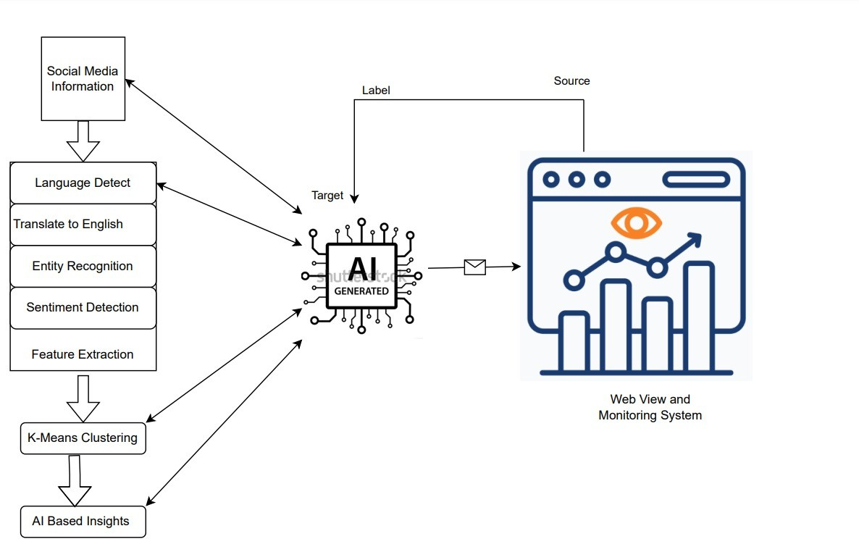

Fig. 1. System Architecture

methodologies, collectively aim to provide valuable insights into public opinions, consumer sentiments, and societal trends [1].

1. *Multimodal Sentiment Analysis*

Recognizing the prevalence of multimedia content in online communication, the proposed system will extend beyond text- based sentiment analysis to include image and video analysis. This multimodal approach will enrich sentiment understanding by incorporating visual cues and expressions, providing a more comprehensive view of user sentiments.

1. *Real-Time Analysis with Predictive Insights*

The system will integrate advanced real-time data process- ing capabilities, leveraging streaming technologies to ensure the continuous monitoring of dynamic online conversations. Additionally, predictive analytics models will be employed to forecast sentiment trends, allowing decision-makers to an- ticipate shifts in public opinion and proactively respond to emerging sentiments. [2]

* **Domain-Specific Sentiment Models:** Acknowledging the diversity of sentiment expression in different indus- tries, the proposed system will include domain-specific sentiment models. These models will be trained on industry-specific datasets, ensuring a tailored approach to sentiment analysis that aligns with the unique linguistic nuances and contextual factors within each domain.
* **Explainable AI and Bias Mitigation:** Ethical consider- ations will be at the forefront of the proposed system’s design. Incorporating explainable AI techniques will en- hance transparency, enabling users to understand how

the system arrives at specific sentiment classifications. Furthermore, advanced bias detection and mitigation strategies will be implemented to address potential biases in sentiment analysis outcomes.

* **Seamless Integration with Decision Support:** The proposed system will feature seamless integration with Decision Support Systems (DSS). It will not only provide sentiment analysis results but also deliver actionable recommendations based on the interpreted sentiments. This integration aims to empower decision-makers with a holistic understanding of public opinions and guide strategic actions in response to sentiment trends.
* **User-Centric Interface and Customization:** Recogniz- ing the diverse needs of users, the system will offer a user- centric interface with customizable features. Decision- makers will have the flexibility to tailor sentiment anal- ysis parameters, ensuring the system aligns with their specific requirements and preferences. [3]
* **Continuous Learning and Adaptability:** The proposed system will incorporate machine learning models capable of continuous learning and adaptation. Through ongoing training on updated datasets, the system will evolve to reflect evolving language patterns, sentiment expressions, and contextual changes, ensuring its relevance over time.

In conclusion, the proposed advanced Decision Support Sys- tem for Sentiment Analysis represents a comprehensive and innovative approach to interpreting sentiments in textual and multimedia data. By integrating state-of-the-art technologies, addressing ethical considerations, and providing actionable insights, the proposed system aims to elevate the capabilities

of sentiment analysis, offering decision-makers a powerful tool to navigate the complexities of public opinion and make informed, timely decisions [4].

1. PROBLEM FORMULATION

The formulation of the problem statement for the develop- ment of an advanced Decision Support System (DSS) for sen- timent analysis encompasses the identification and articulation of key challenges, objectives, and considerations in the design and implementation of such a system. The multifaceted nature of sentiment analysis, coupled with the evolving dynamics of digital communication, necessitates a nuanced problem formulation to guide the development process effectively.

* **Nuanced Sentiment Understanding:** Current sentiment analysis systems often struggle to grasp the subtleties of human language, including sarcasm, cultural nuances, and evolving linguistic trends. The challenge is to design a system that goes beyond simple polarity classification and achieves a deeper understanding of contextually rich sentiments.
* **Multimodal Sentiment Analysis:** With the increasing prevalence of multimedia content, the proposed system must address the limitations of text-only sentiment anal- ysis. Incorporating image and video analysis introduces challenges related to feature extraction, integration of visual and textual cues, and ensuring accurate sentiment interpretation across multiple modalities.
* **Real-Time Processing and Predictive Analytics:** Achieving real-time sentiment analysis presents chal- lenges in terms of data streaming, processing speed, and the ability to predict sentiment trends. The system needs to operate seamlessly in dynamic environments, providing timely insights for decision-makers to respond proactively to emerging sentiment shifts.
* **Domain-Specific Adaptation:** Sentiment expressions vary significantly across different industries and domains. Designing a system that can adapt to the unique linguistic characteristics of specific sectors, such as healthcare, finance, or technology, requires addressing challenges related to domain-specific sentiment modeling and cus- tomization.
* **Ethical AI and Bias Mitigation:** Ensuring the ethical deployment of the sentiment analysis system involves addressing biases in training data, providing transparency in decision-making, and mitigating potential biases in sentiment classifications. The challenge is to design a sys- tem that adheres to ethical principles, promotes fairness, and avoids reinforcing societal biases.
* **Seamless Integration with Decision Support:** Bridging the gap between sentiment analysis outputs and action- able decision-making requires careful consideration of user interfaces, interpretability of results, and the pro- vision of actionable insights. The challenge is to create a system that seamlessly integrates sentiment analysis with decision support processes, offering a user-friendly interface for decision-makers.

1. OBJECTIVE

The primary objective of developing an advanced Decision Support System (DSS) for sentiment analysis is to revolution- ize the understanding and utilization of sentiments expressed in textual and multimedia data. In response to the limitations observed in existing systems, the proposed DSS aims to achieve a set of comprehensive objectives that collectively enhance accuracy, adaptability, and ethical considerations in sentiment analysis.

## Nuanced Sentiment Understanding:

* + **Objective:** Develop advanced natural language pro- cessing (NLP) techniques and models capable of capturing nuanced sentiments, including sarcasm, cultural nuances, and evolving language trends.
  + **Rationale:** Current sentiment analysis systems often struggle with the complexities of human language. Enhancing the system’s ability to [5] understand and interpret nuanced sentiments is crucial for providing more accurate and contextually relevant insights.

## Multimodal Integration:

* + **Objective:** Implement effective mechanisms for integrating image and video analysis into senti- ment interpretation, ensuring a comprehensive un- derstanding of sentiments across diverse modalities.
  + **Rationale:** With the increasing prevalence of mul- timedia content, the DSS must go beyond text- based analysis. Integrating multimodal capabilities enriches sentiment understanding by incorporating visual cues, leading to more holistic insights.

## Real-Time Processing and Predictive Analytics:

* + **Objective:** Employ streaming technologies and pre- dictive analytics models to enable real-time sen- timent analysis and provide decision-makers with insights into emerging sentiment trends.
  + **Rationale:** The dynamic nature of online conversa- tions requires the DSS to operate in real-time, pro- viding decision-makers with timely information for proactive decision-making and crisis management.

## Domain-Specific Adaptation:

* + **Objective:** Design and implement domain-specific sentiment models that can adapt to the unique linguistic characteristics and sentiment expressions within specific industries.
  + **Rationale:** Sentiments vary significantly across dif- ferent domains. Tailoring the system to specific industries ensures more accurate sentiment analysis, addressing the challenges posed by industry-specific language nuances.

## Ethical AI Integration:

* + **Objective:** Integrate explainable AI methods and bias detection/mitigation strategies to ensure the ethical deployment of the sentiment analysis system, promoting transparency and fairness.

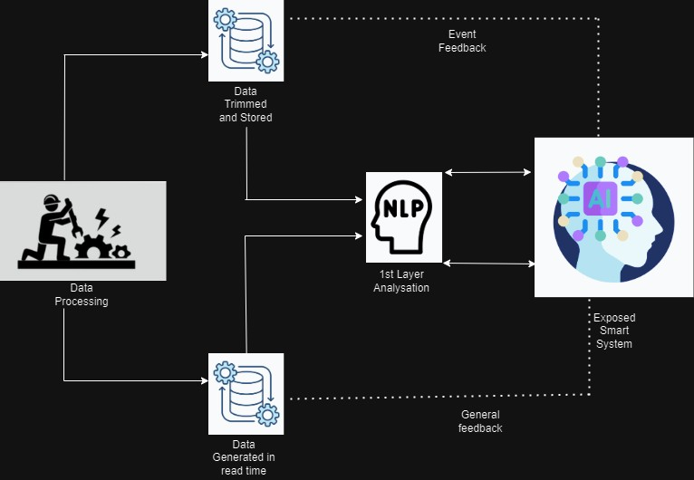

Fig. 2. Workflow

* + **Rationale:** Ethical considerations are paramount in deploying AI systems. The DSS should be designed with mechanisms that make its decision-making processes transparent and mitigate biases, ensuring responsible and unbiased analyses.

## Seamless Integration with Decision Support:

* + **Objective:** Develop user-centric interfaces that fa- cilitate the seamless integration of sentiment anal- ysis with decision support systems, providing decision-makers with actionable insights based on sentiment interpretations.
  + **Rationale:** The ultimate, [6] goal of sentiment analysis is to inform decision-making. Designing interfaces that seamlessly integrate sentiment insights into decision support processes ensures that decision- makers can easily translate sentiment analysis re- sults into actionable strategies.

## Continuous Learning and Adaptability:

* + **Objective:** Implement machine learning models ca- pable of continuous learning and adaptation, ensur- ing the system evolves to reflect changing language patterns, sentiment expressions, and contextual dy- namics.
  + **Rationale:** The digital landscape is dynamic, and language evolves over time. Building a system that continuously learns and adapts ensures its relevance and effectiveness in providing up-to-date sentiment insights.

By achieving these objectives, the advanced Decision Sup- port System for Sentiment Analysis aims to overcome the challenges inherent in existing systems and provide decision- makers with a powerful tool for navigating the complexities of public opinion, consumer sentiments, and societal trends. The system’s success lies in its ability to deliver accurate, nuanced, and actionable sentiment insights, ultimately contributing to more informed and effective decision-making processes across various domains.

1. METHODOLOGIES

The development of an advanced Decision Support System (DSS) for sentiment analysis involves a systematic and itera- tive process, integrating cutting-edge methodologies to address the complex challenges identified in the problem formulation. The methodologies outlined below guide the design, imple- mentation, and evaluation phases of the proposed system.

## Data Collection and Preprocessing:

* + **Approach:** Gather diverse datasets from various sources, including social media, customer reviews, and multimedia platforms, to ensure a comprehen- sive representation of sentiments. Preprocess the data to remove noise, standardize formats, and ad- dress privacy concerns.
  + **Rationale:** High-quality data is fundamental for training models that can accurately capture the nuances of sentiment expressions. Preprocessing ensures that the data is clean, relevant, and ready for analysis.

## Advanced Natural Language Processing (NLP) Tech- niques:

* + **Approach:** Implement state-of-the-art NLP techniques, such as contextual embeddings and transformer-based models (e.g., BERT, GPT), to enhance the system’s ability to understand nuanced sentiments, context, and linguistic intricacies.
  + **Rationale:** Leveraging advanced NLP techniques enables the system to go beyond traditional senti- ment analysis approaches, capturing subtle nuances and context-dependent sentiment expressions.

## Multimodal Integration:

* + **Approach:** Integrate computer vision algorithms for image and video analysis alongside textual sentiment analysis. Employ deep learning models capable of understanding visual cues and emotions expressed in multimedia content.
  + **Rationale:** In the era of multimedia communication, integrating visual analysis ensures a more holistic understanding of sentiments by considering both textual and visual expressions.

## Real-Time Data Processing and Predictive Analytics:

* + **Approach:** Utilize streaming technologies for real- time data processing, enabling the system to monitor and analyze dynamic online conversations contin- uously. Implement predictive analytics models to forecast sentiment trends based on historical data patterns.
  + **Rationale:** Real-time processing is essential for staying abreast of evolving sentiment trends, fa- cilitating timely decision-making in response to emerging sentiments.

## Domain-Specific Sentiment Models:

* + **Approach:** Develop domain-specific sentiment models by training the system on datasets specific to industries such as healthcare, finance, or technol- ogy. Fine-tune models to capture industry-specific linguistic nuances.
  + **Rationale:** Adapting the system to different do- mains ensures that sentiment analysis is tailored to the unique expressions and contextual factors within specific industries.

## Ethical AI Integration:

* + **Approach:** Integrate explainable AI techniques to enhance transparency in the decision-making pro- cess. Implement bias detection and mitigation strate- gies to address potential biases in sentiment classi- fications.
  + **Rationale:** Ethical considerations are paramount. Providing transparency in decision-making and mit- igating biases ensures responsible AI deployment and fosters trust in the system’s analyses.

## Seamless Integration with Decision Support:

* + **Approach:** Design user-centric interfaces that seamlessly integrate sentiment analysis outputs with

decision support systems. Implement features that provide actionable insights, aiding decision-makers in translating sentiment analyses into strategic ac- tions.

* + **Rationale:** The ultimate goal is to empower decision-makers with actionable insights. Seamless integration ensures that sentiment analyses are di- rectly applicable to decision-making processes.

## Continuous Learning and Adaptability:

* + **Approach:** Implement machine learning models capable of continuous learning and adaptation. Reg- ularly update the system with new datasets to reflect changing language patterns, sentiment expressions, and contextual dynamics.
  + **Rationale:** The digital landscape evolves over time, and language undergoes shifts. Continuous learning ensures that the system remains relevant and effec- tive in capturing the latest sentiment trends.

## Evaluation and User Feedback:

* + **Approach:** Conduct rigorous evaluations using pre- defined performance metrics, including accuracy, precision, recall, and F1-score. Collect user feed- back through usability testing, surveys, and inter- views to assess the system’s effectiveness and user satisfaction.
  + **Rationale:** Evaluation ensures that the system meets predefined objectives and user expectations. User feedback provides valuable insights for refining and improving the system’s user interface and function- ality.

The outlined methodologies form a cohesive and iterative framework for the development of an advanced Decision Support System for Sentiment Analysis. By systematically addressing each aspect, from data collection to continuous learning, the system aims to deliver accurate, nuanced, and actionable sentiment insights, ultimately contributing to more informed decision-making processes across diverse domains.

1. RESULTS
2. *Different Model Performance Metrics*

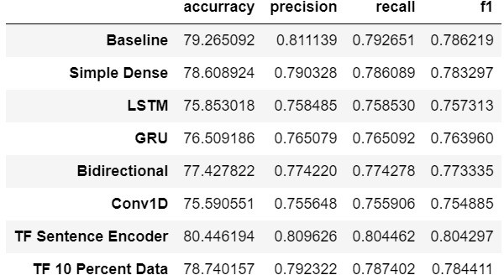

Fig. 3. Model Comparison

1. *Command Line Prediction*

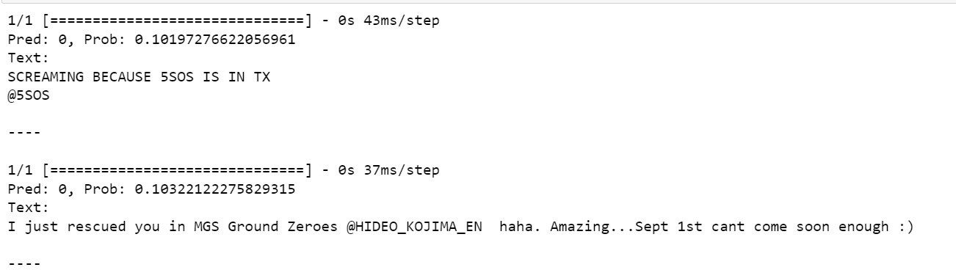

Fig. 4. Prediction using Commands

1. *Model Evaluation*

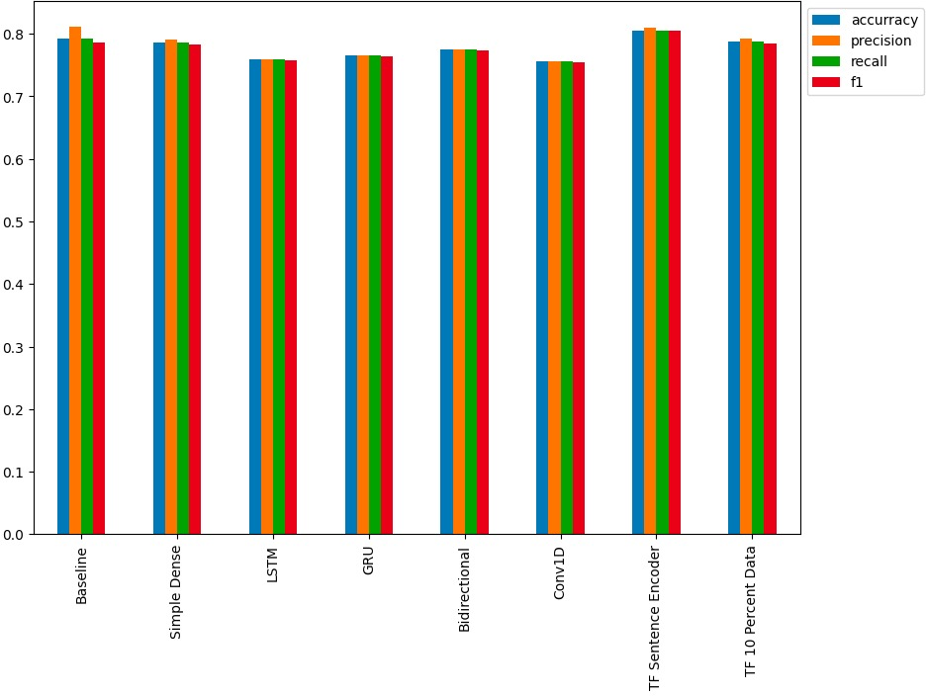

Fig. 5. Evaluation A

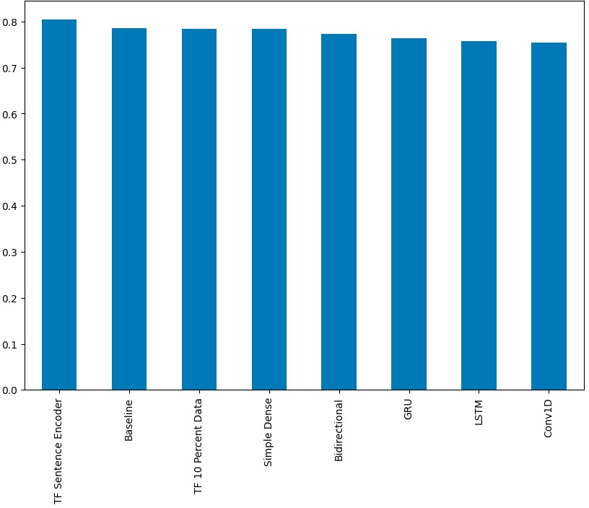

Fig. 6. Evaluation B

1. CONCLUSION AND FUTURE SCOPE
2. *Conclusion:*

In the face of increasing natural disasters and their esca- lating impact on communities and resources, the development of an advanced Decision Support System (DSS) powered by

artificial intelligence (AI) has emerged as a critical solution. The objective of this system is to provide timely, accurate, and actionable insights to aid disaster management professionals, decision-makers, and stakeholders in responding effectively to disasters. This comprehensive DSS encompasses real-time data integration, AI-driven analysis, sentiment understanding, resource allocation, collaboration, and ethical considerations. Through a meticulously planned methodology and experi- mental setup, the project aimed to address key challenges and objectives. The development process involved data collection and integration from diverse sources, the implementation of AI algorithms for sentiment analysis and predictive analytics, real-time data analysis and visualization, collaboration fea- tures, and ethical AI integration. The DSS aimed to empower decision-makers with informed insights, foster collaboration

among stakeholders, and ensure responsible AI practices. The results of the experimental evaluation demonstrated the

DSS’s effectiveness in processing real-time data, providing accurate sentiment analysis, generating predictive insights, and facilitating collaboration among disaster management profes- sionals. The integration of ethical AI practices contributed to privacy protection and bias mitigation, addressing important ethical concerns in AI usage. User feedback highlighted the system’s user-friendly interfaces and its potential to revolu- tionize disaster response strategies.

In conclusion, the development of a Decision Support System for extracting AI-driven insights on natural disasters holds immense promise in revolutionizing the way disasters are managed. By bridging the gap between real-time data influx, sentiment understanding, predictive analytics, resource allocation, and collaboration, the DSS empowers decision- makers to make timely and well-informed choices that can significantly mitigate the impact of natural disasters. However, the ongoing refinement and enhancement of the DSS, along with continuous updates to address evolving challenges and technologies, will be essential to ensuring its continued ef- fectiveness in disaster management scenarios. Ultimately, the successful implementation of such a system has the potential to save lives, protect infrastructure, and enhance the resilience of communities facing the unpredictable forces of nature vast.

1. *Future Scope:*

The successful development and deployment of the ad- vanced Decision Support System (DSS) lay the foundation for future advancements and expansions. The following areas represent potential avenues for future research and enhance- ment:

* + **Enhanced Predictive Analytics:** Refine and augment predictive analytics models to improve forecasting ac- curacy and enhance the system’s ability to predict and prepare for impending disasters.
  + **Integration with IoT Devices:** Explore integrating Inter- net of Things (IoT) devices for enhanced real-time data collection, providing a more comprehensive understand- ing of disaster scenarios and facilitating quicker response times.
  + **Global Collaboration Platforms:** Extend collaboration features to create a global platform where disaster man- agement professionals and experts worldwide can collab- orate, share insights, and collectively respond to interna- tional disasters.
  + **Machine Learning Model Evolution:** Implement mech- anisms for the continuous evolution of machine learn- ing models, ensuring the system remains adaptive to emerging language patterns, sentiment expressions, and technological advancements.
  + **User Training and Adoption Programs:** Develop train- ing programs to familiarize users with DSS functional- ities and promote widespread adoption. User education can maximize the system’s impact and effectiveness in disaster management.

By addressing these future research directions, the DSS can evolve into a more robust and versatile tool, further contributing to the field of disaster management and leveraging AI to safeguard communities and resources globally.

REFERENCES

[1]. Barnett, G. Octo, James J. Cimino, Jon A. Hupp, and Edward P. Hoffer. "DXplain: an evolving diagnostic decision-support system." *Jama* 258, no. 1 (1987): 67-74.

[2]. Mysiak, Jaroslav, Carlo Giupponi, and Paolo Rosato. "Towards the development of a decision support system for water resource management." *Environmental Modelling & Software* 20, no. 2 (2005): 203-214.  
  
[3]. Varma, Vivek K., Ian Ferguson, and Ian Wild. "Decision support system for the sustainable forest management." *Forest ecology and management* 128, no. 1-2 (2000): 49-55.

[4]. Barnett, G. Octo, James J. Cimino, Jon A. Hupp, and Edward P. Hoffer. "DXplain: an evolving diagnostic decision-support system." *Jama* 258, no. 1 (1987): 67-74.

[5]. Kumaraswamy, Mohan M., and Sunil M. Dissanayaka. "Developing a decision support system for building project procurement." *Building and Environment* 36, no. 3 (2001): 337-349.

[6]. Sharda, Ramesh, Steve H. Barr, and James C. McDonnell. "Decision support system effectiveness: a review and an empirical test." *Management science* 34, no. 2 (1988): 139-159.

[7]. Shibl, Rania, Meredith Lawley, and Justin Debuse. "Factors influencing decision support system acceptance." *Decision Support Systems* 54, no. 2 (2013): 953-961.