Micro-Project Report
2CSVS308: Python Programming

3 Player Quiz For Students Performance Analysis
Ayush Mahesh Vibhute (3010)
Yash Dayanand Suryavanshi (3016)

A report submitted in part fulfilment of the course Python Programming
T. Y. B Tech in Computer Science and Engineering

Supervisor: Prof. S.D.Khatavakar

Department of Computer Science and Engineering
Annasaheb Dange College of Engineering and Technology, Ashta 416-301

CERTIFICATE
This is to be certified that,
Ayush Mahesh Vibhute (3010)
Yash Dayanand Suryavanshi (3016)

Student of Third Year B. Tech., semester -V of Computer Science and Engineering Department, Annasaheb Dange College of Engineering and Technology, Ashta have completed their Mini Project entitled,
3 Player Quiz For Students Performance Analysis
They have submitted their Mini-Project Report for the partial fulfilment of the course Python Programming having course code – 2CSVS308.

Date:

Prof. S. D. Khatavakar
Course Coordinator

Date:

Declaration
This report has been prepared on the basis of my own work. Where other published and unpublished source materials have been used, these have been acknowledged.

Student Name:
Ayush Mahesh Vibhute (3010)
Yash Dayanand Suryavanshi (3016)

Date of Submission:

Signature:

Table of Contents
- Introduction
- Objectives
- Methodology
- Technologies Used
- Results
- Future Scope
- Conclusion
- References

1. Introduction
The 3-Player Quiz Game is a Python-based multiplayer quiz application designed for three players to play together using the same Wi-Fi network. Players connect to a server through Wi-Fi and participate in a quiz competition. The game provides an interactive environment where players answer questions and compete to achieve the highest score.
The project uses socket programming to establish communication between the server and the three player clients over the Wi-Fi network. The server sends the same quiz questions and answer options to all players and receives their answers. Python threading is used to handle multiple players simultaneously, allowing the server to manage their responses efficiently.
The game follows a point-based scoring system to determine the players' performance. The player who submits the correct answer first receives 10 marks, the second player to answer correctly receives 8 marks, and the third player to answer correctly receives 6 marks. Players who submit incorrect answers receive 0 marks. This scoring system encourages quick thinking, accuracy, and healthy competition among players.
The main aim of this project is to develop a real-time multiplayer quiz game that demonstrates the practical use of socket programming and multithreading in Python. The application allows three players connected to the same Wi-Fi network to participate in a quiz without requiring an internet connection. The project also demonstrates client-server communication and concurrent processing through a simple and interactive gaming application.

2. Objectives
The main objectives of the project are:
2.1 To develop a multiplayer quiz game for three players that allows them to participate simultaneously through a local Wi-Fi network.

Implementation and Technologies Used
We developed the 3-Player Quiz Game using Python and a client-server architecture. One computer acts as the server, and three players connect to it through separate client applications using the same Wi-Fi network.
The server uses the MAX_PLAYERS = 3 setting to limit the game to three players. Each connected player receives a unique player ID and can enter their name through the graphical interface. The quiz begins when all three players have connected successfully.
Python socket programming is used to establish communication between the server and clients. The threading module allows the server to handle multiple players simultaneously, while Tkinter provides a graphical interface where players can view questions, select answers, and check their scores.
Alternative Approaches and Reasons for Selection
A peer-to-peer architecture could also be used, but it would require the players' devices to coordinate communication and scores directly. We selected the client-server architecture because it centralises question distribution, answer checking, and score calculation, making the system easier to manage.
An internet-based system could connect players from different locations. However, we selected local Wi-Fi communication because it allows the game to operate without requiring an internet connection or cloud hosting.
2.2 To establish server-client communication using Python socket programming for sending quiz questions, answer options, and receiving player responses.
Implementation and Technologies Used
We used Python's socket module to establish TCP communication between the server and the three client applications. The server creates a TCP socket, binds it to port 5000, and listens for incoming client connections.
After the players connect, the server sends quiz questions and answer options to the clients using JSON messages. Each question message contains information such as the question number, total number of questions, question text, and answer options.
The client receives these messages and displays the question and four answer options through a Tkinter-based graphical user interface. When a player selects an answer, the client sends the selected option to the server in a JSON message. The server receives the response, checks the answer, and updates the player's score according to the scoring rules.
Alternative Approaches and Reasons for Selection
UDP communication could be used as an alternative to TCP. However, UDP does not guarantee that messages will arrive or arrive in the correct order. We selected TCP because reliable and ordered communication is important when transferring quiz questions and player responses.
XML could also be used to exchange structured data between the server and clients. However, we selected JSON because it is simple to read and convenient for representing question information and player responses in Python.
A web-based communication system could also be developed, but socket programming was selected because it directly demonstrates client-server communication in Python and suits our local multiplayer application.

2.3 To implement a score-based ranking system for correct and incorrect answers.
Implementation and Technologies Used
We implemented a score-based ranking system using Python. The server checks each player's submitted answer against the correct answer stored with the quiz question.
The scoring system awards marks according to the order in which players submit correct answers:
- The first player to answer correctly receives 10 marks.
- The second player to answer correctly receives 8 marks.
- The third player to answer correctly receives 6 marks.
- Players who submit incorrect answers receive 0 marks.
The server maintains the total score of each player and adds the marks obtained for every question. After each question, the updated scores are sent to the connected clients so that players can view their current performance.
After all questions are completed, the server compares the total scores of the players and determines their final rankings.
Alternative Approaches and Reasons for Selection
One alternative is to award the same marks to every player who answers correctly. However, we selected a ranking-based scoring system because it rewards both accuracy and the speed of answering.
Another approach is to deduct marks for incorrect answers. We did not use negative marking because our current scoring rules assign zero marks to incorrect answers, keeping the system simple and easy for players to understand.
The scoring calculations are handled by the server rather than independently by each client. This centralised approach helps maintain consistent scores across all players.
2.4 To use threading for simultaneous player handling and calculate and display the final scores to determine the player with the highest score as the winner.

Implementation and Technologies Used
We used Python's threading module to handle the three connected players. A separate thread processes communication for each connected player, allowing the server to handle messages from multiple clients without waiting for one player to finish before communicating with another.
The server maintains the scores of all players throughout the quiz. After all questions are completed, it compares the total scores and arranges the players according to their performance.
The player with the highest total score is declared the winner. Finally, the server sends the final scoreboard to all connected clients, and the client application displays the final scores and winner.
This approach allows players to participate in the same quiz while the server manages their responses and scores.
Alternative Approaches and Reasons for Selection
A single-threaded server could be used, but it may have to wait while processing one client's communication before handling another. This could delay responses from other players.
Multiprocessing is another alternative. However, it introduces additional process-management complexity that is unnecessary for a small application designed for three players.
We selected multithreading because Python provides a built-in threading module that allows the server to manage communication with multiple connected players in a straightforward way.

3. Methodology
The 3-Player Quiz Game follows a client-server architecture developed using Python. One computer acts as the server, and three players connect through separate client applications using the same Wi-Fi network.
1. Server and Client Connection: The server uses TCP socket communication on port 5000 to connect all three players. The quiz starts when all players are connected.
2. Question Distribution: The server sends quiz questions and four answer options to all players using JSON messages. The questions are displayed through a Tkinter-based graphical interface.
3. Answer Processing: Players select their answers, which are sent to the server. The server checks the answers and records the response order.
4. Scoring System: The first correct answer receives 10 marks, the second receives 8 marks, and the third receives 6 marks. Incorrect answers receive 0 marks.
5. Multithreading: Python's threading module allows the server to handle all three players simultaneously and update their scores after each question.
6. Winner Declaration: After all questions are completed, the server calculates the final scores, declares the player with the highest score as the winner, and displays the final scoreboard to all players.

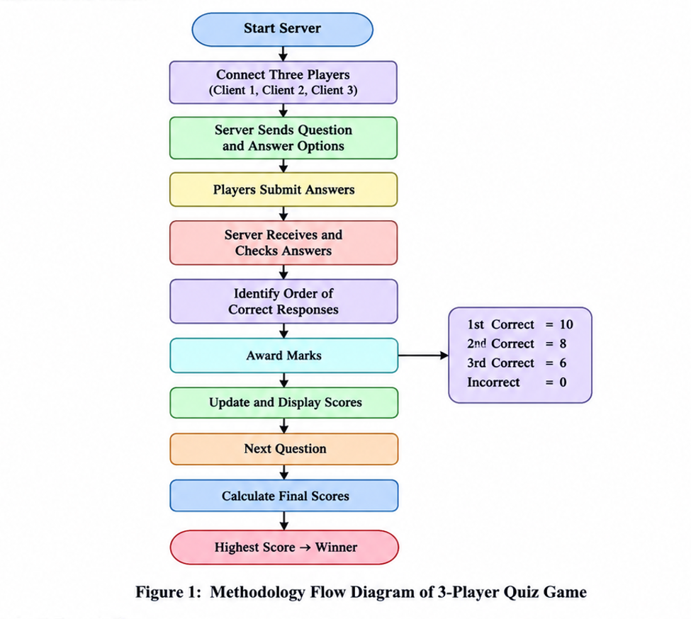

4. Technologies Used
1. Python
Used to develop the server, clients, quiz logic, and scoring system.
2. Socket Programming
Used for communication between the server and three player clients.
3. Threading
Allows the server to handle all three players simultaneously.
4. Tkinter
Used to create the graphical interface for questions, answer options, and scores.
5. Local Wi-Fi
Connects the server and all three players through the same Wi-Fi network.

5. Results
The 3-Player Quiz Game was developed using Python, socket programming, multithreading, and Tkinter. The application allows three players to connect through the same Wi-Fi network, participate in a quiz, submit their answers, and view their scores. The following figures show the working of the application and demonstrate the objectives achieved by the project.
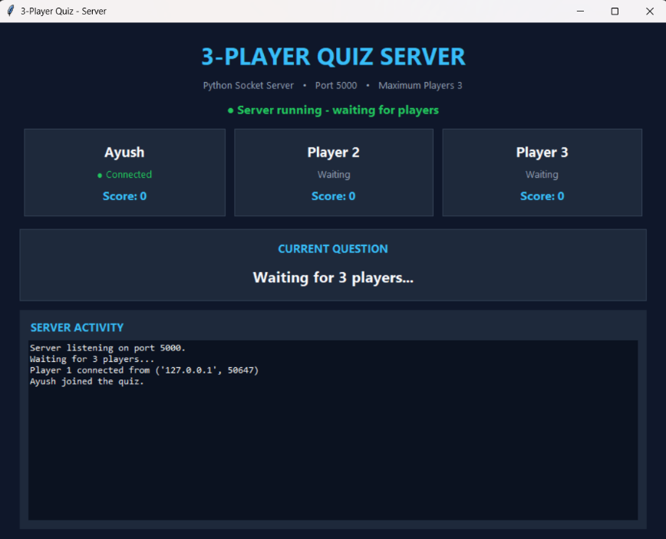

Fig 1: Starting the Quiz Server
This screenshot shows the server interface of the 3-Player Quiz Game running on port 5000. The server is waiting for three players to connect, and the connected-player section displays the current connection status. The server activity panel records connection-related events, while the current-question area indicates that the game is waiting for all three players.

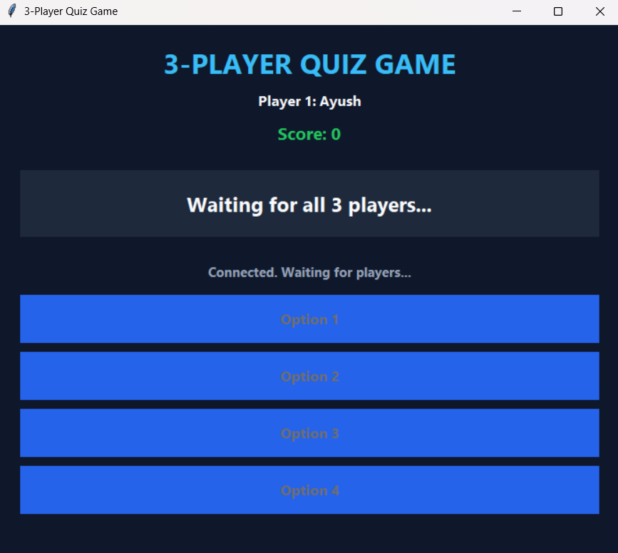

Fig 2: First Player Client Waiting for All Players
This screenshot shows the quiz interface for Player 1, Ayush. The interface displays the player's name and current score, which is zero at this stage. The message “Waiting for all 3 players...” indicates that the quiz has not started yet, while the connection status confirms that the client is connected and waiting for the other players.
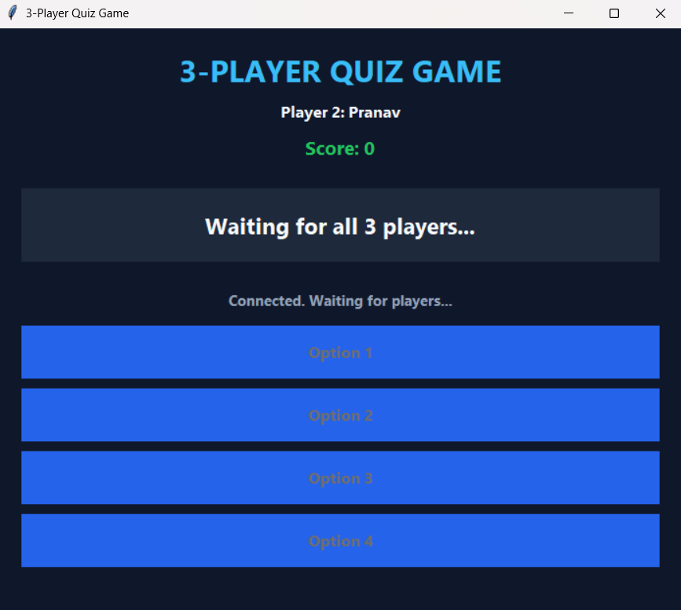

Fig 3: Second Player Client Waiting for All Players

This screenshot shows the quiz interface for Player 2, Pranav. Similar to the first player's interface, it displays the player's name, score, and four answer-option buttons. The message “Waiting for all 3 players...” indicates that the player is waiting for the server to begin the quiz after all required players have connected.

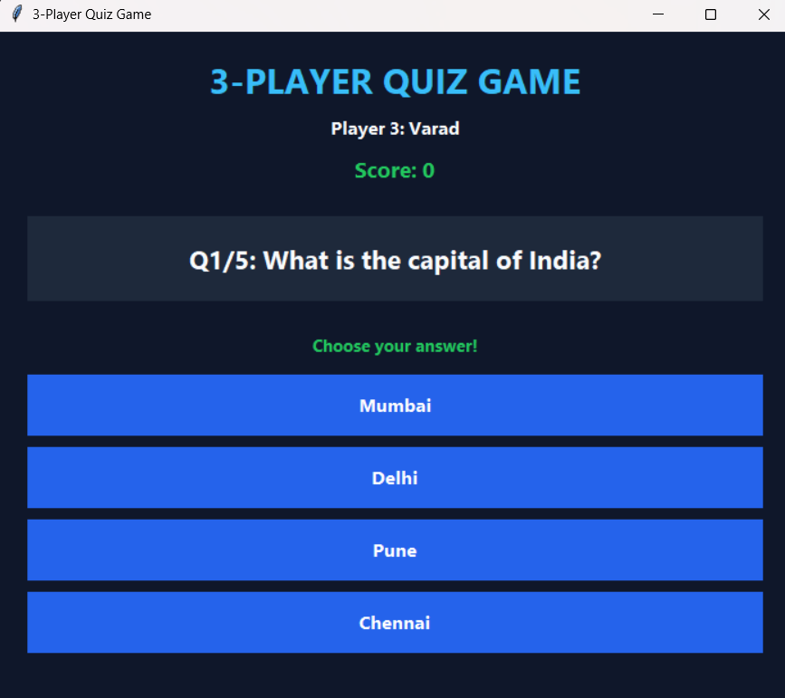

Fig 4: Third Player Connected to the Server

This figure shows the server interface after the third player has connected successfully. All three player connections are now established, and the server has the required number of participants to begin the quiz.

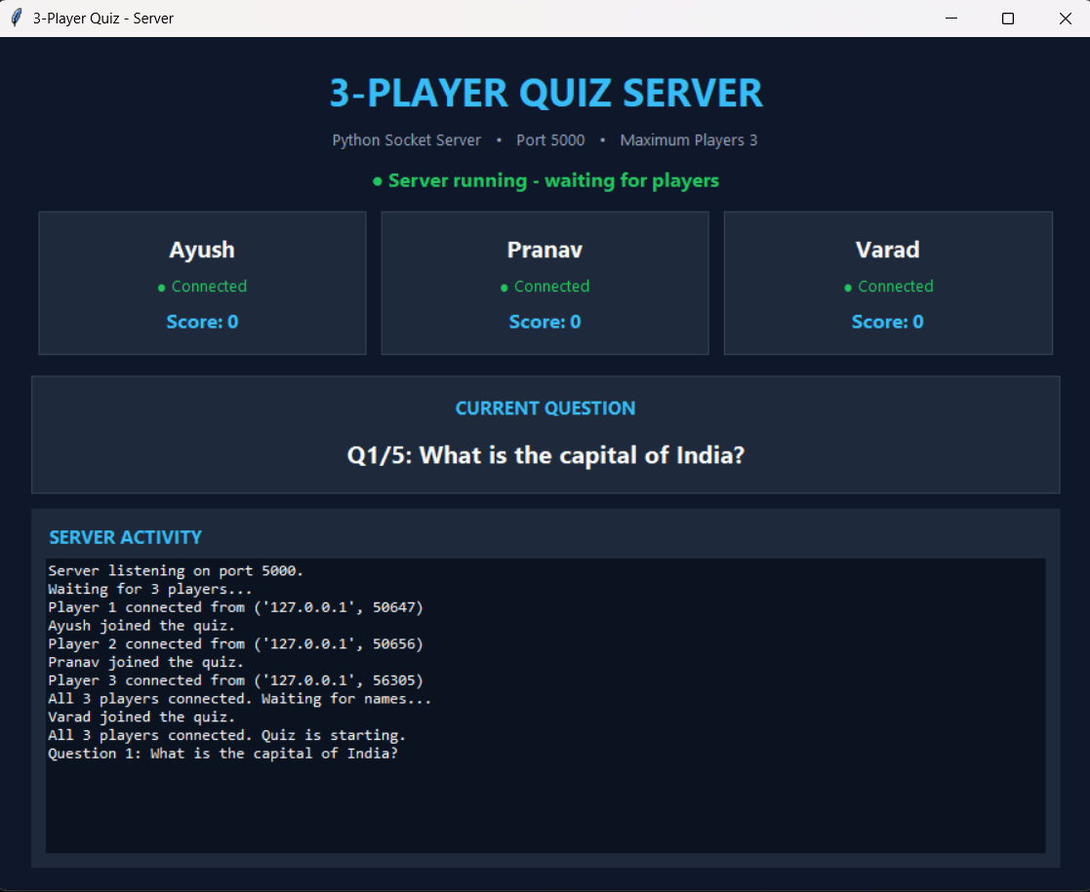

Figure 5: All Three Players Connected and Quiz Started

This figure shows the quiz after all three players have connected and the game has started. The quiz interface displays the question and its multiple-choice answer options. Players can read the question and select their answers through their respective client interfaces. The server coordinates the quiz activity among the connected players.

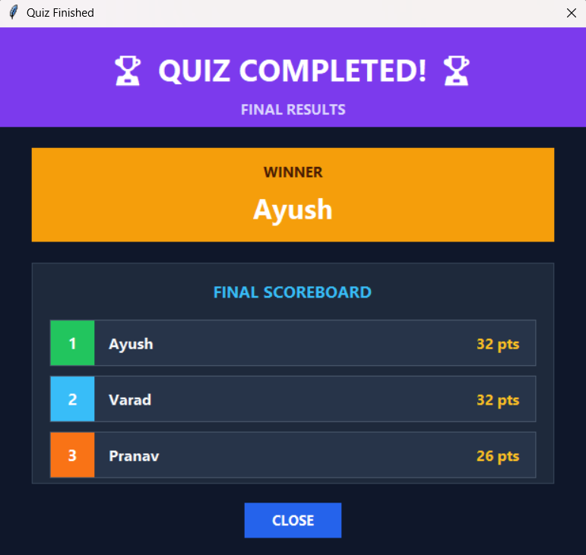

Fig 6: Quiz Completed and Final Results Displayed

This figure shows the final results screen after the quiz has been completed. The scoreboard displays the players' final scores and announces the winner. This allows participants to compare their performance and identify the player with the highest score according to the game's scoring system.

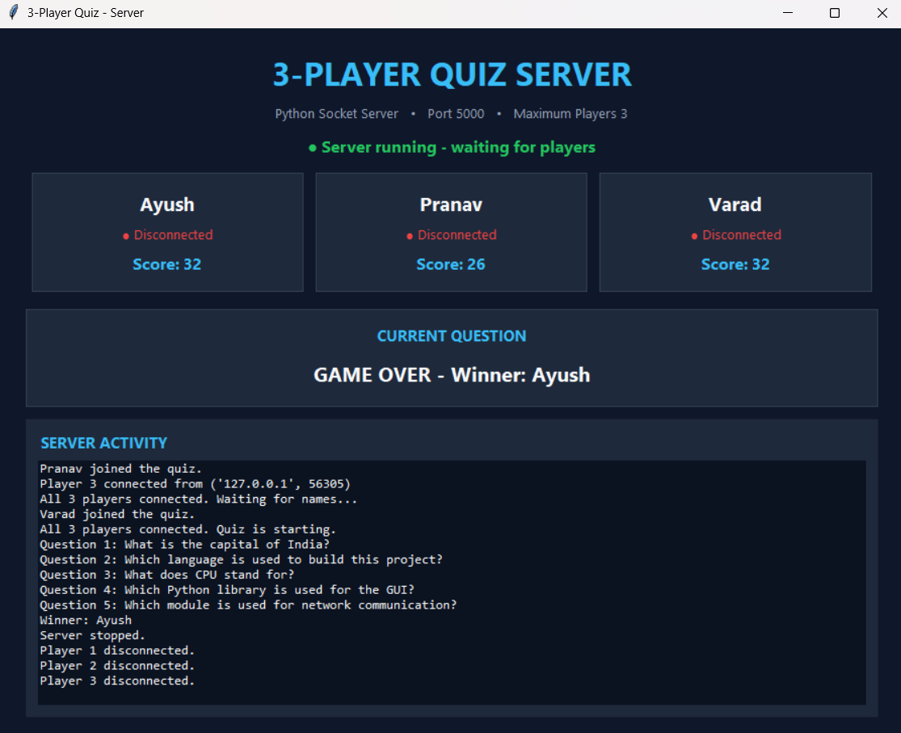

Fig 7: Server Stopped After Quiz Completion

This figure shows the server interface at the end of the quiz session. The server activity log displays the final game-related events, and the player connection information reflects the end of the session. The server is then stopped, completing the execution of the quiz application.

6. Future Scope

- Internet-Based Multiplayer: Extend the game to allow players to participate from different locations over the internet instead of requiring the same Wi-Fi network.
- Multiple Quiz Categories: Introduce categories such as Programming, Data Structures and Algorithms, Operating Systems, Computer Networks, and Database Management Systems.
- Question and Option Shuffling: Randomize the order of questions and answer options for different players to improve fairness and reduce the chances of copying.
- Increased Player Capacity: Enhance the server to support more than three players simultaneously.

7. Conclusion

The 3-Player Quiz Game is a Python-based application that allows three players to participate in a quiz using the same Wi-Fi network. It provides an interactive platform where players can answer questions and compete with each other.The system follows a client-server architecture in which one computer acts as the server and three players connect through separate client applications. The server manages player connections, questions, answers, and scores.
Python socket programming is used for communication between the server and clients. The threading module allows the server to handle all three players simultaneously, while Tkinter provides a simple graphical interface for displaying questions and answer options.The scoring system awards 10 marks for the first correct answer, 8 marks for the second, and 6 marks for the third. Incorrect answers receive 0 marks. The server updates the scores after each question.
After all questions are completed, the server calculates the final scores and declares the player with the highest score as the winner. The final results are displayed to all connected players.
Overall, this project demonstrates the practical use of Python, socket programming, multithreading, and GUI development. It provides an interactive quiz experience over a shared Wi-Fi network without requiring an internet connection.

8. References
- Python Documentation – Used for learning Python programming and basic concepts.
- Python Socket Documentation – Used to understand socket creation and server-client connection.
- Python Threading Documentation – Used to understand how to handle multiple players simultaneously.
- Python Tkinter Documentation – Used to understand how to create the graphical user interface and buttons.

