AI Video Clipping Pipeline
System Workflow

Overview
The pipeline ingests a single long-form video — supplied as a URL or a local file path — and produces a small set of ranked vertical short clips with burned-in word-level captions, suitable for direct upload to Reels, Shorts, or TikTok. A typical request returns three to five 9:16 clips, each 25 to 65 seconds long, packaged inside a per-run output directory on the local machine.
The system is split across two physical machines connected over a private Tailscale network. The Mac is the control plane: it accepts the user request, holds the source video, calls the remote stages in sequence, and writes the final files. The GPU server is the worker tier: it hosts the speech-to-text model, the ranking LLM, and the video render pipeline, and exposes them as four HTTP endpoints. Each side can be developed, restarted, or upgraded independently as long as the HTTP contract between them is preserved.

Architecture
The Mac runs a thin Python CLI (run.py). It contains no machine learning code and no GPU dependencies. Its responsibilities are: deriving a stable job identifier from the source, downloading or symlinking the source video, extracting a small audio file with the locally-installed ffmpeg, calling the GPU server’s endpoints in order, persisting the response of each stage as a cached artifact, and unpacking the final ZIP into a per-run output folder.
The GPU server is a FastAPI service running on a Windows host with an NVIDIA RTX-class GPU. It binds to port 8000 and is reachable from the Mac via the host’s Tailscale IP. All ML inference and all heavy ffmpeg work happens here. Inside a single pipeline run, the server loads and frees the transcription model and the ranking model sequentially so that the 12 GB VRAM budget is respected. Concurrent pipeline requests are rejected with HTTP 409 rather than queued.
Communication is strictly request-response HTTP. The Mac uploads small payloads (a few megabytes of audio) and one larger payload (the source video, on the first render request only) to the server, and downloads JSON responses plus one final ZIP. After the first render call, the server returns an X-Source-Id header that the Mac caches; subsequent render requests on the same source reuse that identifier and skip the video upload entirely.

Pipeline Diagram
The five pipeline stages, the side that owns each one, and the artifacts that travel between them:
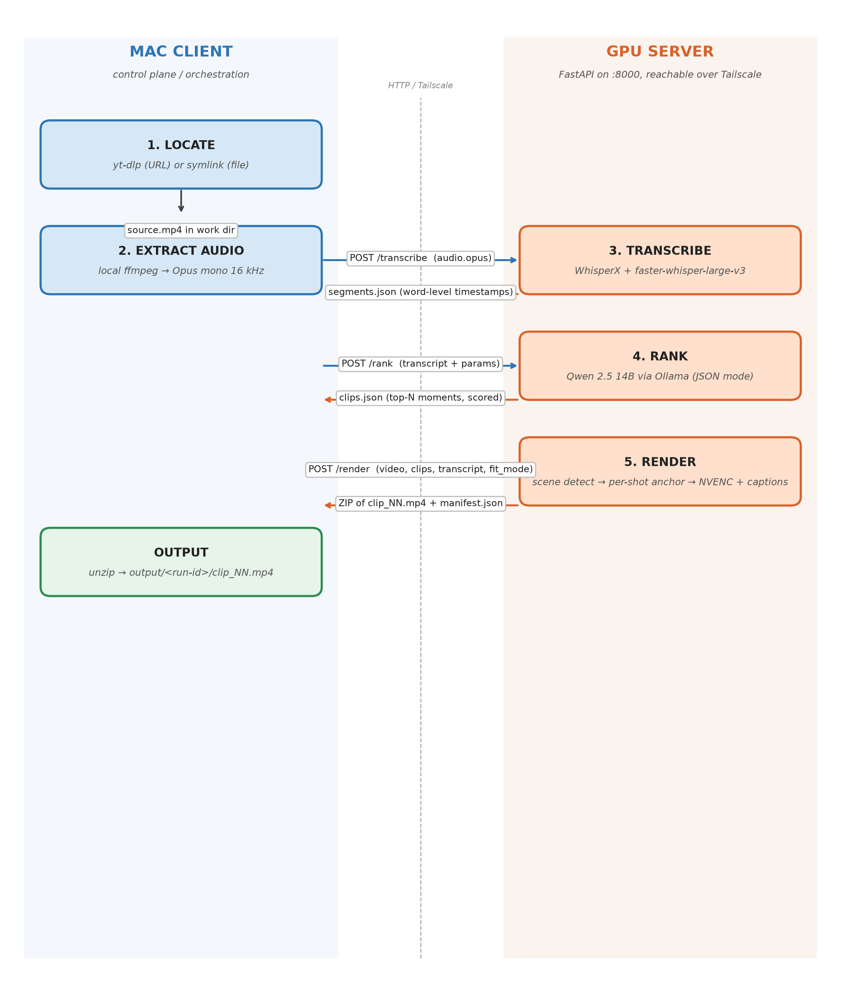

Pipeline Stages
Each numbered stage runs sequentially. A stage only executes if the previous stage has produced its output, and only if its own cached output is missing or invalid.

Stage 1 — Locate source
Runs on the Mac. If the input looks like an HTTP(S) URL, yt-dlp downloads it at up to 1080p and remuxes the result to MP4. If the input is a local file path, the Mac symlinks the file into the per-job work directory so disk is not duplicated. Either way, the stage finishes with source.mp4 inside work/<job-id>/.

Stage 2 — Extract audio
Runs on the Mac. The local ffmpeg encodes a single audio track from the source as Opus, mono, 16 kHz, 32 kbps. The resulting audio.opus is typically a few megabytes even for long sources, which keeps the next stage’s upload over Tailscale fast.

Stage 3 — Transcribe
Runs on the GPU server. The Mac sends audio.opus as a multipart POST to /transcribe. The server runs faster-whisper-large-v3 inside WhisperX to produce a transcript with both segment- and word-level timestamps. Word-level timing is required because the render stage uses it to burn karaoke-style captions onto each clip. The response is written to segments.json on the Mac.

Stage 4 — Rank moments
Runs on the GPU server. The Mac sends the transcript along with the requested clip count and a duration window in a JSON POST to /rank. The server passes the transcript to Qwen 2.5 14B via Ollama in JSON-output mode, with a prompt that scores moments on four criteria: hook strength, self-containment, emotional peak, and clean boundary at a sentence break. The server validates the model’s output, filters clips that fall outside the duration window, drops overlaps, and returns a sorted clips array. The Mac caches this as clips.json.

Stage 5 — Render
Runs on the GPU server. The Mac sends the full source video (or just a previously-returned source_id), the clips JSON, the transcript JSON (for captions), a caption style preset, and a fit_mode in a multipart POST to /render. For each clip the server:
- Splits the clip into shots using PySceneDetect, so editorial cuts inside the clip are recognized.
- Computes a static crop anchor per shot using a three-tier priority: MediaPipe face detection first, YOLO person detection as a fallback for profile or low-light shots, and dead-center as a final default.
- Builds a single ffmpeg filter chain that scales the source so its height matches the 9:16 output, applies the per-shot crop anchors via a sendcmd step function, and burns the word-level caption track in the requested style.
- Encodes the result with h264_nvenc and writes one MP4 per clip into a job-local scratch directory.
Once all clips for the request are written, the server zips them together with a manifest.json describing what was rendered, returns the ZIP to the Mac, and includes the X-Source-Id header so the cached source can be reused on the next call.
The Mac unpacks the ZIP into output/<run-id>/, where <run-id> is a timestamp plus the job ID. A symlink at output/latest always points at the most recent run.

Where Each Stage Lives
Summary of every pipeline component and the machine that runs it:
Stage | What runs | Location | Produces
1 | Locate source: yt-dlp for URLs, symlink for local files | Mac | source.mp4
2 | Extract audio: ffmpeg → Opus mono 16 kHz, 32 kbps | Mac | audio.opus
3 | Transcribe: WhisperX wrapping faster-whisper-large-v3, word-level timestamps | GPU server | segments.json
4 | Rank moments: Qwen 2.5 14B via Ollama, JSON-mode prompt with hook / self-contained / emotional-peak / clean-boundary criteria | GPU server | clips.json
5 | Render: PySceneDetect → per-shot anchor (MediaPipe face / YOLO person / center fallback) → ffmpeg crop+scale+captions, h264_nvenc | GPU server | output.zip
— | Unpack zip into per-run output directory | Mac | output/<run-id>/clip_NN.mp4

HTTP Contract
The integration surface between the Mac client and the GPU server is four HTTP endpoints. The Mac calls them in order on every full pipeline run; cache hits short-circuit the corresponding call. All long-running responses use generous client-side timeouts (10-minute read budget) since transcription and render can take minutes.
Endpoint | Request | Response
GET /health | (none) | JSON with service status, GPU memory, Ollama and Whisper readiness. Used by the Mac client as pre-flight before every run.
POST /transcribe | multipart with audio file | JSON: language, duration, and a segments array. Each segment carries text plus a word array with per-word start, end and confidence — required for caption burn-in downstream.
POST /rank | JSON: transcript segments, num_clips, duration_range | JSON: clips array with rank, start, end, duration, hook, score, reason — sorted by score, non-overlapping, each clip within the requested duration range.
POST /render | multipart: video (or source_id), clips JSON, style preset, fit_mode, transcript | ZIP containing clip_NN.mp4 files and manifest.json. Response header X-Source-Id echoes the server-cached source key so subsequent renders skip the upload.

Caching and Resume
Every stage’s output is written to disk under work/<job-id>/ before the next stage starts. The job ID is a stable hash of the source URL or the source file’s absolute path, size, and modification time, so re-running the same source produces the same job ID and reuses every prior artifact. The cache is parameter-aware where it matters: the rank cache is invalidated when num_clips or duration_range change, and the render cache is invalidated when style, clip count, or fit_mode change.
Users can also force re-entry mid-pipeline with the --from-stage flag (locate, audio, transcribe, rank, or render). The CLI deletes the named stage’s cached artifact and every downstream artifact, then starts the pipeline from that point. Earlier stages still hit cache.
Stage | Cached artifact | Skip condition
Locate | source.mp4 | File exists and non-empty
Audio | audio.opus | File exists and non-empty
Transcribe | segments.json | File exists and parses as valid JSON
Rank | clips.json | File exists AND cached num_clips and duration_range match the current request
Render | output.zip + render_meta.json | Zip exists AND cached style, clip count, and fit_mode match the current request

Output Layout
Each run writes to its own subdirectory under output/ so that earlier runs are not overwritten and can be compared side by side:
- output/<timestamp>_<job-id>/clip_NN.mp4 — the rendered clips for the run
- output/latest — symlink to the most recent run’s directory
- logs/<timestamp>_<job-id>.log — full per-run log including HTTP request and response summaries, subprocess output, cache hits, the server’s render manifest, and any warnings (face-detection fallback, source_id expiry, retries)
- work/<job-id>/ — cached stage artifacts; never auto-cleaned, safe to delete manually
The run ID stem is identical between the log file and the output directory, so any output run can be cross-referenced with its log without grepping.

