Supply-Chain Disruption Prediction System
What We Have Built — A Plain-Language Guide
A complete, non-technical walk-through of every part of the system, the tools it uses, and their current state.

Contents
1. What This System Does (in one paragraph) 2
2. The Big Picture 2
3. The Data Foundation 4
4. The Pipeline, Stage by Stage 4
Stage 1 — Data Collection (Ingestion) 4
Stage 2 — Entity Resolution 4
Stage 3 — Clustering (removing duplicate news) 4
Stage 4 — LLM Extraction (reading the news) 5
Stage 5 — Forecasting (predicting the trend) 5
Stage 6 — Labeling (the answer key) 5
Stage 7 — Feature Builder + the Prediction “Brains” 5
Stage 8 — RAG Explanation (the “why”) 5
Stage 9 — Dashboard (the screen you look at) 6
Stage 10 — Backtest (an honesty check) 6
5. Tools & Models — What, State, How Used 7
6. Two Ways the System Predicts 7
7. What Is Real, and What Is Still Limited 8
8. How It All Runs Together 9

1. What This System Does (in one paragraph)
This system tries to warn us — early — when a critical computer-chip resource is about to become hard to get (what we call “tightening”). It watches four resources: DRAM and NAND (types of memory), HBM (high-bandwidth memory used in AI chips), and GPUs (AI accelerators). Every week, for each resource, it pulls together public signals — stock prices, memory prices, news articles, and company filings — turns them into a small set of numbers, and produces two things: a tightening probability (how likely a shortage is building) and a plain-language explanation backed by real news quotes. Everything runs on free data sources and free or low-cost AI models, and every result is clearly marked as either genuinely data-backed or still experimental.

2. The Big Picture
The system is a pipeline: a chain of ten stages. Data comes in at the top, flows down through a series of steps that clean it, understand it, and turn it into a prediction, and comes out at the bottom as a dashboard you can look at. Every stage reads from and writes to a single database file, so each step builds on the one before it.
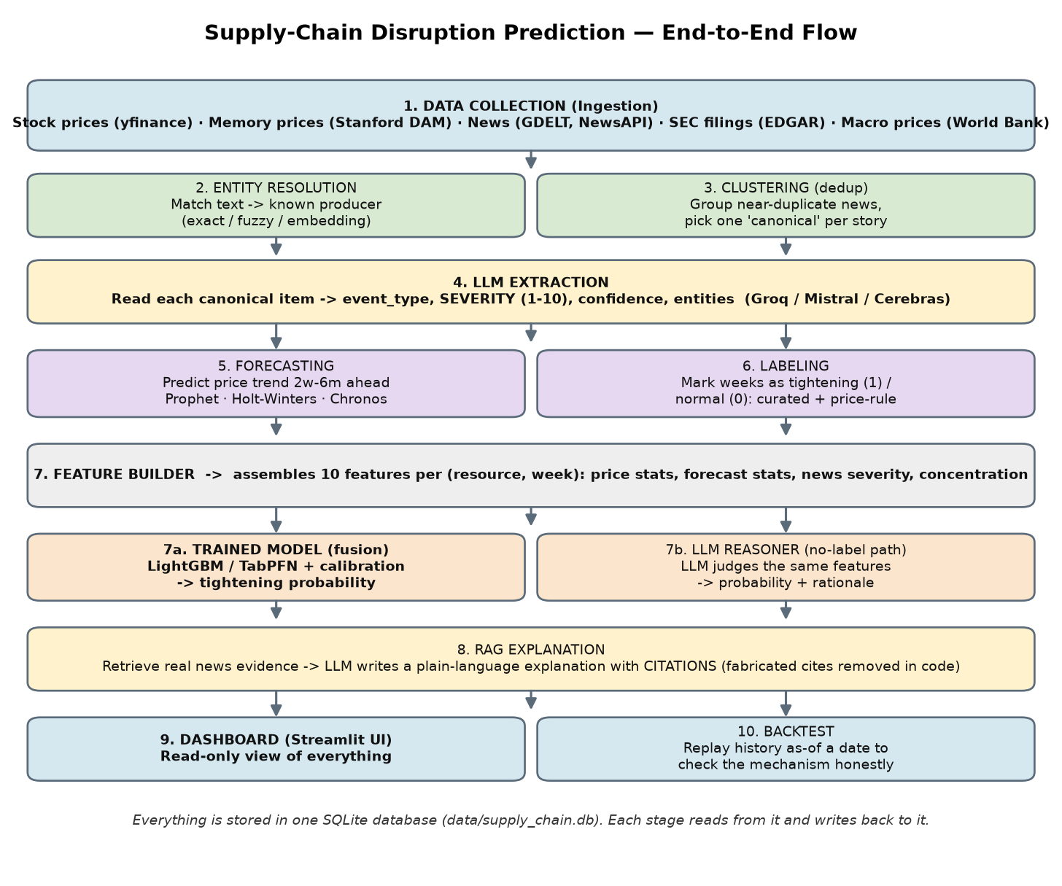
You do not need to understand every box to use the system. The short version: collect data → make sense of it → build features → predict → explain → show it. The rest of this document explains each part in simple terms.

3. The Data Foundation
Everything starts with data. The system collects five kinds of public information, all from free sources. Here is what each one is and how much of it we currently have.
Data type | What it is | Where it comes from | Current state
Stock prices | Daily share prices of chip makers (Micron, Nvidia, TSMC). A weak but useful “market mood” signal. | yfinance (Yahoo Finance) | ~3,400 rows, 2023–2026
Memory prices | The actual price of memory in dollars-per-gigabyte for DRAM/NAND/HBM. | Stanford DAM public dataset | ~200 rows, 2021–2026
News articles | Headlines and snippets about the chip industry. | GDELT + NewsAPI | ~3,300 articles, 2023–2025
Company filings | Capital-spending figures and 8-K event filings from chip makers and big AI buyers. | SEC EDGAR (edgartools) | ~620 filing rows, 2023–2025

Important design choice: we deliberately keep only recent history (about the last 3–5 years). Older data (memory once cost billions of dollars per gigabyte in the 1950s) was removed because it is irrelevant and can confuse the models.

4. The Pipeline, Stage by Stage
Each stage below lists what it does in plain words, the tool it uses, and how it is run.

Stage 1 — Data Collection (Ingestion)
- What it does: downloads the five data types above and stores them in the database. There is a separate small “client” for each source.
- Tools: yfinance, Stanford DAM CSV, GDELT, NewsAPI, SEC EDGAR.
- How it is run: scripts like ingest_market_data.py, ingest_dam_prices.py, ingest_news.py, ingest_sec_filings.py (plus one-time historical back-fill scripts).
- State: Working. History back to 2023 is loaded.

Stage 2 — Entity Resolution
- What it does: figures out which company a piece of text is talking about (e.g. “Micron”, “MU”, “Micron Technology” all mean the same producer). It tries three methods in order — exact match, fuzzy match, then AI-embedding similarity — and honestly says “unknown” rather than guessing.
- Tools: rapidfuzz (fuzzy text), sentence-transformers MiniLM (embeddings, loaded only if needed).
- State: Working.

Stage 3 — Clustering (removing duplicate news)
- What it does: the same story is often reported by many outlets. This groups near-duplicate articles and keeps one “canonical” copy, so the same news is not counted five times.
- Tools: sentence-transformers (embeddings), HDBSCAN (grouping), ChromaDB (a local store of the article vectors for later search).
- How it is run: run_clustering.py.
- State: Working. ~3,300 articles were reduced to ~1,990 unique stories.

Stage 4 — LLM Extraction (reading the news)
- What it does: an AI language model reads each unique news item and company filing and pulls out structured facts: the event type, a severity score from 1 to 10, a confidence, and the entities mentioned. This is how free text becomes a number the model can use.
- Tools: Groq (main), with Mistral and Cerebras as automatic backups. Multiple API keys rotate automatically when limits are hit.
- How it is run: run_extraction.py.
- State: Working. Nearly all unique news and all filings have been scored.

Stage 5 — Forecasting (predicting the trend)
- What it does: for each resource it projects the price trend 2 weeks to 6 months ahead, using three different methods and flagging when they disagree (disagreement = uncertainty).
- Tools: Prophet, Holt-Winters, and Chronos (a modern pre-trained forecasting model).
- How it is run: run_forecasting.py.
- State: Working. In our tests Holt-Winters was most accurate on memory, Chronos best on GPUs.

Stage 6 — Labeling (the answer key)
- What it does: to teach a model, we need examples of “this week was a shortage” (1) and “this week was normal” (0). Labels come from two independent sources: hand-written expert episodes, and an automatic price-spike rule. The two are kept separate and disagreements are recorded, never hidden.
- How it is run: build_labels.py (reads data/curated_episodes.json).
- State: Working, with a known gap: our “normal” examples all come from one period (the 2023 memory glut). See Section 7.

Stage 7 — Feature Builder + the Prediction “Brains”
- What it does: the feature builder combines everything into 10 numbers per resource per week (recent price, price trend, forecast, news severity, supplier concentration, etc.). Then a “brain” turns those numbers into a tightening probability.
- Two brains are available: (a) a trained model that learns from the labels, and (b) an LLM reasoner that needs no labels. See Section 6.
- Tools: LightGBM (default trained model), TabPFN (alternative, via hosted API), isotonic calibration, SHAP (explains which feature mattered).
- How it is run: train_fusion_model.py then predict.py; or llm_reasoner.py for the no-label path.
- State: A genuine data-backed model now trains (a major milestone), but its accuracy is not yet trustworthy — see Section 7.

Stage 8 — RAG Explanation (the “why”)
- What it does: retrieves the most relevant real news for a resource and asks an AI to write a short, plain-language explanation — but every quote the AI cites is checked against the real articles in code, and made-up citations are deleted. A disclaimer is always attached automatically.
- Tools: ChromaDB (retrieval) + the LLM providers (writing).
- How it is run: generate_explanation.py.
- State: Working.

Stage 9 — Dashboard (the screen you look at)
- What it does: a read-only web page that shows, per resource, the current signals, the forecast, the tightening probability, and the explanation. It only displays what the database contains — it never invents numbers.
- Tools: Streamlit (web app) + Plotly (charts).
- How it is run: streamlit run dashboard_ui/app.py.
- State: Built and working.

Stage 10 — Backtest (an honesty check)
- What it does: replays the system “as of” a past date — hiding anything that happened after — to check the machinery behaves correctly and does not peek at the future.
- How it is run: run_backtest.py.
- State: Working (mechanism validated).

5. Tools & Models — What, State, How Used
This table is the quick reference for every external tool and model in the system.
Tool / Model | What it does | Type / cost | How it is used now
yfinance | Downloads producer stock prices | Free library | Called by market-data ingest
Stanford DAM | Real memory ¤/GB prices | Free CSV | Downloaded by DAM ingest
GDELT | Historical + recent news search | Free, no key | News ingest (incl. 2023–25 back-fill)
NewsAPI | Recent news (last ~30 days) | Free key | News ingest (recent only)
SEC EDGAR (edgartools) | Company capex + 8-K filings | Free | SEC ingest, date-aware
Groq / Mistral / Cerebras | Read news → severity; write explanations; reasoner | Free tiers, key rotation | LLM extraction, RAG, reasoner
sentence-transformers | Text-to-vector embeddings | Free, local | Entity resolution + clustering
HDBSCAN + ChromaDB | Group duplicates + store/search vectors | Free, local | Clustering + RAG retrieval
Prophet / Holt-Winters | Classic forecasters | Free, local | Forecasting stage
Chronos | Pre-trained forecaster (added Phase 2) | Free, local | 3rd forecaster, verified
LightGBM | Trained tightening model (default) | Free, local | Fusion model + SHAP
TabPFN | Alternative small-data model | Hosted API + token | Fusion model (verified, optional)
FinBERT | Financial sentiment (extra feature) | Free, local | Available; sentiment ≠ severity
bart-large-mnli | Zero-shot event labeler (tested) | Free, local | NOT adopted (33% vs LLM)
Streamlit + Plotly | Dashboard UI + charts | Free, local | The screen

6. Two Ways the System Predicts
There are two independent ways to produce a tightening probability. They exist because real training labels are scarce, so we want a fallback that needs none.
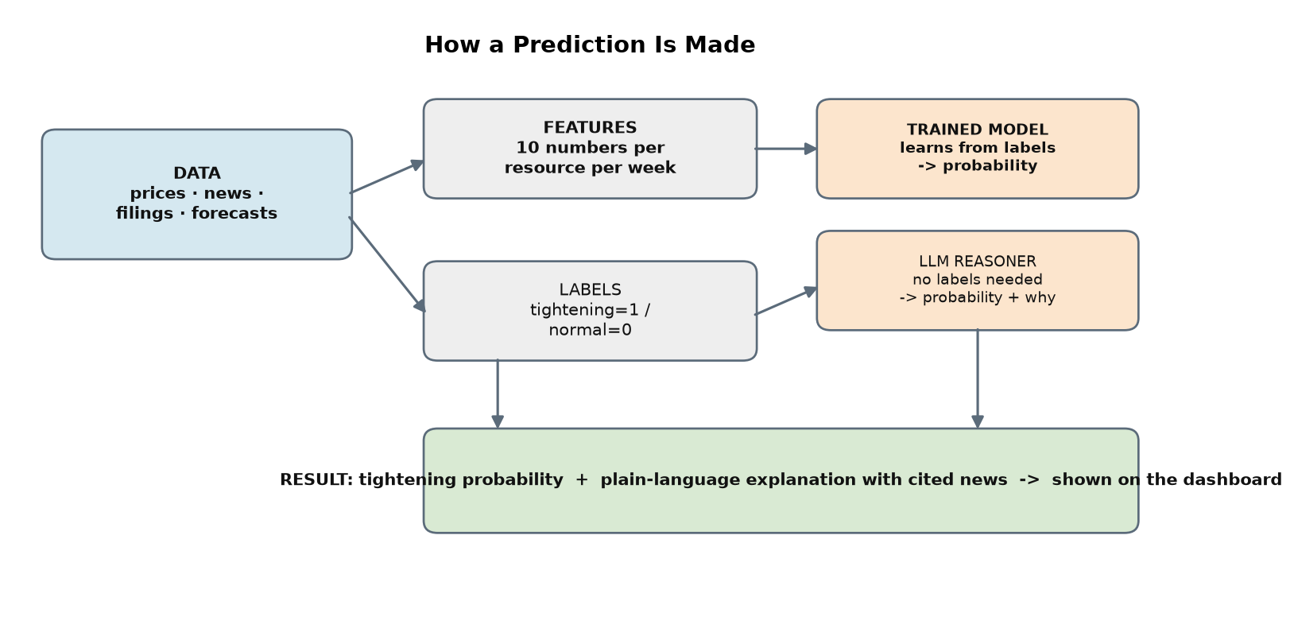

Brain A — The Trained Model (fusion model)
Learns patterns from the labeled examples (shortage weeks vs normal weeks) and outputs a calibrated probability. It can also show which feature drove each prediction (via SHAP). Default engine is LightGBM; TabPFN is an alternative that shines on very small data. This is the preferred path when we trust the labels.

Brain B — The LLM Reasoner (no labels needed)
Feeds the same 10 features plus a few real news snippets to an AI model and asks it to judge the tightening probability and explain its reasoning. It needs no training data, so it works even when labels are missing — but its answer is clearly marked as a judgment, not a calibrated statistic.

7. What Is Real, and What Is Still Limited
The system is deliberately honest about the difference between “the machinery works” and “the prediction can be trusted.” Here is the current status.

What is genuinely working
- All data collection, cleaning, news-reading, forecasting are working on real data.
- A genuine data-backed prediction model now trains — previously only a placeholder “practice” model was possible. This was the main goal, and it is achieved.
- The forecasters and the AI news-reading are verified on real data.

The one important limitation (being transparent)
When we tested the trained model it scored a suspiciously perfect result. On investigation, the reason is our “normal / no-shortage” examples all come from a single period — the 2023 memory glut — and cover only two of the four resources. So the model has really only learned to recognise “the 2023 glut,” not to tell shortage from normal in general. Adding richer news data did not change this, which confirms it is a gap in the example set, not the features.
Bottom line: the hardest part (getting real, matching data flowing end-to-end) is solved. The next step to make predictions trustworthy is to add “normal period” examples from 2024–2025 and for GPUs/HBM — more example variety, not more tools.

8. How It All Runs Together
- One database: a single SQLite file (data/supply_chain.db) holds every table — prices, news, forecasts, labels, predictions, explanations. Each stage reads and writes here.
- Small, separate scripts: each stage is its own script in the scripts/ folder, run in order. Running them separately avoids technical conflicts between the AI libraries.
- Secrets: all API keys live in one local file (.env.local) that loads automatically — no keys are hard-coded.
- Safety rails everywhere: results are always labeled real vs practice; made-up news citations are stripped; missing data is shown as “unknown,” never faked as zero.
- Tested: 200 automated tests cover the pipeline and pass.

In short: the system collects free public signals, reads and understands them with AI, turns them into weekly features, predicts tightening two ways, explains the prediction with cited news, and shows it all on a dashboard — with every result honestly marked as trustworthy or still-experimental.

