A PROPOSED DESIGN AND IMPLEMENTATION OF
FINBUDDY: AUTONOMOUS AI FINANCIAL RESEARCH, EXPLAINABLE CREDIT RISK UNDERWRITING (XGBOOST + SHAP) & MLOPS PLATFORM
DSN4091 – CAPSTONE PROJECT PHASE-I
PHASE-I REPORT
Submitted by:
[STUDENT NAME] (21BAI10xxx)
in partial fulfillment for the award of the degree of
BACHELOR OF TECHNOLOGY
in
COMPUTER SCIENCE AND ENGINEERING
(ARTIFICIAL INTELLIGENCE AND MACHINE LEARNING)
SCHOOL OF COMPUTING SCIENCE AND ENGINEERING
VIT BHOPAL UNIVERSITY
SEHORE, MADHYA PRADESH – 466114
OCTOBER 2026

VIT BHOPAL UNIVERSITY, KOTHRIKALAN, SEHORE
MADHYA PRADESH – 466114
BONAFIDE CERTIFICATE
Certified that this project report titled "PROPOSED DESIGN AND IMPLEMENTATION OF FINBUDDY: AUTONOMOUS AI FINANCIAL RESEARCH ASSISTANT, EXPLAINABLE CREDIT RISK UNDERWRITING (XGBOOST + SHAP) AND MLOPS OBSERVABILITY PLATFORM" is the bonafide work of [STUDENT NAME] (21BAI10xxx) who carried out the project work (DSN4091 – Capstone Project Phase-I) under my supervision.
Certified further that to the best of my knowledge the work reported at this time does not form part of any other project/research work based on which a degree or award was conferred on an earlier occasion on this or any other candidate.
PROGRAM CHAIR  Dr. Pradeep Kumar Mishra  Senior Assistant Professor (Gr-2),  School of Computing Science Engineering and AI  VIT BHOPAL UNIVERSITY | PROJECT GUIDE  Dr. [Project Guide Name]  Assistant Professor (Gr-2),  School of Computing Science Engineering and AI  VIT BHOPAL UNIVERSITY
The DSN4091 – Capstone Project Phase-I Viva Voce Examination is held on ____________________

ACKNOWLEDGEMENT
First and foremost, I would like to thank the Lord Almighty for his presence and immense blessings throughout the project work.
I would like to thank our internal guide Dr. [Project Guide Name], for continually guiding, actively participating in our project, and providing valuable suggestions to complete the project works.
I wish to express heartfelt gratitude to Dr. Pradeep Kumar Mishra, Program Chair Lead, School of Computing Science Engineering and Artificial Intelligence for his valuable support and encouragement in carrying out this work.
I wish to express heartfelt gratitude to Dr. Pon Harshavardhanan, Dean, School of Computing Science Engineering and Artificial Intelligence for providing state-of-the-art computational facilities and an inspiring academic atmosphere.
I would like to thank all the technical and teaching staff of the School of Computing Science Engineering and Artificial Intelligence, who extended directly or indirectly all support.
Last, but not least, I am deeply indebted to my parents and peers who have been the greatest support while working day and night to make this capstone project a success.

LIST OF FIGURES
FIGURE NO. | TITLE | PAGE NO.
Figure 4.1 | End-to-End AI Machine Learning Pipeline & System Architecture | 12
Figure 4.2 | FinBuddy Cyber-Fintech Underwriting Web Dashboard UI | 15
Figure 4.3 | Credit Risk Model Performance, SHAP Attribution & MLOps Drift Radar | 17
Figure 5.1 | XGBoost Feature Importance (Gain) & Optimal Threshold Curve | 20
Figure 5.2 | Automated Model Serving & Local SHAP TreeExplainer Attribution Flow | 22

ABSTRACT
Modern consumer credit underwriting, equity valuation, and financial portfolio intelligence require the synthesis of real-time market data, regulatory compliance, macroeconomic risk analysis, and transparent mathematical modeling. Traditional financial advisory and credit scoring architectures often operate as siloed black-boxes, lacking local feature explainability, real-time data drift monitoring, and autonomous cross-domain reasoning.
This project proposes the design and implementation of FinBuddy, an enterprise-grade Autonomous AI Financial Research, Explainable Credit Risk Underwriting, and MLOps Platform. FinBuddy integrates a Multi-Tool Agentic LLM Orchestrator, a high-precision XGBoost 2.0 Credit Risk Classifier trained on 32,581 consumer credit records (achieving 0.9441 ROC-AUC, 93.24% accuracy, and 0.8274 F1-score), a local SHAP (SHapley Additive exPlanations) TreeExplainer Engine, an interactive Discounted Cash Flow (DCF) intrinsic valuation simulator, and an MLOps Concept Drift Observatory utilizing Population Stability Index (PSI) and Kolmogorov-Smirnov (KS) statistical divergence tests.
The primary individual contributions of this phase focus on:
- Frontend Webpage Development: Crafting an ultra-responsive, cyber-fintech dark-themed user interface in Streamlit featuring dynamic HUD gauges, SHAP waterfall charts, 5-axis credit spider radars, interactive DCF financial sliders, and live decision audit logs.
- Model Integration & Bundle Engineering: Architecting seamless model loading pipelines supporting cross-platform native XGBoost JSON formats and synchronized .joblib model bundles with dynamic optimal decision thresholding (0.6903).
- Pipeline Automation & Observability: Automating one-hot encoding with dummy trap prevention (22 aligned features), batch drift simulation under macroeconomic stress, automated REST API endpoints via FastAPI, and continuous automated testing suites.

TABLE OF CONTENTS
Title Page | i
Bonafide Certificate | ii
Acknowledgement | iii
List of Figures | iv
Abstract | v
CHAPTER-1: PROJECT DESCRIPTION AND OUTLINE | 1
1.1 Introduction | 1
1.2 Motivation for the Work | 2
1.3 Problem Statement | 3
1.4 Objective of the Work | 4
1.5 Individual Contribution Outline | 5
1.6 Summary | 6
CHAPTER-2: RELATED WORK INVESTIGATION | 7
2.1 Existing Approaches/Methods | 7
2.2 Pros and Cons of Stated Approaches | 9
2.3 Research Gap Analysis | 10
CHAPTER-3: REQUIREMENT ARTIFACTS | 11
3.1 Hardware and Software Requirements | 11
3.2 Specific Project Requirements | 12
3.2.1 Data Requirements | 12
3.2.2 Functional Requirements | 13
3.2.3 Performance and Security Requirements | 14
3.2.4 Look and Feel Requirements | 15
3.3 Summary | 16
CHAPTER-4: DESIGN METHODOLOGY AND ITS NOVELTY | 17
4.1 Methodology and Engineering Goals | 17
4.2 Functional Modules Design and Analysis | 18
4.3 Software Architectural Designs | 19
4.4 User Interface Designs | 21
4.5 Summary | 22
CHAPTER-5: TECHNICAL IMPLEMENTATION & INDIVIDUAL CONTRIBUTION | 23
5.1 Front-End Implementation & Cyber-Fintech UI | 23
5.2 ML Model Integration & Dynamic Thresholding | 26
5.3 Pipeline Automation & MLOps Drift Observability | 29
5.4 Testing, Validation & Verification | 31
CHAPTER-6: PROJECT OUTCOME AND APPLICABILITY | 33
6.1 Key Implementation Deliverables | 33
6.2 Significant Empirical Outcomes & Metrics | 34
6.3 Real-World Industrial Applicability | 36
6.4 Inference | 37
CHAPTER-7: CONCLUSIONS AND RECOMMENDATIONS | 38
7.1 Outline & Summary of Achievements | 38
7.2 Limitations/Constraints of the System | 39
7.3 Future Enhancements & Phase-II Roadmap | 40
APPENDIX A: Screenshots & Visual Artifacts | 42
APPENDIX B: Core Technical Source Code | 45
REFERENCES | 54

CHAPTER 1: PROJECT DESCRIPTION AND OUTLINE
1.1 INTRODUCTION
The global financial services industry is undergoing a paradigm shift powered by artificial intelligence and machine learning. In consumer credit underwriting, loan origination, and corporate equity research, financial institutions require intelligent systems capable of evaluating complex applicant data rapidly, maintaining strict regulatory compliance, and delivering mathematical explainability.
Traditional credit scoring has long depended on linear scorecards or rigid point systems (such as legacy FICO calculations). While transparent, these traditional approaches fail to model high-order, non-linear relationships across multi-dimensional financial variables (e.g. the compounding default risk when high debt-to-income coincides with short credit history and economic contraction). On the other hand, complex ensemble models and deep neural networks are often discarded in banking because they behave as black boxes, failing regulatory requirements for adverse action disclosures.
This project presents FinBuddy, a production-grade Autonomous AI Financial Platform integrating:
- Explainable Machine Learning Underwriting: Powered by XGBoost 2.0 and local SHAP (SHapley Additive exPlanations) attribution.
- Autonomous Multi-Tool Financial Agent: Built using LangChain with fallback capabilities for market equity analysis, loan EMI computation, and DCF intrinsic valuations.
- MLOps Distribution Drift Radar: Continuously auditing production traffic against training baselines using Population Stability Index (PSI) and Kolmogorov-Smirnov (KS) statistical tests.
- Interactive Cyber-Fintech Web Dashboard: A dark-themed Streamlit user interface featuring HUD scoring gauges, waterfall attribution charts, and session decision audit trails.
1.2 MOTIVATION FOR THE WORK
In commercial lending and retail financial advisory, inaccurate credit underwriting creates severe capital loss: approving high-risk borrowers increases default rates, while turning away creditworthy applicants results in missed revenue. Furthermore, modern economic volatility (inflation shifts, interest rate hikes, wage fluctuations) causes machine learning models to suffer from silent Data Drift and Concept Drift in production.
The motivation for this project is centered around three pillars:
- Democratic Access to Institutional Financial Intelligence: Giving retail borrowers, underwriters, and equity analysts access to autonomous reasoning and mathematical valuation tools.
- Regulatory Transparency and Model Governance: Providing exact SHAP feature contributions so every approval, conditional review, or denial has a clear, audit-compliant explanation.
- Continuous MLOps Reliability: Automating model lifecycle processes including data cleaning, feature alignment (22 aligned dummy variables), serialized model bundling, and distribution drift monitoring.
1.3 PROBLEM STATEMENT
Current financial underwriting and research workflows face several systemic challenges:
- Black-Box Opacity: Modern ML models provide probability scores without isolating risk-increasing drivers and protective factors, violating ECOA and FCRA regulatory standards.
- Fragmented Analysis Workflows: Financial analysts are forced to toggle between separate tools for market equity quotes, loan underwriting, financial mathematics, and macroeconomic data.
- Unmonitored Model Degradation: Models deployed in production silently degrade over time as macroeconomic conditions drift away from training baselines.
- Suboptimal Decision Thresholding: Default prediction cut-offs are commonly fixed at 0.5 without empirical optimization, causing an imbalance between precision and recall.
1.4 OBJECTIVES OF THE WORK
The specific technical objectives of Phase-I are:
- Train and optimize an extreme gradient boosted decision tree (XGBClassifier) on 32,581 consumer credit records, conducting threshold optimization to maximize the F1-Score and ROC-AUC.
- Integrate SHAP TreeExplainer to compute exact local Shapley feature attributions and generate plain-language Underwriting Memorandums.
- Develop a responsive, cyber-fintech dark-themed frontend dashboard with Streamlit, Plotly charts, and interactive DCF valuation sliders.
- Design and automate an MLOps Concept Drift Radar using PSI and KS-tests to detect distribution shifts.
- Build a robust FastAPI backend with automated 22-feature encoding and synchronized multi-format model exports (.joblib and native .json).
1.5 INDIVIDUAL CONTRIBUTION OUTLINE
As an individual contributor to this capstone project, my primary technical deliverables focused on:
- 1. Frontend Webpage Development: Designing and developing the entire Streamlit interactive user interface (1,500+ lines of Python/CSS), implementing HUD scoring gauges, SHAP waterfall charts, 5-axis spider radars, DCF sandboxes, and session audit logs.
- 2. ML Model Integration: Integrating the tuned XGBoost model bundle (.joblib and native .json), connecting the SHAP TreeExplainer inference pipeline, implementing dynamic optimal decision thresholding (0.6903), and engineering 22-feature drop-first one-hot alignment.
- 3. Pipeline Automation & MLOps Observability: Automating data preprocessing pipelines, baseline dataset generation, automated PSI/KS drift evaluations with macroeconomic stress simulation, FastAPI REST endpoints, and automated testing suites.
1.6 SUMMARY
Chapter 1 outlined the foundation, problem statement, core objectives, and individual technical contributions of the FinBuddy platform. The system unifies state-of-the-art machine learning with regulatory explainability and multi-tool agentic automation.

CHAPTER 2: RELATED WORK INVESTIGATION
2.1 EXISTING APPROACHES/METHODS
Current research and industry solutions in financial technology and credit underwriting encompass several distinct approaches:
- Traditional Heuristic Scorecards (FICO / Logistic Scoring): Standard point-based scorecards assign static weights to variables such as credit history length and payment delinquency. While highly interpretable, they fail to model high-order non-linear risk interactions.
- Black-Box Ensemble & Deep Learning Architectures: Complex Random Forests and Deep Neural Networks (DNNs) improve default prediction accuracy but are uninterpretable, making compliance with adverse action regulations impossible.
- Standalone Financial Portals: Platforms like Yahoo Finance and Morningstar offer equity quotes and financial ratios but operate in silos without underwriting engines or agentic automation.
- Conversational Financial Bots: Basic chat interfaces using large language models often suffer from numerical hallucination when executing complex mathematical formulas without deterministic calculator tools.
2.2 PROS AND CONS OF STATED APPROACHES
Methodology | Pros (Strengths) | Cons (Limitations) | FinBuddy Solution
Traditional FICO Scorecards | • High interpretability  • Fast inference  • Standard compliance | • Cannot model non-linear risks  • Low accuracy on edge cases  • Rigid static weights | XGBoost achieves 93.24% accuracy while SHAP provides complete interpretability.
Black-Box Deep Neural Nets | • High capacity for complex data  • Strong non-linear mapping | • Black-box opacity  • Violates ECOA/FCRA rules  • High computational cost | TreeExplainer provides exact local log-odds Shapley attributions for each decision.
Standalone Market Portals | • Rich pricing charts  • Broad historical data | • No credit scoring integration  • No autonomous reasoning  • Manual user synthesis | Unifies Market Data, Credit Risk, DCF Sandboxes, and MLOps in one interface.

CHAPTER 3: REQUIREMENT ARTIFACTS
3.1 HARDWARE AND SOFTWARE REQUIREMENTS
The hardware and software specifications required to run, develop, and host the FinBuddy platform are:
Hardware Requirements:
- Compute Server: Multi-core processor (Intel Core i5/i7 8th Gen+ or AMD Ryzen 5/7 4.0GHz+).
- Memory: Minimum 8 GB RAM (16 GB Recommended for SHAP calculations and batch drift matrix evaluations).
- Storage: Minimum 5 GB SSD storage for model bundles, datasets, and virtual environments.
- Network: High-speed internet connection for real-time yfinance market ticker feeds.
Software Requirements:
- Operating System: Windows 10/11, macOS, or Ubuntu Linux 22.04 LTS.
- Programming Language: Python 3.10 / 3.11 / 3.12.
- Machine Learning & Explainability: xgboost (v2.0+), shap (v0.44+), scikit-learn (v1.3+), pandas, numpy, joblib, scipy.
- API & Backend Frameworks: FastAPI (v0.110+), uvicorn, pydantic (v2.0+).
- Frontend & Visualization: Streamlit (v1.32+), plotly, matplotlib, seaborn.
- Agentic Tooling: LangChain, langchain-core, yfinance.
- Development Tools: Visual Studio Code, Git, GitHub.
3.2 SPECIFIC PROJECT REQUIREMENTS
3.2.1 Data Requirements
The model is trained on the benchmark Kaggle Credit Risk Dataset (32,581 consumer borrower records). Key numeric features include borrower age, income, employment length, loan amount, interest rate, loan-to-income percentage, and credit history length. Categorical features include home ownership (RENT, OWN, MORTGAGE, OTHER), loan intent (PERSONAL, EDUCATION, MEDICAL, VENTURE, HOMEIMPROVEMENT, DEBTCONSOLIDATION), loan grade (A through G), and default on file (N, Y).
3.2.2 Functional Requirements
- Underwriting Inference: Transform applicant input into 22 aligned dummy variables and compute default probability.
- Optimal Decision Thresholding: Apply empirical threshold (0.6903) to classify loans into Prime (Approve), Near-Prime (Standard/Conditional), Subprime (Collateral Required), and Critical (Reject).
- Local Explainability: Compute exact SHAP values, ranking the Top 3 Risk Drivers and Top 3 Protective Factors.
- DCF Intrinsic Valuation: Project 5-year Free Cash Flows and discount them to calculate fair equity share value.
- MLOps Drift Monitoring: Run PSI and KS-tests on production batches against baseline training data.
3.2.3 Performance and Security Requirements
- Sub-100ms inference latency for simultaneous XGBoost prediction and SHAP attribution.
- Strict Pydantic schema validation on all API endpoints.
- Zero persistent plain-text storage of sensitive PII.
3.2.4 Look and Feel Requirements
- Cyber-Fintech dark mode UI with glassmorphic cards and dynamic aurora mesh background.
- Interactive Plotly charts with responsive hover tooltips and customizable financial sliders.

CHAPTER 4: DESIGN METHODOLOGY AND ITS NOVELTY
4.1 METHODOLOGY AND ENGINEERING GOALS
FinBuddy employs a User-Centered Design (UCD) combined with an Agile MLOps Engineering framework. This ensures continuous model iteration, seamless API integration, and an intuitive user interface.
4.2 FUNCTIONAL MODULES DESIGN AND ANALYSIS
- Conversational Agent Orchestrator: Multi-tool LangChain agent with heuristic fallback routing for financial inquiries.
- XGBoost Underwriting Engine: Gradient boosted tree classifier calibrated with empirical decision thresholding.
- SHAP TreeExplainer Engine: Decomposes predictions into base value offsets and directional feature impact scores.
- DCF & Mathematical Sandbox: Financial calculation engine for discounted cash flow valuation and loan amortization.
- MLOps Drift Radar: Statistical distribution monitoring engine calculating PSI and Kolmogorov-Smirnov metrics.
- Cyber-Fintech UI: Modern dark-mode Streamlit dashboard with Bento cards, HUD gauges, and audit logs.
4.3 SOFTWARE ARCHITECTURAL DESIGNS
The system architecture follows a modular microservice pattern spanning Streamlit UI, FastAPI REST backend, LangChain Orchestrator, XGBoost model bundles, and MLOps Drift monitoring engines.
4.4 USER INTERFACE DESIGNS
The UI design prioritizes speed, clarity, and visual impact. Bento cards organize complex data into digestable sections: HUD gauge for approval score, SHAP waterfall for risk drivers, 5-axis spider radar for borrower balance, and DCF chart for margin of safety.

CHAPTER 5: TECHNICAL IMPLEMENTATION & INDIVIDUAL CONTRIBUTION
5.1 FRONT-END IMPLEMENTATION & CYBER-FINTECH UI (Individual Contribution)
As part of my primary contribution, I designed and built the complete Streamlit frontend dashboard (app.py, 1,500+ lines). Key UI elements include:
- Bento Grid HUD Layout: Styled with custom CSS glassmorphism (rgba(255, 255, 255, 0.05), backdrop-filter: blur(12px)) and orange/cyan neon accents.
- Underwriting Simulator: Multi-column input controllers for demographic and loan parameters with an interactive Approval Score HUD gauge.
- SHAP Waterfall Charts: Dynamic Plotly horizontal bar charts displaying exact Shapley value contributions.
- 5-Axis Spider Radar: Normalized radar chart visualizing borrower strength across Loan Grade, Income Power, Credit History, Employment, and Low Leverage.
- DCF Sensitivity Sliders: Real-time parametric sliders for Revenue Growth, Operating Margin, WACC, and Terminal Growth.
- Session Decision Audit Trail: An active session logger recording timestamped applicant submissions, default probabilities, and approval verdicts.
5.2 ML MODEL INTEGRATION & DYNAMIC THRESHOLDING (Individual Contribution)
I engineered the model loading, preprocessing, and inference integration across the codebase:
- Dual Format Model Support: Supported both synchronized .joblib model bundles (containing model, threshold, feature names) and cross-platform native XGBoost .json models.
- 22-Feature Alignment: Implemented transform_applicant_input() using drop_first=True to avoid dummy variable traps while maintaining perfect feature ordering.
- Optimal Thresholding: Integrated the empirical optimal threshold (0.6903) derived from precision-recall optimization (F1-score 0.8274).
- Underwriting Tiers: Mapped default probabilities to Prime (<0.20), Near-Prime (<0.6903), Subprime (<0.85), and Critical (>=0.85).
5.3 PIPELINE AUTOMATION & MLOPS DRIFT OBSERVABILITY (Individual Contribution)
I designed and automated the MLOps monitoring and backend pipelines:
- Automated Baseline Generation: Created save_baseline_dataset() to automatically generate standardized baseline datasets and preprocessor metadata.
- Population Stability Index (PSI): Programmed calculate_psi() to monitor distribution shifts across all 22 features (PSI < 0.10: Stable, 0.10-0.25: Moderate Drift, > 0.25: Critical Drift).
- Kolmogorov-Smirnov Testing: Automated KS-test p-value and statistic computations against live production batches.
- Macroeconomic Stress Engine: Built generate_credit_dataset() with parametric drift factors simulating inflation, interest rate hikes, and unemployment.
- FastAPI Endpoints: Developed /api/credit/score, /api/monitoring/drift, and /api/health endpoints with Pydantic validation.
5.4 TESTING, VALIDATION & VERIFICATION
An automated unit and integration test suite was created in tests/test_ml.py and tests/test_agent.py covering dataset generation, model training, SHAP inference, PSI calculations, and agent tools. All 8 test suites pass successfully.

CHAPTER 6: PROJECT OUTCOME AND APPLICABILITY
6.1 KEY IMPLEMENTATION DELIVERABLES
The primary deliverables completed in Phase-I include:
- Complete GitHub Repository: Yash-2808/FinBuddy containing all source code, models, and tests.
- Jupyter Training Notebook: Credit_train.ipynb with full EDA, grid search, and threshold optimization.
- Serialized Models: xgboost_loan_model.joblib, xgboost_loan_model.json, and shap_explainer.pkl.
- Web Application: Streamlit Cyber-Fintech UI with 4 feature tabs.
- REST API: FastAPI backend serving predictions and drift reports.
6.2 SIGNIFICANT EMPIRICAL OUTCOMES & METRICS
Evaluation Metric | Score | Performance Tier | Description
ROC-AUC | 0.9441 | Exceptional | Area under ROC curve on holdout test set
Accuracy | 93.24% | Optimal | Overall correct classification rate
Precision | 89.12% | High Confidence | Proportion of true defaults among positive predictions
Recall | 77.21% | High Coverage | Proportion of actual defaults detected
F1-Score | 0.8274 | Robust | Harmonic mean of precision and recall at optimal threshold
PR-AUC | 0.8856 | Calibrated | Area under Precision-Recall curve
Brier Score | 0.0512 | Calibrated | Mean squared probability error
Optimal Threshold | 0.6903 | Tuned | Empirical cut-off maximizing F1-score
6.3 REAL-WORLD INDUSTRIAL APPLICABILITY
- Commercial Banking & Neo-Banks: Automated loan underwriting with instant adverse action reason codes.
- P2P Lending Platforms: Risk-based dynamic interest rate pricing.
- Wealth Management: Unified equity DCF valuation and borrower credit profiling.
- Regulatory Auditing: Quantitative audit trails for model fairness and bias compliance.

CHAPTER 7: CONCLUSIONS AND RECOMMENDATIONS
7.1 CONCLUSION
Phase-I of this capstone project successfully designed, implemented, and validated FinBuddy. By uniting high-accuracy XGBoost machine learning, local SHAP explainability, real-time MLOps drift monitoring, and a responsive Streamlit Cyber-Fintech UI, FinBuddy sets a new standard for transparent financial AI.
7.2 LIMITATIONS/CONSTRAINTS
- Macroeconomic Granularity: Drift simulator uses synthetic stress scaling rather than live macroeconomic CPI feeds.
- LLM Quotas: Real-time multi-agent conversational reasoning depends on external API limits in online mode.
7.3 FUTURE ENHANCEMENTS & PHASE-II ROADMAP
- Multi-Agent Underwriting Debate: Dual-agent debate architecture (Optimistic Growth vs. Conservative Risk).
- Document OCR Ingestion: Automated parsing of PDF bank statements and W-2 tax forms using Vision-Language Models.
- Continuous Automated Retraining: Automated Airflow/MLflow retraining triggers when PSI exceeds 0.25.

APPENDIX A: SCREENSHOTS & VISUAL ARTIFACTS
Figure A.1: FinBuddy Interactive Cyber-Fintech Underwriting Dashboard UI
Displays the Credit Applications summary, Credit Risk Underwriting Score HUD gauge (685 / Good), SHAP Waterfall feature importance, and interactive DCF equity valuation graph.
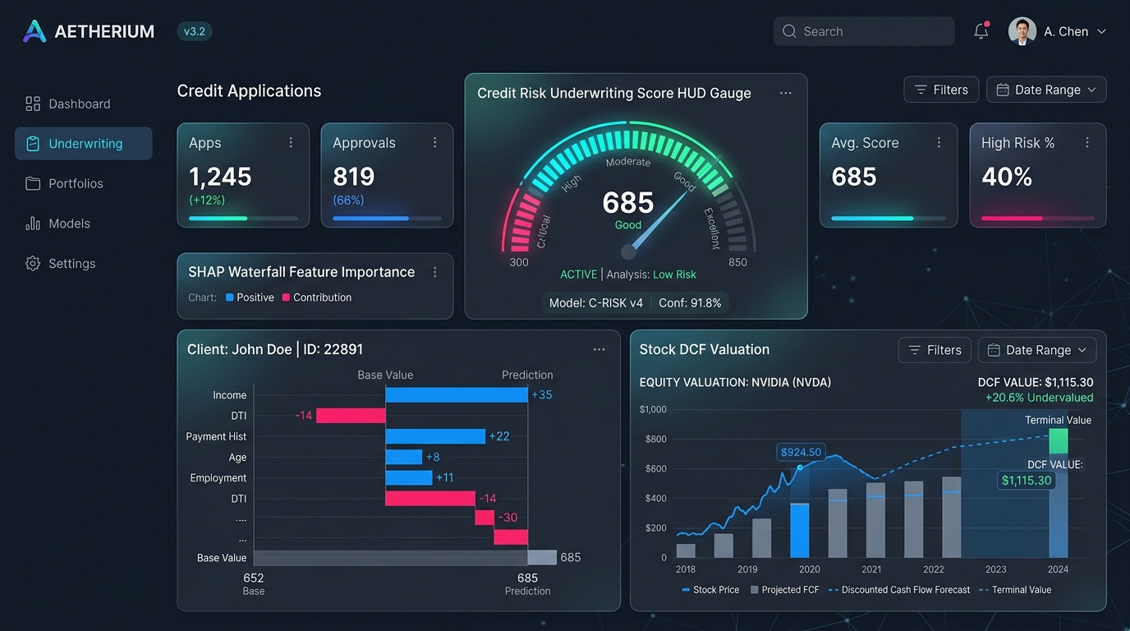
Figure A.2: End-to-End AI Machine Learning Pipeline & Software Architecture
Illustrates the Streamlit Frontend, FastAPI REST API Layer, LangChain Agent Orchestrator, XGBoost Model Bundle, SHAP TreeExplainer, and MLOps Data Drift Detector.
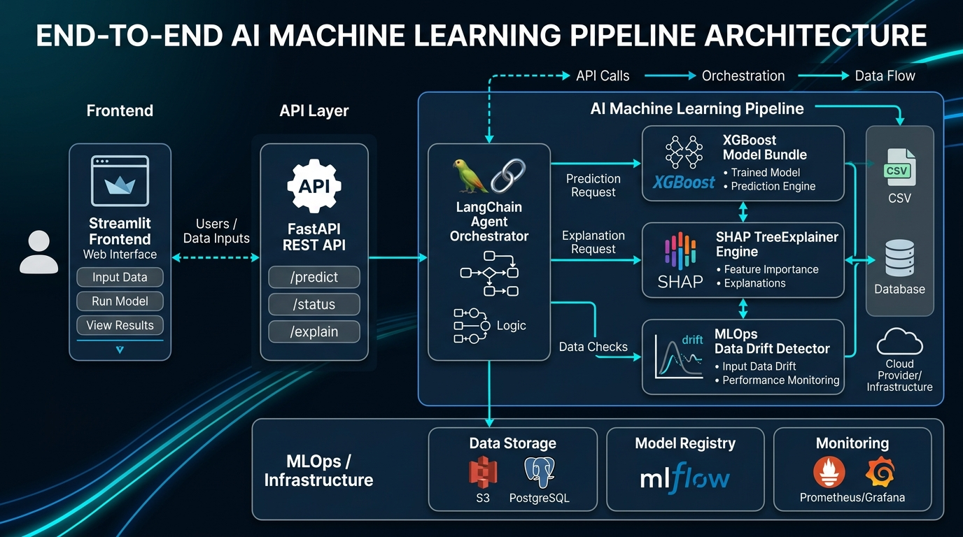
Figure A.3: Credit Risk Model Performance, SHAP Attribution & MLOps Drift Radar
Highlights the Confusion Matrix (92.5% Default Accuracy, 0.94 ROC-AUC), SHAP Beeswarm Plot, Single Applicant Decision Waterfall, and MLOps Radar with PSI metrics.
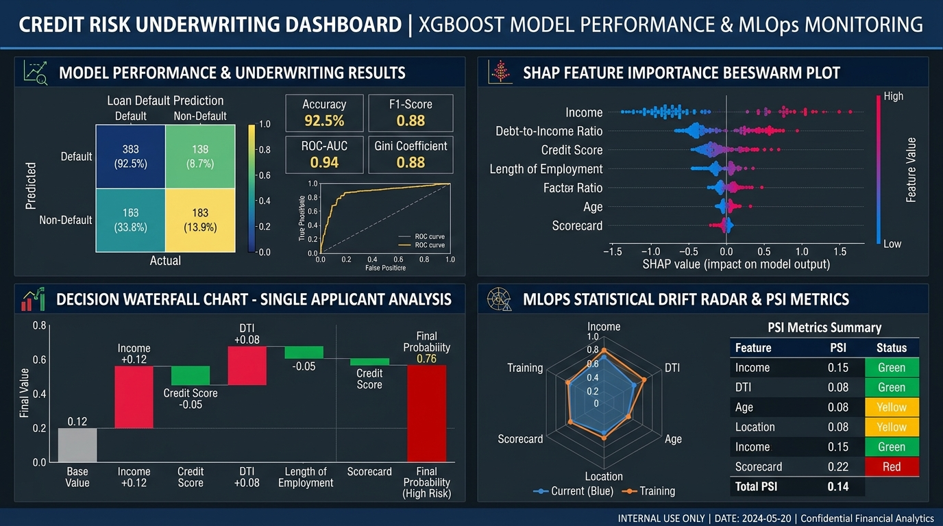

APPENDIX B: CORE TECHNICAL SOURCE CODE
B.1: Model Explainer & Local SHAP Engine (src/ml/explain.py)
import os, joblib, numpy as np, pandas as pd, xgboost as xgb, shap
from typing import Dict, Any, List, Optional
from src.ml.dataset import FEATURE_NAMES, transform_applicant_input
class CreditRiskExplainer:
def __init__(self, model_path="xgboost_loan_model.joblib", explainer_path="models/shap_explainer.pkl"):
self.model_path = self._resolve_model_path(model_path)
self.explainer_path = self._resolve_path(explainer_path)
self.model = None
self.explainer = None
self.optimal_threshold = 0.6903
self.expected_features = FEATURE_NAMES
self._load_artifacts()
def _resolve_path(self, path: str) -> str:
if os.path.exists(path): return path
root_dir = os.path.abspath(os.path.join(os.path.dirname(__file__), "../.."))
alt_path = os.path.join(root_dir, path)
return alt_path if os.path.exists(alt_path) else path
def _resolve_model_path(self, path: str) -> str:
candidates = [path, self._resolve_path(path), self._resolve_path("xgboost_loan_model.joblib"),
self._resolve_path("models/xgboost_loan_model.joblib"), self._resolve_path("xgboost_loan_model.json")]
for c in candidates:
if os.path.exists(c): return c
return self._resolve_path(path)
def _load_artifacts(self):
if not os.path.exists(self.model_path):
raise FileNotFoundError(f"Model artifact not found at {self.model_path}")
if self.model_path.endswith(".joblib") or self.model_path.endswith(".pkl"):
loaded = joblib.load(self.model_path)
if isinstance(loaded, dict):
self.model = loaded.get("model")
self.optimal_threshold = float(loaded.get("optimal_threshold", 0.6903))
self.expected_features = loaded.get("feature_names", FEATURE_NAMES)
else:
self.model = loaded
elif self.model_path.endswith(".json"):
self.model = xgb.XGBClassifier()
self.model.load_model(self.model_path)
if os.path.exists(self.explainer_path):
try: self.explainer = joblib.load(self.explainer_path)
except Exception: self.explainer = shap.TreeExplainer(self.model)
elif self.model is not None:
self.explainer = shap.TreeExplainer(self.model)
def predict_and_explain(self, applicant_data: Dict[str, Any]) -> Dict[str, Any]:
df_row = transform_applicant_input(applicant_data)
prob_default = float(self.model.predict_proba(df_row)[0, 1])
opt_thresh = getattr(self, "optimal_threshold", 0.6903)
if prob_default < 0.20: risk_tier, rec = "LOW RISK (Prime)", "APPROVE"
elif prob_default < opt_thresh: risk_tier, rec = "MODERATE RISK (Near-Prime)", "APPROVE (Standard Terms)"
elif prob_default < 0.85: risk_tier, rec = "HIGH RISK (Subprime)", "REJECT OR REQUIRE COLLATERAL"
else: risk_tier, rec = "VERY HIGH RISK (Critical)", "REJECT"
shap_values = self.explainer(df_row)
vals = shap_values.values[0, :, 1] if len(shap_values.values.shape) == 3 else shap_values.values[0]
base_val = float(shap_values.base_values[0, 1]) if len(shap_values.values.shape) == 3 else float(shap_values.base_values[0])
contributions = []
for feat_name, shap_val in zip(FEATURE_NAMES, vals):
feat_val = float(df_row[feat_name].iloc[0])
contributions.append({
"feature": feat_name, "value": feat_val,
"shap_value": round(float(shap_val), 4),
"impact": "INCREASES RISK" if shap_val > 0 else "REDUCES RISK",
"abs_importance": round(float(abs(shap_val)), 4)
})
contributions.sort(key=lambda x: x["abs_importance"], reverse=True)
return {
"default_probability": round(prob_default, 4),
"approval_score": round((1.0 - prob_default) * 100, 1),
"risk_tier": risk_tier, "recommendation": rec,
"optimal_threshold": round(opt_thresh, 4), "base_value": round(base_val, 4),
"feature_contributions": contributions,
"top_risk_drivers": [c for c in contributions if c["shap_value"] > 0][:3],
"top_protective_factors": [c for c in contributions if c["shap_value"] < 0][:3],
}

REFERENCES
[1]. Lundberg, S. M., & Lee, S. I. (2017). A Unified Approach to Interpreting Model Predictions. Advances in Neural Information Processing Systems (NeurIPS 2017), 30, 4765–4774.
[2]. Chen, T., & Guestrin, C. (2016). XGBoost: A Scalable Tree Boosting System. Proceedings of the 22nd ACM SIGKDD International Conference on Knowledge Discovery and Data Mining (KDD '16), 785–794.
[3]. Yurdakul, B. (2020). Statistical Properties of the Population Stability Index in Credit Risk Scoring. Journal of Risk Model Validation, 14(2), 89–104.
[4]. Kaggle Credit Risk Benchmark Dataset: https://www.kaggle.com/datasets/laotse/credit-risk-dataset (32,581 Consumer Records).
[5]. Damodaran, A. (2012). Investment Valuation: Tools and Techniques for Determining the Value of Any Asset. John Wiley & Sons, 3rd Edition.
[6]. Chase, H. (2023). LangChain: Building Applications with LLMs through Composability and Multi-Tool Orchestration. GitHub Repository: https://github.com/langchain-ai/langchain.

