**Assignment 1: Simple SQL Query with a single table with where clause**

create database Northwind;

Create table Products(

ProductID int primary key,

ProductName nvarchar(50) not null,

SupplierID int not null,

CategoryID int not null,

QuantityPerUnit nvarchar(50) not null,

UnitPrice float not null,

UnitsInStock int not null,

UnitsOnOrder int not null,

ReorderLevel int not null,

Discontinued bit

);

insert into Products values (1,'table',1,1,'10box',18.0,38,0,10,0),

(2,'chair',1,1,'24pic',19.0,17,40,25,0),

(3,'syrup',1,2,'20bottle',10.0,13,70,25,0),

(4,'mobile',2,2,'48 pic',50.00,53,0,0,0),

(5,'dextus medicines',2,2,'36box',21,0,0,0,1),

(6,'spread',3,2,'12jars',25,120,0,25,0)

(7,'peracitamol',2,2,'10box',36.0,50,0,10,0),

(8,'pencil',1,1,'900box',25.0,17,40,25,0),

(9,'pen',1,2,'200box',10.0,13,70,25,0),

(10,'rubber',2,2,'240box',50.00,53,0,0,0),

(11,'sharpener',2,2,'360box',26.00,0,0,0,1),

(12,'milk bag',3,2,'500pic',20,120,0,25,0);

**1. Write a query to get a Product list (id, name, unit price) where current products cost less than $20.**

select ProductID, ProductName, UnitPrice from Products where UnitPrice < 20;

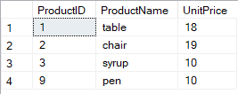

**2. Write a query to get Product list (id, name, unit price) where products cost between $15 and $25**

select ProductID, ProductName, UnitPrice from Products where UnitPrice between 15 and 25;

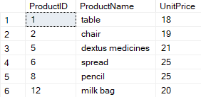

**3. Write a query to get Product list (name, unit price) of above average price.**

select ProductID, ProductName, UnitPrice from Products where UnitPrice > (Select AVG(UnitPrice) from Products);

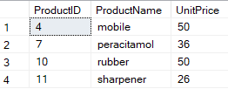

**4. Write a query to get Product list (name, unit price) of ten most expensive products**

select top 10 * from Products order by UnitPrice desc;

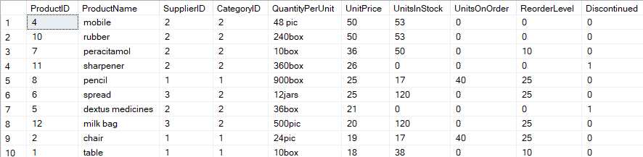

**5. Write a query to count current and discontinued products**

select Discontinued, count(ProductID) "No. of Products" from Products group by Discontinued;



**6. Write a query to get Product list (name, units on order , units in stock) of stock is less than the quantity on order**

select ProductName, UnitsOnOrder, UnitsInStock from Products where UnitsInStock < UnitsOnOrder;

