**Assignment 3: Retrieve data using Group By clause**

CREATE TABLE [Department] (

dept_id INT PRIMARY KEY IDENTITY(1,1),

dept_name VARCHAR(20) NOT NULL

);

CREATE TABLE [Employee] (

emp_id INT PRIMARY KEY IDENTITY(1,1),

dept_id INT FOREIGN KEY REFERENCES Department(dept_id) NOT NULL,

mngr_id INT NOT NULL,

emp_name VARCHAR(20) NOT NULL,

salary FLOAT NOT NULL

);

INSERT INTO Department VALUES('.net'),

('Finanace'),

('networking'),

('java'),

('mobileapp'),

('devops');

INSERT INTO employee VALUES ( 1,2001,'kayling',20000),

( 1,2001,'Tucker',24000),

( 2,2003,'blaze',30000),

( 2,2003,'ADELYN',35000),

( 3,2002,'ADloren',45000),

( 3,2002,'clare',40000),

( 4,2004,'scarlet',50000),

( 4,2004,'blackwidow',55000),

( 5,2005,'frank',60000),

( 5,2005,'fin',65000),

( 6,2006,'wade',70000),

( 6,2006,'vadebarett',75000);

1. **write a SQL query to find Employees who have the biggest salary in their Department**

SELECT e.emp_name, d.dept_name, e.salary FROM Department d JOIN Employee e ON d.dept_id = e.dept_id JOIN (SELECT MAX(salary) 'salary', dept_id FROM Employee GROUP BY dept_id) as mx ON mx.salary = e.salary AND mx.dept_id = e.dept_id;

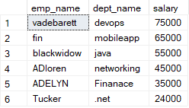

1. **write a SQL query to find Departments that have less than 3 people in it**

SELECT d.dept_name FROM Department d LEFT JOIN Employee e ON d.dept_id = e.dept_id GROUP BY d.dept_name HAVING COUNT(e.emp_id)<3;

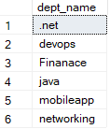

1. **write a SQL query to find All Department along with the number of people there**

SELECT d.dept_name, COUNT(e.emp_id) "No. Of Employee" FROM Department d LEFT JOIN Employee e ON d.dept_id = e.dept_id GROUP BY d.dept_name;

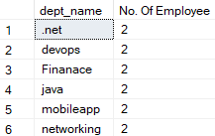

1. **write a SQL query to find All Department along with the total salary there**

SELECT d.dept_name, SUM(e.salary) "Total Salary" FROM Department d LEFT JOIN Employee e ON d.dept_id = e.dept_id GROUP BY d.dept_name;

