**Assignment 4: Create Stored procedure in Northwind database to insert or update a record in a table**

**1. Create a stored procedure in the Northwind database that will calculate the average value of Freight for a specified customer.Then, a business rule will be added that will be triggered before every Update and Insert command in the Orders controller, and will use the stored procedure to verify that the Freight does not exceed the average freight. If it does, a message will be displayed and the command will be cancelled.**

CREATE PROC avg_freight_order

@customerId NCHAR(5)

AS

BEGIN

SELECT CustomerID=@customerId, AVG(Freight) "freight average" FROM Orders GROUP BY CustomerID HAVING CustomerID = @customerId;

END

EXEC avg_freight_order "VINET"



CREATE PROC insert_update_orders

@customerid NCHAR(5), @Freight MONEY

AS

BEGIN

DECLARE @avgfreight MONEY

SELECT @avgfreight = AVG(Freight) FROM Orders GROUP BY CustomerID HAVING CustomerID = @customerid;

IF @Freight > @avgfreight

BEGIN

PRINT 'Freight value is greater than average value';

RETURN

END

END

EXEC insert_update_orders 'ALFKI',50



**2. write a SQL query to Create Stored procedure in the Northwind database to retrieve Employee Sales by Country**

CREATE PROC sp_empsale_by_country

AS

BEGIN

SELECT e.FirstName, e.LastName, e.Country, SUM(od.UnitPrice*od.Quantity) "Sales" FROM Orders o JOIN [Order Details] od ON o.OrderID = od.OrderID JOIN Employees e ON o.EmployeeID = e.EmployeeID GROUP BY e.Country,e.FirstName,e.LastName;

END

EXEC sp_empsale_by_country;

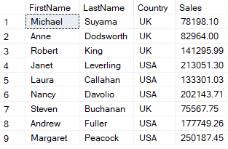

**3. write a SQL query to Create Stored procedure in the Northwind database to retrieve Sales by Year**

CREATE PROC sp_sales_by_year

AS

BEGIN

SELECT YEAR(o.OrderDate) "Year", SUM(st.Subtotal) "Sales" FROM Orders o JOIN [Order Subtotals] st ON o.OrderID = st.OrderID GROUP BY YEAR(o.OrderDate);

END

EXEC sp_sales_by_year

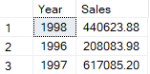

**4. write a SQL query to Create Stored procedure in the Northwind database to retrieve Sales By Category**

CREATE PROC sp_sales_by_category

AS

BEGIN

SELECT CategoryName, SUM(ProductSales) "Sales" FROM [Sales by Category] GROUP BY CategoryName;

END

EXEC sp_sales_by_category;

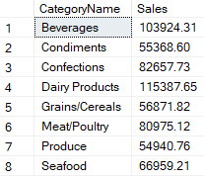

**5. write a SQL query to Create Stored procedure in the Northwind database to retrieve Ten Most Expensive Products**

CREATE PROC sp_10_exp_prod

AS

BEGIN

SELECT TOP 10 ProductName, UnitPrice FROM Products ORDER BY UnitPrice DESC;

END

EXEC sp_10_exp_prod;

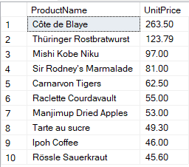

**6. write a SQL query to Create Stored procedure in the Northwind database to insert Customer Order Details**

CREATE PROC insert_order_details

@orderid INT, @productid INT, @unitprice MONEY, @quantity SMALLINT, @discount REAL

AS

BEGIN

INSERT INTO [Order Details] VALUES (@orderid, @productid, @unitprice, @quantity, @discount);

END

EXEC insert_order_details 11075,77,50,10,0.25;

**7. write a SQL query to Create Stored procedure in the Northwind database to update Customer Order Details**

CREATE PROC update_order_details

@orderid INT, @unitprice MONEY, @quantity SMALLINT, @discount REAL

AS

BEGIN

UPDATE [Order Details] SET UnitPrice=@unitprice, Quantity=@quantity, Discount=@discount WHERE OrderID=@orderid;

END

EXEC update_order_details 11075,50,10,0.20