CVI620 – Assignment 1
Summer 2025

Total Mark: | 7.5 marks (7.5% of the total course grade)
Submission file(s): | - Assignment1.py or Assignment1.ipynb (you can upload multiple files)  - Assignment1.docx (this document with your answers)
Deadline | - October 11th, 2025

If you are unable to complete the assignment on-time for any legit reason, please provide documentation explaining your absence (e.g., an appointment confirmation or a work letter).
Please be aware that the assignment is designed to make you research and develop.

Please submit the submission file(s) through Learn@Seneca. Make sure to use GitHub and provide the link to your GitHub account for all your contributions in the box below:
Project GitHub repository:
Share with Ellie749 if private.

Please paste the resulting images and answers in this document.

Part I: Shapes

Recreate the OpenCV logo using OpenCV drawing functions only (e.g., cv2.circle, cv2.line, etc.).


You must draw:
- Three colored shapes (ellipse: Blue, Green, Red) arranged in a triangular pattern.
- Proper positioning and size of circles.
- The text "OpenCV" at the center/bottom.

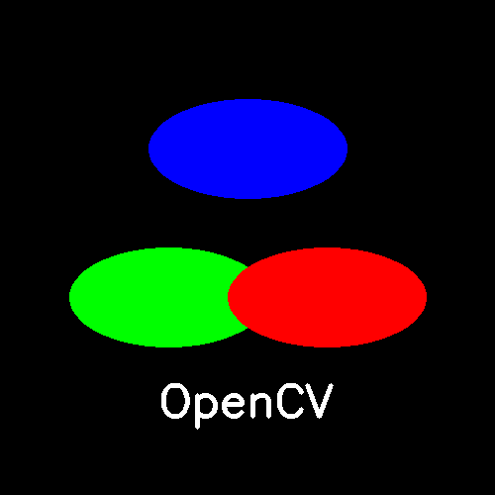
I created the OpenCV logo using cv2.ellipse() for the three colored shapes (Blue, Green, Red) arranged in a triangular pattern on a black background, and cv2.putText() to display “OpenCV”.

Part II: Image Arithmetic

You are asked to build a simple invisible cloak effect using OpenCV.
The idea is to make a specific colored cloth worn by the user become invisible by replacing it with the background.

Instructions:
Complete the function in A1_Q2.py file to implement the logic. The function should:
- Convert the image to HSV.
- Create a mask for green color using cv2.inRange() (you can use two ranges).
- Search about cv2.morphologyEx() and explain it in your code. Then use it on your mask if needed.
- Segment out the green area using the mask.
- Replace the green area with the background.
Upload your .py file and a attach few sample photos here.

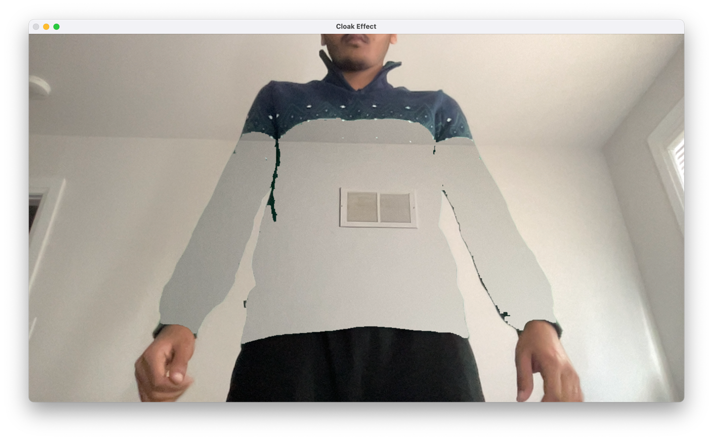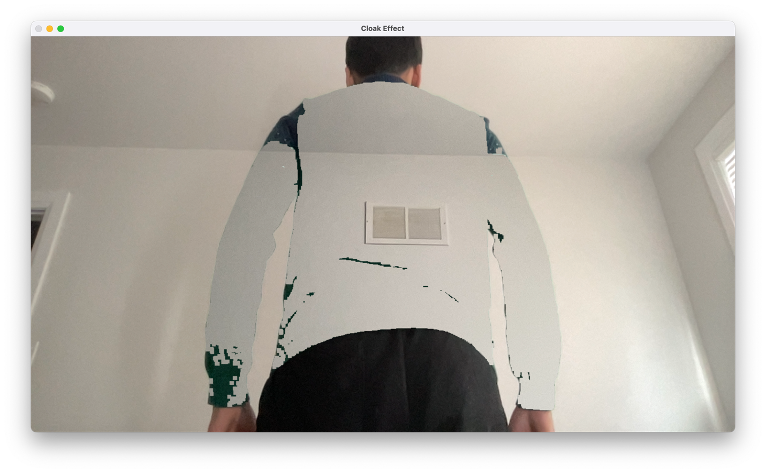

I implemented an invisible-cloak effect by detecting a green cloth in the HSV color space. The program creates a mask using cv2.inRange() and refines it with cv2.morphologyEx() to remove noise. The masked green region is replaced with the pre-captured background using cv2.bitwise_and() and cv2.addWeighted(), making the green cloth appear invisible.

Part III: A photo booth application

Design a modular photo editing application in Python using OpenCV and NumPy. The app should allow users to load an image and apply a sequence of processing steps interactively through a menu interface.

Required Functionalities:
- Load an image from file.
- Show the following menu:

==== Mini Photo Editor ====
1. Adjust Brightness
2. Adjust Contrast
3. Convert to Grayscale
4. Add Padding (choose border type)
5. Apply Thresholding (binary or inverse)
6. Blend with Another Image (manual alpha)
7. Undo Last Operation
8. View History of Operations
9. Save and Exit

- Brightness/Contrast
- Padding: Ask the user to specify the padding size and border type (constant, reflect, replicate, etc.). Additionally, include an option for the user to choose the padding proportion: Square, Rectangle, Custom Ratio (e.g., 4:5)
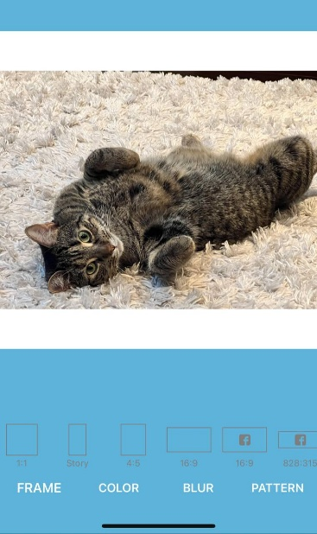

If the user selects a custom ratio like 4:5, your program should calculate and apply the padding so that the final image respects the chosen aspect ratio, regardless of the original size. The user should also be able to adjust the total padding size, and your code must maintain the proportion accordingly. (add smallest padding at the beginning to make it rectangle, then increase or decrease the padding size of the user wants)
- Thresholding: Let user choose between cv2.THRESH_BINARY and cv2.THRESH_BINARY_INV.
- Blending: Ask for a second image path and alpha (0 to 1).
- Undo Feature: Keep a history stack of image states. Allow the user to revert to the previous state.
- History Log: Keep a list of all actions performed (e.g., "brightness +50", "padded 20px with reflect"). Display the list before exiting or when requested.

Additional Requirements:
- Code must be modular. Each operation must be a separate function.
- Allow the user to apply multiple transformations in a row.
- When exiting, ask whether the user wants to save the final image, and under what filename.
- Use matplotlib to show side-by-side [original | preview] after every transformation.
- Include some of the results in this document.

.

With Greyscale

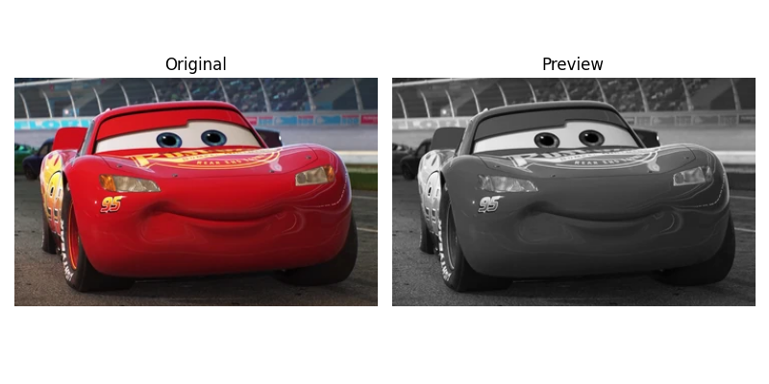

With Padding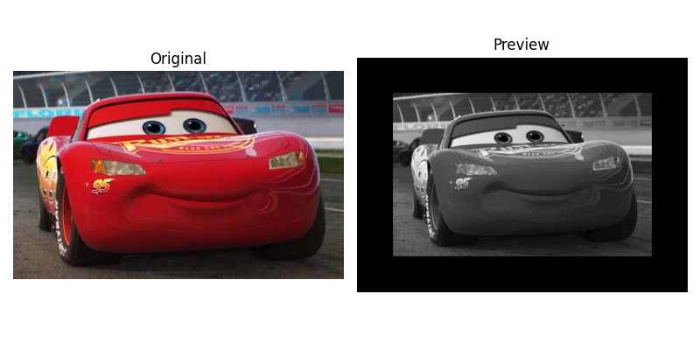

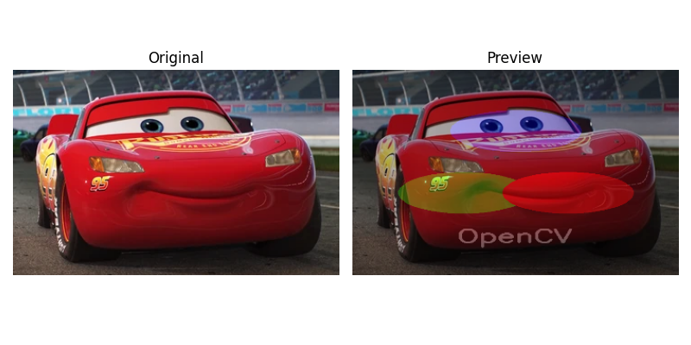

In this photo editor each operation is a separate function, and the program maintains an undo stack and history log. Side-by-side previews are displayed with Matplotlib after each change.
For blending, the program asks for another image and an α (alpha) value between 0 and 1, then merges both images using cv2.addWeighted() for smooth transparency control.

Part IV:
Academic integrity Policy
I, -------Yash Shah----- (mention your name), declare that I have read and understood the Academic Integrity Policy.

GOOD LUCK!

