Predictive Modeling and Optimization in Logistics Systems
Week 4 Task Report
Name: Yash Zujam
Internship: Logistics Data Analyst Intern
GitHub: github.com/Yash-67Tech
Project Repository: https://github.com/Yash-67Tech/logistics-predictive-modeling

1. Problem Definition
Late deliveries are costly: they break service-level agreements (SLAs), trigger penalties and damage customer trust. If a logistics team can predict how long each shipment will take before it ships, it can choose the right transport mode and carrier up front instead of reacting to delays afterwards.
Prediction problem: forecast the delivery time (in hours) of a shipment from its distance, weight, transport mode, carrier, region, traffic, weather, number of stops and season. This is a supervised regression problem.
Optimization problem: use the trained model to (A) select the cheapest transport mode that still meets a 60-hour delivery SLA and (B) allocate shipments across carriers at minimum total cost within carrier capacity limits.
The workflow is: simulate data, prepare features, compare four models, validate with cross-validation, tune the best model, evaluate on unseen data, then feed model predictions into two optimization methods.

2. Dataset Description
A hypothetical dataset of 2,500 shipments was simulated with a fixed random seed (42). Delivery time was generated from a realistic process: travel time (distance divided by mode speed), mode-specific handling time, a traffic effect that applies mainly to road transport, a non-linear weather effect, a delay per stop, a carrier effect, a peak-season delay and random noise. The dataset has no missing values.
Feature | Type | Description
distance_km | Numeric | Route distance, 50 to 3,000 km
weight_kg | Numeric | Shipment weight (gamma distributed)
transport_mode | Categorical | Road, Rail, Air or Sea
carrier | Categorical | FastTrack, SwiftMove, CargoPrime or EcoFreight
region | Categorical | North, South, East, West or Central
traffic_index | Numeric | Congestion score from 0 to 10
weather_severity | Numeric | Weather score from 0 (clear) to 10 (severe)
num_stops | Integer | Intermediate stops, 0 to 5
is_peak_season | Binary | 1 if shipped in the peak season (20% of shipments)
delivery_time_hrs | Target | Total delivery time in hours (the value to predict)
shipping_cost | Numeric | Cost in USD, used later for optimization

Code excerpt: simulating the target
def true_time(d, noise=True):
t = (d["distance_km"] / d["transport_mode"].map(speed)
+ d["transport_mode"].map(handling)
+ np.where(d["transport_mode"] == "Road",
0.9 * d["traffic_index"], 0.1 * d["traffic_index"])
+ 0.12 * d["weather_severity"] ** 2
+ 1.3 * d["num_stops"] + 0.004 * d["weight_kg"]
+ d["carrier"].map(carrier_delay) + 6 * d["is_peak_season"])
if noise:
t = t + rng.normal(0, 3.0, len(d))
return np.clip(t, 2, None)
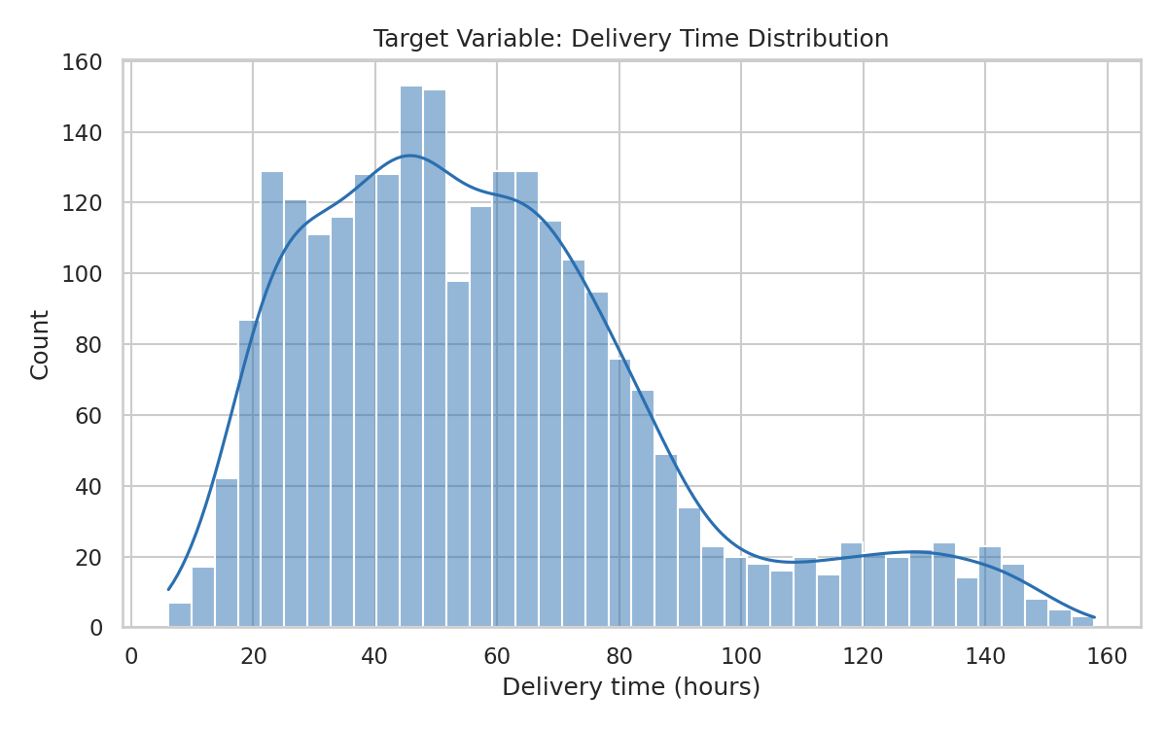
Figure 1: Distribution of the target variable (delivery time)
The target is right-skewed, with most shipments delivered within a few days and a long tail created by sea freight and peak-season delays.

3. Data Preparation
The data was split 80/20 into a training set (2,000 shipments) and a test set (500 shipments). The test set was held back and used only once for final evaluation. Categorical features were one-hot encoded and numeric features were standardized. Both steps were placed inside a scikit-learn Pipeline, so the preprocessing is fitted only on training folds. This prevents data leakage during cross-validation.
cat = ["transport_mode", "carrier", "region"]
num = ["distance_km", "weight_kg", "traffic_index",
"weather_severity", "num_stops", "is_peak_season"]
X, y = df[cat + num], df["delivery_time_hrs"]
X_train, X_test, y_train, y_test = train_test_split(
X, y, test_size=0.2, random_state=42)

prep = ColumnTransformer([
("cat", OneHotEncoder(handle_unknown="ignore"), cat),
("num", StandardScaler(), num),
])

4. Model Selection
Four models of increasing complexity were compared. Starting with a simple baseline makes it clear how much extra accuracy the complex models actually add.
Model | Why it was chosen | Main limitation
Linear Regression | Simple, fast, interpretable baseline | Cannot capture interactions, such as traffic mattering mainly for road
Decision Tree | Captures non-linear rules and interactions, easy to explain | Single trees overfit and are unstable
Random Forest | Averages many trees, which reduces overfitting and handles mixed features well | Less interpretable, slower to train
Gradient Boosting | Builds trees sequentially to correct earlier errors, usually the most accurate on tabular data | Needs tuning and can overfit if untuned

models = {
"Linear Regression": LinearRegression(),
"Decision Tree": DecisionTreeRegressor(max_depth=8, random_state=42),
"Random Forest": RandomForestRegressor(n_estimators=200, random_state=42),
"Gradient Boosting": GradientBoostingRegressor(random_state=42),
}
for name, mdl in models.items():
pipe = Pipeline([("prep", prep), ("model", mdl)])
cv_r2 = cross_val_score(pipe, X_train, y_train, cv=kf, scoring="r2")
pipe.fit(X_train, y_train)
pred = pipe.predict(X_test)

5. Evaluation and Validation

5.1 Evaluation metrics
- MAE (Mean Absolute Error): the average size of the error in hours. It is easy to explain to operations staff.
- RMSE (Root Mean Squared Error): also in hours, but it penalizes large errors more heavily. This matters in logistics, where a few very late predictions do the most damage.
- R-squared: the share of variation in delivery time that the model explains (1.0 is perfect).

5.2 Cross-validation
5-fold cross-validation (shuffled, fixed seed) was run on the training set. Each model was trained on four folds and validated on the fifth, and the results were averaged. This gives a more stable estimate than a single split and shows whether a model is overfitting.

5.3 Results
Model | CV R² | CV RMSE | Test MAE | Test RMSE | Test R²
Linear Regression | 0.932 | 8.04 | 5.32 | 7.79 | 0.926
Decision Tree | 0.961 | 6.08 | 4.45 | 5.57 | 0.962
Random Forest | 0.980 | 4.32 | 3.31 | 4.08 | 0.980
Gradient Boosting | 0.985 | 3.73 | 2.75 | 3.42 | 0.986
Tuned Gradient Boosting | n/a | 3.58 | 2.65 | 3.29 | 0.987

Gradient Boosting was the best model, and the ordering is consistent between cross-validation and the test set, which indicates the models are not overfitting. Linear Regression is already reasonable (R² 0.926) because distance and mode explain much of the variation, but its RMSE of 7.8 hours is more than double that of boosting. This gap comes from the interactions and non-linear weather effect that a linear model cannot represent.
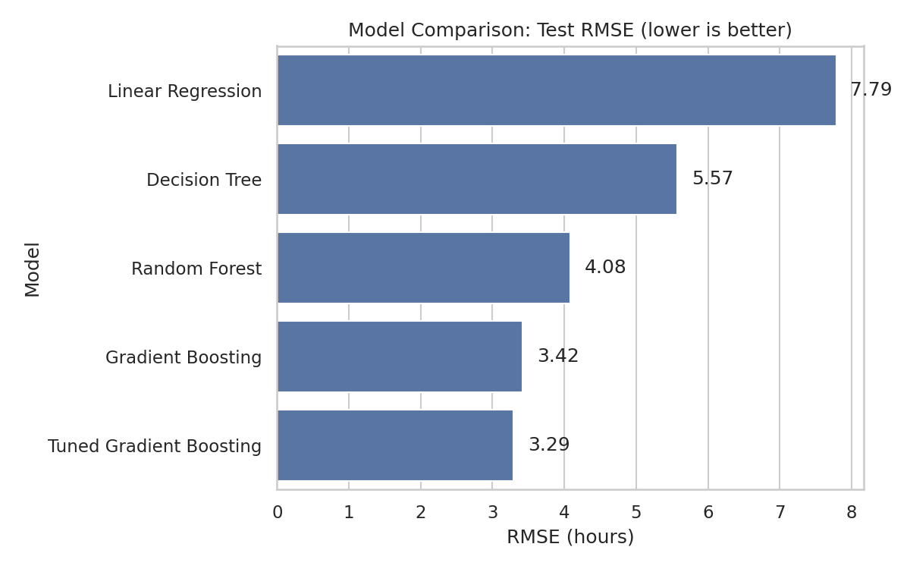
Figure 2: Test RMSE of all models

5.4 Hyperparameter tuning
GridSearchCV was used to tune Gradient Boosting over 18 combinations (3 values of n_estimators, 2 learning rates, 3 tree depths), each evaluated with 5-fold cross-validation, which is 90 model fits. The best setting was n_estimators = 300, learning_rate = 0.05 and max_depth = 3. Tuning lowered the test RMSE from 3.42 to 3.29 hours and the MAE from 2.75 to 2.65 hours. This is a modest but real gain, and the model now predicts delivery time to within about 2.7 hours on average.
grid = {
"model__n_estimators": [100, 200, 300],
"model__learning_rate": [0.05, 0.1],
"model__max_depth": [2, 3, 4],
}
search = GridSearchCV(pipe, grid, cv=kf,
scoring="neg_root_mean_squared_error", n_jobs=-1)
search.fit(X_train, y_train)
best = search.best_estimator_ # used for all later steps

5.5 Prediction quality and residuals
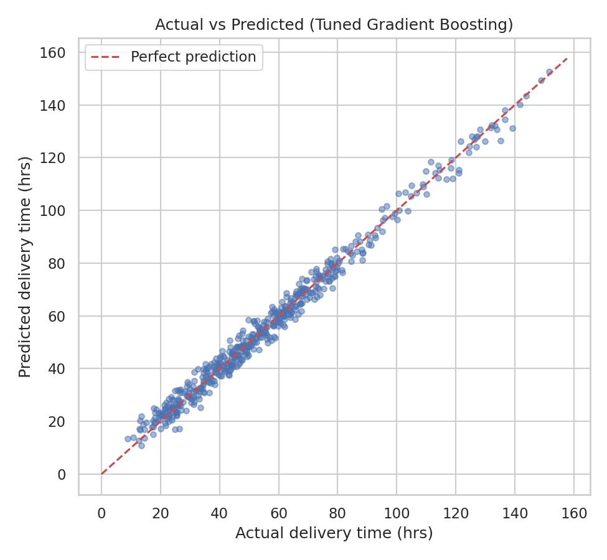
Figure 3: Actual versus predicted delivery time on the test set
Points lie tightly along the red diagonal, so predictions are accurate across short and long deliveries.
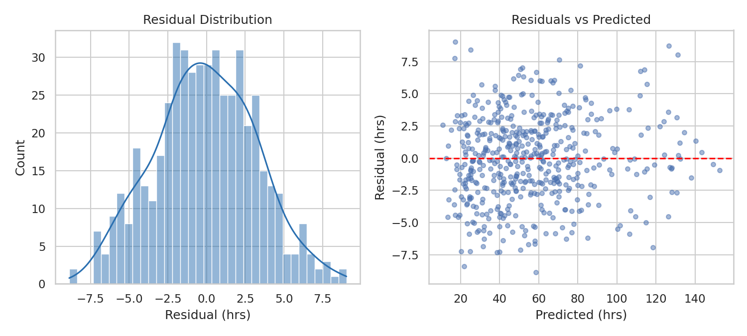
Figure 4: Residual distribution and residuals versus predicted values
Residuals are centred on zero and roughly symmetric, so the model is not systematically over- or under-predicting. The residual-versus-predicted plot shows no strong pattern, which suggests the model form is appropriate.

5.6 Feature importance
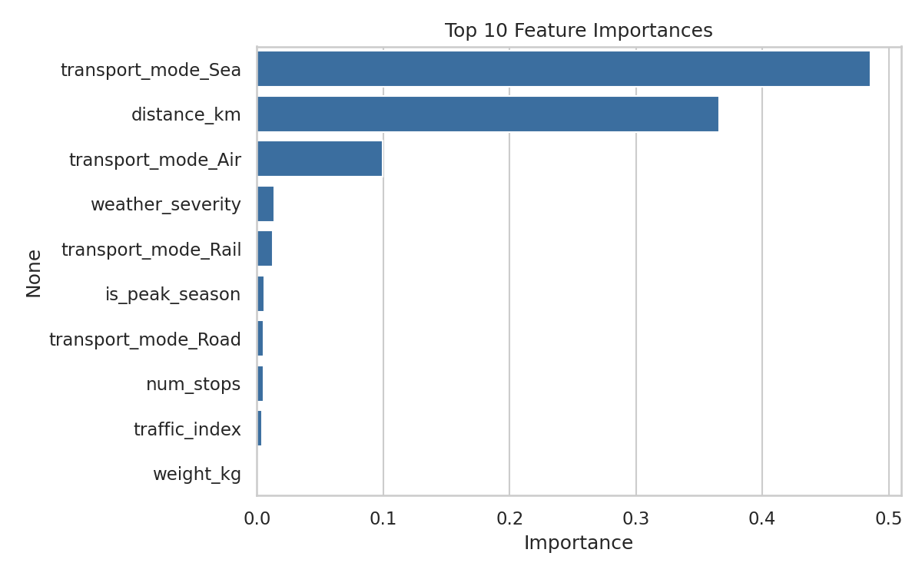
Figure 5: Top 10 feature importances
Transport mode (mainly the Sea and Air indicators, 48.6% and 9.9%) and distance (36.6%) account for most of the predictive power. Weather severity (1.4%) is the next most useful feature. Traffic has low overall importance (0.4%) because it affects only road shipments, and shipment weight is almost irrelevant (0.1%). Note that importance reflects how much the model uses a feature, not a proven cause.

6. Optimization Strategies
The tuned model was applied to the 500 test shipments to power two optimization methods.

6.1 Strategy A: SLA-aware transport mode selection
For every shipment, the model predicts the delivery time under each of the four modes (by changing only the mode feature). The optimizer then picks the cheapest mode whose predicted time is within the 60-hour SLA, or the fastest mode if none qualifies.
for m in modes:
tmp = batch.copy(); tmp["transport_mode"] = m
pred_time[m] = best.predict(tmp[cat + num])
est_cost[m] = tmp["distance_km"] * cost_km[m] + tmp["weight_kg"] * 0.45

for i in range(len(batch)):
ok = [m for m in modes if pt.loc[i, m] <= SLA_HRS]
m = min(ok, key=lambda k: ec.loc[i, k]) if ok else \
min(modes, key=lambda k: pt.loc[i, k])
Policy | Total cost (USD) | Predicted SLA breaches | Mode mix
Current mix | 1,111,128 | 39.2% | Road 49.8%, Rail 22.0%, Sea 17.2%, Air 11.0%
Optimized (model-based) | 2,129,228 | 0.0% | Rail 46.2%, Air 30.2%, Road 12.0%, Sea 11.6%
All shipments by Air | 3,423,882 | 0.0% | Air 100%

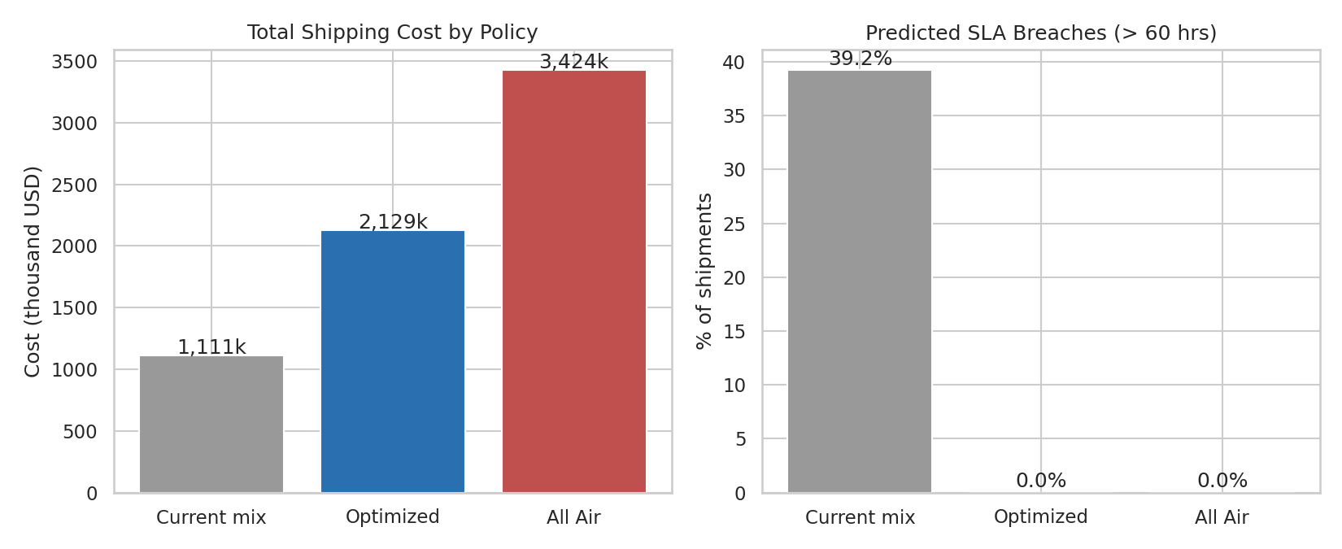
Figure 6: Cost and predicted SLA breaches under three mode policies
Reading the result honestly: the optimized policy does not reduce total cost compared with the current mix. It raises cost by about 92% because it removes all predicted SLA breaches, and the current mix breaches the SLA on 39.2% of shipments. The result splits into two groups:
- 304 shipments already on time: moving them to a cheaper mode that still meets the SLA cuts their cost by 27.5%.
- 196 shipments predicted to be late: fixing them costs 288.7% more, mainly through air freight.
Compared with the simple alternative of sending everything by air, the optimizer meets the same SLA at 37.8% lower cost. The practical lesson is that the 60-hour SLA is expensive to guarantee on the late group, so management should decide whether to pay for compliance on every shipment or to renegotiate SLAs for long-distance shipments.

6.2 Strategy B: Carrier allocation with linear programming
Once modes are chosen, shipments must be assigned to carriers. The problem was formulated as a linear program: minimize the total of shipping cost (adjusted by a carrier price factor) plus a penalty of 2 USD per predicted transit hour, subject to every shipment being assigned to exactly one carrier and each carrier staying within its capacity. The model supplies a predicted delivery time for each shipment-carrier pair, and SciPy's HiGHS solver finds the optimum.
C[:, j] = base_cost * price_factor[c] + pen * p_time # cost matrix
lp = linprog(c_vec, A_ub=A_ub, b_ub=cap_vector, # carrier capacity
A_eq=A_eq, b_eq=np.ones(m), # one carrier each
bounds=(0, 1), method="highs")
Carrier | Capacity (shipments) | Baseline share | Optimized share
FastTrack | 160 | 28.4% | 32.0%
SwiftMove | 135 | 24.6% | 27.0%
CargoPrime | 135 | 24.0% | 27.0%
EcoFreight | 110 | 23.0% | 14.0%

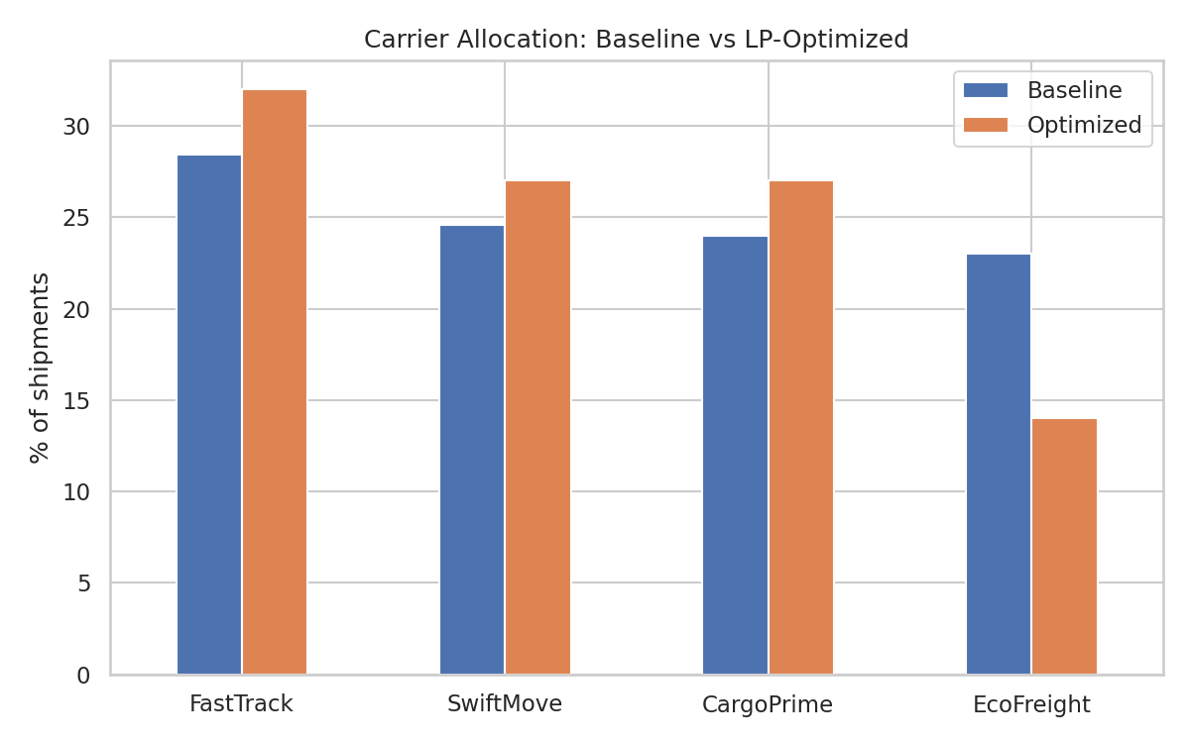
Figure 7: Carrier allocation before and after optimization
The solver finished with an optimal solution and reduced the combined cost-plus-delay objective by 5.3% (2.22 million to 2.10 million). It shifted volume away from EcoFreight, which has the highest price factor (1.08), toward cheaper carriers. This outcome depends on the 2 USD per hour delay penalty: a higher penalty would favour more reliable carriers, so this value should be set from real SLA penalty costs.

7. Recommendations
- Deploy the delivery-time model as a pre-dispatch check: predict each shipment's time before booking and flag any that will exceed the SLA, so they can be re-planned.
- Downgrade mode where there is slack: for shipments predicted to arrive well inside the SLA, use the cheapest compliant mode (usually rail). This saved 27.5% on that group.
- Pay for speed only where needed: limit air freight to shipments that cannot meet the SLA any other way, rather than using it for everything, which would cost 37.8% more.
- Review the SLA for long-distance shipments: guaranteeing 60 hours on the hardest 39% of shipments multiplies their cost, so some may justify a longer SLA or a different price.
- Use LP-based carrier allocation: re-run the allocation each planning cycle with real prices, capacities and a delay penalty based on actual contract terms.
- Plan for weather and peak season: add buffer time to predicted delivery in severe weather and in peak weeks, since both raise delays.
- Retrain regularly: monitor RMSE on new shipments each month and retrain when it drifts.

8. Limitations
- The data is simulated from a known formula, so the very high R² (0.987) is optimistic. Real logistics data is noisier and would give lower accuracy.
- Costs and capacities in the optimization are assumed values and should be replaced with real contract data.
- Predicting a different mode for the same shipment is a what-if estimate, not a measured outcome.
- The optimization treats each shipment independently and does not model vehicle routes or loading, so it is not a full route-planning solution.

9. Conclusion
A tuned Gradient Boosting model predicted delivery time with a test MAE of 2.65 hours and R² of 0.987, clearly outperforming linear regression, a decision tree and a random forest. Using its predictions, a mode-selection rule removed all predicted SLA breaches at a much lower cost than shipping everything by air, and a linear program improved carrier allocation by 5.3%. The results show how prediction and optimization work together: the model estimates what will happen, and the optimizer decides what to do about it. The same pipeline can be applied to real shipment data.

Appendix: Project Repository
GitHub repository: https://github.com/Yash-67Tech/logistics-predictive-modeling
The repository contains the full Python script, the simulated dataset, all figures, the model output log and the saved results file.

