|  |  |  |  |
| --- | --- | --- | --- |
|  | Bansilal Ramnath Agarwal Charitable Trust's  Vishwakarma Institute of Information Technology  **Department of**  **Artificial Intelligence and Data Science** | | |
| Name: Agrawal Yash Pradeep | | | |
| Class: TY | Division: A | | Roll No:371005 |
| Semester: V | | Academic Year:2022-2023 | |
| Subject Name & Code: Cloud Computing and Analytics | | | |
| Title of Assignment: Study of Cloud Computing & Architecture | | | |
| Date of Performance:22-8-2022 | | Date of Submission:26-8-2022 | |

**Aim:** Study of Cloud Computing & Architecture

**Problem Statement:** To explore different fields of AWS cloud such as Cloud Architecture and Cloud Services Provided by AWS cloud.

**Background Information:**

1. **Cloud Architecture:**

The cloud architecture is divided into 2 parts i.e.

Frontend

Backend

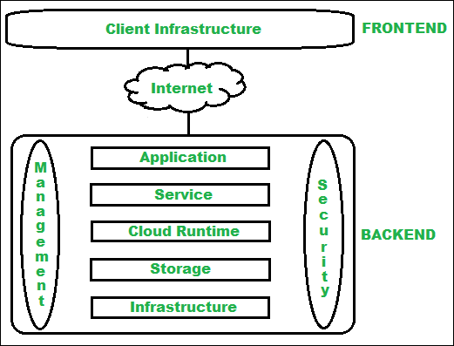

Architecture of cloud computing is the combination of both SOA (Service Oriented Architecture) and EDA (Event Driven Architecture). Client infrastructure, application, service, runtime cloud, storage, infrastructure, management and security all these are the components of cloud computing architecture.

**Benefits of Cloud Computing Architecture :**

Makes overall cloud computing system simpler. Improves data processing requirements.

Helps in providing high security. Makes it more modularized.

Results in better disaster recovery. Gives good user accessibility.

Reduces IT operating costs.

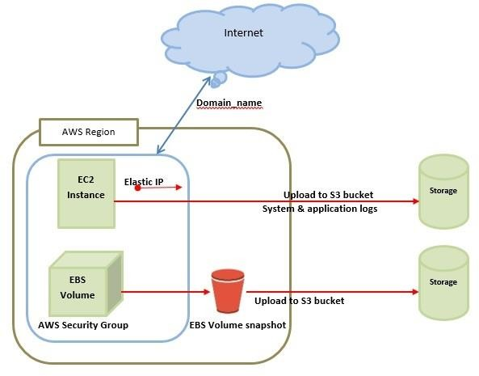

1. **Resource Components**
2. IAM- IAM is a cloud service that controls the permissions and access for users and cloud resources. IAM policies are sets of permission policies that can be attached to either users or cloud resources to authorize what they access and what they can do with it.
3. EC2- Amazon Elastic Compute Cloud (Amazon EC2) provides scalable computing capacity in the Amazon Web Services (AWS) Cloud. Using Amazon EC2 eliminates your need to invest in hardware up front, so you can develop and deploy applications faster.
4. VPN- A cloud virtual private network (cloud VPN) is a form of technology designed to help users access their organization's applications, data, and files

through a website or an application. Unlike traditional or static VPNs, a cloud VPN provides a secure connection that can be rapidly deployed globally.

1. Security Groups- A security group is an AWS firewall solution that performs one primary function: to filter incoming and outgoing traffic from an EC2 instance. It accomplishes this filtering function at the TCP and IP layers, via their respective ports, and source/destination IP addresses.
2. Lambda Function:- Lambda runs your code on high availability compute infrastructure and performs all the administration of your compute resources. This includes server and operating system maintenance, capacity provisioning and automatic scaling, code and security patch deployment, and code monitoring and logging.

3.Billing Information

The AWS Billing console allows you to easily understand your AWS spending, view and pay invoices, manage billing preferences and tax settings, and access additional Cloud Financial Management services. Quickly evaluate whether your monthly spend is in line with prior periods, forecast, or budget, and investigate and take corrective actions in a timely manner. The AWS Bills page provides a monthly view of your chargeable costs. For monthly billing periods that have not yet closed, the Bills page will display the most recent estimated charges based on services metered to date. Invoices are generated when a monthly billing period closes, or when subscriptions or one-time purchases are made

**Cloud Resource Requirements:**

AWS CLOUD ROOT LOGIN

**Steps:**

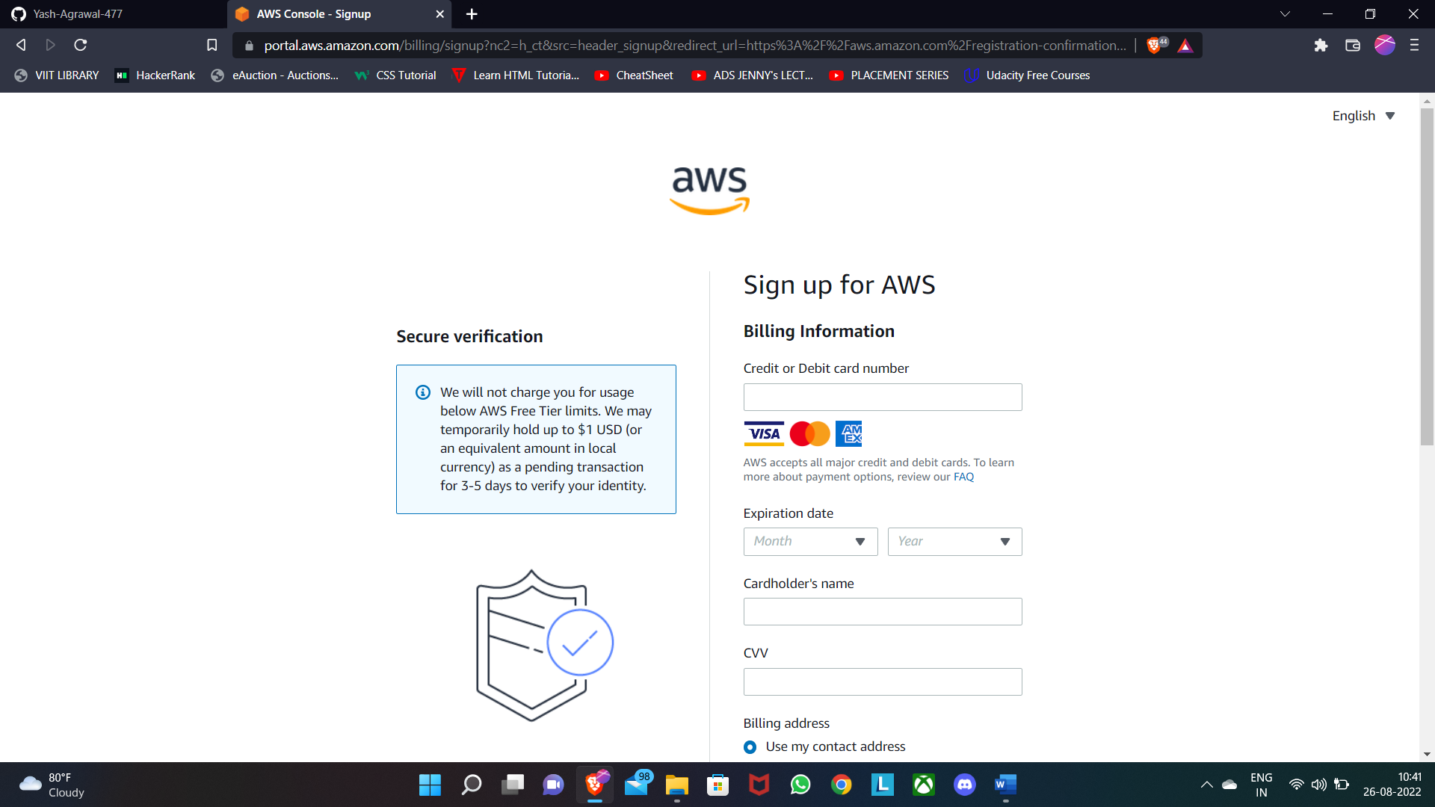

**Github Repo Link:**

**Conclusion:**

Explored the concepts of cloud architecture, how cloud works , how cloud services works, Interface of amazon web service cloud ,Billing system of AWS cloud.