Online Code Collaboration Platform (Live Editor)

Group number :15
Group member name:
Yash Agrawal (2415990045)
Harsh Pratap Singh (2415990019)
Yashdeep Chaudhary (2315002554)
Yuvika Chaudhary (2315002570)
Yogesh Kumar (2315002567)

1. Overview
CodeGo is a web-based collaborative coding platform that allows multiple users to join shared workspaces and write code together in real time. It provides a seamless environment similar to an online IDE where users can create rooms, join using a unique ID, and collaborate efficiently.
The application is deployed on Render, a cloud platform that enables easy deployment, scaling, and hosting of web applications with minimal DevOps effort.

2. Objective
- Build a real-time coding collaboration tool
- Enable multiple users to code simultaneously
- Provide a simple login-based workspace system
- Simulate a lightweight online IDE experience
- Improve teamwork and remote coding collaboration

3. Technologies Used
Frontend: React.js, Tailwind CSS / CSS
Backend: Node.js, Express.js
Database: MongoDB
Real-Time Communication: Socket.IO
Deployment: Render

4. Features
- User authentication (Signup/Login)
- Create and join coding workspaces
- Real-time collaboration with live typing indicators
- Code editor with language selection
- Cloud-based browser access

5. Working
- User registers by entering name, email, and password.
- User logs in and is redirected to dashboard.
- Dashboard allows creating or joining a workspace.
- Workspace provides real-time code editor with unique room ID.
- Multiple users collaborate with instant synchronization.

6. Screenshots

Landing page

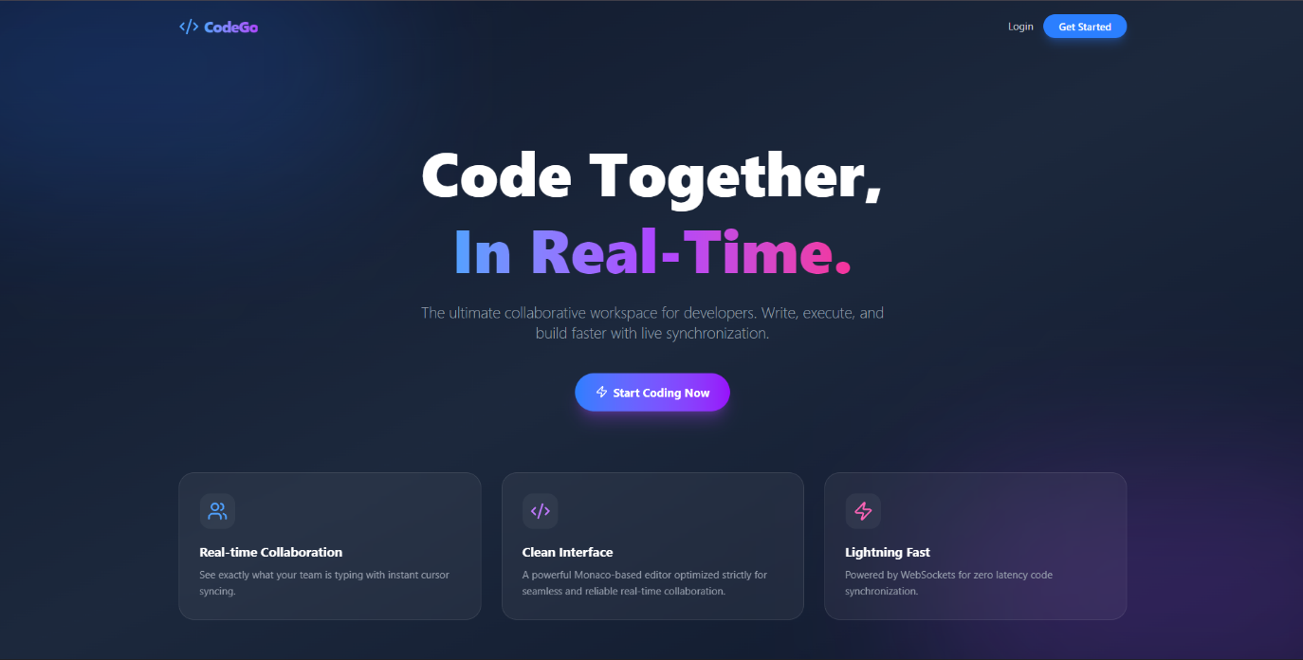
Signup Page

Login Page
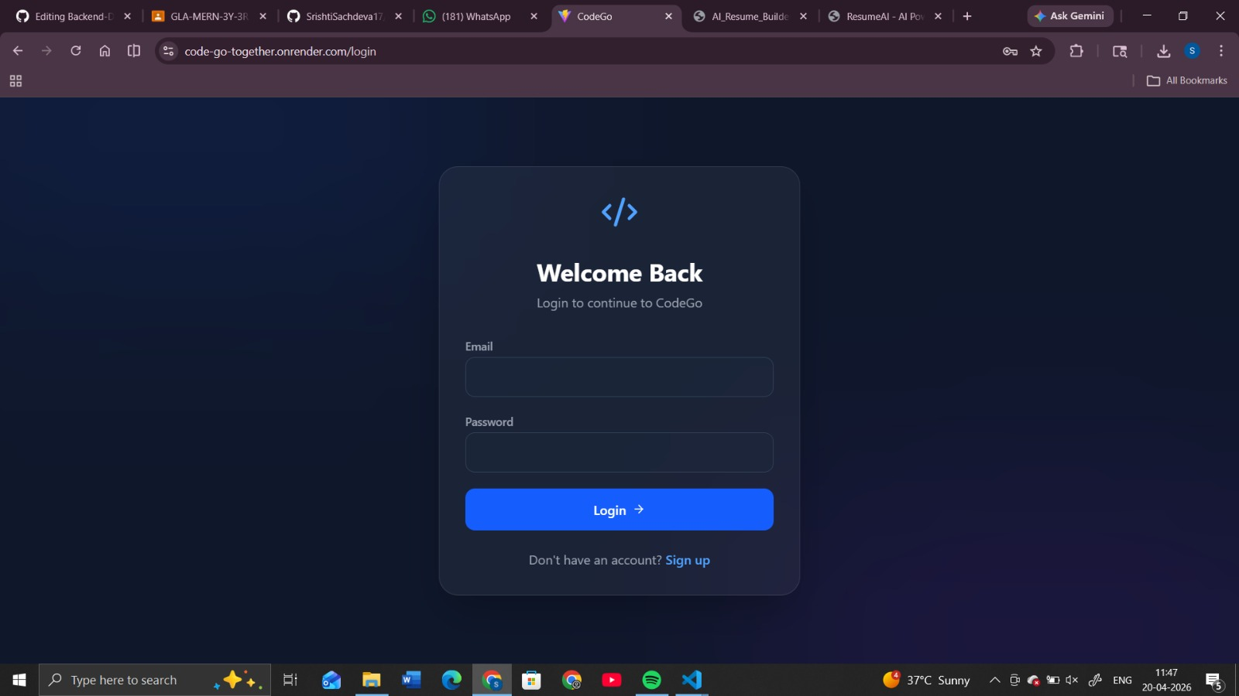

Dashboard(from Srishti view)
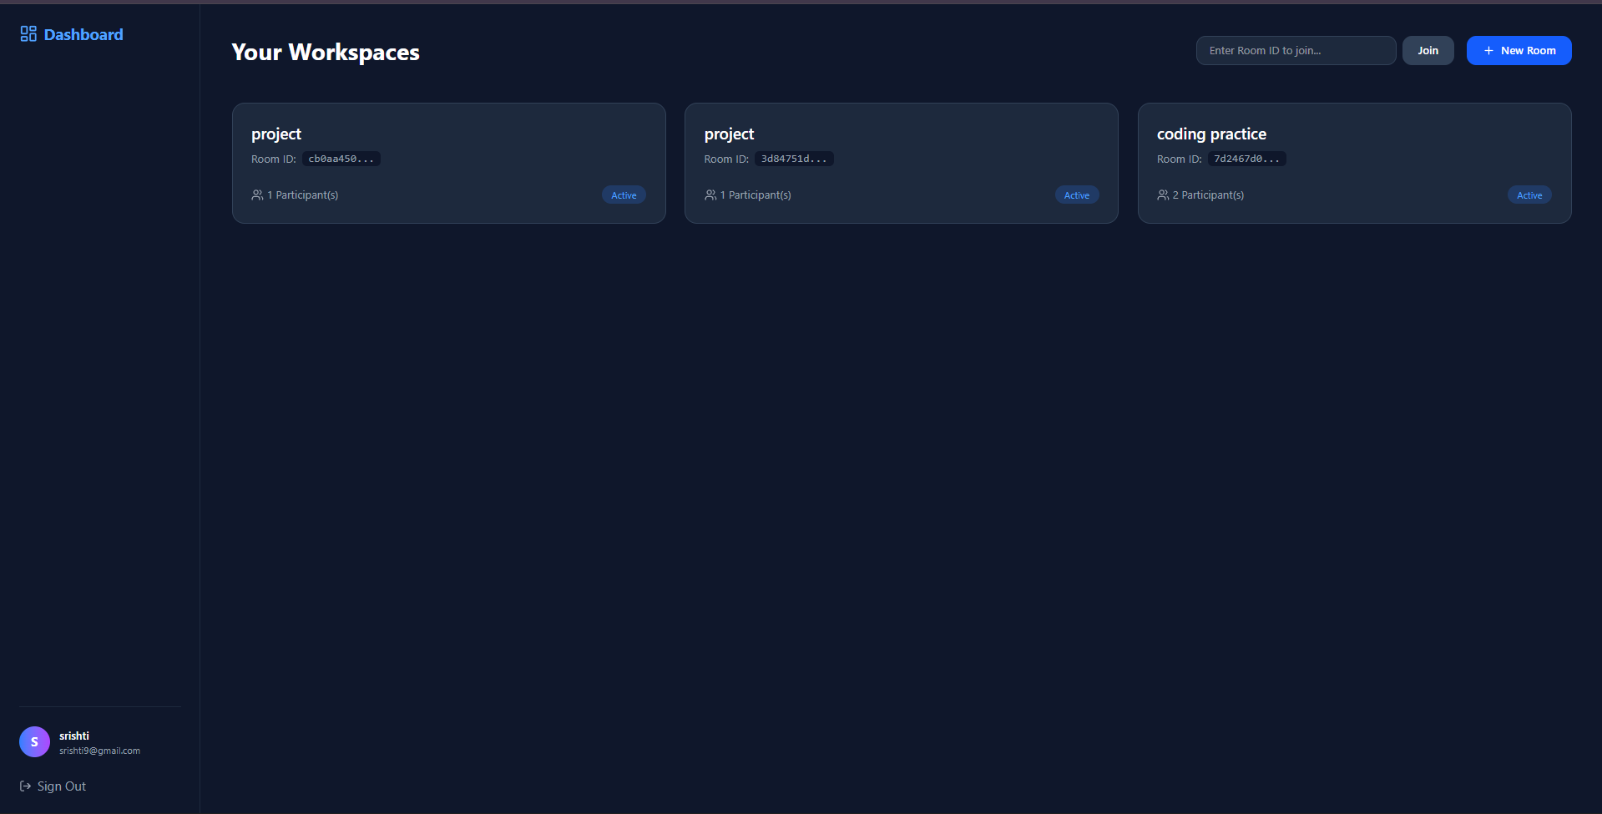

Room Created
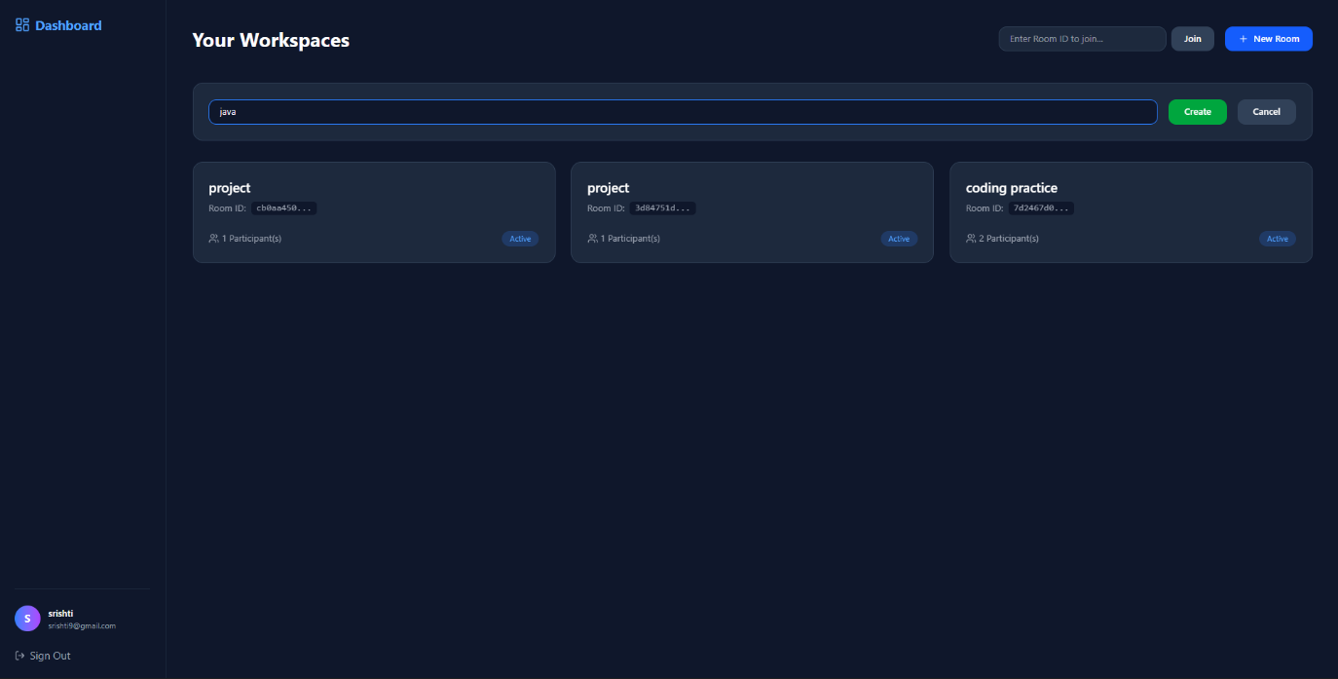
WorkSpace Editor(Srishti view)
1
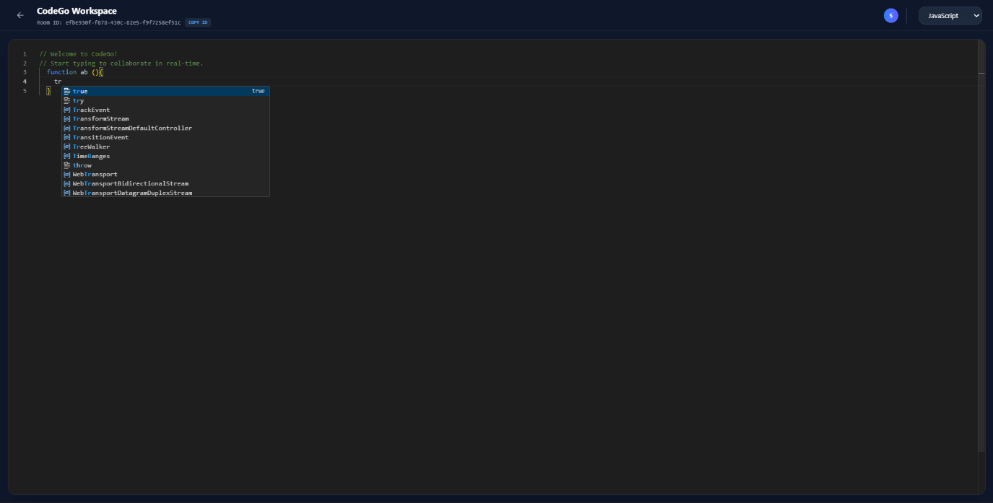
2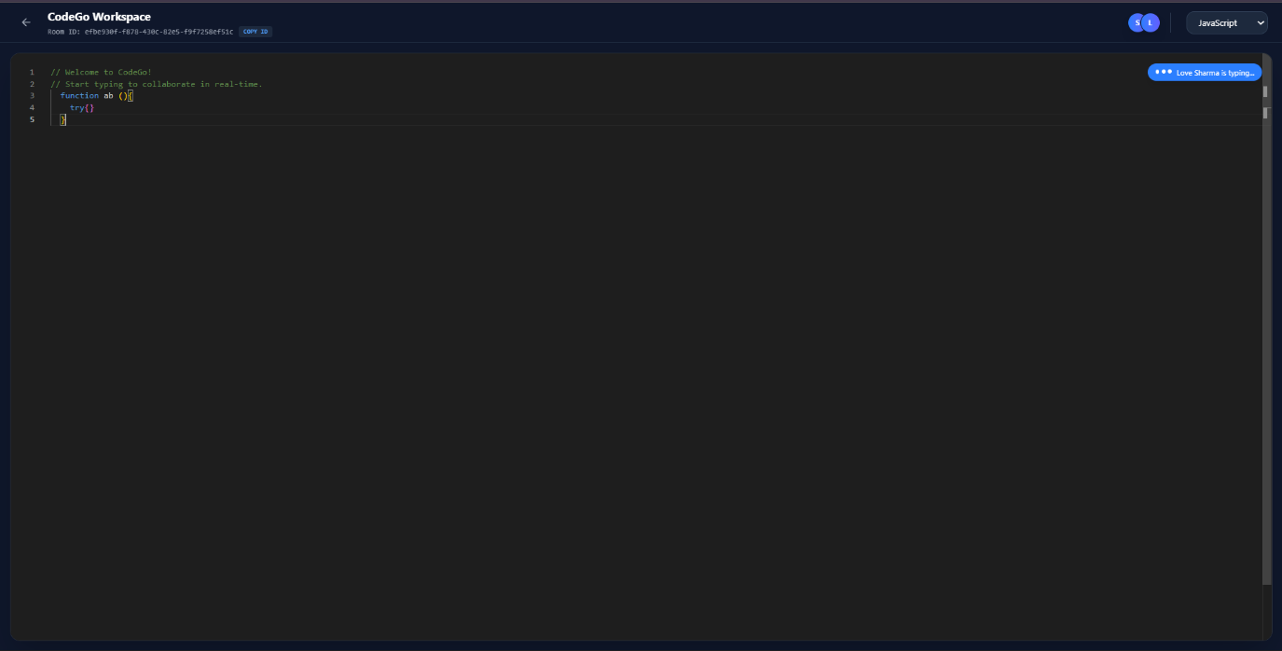

Dashboard(from love view)
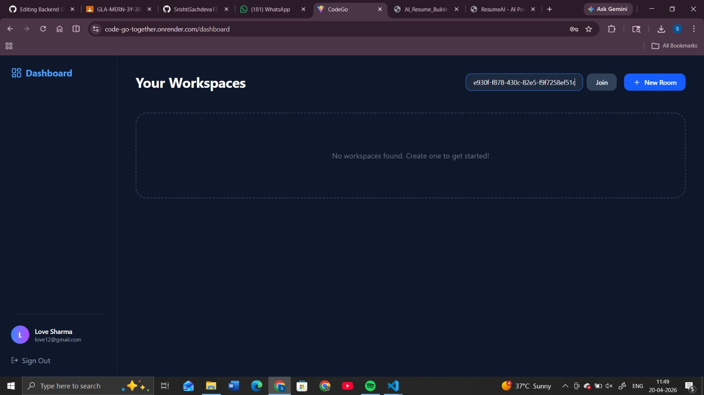

Workspace Editor(love view)
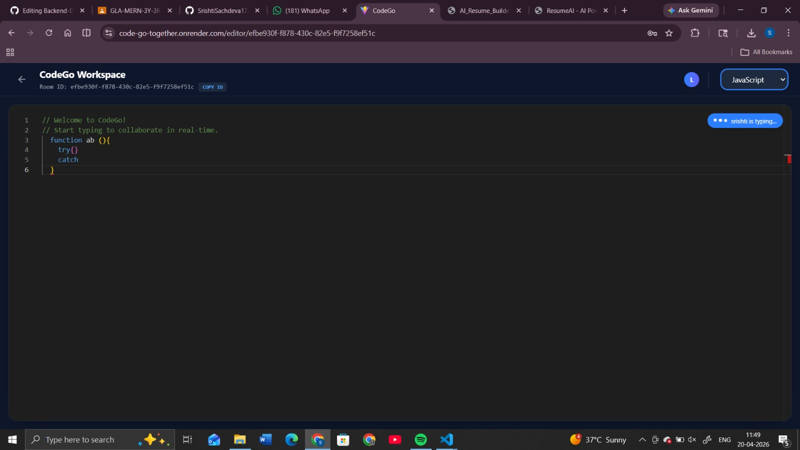

7. Advantages
- Enables remote teamwork
- Improves coding efficiency
- Easy to use interface
- No installation required

8. Future Enhancements
- Add video/audio chat
- Enable code execution
- File sharing support
- Version control integration
- AI-based code suggestions

9. Conclusion
CodeGo demonstrates a real-time collaborative coding environment using modern web technologies. It integrates authentication, workspace management, and live synchronization effectively. Deployment on Render ensures accessibility and scalability, making it a strong foundation for future enhancements.

