
GLA UNIVERSITY, MATHURA
Department of Computer Engineering Application

SYNOPSIS

F
or

Online Code Collaboration Platform (Live Editor)

B.Tech CSE 3rd
Year

Submitted
by
:

Yash
Agrawal (2415990045)

Harsh Pratap Singh (
2415990019
)

Yashdeep Chaudhary

(
2315002554
)

Yuvika Chaudhary

(
2315002570
)

Yogesh Kumar

(
2315002567)

Under the supervision of:

Mr. Satya Prakash Singh

Abstract
The Online Code Collaboration (Live Editor) project aims to develop a real-time platform that enables multiple users to write, edit, and execute code collaboratively over the internet. The primary purpose of this system is to enhance teamwork among developers, students, and instructors by providing a seamless and interactive coding environment, regardless of geographical location.
The methodology involves building a web-based application using modern technologies such as frontend frameworks (e.g., React), backend services (e.g., Node.js), and real-time communication protocols like WebSockets. The system will support features such as synchronized code editing, multiple programming language support, user authentication, and live output display.

The expected outcomes of this project include improved collaboration efficiency, reduced communication gaps during coding sessions, and a user-friendly interface that simulates an inperson coding experience. This platform can be beneficial for coding interviews, pair programming, online teaching, and team-based software development.

Keywords
MERN Stack
MongoDB
Express.js
React.js
Node.js
Web Application
Real-Time Collaboration
Live Code Editor
WebSockets
Code Sharing
Multi-User Editing
Online IDE

1. Introduction
In today’s rapidly evolving technological landscape, software development has become highly collaborative, often involving teams working from different geographical locations. Traditional coding environments lack real-time interaction, making collaboration less efficient and increasing dependency on manual code sharing methods. This creates a need for a platform that enables seamless and instant collaboration among developers.

The motivation behind the Online Code Collaboration (Live Editor) project is to bridge this gap by providing a unified environment where multiple users can simultaneously write, edit, and execute code in real time. With the growing demand for remote work, online learning, and technical interviews, such platforms have become increasingly essential for improving productivity and communication among users.
This project aims to develop a web
-
based application
using the MERN stack,
integrating technologies that support real
-
time communication and synchronization.
The system will allow users to collaborate on coding tasks, share ideas instantly, and
view live outputs, thereby simulating a real
-
world collaborative

coding experience.

Overall, the proposed solution focuses on enhancing teamwork, simplifying the
coding process, and providing an efficient and user
-
friendly interface for developers,
students, and educators.

2. Problem Statement
In the current software development and learning environment, collaboration among programmers is often limited by the lack of real-time interactive tools. Most existing platforms either support version control or static code sharing, but they do not provide a seamless environment for multiple users to simultaneously write and edit code together. This leads to delays in communication, inefficient teamwork, and difficulties in conducting collaborative coding sessions, especially in remote settings.
Additionally, traditional methods of code sharing, such as sending files or copying code snippets through messaging platforms, are time-consuming and prone to errors. The absence of an integrated system that combines real-time editing, instant synchronization, and code execution further restricts the efficiency of developers, students, and instructors.
Therefore, there is a need for a web-based solution that enables real-time code collaboration, allowing multiple users to work on the same codebase simultaneously with features such as live updates, shared editing environment, and optional code execution. This system aims to overcome the limitations of existing approaches and provide a more efficient and interactive coding experience.

3. Objectives
The main objectives of the Online Code Collaboration (Live Editor) project are as follows:
- To develop a web-based platform that allows multiple users to collaborate on code in real time.
- To implement a synchronized code editor where changes made by one user are instantly reflected to all connected users.
- To provide a user-friendly and interactive interface for seamless coding and collaboration.
- To integrate real-time communication technologies (such as WebSockets) for efficient data exchange.
- To enable support for multiple programming languages within the editor.
- To incorporate a code execution feature that allows users to run code and view output instantly.
- To ensure secure user authentication and session management.
- To minimize communication gaps and improve teamwork among developers, students, and instructors.
- To create a scalable and efficient system that can handle multiple users simultaneously.


4. Literature Review
The concept of collaborative coding has gained significant attention with the rise of remote work and online learning environments. Several existing platforms and research efforts have focused on improving collaboration among developers, but each has certain limitations.
Platforms like GitHub and GitLab primarily provide version control and code management features. While they are highly effective for maintaining code repositories and tracking changes, they lack real-time collaborative editing capabilities, making them less suitable for live coding sessions.
On the other hand, tools such as CodePen and JSFiddle allow users to write and test code online. However, their real-time collaboration features are limited or not designed for multiuser synchronized editing at a large scale.
More advanced platforms like Replit and Visual Studio Code Live Share support real-time collaboration and code execution. These systems demonstrate the effectiveness of integrating live editing with execution capabilities, but they can be complex or resource-intensive for basic users.
From the research perspective, various studies highlight the importance of real-time synchronization using technologies such as WebSockets and operational transformation algorithms to maintain consistency among multiple users. These approaches ensure that changes made by different users are accurately reflected without conflicts.
Despite the availability of these tools, there remains a need for a simple, efficient, and userfriendly platform that combines real-time collaboration with optional code execution in a lightweight web-based environment. The proposed system aims to address these gaps by integrating essential features into a unified solution.

5. Proposed Methodology
The proposed system is a web-based application developed using the MERN stack, including React for the frontend, Node.js and Express.js for the backend, and MongoDB for data storage.
The system follows a client-server architecture where users interact through a code editor interface. Real-time collaboration is achieved using WebSockets, allowing multiple users to edit code simultaneously with instant synchronization.
For code execution, an external API such as Judge0 is used to compile and run code securely, with output displayed to all users.

Overall, the system enables efficient real-time collaboration with a simple and interactive user interface.
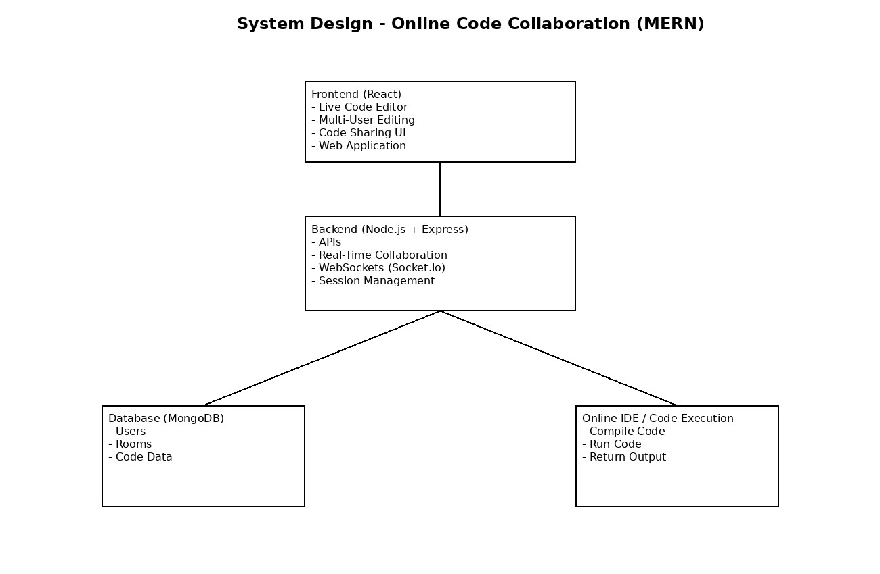
6.

System
Architecture

The Online Code Collaboration (Live Editor) system follows a client-server architecture based on the MERN stack. The frontend, developed using React, provides an interactive interface where users can write and edit code collaboratively.
The backend, built with Node.js and Express.js, manages user requests, sessions, and realtime communication. WebSockets are used to enable instant synchronization of code among multiple users.
The database, MongoDB, stores user information and session data. For code execution, an external service like Judge0 is integrated, which securely processes and returns the output.
This architecture ensures scalability, real-time performance, and efficient collaboration among users.

7. Implementation Plan
The development of the Online Code Collaboration (Live Editor) project will be carried out in multiple phases to ensure a structured and efficient workflow.
Phase 1: Requirement Analysis & Planning
Identify system requirements, define features, and design the overall architecture.
Phase 2: Frontend Development
Develop the user interface using React, including the code editor, user interaction components, and layout design.
Phase 3: Backend Development
Build server-side functionalities using Node.js and Express.js to handle APIs, authentication, and session management.
Phase 4: Real-Time Integration
Implement WebSockets (e.g., Socket.IO) to enable live code synchronization among multiple users.
Phase 5: Code Execution Integration
Integrate an external API such as Judge0 to compile and execute code securely.
Phase 6: Database Integration
Use MongoDB to store user data and session details.
Phase 7: Testing & Deployment
Perform testing to ensure functionality, fix bugs, and deploy the application for use.

8. Expected Results

The Online Code Collaboration (Live Editor) is expected to provide a seamless and efficient platform for real-time collaborative coding. The system will enable multiple users to simultaneously write, edit, and view code with instant synchronization, improving teamwork and reducing communication delays.
The platform will also allow users to execute code and view output in real time, enhancing its usefulness for learning, coding interviews, and group development tasks. The integration of a user-friendly interface will ensure ease of use for both beginners and experienced developers.
Overall, the project is expected to improve productivity, support remote collaboration, and provide an interactive coding environment that simulates real-world development practices.

9. Conclusion
The Online Code Collaboration (Live Editor) project presents an effective solution to the challenges of real-time collaborative coding in modern development environments. By integrating features such as live code synchronization, multi-user interaction, and optional code execution, the system enhances the overall coding experience for users.
The project contributes by providing a unified and user-friendly platform that supports remote collaboration, improves communication, and increases productivity among developers, students, and educators. It also demonstrates the practical implementation of modern web technologies and real-time communication mechanisms.
In conclusion, the proposed system holds significant importance in today’s digital era, where collaboration and remote accessibility are essential, making it a valuable tool for both learning and professional development.



References
Node.js Foundation, “Node.js Documentation”.
React Team, “React Official Documentation” .
MongoDB Inc., “MongoDB Basics Guide” .
Socket.IO, “Real-Time Communication Guide”



