Project Report

Monthly Land Cover from Sentinel-1 Radar

Abstract
This project maps land cover every month from Sentinel-1 radar alone, so that clouds and rainy seasons do not leave gaps. A user gives a coordinate and a start month. The system returns twelve monthly maps of a 10 km square, the share of each of seven classes, and what changed between months.
The model is a U-Net with a ResNet-50 encoder, trained from scratch on 103 sites worldwide. Its input is the month's VV and VH backscatter plus the yearly median of both, which gives each month a sense of what is normal for that place. Labels come from Dynamic World, filtered for agreement with ESA WorldCover.
Every design choice went through a decision rule written before the result was known. Twelve experiments were run this way; most ideas failed their rule and are reported as negative results. On 14 holdout sites scored once, the final model reaches 0.481 mIoU against Dynamic World (built 0.81, water 0.79, trees 0.63). Flooded vegetation (0.07) and bare ground (0.24) remain weak. Averaging two seeds and three neighbouring months cuts false month-to-month changes (pixels that switch class while Dynamic World keeps its class) from 8.8% to 3.6%.
A Streamlit prototype runs the whole pipeline for any coordinate. In a stress test it tracked the draining of the Kakhovka reservoir, the return of Tulare Lake and the 2022 Manchar Lake flood. It missed the 2025 Palisades fire and fails on snow and steep mountains.

Code, data and model availability
Everything needed to check or rerun this work is public:
 | Link
Dataset | huggingface.co/datasets/YashAnnapure/sentinel1-lulc-dataset: 120 sites, monthly Sentinel-1 radar with Dynamic World and ESA WorldCover labels
Training code | github.com/Yash-Annapure/Deep_learning_project: notebooks/02_train.ipynb, run_experiments.py, lulc.py
Model weights | huggingface.co/YashAnnapure/sentinel1-lulc-unet: the final model, both seeds
Prototype code | app.py and prototype.py in the same repository
The dataset contains modified Copernicus Sentinel data (2021 to 2025), processed in Google Earth Engine. Its labels come from Dynamic World V1 (Google, the National Geographic Society and the World Resources Institute) and ESA WorldCover 2021 (© ESA WorldCover project), both under CC BY 4.0.

1. Introduction
Monthly land-cover maps from optical satellites break down exactly where change matters most. Floods, monsoon crops and wetland seasons happen under cloud. Sentinel-2 can go months without a clear view of a tropical river plain. Sentinel-1 is a radar: it sends its own microwave signal and sees through cloud, day and night, every 6 to 12 days.
The catch is that radar does not see colour. It measures how rough, wet and structured a surface is. Calm water and smooth dry soil both look dark; crops, grass and shrubs look much alike. The question behind this project is how far a model can get with that signal alone.

1.1 Task
The brief asked for a land-use and land-cover (LULC) segmentation model that uses Sentinel-1 as its only input, and a prototype around it. The prototype takes a latitude, a longitude and a start month. It returns:
- twelve monthly maps of a 10 km by 10 km square around the point;
- the share of each class in every month;
- the change in each class from month to month and from the first to the last month.
The main test is whether the system can spot real change across months without inventing change that is not there.

1.2 Research questions
- How well can a radar-only model reproduce an optical land-cover map, class by class?
- Which choices matter most: more data, cleaner labels, a different architecture, pretraining, or post-processing?
- Does the model generalise to regions it was never trained on, including temperate and high-latitude places?
- Can the monthly maps detect real events, and how many false changes do they produce?

1.3 Contributions
- A curated dataset of 120 sites with five roles (training, validation, a development test, a block used only by the final model, and a holdout), covering kinds of place the first version lacked.
- Twelve experiments, each judged by a rule written before its result. Negative results are reported with the same weight as positive ones.
- A final model scored once on 14 unseen holdout sites, with results split into tropical and new regions.
- A Streamlit prototype that fetches the radar for any coordinate, runs the model, and explains its numbers in plain words.
- A stress test on 20 places, including four documented change events.
Section 2 describes the data and Section 3 the model and evaluation. Section 4 walks through the experiments, Section 5 gives the results, and Section 6 the prototype. Section 7 discusses what the model cannot do and why.

2. Data
The dataset pairs one month of Sentinel-1 radar with one month of land-cover labels, for 10 km squares at 120 sites. All data was exported from Google Earth Engine on a 10 m grid. The full export is 2,448 files and about 25 GB.

2.1 Radar input
The input is Sentinel-1 Ground Range Detected data in Interferometric Wide swath mode, with both polarisations: VV and VH. For each site and month, all scenes from one orbit direction are combined into a median composite. A month usually has two to six scenes. Values are in decibels; each band is clipped to the 1st to 99th percentile range of the training sites and scaled to 0 to 1.
Pixels without any radar coverage are marked and ignored during training. In the prototype, a month with more than 5% uncovered area is skipped, because a half-empty month would show up as a large fake change.

2.2 Labels
The labels come from Dynamic World (Brown et al., 2022), a near-real-time land-cover product that Google derives from Sentinel-2 optical images. For each month, the class probabilities are averaged and the most likely class becomes the label. Dynamic World has nine classes. Grass and shrub are merged into low vegetation, because radar separates them poorly. Snow and ice is left out (Section 7 discusses what that costs). The seven classes are water, trees, low vegetation, flooded vegetation, crops, built and bare.
Monthly optical labels have gaps exactly where radar is most useful. In the first export, 75 of 120 site-months had at most 20% of their pixels missing, and the gaps followed each site's rainy season. Kisumu was the only site without gaps.
Two decisions follow from this:
- Hybrid labels. A pixel takes its monthly label where one exists. Where it does not, the yearly label fills in with a lower loss weight (0.3).
- Agreement filter (AGREE). A filled yearly label is kept only where ESA WorldCover 2021 (Zanaga et al., 2022) agrees with it. Real monthly labels are never filtered.
Because AGREE uses WorldCover during training, WorldCover is no longer a fully independent check. The prototype still shows it next to Dynamic World, and the report says so wherever it is used.

2.3 Matching radar and label dates
A monthly pairing window sits well inside normal practice. SEN12MS pairs Sentinel-1 and Sentinel-2 within a meteorological season of about three months and uses annual MODIS labels (Schmitt et al., 2019). SSL4EO-S12 uses a 30-day window around four reference dates (Wang et al., 2023).
SSL4EO-S12 also discards locations without cloud-free optical coverage, and its own limitations section names the geographic bias this causes. This project keeps cloudy tropical sites, because the model is meant to work in exactly those regions.

2.4 Sites and splits
The 120 sites were chosen by hand, in rounds, to cover kinds of place the model got wrong. Each site has one of five roles:
Role | Sites | Years | Used for
train | 29 | up to 4 (2022 to 2025) | training every model
val | 12 | 1 | choosing epochs and judging experiments
development test | 3 | 1 | early checks (looked at too often to stay a fair test)
final | 62 | 1 | the exp8 tiebreak, then training the final model
holdout | 14 | 1 | scored once, at the end
The first 50 sites all lay between 27°N and 25°S. The model had never seen a temperate place, while the prototype is supposed to work at any coordinate. About 51 sites in Europe and the Americas were added on 5 November, and 7 more in East Asia, Australia, temperate southern Africa and Anatolia.
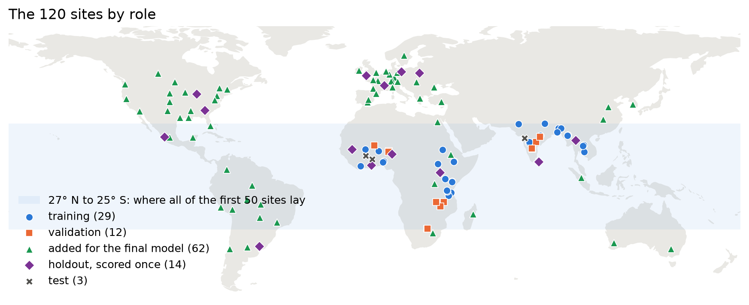
Figure 1. The 120 sites by role. The first 50 sites all lay between 27°N and 25°S; the later rounds filled Europe, the Americas, East Asia and Australia.
Rural sites were found by searching a 3 by 3 grid around geocoded anchor towns and keeping squares with under 15% built area and at least 90% labelled pixels. The ten original site centres were checked against OpenStreetMap's Nominatim geocoder; all agree within about 2 km. One lesson from that check: a plain place-name search can return an administrative region instead of the city (this happened for Morogoro, Mymensingh and Battambang). At the time of the pipeline review, every validation and test site was at least 82 km from the nearest training site.
Each site-month is cut into 256 by 256 pixel windows with a stride of 128. Windows overlap, so a pixel can be counted up to four times in a score. This inflates pixel counts but does not affect comparisons between runs.

3. Method
The model is a standard U-Net (Ronneberger et al., 2015) with a ResNet-50 encoder (He et al., 2016), trained from scratch with the segmentation_models_pytorch library. The architecture is deliberately plain. Section 4 shows that alternatives were tried and none earned its place.

3.1 Input: the month plus its year
Each sample has four channels: the month's VV and VH, and the yearly median of VV and VH at the same place. The yearly channels came out of a failure. The first model called many smooth dry surfaces water, and only 7% of its predicted water on the test sites was truly water.
My idea was to give the model the year's context: vegetation and soil change with the seasons, while water stays dark. A quick measurement on the training sites supported it. A single threshold on the yearly median VV caught 81% of water with 11% false alarms; the same threshold on a single month caught 59% with 18%. Interestingly, water varies more from month to month than other classes (2.9 dB against 1.3 to 2.0 dB). The useful signal is its typical level, not its stability.
In the prototype, the twelve monthly composites are computed first and their median becomes the context. Any twelve-month window contains each calendar month once, so this matches training. The trade-off is that the context is the same for all twelve months. It steadies the maps, but it can also dampen a real change (Section 7.3).

3.2 Training
Setting | Value
Loss | cross-entropy, class weights 1 / sqrt(class frequency); filled yearly labels weighted 0.3
Optimiser | AdamW, learning rate 1e-3, weight decay 1e-4
Schedule | cosine annealing over all steps
Batch, epochs | 16 windows, 15 epochs
Augmentation | random 90° rotations and flips
Epoch kept | best validation mIoU (experiments); last epoch (final model)
The final model is trained on the train, val and final sites together (103 sites). Validation is then part of its training data, so it cannot pick an epoch, and the last epoch is kept. Two seeds are trained.

3.3 Inference in the prototype
The prototype averages the softmax probabilities of both seeds. It then replaces each month's probabilities by the mean of that month and its two neighbours, wherever both neighbours have radar. The first and last months stay as they are. The class with the highest averaged probability becomes the map. Section 5.3 shows what this costs and gains.

3.4 Evaluation
The main score is intersection over union (IoU) per class against Dynamic World, and its mean over the seven classes (mIoU). Scores use real monthly labels only. The yearly fill is left out, otherwise the hybrid models would be graded partly on their own training signal.
For change, two rates are measured between consecutive months that both have radar:
- false changes: the share of pixels that keep their Dynamic World class from one month to the next but switch class in the model's map;
- missed changes: the share of pixels that switch class in Dynamic World but keep their class in the model's map.
Overall accuracy is reported rarely. In a city that is 72% built, a map that says "built" everywhere already scores 72%.

3.5 Decision rules and split discipline
Every experiment has a README in which the question, the setup and the decision rule were written before training started. A typical rule: averaged over two seeds on the 12 validation sites, mIoU must rise by at least 0.010 and no class may drop more than 0.05. Two seeds per setup give a measure of run-to-run spread, and gains smaller than that spread do not count.
The discipline was not perfect from the start. The three original test sites were used for several early decisions, which made them a development test rather than an unseen exam. Once that was clear, they were renamed, and a fresh holdout was set aside. The holdout was scored exactly once, on 7 November, after the final model was fixed. The prototype was committed to the final model before that score existed, so the holdout chose nothing; it only measured.

4. Experiments
Twelve experiments shaped the final model, and data changes beat model changes almost every time. The table lists each one with the result of its pre-registered rule. Scores are mIoU against Dynamic World, mean of two seeds unless noted.
Exp | Question | Rule | Outcome
0 | First model: 9 sites, 2024 only | none (baseline) | test mIoU 0.21 to 0.25; false water in dry regions
1 | More sites, more years, label filter, radar filters? | per change | dry sites fixed false water; filters hurt
2 | U-Net++, ImageNet weights, yearly context? | not met (it targeted trees) | architecture adds nothing; context kept anyway for its test-water gain
3 | WorldCover agreement filter, rare-class oversampling? | partly met | AGREE kept, oversampling dropped
4 | 34 to 50 sites, aimed at weak classes | met | validation +0.059; every class improves
5 | Add interferometric coherence | not met | reported as a finding
6 | Add month-to-month spread channels | not met | trees +0.018, crops +0.013 (bar 0.03)
7 | DeepLabV3+ instead of U-Net | not met | +0.006 (bar +0.010)
8 | ResNet-50, from scratch or SSL4EO-pretrained | 2 of 3 met; tie | scratch wins tiebreak on 62 new sites
9 | Convolutional CRF after the model | not met | +0.001 / −0.001, two settings (bar +0.010)
10 | Final model on 103 sites | scored once | holdout 0.481 (Section 5)
11 | Average seeds, views, months? | 2 of 3 met | 2 seeds + 3-month mean kept
12 | Add Lovász-softmax loss | not met | +0.001 (bar +0.010)
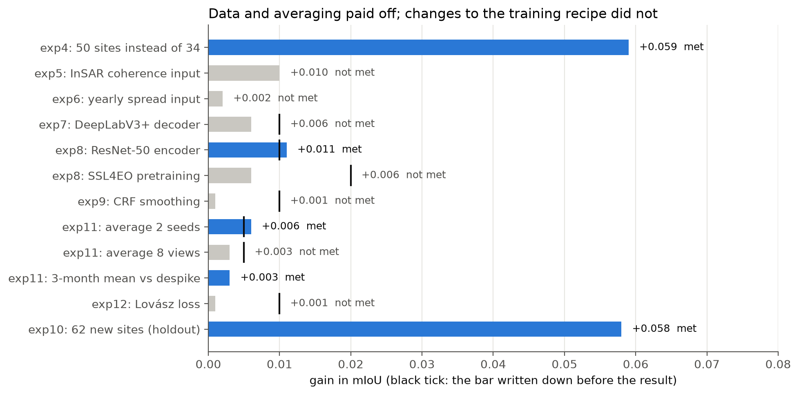
Figure 2. Experiments 4 to 12 against their decision rules: gain in mIoU, with the bar set beforehand as a black tick. Data and averaging passed; changes to the training recipe did not.

4.1 Hybrid against monthly-only labels
The first comparison tested whether filling label gaps with the yearly label helps. Before running it, I predicted that monthly-only labels would score higher overall, and that the biggest difference would show in monsoon months, where missing or wrong data surfaces.
The overall prediction did not hold. On the four validation sites of the time, hybrid labels scored 0.273 for both seeds, against 0.260 for monthly-only. On the test sites the two overlapped (monthly-only 0.215, hybrid 0.211 and 0.232). In the rainy-season months that have any test labels, monthly-only was actually ahead (June: 0.353 against 0.345 and 0.321; September: 0.149 against 0.104 and 0.130), which leans the way I predicted. Those months rest on very few labelled pixels, though, and July and August have none at all. The difference was small, and hybrid labels stayed because they let every month train.

4.2 The false-water problem and what fixed it
The first models drew water across dry land. On the dry test sites in the Sahel, northern Ghana and Nashik, test water IoU was only 0.065 to 0.105. The validation sites had no dry places, so validation could not see the problem at all.
The yearly context (Section 3.1) lifted test water IoU sharply but did not help on validation (Figure 3). The real fix was data. Adding dry-region training sites (Dodoma, Kitui, Solapur, Pakokku, Khon Kaen, Adama) and more years raised test water IoU from about 0.1 to 0.42. Test mIoU went from 0.21 to 0.25 up to 0.335.
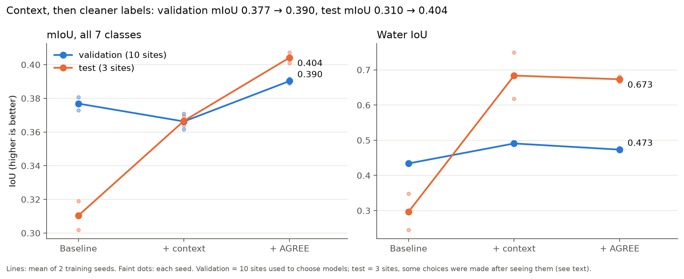
Figure 3. Experiments 1 to 3, mean of two seeds (dots: each seed). The yearly context lifts test water IoU from 0.30 to 0.68 but lowers validation mIoU slightly; the agreement filter then lifts both sets.
Two side results came out of this:
- Sites matter more than years, until training gets long. Twenty-one sites with 2024 alone matched the four-year run at short training. At the same step count, though, one year overfits: every image is seen 60 times, test mIoU falls to 0.26 to 0.28, and false water returns. Four years of the same places, with different weather and soil moisture, prevent this.
- Raw radar beats filtered radar. Sharpening and smoothing filters left validation unchanged but cut test water IoU from 0.42 to 0.12 and 0.20.
This was the point where validation was clearly blind to dry regions. Dry validation sites were added, and later the whole split was rebuilt.

4.3 Cleaner labels, then different data
The agreement filter (AGREE) beat the baseline on both seeds and on both the test and validation sets (Figure 3: validation 0.366 to 0.390, test 0.366 to 0.404). Crops and low vegetation improved. Trees dropped 0.04 on validation, so the rule was only partly met, and AGREE was kept with trees noted as a trade-off.
For flooded vegetation, cleaner labels did more than extra exposure (Figure 4). Showing rare-class windows twice as often raised its validation IoU from 0.10 to 0.16, but the two seeds disagreed widely (0.12 and 0.19) and water got worse. AGREE raised it to 0.19 with both seeds close together. In experiment 4 the dataset grew from 34 to 50 sites, and the new training sites were aimed at the weak classes (Mopti, Khulna and the Sudd for flooded vegetation, Jaisalmer for bare). Validation mIoU rose by 0.059 and flooded vegetation nearly doubled. More varied data beat more exposure to the same data.
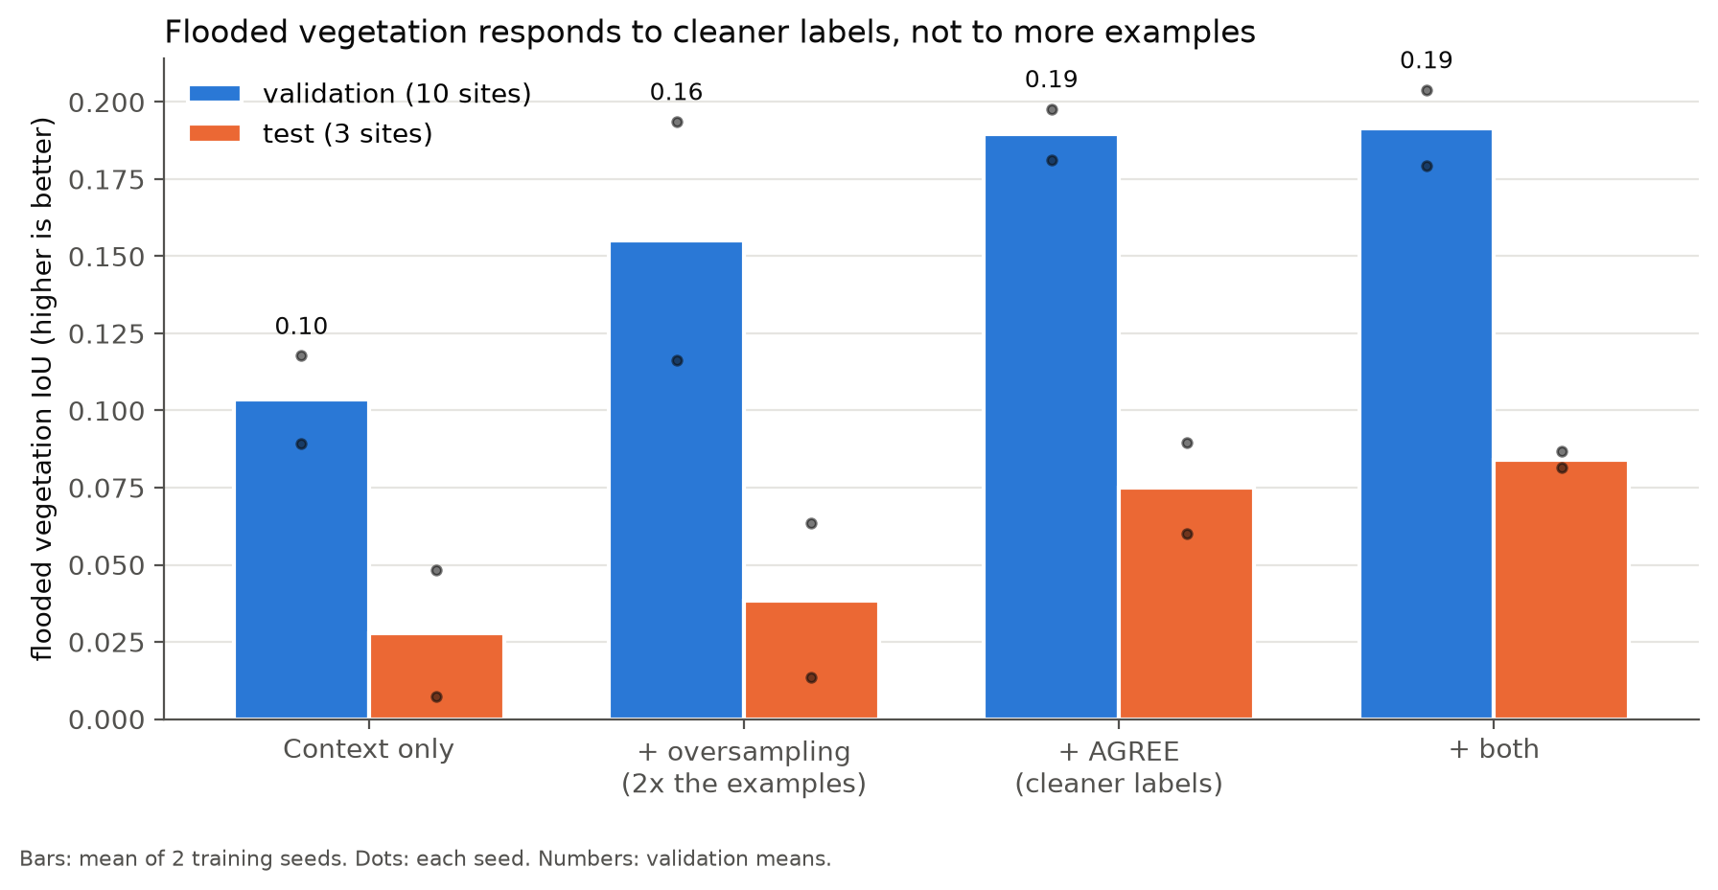
Figure 4. Flooded vegetation IoU in experiment 3. Cleaner labels (AGREE) beat twice the examples, and their two seeds agree more closely.

4.4 Coherence: a prediction that went the wrong way
Sentinel-1 also records the phase of its signal. Comparing two passes 12 days apart gives coherence: stable surfaces such as walls stay high, while vegetation and water decorrelate. I expected coherence to fix the confusion between built and bare ground.
A proof of concept at two sites (Pakokku and Kisumu, 2024, processed with ASF HyP3) showed something else. Coherence barely separates built from bare (AUC 0.64 and 0.55), because dry soil is as stable as a building. It separates built from trees very well (AUC 0.83 and 0.87), which brightness alone cannot do. Adding coherence to a simple per-class classifier raised balanced accuracy by 0.085 at Pakokku and 0.146 at Kisumu.
In the full model (experiment 5), coherence raised mIoU by 0.010 but built (+0.004) and bare (+0.017) missed the required +0.03. With coherence zeroed, the model fell below the radar-only baseline (0.415), so it had come to depend on coherence. Coherence also takes hours to days to compute per place, which the prototype cannot afford. It is reported as a finding, not used.

4.5 Model changes that did not pay
Experiments 6 to 9 each tried one change on top of experiment 4: spread channels, DeepLabV3+, a larger encoder with and without pretraining, and a CRF. None passed except the larger encoder.
Experiment 8 is the interesting one. ResNet-50 pretrained on Sentinel-1 with SSL4EO-S12 beat ResNet-50 from scratch by only 0.006 on validation, below the 0.020 bar. Both beat experiment 4, so most of the gain came from the larger encoder, not from pretraining. A 0.006 gap is smaller than the gap between two seeds of the same setup, so the tie went to new data: on the 62 final sites, scratch scored 0.392 and SSL4EO 0.386. Scratch was chosen. The holdout later confirmed the choice (0.423 against 0.414).

4.6 Going beyond the tropics
Before choosing temperate sites, the best model at that point was run on six places it had never seen, to find out what goes wrong there. It was not broken: it agreed with Dynamic World on 72% to 91% of each square. Three weaknesses stood out:
- leafless deciduous forest in winter read as low vegetation (Massachusetts: trees fell to 32% in December);
- winter cereals and rolled spring fields read as low vegetation or even water (Picardy: 42% "water" in May);
- harvested fields on the dry Great Plains read as bare (Nebraska: 85% bare in February).
A first block of new sites aimed at exactly these. After retraining on 103 sites, the same places agreed with Dynamic World on 86% to 96%. The swings disappeared, which is correct: by Dynamic World's definitions a deciduous forest is trees all year. These places are not an unbiased test, since the new sites were chosen to fix them, and that is what the holdout is for.
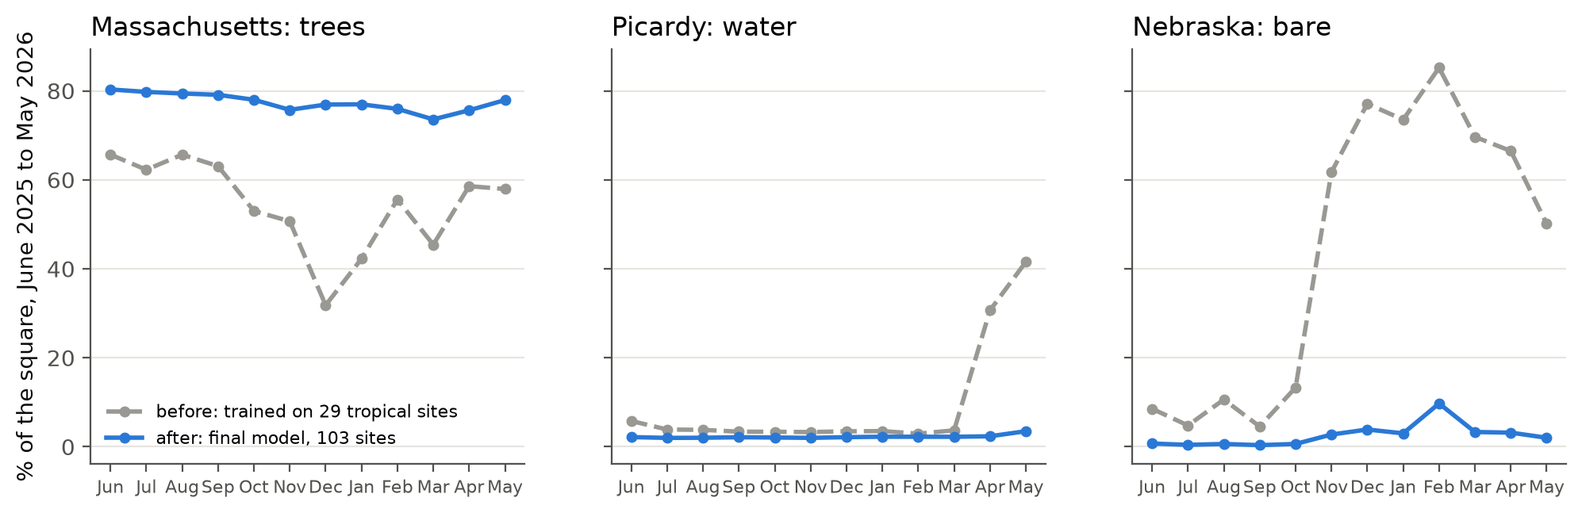
Figure 5. The new-regions diagnosis, June 2025 to May 2026. Before: false seasonal swings in trees, "water" and bare. After training on 103 sites: flat curves, as Dynamic World's definitions require.

4.7 Averaging and loss
Experiment 11 tested three kinds of averaging on 74 sites, using the 29-site models so that the final model's data stayed untouched. Averaging two seeds passed (+0.006). Averaging eight rotated and flipped views did not (+0.003). A three-month mean of probabilities replaced the earlier one-month despike filter: equal or better mIoU, fewer false changes, and 1.7 points more missed changes, inside the 5-point guard. Experiment 12 added the Lovász-softmax loss (Berman et al., 2018), which directly targets IoU. It scored 0.393 against 0.392, so the final model was trained without it.

5. Results
The final model reaches 0.481 mIoU on 14 holdout sites it never saw, and the gain over earlier models comes from the new training sites. All holdout numbers below were computed once, on 7 November 2026, and every model scored is reported, including those that make the final model look worse.

5.1 Holdout scores
The holdout has six tropical sites, chosen on 27 October, and eight in Europe and the Americas (four cities, four countryside). Windows are scored as in validation; two seeds are averaged where a setup has two.
Model | Sites trained on | mIoU | Tropics (6) | New regions (8)
Experiment 4 (ResNet-34, first prototype model; seed 0 only) | 29 | 0.433 | 0.357 | 0.437
Experiment 8, ResNet-50 from scratch | 29 | 0.423 | 0.366 | 0.414
Experiment 8, ResNet-50 SSL4EO | 29 | 0.414 | 0.338 | 0.423
Final model (ResNet-50 from scratch) | 103 | 0.481 | 0.366 | 0.493
Three things stand out:
- The new sites did the work. The same setup goes from 0.423 on 29 sites to 0.481 on 103 (+0.058). Almost all of it is in the new regions (0.414 to 0.493), where the new sites were aimed. The tropics do not move (0.366 both).
- The larger encoder did not hold up. On validation, ResNet-50 beat ResNet-34 by 0.011. On the holdout, the 29-site ResNet-34 scores higher (0.433 against 0.423). That validation gain was probably noise, and it is reported here as not confirmed.
- The tiebreak was right. From scratch beats SSL4EO on the holdout (0.423 against 0.414), as it did on the 62 tiebreak sites.
The two seeds of the final model agree closely (0.481 and 0.481).

5.2 Per-class performance
Class | Exp 4 | Final model
built | 0.793 | 0.807
water | 0.743 | 0.790
trees | 0.568 | 0.633
low vegetation | 0.364 | 0.422
crops | 0.339 | 0.409
bare | 0.189 | 0.238
flooded vegetation | 0.037 | 0.070
The final model is better than every earlier model on every class. Built and water are strong because radar sees them directly: walls and corners reflect the signal straight back, calm water reflects it away. Crops and low vegetation are moderate. Bare ground and flooded vegetation are weak.
The confusion matrix (Figure 6) shows why. The model recognises 92% of built pixels, 85% of water and 73% of trees. But 40% of bare ground is called built: dry, bright soil around Sahel towns echoes much like buildings. Flooded vegetation is recognised only 14% of the time, and its errors spread over all other classes. C-band radar mostly sees the top of the canopy, not the water underneath.
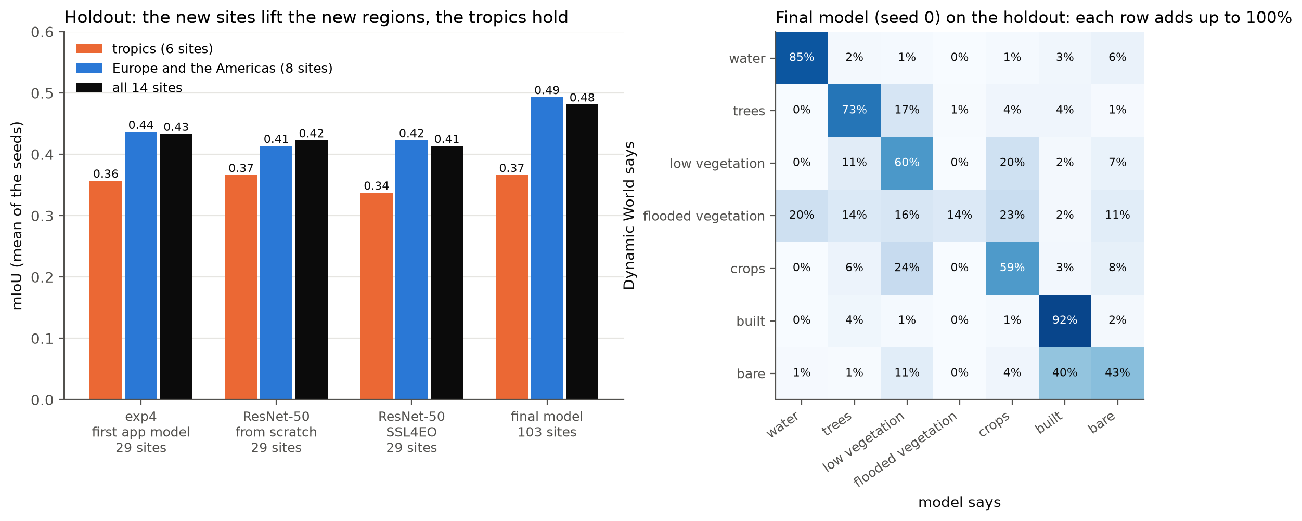
Figure 6. Holdout results, scored once. Left: mIoU per model for the tropics, the new regions and all 14 sites. Right: the final model's confusion matrix (seed 0), rows normalised to the Dynamic World label.

5.3 False and missed changes
Averaging trades missed changes for fewer false ones. On the holdout, with full scenes and real monthly labels:
Setup | mIoU | False changes | Missed changes
one seed, raw monthly maps | 0.481 | 8.8% | 80.7%
two seeds | 0.486 | 7.9% | 82.1%
two seeds + 3-month mean (prototype) | 0.489 | 3.6% | 92.2%
The prototype's setup cuts false changes by more than half. The cost is that it misses even more of the pixel-level switches Dynamic World records. Most of those switches are small and scattered, and part of them is likely noise in Dynamic World itself, but that was not measured. The safe reading is this: the maps are good at large, lasting changes and poor at small or one-month ones. Section 5.5 shows both.

5.4 Stress test: 20 places
The prototype was run on 20 places chosen to probe its limits: ten everyday landscapes, six edge cases and four documented events. Agreement is the model's map of the year against Dynamic World and ESA WorldCover.
Place | Nearest training site | vs Dynamic World | vs WorldCover
Amazonas, rainforest | 230 km | 100% | 100%
Krasnoyarsk krai, taiga | 3,365 km | 97% | 97%
Nile delta, farmland | 332 km | 96% | 86%
Paris, city | 92 km | 91% | 82%
Furano, Japan, farmland and forest | 1,512 km | 91% | 82%
Lahti, Finland, lakes and forest | 600 km | 89% | 79%
Lucknow, city and fields | 265 km | 87% | 76%
Iowa, corn belt | 63 km | 82% | 62%
Pampas, cropland | 183 km | 81% | 75%
Longreach, Australia, cattle country | 1,235 km | 52% | 34%
Grand Erg Oriental, sand sea | 1,289 km | 74% | 74%
Dubai, coast, city and desert | 1,573 km | 71% | 66%
Bernese Alps | 157 km | 35% | 40%
Everest | 343 km | 0% | 2%
Nine of the ten everyday places agree with Dynamic World on 81% to 100%. Distance from training is a weak guide: Furano, 1,512 km from the nearest training site, agrees on 91%. The model fails on the dry Australian outback (52%), on steep, snowy mountains (Alps 35%, Everest 0%) and in Greenland, where only 3 of 12 months had radar. In the sand sea, about 6% of the square turns from bare to "water" between the first and last month, the old false-water problem in its purest form. The open Atlantic returns a clear error message ("no Sentinel-1 scenes at this location") rather than a map.
The high agreement for Krasnoyarsk hides a problem. Its biggest change is trees falling by 26 points into low vegetation, which is most likely snow on the taiga in winter. The model has no snow class, so it picks the nearest thing.

5.5 Change detection
Figure 7 shows four seasonal landscapes from the demo set, June 2025 to May 2026:
- Bagre reservoir, Burkina Faso: crops rise from 17% to 46% in the rainy season (August) and give way to bare ground in the dry season (44% in May).
- Tonle Sap, Cambodia: the lake's flood pulse. Water grows from 6% in June to 60% in October and falls back to 5% by March.
- Satkhira, Bangladesh: water and flooded vegetation trade places through the year in a coastal landscape of ponds and paddies.
- Lake Debo, Mali: the inner Niger delta floods. Flooded vegetation rises from 5% to 37% (September to November) and bare ground returns in May. The flood shows as flooded vegetation, not open water, which is right for a vegetated flood plain.
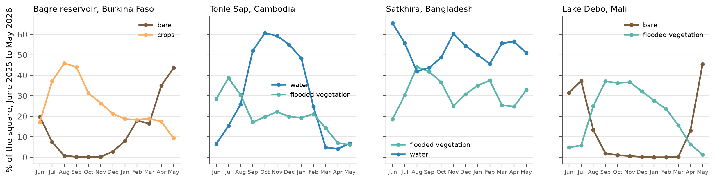
Figure 7. Seasonal change at four demo sites, June 2025 to May 2026, share of the 10 km square.
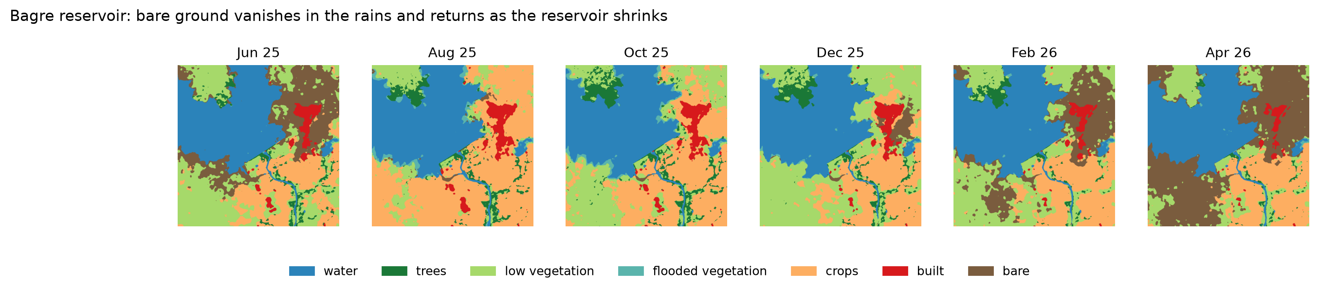
Figure 7b. Bagre reservoir, Burkina Faso, month by month: crops in the rainy season, bare ground in the dry season.
The stress test included four events with known dates (Figure 8). Values are the share of the 10 km square in the smoothed monthly maps.
Event | Class | Before | After
Kakhovka dam destroyed, 6 June 2023 | water | 73% to 76% (Jan to May) | 38% (June), 12% (July), then 9% to 14% to December
Tulare Lake returns, spring 2023 | water | 35% to 41% (Oct to Feb) | 50% (March), rising to 74% (July)
Manchar Lake floods, August 2022 | water | 67% to 74% (Apr to Jul) | 96% (Aug to Oct), 75% by March
Palisades fire, January 2025 | trees | about flat | about flat (missed)
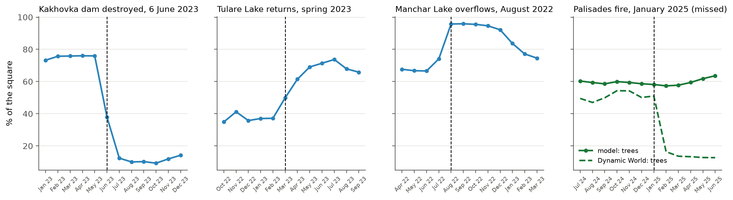
Figure 8. The four change events. For Palisades, Dynamic World's tree share is shown next to the model's: the labels drop after the fire, the model barely moves.
Three of four events are detected in the right month. At Kakhovka the drained bed shows the old river channels coming back, and vegetation (mapped mostly as flooded vegetation) spreads over the bed from September to December (Figure 8b). At Manchar, land and winter crops re-emerge from December to March.
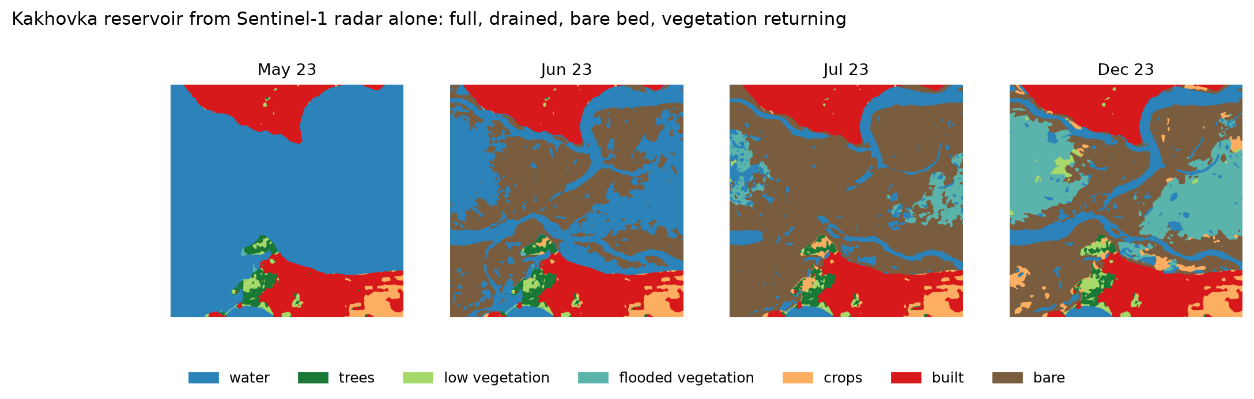
Figure 8b. Kakhovka reservoir, 2023, month by month: water until May, the drained bed from June, then vegetation spreading over it.
Two caveats. First, the Kakhovka and Manchar squares were misplaced in the first runs (one sat on a shore town) and both events were missed until the coordinates were corrected. Second, Tulare already starts at 35% water before the lake came back: smooth fallow fields on the old lake bed read as water.
The Palisades fire is a real miss. According to Dynamic World, trees fell from 51% to 16% of the square, mostly to low vegetation, not bare. The radar saw it too: VH dropped by about 3 dB over 22% of the square. The model moved by about 2 points. Section 7.3 gives the likely reason.

6. Prototype
The prototype is a single-page Streamlit app that runs the full pipeline for any point on Earth and explains each number it shows. It runs on a GPU server. A new place takes under a minute (about 20 seconds in the demo video); a place analysed before opens instantly from its saved run.

6.1 Pipeline
- The user clicks a satellite map (Esri World Imagery) or types a latitude and longitude, and picks the first of twelve months.
- The app asks Google Earth Engine for all Sentinel-1 scenes over the 10 km square in those months, builds one median composite per month, and the yearly median as context.
- A month with more than 5% of the square uncovered is left out, so a gap is never counted as a change.
- Both seeds of the final model predict every month. Their probabilities are averaged, then smoothed with the three-month mean.
- Dynamic World and ESA WorldCover for the same square are fetched for comparison.
- The run is saved to disk. Each save writes a temporary file first and renames it when complete, so an interrupted run can never leave a broken file behind.

6.2 What the user sees
The page opens with a summary card that gives the answer first. It names the place and the period, and shows the three classes that changed most as tiles: each class's share of the square in the last month, and its change since the first month in percentage points. On a 10 km square, 1% equals 1 km², so the numbers translate directly into area. A fourth tile counts the months with radar.
Below the card:
- Trend chart: the share of each class per month, in the map colours. Hovering over a month lists every class.
- Month viewer: a slider through the twelve maps. It opens on the month with the most change. A switch highlights pixels that changed since the previous month, and another lays the map over the satellite photo with adjustable opacity. A play button animates the year.
- All twelve months: a grid of small maps, with dark tiles for months without radar.
- Comparison: the model's map of the year next to Dynamic World and WorldCover, with three agreement numbers, including how far Dynamic World and WorldCover agree with each other.
A switch next to the heading turns the three-month mean off, so a user can see the raw monthly maps and judge how much of a change is flicker.

6.3 Honesty features
Several parts of the interface exist because the stress test exposed a weakness:
- Familiarity badge. It gives the distance to the nearest training site and what kind of place that site is. The stress test showed distance alone can mislead: it called Everest familiar because a training site lies 343 km away.
- Snow and ice warning. When WorldCover marks more than 5% of the square as snow, ice or moss and lichen, the card warns that the model has no class for it, whatever the distance says.
- Low-reliability marks. Flooded vegetation and bare ground carry an asterisk in the legend, with a note that they were weak in testing.
- "How to read the numbers." An expandable section explains every number on the page in plain words, including the holdout scores for each class.
The open-ocean case returns a clear message instead of an empty map, and saved runs that cannot be read are skipped rather than breaking the page.

7. Critical discussion
The scores in this report measure agreement with another model, through a sensor that cannot see colour, on a small holdout. Each of those three facts limits what the numbers can claim.

7.1 The labels are a model, not ground truth
Dynamic World is itself a neural network applied to Sentinel-2 images. Every score here is agreement with it, not with what is on the ground. Dynamic World and ESA WorldCover, two respected 10 m products, agree on only about 60% of pixels in our sites. For crops and low vegetation they disagree on about 40%. A radar model trained on one of them cannot be expected to reach 90% pixel accuracy, and that was never the goal.
Some apparent errors are label conventions. In towns, the model calls many trees "built" when compared with WorldCover. Where it does, Dynamic World says "built" too (68% to 94% of those pixels in most places, 45% in Massachusetts): Dynamic World labels leafy streets and gardens as built, WorldCover as trees. The model learned its teacher's convention. More data would not change that.
The agreement filter uses WorldCover in training, so WorldCover is not a fully independent second opinion. It is still shown in the app, and the comparison with it should be read with that in mind.

7.2 What C-band radar cannot see
Limitation | What it means | Seen in this project
No colour | similar structures look alike | crops and low vegetation at about 0.41 IoU
Smooth surfaces are dark | calm water and smooth dry soil both look dark | false water in dry regions; sand turning to "water" in the Sahara (about 6 points)
Bright dry soil | dry, rough ground echoes like walls | 40% of bare called built
C-band sees the canopy top | water under plants is hidden | flooded vegetation at 0.07 IoU
Speckle | grainy noise, needs averaging | only 2 to 6 scenes per month
About 20 m true resolution | edges and small objects mix | errors along class borders; small parks absorbed into built
Side-looking geometry | shadow and distortion on slopes | Everest 0%, Alps 35%
Moisture | rain changes the signal without any land change | seasonal swings that can look like change
Coverage gaps | some months lack full coverage | Greenland: 3 of 12 months
Sentinel-1 is good at classes with a distinct structure or wetness and weak at classes that differ mainly in colour. The per-class results follow that line almost exactly.

7.3 Limits of the change detection
The Palisades fire shows the main design weakness. The yearly median context covers all twelve months, and six of them (January to June 2025) came after the fire. The context therefore already looks partly burnt, which dilutes a subtle change. Kakhovka and Manchar were large changes in water, which radar sees strongly, so they came through anyway. A rolling or pre-event context would likely fix this, but it was found after the model was frozen and was not tested.
The averaging that removes false changes also removes real one-month events. A flood that lasts a single month can be flattened by the three-month mean. The switch in the app lets a user check the raw maps, but the default view favours lasting change.
Soil moisture after rain changes the radar signal. Part of what the model reports as seasonal change may be wetness, not land cover. This was not separated in the evaluation.

7.4 Generalisation
The model generalises well to ordinary landscapes far from training, from Japan to Finland. It does not handle snow and ice, because those were excluded from the classes and the training sites had none. Snowy or high places therefore get the nearest of the seven classes, often water or low vegetation. The tropics did not improve with the final model (0.366 both before and after), so the new sites helped only where they were placed.
Distance to training data is a weak guide to reliability. Furano is 1,512 km away and scores 91%; Everest is 343 km away and scores 0%. The app's familiarity badge uses distance, which is why the snow warning was added.

7.5 Evaluation caveats
- The three development test sites were used for early decisions, including the choice of the yearly context. Results on them are not unbiased.
- One rule in experiment 8 was added after one result was seen. It is marked as such in the experiment notes, and new data decided the tie instead.
- Validation scores are slightly optimistic, because the best epoch is chosen on validation.
- The holdout has 14 sites; the tropical part only six. A single site can move the group score noticeably.
- Overlapping windows count some pixels up to four times. This affects pixel counts, not comparisons.

7.6 Future work
The final model was frozen on 7 November, two days before the deadline. The holdout was spent, so any new model scored on it would be tuned to known results. The weak classes were therefore documented, not retrained. The most promising fixes are:
- Flooded vegetation: more wetland sites with reliable labels. L-band radar (ALOS-2, NISAR) sees water under the canopy, but that would break the Sentinel-1-only brief.
- Crops against low vegetation: a time-series model such as U-TAE (Sainte Fare Garnot and Landrieu, 2021), which reads the crop cycle across months instead of one month at a time.
- Abrupt change: a rolling or pre-event context instead of the yearly median.
- Snow and ice: an eighth class, with training sites in mountains and at high latitude.
- Built against trees: interferometric coherence, once it can be computed fast enough for the prototype.
- Rare classes: copy-paste augmentation with real rare-class pixels. The risks are known: the model could learn the artificial edge of a pasted patch instead of the class. Pasting along the label's own shape, within the same month and orbit direction, should reduce that.

7.7 Reflection
The clearest lesson is that data decisions moved the score far more than model decisions. Dry-region sites fixed false water. Sites aimed at flooded vegetation nearly doubled it. Temperate sites added 0.08 in new regions. Architectures, pretraining, post-processing and a new loss together added almost nothing that survived a fair test.
The second lesson is about evaluation. Twice, a validation set was blind to the problem that mattered: first to dry regions, then to temperate ones. Writing rules down before results did not prevent that, but it made each blind spot visible and stopped the numbers from being bent afterwards. If I started again, I would set aside a geographically broad holdout on the first day.

8. Conclusion
A radar-only model can produce useful monthly land-cover maps for most ordinary landscapes, and it can detect large changes in the right month. It cannot replace optical maps for classes that differ mainly in colour.
The four research questions have these answers:
- Class by class: on 14 unseen holdout sites the final model reaches 0.481 mIoU against Dynamic World. Built (0.81), water (0.79) and trees (0.63) are reliable; crops and low vegetation (about 0.41) are moderate; bare ground (0.24) and flooded vegetation (0.07) are not reliable.
- What matters: varied training data, aimed at known weaknesses. New sites gave every large gain in the project. Architecture changes, Sentinel-1 pretraining, a CRF and the Lovász loss each failed their pre-registered rule.
- Generalisation: good for ordinary landscapes far from training (Furano 91%, Lahti 89%); poor on snow, steep mountains and dry outback, which the training data does not cover.
- Change detection: the Kakhovka drainage, the return of Tulare Lake and the Manchar flood are all visible in the right month. Averaging cuts false changes from 8.8% to 3.6%, at the price of missing small and one-month changes. The Palisades fire was missed, most likely because the yearly context already contains the burnt months.
The prototype makes these limits visible to the user instead of hiding them: it marks the weak classes, warns about snow, and shows how far the two reference maps disagree with each other. Every number in this report can be traced to an experiment file in the repository, and every decision to a rule written before its result.

References
Berman, M., Rannen Triki, A., & Blaschko, M. B. (2018). The Lovász-softmax loss: A tractable surrogate for the optimization of the intersection-over-union measure in neural networks. Proceedings of the IEEE Conference on Computer Vision and Pattern Recognition (CVPR), 4413–4421.
Brown, C. F., Brumby, S. P., Guzder-Williams, B., et al. (2022). Dynamic World, near real-time global 10 m land use land cover mapping. Scientific Data, 9, 251.
Chen, L.-C., Zhu, Y., Papandreou, G., Schroff, F., & Adam, H. (2018). Encoder-decoder with atrous separable convolution for semantic image segmentation. Proceedings of the European Conference on Computer Vision (ECCV).
Gorelick, N., Hancher, M., Dixon, M., Ilyushchenko, S., Thau, D., & Moore, R. (2017). Google Earth Engine: Planetary-scale geospatial analysis for everyone. Remote Sensing of Environment, 202, 18–27.
He, K., Zhang, X., Ren, S., & Sun, J. (2016). Deep residual learning for image recognition. Proceedings of the IEEE Conference on Computer Vision and Pattern Recognition (CVPR), 770–778.
Iakubovskii, P. (2019). Segmentation Models Pytorch [Software]. GitHub. https://github.com/qubvel/segmentation_models.pytorch
Ronneberger, O., Fischer, P., & Brox, T. (2015). U-Net: Convolutional networks for biomedical image segmentation. Medical Image Computing and Computer-Assisted Intervention (MICCAI), LNCS 9351, 234–241.
Sainte Fare Garnot, V., & Landrieu, L. (2021). Panoptic segmentation of satellite image time series with convolutional temporal attention networks. Proceedings of the IEEE/CVF International Conference on Computer Vision (ICCV), 4872–4881.
Schmitt, M., Hughes, L. H., Qiu, C., & Zhu, X. X. (2019). SEN12MS: A curated dataset of georeferenced multi-spectral Sentinel-1/2 imagery for deep learning and data fusion. ISPRS Annals of the Photogrammetry, Remote Sensing and Spatial Information Sciences, IV-2/W7, 153–160. https://arxiv.org/abs/1906.07789
Teichmann, M. T. T., & Cipolla, R. (2018). Convolutional CRFs for semantic segmentation. arXiv preprint arXiv:1805.04777.
Torres, R., Snoeij, P., Geudtner, D., et al. (2012). GMES Sentinel-1 mission. Remote Sensing of Environment, 120, 9–24.
Wang, Y., Braham, N. A. A., Xiong, Z., Liu, C., Albrecht, C. M., & Zhu, X. X. (2023). SSL4EO-S12: A large-scale multimodal, multitemporal dataset for self-supervised learning in Earth observation. IEEE Geoscience and Remote Sensing Magazine, 11(3), 98–106. https://arxiv.org/abs/2211.07044
Zanaga, D., Van De Kerchove, R., Daems, D., et al. (2022). ESA WorldCover 10 m 2021 v200 [Data set]. Zenodo. https://doi.org/10.5281/zenodo.7254221
Zhou, Z., Rahman Siddiquee, M. M., Tajbakhsh, N., & Liang, J. (2018). UNet++: A nested U-Net architecture for medical image segmentation. Deep Learning in Medical Image Analysis (DLMIA), LNCS 11045, 3–11.
Data and services: Copernicus Sentinel-1 data (European Space Agency), accessed through Google Earth Engine; Dynamic World V1 and ESA WorldCover 2021 through Google Earth Engine; ASF HyP3 on-demand InSAR processing (Alaska Satellite Facility); Esri World Imagery basemap; OpenStreetMap Nominatim geocoder.

Appendix

A. Repository map
File | Purpose
notebooks/01_data_export.ipynb, export_sites.py | site selection, screening and export from Google Earth Engine
notebooks/02_train.ipynb | training notebook (all settings at the top)
lulc.py | dataset, windows, class mapping, label handling
run_experiments.py | experiment queue, rescoring, holdout scoring
averaging.py | experiment 11: seeds, views and month smoothing
notebooks/04_coherence_poc.ipynb, coherence.py | coherence proof of concept (Pakokku, Kisumu)
prototype.py | fetch, predict and compare for any coordinate
app.py | Streamlit interface
stress_test.py | the 20-place stress test
notebooks/03_report_figures.ipynb | all report figures, saved to docs/figures/

B. Where each number comes from
Section | Source file
4 (experiments) | experiments/exp0_old_9sites to experiments/exp12_lovasz, one README each, rule written before results
4.6 (new regions) | experiments/new_regions_diagnosis.md
5.1, 5.2 (holdout) | experiments/holdout_results.md, experiments/exp10_final/README.md
5.3 (averaging) | experiments/exp11_averaging/results_holdout.md
5.4, 5.5 (stress test) | experiments/stress_test.md
exp8 tiebreak, exp12 | experiments/exp8_ssl4eo/README.md, experiments/exp12_lovasz/README.md

C. Glossary
- VV, VH: the two Sentinel-1 polarisations. VV sends and receives vertically; VH sends vertically and receives horizontally. VH responds more to vegetation volume.
- Backscatter (dB): the share of the radar signal that returns to the satellite, on a logarithmic scale.
- IoU: intersection over union. For one class, the overlap between predicted and labelled pixels divided by their union. 1 is perfect, 0 is no overlap.
- mIoU: the mean IoU over the seven classes. Rare classes count as much as common ones.
- Percentage point: the difference between two percentages. On a 10 km square, one point equals 1 km².
- Seed: the random starting point of a training run. Two seeds of the same setup show how much results vary by chance.
- Holdout: sites kept out of every decision and scored once at the end.

D. List of figures
- Map of all 120 sites by role.
- Experiments 4 to 12 against their decision rules.
- Experiments 1 to 3: the yearly context, then cleaner labels (mIoU and water IoU).
- Flooded vegetation: oversampling against cleaner labels (experiment 3).
- The new-regions diagnosis, before and after the final model.
- Holdout scores per model and region, and the final model's confusion matrix.
- Seasonal change at four demo sites; 7b: Bagre reservoir month by month.
- The four stress-test change events; 8b: the Kakhovka reservoir month by month.

