**WALCHAND COLLEGE OF ENGINEERING, SANGLI**

**DEPARTMENT OF COMPUTER SCIENCE AND ENGINEERING**

**LA4/ESE SCHEDULE (POE)**

**COURSE: PROGRAMMING LABORATORY-3 (4CS354)**

**CLASS: TY CSE**

**DATE & TIME: 01/01/2021, FRIDAY, 3.30 PM TO 5.30 PM**

------------------------------------------------------------------------------------------------

Exam Seat Number: 2018btecs00109

Name: Yash Siddharth Bhange

Problem Statement: Design a website for Online Photography with following objectives

Screen Shots: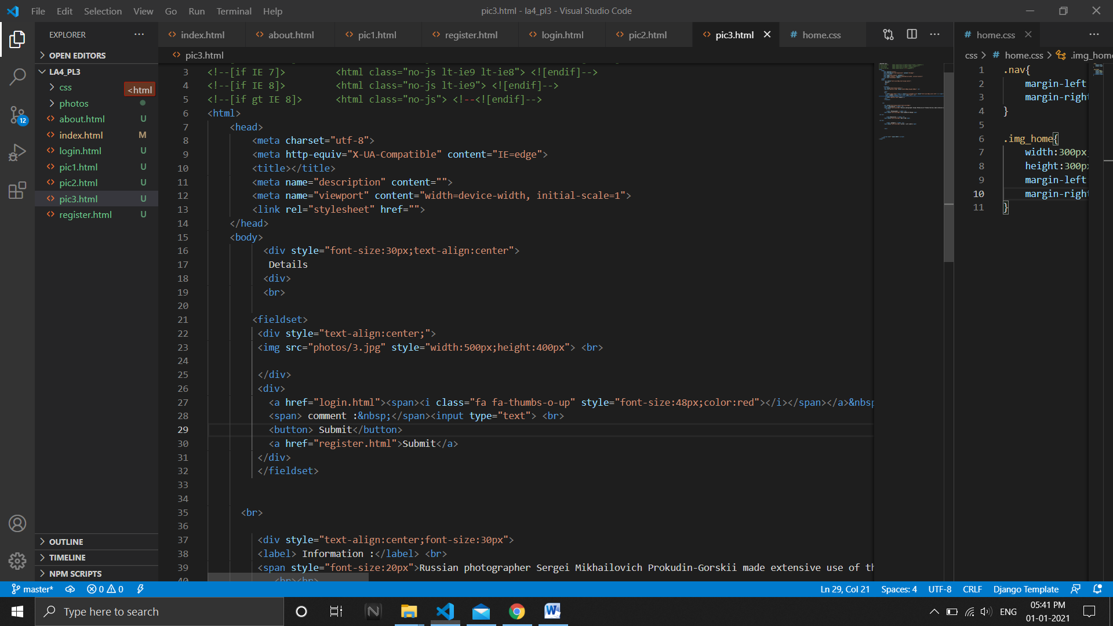

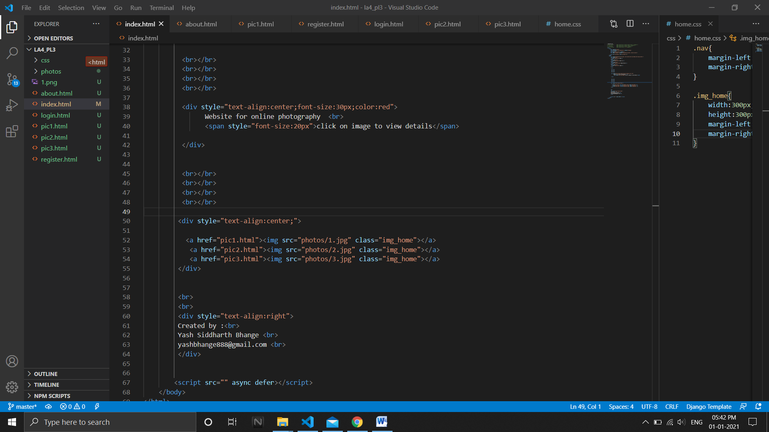

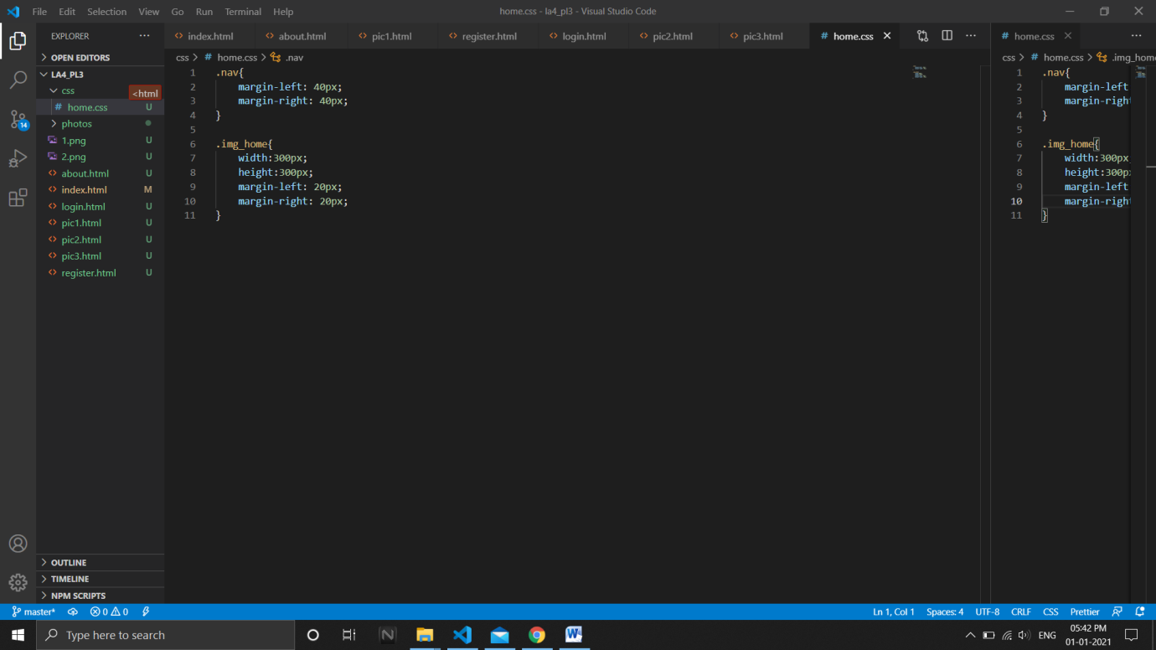

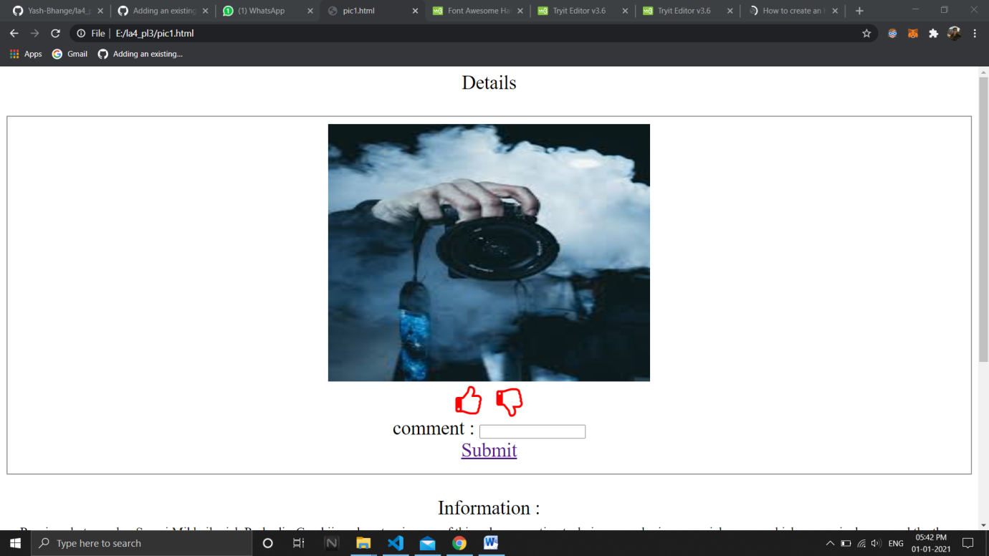

GitHub Link: https://github.com/Yash-Bhange/la4_pl3.git

Hosting Link: https://yash-bhange.github.io/la4_pl3/