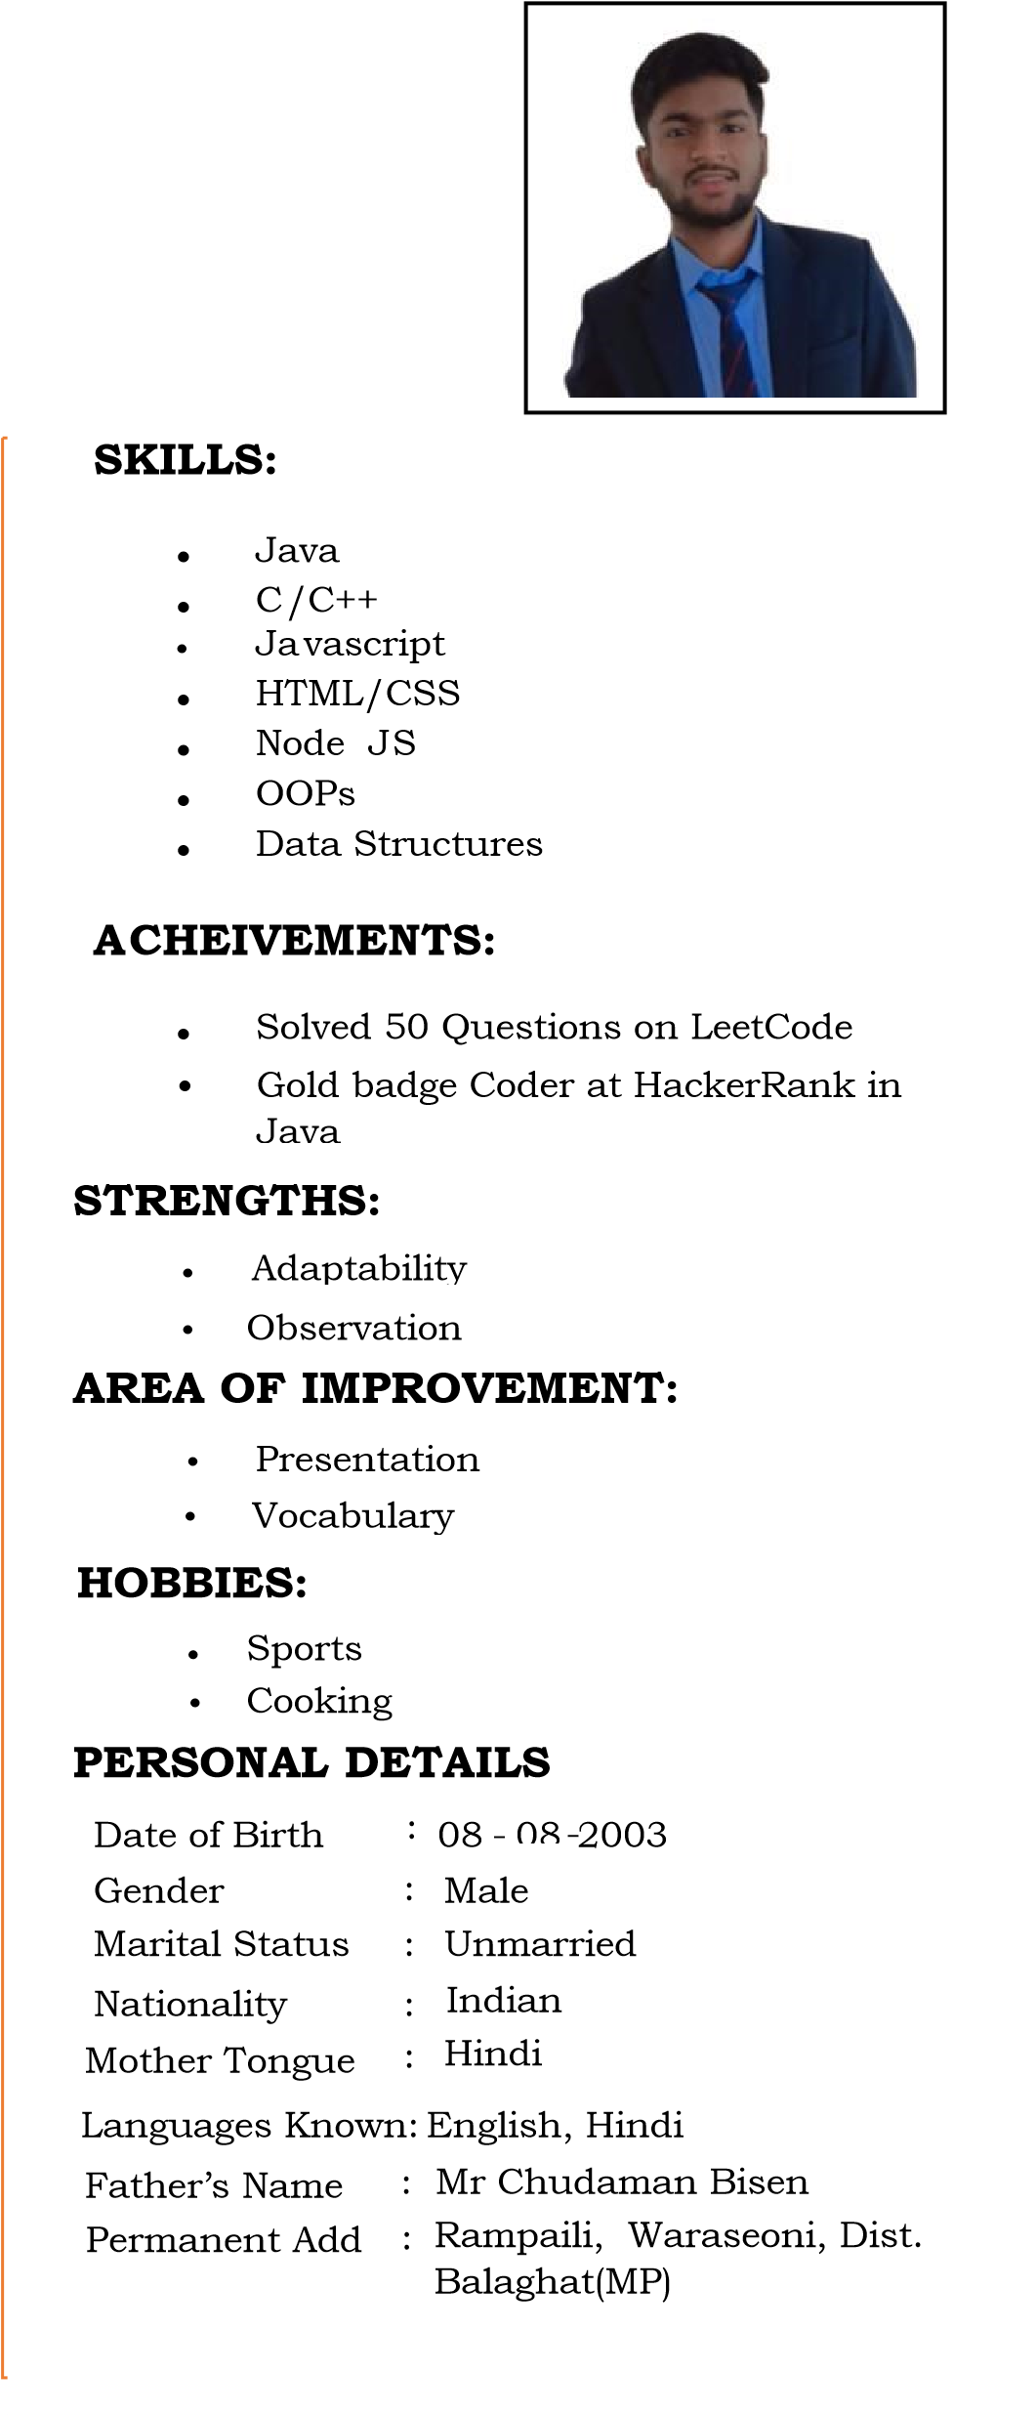**Yash Bisen**

**Address :** Vijay Nagar, Indore(MP) +91 – 871-8898-787 yashbisen0803@gmail.com  yash-bisen-820b2420a

**CAREER OBJECTIVE:**

To Obtain a job or entry-level position as a Web Developer to gain hands-on experience and apply classroom knowledge to real-world projects.

**ACADEMIC RECORD:**

* Bachelor in Technology in Information Technology: **7.87 CGPA,** Acropolis Institute of technology and Research, Indore (M.P)
* Higher Secondary (12th CBSE): **75 %** SDJ Higher

Secondary School, Balaghat (M.P)

* Senior Secondary (10th CBSE): **87.8%** SDJ Higher Secondary School, Balaghat(M.P)

**PROJECTS:**

* **Travel and Tourism Management:**

It’s an Web application which help people to booking the travel packages, Rent Vehicles, Travel booking and book a tour Guide .

**Role : Back End Developer**

**TRAINING/INTERNSHIP:**

* **Udemy:**

Full stack web Development Bootcamp

[July 2022 – Feb 2023]

* **Universal Informatics:**  Programming in C/C++

[Nov 2021 – Jan 2022]

* **Oasis Infobyte:**

Internship as a front end Developer

[Fab 2023 – Mar 2023]

**CO CURRICULAR ACTIVITIES:**

* **Member of EDC**

**Reference**: Atul Bharat , Group Director Acropolis Group of Institutes . atul@acropolis.in +91 9893540400 **Declaration:** I hereby declare that the information above is true to best of my knowledge.

|  |  |
| --- | --- |
|  | **Yash Bisen** |

**Date : 15-07-2023**

**Place: Indore**

# 