* Makefile command: make (command inside file: nvcc -o rpsadi rpsadi.cu -lcurand -lcusolver -lcublas -lm)
* Output for N = 128, alpha = 9.0, M =20000, seed = 12345:

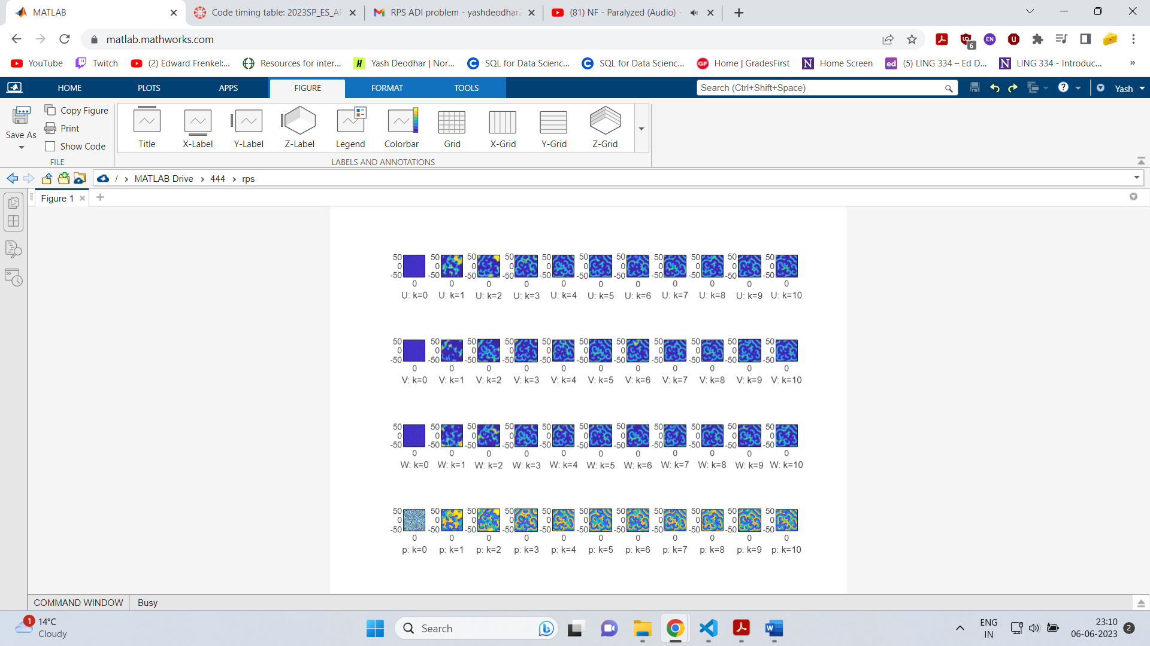

* 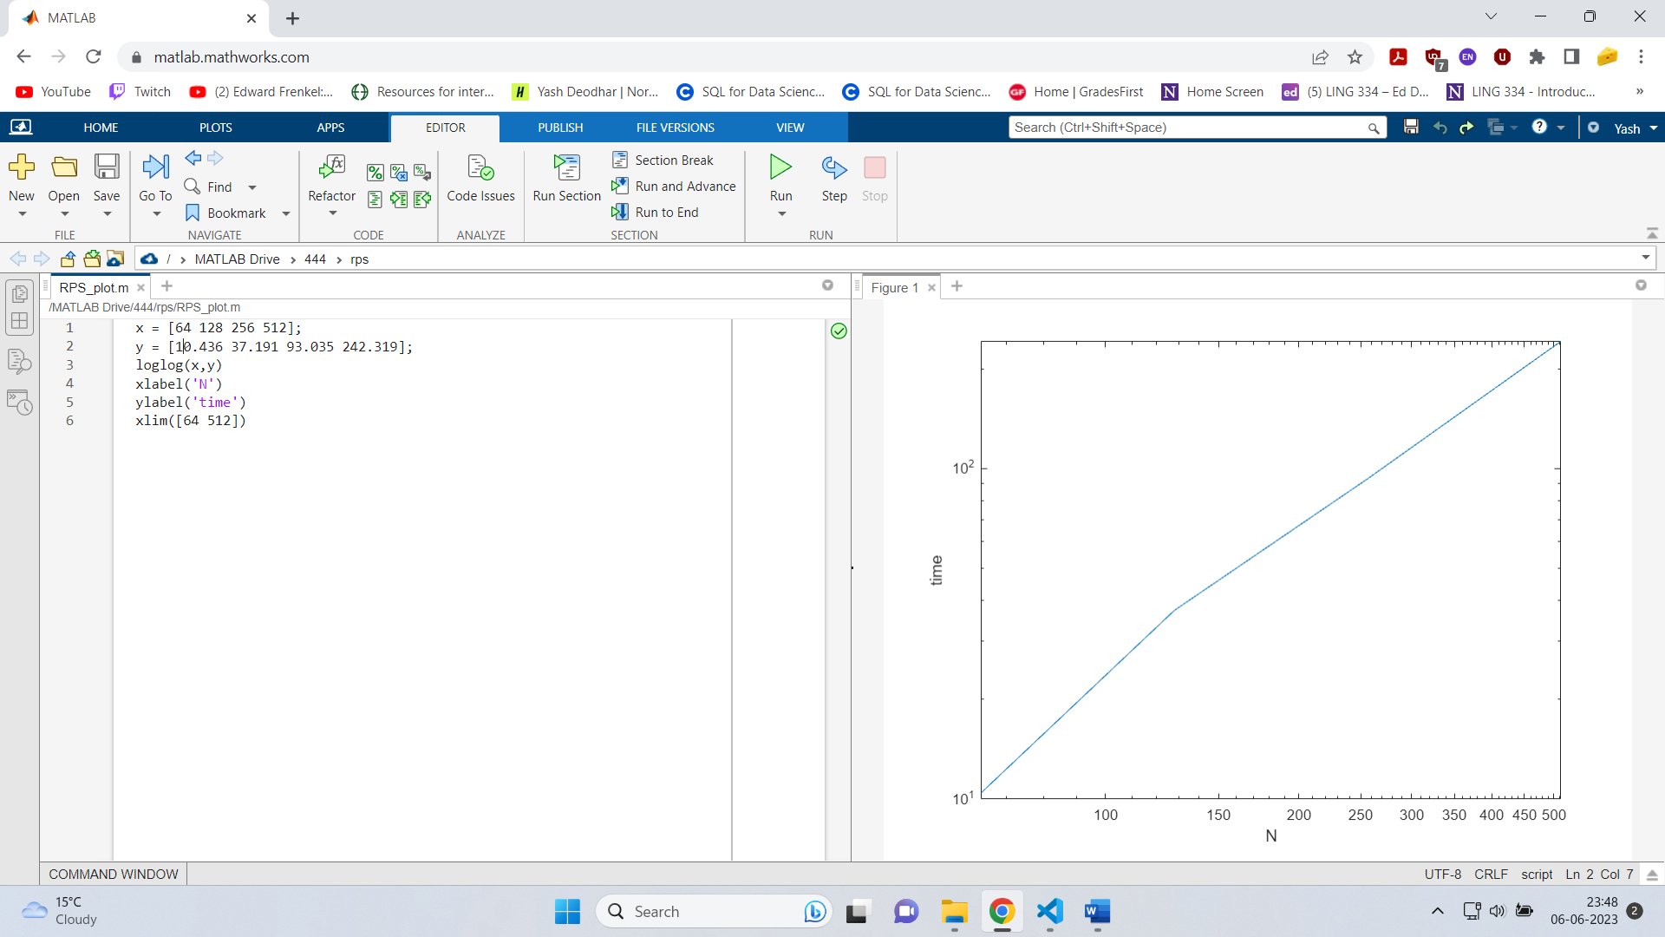N vs time plot:
* Time Comparison:

Chopp time: 37.0 seconds

My time: 37.19 seconds

I feel like my code could have been faster if I didn’t use if statements in my kernels and instead used separate kernels to implement the boundary conditions