* Makefile command required: make (compile command inside: gcc -o cgl cgl.c -lfftw3 -lm -lrt)
* My plots for N = 128, c1 = 1.5, c3 = 0.25, M = 100000, seed = 1682716224:

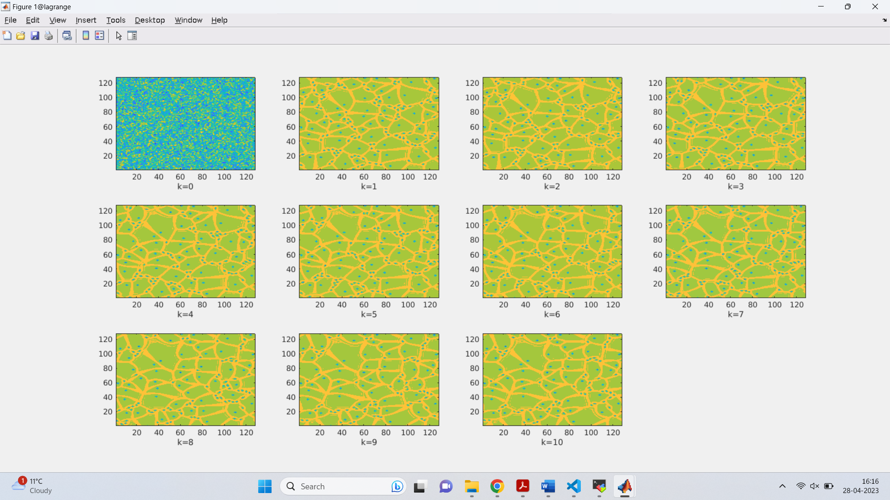Magnitude of A:

Argument of A:

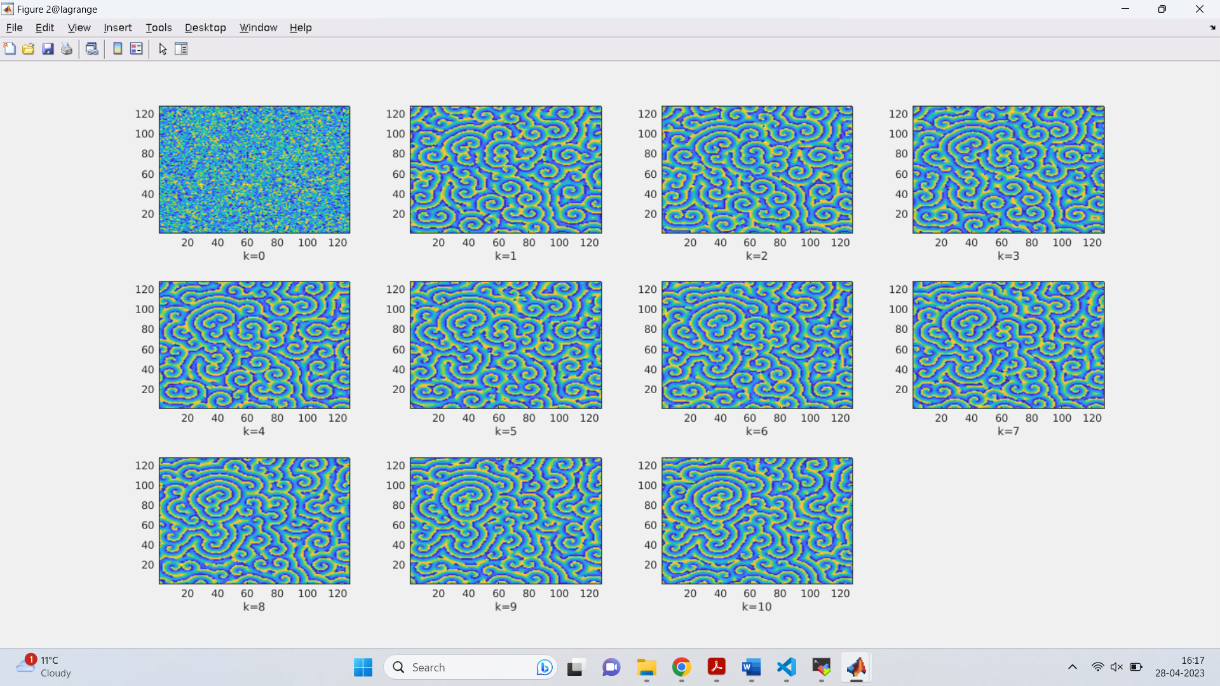

* 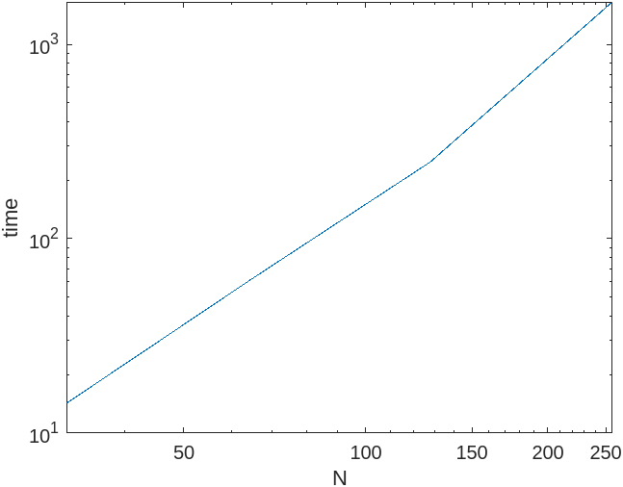LogLog plot of number of grid points vs time:
* My time for 128 1.5 0.25 100000: 248.481 seconds

Chopp time: 80.7 seconds

Last year’s class average: 350.4 seconds

To make my code faster I could have tried changing the Laplacian function so that 2 if statements aren’t encountered in each iteration. I could also have reduced time by not adding the complex_mul function and calculating the real and imaginary part by hand and then coding that.