* Makefile command required: make (compile command inside: mpicc -o diffusion diffusion.c -lrt -lm)
* 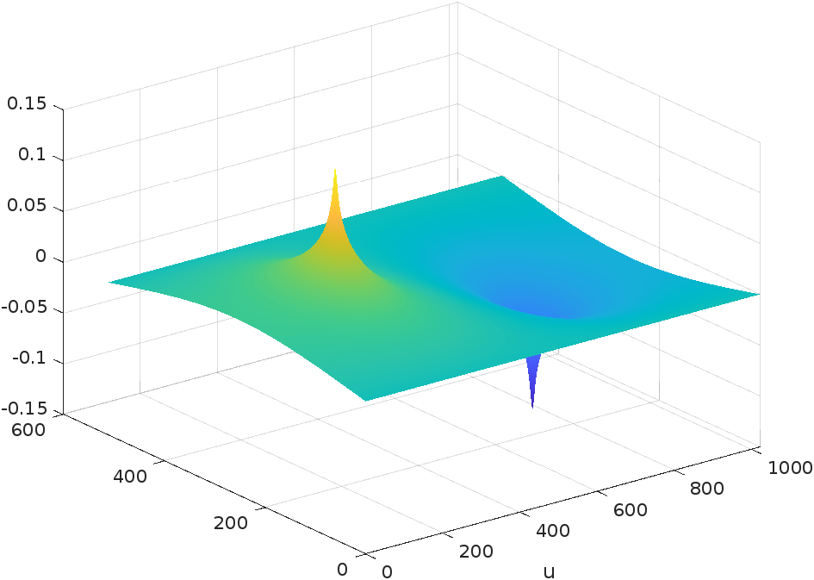My plot for N = 512, omega = 1.95, tolerance = 1e-9, max_iterations = 30000:
* 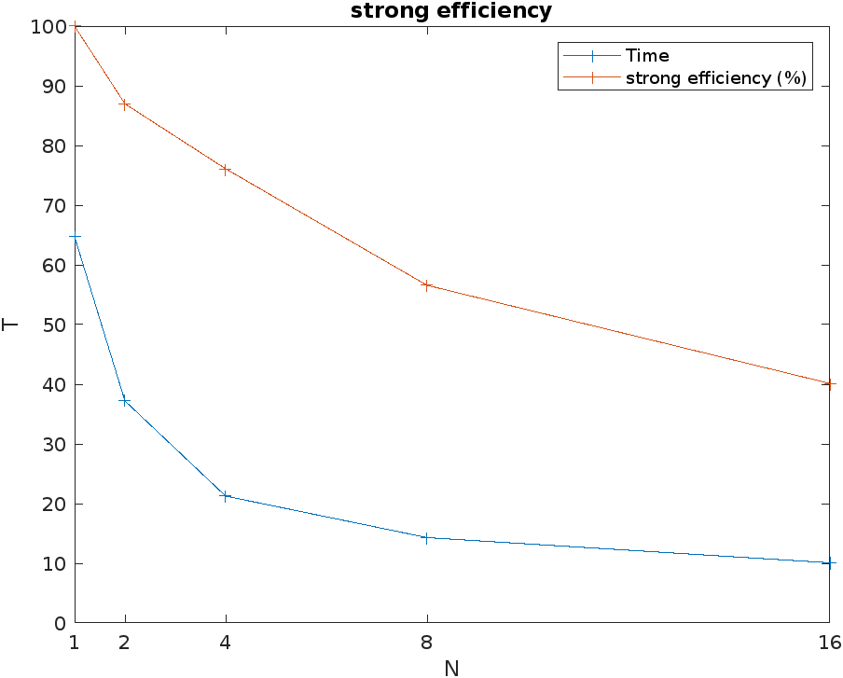Strong Efficiency:
* 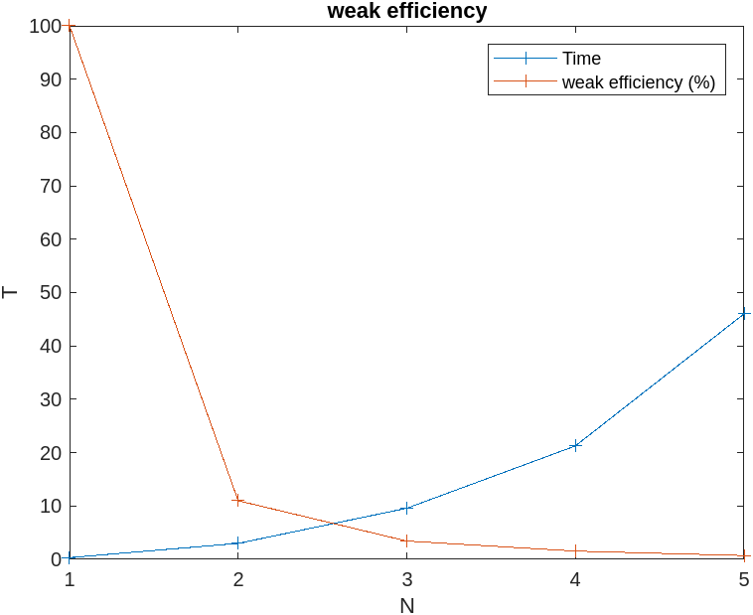Weak Efficiency (x-axis are multiples of N=128):

|  |  |  |
| --- | --- | --- |
|  | 4 cores | 16 cores |
| My Time (s) | 21.26 | 10.08 |
| Chopps time (s) | 8.3 | 2.7 |
| Last years class avg. (s) | 55 | 47 |

* Time comparison:

In my code, I have used blocking communication which may be slowing down the process. I could instead use non-blocking communication which could improve speeds since the processors don’t have to wait for each other anymore.