* Makefile command required: make (compile command inside it: gcc -o vdp vdp.c -lm -lrt)
* My plot for alpha = 1, sigma = 0.5, M = 1000, N = 100000, seed = 5:

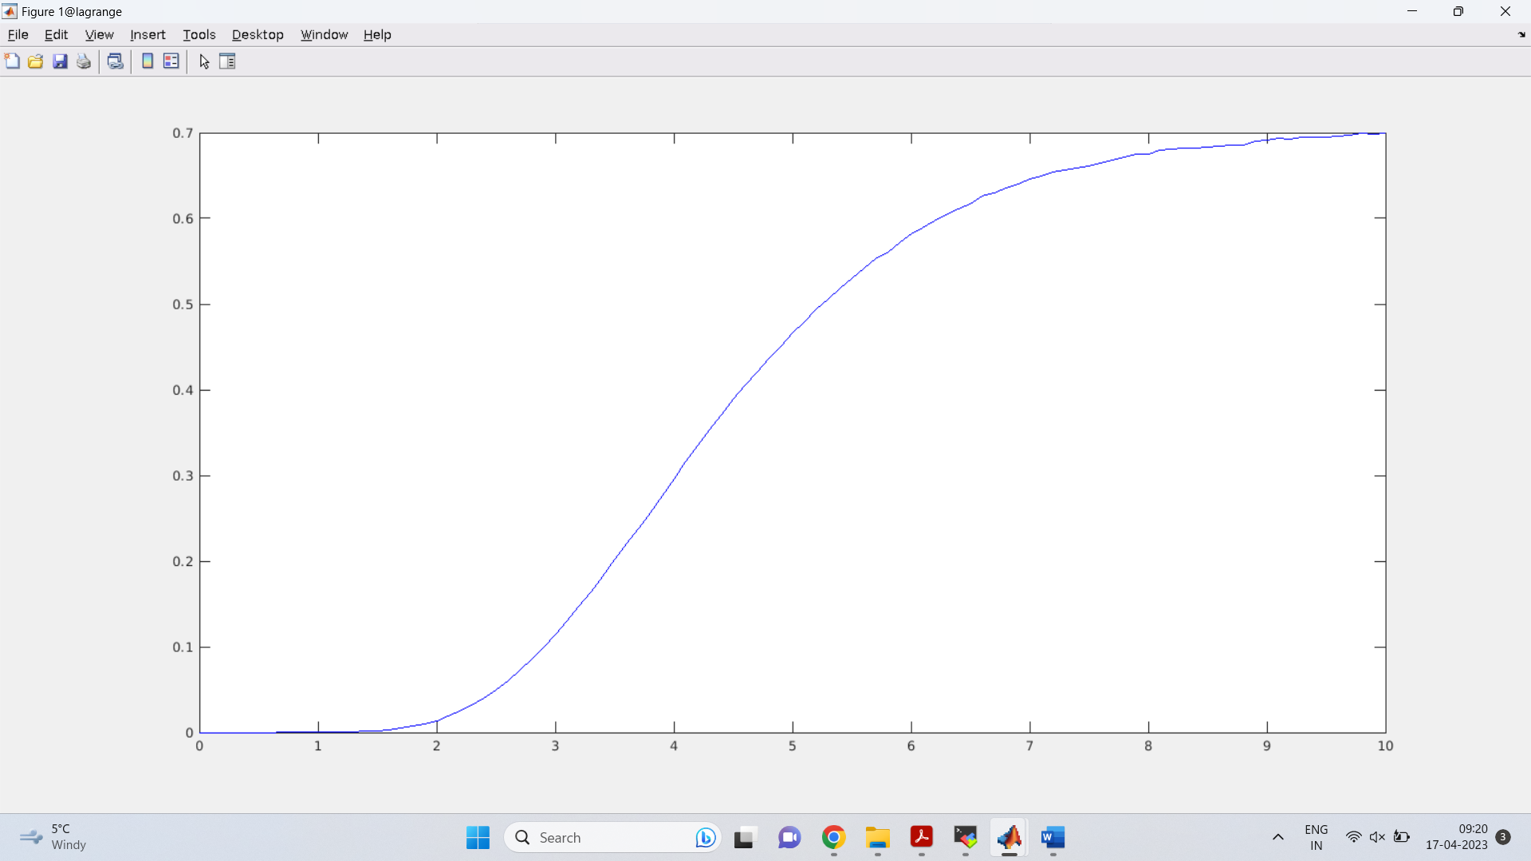

* 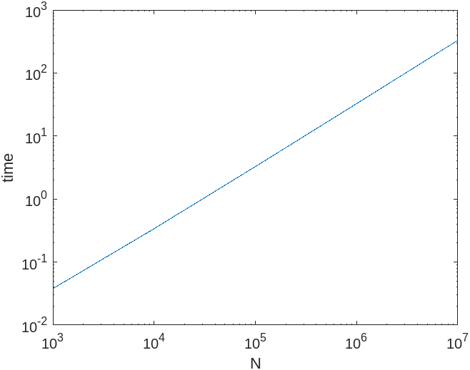Loglog plot of time vs number of iterations:
* My time for 1 0.5 1000 100000: ~3.27 seconds

Chopp time: 2.9 seconds

Last year’s class average: 4.9 seconds

I think I have optimized my code well but clearly it can be more efficient. I feel like I could have made the if statements more efficient by using the ‘?’ operator but I am not sure how much that would have sped up the process