ECE/CS 552 Introduction to Computer Architecture
Fall 2023
University of Wisconsin-Madison
Prof. Joshua San Miguel

Final Exam
Friday, December 15, 2023
120 Minutes, Wendt Commons 324

- The exam is two-sided and has 16 pages, which includes two blank pages and the two-page MIPS Green Card in the end.
- Closed book/closed notes examination.
- No handheld computers or portable computers allowed.
- Calculator allowed.
- A single 8.5”x11” double-sided, hand-written cheat sheet is allowed.
- When applicable, show your work. Any partial points will be awarded based only on what appears in your answers.
- No one should leave the room during the last 5 minutes of the examination.
- Upon announcement of the end of the exam, stop writing on the exam paper immediately. Wait for proctors to pick up all exams. The instructor will announce when you may leave the room.
- Failure to follow instructions may result in forfeiture of your exam and will be handled according to UWS 14 academic misconduct procedures.

FIRST (GIVEN) NAME: ______________________________________________________

LAST (FAMILY) NAME: ______________________________________________________

STUDENT ID#: __________________________________________________________

 | Achieved Marks | Maximum Marks
Problem 1 |  | / 18
Problem 2 |  | / 6
Problem 3 |  | / 6
Problem 4 |  | / 19
Problem 5 |  | / 5
Problem 6 |  | / 7
Problem 7 |  | / 10
Total |  | / 71

Problem 1 (18 marks)

- (3 marks) If you run a program with a cache that is fully-associative, initially empty and has infinite capacity, then which of the following types of cache misses are possible? Select all that apply.

  - Cold (compulsory) misses

  - Capacity misses

  - Conflict misses

- (3 marks) You plan to build a virtually-indexed, physically-tagged (VIPT) cache but would like to avoid the synonym problem. Without changing the cache capacity nor the page size, would it be better to decrease the associativity of your cache or increase it? Explain your answer.

- (4 marks) Consider your program running on a parallel processor. If your program is 90% parallelizable, what would be the speedup of your entire program when executed on a multiprocessor with infinitely many cores?

- (4 marks) Assume a shared-memory multiprocessor with two private caches (Cache A and B) using the modified-shared-invalid (MSI) coherence protocol from class. In the table below, the rows indicate the possible states of Cache A and the columns indicate the possible states of Cache B for a single shared memory block X. In each cell in the table, specify if it is possible (Y/N) for the two caches to be in their respective states (for block X) at the same time. One cell has been filled in for you.

Current State of Block X |  | Cache B
 |  | I | S | M
Cache A | I | Y
Cache A | S
Cache A | M

- (4 marks) You use Booth's algorithm to perform 8-bit signed integer multiplication. If the multiplicand is -47 (in decimal) and the multiplier is -9 (in decimal), answer the following:

  - How many addition operations are needed?

  - How many subtraction operations are needed?

Problem 2 (6 marks)

Consider a (little-endian) MIPS system with 32-bit virtual addresses, 24-bit physical addresses and a page size of 4KB. The processor has an 8-entry 2-way set-associative TLB and a 2-way set-associative data cache with 32B capacity and 8B block size, the contents of which are shown below. The cache is physically-indexed physically-tagged (PIPT). Both the TLB and cache use the standard set indexing scheme described in class. You run the following instruction:

lbu $s0, 0($s1) # [$s1] = [0x4C00900C]

TLB
Set | 18-bit Tag | 12-bit PPN
0 | 0x0F001 | 0x900
0 | 0x13002 | 0xCC0
1 | 0x2C100 | 0x660
1 | 0x13002 | 0xB2E
2 | 0x33004 | 0x2C0
2 | 0x0F001 | 0xCC4
3 | 0x2C002 | 0x66C
3 | 0x0F000 | 0x902

Data Cache
Set | 20-bit Tag | Data Words in Block
Set | 20-bit Tag | Offset 0 | Offset 4
0 | 0x660CC | 0x11111111 | 0xAAAAAAAA
0 | 0xB2E00 | 0x22222222 | 0xBBBBBBBB
1 | 0xB2E00 | 0x33333333 | 0xCCCCCCCC
1 | 0xCC000 | 0x44444444 | 0xDDDDDDDD

- (2 marks) What are the set and tag bits (in hexadecimal) when accessing the TLB?

- (3 marks) What are the set, offset and tag bits (in hex) when accessing the cache?

- (1 mark) What are the 32-bit contents of $s0 (in hex) after you run the above instruction?

Problem 3 (6 marks)

You have a processor system with 32-bit virtual addresses and a page size of 64KB; thus virtual page numbers (VPNs) are 16-bit. You have been running a program on this system, and it has accessed memory in the code, heap and stack segments as below. Assume all virtual addresses within the ranges shown are currently residing in physical memory (and no virtual pages outside these ranges have been allocated).

Code segment: 0x00000000 to 0x00002000
Heap segment: 0x30000000 to 0x40020B00
Stack segment: 0x7FFD0000 to 0x7FFFFFFF

The system employs a two-level page table that is accessed by dividing the 16-bit VPN into two fields: the most-significant 8 bits are used to index into the first-level table, and the least-significant 8 bits are used to index into the second-level tables.

- (3 marks) How many entries are currently valid (i.e., not a null pointer) in the first-level page table? Show your work.

- (3 marks) How many entries are currently valid (i.e., a physical page number exists) in total across all the second-level page tables? Show your work.

Problem 4 (19 marks)

Consider the following MIPS assembly program running on the R10K-like processor from class, with 15 physical registers:

L0: | lw | $t2, 0($t1)
L1: | ori | $t1, $t6, $t2
L2: | sub | $t5, $t1, $t3
L3: | addi | $t3, $t4, $t6
L4: | lw | $t4, 4($t3)
L5: | sw | $t6, 0($t3)
L6: | add | $t1, $t1, $t5
L7: | sub | $t6, $t2, $t5

Assume that initially: the reservation stations and reorder buffer are empty, and the contents of the map table and free list are as follows. Registers are popped from the left of the free list and pushed back onto the right.

Map Table
Architectural Reg | Physical Reg | Ready (Y/N)
$t1 | P1 | Y
$t2 | P2 | Y
$t3 | P3 | Y
$t4 | P4 | Y
$t5 | P5 | Y
$t6 | P6 | Y

Free List | P7, P8, P9, P10, P11, P12, P13, P14, P15

All instructions use the same type of reservation station and functional unit, and they take 1 cycle to execute (i.e., 1-cycle X stage). Assume that there are infinitely many reservation stations and functional units. The pipeline diagram is provided below.

Insn | Cycle
Insn | 1 | 2 | 3 | 4 | 5 | 6 | 7 | 8 | 9 | 10 | 11 | 12 | 13 | 14 | 15 | 16
L0 | F | De | Di | S | X | C | R
L1 |  | F | De | Di | S | S | X | C | R
L2 |  |  | F | De | Di | S | S | S | X | C | R
L3 |  |  |  | F | De | Di | S | X | C | R | R | R
L4 |  |  |  |  | F | De | Di | S | S | X | C | R | R
L5 |  |  |  |  |  | F | De | Di | S | X | C | R | R | R
L6 |  |  |  |  |  |  | F | De | Di | S | X | C | R | R | R
L7 |  |  |  |  |  |  |  | F | De | Di | Di | S | X | C | R | R

- (12 marks) Specify the contents of the map table at the end of cycle 9 (the bolded line in the pipeline diagram above).

Map Table
Architectural Reg | Physical Reg | Ready (Y/N)
$t1
$t2
$t3
$t4
$t5
$t6

- (2 marks) Which physical register is causing instruction L2 to wait in the Issue stage at cycle 6? In other words, which physical register is L2 waiting for?

- (2 marks) At the end of which cycle is physical register P3 pushed back onto the free list?

- (3 marks) Is it possible to know exactly how many reorder buffer entries there are in this processor? Explain why or why not. And if so, state the number of entries.

Problem 5 (5 marks)

Consider the following 8-bit SECDED codeword (W₈W₇W₆W₅W₄W₃W₂W₁), which encodes a 4-bit data value (b₄b₃b₂b₁), using the encoding scheme described in class (shown below):

Codeword Bits
W₈ | W₇ | W₆ | W₅ | W₄ | W₃ | W₂ | W₁
1 | 0 | 0 | 1 | 1 | 0 | 0 | 0

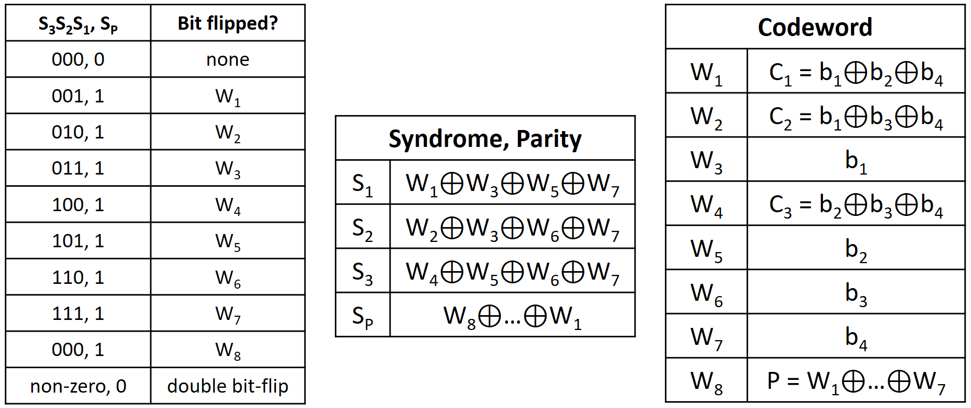

Compute the syndrome bits (S₁, S₂, S₃, S_{P}) and specify which one of the following has occurred:
- None of the bits in the codeword have flipped.
- One of the bits in the codeword has flipped.
- Two different bits in the codeword have flipped.

If either (i) or (ii) has occurred, what was the original 4-bit data (b₄b₃b₂b₁)?

Problem 6 (7 marks)

Consider the MIPS program below with two threads running in parallel on a 2-core shared-memory multiprocessor. There are no private caches, and all memory contents are initially 0.

# thread A |  |  |  | # thread B
A0: | ori | $s0, $zero, 4000 |  | B0: | ori | $s0, $zero, 4000
A1: | addi | $t1, $zero, 1 |  | B1: | addi | $t2, $zero, 1
A2: | sw | $t1, 0($s0) |  | B2: | sw | $t2, 4($s0)
A3: | lw | $t1, 4($s0) |  | B3: | lw | $t2, 0($s0)

- (4 marks) Which of the following program outcomes are possible assuming the multiprocessor supports sequential consistency? Select all that apply.

  - [$t1] = 0 and [$t2] = 0

  - [$t1] = 0 and [$t2] = 1

  - [$t1] = 1 and [$t2] = 0

  - [$t1] = 1 and [$t2] = 1

- (3 marks) What is the minimum number of memory fences needed to guarantee sequential consistency for this program when executed on any arbitrary multiprocessor? And where exactly would you insert them into the code?

Problem 7 (10 marks)

You build a custom floating-point representation that has less exponent and significand bits than the IEEE 754 standard. Your representation has the following simplified 6-bit format:

2-bit Exponent (with Bias of 1) | 4-bit Significand (with an implicit leading 1)

Note that the significand is encoded as 4 bits, excluding the leading 1. This representation does not support negative numbers (i.e., no sign bit) nor special values (e.g., zero, infinity). With your representation, every number is simply computed as:

1.Significand × 2^{(Exponent – Bias)}

- (5 marks) Given this encoding, fill in the table below, specifying both the binary and decimal encoding for each of the following numbers.

 | Decimal | Binary
Largest Number Representable
Smallest Number Representable
0.75 | 0.75

- (5 marks) Upon implementing your custom floating point representation, you forget to support the implicit leading 1. Your representation now encodes the following instead:

0.Significand × 2^{(Exponent – Bias)}

Given this buggy encoding, fill in the table below, specifying both the binary and decimal encoding for each of the following numbers. If there are multiple encodings for the number, you must list all of them.

 | Decimal | Binary
Largest Number Representable
Smallest Number Representable
0.75 | 0.75

This page is left intentionally blank, in case you need extra space for answers.

