**Project Report**

**on**

**Gym & Fitness Management System**

By,

C 57 - Vaibhav Devkar

C 74 - Yash Kad

C 65 - Vinayak Keswad

Indira College of Commerce and Science, Pune.

B.Sc.( Computer Science)-VI

**Acknowledgment**

It is indeed a great pleasure to express our thanks and gratitude to all those who helped us during this project. This project would not have materialized without the help of many who asked us good questions and rescued us from various red tape crises.

If one does not know how to put theoretical knowledge into practice, it is meaningless. We are grateful to our institution for giving us the chance to use the project to put our theoretical knowledge into practice. We feel obligated to turn in this project for our curriculum.

We would like to use this opportunity to humbly thank Prof. Avantika Bijwe, our project guide, for her guidance. Her unwavering support and readiness to impart her extensive knowledge allowed us to grow intellectually and assisted us in perfectly finishing the duties that were given to us. This project might not have been successful without her work, encouragement, and incredible testing skills. Without her guidance and assistance, this undertaking would not have been feasible.

Thanking you,

Vaibhav Devkar

Yash Kad

Vinayak Keswad .

**TABLE OF CONTENTS**

**CHAPTER 1: INTRODUCTION**

1.1 Existing System and Need for System

1.2 Scope of Work

1.3 Operating Environment – Hardware and Software

**CHAPTER 2: SYSTEM ANALYSYS**

2.1 Proposed System

2.2 User Requirements

2.3 Feasibility Study

**CHAPTER 3: SYSTEM DESIGN**

3.1 Entity Relationship Diagram (ERD)

3.2 UML Diagram

3.2.1 Class Diagram

3.2.2 Use Case Diagram

3.2.3 Sequence Diagram

3.2.4 Collaboration Diagram

3.2.5 Activity Diagram

3.2.6 Component Diagram

3.2.7 Deployment Diagram

3.3Menu Screens

**CHAPTER 4: Limitations and Enhancement**

5.1 Drawbacks and Limitations

5.2 Future Enhancements

**CHAPTER 5: Conclusion**

**CHAPTER 6: Bibliography**

**Chapter 1: Introduction**

**1.1 Existing System and Need for System**

In the current situation, Gyms and fitness centres frequently use manual methods to manage their operations, which results in inefficiencies in the areas of membership management, workout scheduling, sales management, member attendance, Subscription Management and announcements. As a result, keeping accurate records, guaranteeing member satisfaction, and maximizing resource utilization present difficulties for gym administrators.

The need for a robust Gym and Fitness Management System arises from the inadequacies of the existing systems. Such a system would streamline administrative tasks, improve member experience, and enhance overall operational efficiency. By leveraging modern technologies such as PHP and MySQL, this system aims to and provide a comprehensive solution tailored to the specific requirements of gym and fitness centre management.

**1.2 Scope of Work**

The scope of this project encompasses the development of a Gym and Fitness Management System with separate views for Administrators (admins) and Users (members). The system will include modules(Admin) for Membership management, Sales Management, Subscription Management. Admins will have access to additional functionalities for Workout Planning, Create Announcements while members will be able to view their Membership details, Buy Membership, Mark Attendance, Get Fitness Report, Workout Plan, Track Weight and Announcements.

**1.3 Operating Environment – Hardware and Software**

The proposed system will operate in a typical web-based environment, requiring hardware components such as server, computer, and network infrastructure. The software environment will consist of PHP for server-side scripting, MySQL for database management, HTML, CSS, and JavaScript for front-end development, and Apache as the web server. The system will be compatible with modern web browsers and accessible on Desktop /Laptop.

**Hardware Requirements:-**

PROCESSOR: - Core 2 Duo or [Athlon X2](http://en.wikipedia.org/wiki/Athlon_X2) at 2.4 GHz

RAM: - 2 GB RAM

HARD DISK: - 250 GB

**Software Requirements:-**

Operating System: - Windows 2003/2008 or above

Web Server: - Apache Xampp

Web Browser: - Google Chrome, Firefox, Edge, etc.

Chapter 2: System Analysis

**2.1 Proposed System**

The proposed Gym and Fitness Management System will provide a centralized platform for managing all aspects of gym operations. It will feature separate interfaces for admins and users, offering functionalities tailored to their respective roles and requirements. The system will utilize PHP and MySQL to ensure scalability, security, and reliability.

**2.2 User Requirements**

The user requirements for the proposed system are categorized into two main roles: admins and users.

* **Admins** require functionalities for managing members, subscription plans, workout planning for the gym, Sales reporting and make announcements.
* **Users** (members) require functionalities for viewing/updating their membership or profile details, view workout plan for the day, mark or track attendance, and view announcements. Additionally, both admin and user expect the system to be user-friendly, responsive, and secure.

**2.3 Feasibility Study**

1. Operational Feasibility:

The operational feasibility of the Gym and Fitness Management System project is to assess its practicality and effectiveness in meeting the needs of users and stakeholders.

Usability tests conducted on the platform's prototype received positive feedback regarding its good interface and functionality, suggesting ease of use for both customers and home cooks.

2. Economic Feasibility:

The economic feasibility of the project aims to determine its financial viability and cost-effectiveness.

It checks whether project is financially viable, with anticipated returns exceeding development and operating costs.

3. Technical Feasibility:

The technical feasibility of the project assesses its feasibility in terms of technology, resources, and infrastructure.

The chosen technologies, frameworks, and platforms are well-suited for implementing the system's functionalities, ensuring compatibility and scalability.

**CHAPTER 3 : SYSTEM DESIGN**

**3.1 ER DIAGRAM**

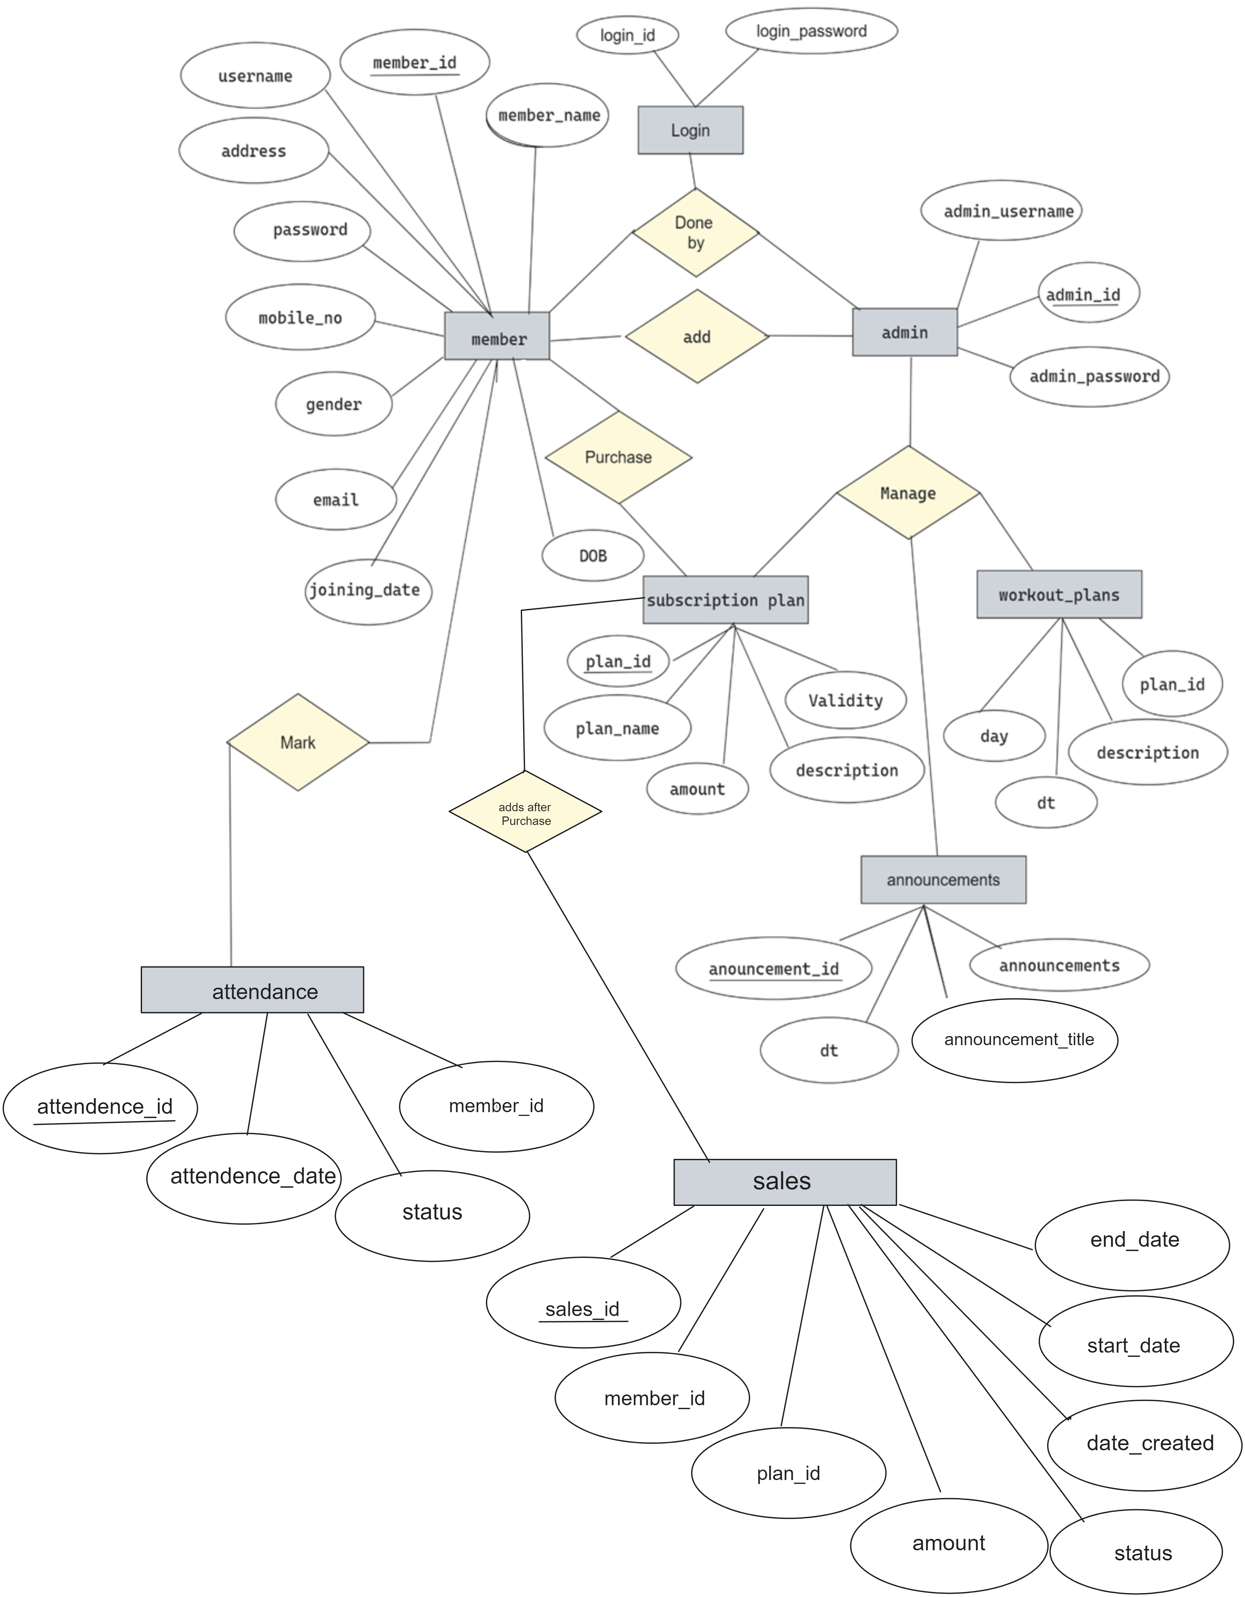

**3.2 UML DIAGRAMS**

**3.2.1 CLASS DIAGRAM**

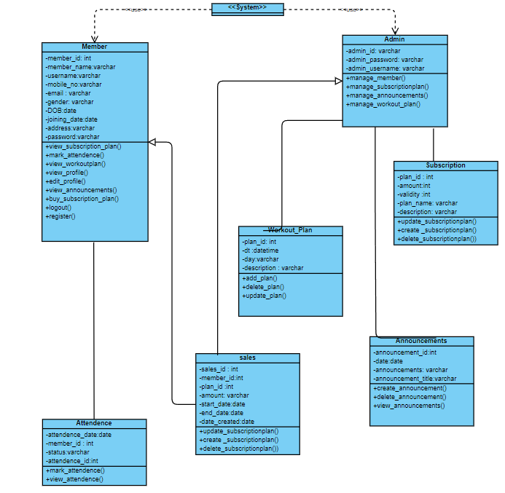

**3.2.2 USE CASE DIAGRAM**

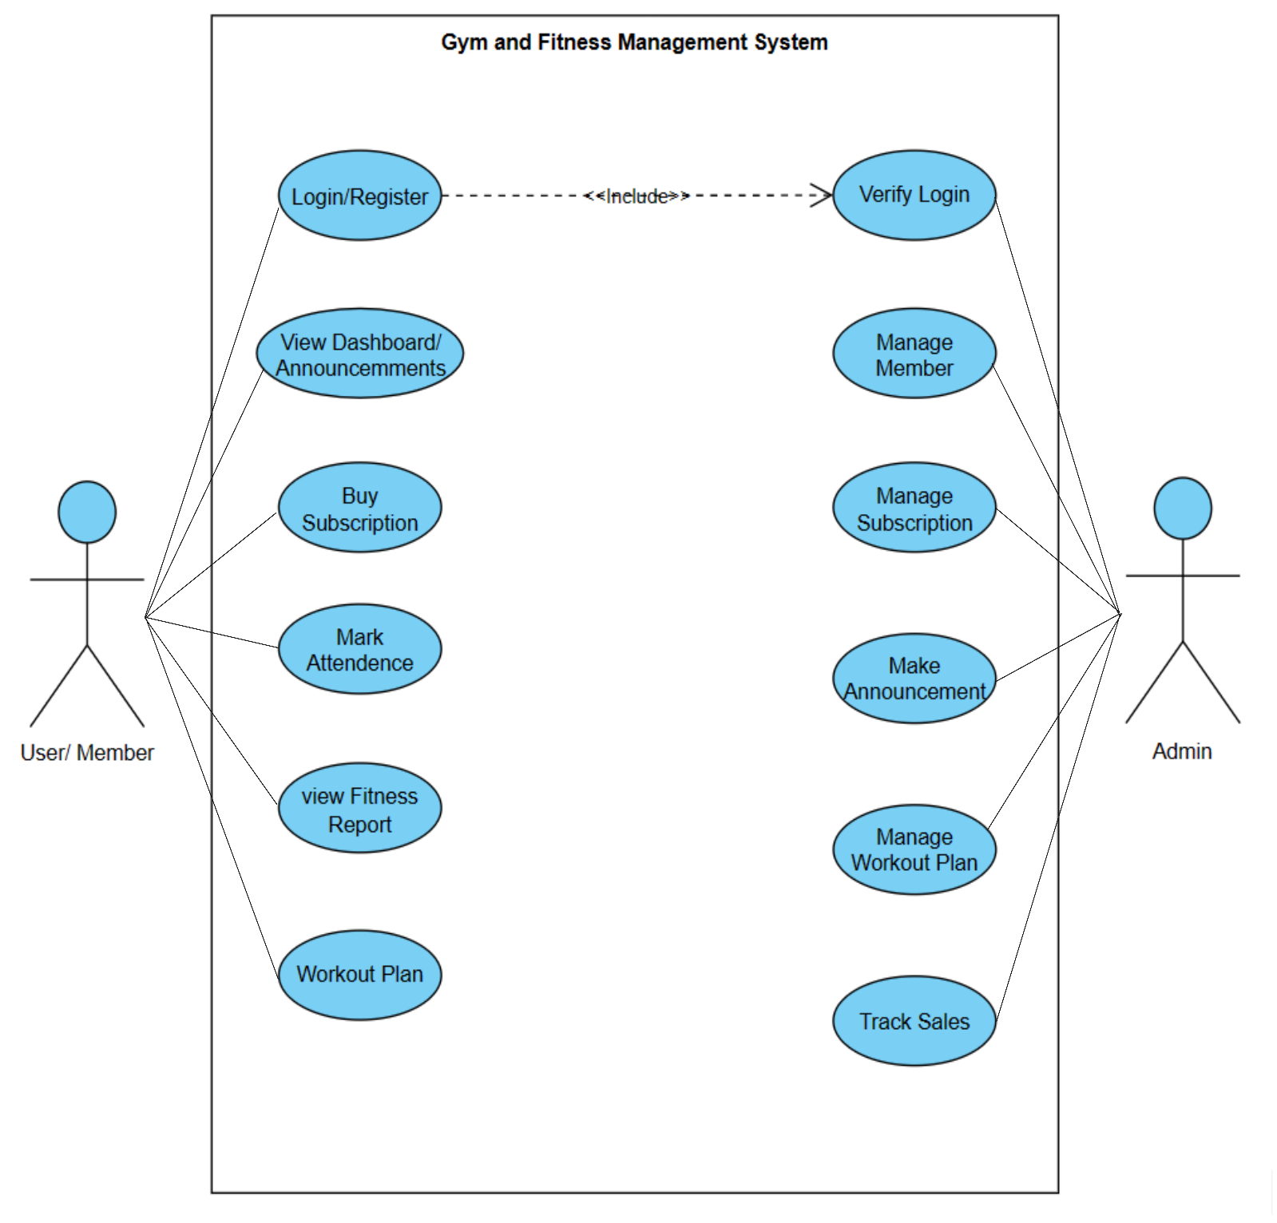

**3.2.3 SEQUENCE DIAGRAM**

**3.2.4 COLLABORATION DIAGRAM**

**3.2.5 ACTIVITY DIAGRAM**

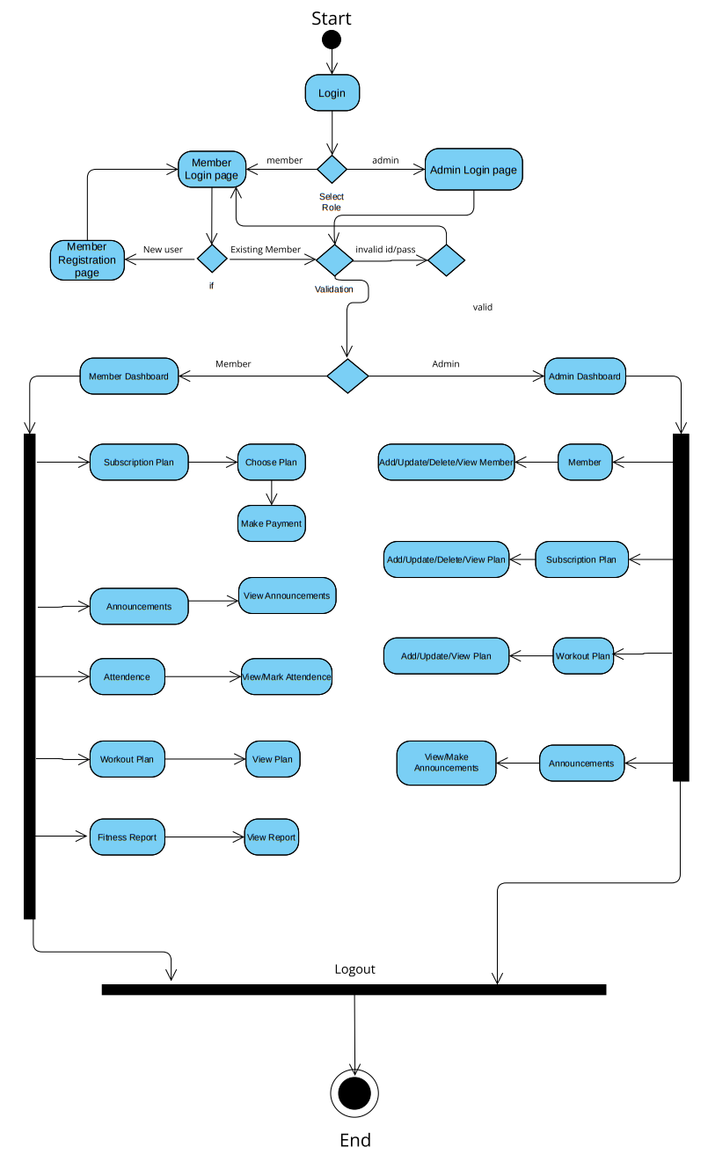

**3.2.6 COMPONENT DIAGRAM**

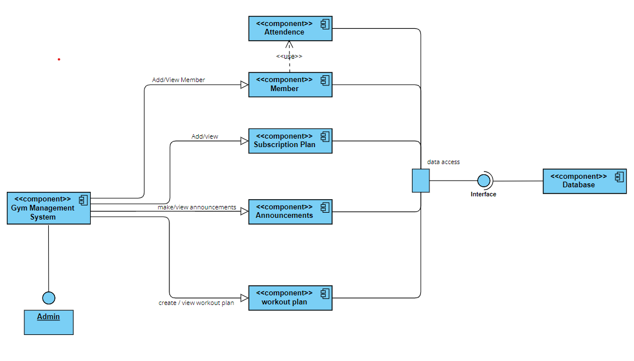

**3.2.7 DEPLOYEMNET DIAGRAM**

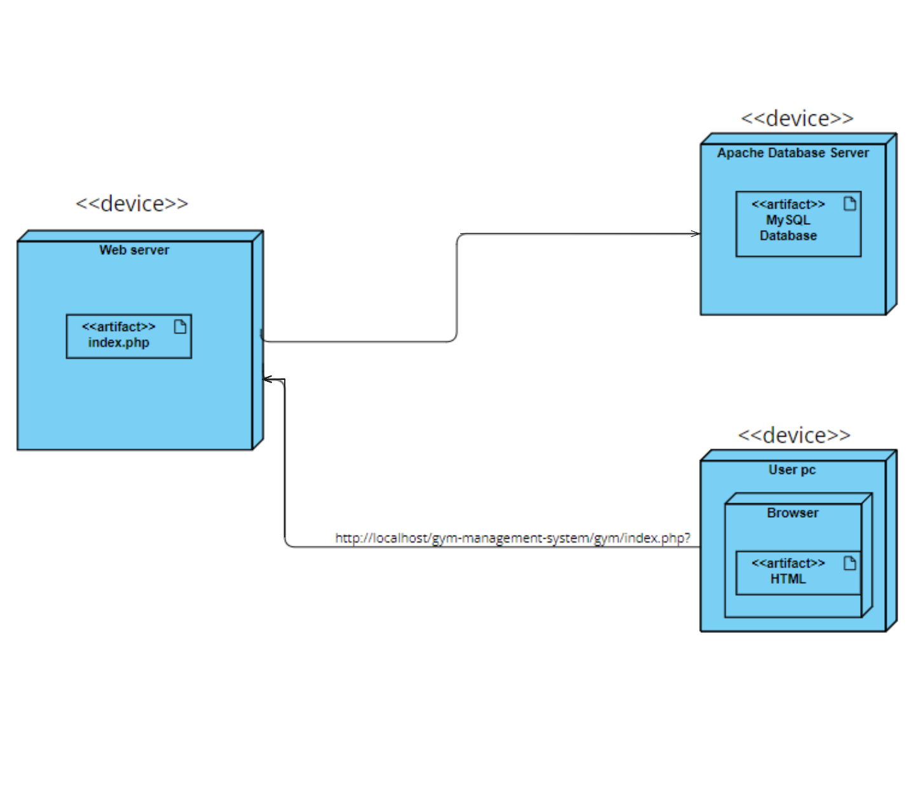

**Chapter 4: Limitations and Enhancement**

**4.1 Drawbacks and Limitations:**

1. **Initial Implementation Cost:** The project may require a significant upfront investment in terms of development, infrastructure, and training.
2. **Learning Curve:** Users may face challenges in adapting to the new system, leading to initial resistance and decreased productivity.
3. **Technical Issues:** Potential technical issues such as bugs, glitches, or system crashes could disrupt gym operations and compromise data integrity.
4. **Data Security Concerns:** Storing sensitive member information within the system poses risks of data breaches and privacy violations if not adequately secured.
5. **Limited Customization:** The system may lack flexibility in meeting the unique requirements of different gyms or fitness centres.

**4.2 Future Enhancements:**

1. **Mobile Application:** Developing a mobile application for the system would enhance accessibility and convenience for members.
2. **Gym Equipment :** Adding a feature of Gym equipment management in Admin Module where owners can keep track of all equipment.
3. **Integration with Wearable Devices:** Integrating the system with wearable fitness devices would enable automatic tracking of member activities, such as workouts and weight measurements.
4. **Enhanced Reporting and Analytics:** Adding advanced reporting and analytics features would provide administrators with deeper insights into gym performance and member engagement metrics.
5. **Personalized Recommendations:** Implementing algorithms for personalized workout recommendations and fitness goal tracking would further enhance member satisfaction and retention.

**CHAPTER 5: Conclusion**

The Gym and Fitness Management System offers a comprehensive solution for managing gym operations and enhancing member experiences. This project gave us an opportunity to understand and implement what we learned. By providing separate views for Administrators and Users, the system effectively caters to the diverse needs of both. With modules for Membership Management, Sales Management, and Subscription Management, administrators can efficiently handle administrative tasks while also accessing additional functionalities such as Workout Planning and Announcement Creation.

For members, the system facilitates easy access to membership details, purchasing memberships, marking attendance, accessing fitness reports, workout plans, tracking weight, and viewing announcements. This user-friendly interface promotes member engagement and satisfaction, contributing to a positive gym experience.

**Chapter 6: Bibliography**

1. W3School's HTML, CSS Tutorials, References and Examples @https://www.w3schools.com/.
2. MySQL and PHP on Stack Overflow @https://stackoverflow.com/.
3. PHP & MySQL: The Missing Manual, 2nd Edition

**------------------------------ THANK YOU ------------------------------**