Lab Practical #03:

Study of different types of network cables & connectors and crimping a LAN.

# Practical Assignment #03:

1. List various networks cable. Also, write short description.
2. Difference between guided and unguided media.
3. Give cross-wired cable and straight through cable diagram (Color Code wise).

## List various networks cable and connectors. Also, write short description.

1. **Unshielded Twisted Pair (UTP) Cable:** 
   * **Description**: Unshielded twisted pair cable is one of the most commonly used cables in computer networks at present time. UTP consists of two insulated copper wires twisted around one another, the twisting of wires helps in controlling interference. It is inexpensive and easy to install. It is also Flexible and lightweight.
   * **Diagram**:

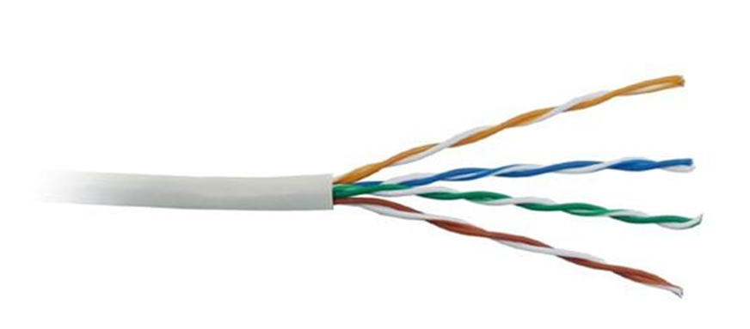

1. **Shielded Twisted Pair (STP) Cable:** 
   * **Description**: In STP the wires are covered by a copper braid covering or a foil shield, this foil shield adds a layer that protects it against interference leaking into and out of the cable. Hence, they are used for longer distances and higher transmission rates. Much better at blocking interference (EMI and radio-frequency interference). More reliable in “noisy” environments. Thicker, heavier, and more expensive than UTP.
   * **Diagram**:

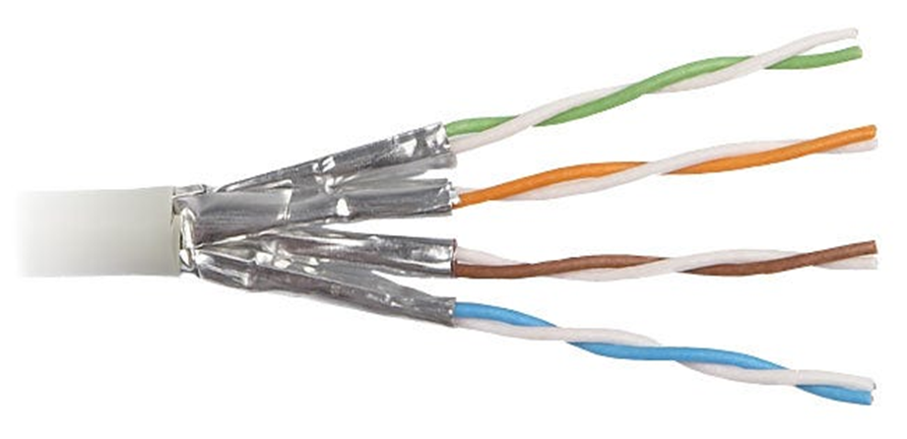

1. **Coaxial Cables:** 
   * **Description**: Coaxial cables contain a center conductor and a metal shield insulated by a plastic layer placed in between. The metal shield in coaxial cables blocks any elements or interferences from the outside.

In a coaxial cable, the outer layer, known as sheath, protects the cable from physical damage. Meanwhile, the metal shield protects the cable from any external interference, and the insulation between the metal shield and the conductor protects the conductor – the core of the coaxial cable. Good protection from interference thanks to its thick shielding. Can carry high-frequency signals.

* + **Diagram**:



1. **Fiber Optic Cables:** 
   * **Description**: Fiber optic cables use optical fibers which are made of glass cores surrounded by several layers of covering material generally made of PVC or Teflon. It transmits data in the form of light signals due to which there are no interference issues in fiber optics. Fiber optics can transmit signals over a very long distance as compared to twisted pairs or coaxial cables. Immune to electromagnetic interference. Far greater bandwidth (can carry more data at once). Extremely long-distance runs without boosters
   * **Diagram**:



## Difference between guided and unguided media.

|  |  |  |
| --- | --- | --- |
| **Feature** | **Guided Media** | **Unguided Media** |
| **Definition** | Data travels through a **physical medium** | Data travels through **air or space** |
| **Examples** | Twisted Pair, Coaxial, Fiber Optic | Radio waves, Microwaves, Infrared |
| **Reliability** | More reliable, less interference | Less reliable, affected by weather/interference |
| **Speed** | Usually faster due to dedicated paths | Slower over long distances |
| **Cost** | Installation is costlier | Cheaper to deploy, especially over large areas |
| **Usage** | LAN, WAN, telephony | Wi-Fi, satellite, cellular communication |

## Give cross-wired cable and straight through cable diagram (Color Code wise).

1. Cross-wired Cable Diagram (Color Code)

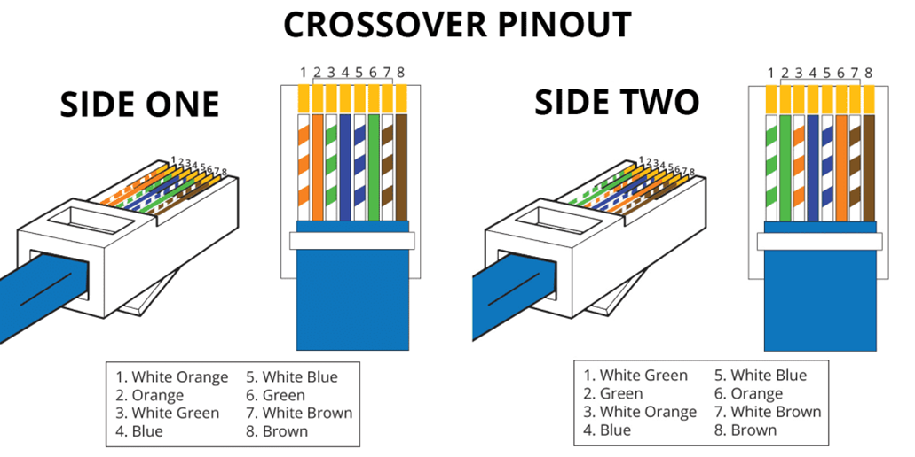

1. Straight Through Cable Diagram (Color Code)

